The Mathematics Tower, Volume 2: The Middle Floors
Storeys 13–25: From Multivariable Calculus to Set Theory & Logic

by Lothar J. Musiol

Copyright © 2026 Lothar J. Musiol. All rights reserved.

Table of Contents
Table of Contents 3
About This Volume 8
On Storeys and Rooms 9
Storey 13: Multi-Variable Functions 10
Room 13.1: What a Function of Several Variables Actually Is 11
Room 13.2: Domains, Graphs, and Level Sets 14
Room 13.3: Limits and Continuity in Several Variables 18
Room 13.4: Partial Derivatives 22
Room 13.5: The Gradient and Directional Derivatives 26
Room 13.6: The Chain Rule in Several Variables 29
Room 13.7: Tangent Planes and Linear Approximation 32
Room 13.8: Extrema and the Second-Derivative Test 35
Room 13.9: Looking Ahead: From Multi-Variable Functions to Multi-Variable Calculus 39
Storey 14: Multi-Variable Calculus 43
Room 14.1: Double Integrals and Iterated Integrals 44
Room 14.2: Triple Integrals and Applications 49
Room 14.3: Change of Variables and Jacobians 54
Room 14.4: Vector Fields and Line Integrals 57
Room 14.5: Conservative Fields and Potential Functions 60
Room 14.6: Surface Integrals and Flux 64
Room 14.7: Green's Theorem 67
Room 14.8: Stokes' Theorem and the Divergence Theorem 70
Room 14.9: Looking Ahead: From Multi-Variable Calculus to Vector Calculus Applications and Beyond 74
Storey 15: Vector Calculus 77
Room 15.1: Vector Fields Revisited 78
Room 15.2: The Gradient, Divergence, and Curl 81
Room 15.3: Identities and the Algebra of Differential Operators 85
Room 15.4: Line Integrals and Conservative Fields 88
Room 15.5: Surface Integrals and Flux 92
Room 15.6: Green's, Stokes', and Gauss's Theorems Revisited 95
Room 15.7: Potential Theory and Helmholtz Decomposition 99
Room 15.8: Physical Applications 101
Room 15.9: Looking Ahead: Differential Forms, Manifolds, and Beyond 105
Storey 16: Series 108
Room 16.1: What a Series Actually Is 109
Room 16.2: Numerical Series: Convergence Tests 113
Room 16.3: Power Series and Radius of Convergence 117
Room 16.4: Taylor and Maclaurin Series 121
Room 16.5: Operations on Power Series 125
Room 16.6: Fourier Series: The Basic Theory 129
Room 16.7: Convergence of Fourier Series and Applications 132
Room 16.8: Other Expansions and Generating Functions 136
Room 16.9: Looking Ahead: From Series to Transforms and Functional Analysis 141
Storey 17: Fourier Transforms and FFT 146
Room 17.1: From Fourier Series to the Fourier Transform 147
Room 17.2: The Fourier Transform on the Line 150
Room 17.3: Inversion, Plancherel, and Parseval 154
Room 17.4: Convolution and the Convolution Theorem 159
Room 17.5: The Discrete Fourier Transform 164
Room 17.6: The Fast Fourier Transform 168
Room 17.7: Applications: Filtering, PDEs, and Signal Processing 171
Room 17.8: Windows, Uncertainty, and Limitations 175
Room 17.9: Looking Ahead: From Fourier to Laplace, Wavelets, and Spectral Theory 179
Storey 18: Laplace Transform 183
Room 18.1: What the Laplace Transform Actually Is 184
Room 18.2: Basic Transforms and Operational Rules 188
Room 18.3: The Inverse Transform and Partial Fractions 192
Room 18.4: Solving Linear Differential Equations 197
Room 18.5: Discontinuous and Impulsive Forcing 202
Room 18.6: Convolution and the Convolution Theorem 206
Room 18.7: Systems and Transfer Functions 210
Room 18.8: Further Properties and Techniques 214
Room 18.9: Looking Back, and Ahead 218
Storey 19: Integral Geometry 221
Room 19.1: What Integral Geometry Actually Is 222
Room 19.2: Invariant Measures on Spaces of Lines and Planes 226
Room 19.3: The Cauchy–Crofton Formula 230
Room 19.4: Crofton Formulas in the Plane and in Space 233
Room 19.5: Kinematic Formulas and the Principal Kinematic Formula 237
Room 19.6: The Radon Transform 241
Room 19.7: Inversion of the Radon Transform and Tomography 245
Room 19.8: Stereology and Practical Measurement 249
Room 19.9: Looking Ahead: From Integral Geometry to Geometric Measure Theory and Advanced Topics 253
Storey 20: Matrices 257
Room 20.1: What a Matrix Actually Is 258
Room 20.2: Matrix Arithmetic: Addition, Scalar Multiplication, Multiplication 262
Room 20.3: The Identity, Inverses, and Elementary Matrices 266
Room 20.4: Determinants 269
Room 20.5: Row Reduction, Rank, and Solving Systems 273
Room 20.6: Matrices as Linear Maps 277
Room 20.7: Eigenvalues and Eigenvectors: A First Look 281
Room 20.8: Special Matrices and Factorizations 285
Room 20.9: Looking Ahead: From Matrices to Linear Algebra 289
Storey 21: Linear Algebra 292
Room 21.1: Vector Spaces and Subspaces 293
Room 21.2: Linear Independence, Bases, and Dimension 298
Room 21.3: Linear Maps and Matrices with Respect to Bases 302
Room 21.4: Rank, Nullity, and the Fundamental Theorem 307
Room 21.5: Eigenvalues, Eigenvectors, and Diagonalization 311
Room 21.6: Inner-Product Spaces and Orthogonality 315
Room 21.7: The Spectral Theorem and Quadratic Forms 319
Room 21.8: Jordan Form, SVD, and Canonical Forms 324
Room 21.9: Looking Ahead: From Linear Algebra to Modules, Representations, and Functional Analysis 328
Storey 22: Analytic Geometry 333
Room 22.1: What Analytic Geometry Actually Is 334
Room 22.2: Lines and Planes in Coordinates 337
Room 22.3: Distances, Angles, and Projections 341
Room 22.4: Circles, Spheres, and Simple Quadric Surfaces 344
Room 22.5: Conic Sections: Classification and Properties 349
Room 22.6: The General Second-Degree Equation 353
Room 22.7: Quadric Surfaces in Space 357
Room 22.8: Transformations and Invariants 361
Room 22.9: Looking Ahead: From Analytic Geometry to Differential Geometry and Algebraic Geometry 366
Storey 23: Complex Analysis 370
Room 23.1: Complex Numbers and the Complex Plane 371
Room 23.2: Holomorphic Functions and the Cauchy–Riemann Equations 376
Room 23.3: Contour Integrals and Cauchy's Theorem 380
Room 23.4: The Cauchy Integral Formula and Power Series 383
Room 23.5: Laurent Series and Singularities 388
Room 23.6: The Residue Theorem and Applications 392
Room 23.7: Conformal Mapping and the Riemann Mapping Theorem 396
Room 23.8: Harmonic Functions and Boundary-Value Problems 400
Room 23.9: Looking Ahead: From Complex Analysis to Riemann Surfaces and Several Complex Variables 404
Storey 24: Counting Carefully 407
Room 24.1: What Discrete Mathematics Actually Is 408
Room 24.2: Counting Principles and Generating Functions 412
Room 24.3: Recurrence Relations 419
Room 24.4: Graph Theory: Basics, Paths, and Trees 426
Room 24.5: Connectivity, Colorings, and Matchings 430
Room 24.6: Logic, Proofs, and Boolean Algebra 434
Room 24.7: Sets, Relations, and Functions (Discrete View) 439
Room 24.8: Introduction to Algorithms and Complexity 443
Room 24.9: Looking Ahead: From Discrete Mathematics to Combinatorics, Graph Theory, and Theoretical CS 448
Storey 25: Set Theory & Logic 453
Room 25.1: What Set Theory and Logic Actually Are 454
Room 25.2: Naive Set Theory: Operations, Relations, Functions 459
Room 25.3: Infinite Sets, Cardinality, and Cantor's Theorems 464
Room 25.4: The Axiom of Choice and Its Equivalents 469
Room 25.5: Ordinals, Well-Ordering, and Transfinite Induction 473
Room 25.6: Propositional and Predicate Logic 477
Room 25.7: Formal Proofs, Completeness, and Soundness 481
Room 25.8: Incompleteness and Undecidability 485
Room 25.9: Looking Ahead: From Foundations to Category Theory, Model Theory, and Beyond 489

About This Volume
This is Volume 2 of The Mathematics Tower, a single fifty-storey mathematics book published across four volumes because no single spine could plausibly hold the whole climb. Volume 1 covers Storeys 1 through 12 — arithmetic up through single-variable calculus — and is where the Tower's full preface lives, along with the complete story of why its chapters are called ‘rooms’ and its parts are called ‘storeys.’ If this is your first volume, the short version of that story follows immediately, in ‘On Storeys and Rooms’; the long version is one volume behind you, and worth the detour.
This volume covers Storeys 13 through 25: multivariable and vector calculus, series and integral transforms, matrices and linear algebra, analytic and integral geometry, complex analysis, discrete mathematics, and set theory & logic. Thirteen storeys, in short, that take everything Volume 1 built in one variable and generalize it — more dimensions, more structure, and, by the end, the first proper look at the foundations mathematics itself stands on.
Behind you: integral calculus, Volume 1's final storey, still faintly warm. Ahead, waiting in Volume 3: differential equations, optimization, and the geometry that holds them up. Mind the gap between volumes — it is smaller than it looks. Up we go.

On Storeys and Rooms
A brief note is owed on why perfectly good words like 'book' and 'chapter' have been evicted from this text and replaced with 'storey' and 'room', since I am aware this is the sort of decision that can look, from the outside, like whimsy that has got badly out of hand. The honest answer is that it has, rather, but let me at least make the case for the defence before you reach for a refund.
The trouble with 'book' is that this is no longer fifty of them; it is one, and a text that keeps referring to itself as 'this book' while also gesturing at 'the next book in the series' is not being quaint, it is being confused about its own word count. 'Storey' does the same job — a bounded, coherent stretch of related material — while also admitting, honestly, that the thing you are standing in only makes sense as one level of something larger. It is a small change of noun that happens to fix a structural lie, which is about as good a return as you ever get from renaming things.
'Room' replaces 'chapter' for similar reasons, but with the added benefit of matching the numbering to the metaphor rather than fighting it: Room 6.3 tells you, without further ceremony, that you are in the third room of the sixth storey, which is more information than 'Chapter 3' ever gave you and considerably more information than 'Chapter 3 of Book 6, one of a fifty-book series' gave you at roughly triple the word count. Efficiency, in the end, dressed up as a joke — which is, if I am honest, how most good jokes in mathematics arrive.
I will not pretend the metaphor is load-bearing in any technical sense; you cannot factor a polynomial faster for knowing it lives in a room rather than a chapter. But a reader climbing from arithmetic to category theory over fifty storeys deserves a mental image sturdier than 'a very long document', and a tower — with its floors resting on each other, its lift for the impatient, its occasional draughty landing — happens to be a much better description of how mathematical knowledge is actually built than a shelf of unrelated paperbacks ever was. So: storeys, rooms, and no further apology. Do come in.

Storey 13: Multi-Variable Functions
Surfaces, Level Sets, and the Art of Depending on More Than One Thing
Twelve storeys behind us now, and in every one of them the variable has been singular — dignified, well-behaved, content to sit alone on the horizontal axis while we did unspeakable things to it with derivatives and integrals. We differentiated it, integrated it, took limits of it, occasionally set it equal to zero and asked it to explain itself. Through it all, x never had to share the stage.
That arrangement ends here. Somewhere on the climb up from Storey 12 — where we spent a great deal of effort teaching integral calculus to compute areas, volumes, and the occasional arc length — the building committee has decided that reality, rather inconveniently, tends to depend on more than one thing at once. Temperature depends on both latitude and longitude. Profit depends on both price and quantity. The height of the actual staircase you are climbing depends on both how far east and how far north you have wandered from the lobby. A function of one variable was always something of a simplification, a laboratory condition; Storey 13 is where we let the experiment out into the weather.
A small and entirely honest confession before we begin: the jump from one variable to several is a good deal larger than the notation suggests. Adding a subscript feels like a modest act of housekeeping — f(x) becomes f(x, y), a comma appears, and one might reasonably expect the rest of calculus to follow along meekly, subscripts and all. It does not. Limits that exist along every straight line through a point can still fail to exist. Points where every partial derivative vanishes can turn out to be neither peaks nor valleys but something new — a saddle, a mountain pass, a place where the ground rises in one direction and falls in another. The extra dimensions are not merely more of the same; they are qualitatively new territory, and this storey exists to survey it properly before Storey 14 arrives to build the full differential and integral calculus on top of it.
So: new floor, new furniture, same building. We keep the voice, we keep the habit of checking every calculation by hand before committing it to paper, and we add, for the first time in this Tower, a second axis to worry about. Let's add variables.

Room 13.1: What a Function of Several Variables Actually Is
In Which the Input Gets Company
A function f of two variables assigns to each point (x, y) in some domain a single real number f(x, y). Nothing more mysterious is going on than in the single-variable case — you feed the machine an input and it hands back one number — except that now the input itself has two parts, and the machine has to look at both before it answers.
A function of three variables does exactly the same thing for points (x, y, z), and the pattern generalizes without resistance to n variables: the domain is some subset of ℝⁿ (real n-dimensional space, the set of all ordered lists of n real numbers), and the codomain — where the output lives — is still just ℝ, the ordinary real line. Only the input has grown; the output remains a single, solitary number, as respectable as ever.
Numeric example — Feeding a point to a two-variable function. Let f(x, y) = x² + y², and evaluate it at the point (3, 4).
f(3, 4) = 3² + 4² = 9 + 16 = 25
That is the entire computation — no calculus required yet, just arithmetic. Notice, incidentally, that this is the same 9 + 16 = 25 that has been quietly running the Pythagorean theorem since Storey 1: f(x, y) = x² + y² is, geometrically, the squared distance from the point (x, y) to the origin.
The function hasn't changed; we have simply given it two independent things to keep track of instead of one.
Nothing in the definition insists that the two variables be spatial coordinates. They might just as easily be price and quantity, temperature and pressure, or rainfall and crop yield.
The geometric language of ℝ² and ℝ³ — planes, points, distances — is simply the most convenient vocabulary available for discussing dependence on several quantities, borrowed for convenience rather than imposed by necessity. An economist writing profit as a function of price and quantity sold is doing exactly the same kind of mathematics as a physicist writing temperature as a function of latitude and longitude; both have a single output depending on two independent inputs, and both can be studied with the same machinery.
Numeric example — A function with no geometry in sight. Suppose a small publisher sells a book at price p per copy and sells q copies, at a printing cost of 3 per copy plus a fixed cost of 50 for the print run. Profit is a perfectly ordinary function of two variables that never once mentions a coordinate plane:
π(p, q) = pq − 3q − 50
At p = 10, q = 20, revenue is:
pq = 10 × 20 = 200
printing cost is:
3 × 20 = 60
and total cost is:
60 + 50 = 110
Profit is:
π(10, 20) = 200 − 110 = 90
We shall return to this function in Room 13.4, where its partial derivatives reveal exactly how sensitive profit is to price and to quantity, taken one at a time.
The graph of a function of two variables is the set of all points (x, y, f(x, y)) in three-dimensional space — no longer a curve, as it was for one variable, but a surface, a genuine sheet hovering over the xy-plane at a height determined by f.
The graph of a function of three variables would need to live in four-dimensional space, since we require three axes for the input and one more for the output, and four-dimensional pictures are notoriously unavailable to anyone without either a very unusual imagination or a willingness to lie about what they can visualize.
We manage perfectly well without drawing it directly, by studying it through slices and level sets instead — tools that Room 13.2 develops properly.
Numeric example — A function too big to draw. Let g(x, y, z) = x² + y² + z², and evaluate it at the point (1, 2, 2):
g(1, 2, 2) = 1² + 2² + 2² = 1 + 4 + 4 = 9
Its graph would be a surface living in ℝ⁴ — four coordinates, one per input variable plus one for the output — and no amount of squinting at the page will produce it. What we can draw, and what turns out to be just as informative, is a level set: the set of points where g equals a constant.
Since g(1, 2, 2) = 9, the point (1, 2, 2) lies on the level surface
g(x, y, z) = 9
which is simply the sphere of radius 3 centred at the origin (because √9 = 3, and g is exactly the squared distance from the origin, echoing the previous example).
We cannot draw the graph; we can draw the sphere, and the sphere tells us a great deal.
The central questions of this storey are the same ones that occupied us for a single variable, and that is meant as reassurance, not a trick: Where is the function defined? Where is it continuous? Where does it attain its largest and smallest values? How does it change as the inputs change?
Only the answers grow more elaborate, because a point in the plane or in space has infinitely many directions in which to move away from it, where a point on the real line had only two. Everything that follows in this storey is, in one sense, the working-out of that single observation.

Room 13.2: Domains, Graphs, and Level Sets
Reading the Contour Map Before You Climb the Mountain
The domain of a function of several variables is, as before, the set of input points for which the defining expression actually produces a real number.
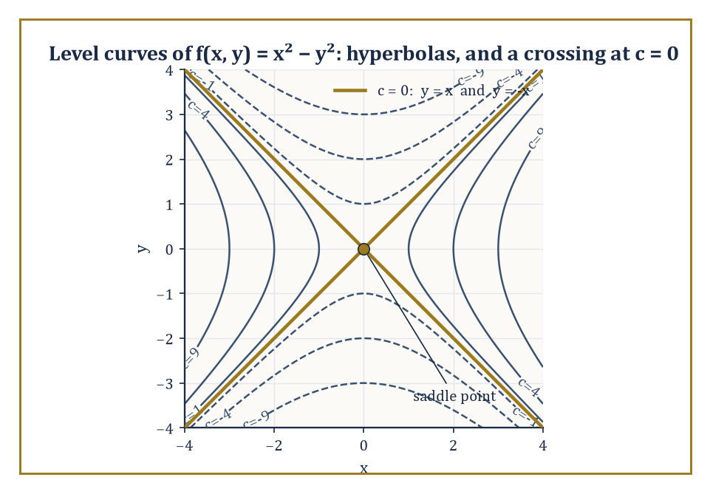
Nested hyperbolas everywhere except at c = 0, where they snap straight and cross — the ground's way of announcing a mountain pass.
For f(x, y) = √(1 − x² − y²), the expression under the square root must be non-negative, so we need:
x² + y² ≤ 1
That is the closed unit disk, all points within (or on) distance 1 of the origin. For f(x, y) = 1/(x − y), the only forbidden inputs are those making the denominator zero, so the domain is the entire plane with the line x = y removed — a plane with a single straight scar running through it.
Sketching the domain is a routine but genuinely necessary first step in any multi-variable problem; a function is meaningless outside it, however elegant the formula looks.
Numeric example — Testing points against a domain. Take f(x, y) = √(1 − x² − y²) again. Is the point (0.5, 0.5) in its domain? Compute:
1 − x² − y² = 1 − 0.25 − 0.25 = 0.5
This is non-negative, so yes:
f(0.5, 0.5) = √0.5 ≈ 0.707
Now try (1, 1):
1 − 1² − 1² = 1 − 1 − 1 = −1
This is negative, so (1, 1) is outside the domain — the square root of a negative number is not a real number, and f simply refuses to answer. The boundary between yes and no here is exactly the circle
x² + y² = 1
which is why the domain came out to be a disk in the first place.
The graph z = f(x, y) is a surface, and while the object itself is perfectly well-defined, getting a useful picture of it usually requires some assistance.
A trace is the curve obtained by intersecting the surface with a vertical plane — setting y equal to a constant, for instance, and seeing what curve remains in the resulting xz-plane. A contour map does the opposite: it fixes the height z and records the resulting curve in the xy-plane.
The same surface, viewed from different angles or sliced in different ways, can look startlingly different; the mathematical object f itself never changes, only our vantage point on it.
Numeric example — Two traces of a paraboloid. Let f(x, y) = x² + y². The trace at y = 0 is obtained by substituting:
z = x² + 0² = x²
That is an ordinary upward parabola in the xz-plane. The trace at x = 0 is, by the same logic:
z = y²
a parabola in the yz-plane. Both traces are parabolas opening upward, which is a strong hint (confirmed properly in Room 13.8) that the surface itself is a paraboloid — a bowl-shaped surface, symmetric about the z-axis, with its lowest point at the origin.
A level set — a level curve in the plane, a level surface in space — is the set of all points where f takes one particular constant value:
f(x, y) = c
Level curves are exactly the contour lines on a topographic map, each one tracing out the points at a fixed altitude.
The geometry of the family of level sets, taken as a whole, encodes the geometry of the function almost completely: level sets that crowd close together indicate a steep function (a small step sideways produces a large change in height), while widely spaced level sets indicate a gentle slope.
We will make this precise in Room 13.5, where it turns out that the function changes fastest in the direction perpendicular to its level sets — but the intuition is available already, from any map with contour lines on it.
Numeric example — Level curves of a paraboloid. For f(x, y) = x² + y² again, the level curve at c = 9 is the set of points satisfying:
x² + y² = 9
That is a circle of radius 3 centred at the origin (since √9 = 3). At c = 4 it is a circle of radius 2; at c = 0 it degenerates to the single point (0, 0), the bottom of the bowl.
As c increases, the circles grow steadily larger, exactly matching the picture of a bowl that widens as you rise up its sides. Nested, evenly spaced circles growing outward: that is what a paraboloid looks like from above, on a contour map.
Reading a contour map is, properly understood, an exercise in reading a function of two variables without ever seeing its formula. The spacing of the contours tells you the steepness; closed contours that shrink down toward a point indicate a local extremum, a peak or a pit, at that point.
Contours that cross — or, more precisely, the degenerate case where the level curve at one particular height is not a smooth closed loop but a pair of crossing lines — indicate something more interesting: a saddle point, a mountain pass between two peaks, where the ground rises in one direction and falls in the perpendicular one.
Abstract example — The telltale contour of a saddle. Consider f(x, y) = x² − y², a function whose level curves are:
x² − y² = c
For c > 0 these are hyperbolas opening left and right; for c < 0 they are hyperbolas opening up and down; but at the critical value c = 0, the equation
x² − y² = 0
factors as
(x − y)(x + y) = 0
giving the two straight lines y = x and y = −x, crossing at the origin. That crossing is the signature of a saddle: as you approach the origin along y = x, the function is
f(x, x) = x² − x² = 0
the whole way, perfectly flat; but move instead along the x-axis (y = 0), and
f(x, 0) = x²
rises; move along the y-axis (x = 0), and
f(0, y) = −y²
falls. The same point is simultaneously a minimum in one direction and a maximum in another — precisely what a contour map with crossing lines is trying to tell you. We meet this function again, formally classified, in Room 13.8.

Room 13.3: Limits and Continuity in Several Variables
Where the Plane Starts Making Trouble
The limit of f(x, y) as (x, y) approaches (a, b) is L if f(x, y) gets arbitrarily close to L whenever (x, y) gets sufficiently close to (a, b) — and the crucial phrase, doing all the work in that sentence, is 'however (x, y) approaches', by any route whatsoever.
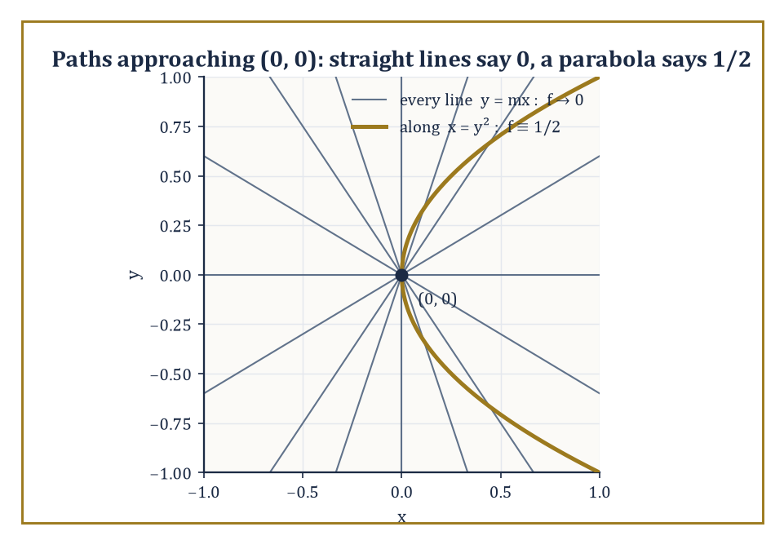
Every straight road into the origin insists the limit is 0; the one curved road that actually matters insists on 1/2.
On the real line there were only two directions of approach, from the left and from the right, and checking both was enough. In the plane there is a full disk of directions, and the precise ε–δ definition (recall Storey 8's careful treatment of limits) simply replaces the interval neighbourhood of one variable with a disk neighbourhood: for every ε > 0 there must exist a δ > 0 such that whenever the distance from (x, y) to (a, b) is less than δ, the distance from f(x, y) to L is less than ε.
The bookkeeping generalizes painlessly; the consequences do not.
Numeric example — A straightforward limit, before the complications begin. Not every multi-variable limit is a minefield; most of them are perfectly tame, and it would be unfair to introduce the subject as nothing but hazards. Let f(x, y) = x² + 3y, and consider the limit as (x, y) → (2, 1).
Because f is a polynomial, it is continuous everywhere (a fact this room confirms properly in a moment), and for a continuous function the limit at a point simply equals the value of the function there: substitute directly,
f(2, 1) = 2² + 3(1) = 4 + 3 = 7
No ε–δ argument, no checking of paths, no cause for alarm — the limit is 7, exactly as evaluating the function directly suggests.
The suspicion that occupies the rest of this room is reserved for functions that are not so obliging at the point in question, typically because the formula collapses to 0/0 there; a plain polynomial has never given anyone that kind of trouble.
The extra directions of approach create a genuinely new phenomenon that has no analogue on the line: a limit can exist and agree along every straight-line path through the point, and still fail to exist overall, because some more devious curved path — a parabola, say — produces a different value.
This is the first place where multi-variable calculus stops being 'single-variable calculus with subscripts' and starts requiring its own suspicion.
To prove a limit does exist, one typically needs an algebraic estimate — often a squeeze, bounding |f(x, y) − L| by something that shrinks uniformly across the whole disk, not just along one path. To prove a limit does not exist, it suffices to exhibit just two paths yielding two different answers; the asymmetry between proving existence and proving non-existence is worth sitting with, because it recurs throughout analysis.
Numeric example — Proving a limit exists, by squeezing it. Before seeing a limit fail to exist, it is worth seeing one succeed, honestly, by the squeeze method. Let f(x, y) = x²y/(x² + y²) for (x, y) ≠ (0, 0), and consider the limit as (x, y) → (0, 0).
Since x² ≤ x² + y² always (because y² ≥ 0), we have:
x²/(x² + y²) ≤ 1 for every (x, y) ≠ (0, 0)
Multiplying both sides by |y| gives:
|f(x, y)| = |x²y/(x² + y²)| = [x²/(x² + y²)]·|y| ≤ 1·|y| = |y|
As (x, y) → (0, 0), certainly |y| → 0, and since
0 ≤ |f(x, y)| ≤ |y| → 0
the squeeze theorem (Storey 8's old friend, still working) forces f(x, y) → 0 as well.
Unlike the checking-every-straight-line approach, which can never rule out some cleverer curved path lurking undetected, this bound |f(x, y)| ≤ |y| holds uniformly over the whole disk around the origin, for every path simultaneously — which is exactly the kind of estimate a genuine existence proof requires.
Numeric example — A limit that fools every straight line. Let f(x, y) = xy²/(x² + y⁴), and consider the limit as (x, y) → (0, 0). First, approach along any straight line through the origin, y = mx, for a fixed slope m. Substituting:
f(x, mx) = x(mx)²/(x² + (mx)⁴) = m²x³/(x² + m⁴x⁴) = m²x³/[x²(1 + m⁴x²)] = m²x/(1 + m⁴x²)
As x → 0, the numerator m²x → 0 and the denominator → 1, so the whole expression → 0, for every single value of m, including the vertical line x = 0, where:
f(0, y) = 0/y⁴ = 0
Every straight-line approach gives 0. It is tempting, and wrong, to conclude the limit is 0. Now approach along the parabola x = y²:
f(y², y) = y² · y²/((y²)² + y⁴) = y⁴/(y⁴ + y⁴) = y⁴/(2y⁴) = 1/2, for every y ≠ 0
Along this curved path the function is constantly 1/2, however close y gets to 0 — utterly different from the 0 obtained along every straight line. Since two paths give two different limiting values, the limit of f at (0, 0) does not exist. Straight lines, it turns out, were never enough to settle the question.
Continuity is defined exactly as it was for a single variable: f is continuous at (a, b) if the limit as (x, y) → (a, b) exists and equals f(a, b) itself.
Sums, products, quotients, and compositions of continuous functions remain continuous wherever they are defined, by the same combination rules proved back in Storey 8; in particular, every polynomial in several variables is continuous everywhere, and every rational function (a quotient of polynomials) is continuous on its entire domain — meaning everywhere except where the denominator vanishes.
Numeric example — Continuity and its exceptions. Let g(x, y) = 1/(x² + y² − 1). This is a rational function, hence continuous throughout its domain — which is the entire plane except the unit circle
x² + y² = 1
where the denominator vanishes and g is simply undefined. At (0, 0):
x² + y² − 1 = 0 + 0 − 1 = −1
so
g(0, 0) = 1/(−1) = −1
perfectly well-defined and, since (0, 0) is comfortably away from the unit circle, continuous there too. The statement 'g is continuous on its domain' is not a dodge — it is the precise and complete claim: everywhere g is defined, it is also continuous; the unit circle was simply never part of the domain to begin with.
The subtlety uncovered above is the first proper warning, delivered early and deliberately, that multi-variable calculus is not merely single-variable calculus wearing extra subscripts.
Every later tool in this storey — partial derivatives, the gradient, tangent planes — will be built on limits, and every one of them inherits this same need for caution about the direction of approach. It is worth carrying that caution forward rather than assuming, out of habit from twelve storeys of one variable, that checking a couple of obvious paths settles the matter.

Room 13.4: Partial Derivatives
Differentiating One Variable at a Time, Politely Ignoring the Others
A partial derivative is simply an ordinary derivative taken with respect to one variable while every other variable is held rigidly, temporarily, fixed — frozen in place like a well-behaved constant, which for the duration of the calculation is exactly what it is.
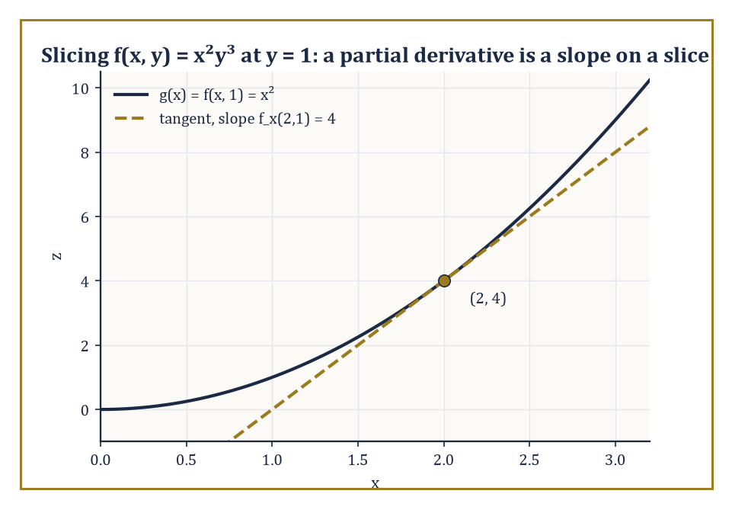
Freeze y at 1, and the surface's slice through x is just an ordinary parabola with an ordinary tangent line.
The partial derivative of f with respect to x at the point (a, b) is defined as the ordinary derivative, in the sense of Storey 6, of the single-variable function g(x) = f(x, b) — that is, f with y nailed down at the value b — evaluated at x = a.
Geometrically, this is the slope of the tangent line to the curve you get by slicing the surface z = f(x, y) with the vertical plane y = b: hold y still, watch how z changes as x moves, and you have your partial derivative.
Numeric example — A partial derivative, computed two ways. Let f(x, y) = x²y³, and find the partial derivatives at the point (2, 1). Treating y as a constant, differentiate with respect to x:
f_x(x, y) = 2xy³, so f_x(2, 1) = 2(2)(1)³ = 4
Treating x as a constant, differentiate with respect to y:
f_y(x, y) = 3x²y², so f_y(2, 1) = 3(2)²(1)² = 3(4)(1) = 12
Now verify f_x(2, 1) = 4 the slow way, exactly as the definition demands: slice at y = 1 to get:
g(x) = f(x, 1) = x²(1)³ = x²
an ordinary single-variable function. Then:
g′(x) = 2x, and g′(2) = 4
matching f_x(2, 1) precisely. The shortcut (treat the other variable as a constant, differentiate as usual) and the slow method (slice the surface, differentiate the resulting curve) agree, as they must.
Notation for partial derivatives comes in several dialects that all mean the same thing: ∂f/∂x, f_x, and D_x f are interchangeable.
Higher-order partial derivatives are obtained by differentiating again, and here a pleasant surprise awaits: the mixed partial derivatives f_xy and f_yx (differentiating twice, once with respect to each variable, in opposite orders) turn out to be equal, provided both are continuous.
This is Clairaut's theorem, and it is one of those results that feels like it ought to require heroic effort and instead falls out almost for free once continuity is assumed; the order in which you take two partial derivatives simply does not matter, under mild and usually automatically-satisfied conditions.
Numeric example — Checking Clairaut's theorem. Continue with f(x, y) = x²y³. We have f_x = 2xy³, so differentiating that with respect to y gives:
f_xy = ∂/∂y(2xy³) = 6xy²
We also have f_y = 3x²y², so differentiating that with respect to x gives:
f_yx = ∂/∂x(3x²y²) = 6xy²
The two mixed partials, computed in opposite orders, are algebraically identical: both equal 6xy². At the point (2, 1):
f_xy(2,1) = 6(2)(1)² = 12, and f_yx(2, 1) = 6(2)(1)² = 12
the same number, exactly as Clairaut's theorem promises for a smooth polynomial like this one.
The mechanics of computing a partial derivative are pure ordinary differentiation, with the added discipline of remembering, at every step, which letters are currently allowed to vary and which are frozen.
Every rule from earlier storeys — product rule, quotient rule, chain rule for single-variable compositions — applies exactly as before within the variable you are differentiating; the algebra has not changed one bit. Only the geometric meaning has: a derivative used to be the slope of a tangent line to a curve, and now it is the slope of a tangent line to a slice of a surface, one direction at a time.
Numeric example — A partial derivative with a product inside. Let f(x, y) = sin(xy) + x³, and compute the partial derivatives at (0, π). Differentiating with respect to x, treating y as constant, requires the chain rule on sin(xy):
f_x = y·cos(xy) + 3x²
Differentiating with respect to y, treating x as constant:
f_y = x·cos(xy)
(the x³ term vanishes, since it contains no y). At (0, π):
xy = 0 × π = 0, so cos(xy) = cos(0) = 1
Then:
f_x(0, π) = π·(1) + 3(0)² = π + 0 = π, and f_y(0, π) = 0·(1) = 0
The x-partial is π; the y-partial is 0 — sensible, since at x = 0 the surface's cross-section in the y-direction,
f(0, y) = sin(0) + 0 = 0
is constant, and constants have zero slope.
Partial derivatives have a second life outside pure geometry: in economics, and in applied mathematics generally, they are usually called marginal quantities.
The partial derivative of a profit function with respect to price is the marginal effect of price on profit — how much profit changes for a small increase in price, quantity held fixed — and the partial with respect to quantity is the marginal effect of quantity, price held fixed.
This is exactly the same operation as slicing a surface with a vertical plane; economics simply gives the slice a more evocative name.
Numeric example — Marginal profit, revisited from Room 13.1. Recall the publisher's profit function from Room 13.1:
π(p, q) = pq − 3q − 50
The partial derivatives are:
π_p = q (the q and the −3q term vanish, leaving q), and π_q = p − 3
At the point (p, q) = (10, 20), where we computed π(10, 20) = 90 back in Room 13.1:
π_p(10, 20) = 20
meaning a small increase in price, quantity held fixed, increases profit at a rate of about 20 per unit of price; and:
π_q(10, 20) = 10 − 3 = 7
meaning a small increase in the number of copies sold, price held fixed, increases profit at a rate of about 7 per extra copy. Price, at this particular combination, is the far more sensitive lever — which is exactly the sort of fact a partial derivative is built to reveal at a glance, without re-deriving the whole profit formula.
Partial derivatives measure the rate of change of f only in the two special coordinate directions — purely along x, or purely along y — and say nothing directly about what happens if you set off diagonally, or in any other direction of your choosing.
To measure the rate of change in an arbitrary direction, we need two new ideas that turn out to be the same idea viewed from different angles: the directional derivative, and the gradient. That is the business of Room 13.5.

Room 13.5: The Gradient and Directional Derivatives
The Single Vector That Knows Which Way Is Up
The gradient of f is the vector formed by collecting all the first partial derivatives together:
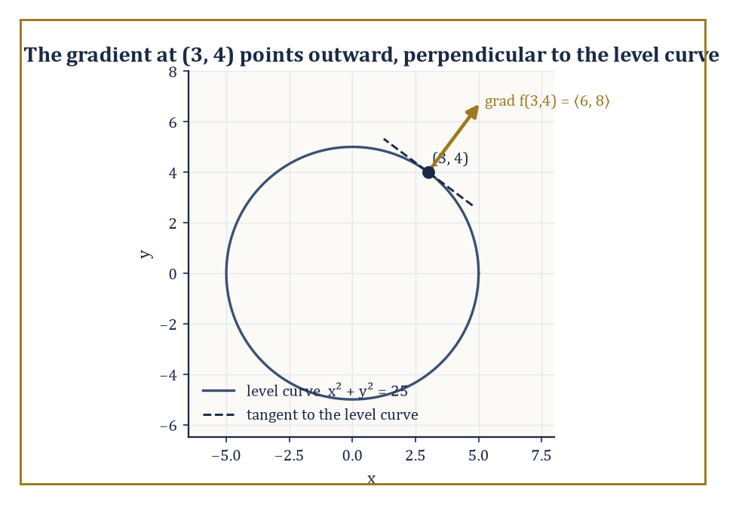
The gradient points straight out along the radius, at a right angle to the very circle it lives on.
∇f = ⟨f_x, f_y⟩ in the plane, or ⟨f_x, f_y, f_z⟩ in space
The symbol ∇ (nabla) is read 'grad' or 'del', and the object it produces is not a number but a vector — one that lives at each point of the domain and points in the direction in which f increases most rapidly at that point, with its length (magnitude) equal to the rate of that fastest increase.
It is, in a real sense, the correct generalization of 'the derivative' to several variables: a single object that captures everything the partials capture, and arranges it usefully as a direction and a speed.
Numeric example — Computing a gradient and its magnitude. Let f(x, y) = x² + y², our familiar paraboloid from Rooms 13.1 and 13.2. Its gradient is:
∇f = ⟨2x, 2y⟩
At the point (3, 4):
∇f(3, 4) = ⟨6, 8⟩
The magnitude of this vector is:
|∇f(3,4)| = √(6² + 8²) = √(36 + 64) = √100 = 10
So at (3, 4), the function is increasing fastest in the direction ⟨6, 8⟩ — or, normalized to a unit vector, ⟨3/5, 4/5⟩ — and the rate of that fastest increase is exactly 10. Geometrically, this makes complete sense: the paraboloid gets steeper the farther out you go from its centre, and (3, 4) is a fair distance from the origin (5 units, in fact — another old friend, the 3-4-5 triangle, still turning up on Storey 13).
The directional derivative of f at a point, in the direction of a unit vector u (a vector of length exactly 1, so that it specifies a pure direction with no extra scaling), is the ordinary rate of change of f as you move from that point along the straight line in direction u. Rather than recomputing this from first principles every time, there is a remarkably clean formula:
directional derivative = ∇f · u
Since the dot product of a fixed vector with a unit vector is maximized exactly when the unit vector points the same way as the fixed vector, and minimized when it points the opposite way, this single formula immediately tells us that the directional derivative is largest when u is the direction of ∇f, and smallest (most negative) when u points directly away from ∇f.
Numeric example — Directional derivatives in three directions. Continue with f(x, y) = x² + y² at (3, 4), where we found ∇f(3, 4) = ⟨6, 8⟩. First, take u = ⟨1/√2, 1/√2⟩, the unit vector pointing north-east at 45°. The directional derivative is:
∇f · u = 6(1/√2) + 8(1/√2) = 14/√2 = 7√2 ≈ 9.899
This is less than the maximum possible rate of 10 found in the previous example, as it should be, since u is not quite aligned with the gradient direction ⟨3/5, 4/5⟩. Second, take u pointing exactly opposite to the gradient's direction, u = ⟨−3/5, −4/5⟩: the directional derivative is:
6(−3/5) + 8(−4/5) = −18/5 − 32/5 = −50/5 = −10
This is the minimum possible value, exactly the negative of the maximum found before, confirming that moving directly toward the origin decreases f as fast as possible.
Perhaps the single most useful geometric fact about the gradient is that it is always orthogonal (perpendicular) to the level set passing through that point.
This one fact explains, in a single stroke, why the contour lines on any topographic map are perpendicular to the direction of steepest ascent — hikers who want the gentlest route around a hillside walk along a contour line, precisely because that direction produces zero change in height, while the direction of maximum change (the gradient) cuts straight across the contours at a right angle.
Abstract example — Gradient meets level curve, at right angles. Take f(x, y) = x² + y² once more. The level curve through (3, 4) is:
x² + y² = 25 (since 3² + 4² = 25)
a circle of radius 5 centred at the origin. We found ∇f(3, 4) = ⟨6, 8⟩, which is simply twice the radius vector ⟨3, 4⟩ — pointing straight outward from the centre of the circle, along the radius. The tangent direction to a circle at the point (3, 4), meanwhile, is perpendicular to the radius, and one such tangent vector is ⟨−4, 3⟩ (swap the coordinates and negate one — a standard trick for rotating a vector 90°). Checking orthogonality with a dot product:
⟨6, 8⟩ · ⟨−4, 3⟩ = 6(−4) + 8(3) = −24 + 24 = 0
The gradient and the tangent to the level curve are exactly perpendicular, as the general theorem promised, and this was no coincidence of the particular numbers chosen — it holds at every point, for every differentiable function.
Once the gradient is in hand, a whole cluster of first-order questions collapse into short calculations with vectors rather than fresh derivations each time: the rate of change of f in any given direction is a single dot product; the direction of fastest increase is simply 'the direction the gradient points'; and, as Room 13.7 will show, the equation of the tangent plane to a surface falls out of the gradient almost as an afterthought.
The gradient earns its keep as the natural generalization of 'the derivative' precisely because so much useful geometry radiates outward from that one vector.

Room 13.6: The Chain Rule in Several Variables
What Happens When the Inputs Have Their Own Inputs
When each input variable of f is itself a function of some further variable — say a single parameter t, tracing out a path through the domain — the derivative of the resulting composite function is given by a multi-variable chain rule. If z = f(x, y) with x = x(t) and y = y(t), then:
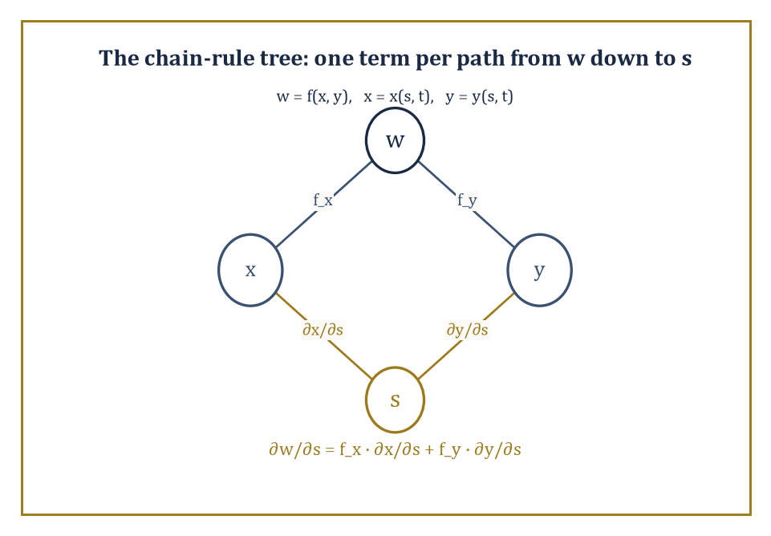
One branch per intermediate variable, one term per branch — the chain rule's bookkeeping, drawn instead of memorized.
dz/dt = f_x · dx/dt + f_y · dy/dt
Read geometrically, this is precisely the directional derivative of f (from Room 13.5) taken in the direction of the path's velocity vector ⟨dx/dt, dy/dt⟩ — the chain rule and the directional derivative turn out to be the same calculation, wearing two different names depending on context.
Numeric example — The chain rule, verified against direct substitution. Let z = f(x, y) = x²y, with x(t) = t² and y(t) = t + 1. We want dz/dt at t = 1. First, via the chain rule:
f_x = 2xy, f_y = x², dx/dt = 2t, dy/dt = 1, so dz/dt = 2xy · 2t + x² · 1
At t = 1:
x = 1² = 1, y = 1 + 1 = 2, so f_x = 2(1)(2) = 4, f_y = 1² = 1, dx/dt = 2(1) = 2, dy/dt = 1
Then:
dz/dt = 4(2) + 1(1) = 8 + 1 = 9
Now check this the slow way, by substituting first and differentiating a single-variable function:
z(t) = x(t)²y(t) = (t²)²(t + 1) = t⁴(t + 1) = t⁵ + t⁴, so dz/dt = 5t⁴ + 4t³
and at t = 1:
dz/dt = 5(1) + 4(1) = 5 + 4 = 9
Both methods give 9. The chain rule is not a separate fact requiring separate faith; it is a bookkeeping shortcut that always agrees with direct substitution, and is indispensable once direct substitution becomes too painful to attempt.
When there are more intermediate variables, or more final variables, the pattern simply grows more terms, each of the same shape: for every intermediate variable, take the partial derivative of f with respect to that intermediate, and multiply it by the derivative of that intermediate with respect to the final variable, then sum all such contributions.
Tree diagrams — drawing f branching down to its intermediate variables, and each of those branching down further to the ultimate variables — are the standard bookkeeping device for keeping every term accounted for and none double-counted or forgotten.
Numeric example — Two intermediate variables, two final variables. Let w = f(x, y) = xy, with x(s, t) = s + t and y(s, t) = s − t. To find ∂w/∂s, the tree diagram has two branches from w down to x and y, and one branch each from x and y down to s:
∂w/∂s = f_x · ∂x/∂s + f_y · ∂y/∂s
Here:
f_x = y, f_y = x, ∂x/∂s = 1, ∂y/∂s = 1, so ∂w/∂s = y(1) + x(1) = x + y = (s + t) + (s − t) = 2s
Checking directly by substitution:
w(s, t) = (s + t)(s − t) = s² − t², so ∂w/∂s = 2s
The two methods agree, and notice that with two intermediate variables (x and y) feeding into one final variable (s), the chain rule needed exactly two terms — one per intermediate variable — exactly as the tree diagram predicts.
The chain rule also settles, quietly and elegantly, a question that might otherwise seem to need entirely new machinery: implicit differentiation. If a curve is defined implicitly by an equation F(x, y) = 0 — the variables tangled together rather than one solved neatly in terms of the other — we can regard y as some function y(x) along the curve and differentiate F(x, y(x)) = 0 with respect to x using the chain rule:
F_x + F_y·(dy/dx) = 0
Since the right-hand side is constantly zero and hence has derivative zero, solving gives:
dy/dx = −F_x/F_y
a formula that replaces the sometimes-impossible task of solving for y explicitly with the comparatively painless task of computing two partial derivatives.
Numeric example — Implicit differentiation, on an old friend of a circle. Let F(x, y) = x² + y² − 25, so that F(x, y) = 0 describes the circle x² + y² = 25 — the very circle of radius 5 that carried the point (3, 4) through Room 13.5's gradient examples. Find dy/dx at (3, 4) via the chain-rule formula:
F_x = 2x = 6 and F_y = 2y = 8, so dy/dx = −F_x/F_y = −6/8 = −3/4
Checking directly: on the upper half of the circle,
y = √(25 − x²), so dy/dx = −x/√(25 − x²)
and at x = 3 this is:
−3/√(25 − 9) = −3/√16 = −3/4
The two methods agree, and the implicit method needed no square root at all — only two partial derivatives and a division, a considerable saving when F is messier than a circle.
The multi-variable chain rule is not merely a convenience; it is the mechanism that lets us differentiate functions built from complicated substitutions without ever having to substitute them out explicitly, and it is the algebraic engine behind related-rates problems in several variables — the natural extension of the related-rates work from Storey 6, now with several quantities changing simultaneously and interacting through a shared function.
It will resurface, more importantly still, as the foundation of change-of-variables in multiple integrals in the next storey, where switching from Cartesian to polar or spherical coordinates is, underneath the hood, nothing but a careful application of exactly this rule.

Room 13.7: Tangent Planes and Linear Approximation
The Best Flat Guess at a Curved Truth
The tangent plane to the surface z = f(x, y) at a point (a, b, f(a, b)) is the plane that best approximates the surface in the immediate neighbourhood of that point — the direct generalization of the tangent line from single-variable calculus, now flattened out into two dimensions instead of one. Its equation is:
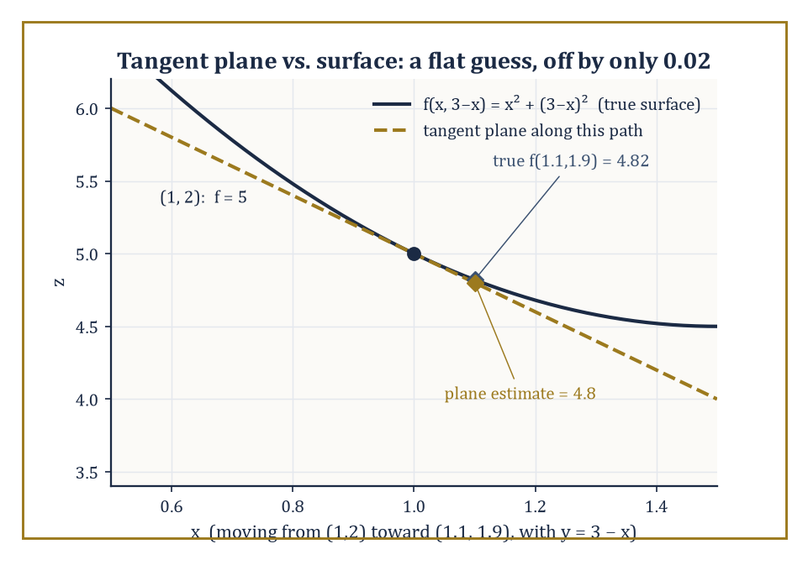
A flat plane, glued on at (1, 2), tracks the bowl closely enough that nobody two decimal places away would notice the difference.
z = f(a, b) + f_x(a, b)(x − a) + f_y(a, b)(y − b)
Start at the known height f(a, b), then add a correction proportional to how far x has moved (scaled by the x-slope) and a correction proportional to how far y has moved (scaled by the y-slope).
In vector language, this plane is exactly the plane orthogonal to the gradient of F(x, y, z) = f(x, y) − z, a fact that ties the tangent plane directly back to the gradient developed in Room 13.5.
Numeric example — Building a tangent plane, and testing it. Let f(x, y) = x² + y² at the point (1, 2). First:
f(1, 2) = 1² + 2² = 1 + 4 = 5
The partials are f_x = 2x and f_y = 2y, so:
f_x(1, 2) = 2 and f_y(1, 2) = 4
The tangent plane is:
z = 5 + 2(x − 1) + 4(y − 2) = 5 + 2x − 2 + 4y − 8 = 2x + 4y − 5
Sanity check at the base point:
2(1) + 4(2) − 5 = 2 + 8 − 5 = 5
matching f(1, 2) exactly, as it must. Now use the plane to estimate f at a nearby point, (1.1, 1.9), without touching the original formula: the plane gives:
2(1.1) + 4(1.9) − 5 = 2.2 + 7.6 − 5 = 4.8
The true value is:
f(1.1, 1.9) = 1.1² + 1.9² = 1.21 + 3.61 = 4.82
The tangent plane's estimate, 4.8, is off by only 0.02 — a small, flat, linear guess getting remarkably close to a small step of a curved truth.
The linear approximation, sometimes called the total differential, is precisely the correction terms of the tangent plane, repackaged as a statement about small increments:
Δf ≈ f_x Δx + f_y Δy
where Δx and Δy are small changes in x and y and Δf is the resulting (approximate) change in f. This is the exact multi-variable analogue of the single-variable approximation Δf ≈ f′(a)Δx from Storey 6 — the same idea of using the slope (now two slopes) to predict a small change without recomputing the function from scratch.
Numeric example — Estimating a change with the linear approximation. Continuing with f(x, y) = x² + y² at (1, 2), take Δx = 0.1 and Δy = −0.1 (moving to the same point (1.1, 1.9) as before, approached from the increment side). The linear approximation gives:
Δf ≈ f_x(1,2)Δx + f_y(1,2)Δy = 2(0.1) + 4(−0.1) = 0.2 − 0.4 = −0.2
The true change is:
Δf = f(1.1, 1.9) − f(1, 2) = 4.82 − 5 = −0.18
The approximation, −0.2, is close to the true value, −0.18 — the same small error of 0.02 seen in the previous example, arrived at from the increment point of view rather than the absolute-value point of view. Both are the same calculation wearing different clothes.
Differentiability in several variables turns out to be a genuinely stronger condition than the mere existence of the two partial derivatives f_x and f_y, and this is one of the more startling surprises of the multi-variable world.
True differentiability requires that the linear approximation actually be a good approximation, in the precise technical sense that the error between f and its tangent plane shrinks to zero faster than the distance to the base point shrinks to zero — not merely that two particular slices of the surface (along the x-axis and along the y-axis) happen to have well-defined slopes.
If the partial derivatives are themselves continuous near the point, differentiability is guaranteed; but continuity of the partials is a sufficient condition, not a necessary one, and the mere existence of f_x and f_y — with no continuity assumed — is not enough to guarantee differentiability at all.
Worked example — Partials that exist, but a function that is not even continuous. Define f(x, y) = xy/(x² + y²) for (x, y) ≠ (0, 0), and f(0, 0) = 0. Check the partial derivative f_x(0, 0) directly from its definition, using the difference quotient along the x-axis:
f_x(0, 0) = lim_{h→0} [f(h, 0) − f(0, 0)]/h
Since:
f(h, 0) = h·0/(h² + 0²) = 0 for every h ≠ 0
the difference quotient is [0 − 0]/h = 0 for all h, so f_x(0, 0) = 0. By the same argument along the y-axis, f_y(0, 0) = 0 as well. Both partial derivatives exist at the origin, and both are zero — everything looks perfectly innocent along the two coordinate axes. But now approach the origin along the diagonal line y = x instead: for x ≠ 0,
f(x, x) = x·x/(x² + x²) = x²/(2x²) = 1/2
a constant value of 1/2 no matter how close x gets to 0. Since f(0,0) = 0 but the function equals 1/2 arbitrarily close to the origin along this diagonal, f is not even continuous at (0, 0) — let alone differentiable there — despite both partial derivatives existing and being perfectly well-defined. Existence of the partials was never enough; this is precisely the trap the previous paragraph's theorem is warning against.

Room 13.8: Extrema and the Second-Derivative Test
Peaks, Pits, and the Treacherous Mountain Pass
A local maximum or minimum of a function of several variables, exactly as in the single-variable case, can occur only at a critical point — a point where the gradient vanishes entirely (every partial derivative is zero) or fails to exist.
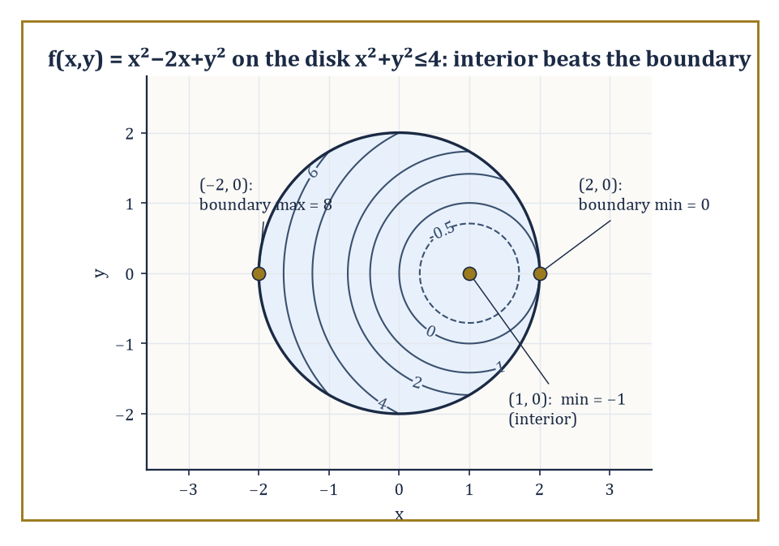
The disk's quietest point beats every noisy point on its rim — the boundary does not automatically win.
This is a necessary condition, not a sufficient one: finding a critical point tells you where to look for an extremum, not that you have found one, since (as Room 13.2's saddle-point example already hinted) plenty of critical points turn out to be neither maxima nor minima at all.
Numeric example — Finding a critical point. Let f(x, y) = x² + y² − 4x + 6y + 13. To find critical points, set both partials to zero:
f_x = 2x − 4 = 0 gives x = 2; f_y = 2y + 6 = 0 gives y = −3
The only critical point is (2, −3). Evaluating there:
f(2, −3) = 2² + (−3)² − 4(2) + 6(−3) + 13 = 4 + 9 − 8 − 18 + 13 = 0
In fact this f is secretly a disguised sum of squares — completing the square gives:
f(x, y) = (x − 2)² + (y + 3)²
which is manifestly never negative and equals zero exactly at (2, −3) — so we already know, by inspection, that this critical point is not merely a local minimum but the global minimum. The second-derivative test below will confirm this by more general means, ones that work even when no convenient algebraic trick is available.
The second-derivative test for a function of two variables uses the Hessian determinant,
H = f_xx f_yy − (f_xy)²
a single number built from the three distinct second partial derivatives (recall f_xy = f_yx by Clairaut's theorem, Room 13.4, so there really are only three, not four).
If H > 0 and f_xx > 0, the critical point is a local minimum; if H > 0 and f_xx < 0, it is a local maximum; if H < 0, it is a saddle point — a mountain pass, rising in one direction and falling in another; and if H = 0, the test is inconclusive and finer methods are required.
Numeric example — Applying the Hessian test, twice. First, revisit f(x, y) = x² + y² − 4x + 6y + 13 from the previous example, with critical point (2, −3). The second partials are f_xx = 2, f_yy = 2, and f_xy = 0 (constants, so the same everywhere). The Hessian is:
H = (2)(2) − 0² = 4
which is positive, and f_xx = 2 is also positive — so the test confirms a local minimum, matching the sum-of-squares reasoning above. Second, revisit g(x, y) = x² − y² from Room 13.2's saddle example. Critical points:
g_x = 2x = 0 gives x = 0; g_y = −2y = 0 gives y = 0
the only critical point is (0, 0). The second partials are g_xx = 2, g_yy = −2, g_xy = 0, so:
H = (2)(−2) − 0² = −4
which is negative — the test confirms a saddle point, exactly matching the crossing-contour-lines picture from Room 13.2. It is satisfying, and not an accident, that the algebraic test and the geometric contour picture agree perfectly.
Absolute (global) extrema of a function on a closed, bounded region are found by comparing the values at the interior critical points with the extreme values attained on the boundary of the region — exactly the same two-step strategy used for single-variable extreme-value problems on a closed interval in Storey 6.
The second step (the boundary analysis) itself typically reduces to a single-variable or constrained optimization problem, since the boundary of a two-dimensional region is usually a one-dimensional curve.
Numeric example — Absolute extrema on a disk. Let f(x, y) = x² − 2x + y² on the closed disk x² + y² ≤ 4 (radius 2, centred at the origin). Interior critical point:
f_x = 2x − 2 = 0 gives x = 1; f_y = 2y = 0 gives y = 0
The point (1, 0) satisfies 1² + 0² = 1 ≤ 4, so it lies inside the disk. There:
f(1, 0) = 1 − 2 + 0 = −1
Checking the Hessian:
f_xx = 2, f_yy = 2, f_xy = 0, so H = 4 > 0 and f_xx > 0
a local minimum, value −1. For the boundary, parametrize the circle x² + y² = 4 as x = 2cos θ, y = 2sin θ, so:
f = 4cos²θ − 4cos θ + 4sin²θ = 4(cos²θ + sin²θ) − 4cos θ = 4 − 4cos θ
using cos²θ + sin²θ = 1. Since cos θ ranges over [−1, 1], the expression 4 − 4cos θ ranges over:
[4 − 4(1), 4 − 4(−1)] = [0, 8]
So on the boundary, f reaches a minimum of 0 (at θ = 0, the point (2, 0)) and a maximum of 8 (at θ = π, the point (−2, 0)). Comparing all candidates — the interior critical value −1, and the boundary range [0, 8] — the absolute minimum of f on the whole disk is −1, attained at the interior point (1, 0), and the absolute maximum is 8, attained at the boundary point (−2, 0). Note that the interior point actually beats every boundary point for the minimum — a useful reminder that the boundary does not automatically win.
Constrained optimization — finding the extrema of f subject to some side condition g(x, y) = c, rather than searching the whole plane — receives its proper, general treatment through Lagrange multipliers in the next storey.
But even without that machinery, a constraint that can be solved explicitly for one variable in terms of the other reduces the problem to an ordinary single-variable optimization, using nothing more than the tools already in hand.
Numeric example — A constrained optimization by direct substitution. Maximize f(x, y) = xy subject to the constraint x + y = 10. Solve the constraint for y: y = 10 − x, and substitute into f to get a single-variable function:
h(x) = x(10 − x) = 10x − x²
Differentiate:
h′(x) = 10 − 2x, which is zero when x = 5
Then:
y = 10 − 5 = 5, and h(5) = 5(10 − 5) = 5(5) = 25
Checking that this is a maximum rather than a minimum:
h″(x) = −2
which is negative everywhere, so h is concave down throughout, confirming x = 5 gives the global maximum of h — and hence of f along the constraint — with maximum value xy = 25 at (5, 5). This is precisely the kind of problem Lagrange multipliers will handle more systematically once the constraint cannot be solved so conveniently by hand.

Room 13.9: Looking Ahead: From Multi-Variable Functions to Multi-Variable Calculus
Packing the Toolbox for the Next Storey
We have, over the last eight rooms, acquired the basic vocabulary needed to talk sensibly about functions of several variables: domains and graphs and level sets (Room 13.2); the genuine subtleties of limits and continuity that several variables introduce and one variable never could (Room 13.3); partial derivatives, computed one direction at a time (Room 13.4); the gradient and directional derivatives, which gather those partials into a single vector that knows which way is steepest (Room 13.5); the chain rule for composite functions built from several intermediate variables (Room 13.6); tangent planes and the linear approximation they encode (Room 13.7); and finally the second-derivative test for telling peaks from pits from mountain passes (Room 13.8).
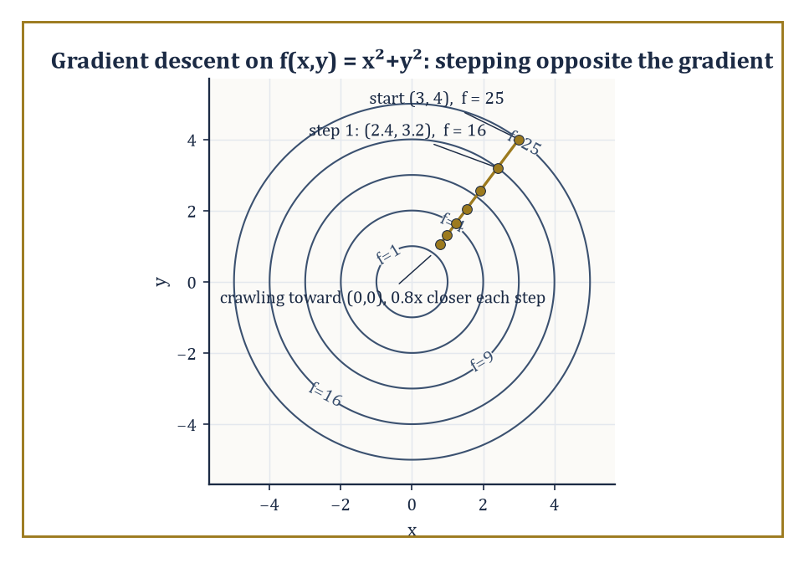
Each step shrinks the distance to the minimum by a fixed 20 percent, whether or not anyone is watching.
Each tool generalizes something familiar from the single-variable storeys below us, and each one, in the generalizing, revealed something genuinely new that a single variable was never rich enough to show.
It is worth pausing, before we climb further, on a small piece of comedy inherent in the phrase 'critical point'. In everyday English a crisis is a moment of maximal urgency; in mathematics a critical point is often nothing of the sort.
Choose a critical point at random from among all the places where a gradient could vanish, in the presence of enough variables, and it is more likely than not to be a saddle — a mountain pass of supreme indifference, neither triumph nor disaster, rising here and falling there with no opinion on the matter whatsoever. The universe of smooth functions is, on this evidence, considerably more equanimous than the committees named after them.
These are the tools Storey 14 will build on directly, developing the full differential and integral calculus of several variables: multiple integrals over regions of the plane and of space, the vector calculus of fields that assign a vector (rather than a scalar) to every point, and the three classical capstone theorems — Green's, Stokes', and Gauss's (the Divergence Theorem) — that tie derivatives and integrals together across dimensions in ways that make the Fundamental Theorem of Calculus from Storey 11 look, in hindsight, like a modest special case of something much larger.
Further up the Tower still, differential geometry and partial differential equations will return to these same objects — surfaces, gradients, critical points — and examine them with tools sharper again than anything available here.
The deeper lesson of this storey, underneath all the specific formulas, is that dependence on several quantities simultaneously is the ordinary condition of the world, not a special or unusual case requiring apology.
Almost nothing worth measuring in physics, economics, biology, or engineering depends on exactly one influence in isolation; multi-variable functions are simply the honest mathematical description of that fact, and the geometric and analytic language built for a single variable across Storeys 1 through 12 extends upward to meet it — with genuine new phenomena at every turn, as we have seen, but without ever losing its footing.
Numeric example — A capstone example: every tool from this storey, on one function. Let f(x, y) = 4 − x² − y², a downward-opening paraboloid, a dome rather than a bowl. Domain: the expression is defined for every real (x, y), so the domain is all of ℝ² — no restrictions to sketch this time.
Level sets: setting 4 − x² − y² = c gives:
x² + y² = 4 − c
a circle of radius √(4 − c) whenever c < 4, shrinking to the single point (0, 0) at c = 4, and empty for c > 4 (since x² + y² can never be negative).
Gradient:
∇f = ⟨−2x, −2y⟩; at (1, 1), this is ⟨−2, −2⟩, with magnitude √((−2)² + (−2)²) = √8 = 2√2
pointing back toward the centre of the dome, exactly as intuition about a dome-shaped surface would suggest.
Critical point: ∇f = ⟨0, 0⟩ requires x = 0 and y = 0, giving the single critical point (0, 0), where f(0, 0) = 4.
Second-derivative test:
f_xx = −2, f_yy = −2, f_xy = 0, so H = (−2)(−2) − 0² = 4 > 0 and f_xx < 0
a local maximum, and by the same sum-of-squares-in-disguise reasoning as Room 13.8, actually the global maximum, value 4.
Tangent plane at (0, 0, 4):
z = f(0,0) + f_x(0,0)(x − 0) + f_y(0,0)(y − 0) = 4 + 0(x) + 0(y) = 4
a perfectly horizontal plane — which is exactly what geometric common sense demands at the very top of a smooth dome, where the surface momentarily has no tilt in any direction at all, echoing f′(x) = 0 at a single-variable extremum all the way back in Storey 6.
Every tool acquired in this storey, applied to one function, tells a single consistent story: a dome, centred at the origin, rising to height 4, perfectly flat at its summit, and sloping away symmetrically in every direction. That consistency is not a coincidence arranged for the example; it is what it means for a body of mathematics to actually hang together.
Numeric example — One step of gradient descent, by hand. The gradient's role as 'the direction of fastest increase' has a famous practical inversion: moving opposite the gradient is the fastest way to decrease f, which is precisely the idea behind gradient descent, the workhorse optimization algorithm underneath most of modern machine learning.
Take the bowl f(x, y) = x² + y² from Room 13.1, and start at (3, 4), where Room 13.5 computed ∇f(3, 4) = ⟨6, 8⟩ and f(3, 4) = 25. One step of gradient descent, with a chosen step size (learning rate) of 0.1, moves to a new point:
(3, 4) − 0.1⟨6, 8⟩ = (3 − 0.6, 4 − 0.8) = (2.4, 3.2)
Evaluating there:
f(2.4, 3.2) = 2.4² + 3.2² = 5.76 + 10.24 = 16.00
That is down from 25 to 16 in a single step, simply by walking a short distance opposite the gradient. Repeat this enough times, shrinking the step size as the gradient itself shrinks near the minimum at the origin, and the sequence of points crawls its way down to the bottom of the bowl, f = 0, at (0, 0).
No new theory is required for this — only the gradient, computed at each new point in turn — which is as good a demonstration as any that the modest vector ⟨f_x, f_y⟩ introduced in Room 13.5 is quietly running rather more of the modern world than its two subscripts would suggest.
We arrived at this storey with a single respectable variable and its single respectable derivative, and we leave it with vectors of partial derivatives, planes tangent to bowls and domes, and a healthy new suspicion of any limit we haven't personally interrogated from at least two directions. That suspicion, if it feels uncomfortable, is doing exactly its job: multi-variable functions are not a cosmetic extension of what came before, and pretending otherwise is how good students get quietly ambushed by saddle points.
Storey 14 collects the differential vocabulary built here — gradients, tangent planes, the chain rule, the classification of critical points — and puts it to work integrating over genuinely two- and three-dimensional regions, culminating in theorems (Green, Stokes, Gauss) that reveal the Fundamental Theorem of Calculus from Storey 11 as merely the first, one-dimensional verse of a much longer song. Further up still, differential geometry and partial differential equations will take these same surfaces and treat them with tools sharper than anything on offer here — but that, as ever in this Tower, is a concern for a later landing.
The tower continues upward. The functions have learned to depend on more than one thing at once, and — rather touchingly, for objects with no feelings whatsoever — they seem entirely unbothered by the extra responsibility.

Storey 14: Multi-Variable Calculus
Multiple Integrals, Vector Fields, and the Art of Integrating Over Regions and Flows
Storey 13 left us in a peculiar state: fluent in the differential habits of functions of several variables, able to find a gradient, spot a saddle point, and interrogate a surface about its steepest ascent, but with no way whatsoever to add anything up. We could describe the slope of a mountain at every point on it; we could not yet weigh the mountain, or work out how much rain it would catch, or how hard the wind would have to blow to knock a flag off its summit. Differentiation without integration is a magnificent diagnostic tool and a fairly useless accountant. This storey exists to fix that.
The fix, as usual in this Tower, is to take an idea that worked perfectly well on the number line and drag it, sometimes kicking and screaming, into higher dimensions. The single-variable integral summed a quantity along an interval; we now sum quantities over regions of the plane, over solid chunks of space, along curves, and across surfaces. The Riemann sum survives the journey more or less intact — chop, sample, multiply, add, take a limit — but the bookkeeping around it grows considerably more elaborate, because regions in the plane do not queue up politely between two endpoints the way intervals do. Expect more sketching than you are used to. Expect it to matter.
The payoff, and it is a substantial one, is a suite of theorems — Green's, Stokes', and the Divergence Theorem of Gauss — that all say the same single beautiful thing in three different dialects: what happens inside a region is completely determined by what happens on its boundary, provided you differentiate correctly on the way out. This is the Fundamental Theorem of Calculus again, wearing a series of increasingly elaborate disguises, and part of the quiet pleasure of this storey is watching the disguise slip a little more with each theorem until, by the end, you can see the same face underneath all three.
A note on the climb ahead: the computations here are heavier than anything in Storey 13, and heavier still than the tidy single integrals of the calculus storeys further down the Tower. Setting up limits of integration correctly is a skill that punishes carelessness swiftly and without appeal — get the region wrong and every subsequent line of arithmetic, however dazzling, computes the wrong thing beautifully. Practice is not optional. The reward, once the machinery is running, is a toolkit that underwrites the whole of classical physics and a good deal of engineering besides, and prepares the ground directly for the next storey, Vector Calculus, where these same fields and flows go to work on electromagnetism and fluid flow in earnest. Let us integrate in higher dimensions.

Room 14.1: Double Integrals and Iterated Integrals
Or: How to Add Up Infinitely Many Infinitesimal Rectangles Without Losing Your Nerve
A double integral of a function f over a region D in the plane begins life exactly the way the single-variable integral did: as a Riemann sum. Chop D into a great many small rectangles (or, for the fastidious, small pieces of any convenient shape that tile the region), pick a sample point in each piece, multiply the value of f there by the area of that piece, and add everything up. Refine the chopping — smaller pieces, more of them — and take the limit. Assuming f is not being deliberately difficult, the sums settle down to a single number, written
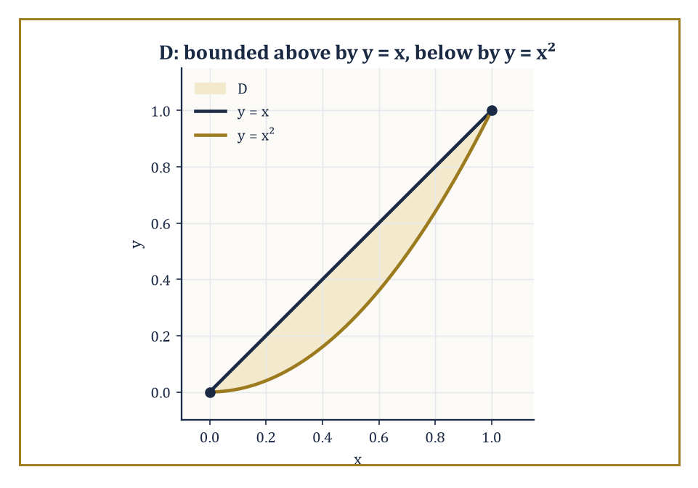
The region D between y = x and y = x², the shaded sliver whose area the worked example finds to be 1/6.
∬_D f(x, y) dA
This is the same ritual that built the single integral, with one change of scenery: the 'width' of each little piece is now an area rather than a length, and D is free to be almost any shape at all, rather than an interval sitting patiently between two endpoints. Geometrically, when f ≥ 0, the double integral measures the volume trapped between the surface z = f(x, y) and the region D beneath it in the xy-plane — a solid slab of variable height, weighed by integration instead of by scales. When f represents a density, the same integral gives a mass; when f is simply 1, it gives an area. The double integral, in short, is the single all-purpose machine for accumulating anything spread continuously over a region.
Numeric example — Worked example — mass from a density. Let D be the unit square, 0 ≤ x ≤ 1 and 0 ≤ y ≤ 1, and suppose a thin metal lamina occupying D has density ρ(x, y) = x + y (grams per square unit, heavier towards the far corner). Its total mass is
M = ∬_D (x + y) dA
Working the inner integral over x first, treating y as a constant:
∫₀¹ (x + y) dx = [x²/2 + xy]₀¹ = 1/2 + y
Now integrate that result over y:
∫₀¹ (1/2 + y) dy = [y/2 + y²/2]₀¹ = 1/2 + 1/2 = 1
So M = 1 gram. Note how little drama was involved: two ordinary single-variable integrals, performed one after the other, and the double integral simply falls out. Keep this lamina — density x + y, mass 1 gram — in mind; it returns shortly.
The double integral would be dreadful to compute directly from its defining limit — nobody wants to take a limit of Riemann sums by hand, and certainly not more than once — so mathematicians did what mathematicians always do when faced with drudgery: found a theorem that lets someone else, namely the ordinary single-variable integral, do the actual work. Fubini's theorem is the labour-saving device of multivariable calculus. It states that, provided f and D are reasonably well-behaved (continuity on a bounded region will more than suffice here), the double integral can be evaluated as an iterated integral: integrate first with respect to one variable, holding the other fixed, to produce a function of the remaining variable, then integrate that. In symbols,
∬_D f dA = ∫∫ f(x, y) dy dx
worked from the inside out, rather like nested Russian dolls, or a bureaucratic form that requires you to fill in section 2 before section 1 will accept your signature. The genuine work in any double-integral problem is not the integration itself — that is routine — but determining the correct limits, which requires looking honestly at the shape of D rather than integrating on autopilot.
Numeric example — Worked example — an iterated integral over a rectangle. Evaluate ∬_D xy dA where D is the rectangle 0 ≤ x ≤ 2, 0 ≤ y ≤ 3. By Fubini,
∬_D xy dA = ∫₀² ∫₀³ xy dy dx
Inner integral, x held fixed:
∫₀³ xy dy = x·[y²/2]₀³ = x·(9/2) = 9x/2
Outer integral:
∫₀² (9x/2) dx = (9/2)·[x²/2]₀² = (9/2)·2 = 9
So ∬_D xy dA = 9. Reversing the order changes nothing except the order of typing:
∫₀³ ∫₀² xy dx dy = ∫₀³ y·2 dy = 2·[y²/2]₀³ = 9
as it must, since D here is a plain rectangle and both orders are equally painless — the interesting decisions about order only arise once D stops being a rectangle.
Because Fubini's theorem sanctions either order of integration — dy dx or dx dy — one is free to choose whichever produces the friendlier antiderivatives. This is sometimes a matter of taste and sometimes a matter of survival: one order yields an elementary antiderivative in three lines, the other produces an integral that no undergraduate, however well-intentioned, will ever finish by hand (the function e^{x²} makes a habit of appearing exactly where you least want it, and it has no elementary antiderivative at all — this is not a skill issue on your part, it is a fact about the function). The discipline that prevents disaster is simple to state and, under exam pressure, curiously easy to abandon: sketch the region D before writing a single limit of integration. Only once the region is actually visible on paper — its boundary curves, where they intersect, which curve bounds it from above and which from below, for a given order — can you write down limits that describe D rather than limits that merely look plausible and describe something else entirely.
Numeric example — Worked example — area between two curves. Find the area of the region D bounded above by y = x and below by y = x², for x between 0 and 1 (sketch mentally: the two curves meet at (0, 0) and (1, 1), and the straight line sits above the parabola throughout that interval, since for 0 < x < 1 we have x² < x). The area is ∬_D 1 dA, and because D is described most simply by fixing x and letting y run between the two curves, the natural order is dy dx:
A = ∫₀¹ ∫_{x²}^{x} dy dx
Inner integral:
∫_{x²}^{x} dy = x − x²
Outer integral:
∫₀¹ (x − x²) dx = [x²/2 − x³/3]₀¹ = 1/2 − 1/3 = 1/6
The area between the two curves is 1/6 of a square unit — a small, tidy number for a region that, without the sketch, would have been easy to set up backwards.
Once the machinery is running, double integrals compute almost anything describable as 'add up this quantity, continuously, over a region.' Set f = 1 and you recover the area of D, as above. Let f = ρ(x, y), a density, and the integral gives the total mass of a flat lamina shaped like D, as in the very first example of this room. Weight each infinitesimal piece of mass by its (signed) distance from an axis and integrate, and you get a moment; the ratio of a moment to the total mass gives one coordinate of the centre of mass — the single point at which the lamina would balance on the tip of a needle, a claim from physics that pure calculus is happy to make good on. Weight instead by the square of the distance from an axis, and the integral gives the moment of inertia, which measures how reluctant the lamina is to be spun up around that axis. Finally, dividing ∬_D f dA by the area of D gives the average value of f over the region: the single flat height that, spread evenly across D, would enclose exactly the same volume as the original, bumpier surface. All four quantities are the same integral, differently dressed.
Numeric example — Worked example — centre of mass of the density-x+y lamina. Return to the unit-square lamina of density ρ(x, y) = x + y, whose mass we found to be M = 1. Its centre of mass (x̄, ȳ) is given by
x̄ = (1/M) ∬_D x·ρ(x, y) dA, ȳ = (1/M) ∬_D y·ρ(x, y) dA
For x̄:
∬_D x(x + y) dA = ∬_D (x² + xy) dA = ∫₀¹∫₀¹ x² dx dy + ∫₀¹∫₀¹ xy dx dy = (1/3)·1 + (1/2)·(1/2) = 1/3 + 1/4 = 7/12
Since M = 1, x̄ = 7/12. By the symmetry of the density under swapping x and y, the same computation for ȳ gives
∬_D (xy + y²) dA = 1/4 + 1/3 = 7/12
so ȳ = 7/12 as well. The centre of mass sits at (7/12, 7/12) ≈ (0.583, 0.583) — pulled, sensibly, away from the centre of the square (0.5, 0.5) and towards the far corner (1, 1), exactly where the density is heaviest. Calculus, once again, confirming what common sense suspected, but this time with a number attached.

Room 14.2: Triple Integrals and Applications
Or: The Same Trick, One Dimension Fatter
Triple integrals extend the double-integral idea to solid regions in three-dimensional space, and the extension is almost insultingly straightforward once the double-integral machinery is in place: chop a solid E into small blocks of volume, sample f at a point in each, multiply and sum, take the limit, and call the result
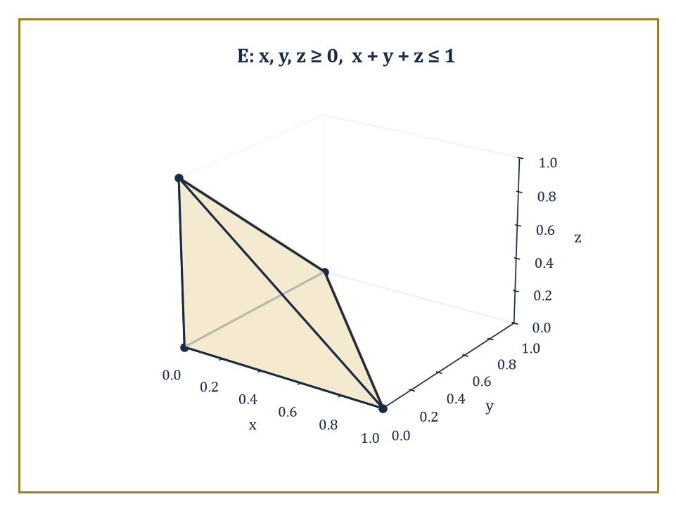
The tetrahedron E in the first octant bounded by the plane x + y + z = 1, whose volume the worked example finds to be 1/6.
∭_E f(x, y, z) dV
There is no new conceptual content here — only one more dimension to keep track of, which in practice means one more integral sign and one more variable's worth of limits to determine correctly. Fubini's theorem again reduces the triple integral to an iterated integral, now with three nested single integrations rather than two; the trick, as before, is entirely in describing E correctly, this time in three dimensions, which usually means picturing (or sketching, badly, on the back of an envelope) how the solid looks when sliced by planes of constant x, or constant z, or whichever variable you have chosen to peel off first.
Numeric example — Worked example — volume of a tetrahedron. Let E be the solid tetrahedron in the first octant bounded by the coordinate planes and the plane x + y + z = 1 (so x, y, z ≥ 0 and x + y + z ≤ 1). Its volume is
V = ∭_E dV = ∫₀¹ ∫₀^{1−x} ∫₀^{1−x−y} dz dy dx
The innermost integral is immediate:
∫₀^{1−x−y} dz = 1 − x − y
For the next integral, fix x and write u = 1 − x for brevity:
∫₀^{u} (u − y) dy = [uy − y²/2]₀^{u} = u² − u²/2 = u²/2
Substituting back, this is (1 − x)²/2. Finally,
∫₀¹ (1 − x)²/2 dx = [−(1 − x)³/6]₀¹ = (0) − (−1/6) = 1/6
The tetrahedron has volume 1/6 — which matches the schoolroom formula (1/3)·(base area)·(height) = (1/3)·(1/2)·1 = 1/6 exactly, a small comfort confirming that all this machinery agrees with the geometry you already trusted.
The applications transfer over unchanged from the plane, only now they describe solids rather than laminas — the lamina, so to speak, has bulked up by a dimension. Set f = 1 and ∭_E dV gives the volume of E, as just demonstrated. Let f = ρ(x, y, z) be a density function and the integral gives the total mass of a solid body whose density varies from point to point — heavier at the core, say, than at the surface, the way a planet is rarely as dense at its crust as at its centre. Moments and centres of mass follow exactly as before, now with three coordinates x̄, ȳ, z̄ to find rather than two, each obtained by weighting the density by the corresponding coordinate and dividing by the total mass. Moments of inertia about each of the three coordinate axes follow the same pattern, weighting by the square of distance from that axis rather than from a point. The computational pattern is, reassuringly, identical in every case to the double-integral version — the only price of the extra dimension is one more integral sign and correspondingly more careful bookkeeping of limits, which is a fair exchange rate as these things go.
Numeric example — Worked example — mass of a solid cube. A solid occupying the unit cube 0 ≤ x, y, z ≤ 1 has density ρ(x, y, z) = x² + y² + z² (grams per cubic unit — denser towards the far corner (1,1,1), and zero, somewhat implausibly, at the origin, but it is only an exercise). Its mass is M = ∭ (x² + y² + z²) dV over the cube. By linearity, split this into three separate triple integrals:
M = ∭ x² dV + ∭ y² dV + ∭ z² dV
By the symmetry of the cube, each of these three integrals has the same value; compute just the first.
∭ x² dV = ∫₀¹∫₀¹∫₀¹ x² dz dy dx = ∫₀¹ x² dx · ∫₀¹ dy · ∫₀¹ dz = (1/3)·1·1 = 1/3
since x² does not depend on y or z, and the two trailing integrals are each simply the length of the unit interval. By symmetry the y² and z² integrals also each equal 1/3. Total mass M = 1/3 + 1/3 + 1/3 = 1 gram — a suspiciously clean answer, but a correct one, and a useful reminder that symmetry, spotted early, can save two-thirds of the arithmetic.
When the solid E has rotational symmetry — around an axis, or around a point — Cartesian coordinates become an act of self-sabotage, and cylindrical coordinates take over. Cylindrical coordinates describe a point by (r, θ, z): the same polar radius and angle as in the plane, applied to the x and y coordinates, with z left alone. The volume element transforms from dx dy dz into
r dr dθ dz
that extra factor of r is not decorative; it is the same area-scaling factor that appears in plane polar coordinates, simply carried along for the ride, and it accounts for the fact that a thin shell of fixed angular width sweeps out more actual area the further out it sits from the axis.
Numeric example — Worked example — volume of a cone via cylindrical coordinates. Find the volume of a right circular cone of base radius 2 and height 5, apex pointing upward, base sitting in the plane z = 0. At height z, the cross-sectional disc has shrunk linearly from radius 2 (at z = 0) to radius 0 (at z = 5); solving for the radius as a function of height, the disc at height z has radius r_max(z) = 2(1 − z/5), or equivalently, at a fixed radius r, the cone extends in z from 0 up to z_max(r) = (5/2)(2 − r). Using cylindrical coordinates and integrating in the order z, then r, then θ:
V = ∫₀^{2π} ∫₀² ∫₀^{(5/2)(2−r)} r dz dr dθ
Inner integral:
∫₀^{(5/2)(2−r)} r dz = r·(5/2)(2 − r) = (5/2)(2r − r²)
Next:
∫₀² (5/2)(2r − r²) dr = (5/2)·[r² − r³/3]₀² = (5/2)·(4 − 8/3) = (5/2)·(4/3) = 10/3
Outer integral over θ just multiplies by 2π:
V = 2π·(10/3) = 20π/3
This matches the schoolroom cone-volume formula (1/3)πr²h = (1/3)π(4)(5) = 20π/3 exactly — cylindrical coordinates, correctly wielded, reproduce a formula you have known since school, which is precisely the reassurance one wants from a new technique before trusting it on a shape with no textbook formula at all.
When the solid instead has spherical symmetry — centred on the origin, indifferent to direction — spherical coordinates (ρ, φ, θ) take over, where ρ is distance from the origin, φ is the angle down from the positive z-axis (colatitude), and θ is the familiar angle around the z-axis. The volume element becomes
ρ² sin φ dρ dφ dθ
a factor stranger-looking than the cylindrical case but built from exactly the same idea: it measures how much actual volume a small box in (ρ, φ, θ)-space corresponds to once mapped into ordinary xyz-space, and that correspondence depends on both how far out you are (hence ρ²) and how close to the poles you are (hence sin φ, which vanishes at the poles themselves, where meridians of longitude all crowd together to a single point and a full range of θ sweeps out almost no actual space at all).
Numeric example — Worked example — volume of a sphere via spherical coordinates. Find the volume of a solid sphere of radius 3 centred at the origin. In spherical coordinates the sphere is simply 0 ≤ ρ ≤ 3, 0 ≤ φ ≤ π, 0 ≤ θ ≤ 2π — about as painless a description as a region ever gets.
V = ∫₀^{2π} ∫₀^{π} ∫₀³ ρ² sin φ dρ dφ dθ
The three integrals separate completely, since the integrand factors and none of the limits depend on the other variables:
∫₀³ ρ² dρ = [ρ³/3]₀³ = 9
∫₀^{π} sin φ dφ = [−cos φ]₀^{π} = (−cos π) − (−cos 0) = 1 + 1 = 2
∫₀^{2π} dθ = 2π
Multiplying:
V = 9 · 2 · 2π = 36π
Compare against the schoolroom formula (4/3)πr³ = (4/3)π(27) = 36π — exact agreement, as it should be, since the schoolroom formula was itself proved by essentially this calculation, long before either of us was born.

Room 14.3: Change of Variables and Jacobians
Or: Substitution, But It Brought a Determinant
A change of variables in a multiple integral is the higher-dimensional descendant of ordinary substitution — the trick, familiar from single-variable calculus, of replacing x by some function of a new variable u to make an awkward integral tractable. In several variables the substitution becomes a transformation: a map x = x(u, v), y = y(u, v) sending a region in the uv-plane onto the region of integration in the xy-plane. The integral transforms according to
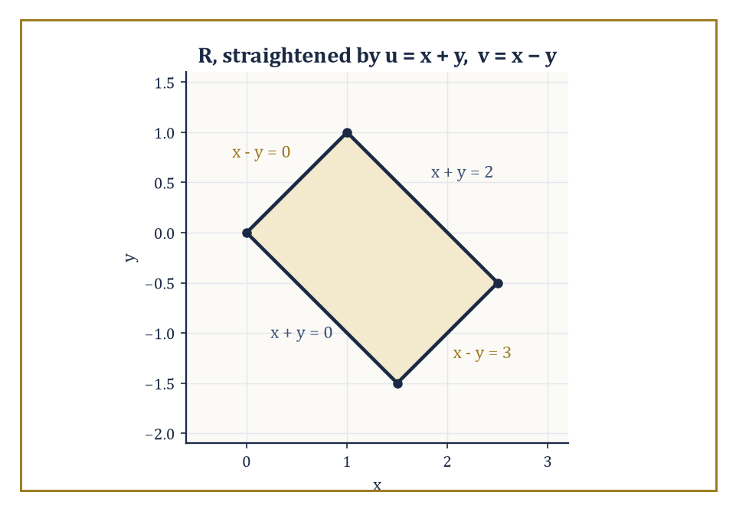
The slanted parallelogram R, straightened into a plain rectangle by u = x + y, v = x − y before the Jacobian ever has to do any work.
∬_{D_{xy}} f(x, y) dA = ∬_{D_{uv}} f(x(u,v), y(u,v)) |J| du dv
where J is the Jacobian determinant of the transformation — the determinant of the matrix of partial derivatives ∂(x,y)/∂(u,v). This is not an arbitrary decoration; it is forced by exactly the same reasoning that produced the ordinary substitution rule dx = (dx/du) du in one variable, applied to the way small rectangles in uv-space get stretched, squashed, and sheared into small parallelograms in xy-space. The absolute value is there because area, unlike a signed one-dimensional length, does not care which way the transformation happens to be oriented.
Numeric example — Worked example — deriving the polar Jacobian. The most familiar change of variables is plane polar coordinates, x = r cos θ, y = r sin θ. Its Jacobian is computed exactly as the definition demands, from the four partial derivatives ∂x/∂r = cos θ, ∂x/∂θ = −r sin θ, ∂y/∂r = sin θ, ∂y/∂θ = r cos θ, arranged into a 2×2 determinant:
J = (∂x/∂r)(∂y/∂θ) − (∂x/∂θ)(∂y/∂r) = (cos θ)(r cos θ) − (−r sin θ)(sin θ) = r cos²θ + r sin²θ = r(cos²θ + sin²θ) = r
So |J| = r (since r ≥ 0, the absolute value changes nothing), and dA = r dr dθ — precisely the area element you were handed, on trust, back when polar coordinates were first introduced. Now you know exactly where that stray factor of r came from: it is not decoration, it is a determinant, quietly doing its job, measuring how a small rectangle of sides dr and dθ in (r, θ)-space gets stretched into a small, r-scaled, roughly-rectangular patch out in the xy-plane.
Polar coordinates, and their solid-geometry cousins cylindrical and spherical coordinates, are simply the three most common special cases of this general formula, each with its own Jacobian computed once and then reused forever (r for polar and cylindrical, ρ² sin φ for spherical, as met in the previous room). But the change-of-variables formula is not limited to these three celebrities. It is genuinely useful whenever a region or an integrand simplifies dramatically under some other, less famous transformation — a linear map that straightens a parallelogram into a rectangle, for instance, or a substitution tailored to an elliptical region so that the ellipse becomes a circle in the new coordinates. The general principle is: if the region D looks awkward in xy-coordinates but would look like a plain rectangle in some other coordinates (u, v), find the transformation, compute its Jacobian once, and let the awkwardness dissolve.
Numeric example — Worked example — straightening a parallelogram. Evaluate ∬_R (x + y) e^{x−y} dA, where R is the parallelogram bounded by the four lines x + y = 0, x + y = 2, x − y = 0, and x − y = 3. Set u = x + y and v = x − y. Solving back for x and y: x = (u + v)/2, y = (u − v)/2. The Jacobian of this inverse transformation is computed from ∂x/∂u = 1/2, ∂x/∂v = 1/2, ∂y/∂u = 1/2, ∂y/∂v = −1/2:
J = (1/2)(−1/2) − (1/2)(1/2) = −1/4 − 1/4 = −1/2
so |J| = 1/2. In (u, v)-coordinates the parallelogram R becomes the plain rectangle 0 ≤ u ≤ 2, 0 ≤ v ≤ 3 — exactly the point of the substitution — and the integrand x + y = u, x − y = v become simply u e^{v}. The integral becomes
∬_{0≤u≤2,\ 0≤v≤3} u e^{v} · (1/2) du dv = (1/2) ∫₀² u du · ∫₀³ e^{v} dv = (1/2)·2·(e³ − 1) = e³ − 1
So ∬_R (x + y) e^{x−y} dA = e³ − 1 ≈ 19.09 — a value that would have been a nightmare to extract directly from the slanted parallelogram in xy-coordinates, and fell out in three lines once the region was straightened.
Mastery of the Jacobian is, in a very real sense, the technical key that unlocks a large fraction of the otherwise-intractable multiple integrals one meets in practice. There is a certain dry satisfaction in this: an entire integral, hopeless in its original coordinates, capitulates the moment you find the right disguise for it and compute one determinant. The single most celebrated instance of the technique — the one every mathematician remembers fondly, the way one remembers a favourite conjuring trick — evaluates an integral that has no elementary antiderivative at all, by the cunning expedient of squaring it first.
Numeric example — Worked example — the Gaussian integral by polar substitution. The function e^{−x²} has no elementary antiderivative — none of the usual functions differentiate to give it back — so ∫_{−∞}^{∞} e^{−x²} dx cannot be evaluated by finding an antiderivative and plugging in limits, the standard trick simply does not apply. Call this unknown value I. The trick is to consider I² instead, written as a product of two copies of the same integral in different dummy variables, then recombined into a double integral:
I² = (∫_{−∞}^{∞} e^{−x²} dx)(∫_{−∞}^{∞} e^{−y²} dy) = ∬_{ℝ²} e^{−(x²+y²)} dA
since the two separate single integrals over the whole line multiply out, term by term, into a double integral over the whole plane. Now switch to polar coordinates: x² + y² = r², and dA = r dr dθ.
I² = ∫₀^{2π} ∫₀^{∞} e^{−r²} r dr dθ
The inner integral yields to the ordinary substitution s = r², ds = 2r dr:
∫₀^{∞} e^{−r²} r dr = (1/2) ∫₀^{∞} e^{−s} ds = (1/2)[−e^{−s}]₀^{∞} = (1/2)(0 − (−1)) = 1/2
The outer integral is just ∫₀^{2π} dθ = 2π. So
I² = 2π · (1/2) = π, therefore I = √π
The Jacobian factor r, which looked like a bureaucratic nuisance when it first appeared, is the single ingredient that makes this integral — otherwise permanently stuck — collapse into a number. It is one of the more pleasing moments in the entire subject, and no one who has seen it forgets it.

Room 14.4: Vector Fields and Line Integrals
Or: Arrows Everywhere, and What Happens When You Walk Through Them
A vector field assigns not a number but a vector to each point of a region — an arrow, with both length and direction, planted at every point of the plane or of space. The familiar physical examples are a force field (the pull of gravity, differing in direction and strength from place to place), the velocity field of a moving fluid (a different current speed and direction at every point of a river), and — a link back to Storey 13 — the gradient field of a scalar function, whose arrow at each point points in the direction of steepest ascent and has length equal to the steepness there. In components, a vector field in the plane is written
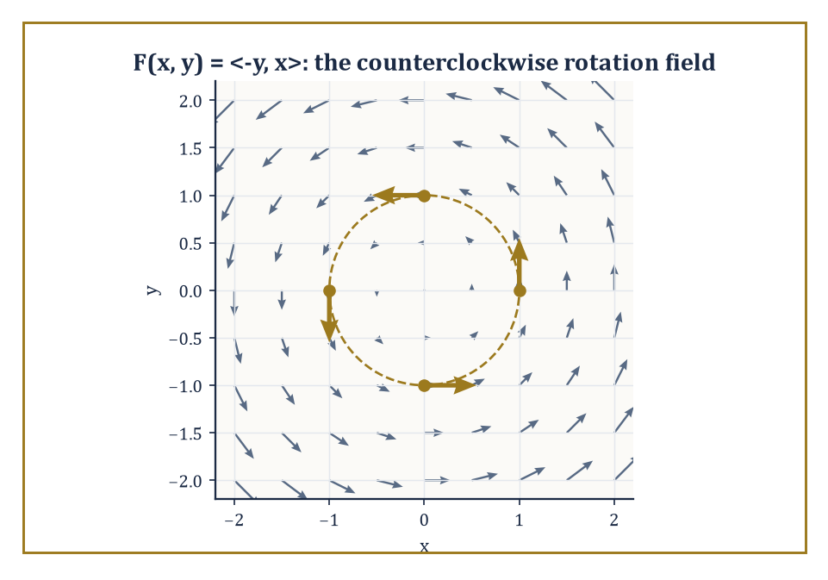
The rotation field F = ⟨−y, x⟩, with the four sample points from the worked example picked out in gold on the unit circle.
F = ⟨P(x, y), Q(x, y)⟩
a pair of ordinary scalar functions bundled together as the two components of the arrow at (x, y); in space a third component R(x, y, z) joins them. Nothing here is conceptually new — it is simply two or three ordinary multivariable functions travelling together, relabelled as the components of an arrow rather than treated as separate unrelated quantities.
Numeric example — Worked example — plotting a rotation field by hand. Consider the vector field F(x, y) = ⟨−y, x⟩, and evaluate it at a few sample points to see what kind of arrow-pattern it draws.
At (1, 0): F = ⟨−0, 1⟩ = (0, 1)
At (0, 1): F = ⟨−1, 0⟩ = (−1, 0)
At (−1, 0): F = ⟨0, −1⟩
At (0, −1): F = ⟨1, 0⟩
At (1, 0) the arrow points straight up; at (0, 1) it points left; at (−1, 0) it points down; at (0, −1) it points right. Notice the pattern: at each of these four points on the unit circle, the arrow is perpendicular to the position vector and points in the counterclockwise direction around the origin. This is not a coincidence of the four points chosen — F = ⟨−y, x⟩ is, at every point in the plane, exactly the position vector ⟨x, y⟩ rotated 90° counterclockwise. It is the vector field of a rigid body spinning counterclockwise about the origin at unit angular speed, and it will reappear, not at all by accident, in every room for the rest of this storey.
A line integral of a vector field F along a curve C measures the work done by the field in dragging a particle along C — or, if F is the velocity field of a fluid, the circulation of the flow along C. It is defined as
∫_C F · T ds
integrating the component of F along the curve's unit tangent direction T with respect to arc length; in components this becomes
∫_C P dx + Q dy
(with an R dz term added in space), evaluated by parametrizing the curve and reducing everything to a single ordinary integral over the parameter. Physically: F · T at a point measures how much of the field's push is aligned with the direction of travel at that instant — a headwind contributes negatively, a tailwind positively, a crosswind not at all — and the line integral totals this contribution along the whole journey.
Numeric example — Worked example — work along a straight path. Compute the line integral of F = ⟨y, x⟩ along the straight-line path C from (0, 0) to (1, 1), parametrized by x = t, y = t for t running from 0 to 1 (so dx = dt, dy = dt). The line integral is
∫_C P dx + Q dy = ∫₀¹ (y dx + x dy) = ∫₀¹ (t · dt + t · dt) = ∫₀¹ 2t dt = [t²]₀¹ = 1
So the work done by F in moving a particle along this straight path from the origin to (1, 1) is 1 unit. This particular field, as it happens, is unusually well-behaved — hold that thought; the next room explains exactly why, and exactly what makes it different from the rotating field met a moment ago.
The value of a line integral depends, in general, on the specific path taken between two points, not merely on where it starts and ends — push a particle around by two different routes through a swirling fluid, and the total work done can come out different each time, since one route might spend longer riding with the current and the other longer fighting against it. When, for a particular field, the line integral happens to depend only on the endpoints and never on the path connecting them, the field earns the name conservative, and its line integral reduces to the difference of a single scalar potential function evaluated at the two endpoints — a considerable simplification, since it replaces an integral along a possibly complicated curve with the evaluation of one function at two points. Whether a given field has this pleasant property is the subject of the next room; for now, the crucial test case is the rotating field F = ⟨−y, x⟩ met above, taken all the way around a closed loop back to its own starting point.
Numeric example — Worked example — circulation around a closed loop. Compute the line integral of the rotation field F = ⟨−y, x⟩ around the unit circle, traversed once counterclockwise, parametrized by x = cos t, y = sin t for t from 0 to 2π (so dx = −sin t dt, dy = cos t dt). The line integral is
∫_C P dx + Q dy = ∫₀^{2π} [(−sin t)(−sin t dt) + (cos t)(cos t dt)] = ∫₀^{2π} (sin²t + cos²t) dt = ∫₀^{2π} 1 dt = 2π
The circulation around the closed loop is 2π — not zero. Since the path starts and ends at the very same point, (1, 0), a path-independent (conservative) field would have been forced to give zero here, the difference of a potential function with itself. That it instead gives a stubbornly nonzero 2π is the field's way of announcing, loudly, that it is not conservative — there is genuine rotation baked into it, and a particle carried once around the loop picks up real net work from the field, purely from having gone in a circle. Room 14.5 makes this diagnosis precise; Room 14.7 explains exactly where the number 2π comes from.

Room 14.5: Conservative Fields and Potential Functions
Or: Fields That Remember Where They Started and Fields That Don't
A vector field is called conservative if it is the gradient of some scalar function f, that is,
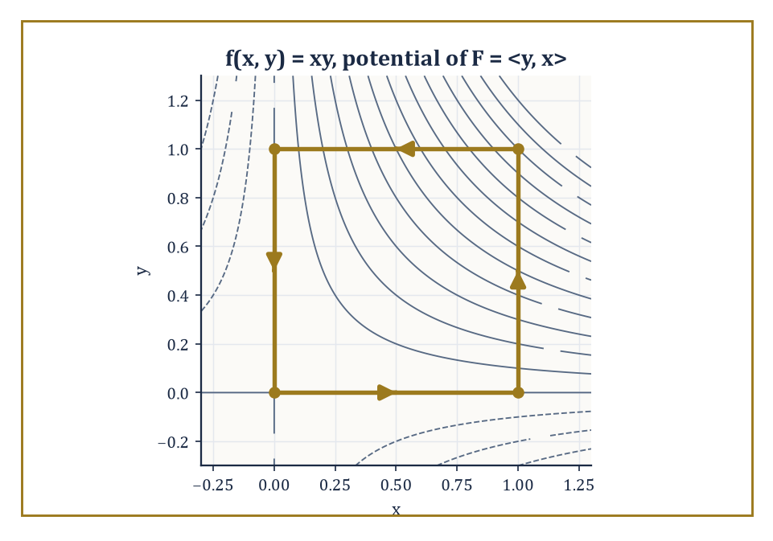
Level curves of the potential f(x, y) = xy, with the closed unit-square path from the worked example traced in gold — same start and end point, hence zero net work.
F = ∇f
This single algebraic condition turns out to be equivalent to two other, more physically flavoured descriptions met in the previous room: the field's line integrals are path-independent (depending only on endpoints), and equivalently again, its integral around every closed curve vanishes. In a simply connected domain — loosely, a region with no holes for a loop to snag on — a continuously differentiable field is conservative if and only if its curl vanishes; in the plane this reduces to the tidy condition
∂P/∂y = ∂Q/∂x
a single equation, checkable by two quick partial derivatives, that settles the entire question without ever needing to compute a single line integral. This is precisely the test that would have flagged the difference between the two fields of the previous room before any integration was attempted at all.
Worked example — Worked example — testing both fields from the previous room. For F = ⟨y, x⟩, so P = y and Q = x:
∂P/∂y = 1, ∂Q/∂x = 1
These are equal, so the curl test passes and F = ⟨y, x⟩ is conservative — consistent with the tidy, path-looking answer of 1 obtained for its line integral along the straight segment from (0,0) to (1,1) in the previous room. For F = ⟨−y, x⟩, so P = −y and Q = x:
∂P/∂y = −1, ∂Q/∂x = 1
These are not equal (they differ by 2), so the curl test fails and F = ⟨−y, x⟩ is not conservative — consistent with its stubbornly nonzero circulation of 2π around the unit circle. Two derivatives, computed in seconds, would have predicted both outcomes before a single line integral was set up. This is the payoff of the curl test: diagnosis without computation.
When a field passes the curl test, finding its potential function f is a matter of successive integration, undone one partial derivative at a time — a kind of detective work in which each clue narrows down f a little further, up to an unavoidable ambiguity that the next clue then resolves. Integrate P with respect to x, treating y as a constant, to get f up to an unknown function of y alone (since differentiating that unknown function with respect to x would have given zero, it is invisible to the first integration). Then differentiate this partial result with respect to y, compare against Q, and solve for the unknown function. The procedure generalizes routinely to three variables, one extra unknown function and one extra comparison at a time.
Numeric example — Worked example — finding a potential and computing work from it. Let F = ⟨2xy + 3, x² − 4y⟩. First, the curl test:
∂P/∂y = 2x, ∂Q/∂x = 2x
Equal, so F is conservative and a potential f exists. Integrate P = 2xy + 3 with respect to x:
f(x, y) = x²y + 3x + g(y)
where g(y) is the as-yet-unknown function invisible to differentiation in x. Now differentiate this f with respect to y:
∂f/∂y = x² + g'(y)
This must equal Q = x² − 4y, so g'(y) = −4y, giving g(y) = −2y² + C for an arbitrary constant C (which may as well be taken as 0, since only differences of f will ever be used). So
f(x, y) = x²y + 3x − 2y²
The work done by F moving a particle from (0, 0) to (2, 1), along any path whatsoever, is simply
f(2, 1) − f(0, 0) = [(4)(1) + 3(2) − 2(1)] − [0] = (4 + 6 − 2) − 0 = 8
No parametrization of any path was ever needed — the entire calculation reduced to evaluating one function at two points, which is the whole point of finding the potential in the first place.
Conservative fields are, in fact, an old acquaintance under a new name: they are precisely the gradient fields first met in Storey 13, and the scalar function whose gradient they are is exactly the kind of function that room studied. The work done by a conservative field along a path is the difference in potential energy between the endpoints — a phrase borrowed directly from physics, where it earns its keep: gravity and the electrostatic field, in regions free of electric charge, are the two great classical examples of conservative fields, and it is precisely their conservativeness that lets physicists speak of 'potential energy' at all, as a well-defined quantity attached to a position rather than to a particular route travelled to reach it. A ball thrown up and caught again at the same height has done zero net work against gravity, regardless of how curved or fast its path — a fact so familiar from ordinary experience that it is easy to forget it is really a theorem.
Numeric example — Worked example — a closed loop, checked directly. As a direct confirmation that a conservative field really does give zero around every closed loop, take F = ⟨y, x⟩ (shown conservative above, with potential f = xy) and integrate it around the boundary of the unit square, traversed counterclockwise: (0,0) → (1,0) → (1,1) → (0,1) → (0,0).
Segment 1, (0,0)→(1,0): y = 0, x = t, dy = 0, t: 0→1; integrand y dx + x dy = 0·dt + t·0 = 0; contributes 0.
Segment 2, (1,0)→(1,1): x = 1, y = t, dx = 0, t: 0→1; integrand = t·0 + 1·dt = dt; contributes
∫₀¹ dt = 1
Segment 3, (1,1)→(0,1): y = 1, x = 1−t, dx = −dt, dy = 0, t: 0→1; integrand = 1·(−dt) + (1−t)·0 = −dt; contributes
∫₀¹ (−dt) = −1
Segment 4, (0,1)→(0,0): x = 0, y = 1−t, dx = 0, dy = −dt; integrand = y·0 + 0·(−dt) = 0; contributes 0.
Total:
0 + 1 − 1 + 0 = 0
exactly as the potential-function shortcut predicted — f(0,0) − f(0,0) = 0, trivially, since the loop begins and ends at the same point. It is a small ceremony, checking by brute force what theory already guaranteed, but it is a reassuring one, and it is precisely this kind of arithmetic that Green's theorem, two rooms from now, will explain in one stroke rather than four.

Room 14.6: Surface Integrals and Flux
Or: How Much Is Passing Through, and Which Way
A surface integral of a scalar function is the natural extension of a plain surface-area calculation: instead of merely measuring the area of a curved surface, it accumulates the values of some function g over that surface, weighting each infinitesimal patch of area by g there — mass of a curved shell of variable density, say, rather than of a flat lamina. Both a surface's area and this weighted accumulation are computed by parametrizing the surface with two parameters, say u and v, forming the two tangent vectors r_u and r_v at each point, and taking the magnitude of their cross product |r_u × r_v| as the local area-scaling factor — the two-dimensional cousin of the single derivative that scaled arc length along a curve, and a close relative of the Jacobian met two rooms ago. The surface integral is then
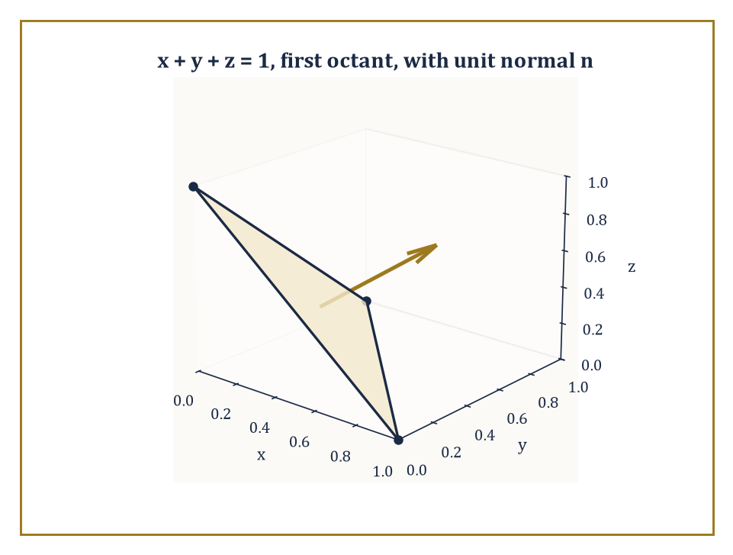
The tilted triangular patch x + y + z = 1 in the first octant, with its upward unit normal — the surface whose area (√3/2) and flux (1/2) the room's worked examples compute.
∬ g |r_u × r_v| du dv
an ordinary double integral over the flat parameter domain, dressed up to account for however the surface is stretched, tilted, or curved in actual space.
Numeric example — Worked example — area of a tilted plane. Find the surface area of the portion of the plane x + y + z = 1 lying in the first octant (x, y, z ≥ 0) — a flat triangular patch, tilted at an angle to all three coordinate axes. Parametrize by x and y directly, writing z = 1 − x − y, so r(x, y) = (x, y, 1 − x − y). The two tangent vectors are r_x = (1, 0, −1) and r_y = (0, 1, −1). Their cross product:
r_x × r_y = (0·(−1) − (−1)·1,\ (−1)·0 − 1·(−1),\ 1·1 − 0·0) = (0 + 1,\ 0 + 1,\ 1) = (1, 1, 1)
of magnitude √(1²+1²+1²) = √3. The parameter domain D is the triangle in the xy-plane where x ≥ 0, y ≥ 0, x + y ≤ 1 — a right triangle of legs 1 and 1, area 1/2. So the surface area is
∬_D √3 dA = √3 · (area of D) = √3 · (1/2) = √3/2 ≈ 0.866
The constant factor √3, notice, is exactly the ratio by which the tilted plane's area exceeds its flat 'shadow' triangle's area of 1/2 in the xy-plane — a tilted roof always covers more actual roofing material than its footprint on the ground, and √3 is precisely how much more, for a plane tilted equally in all three directions.
A surface integral of a vector field — the flux integral — measures something different in kind: not an accumulated scalar quantity but the flow of the field through the surface, the net rate at which whatever the field represents (fluid, electric field lines, heat) crosses from one side to the other. It is defined by
∬_S F · n dS
integrating the component of F along the surface's unit normal vector n, so that only the part of F actually piercing the surface counts — a component of F running parallel to the surface, however large, contributes nothing to the flux, exactly as a tailwind blowing along the plane of a sail contributes nothing to filling it. Crucially, a surface has two possible normal directions at every point, and choosing one over the other — orienting the surface — determines both the direction n and hence the sign of the resulting flux; flip the orientation and the flux simply changes sign.
Numeric example — Worked example — flux through the tilted plane. Compute the flux of the constant vector field F = (0, 0, 1) — a uniform flow straight upward — through the same triangular plane surface x + y + z = 1 in the first octant, oriented so its normal points upward (has positive z-component). Using the parametrization above, the (non-unit, area-scaling) normal vector is r_x × r_y = (1, 1, 1), already computed, and it does have positive z-component, so it matches the requested orientation without needing to flip sign. The flux is
∬_D F(x, y, z(x,y)) · (r_x × r_y) dA = ∬_D (0, 0, 1) · (1, 1, 1) dA = ∬_D 1 dA = area of D = 1/2
The flux of the upward-pointing field through this upward-tilted surface is 1/2. Notice this is a smaller number than the raw surface area √3/2 found above — makes sense, since the plane is tilted away from the vertical field direction, so only part of the flow actually pierces it rather than skimming along its slanted face.
Flux is best pictured as the continuous version of counting field lines: imagine the vector field sketched as a dense pattern of arrows or streamlines, and the flux through a surface as (roughly) the net number of those lines crossing from the negative side to the positive side, positive crossings counted plus and negative crossings counted minus, so that a surface sitting entirely parallel to the flow, or a field that enters and leaves in equal measure, contributes zero net flux even though plenty of field is passing nearby. This bookkeeping quantity — signed, orientation-dependent, additive over pieces of a surface — is the central actor in the Divergence Theorem two rooms from now, and it is the mathematical language behind conservation laws throughout physics: the total electric flux through a closed surface tells you the total charge enclosed; the total mass flux through the boundary of a region tells you whether fluid is accumulating or draining inside.
Numeric example — Worked example — orientation reverses the sign. Recompute the previous flux example with the surface's orientation flipped, so the normal now points downward instead. The downward normal is the negative of the one used before: −(1, 1, 1) = (−1, −1, −1). The flux becomes
∬_D (0, 0, 1) · (−1, −1, −1) dA = ∬_D (−1) dA = −(area of D) = −1/2
Exactly as promised: reversing orientation reversed the sign of the flux, from +1/2 to −1/2, while the magnitude — the sheer amount of field crossing the surface — stayed the same. Orientation is bookkeeping, not physics; it tells you which direction you have chosen to call 'positive', and the physical flow through the plane has not changed one drop, or one field line, by your having chosen differently.

Room 14.7: Green's Theorem
Or: The Fundamental Theorem of Calculus, Now With a Boundary
Green's theorem relates a line integral around the positively oriented boundary of a plane region D (counterclockwise, by the standard convention, so that D always sits to the left as you walk the boundary) to a double integral over the region itself:
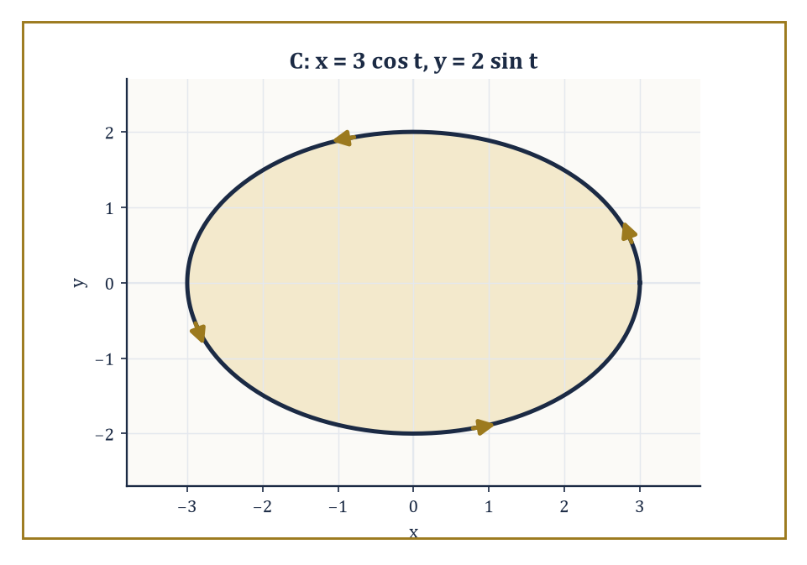
The ellipse x = 3 cos t, y = 2 sin t, walked once counterclockwise — its area, 6π, read off entirely from this boundary via Green's theorem.
∮_C P dx + Q dy = ∬_D (∂Q/∂x − ∂P/∂y) dA
The quantity ∂Q/∂x − ∂P/∂y in the integrand is precisely the curl test from Room 14.5, no longer merely checked for being zero but now integrated in its own right whenever it is not — it measures, at each point, the local rotational tendency (the two-dimensional curl) of the field, and Green's theorem says that adding up all this local spin across the whole region gives exactly the total circulation observed on the boundary. It is the precise planar analogue of the ordinary Fundamental Theorem of Calculus,
∫_a^b f'(x) dx = f(b) − f(a)
there, the integral of a derivative over an interval equals the values of the original function at the interval's boundary (its two endpoints); here, the integral of a derivative-like quantity over a two-dimensional region equals a suitably summed version of the original field on the region's boundary (now an entire curve, rather than two points).
Numeric example — Worked example — verifying the theorem on the rotation field. Verify Green's theorem directly for F = ⟨−y, x⟩ around the unit circle, the exact pairing already computed by brute force in Room 14.4. The left-hand side — the line integral — was found there to equal 2π. The right-hand side requires ∂Q/∂x − ∂P/∂y with P = −y, Q = x:
∂Q/∂x = 1, ∂P/∂y = −1
so the integrand is 1 − (−1) = 2, a constant, at every point of the disc. The double integral is then simply 2 times the area of the unit disc:
∬_D 2 dA = 2 · (π · 1²) = 2π
Both sides equal 2π exactly. Green's theorem has converted a line integral, requiring a trigonometric parametrization and a page of algebra, into an area integral of a constant, requiring nothing more than knowing the area of a circle — the theorem has done, in one line, what took four lines of segment-by-segment work back in Room 14.5 for the analogous square-boundary example, and would have taken considerably more for any boundary curve less obliging than a circle.
The practical uses of Green's theorem run in both directions. Read left to right, it converts an awkward line integral — a boundary that twists and turns, defying easy parametrization — into a double integral over the enclosed region, which is very often the easier of the two calculations. Read right to left, and specialized suitably, it computes the area of a region purely from a line integral around its boundary: choosing P = −y/2, Q = x/2 makes ∂Q/∂x − ∂P/∂y = 1/2 + 1/2 = 1 everywhere, so
∮_C (−y/2) dx + (x/2) dy = area of D
a formula prized by anyone who has ever needed to find the area enclosed by a complicated closed curve and would rather integrate along its edge than describe its interior.
Numeric example — Worked example — area of an ellipse by boundary integral. Find the area enclosed by the ellipse x = 3 cos θ, y = 2 sin θ (semi-axes a = 3, b = 2), using the boundary formula A = (1/2) ∮_C (x dy − y dx). Here dx = −3 sin θ dθ and dy = 2 cos θ dθ, for θ running from 0 to 2π. Compute the integrand:
x dy − y dx = (3 cos θ)(2 cos θ dθ) − (2 sin θ)(−3 sin θ dθ) = 6 cos²θ dθ + 6 sin²θ dθ = 6(cos²θ + sin²θ) dθ = 6 dθ
So
A = (1/2) ∫₀^{2π} 6 dθ = (1/2)·6·2π = 6π
This matches the standard formula for the area of an ellipse, πab = π·3·2 = 6π, exactly — obtained here without ever writing down the ellipse's interior at all, purely by walking once around its rim.
Green's theorem also settles, in a single stroke, the question that occupied the whole of Room 14.5: whether a given field is conservative. Since a conservative field has ∂P/∂y = ∂Q/∂x everywhere, its integrand ∂Q/∂x − ∂P/∂y vanishes identically, and the double integral over any region is automatically zero — which, by Green's theorem, forces the line integral around every closed curve bounding that region to be zero as well, exactly the path-independence criterion from two rooms back, now derived rather than merely observed. Green's theorem is, in this sense, the machine that manufactures the closed-loop-integral-equals-zero property, rather than a separate fact requiring its own separate proof.
Numeric example — Worked example — Green's theorem confirms the earlier zero. Recheck the closed-loop calculation for F = ⟨y, x⟩ around the unit square from Room 14.5, this time via Green's theorem rather than four separate segment integrals. Here P = y, Q = x, so
∂Q/∂x − ∂P/∂y = 1 − 1 = 0
at every point — the field's curl vanishes identically, consistent with it having been shown conservative back in Room 14.5. The double integral is then ∬_D 0 dA = 0, regardless of the shape or size of D, so in particular it is 0 for the unit square. This instantly reproduces the answer obtained the hard way, segment by segment, in the previous room — and it would reproduce the same zero for absolutely any closed boundary at all, a square, a circle, an amoeba-shaped blob, without a single new calculation. That is the entire point of the theorem: it turns an infinite family of separate closed-loop calculations into one glance at a single partial-derivative identity.

Room 14.8: Stokes' Theorem and the Divergence Theorem
Or: Green's Theorem Learns to Fly and Then Learns to Enclose Volume
Stokes' theorem lifts Green's theorem out of the flat plane and onto a curved surface hanging in three-dimensional space: it states that the line integral of a vector field F around the oriented boundary curve of a surface S equals the surface integral, over S itself, of curl F — the three-dimensional generalization of the two-dimensional curl quantity ∂Q/∂x − ∂P/∂y met in the previous room, now a full vector, ∇ × F, whose component in the direction of the surface's chosen normal is what actually gets integrated. When the surface S happens to be flat and lying in the xy-plane, Stokes' theorem collapses back down to exactly Green's theorem — not a coincidence, not an analogy, but literally the very same statement, viewed from a vantage point one dimension higher.
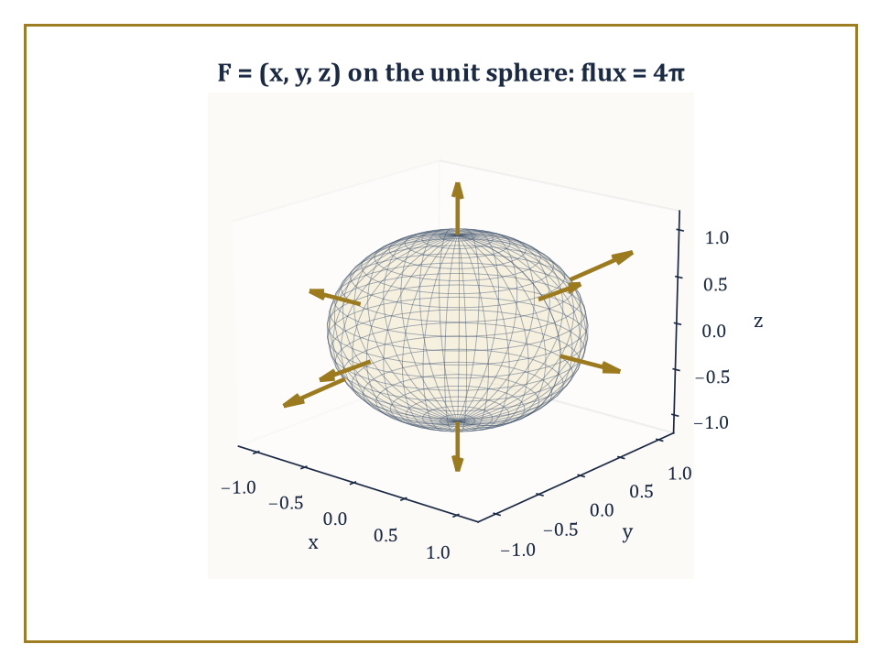
The outward radial field F = (x, y, z) piercing the unit sphere everywhere perpendicular to its surface, giving the Divergence Theorem's worked flux of 4π.
Numeric example — Worked example — Stokes' theorem on a flat disc. Take F = ⟨−y, x, 0⟩ — the familiar rotation field from Rooms 14.4 and 14.7, now written with an explicit (zero) third component so it lives properly in three-dimensional space — and let S be the flat unit disc x² + y² ≤ 1 sitting in the plane z = 0, oriented with upward normal n = (0, 0, 1), whose boundary is then the unit circle traversed counterclockwise (matching the orientation used throughout this storey). First, curl F: with P = −y, Q = x, R = 0,
curl F = ∇ × F = (∂R/∂y − ∂Q/∂z,\ ∂P/∂z − ∂R/∂x,\ ∂Q/∂x − ∂P/∂y) = (0 − 0,\ 0 − 0,\ 1 − (−1)) = (0, 0, 2)
The surface integral of curl F over the flat disc, with normal (0,0,1), reduces to
∬_S curl F · n dS = ∬_S 2 dA = 2 · (area of unit disc) = 2π
This equals the boundary line integral of F around the unit circle, already computed in Room 14.4 by brute-force parametrization to be exactly 2π. The two calculations — one purely in space via curl and a surface integral, one purely on the boundary via parametrization — agree perfectly, and indeed they had no choice, since for a flat disc in the xy-plane, Stokes' theorem simply is Green's theorem wearing a slightly more three-dimensional-looking coat.
The Divergence Theorem, also called Gauss's theorem, plays the same game one dimension further still, and declines to apologise for how greedy it is: it states that the flux of a vector field F through the entire closed boundary surface of a solid region E equals the triple integral, throughout the volume of E, of div F — the divergence,
∇ · F = ∂P/∂x + ∂Q/∂y + ∂R/∂z
a single scalar measuring how much the field is 'spreading out' (a positive divergence, a point behaving like a tiny source) or 'converging' (a negative divergence, a point behaving like a tiny drain) at each point. It is the three-dimensional cousin of the two-dimensional curl-quantity that drove Green's theorem, though it has traded rotation for plumbing: it measures expansion and contraction rather than spin.
Numeric example — Worked example — divergence theorem on the unit sphere. Let F = ⟨x, y, z⟩, the outward-pointing position-vector field, and let E be the solid unit ball, its closed boundary the unit sphere. Compute the divergence, a constant:
div F = ∂x/∂x + ∂y/∂y + ∂z/∂z = 1 + 1 + 1 = 3
By the divergence theorem, the total outward flux through the unit sphere equals
∭_E 3 dV = 3 · (volume of the unit ball) = 3 · (4π/3) = 4π
This can be checked directly, without invoking the theorem at all: on the unit sphere, the outward unit normal at any point equals the position vector itself, n = (x, y, z), since the sphere has radius 1 and the outward normal at a point on a sphere always points straight away from the centre, scaled to unit length — but on the unit sphere the position vector already has length 1, so n = (x, y, z) exactly. Then
F · n = (x, y, z) · (x, y, z) = x² + y² + z² = 1
everywhere on the sphere (since the sphere's equation is exactly x² + y² + z² = 1). So the flux integral is simply
∬_sphere 1 dS = surface area of the unit sphere = 4π
Both routes — the volume integral of the divergence, and the direct surface integral of the flux — give 4π, in perfect agreement, and the direct route required nothing more than recognizing that F · n happened to equal 1 at every single point of the sphere, a small piece of luck that the divergence theorem did not need at all.
Green's theorem, Stokes' theorem, and the Divergence Theorem are, at bottom, three dialects of one sentence: the integral of a derivative over a region equals the integral of the original quantity over the region's boundary. The derivative in question is the two-dimensional curl for Green, the full curl for Stokes, and the divergence for Gauss; the region is a plane area, a curved surface, and a solid volume respectively; the boundary is a bounding curve in the first two cases and a bounding surface in the third. All three are continuous descendants of the humble telescoping sum that underlies the one-dimensional Fundamental Theorem of Calculus itself — a fact easy to state and worth pausing over, since it is the single organizing idea beneath this entire storey.
Worked example — Worked example — the telescoping sum underneath everything. The discrete ancestor of all three theorems is the elementary observation that a sum of consecutive differences collapses to the difference of the two ends:
Σ_{k=1}^{n} (a_k − a_{k−1}) = a_n − a_0
because every interior term cancels against its neighbour, leaving only the first and last. Take a_k = k² for k = 0, 1, 2, 3, 4, so a_0 = 0, a_1 = 1, a_2 = 4, a_3 = 9, a_4 = 16. The individual differences are
(1−0) + (4−1) + (9−4) + (16−9) = 1 + 3 + 5 + 7 = 16
and indeed a_4 − a_0 = 16 − 0 = 16 — the sum of differences equals the difference of the ends, exactly as claimed, with every interior value (1, 4, 9) cancelling invisibly in the middle. This is precisely the mechanism, in miniature, that the Fundamental Theorem of Calculus performs in the continuous limit — ∫_a^b f'(x) dx telescopes infinitesimal differences of f into f(b) − f(a) — and it is the very same mechanism, generalized to regions and their boundaries rather than intervals and their endpoints, that Green, Stokes, and Gauss each perform in their own dimension. One idea; three costumes; a great many exam questions.

Room 14.9: Looking Ahead: From Multi-Variable Calculus to Vector Calculus Applications and Beyond
Or: We Have Learned to Add Up in Every Direction At Once
We have now acquired the full working vocabulary of multi-variable calculus: double and triple integrals and the iterated integrals that make them computable, the change-of-variables formula and its Jacobian, vector fields and the line integrals that measure work and circulation along them, conservative fields and the potential functions that tame them, surface integrals and the flux integrals that measure flow through them, and finally the three great integral theorems — Green's, Stokes', and Gauss's — that tie the interior of a region to its boundary in exact analogy with the one-dimensional Fundamental Theorem of Calculus. It has been, by any honest accounting, the most computationally demanding storey so far in this Tower; if your hand is tired from limits of integration, it has earned the rest.
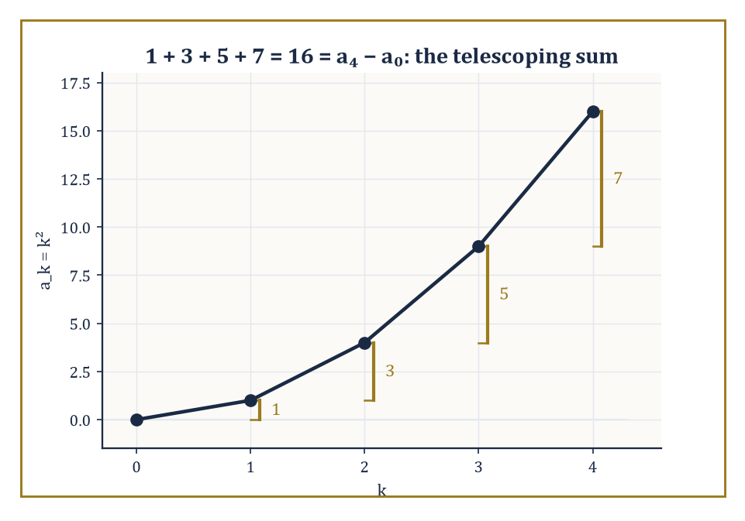
The telescoping sum 1 + 3 + 5 + 7 = 16, the humble discrete ancestor of Green's, Stokes', and Gauss's theorems alike.
This vocabulary is the direct foundation for the next storey, Vector Calculus, where these same fields, flows, and flux integrals go to work in earnest on the physics of electricity, magnetism, and fluid motion — the equations of that storey will be written almost entirely in the div, curl, and flux notation assembled here, and the three integral theorems of Room 14.8 will be invoked, by name, on nearly every page. Further up the Tower, differential geometry will perform these same integrals over curved manifolds rather than flat regions of the plane or ordinary Euclidean space; partial differential equations will lean on divergence and curl to write down the classical field equations of physics; and eventually, differential forms will arrive to unify Green's, Stokes', and Gauss's theorems — three separate-looking statements in this storey — into one single formula,
∫_M dω = ∫_∂M ω
valid on a manifold M of any dimension whatsoever.
Abstract example — Worked example — one formula, four familiar faces. The abstract unifying formula ∫_M dω = ∫_∂M ω instantiates, at the level of introductory calculus, into every theorem this storey has met. Take M to be an interval [a, b] (a one-dimensional manifold) and ω to be a function f (what a later storey will call a zero-form); then dω is f' dx, and the formula reads
∫_a^b f'(x) dx = f(b) − f(a)
the ordinary Fundamental Theorem of Calculus. Take M to be a plane region D (two-dimensional) and ω to be P dx + Q dy (a one-form); then dω works out to (∂Q/∂x − ∂P/∂y) dx∧dy, and the formula reads
∬_D (∂Q/∂x − ∂P/∂y) dA = ∮_∂D P dx + Q dy
Green's theorem. Take M to be a curved surface S in space, with the same kind of one-form ω = P dx + Q dy + R dz; then dω encodes the curl of F, and the formula becomes Stokes' theorem. Take M to be a solid E and ω a two-form built from the components of F; then dω encodes the divergence, and the formula becomes the Divergence Theorem. Four theorems, met across three separate rooms of this storey, each independently checked by hand against a concrete numeric example — all turn out, from sufficiently far up the Tower, to be one single sentence, said in four different accents. That is not a coincidence to be marvelled at from a safe distance; it is the entire subject, quietly confessing that it was one idea all along.
The deeper lesson of this storey, then, is not any one formula but the persistence of the pattern: the Fundamental Theorem of Calculus was never a peculiar fact about the real number line, one-dimensional and slightly parochial. It is the prototype of a relationship between differentiation and integration that survives, essentially unchanged, in every dimension and on every reasonably well-behaved geometric object — a piece of good news about the universe, or at least about the mathematics we use to describe it, that took mathematicians the better part of two centuries to state in its full generality, and that this storey has now handed to you across nine rooms and rather more worked examples than is strictly fashionable.
Multi-variable calculus is therefore both an ending and a beginning: the completion of the calculus sequence proper, and simultaneously the opening move of the geometric analysis of fields and flows that occupies a great deal of higher mathematics and essentially all of mathematical physics. We came into this storey able to differentiate functions of several variables and unable to add anything up over a region; we leave it able to integrate over areas, volumes, curves, and surfaces, and equipped with three theorems that tell us, with total generality, that what happens inside is written entirely on the boundary. The Tower continues upward, and the next storey is waiting to put all of this to work.
So: we have learned to integrate over regions and around boundaries, to weigh laminas and solids that a page ago were merely differentiable, and to recognize the same Fundamental Theorem of Calculus wearing three increasingly elaborate disguises. It has been, without much competition, the most arithmetically demanding storey of the Tower thus far, and if a small, weary part of you is relieved to have reached the far wall of it, that part of you has been paying proper attention.
The next storey, Vector Calculus, takes everything assembled here — div, curl, flux, the three great theorems — and sends it out to do actual physics: Maxwell's equations, fluid dynamics, and the classical field theory that these tools were, historically, invented to serve. Nothing in that storey will require anything beyond what has just been built; it will simply put the machine to work.
Onward and upward, then, one theorem's worth of boundary at a time.

Storey 15: Vector Calculus
Fields, Flux, Circulation, and the Art of Differentiating and Integrating in Space
Storey 14 left us fluent in a particular kind of geometry: integrating over blobs, curves, and surfaces embedded in space, and differentiating functions of several variables until the partial derivatives ran out of new things to say. What we did not yet ask, seriously, is what happens when the thing you are integrating is itself a vector — when instead of a scalar height field you have an arrow attached to every point of space, an arrow that might represent a velocity, a force, or (with slightly more drama than the mathematics strictly requires) a field of destiny. That is the business of this storey.
Vector calculus is where multivariable calculus meets physics and discovers they have been secretly compatible the whole time. Three new differential operators — the gradient, the divergence, and the curl — turn scalar and vector fields into each other, measuring uphill slope, local expansion, and local spin respectively. Three integral theorems — Green's, Stokes', and the divergence theorem — turn out to be one and the same idea wearing three different coats: what happens inside a region is entirely accounted for by what happens on its boundary. It is, when you say it like that, suspiciously close to a moral principle, and mathematicians have learned not to trust moral principles that turn out to be theorems, or theorems that turn out to be moral principles.
None of this is optional scenery. Fluid flow, electromagnetism, gravity, and the stresses inside a bent girder are all written natively in this language; a physicist who cannot compute a divergence is not so much handicapped as monolingual in a country where everyone else speaks four languages fluently and one of them is Latin. We shall try to leave you at least trilingual.
Ahead, once this storey's business of arrows, spin, and flux is settled, Storey 16 turns to series — the art of approximating a function by an infinite sum of simpler pieces, Taylor and Fourier chief among the offenders. There is a pleasing symmetry to the sequence: multivariable calculus gave us the shape of space, vector calculus gives us the physics that lives on it, and series will shortly give us licence to replace anything difficult with an infinite queue of easy things and hope nobody notices the substitution. Onward.

Room 15.1: Vector Fields Revisited
In Which Arrows Move In
A vector field on a region of space assigns to each point a vector — not a number, an arrow. In coordinates we write:
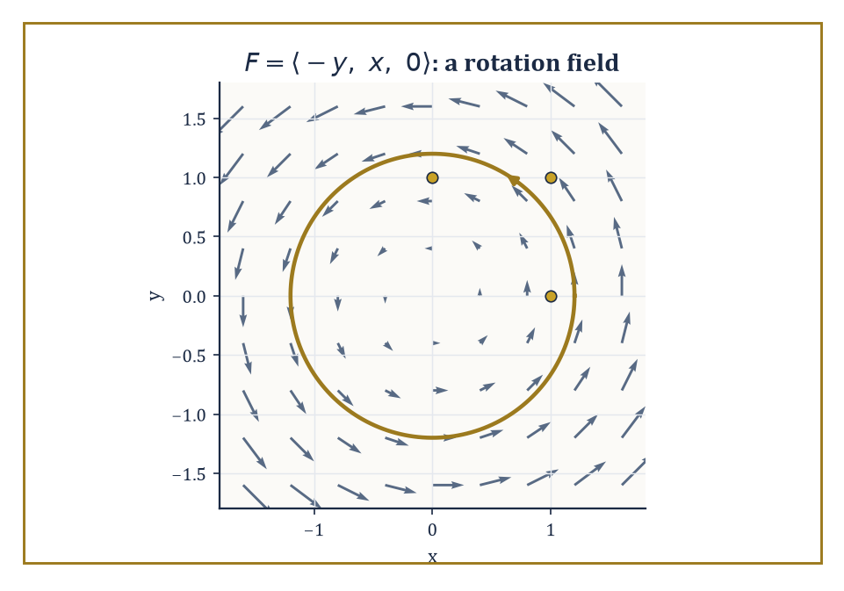
The rotation field F = ⟨−y, x, 0⟩, its arrows curling faithfully around the z-axis, with one streamline traced counterclockwise.
F = ⟨P, Q, R⟩
P, Q, and R are themselves ordinary scalar functions of x, y, and z, one supplying each component of the arrow at that point. Geometrically, imagine a small arrow sprouting from every point of space, its length and direction changing smoothly as you move about; physically, that arrow might be a velocity (how fast and which way the wind is blowing right here), a force (how hard and which way gravity is pulling right here), or a flux density (how much of something is flowing through right here, and in which direction).
The scalar fields of the last storey told you the temperature at each point. Vector fields tell you which way the wind is blowing while it happens.
Numeric example — Worked example: evaluating a field. Take the field defined on all of ℝ³ by:
F(x, y, z) = ⟨−y, x, 0⟩
At the point (1, 0, 0) it evaluates to an arrow pointing straight along the positive y-axis:
F = ⟨0, 1, 0⟩
At (0, 1, 0) it evaluates to an arrow pointing along the negative x-axis:
F = ⟨−1, 0, 0⟩
At (1, 1, 0) it gives:
⟨−1, 1, 0⟩
Plot enough of these arrows and a pattern announces itself: every arrow is perpendicular to the position vector at that point, and all of them curl the same way around the z-axis. This is, unsurprisingly, a rotation field — the velocity field of a rigid body spinning about the z-axis at one radian per second — and we shall meet it so often in this storey that you would do well to make its acquaintance now.
Visualizing a vector field is as much art as arithmetic. One approach draws a representative sample of arrows, each scaled to its magnitude, dotted around the domain like iron filings around a magnet — which is, not coincidentally, exactly what iron filings are doing.
A second approach draws streamlines (also called integral curves): curves that are everywhere tangent to the field, so that a particle released into the flow simply follows the arrows wherever they lead.
A third, available only when the field happens to be a gradient (Room 15.2 will explain why this is a special privilege, not a general right), draws the level surfaces orthogonal to the field.
Computer plots make all three easier, but the mental picture — arrows, streamlines, and the shape they trace out together — remains the thing you actually need in your head when a differential equation later asks you to imagine a fluid in motion.
Abstract example — Worked example: finding streamlines. Continue with F = ⟨−y, x, 0⟩ from above, and ask for its streamlines: curves (x(t), y(t), z(t)) whose velocity vector at every instant equals F evaluated at that point. That means:
dx/dt = −y, dy/dt = x, dz/dt = 0
Guess a circular orbit of fixed radius r:
x(t) = r cos t, y(t) = r sin t, z(t) = 0
Check it. First:
dx/dt = −r sin t
and this matches, since −y = −r sin t exactly.
dy/dt = r cos t
This too matches, since x = r cos t exactly. So every circle centred on the z-axis, at any radius r and any height, is a streamline of this field, traced out at unit angular speed. The rotation field's arrows, followed faithfully, simply go round in circles forever — which is either a satisfying confirmation of the obvious or a fairly bleak metaphor for a Monday, depending on your mood.
Vector fields can be added pointwise (add the arrows at each point separately), multiplied by a scalar function (stretch or shrink each arrow, possibly by a different factor at each point), and composed with scalar functions in various ways. None of this is deep; it is the linear algebra of arrows, done one point at a time.
What is deep — and what occupies the rest of this storey — is the differential structure: whether a field expands or compresses as you move through it, whether it swirls, and whether it can be written as the gradient of some underlying scalar potential. Those questions are answered by three operators we are about to meet, and once the answers are known they tell you almost everything about the field's behaviour without your having to stare at a picture of arrows at all.
Numeric example — Worked example: combining fields. Consider two fields together:
F = ⟨−y, x, 0⟩, G = ⟨1, 0, 0⟩
G is a uniform field blowing steadily in the x-direction, like a light and very well-behaved wind. At the point (0, 1, 0), F evaluates to ⟨−1, 0, 0⟩ and G evaluates to ⟨1, 0, 0⟩, since G is the same everywhere — that being rather the point of it.
The combined field H = F + 2G evaluates at that point to:
H = ⟨−1, 0, 0⟩ + 2⟨1, 0, 0⟩ = ⟨−1 + 2, 0, 0⟩ = ⟨1, 0, 0⟩
Physically: a spinning disc sitting in a steady crosswind twice as strong as the disc's own rim speed there. The wind wins, locally, and the arrow points downwind.

Room 15.2: The Gradient, Divergence, and Curl
Three Operators, One Nabla, Considerable Existential Content
The gradient of a scalar field f is the vector field built from the partial derivatives introduced in the last storey, simply gathered into a single arrow:
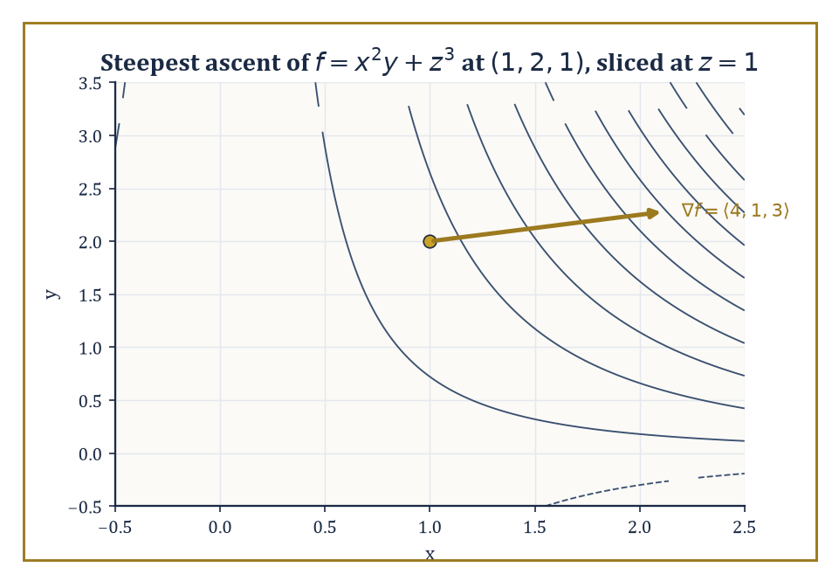
Level curves of f = x²y + z³ sliced at z = 1, with the gradient ⟨4, 1, 3⟩ at (1, 2, 1) pointing, as it must, straight uphill and perpendicular to the contour through that point.
∇f = ⟨∂f/∂x, ∂f/∂y, ∂f/∂z⟩
It points in the direction of steepest ascent of f — the direction a thirsty, ambitious raindrop rolling uphill (an unlikely raindrop, granted) would travel fastest — and its magnitude |∇f| is the rate of that ascent, i.e. how steep the steepest slope actually is.
For any unit vector u, the directional derivative of f in the direction u — the rate of change of f if you walk in direction u instead of straight uphill — is given by the elegantly compact formula:
∇f · u
Walking straight uphill (u parallel to ∇f) gives the maximum possible rate, |∇f|; walking along a level contour (u perpendicular to ∇f) gives zero, because you are, by definition, not going up or down at all.
Numeric example — Worked example: gradient and directional derivative. Let:
f(x, y, z) = x²y + z³
Then the partial derivatives are:
∂f/∂x = 2xy, ∂f/∂y = x², ∂f/∂z = 3z²
so:
∇f = ⟨2xy, x², 3z²⟩
At the point (1, 2, 1):
∇f = ⟨2·1·2, 1², 3·1²⟩ = ⟨4, 1, 3⟩
This is the direction of steepest ascent at that point, and its magnitude is how steep that ascent is:
√(16+1+9) = √26 ≈ 5.10
Now take the direction u = ⟨1/√2, 1/√2, 0⟩, a unit vector, since:
(1/√2)² + (1/√2)² + 0² = 1
The directional derivative there is:
∇f · u = 4·(1/√2) + 1·(1/√2) + 3·0 = 5/√2 = 5√2/2 ≈ 3.54
This is less than the maximum 5.10, exactly as it should be, since u is not the steepest direction, merely a direction.
The divergence of a vector field F = ⟨P, Q, R⟩ is the scalar field:
div F = ∇ · F = ∂P/∂x + ∂Q/∂y + ∂R/∂z
It measures the local rate at which the field is expanding — imagine a tiny balloon of fluid centred at the point, carried along by the flow, and ask whether it is inflating or deflating as it moves.
Where div F > 0, the point behaves like a source (fluid is being created, or at least spreading outward, locally); where div F < 0, it behaves like a sink; where div F = 0 everywhere, the flow is incompressible — fluid neither piles up nor thins out anywhere, it merely rearranges itself, which is rather the fluid-dynamical equivalent of shuffling deckchairs.
Numeric example — Worked example: divergence of two fields. For:
F = ⟨x², y², z²⟩
the divergence is:
div F = ∂(x²)/∂x + ∂(y²)/∂y + ∂(z²)/∂z = 2x + 2y + 2z
At (1, 1, 1) this is:
2+2+2 = 6
strongly positive — a genuine expansion, the field's arrows growing longer the further out you go in every direction, like a rather enthusiastic explosion frozen mid-frame.
Contrast this with the rotation field from Room 15.1:
F = ⟨−y, x, 0⟩
div F = ∂(−y)/∂x + ∂(x)/∂y + ∂(0)/∂z = 0 + 0 + 0 = 0
A spinning disc of fluid neither inflates nor deflates as it spins — it just spins — and the vanishing divergence confirms mathematically what your intuition already told you for free.
The curl of F is the vector field curl F = ∇ × F, computed by the formula:
curl F = ⟨∂R/∂y − ∂Q/∂z, ∂P/∂z − ∂R/∂x, ∂Q/∂x − ∂P/∂y⟩
Where divergence measured expansion, curl measures local rotation. Its direction is the axis about which the field is locally spinning (by the right-hand rule: curl your right-hand fingers in the direction of rotation and your thumb points along curl F), and its magnitude is exactly twice the angular speed of the rigid rotation that best approximates the field near that point.
A field with curl F = 0 everywhere is called irrotational: it may still flow, expand, or contract, but it never locally spins — a leaf dropped into it would translate and stretch, but never pirouette.
Numeric example — Worked example: curl of the rotation field. Return once more to F = ⟨−y, x, 0⟩, so P = −y, Q = x, R = 0. Then:
curl F = ⟨∂R/∂y − ∂Q/∂z, ∂P/∂z − ∂R/∂x, ∂Q/∂x − ∂P/∂y⟩ = ⟨0 − 0, 0 − 0, 1 − (−1)⟩ = ⟨0, 0, 2⟩
The curl points along the z-axis, exactly the axis we already identified by eye as the axis of rotation, and its magnitude is 2.
Since magnitude equals twice the angular speed, the angular speed is 1 radian per second — precisely the speed at which our streamlines from Room 15.1 traced out their circles. Everything the algebra says agrees with everything the picture already told you; this happy agreement is either deeply reassuring or a sign that we chose an unusually cooperative example, and in this storey it is always slightly both.
Higher-order differential operators are built by composing these three. The Laplacian of a scalar field is:
∇²f = div(grad f) = ∂²f/∂x² + ∂²f/∂y² + ∂²f/∂z²
It measures how the value at a point compares to the average of its immediate neighbours, and turns up everywhere from heat flow to Storey 16's discussion of Fourier series.
Two further facts — that the curl of a gradient always vanishes, and that the divergence of a curl always vanishes — are so important, and so consequence-laden, that they earn their own room next.
Numeric example — Worked example: the Laplacian. For f(x, y, z) = x²y + z³ from earlier, the second partial derivatives are:
∂²f/∂x² = ∂(2xy)/∂x = 2y, ∂²f/∂y² = ∂(x²)/∂y = 0, ∂²f/∂z² = ∂(3z²)/∂z = 6z
So:
∇²f = 2y + 0 + 6z
At (1, 2, 1):
∇²f = 2·2 + 6·1 = 4 + 6 = 10
A positive Laplacian at a point roughly says the point is a local dip relative to its neighbours — like the bottom of a small dent in an otherwise smoother landscape — which, for a temperature field, is exactly the situation in which heat would be flowing inward.

Room 15.3: Identities and the Algebra of Differential Operators
Or: Nabla Behaves Itself, Mostly
A handful of identities follow immediately from the definitions, courtesy of the equality of mixed partial derivatives (Clairaut's theorem, quietly doing enormous amounts of unglamorous labour behind the scenes since Storey 14). The two load-bearing ones are the curl of any gradient field, always, whatever f is:
curl(grad f) = 0
and the divergence of any curl field, always, whatever F is:
div(curl F) = 0
Alongside these sit the product rules:
div(f F) = f div F + ∇f · F
curl(f F) = f curl F + ∇f × F
These behave exactly as the ordinary product rule from Storey 11 would lead you to expect, once you remember that ∇ is itself a kind of derivative and so insists on hitting every factor in turn.
Abstract example — Worked example: verifying curl(grad f) = 0. Take f(x, y, z) = x²y + z³ once more (this field is getting rather a lot of use this storey; it has earned its keep). We already found:
∇f = ⟨2xy, x², 3z²⟩
Compute its curl, with P = 2xy, Q = x², R = 3z²:
curl(∇f) = ⟨∂R/∂y − ∂Q/∂z, ∂P/∂z − ∂R/∂x, ∂Q/∂x − ∂P/∂y⟩ = ⟨0 − 0, 0 − 0, 2x − 2x⟩ = ⟨0, 0, 0⟩
The last component is the instructive one: it is 2x − 2x, not some more mysterious cancellation, and it vanishes precisely because ∂²f/∂x∂y and ∂²f/∂y∂x are the same second-order mixed partial computed in two different orders. Every instance of curl(grad f) = 0 is, at bottom, this same equality of mixed partials, dressed up in three different coordinate slots simultaneously.
The product rule:
div(f F) = f div F + ∇f · F
says that the divergence of a scaled field splits into a term from the field's own expansion, weighted by the scale factor, plus a term from the scale factor's own gradient dragging the field along with it.
It is precisely the ordinary product rule for differentiation, applied component by component and then summed — the sort of identity that looks like it ought to require a footnote and, disappointingly for anyone hoping for drama, does not.
Abstract example — Worked example: the divergence product rule. Let f = x and F = ⟨y, z, x⟩. Directly:
f F = ⟨xy, xz, x²⟩
div(f F) = ∂(xy)/∂x + ∂(xz)/∂y + ∂(x²)/∂z = y + 0 + 0 = y
Via the identity:
div F = ∂y/∂x + ∂z/∂y + ∂x/∂z = 0
and:
∇f = ⟨1, 0, 0⟩, so ∇f · F = 1·y + 0·z + 0·x = y
Then:
f div F + ∇f · F = x·0 + y = y
Both routes give y. The direct route was three differentiations and an addition; the identity route required no differentiation of F at all once div F and ∇f were known, which is rather the point of having identities lying around.
The curl product rule:
curl(f F) = f curl F + ∇f × F
works the same way but with a cross product replacing the dot product, since curl itself is built from a cross product (∇ × F) rather than a dot product — swap the operation throughout and the whole argument follows along obediently, asking no further questions.
Abstract example — Worked example: the curl product rule. With the same f = x, F = ⟨y, z, x⟩: directly, f F = ⟨xy, xz, x²⟩, and:
curl(f F) = ⟨∂(x²)/∂y − ∂(xz)/∂z, ∂(xy)/∂z − ∂(x²)/∂x, ∂(xz)/∂x − ∂(xy)/∂y⟩ = ⟨0 − x, 0 − 2x, z − x⟩ = ⟨−x, −2x, z−x⟩
Via the identity:
curl F = ⟨∂x/∂y − ∂z/∂z, ∂y/∂z − ∂x/∂x, ∂z/∂x − ∂y/∂y⟩ = ⟨−1, −1, −1⟩
so:
f curl F = ⟨−x, −x, −x⟩
and:
∇f × F = ⟨1,0,0⟩ × ⟨y,z,x⟩ = ⟨0·x − 0·z, 0·y − 1·x, 1·z − 0·y⟩ = ⟨0, −x, z⟩
Adding:
⟨−x+0, −x−x, −x+z⟩ = ⟨−x, −2x, z−x⟩
The two routes agree exactly, component by component, which they had jolly well better, since the identity is a theorem and not a suggestion.
It helps to treat ∇ formally as a vector,
∇ = ⟨∂/∂x, ∂/∂y, ∂/∂z⟩
and apply the ordinary rules of vector algebra to it, remembering only that every derivative in the expression acts on everything sitting to its right and must not be allowed to sneak past a function it was meant to differentiate.
Treated this way, the vector-algebra identity for a triple cross product,
a × (b × c) = b(a·c) − c(a·b)
applied with a = b = ∇ and c = F, yields:
curl(curl F) = ∇(div F) − ∇²F
where ∇²F means the Laplacian applied separately to each component of F. This one identity quietly underlies the wave equation in electromagnetism and the viscous term in the Navier–Stokes equations, so it is worth more respect than its slightly menacing appearance suggests.
Abstract example — Worked example: verifying curl(curl F) = ∇(div F) − ∇²F. Take F = ⟨xy, yz, zx⟩. First:
div F = y + z + x
so:
∇(div F) = ⟨1, 1, 1⟩
a constant field, since x+y+z has constant partial derivatives. Second, each component of F is a product of two different coordinates, and the Laplacian of any such product is zero — for instance ∂²(xy)/∂x² = 0 and ∂²(xy)/∂y² = 0 — so:
∇²F = ⟨0, 0, 0⟩
The identity therefore predicts:
curl(curl F) = ⟨1,1,1⟩ − ⟨0,0,0⟩ = ⟨1,1,1⟩
Now check directly. With P = xy, Q = yz, R = zx:
curl F = ⟨∂R/∂y − ∂Q/∂z, ∂P/∂z − ∂R/∂x, ∂Q/∂x − ∂P/∂y⟩ = ⟨0 − y, 0 − z, 0 − x⟩ = ⟨−y, −z, −x⟩
Taking the curl again, with P′ = −y, Q′ = −z, R′ = −x:
curl(curl F) = ⟨∂R′/∂y − ∂Q′/∂z, ∂P′/∂z − ∂R′/∂x, ∂Q′/∂x − ∂P′/∂y⟩ = ⟨0 − (−1), 0 − (−1), 0 − (−1)⟩ = ⟨1, 1, 1⟩
It matches the prediction exactly — a small but satisfying confirmation that treating ∇ as a bona fide vector, and trusting the algebra, genuinely works.

Room 15.4: Line Integrals and Conservative Fields
Potential, Realised
The line integral of a vector field F along a curve C, written
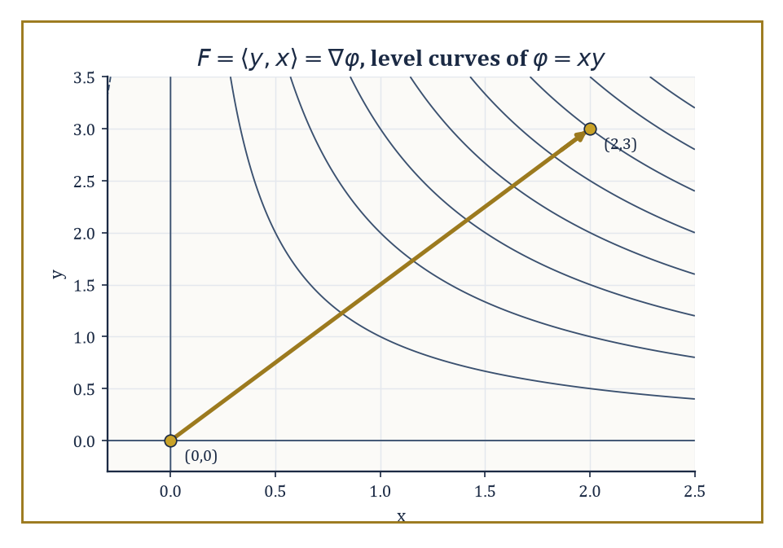
Level curves of the potential φ = xy, with the straight path from (0,0) to (2,3) that made the line integral of F = ⟨y, x⟩ so cheap to compute.
∫_C F · dr
measures the total work done by the field on a particle travelling along C — at each instant, only the component of F pointing along the direction of travel contributes, exactly as a force does no work when it pushes perpendicular to your motion. When the curve is closed, the same integral is called the circulation of F around the loop.
The central question of this room is when ∫_C F · dr depends only on the endpoints of C, and not on the particular path taken between them — because when it doesn't depend on the path, computing it becomes almost embarrassingly easy.
This happens precisely when F is conservative: when
F = ∇φ
for some scalar potential φ. On a simply connected domain (one with no holes to trip over — we will meet the exception shortly), a continuously differentiable field is conservative if and only if curl F = 0 everywhere on that domain.
Numeric example — Worked example: a conservative field, two ways. Let F = ⟨y, x⟩, and guess the potential φ(x, y) = xy, since:
∇φ = ⟨y, x⟩ = F
Confirm conservativity, with P = y, Q = x, R = 0:
curl F = ⟨0, 0, ∂x/∂x − ∂y/∂y⟩ = ⟨0, 0, 1−1⟩ = 0
as required. Compute ∫_C F · dr along the straight line C from (0,0) to (2,3), parametrized:
r(t) = (2t, 3t), t ∈ [0,1], so r′(t) = (2,3)
Then F(r(t)) = ⟨3t, 2t⟩, since the y-coordinate 3t feeds the first component of F and the x-coordinate 2t feeds the second, and:
F · r′ = 3t·2 + 2t·3 = 6t + 6t = 12t
So:
∫_C F · dr = ∫₀¹ 12t dt = [6t²]₀¹ = 6
Now the lazy route: since F is conservative,
∫_C F · dr = φ(2,3) − φ(0,0) = (2·3) − 0 = 6
Same answer, a fraction of the effort — and any other path from (0,0) to (2,3), however wandering, would give exactly 6 as well.
When a field is known to be conservative, its potential can be found by integrating one component at a time and patching the results together.
Integrate ∂φ/∂x = P with respect to x, which recovers φ up to an unknown function of y (and z); differentiate that partial result with respect to y and compare against Q to pin down the missing function; repeat with R if there is a third variable.
It is a small act of detective work, and like all good detective work it ends with a verification step you should never skip.
Numeric example — Worked example: finding a potential. Let F = ⟨2xy, x² + 3y²⟩. Set ∂φ/∂x = 2xy and integrate with respect to x:
φ = x²y + g(y)
for some function g depending only on y. Differentiate with respect to y:
∂φ/∂y = x² + g′(y)
This must equal the second component, x² + 3y², so:
g′(y) = 3y², giving g(y) = y³
plus an arbitrary constant, which we may as well set to zero. So:
φ(x, y) = x²y + y³
Check:
∇φ = ⟨2xy, x² + 3y²⟩ = F
confirmed. The line integral of F from (0,0) to (1,1), along any path whatsoever, is now:
φ(1,1) − φ(0,0) = (1·1 + 1) − 0 = 2
For a conservative field, the circulation around any closed curve is zero:
∮_C ∇φ · dr = φ(end) − φ(start) = φ(P) − φ(P) = 0
since a closed curve starts and ends at the same point. This is the continuous cousin of the fact that a function returns to its own value after a round trip — hardly a surprise once stated, though it is worth stating, because the converse is treacherous.
Vanishing curl everywhere on the domain does not, by itself, guarantee a global potential exists; it guarantees only a local one, valid near each point.
To upgrade 'local potential everywhere' to 'one global potential', the domain must have no holes for a loop to snag on — it must be simply connected. Where that fails, curl-free fields can still have nonzero circulation around loops that encircle the hole, and no potential exists that is single-valued on the whole domain.
Worked example — Worked example: curl-free but not conservative. The standard counterexample is:
F = ⟨−y/(x²+y²), x/(x²+y²)⟩
defined everywhere except the single punctured point (0,0). A direct computation gives curl F = 0 everywhere on its domain — the field genuinely is irrotational away from the puncture.
Yet its circulation around the unit circle is nonzero. Parametrizing x = cos θ, y = sin θ for θ from 0 to 2π gives:
F = ⟨−sin θ, cos θ⟩, dr = ⟨−sin θ, cos θ⟩ dθ
so:
F · dr = sin²θ dθ + cos²θ dθ = dθ
and:
∮ F · dr = ∫₀^(2π) dθ = 2π
A curl-free field with a nonzero loop integral: the theorem's topological hypothesis was not decoration, it was load-bearing, and the punctured plane — the plane with a single point removed — is the smallest possible hole through which this particular piece of mathematics can go wrong.

Room 15.5: Surface Integrals and Flux
How Much Is Going Through
The flux of a vector field F through an oriented surface S measures the net amount of the field passing through the surface — 'oriented' meaning that one of the surface's two possible unit normal directions, n, has been chosen as positive.
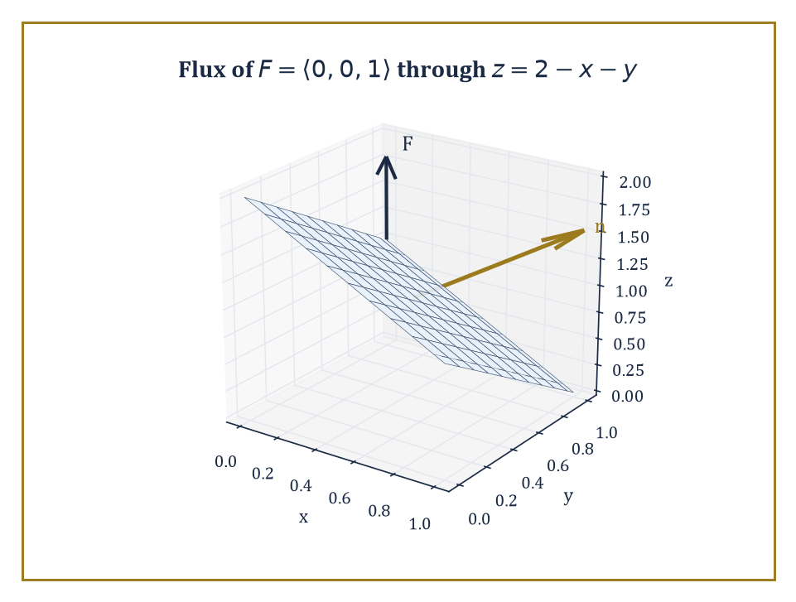
The tilted plane z = 2 − x − y over the unit square, its normal ⟨1,1,1⟩ from r_x × r_y set against the uniform field F = ⟨0,0,1⟩ passing through it.
Flux is computed as the surface integral:
∬_S F · n dS
At each point, only the component of F perpendicular to the surface contributes — a field flowing exactly along the surface passes nothing through it, the same way a river flowing parallel to a fishing net catches no fish.
Numeric example — Worked example: flux through a flat disc. Let F = ⟨x, y, z⟩, and let S be the disc of radius 1 lying in the plane z = 2, oriented with upward normal n = ⟨0,0,1⟩.
On S, every point has z = 2, so F restricted to S is ⟨x, y, 2⟩, and:
F · n = 2
at every point of the disc — the x and y components of F, however large, are killed by the dot product with a purely vertical normal. The flux is then just this constant value times the area:
Flux = 2 × (π · 1²) = 2π
For a surface given as a parametrization r(u, v), the surface integral reduces to an ordinary double integral over the parameter domain, via:
∬_S F · n dS = ∬ F(r(u,v)) · (r_u × r_v) du dv
The cross product of the two partial derivatives r_u and r_v does double duty: its magnitude supplies the area-scaling factor — how much a small rectangle in (u,v)-space gets stretched or squashed when mapped onto the curved surface — and its direction supplies the normal vector n itself, orientation included.
Numeric example — Worked example: flux via parametrization. Let S be the portion of the plane z = 2 − x − y lying over the unit square 0 ≤ x ≤ 1, 0 ≤ y ≤ 1, parametrized by:
r(x,y) = ⟨x, y, 2−x−y⟩
using x and y themselves as the parameters, a common and convenient choice for graphs. Then:
r_x = ⟨1, 0, −1⟩, r_y = ⟨0, 1, −1⟩
and their cross product is:
r_x × r_y = ⟨(0)(−1) − (−1)(1), (−1)(0) − (1)(−1), (1)(1) − (0)(0)⟩ = ⟨1, 1, 1⟩
The positive z-component confirms this normal points broadly upward, matching an upward choice of orientation. Take F = ⟨0, 0, 1⟩, a uniform vertical field. Then:
F · (r_x × r_y) = 0 + 0 + 1 = 1
at every point, and the flux is:
∫₀¹∫₀¹ 1 dx dy = 1
As a sanity check: a purely vertical field passing through a tilted plane sees only the plane's projected area onto the horizontal, which here is exactly the unit square's own area, 1 — the tilt does not matter for a field with no horizontal component, and the arithmetic duly confirms it.
Reversing the chosen orientation — swapping n for −n, or equivalently swapping the order of the parameters as r_y × r_x instead of r_x × r_y — reverses the sign of the flux and nothing else.
For closed surfaces (spheres, cubes, anything fully enclosing a region), the universal convention is to take the outward normal as positive; this convention is what makes the divergence theorem of Room 15.6 come out with a plus sign rather than requiring a footnote every time it is invoked.
Numeric example — Worked example: reversing orientation. Reversing the parametrization order in the previous example:
r_y × r_x = −⟨1,1,1⟩ = ⟨−1,−1,−1⟩
and:
F · (r_y × r_x) = −1
at every point, giving a flux of:
∫₀¹∫₀¹ (−1) dx dy = −1
the exact negative of before, and nothing more mysterious than a bookkeeping choice about which side of the plane counts as 'through'.

Room 15.6: Green's, Stokes', and Gauss's Theorems Revisited
Three Theorems, One Sentence
Green's theorem, Stokes' theorem, and the divergence theorem (also called Gauss's theorem) are the three classical integral theorems of vector calculus, and they are, at heart, three dialects of a single sentence: the total behaviour of a differential operator inside a region equals the corresponding behaviour of the original field on the region's boundary.
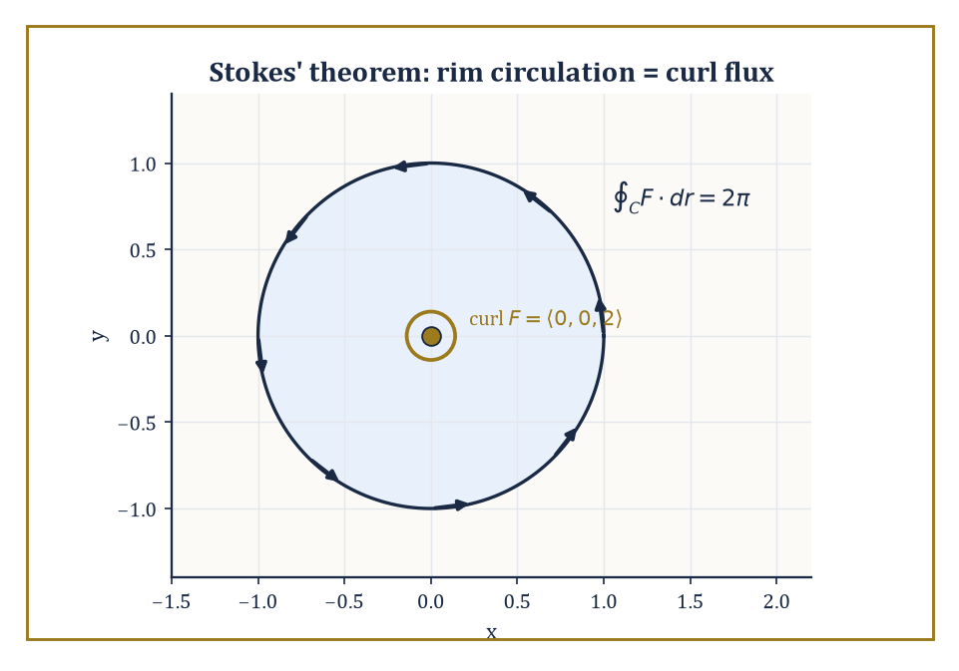
Stokes' theorem on the rotation field: circulation of 2π around the unit circle's counterclockwise rim, exactly matched by the flux of curl F = ⟨0,0,2⟩ straight up through the disc it bounds.
Green's theorem is the planar special case: for F = ⟨P, Q⟩ on a region D in the plane with boundary curve C traversed counterclockwise:
∮_C P dx + Q dy = ∬_D (∂Q/∂x − ∂P/∂y) dA
Stokes' theorem lifts this into three dimensions for a curved oriented surface S with boundary curve C:
∮_C F · dr = ∬_S curl F · n dS
The divergence theorem trades a surface's boundary curve for a solid's boundary surface: for a solid region E with closed boundary surface ∂E, outward-oriented:
∬_(∂E) F · n dS = ∭_E div F dV
Numeric example — Worked example: Green's theorem. Let P = xy, Q = x² on the unit square D = [0,1] × [0,1], boundary traversed counterclockwise. The right-hand side:
∂Q/∂x = 2x, ∂P/∂y = x
so the integrand is 2x − x = x, and:
∬_D x dA = ∫₀¹∫₀¹ x dx dy = (∫₀¹ x dx)(∫₀¹ dy) = (1/2)(1) = 1/2
The left-hand side, computed the hard way around all four sides. On the bottom edge (y=0, x: 0→1):
F·dr = P dx = (x·0) dx = 0
contributing 0. On the right edge (x=1, y: 0→1):
F·dr = Q dy = 1·dy, contributing ∫₀¹ dy = 1
On the top edge (y=1, x: 1→0):
F·dr = P dx = x dx, contributing ∫₁⁰ x dx = −1/2
On the left edge (x=0, y: 1→0):
F·dr = Q dy = 0·dy
contributing 0. Total:
0 + 1 − 1/2 + 0 = 1/2
The two sides agree, as advertised, and note how much less arithmetic the area integral required.
Stokes' theorem contains Green's theorem as the flat special case: take S to be a region in the xy-plane, with n = ⟨0,0,1⟩, and curl F · n reduces exactly to the Green's-theorem integrand ∂Q/∂x − ∂P/∂y.
More generally it holds for any oriented surface with a boundary curve, however curved the surface itself may be, provided the orientation of the surface's normal and the direction of travel along its boundary are linked by the same right-hand rule that linked curl's direction to the sense of rotation back in Room 15.2.
Numeric example — Worked example: Stokes' theorem. Let F = ⟨−y, x, 0⟩, our recurring rotation field, S the unit disc in the plane z = 0 with upward normal, and C its boundary, the unit circle, traversed counterclockwise. We already found curl F = ⟨0,0,2⟩ in Room 15.2. The flux of curl F through S is:
∬_S ⟨0,0,2⟩ · ⟨0,0,1⟩ dA = 2 × (area of unit disc) = 2π
The circulation ∮_C F · dr, computed directly as in Room 15.4: on the unit circle:
F = ⟨−sin θ, cos θ, 0⟩, dr = ⟨−sin θ, cos θ, 0⟩ dθ
so:
F · dr = sin²θ + cos²θ = 1
per unit dθ, giving:
∮_C F · dr = 2π
Both sides equal 2π: the flux of the spin through the disc matches the circulation around its rim exactly, which is Stokes' theorem doing precisely what it says on the tin.
The divergence theorem says that the total outward flux through a closed surface equals the total 'sourceness' (divergence, summed up) of the field throughout the enclosed solid.
Every little bit of local expansion inside eventually has to push its way out through the boundary, and the theorem is simply the bookkeeping statement that nothing gets lost or double-counted along the way.
Numeric example — Worked example: the divergence theorem. Let F = ⟨x, y, z⟩, so:
div F = 1 + 1 + 1 = 3
a constant. Let E be the solid unit ball. The right-hand side:
∭_E 3 dV = 3 × (volume of unit ball) = 3 × (4π/3) = 4π
The left-hand side: on the unit sphere, the outward unit normal at a point (x,y,z) is simply the position vector itself, n = ⟨x,y,z⟩, since the sphere has radius 1 and position vectors on it already have length 1. So:
F · n = x² + y² + z² = 1
at every point of the sphere, because the sphere's equation is exactly x²+y²+z²=1. The flux is therefore:
∬_(sphere) 1 dS = surface area of the unit sphere = 4π
Both sides equal 4π, and the divergence theorem again earns its keep.
All three theorems demand some regularity — continuously differentiable fields, sufficiently smooth boundaries, compatible orientations — and violating the fine print is how careless students, and the occasional careless don, generate apparent paradoxes out of thin air.
Used correctly, though, the theorems are simply a choice of which side of an equation is easier to compute, and a competent practitioner reaches automatically for whichever side that is.

Room 15.7: Potential Theory and Helmholtz Decomposition
Every Field Is a Rotation Plus a Push, More or Less
A scalar potential for a vector field F is a scalar function φ with ∇φ = F; we met these in Room 15.4.
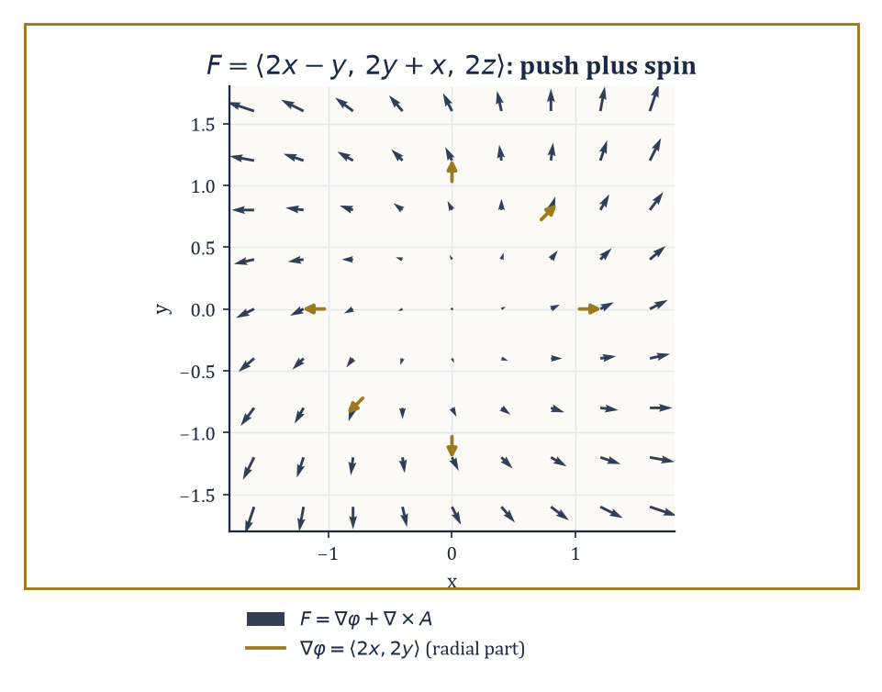
F = ⟨2x−y, 2y+x, 2z⟩ in the xy-plane, its spiral shape visibly the sum of a radial push ∇φ = ⟨2x,2y⟩ (gold) and the familiar rotation field underneath.
A vector potential is the less familiar cousin: a vector field A with curl A = F.
Existence of a scalar potential requires curl F = 0 (plus, as we saw, the right topology); existence of a vector potential requires div F = 0 (again, plus topology, since div(curl A) = 0 is compulsory for any A, so a field with nonzero divergence can never be a pure curl, however much it might privately wish otherwise).
Abstract example — Worked example: a vector potential. Take the uniform field F = ⟨0, 0, 1⟩ — think of a constant magnetic field pointing straight up. A vector potential is:
A = ⟨−y/2, x/2, 0⟩
Check, with P = −y/2, Q = x/2, R = 0:
curl A = ⟨∂R/∂y − ∂Q/∂z, ∂P/∂z − ∂R/∂x, ∂Q/∂x − ∂P/∂y⟩ = ⟨0 − 0, 0 − 0, 1/2 − (−1/2)⟩ = ⟨0, 0, 1⟩ = F
confirmed. Note div F = 0 here trivially, since F is constant, consistent with the necessary condition.
The Helmholtz decomposition theorem states that, under mild decay conditions at infinity (the field must not misbehave too badly far from the origin), any sufficiently smooth vector field F on ℝ³ can be written uniquely as:
F = ∇φ + ∇ × A
the sum of a curl-free ('irrotational') part and a divergence-free ('solenoidal') part.
It is the field-theoretic analogue of splitting a square matrix into its symmetric and antisymmetric halves, or a vector into components parallel and perpendicular to a fixed direction — in each case, an arbitrary object of some type decomposes uniquely into two pieces from complementary, non-overlapping subtypes.
It also explains, retrospectively, why the two conditions curl F = 0 and div F = 0 kept showing up throughout this storey as the natural things to check: they are exactly the conditions under which one half of the decomposition vanishes and the field is purely the other kind.
Abstract example — Worked example: an explicit decomposition. A fully general Helmholtz decomposition requires solving a Poisson equation (more on those in later storeys), which is not an afternoon's hand computation. But a small, honestly worked instance is within reach.
Let F = ⟨2x − y, 2y + x, 2z⟩. Split it as:
F = ⟨2x, 2y, 2z⟩ + ⟨−y, x, 0⟩
The first piece is ∇φ for φ = x² + y² + z², direct check:
∇φ = ⟨2x, 2y, 2z⟩
correct, and a gradient is automatically curl-free by the identity of Room 15.3.
The second piece, ⟨−y, x, 0⟩, is our familiar rotation field, already shown in Room 15.2 to have zero divergence, and it is also a genuine curl: with A = ⟨0, 0, −(x²+y²)/2⟩:
curl A = ⟨∂R/∂y − ∂Q/∂z, ∂P/∂z − ∂R/∂x, ∂Q/∂x − ∂P/∂y⟩ = ⟨−y − 0, 0 − (−x), 0 − 0⟩ = ⟨−y, x, 0⟩
matching exactly. So:
F = ∇φ + ∇×A, with φ = x²+y²+z² and A = ⟨0,0,−(x²+y²)/2⟩
a fully explicit, fully verified instance of the general theorem, even though most fields are not considerate enough to arrange themselves this tidily in advance.

Room 15.8: Physical Applications
Where All This Turns Out to Matter
In fluid dynamics, the velocity field u of an incompressible flow satisfies div u = 0 — the defining condition, as we saw in Room 15.2, of a flow in which fluid neither accumulates nor thins anywhere.
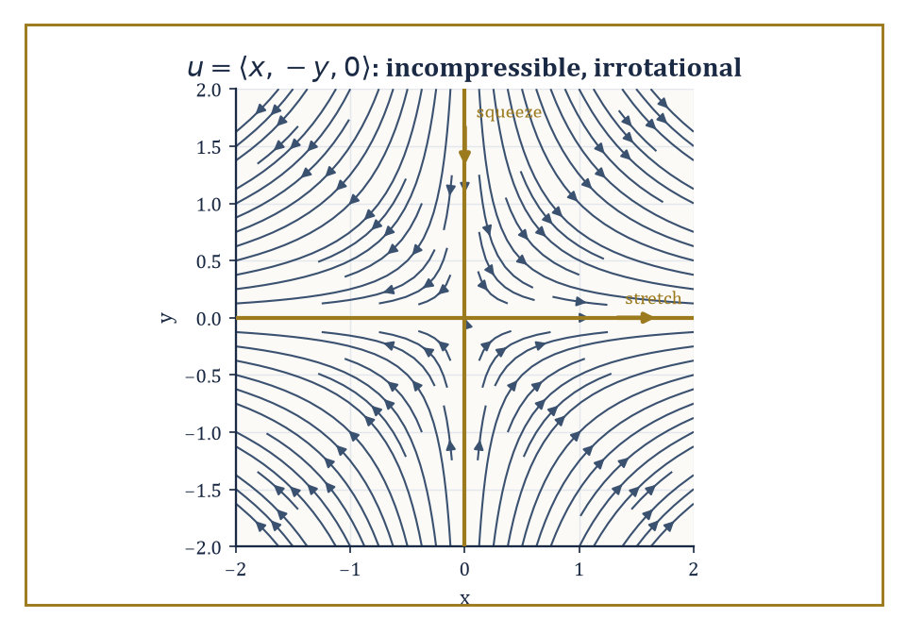
The straining flow u = ⟨x, −y, 0⟩: streamlines stretching fluid along the x-axis and squeezing it along the y-axis, all while quietly conserving volume.
The vorticity of the flow, curl u, measures the local spin of fluid parcels: whirlpools and eddies are precisely the regions where vorticity is large.
Euler's equations (for an ideal, frictionless fluid) and the Navier–Stokes equations (which add viscosity) are, at their core, statements about how these divergence and curl properties of u evolve in time under the influence of pressure and external forces — a great deal of hard-won physics, when you strip away the notation, for the simple observation that fluid is not allowed to teleport.
Abstract example — Worked example: an incompressible, irrotational flow. Let u = ⟨x, −y, 0⟩, a simple 'straining' flow, stretching fluid along the x-axis while squeezing it along the y-axis, like dough being rolled in one direction and compressed in the perpendicular one.
Check incompressibility:
div u = 1 + (−1) + 0 = 0
confirmed: this flow conserves fluid volume even while dramatically reshaping it.
Check vorticity, with P=x, Q=−y, R=0:
curl u = ⟨0−0, 0−0, 0−0⟩ = ⟨0,0,0⟩
The flow is also irrotational; it stretches and squeezes fluid parcels but never spins them. Contrast this with the rotation field of Room 15.1, which was incompressible but maximally rotational: two flows, both volume-preserving, doing entirely different things to a small blob of dye dropped into them.
In electromagnetism, Maxwell's equations relate the divergence and curl of the electric field E and magnetic field B to the charge density and current density that generate them. Their integral forms — Gauss's law for electricity and magnetism, and the Maxwell–Faraday and Ampère–Maxwell laws — are precisely the divergence theorem and Stokes' theorem, respectively, applied to E and B.
This is not an analogy or a loose resemblance; the integral and differential forms of Maxwell's equations are literally the same physical laws, related to each other by exactly the theorems of Room 15.6.
Numeric example — Worked example: Gauss's law for a point charge. Take a point charge q = 2 at the origin, choosing units in which Coulomb's constant k = 1, purely for arithmetical tidiness, producing an electric field directed radially outward, of magnitude:
|E| = kq/R² = q/R²
at distance R. On a sphere of radius R = 3 centred at the charge:
|E| = 2/9
at every point of the sphere, directed along the outward normal, so E · n = 2/9 everywhere on it. The flux through the sphere is therefore:
|E| × (surface area) = (2/9) × 4π(3)² = (2/9) × 36π = 8π
Gauss's law predicts this flux should equal:
4πkq = 4π(1)(2) = 8π
The two agree, and note that R dropped out of the final answer entirely — the flux through any sphere centred on the charge is the same 8π regardless of its radius, because the field weakens by exactly the same factor (1/R²) as the sphere's area grows (by R²), and the two effects cancel perfectly.
This cancellation is the entire content of the inverse-square law, restated as a flux computation.
In gravitation and electrostatics alike, the field is the gradient of a scalar potential (Newtonian potential or electrostatic potential respectively), and that potential satisfies Poisson's equation:
∇²φ = −ρ
up to constants depending on convention, where ρ is the mass or charge density generating the field.
Away from any mass or charge — in the vacuum — this becomes Laplace's equation:
∇²φ = 0
and functions satisfying it are called harmonic: they have the pleasant property, already hinted at when we discussed the Laplacian in Room 15.2, of having no local dips or bumps relative to their neighbours anywhere in the vacuum region.
Worked example — Worked example: Laplace's equation for the 1/r potential. The potential of a point mass (or charge) at the origin is proportional to f = 1/r, where r = √(x²+y²+z²). Differentiating, from the chain rule applied to (x²+y²+z²)^(−1/2):
∂f/∂x = −x/r³
and a second differentiation gives:
∂²f/∂x² = −1/r³ + 3x²/r⁵
with matching expressions for y and z by symmetry. Summing:
∇²f = −3/r³ + 3(x²+y²+z²)/r⁵ = −3/r³ + 3r²/r⁵ = −3/r³ + 3/r³ = 0
Laplace's equation holds everywhere except at the singular point r=0 itself, exactly as advertised.
As a numerical check, evaluate the x-term at the point (1,1,1), where r² = 3, r = √3, r³ = 3√3, r⁵ = 9√3:
∂²f/∂x² = −1/(3√3) + 3(1)/(9√3) = −1/(3√3) + 1/(3√3) = 0
By the symmetry of x=y=z=1, the y- and z-terms vanish identically too, and the sum is 0, matching the general result.

Room 15.9: Looking Ahead: Differential Forms, Manifolds, and Beyond
One Derivative to Rule Them All
We have now assembled the classical apparatus of vector calculus in full: the three differential operators, the three integral theorems that relate them to boundaries, potential theory, and the leading physical applications that make all of it worth doing.
It is a formidable toolkit, and also — let us be honest with each other, this deep into the Tower — a slightly untidy one. Gradient, divergence, and curl are three different operators, defined by three different formulas, obeying three different-looking product rules, and Green's, Stokes', and the divergence theorem look, on first meeting, like three unrelated theorems that happen to share a family resemblance.
They are not three unrelated theorems. The modern language that reveals this is the calculus of differential forms, in which the gradient, divergence, and curl all become special cases, in dimension three, of a single operator called the exterior derivative, usually written d.
Green's theorem, Stokes' theorem, and the divergence theorem all become special cases of a single generalized Stokes' theorem, valid on manifolds of any dimension whatsoever:
∫_M dω = ∫_(∂M) ω
Later storeys on differential geometry and manifolds will build this language properly. For now, a single small taste is worth the detour.
Abstract example — Worked example: the exterior derivative recovers the gradient. In the language of forms, a scalar field f is called a 0-form, and its exterior derivative df is defined as:
df = (∂f/∂x) dx + (∂f/∂y) dy + (∂f/∂z) dz
Take f(x,y,z) = xyz: then:
∂f/∂x = yz, ∂f/∂y = xz, ∂f/∂z = xy
so:
df = yz dx + xz dy + xy dz
Strip away the dx, dy, dz 'basis labels' and read off the coefficients in order — (yz, xz, xy) — and you have recovered exactly ∇f, the ordinary gradient, computed by exactly the same partial derivatives as always.
The exterior derivative of a 0-form is the gradient; applied to a suitably encoded vector field (a 1-form) it becomes the curl; applied again (to a 2-form) it becomes the divergence. One operator, one rule (d² = 0, which is the forms-language version of curl(grad f) = 0 and div(curl F) = 0 simultaneously), infinitely reusable in any number of dimensions.
Three operators were, it turns out, always secretly one operator wearing three different disguises appropriate to three different low-dimensional situations — rather like discovering, late in a long-running detective novel, that three seemingly unrelated suspects were the same person in three different hats.
None of this retires the classical apparatus. Working engineers, physicists, and most working mathematicians continue to write ∇·, ∇×, and ∇ rather than d, for the excellent reason that the classical notation is faster to compute with and carries physical intuition — expansion, rotation, uphill — that the more austere forms language deliberately strips away in exchange for its generality.
Mastery of gradient, divergence, curl, and the three integral theorems remains, in the driest possible sense, permanent intellectual capital: the sort of thing that keeps paying dividends long after the fashionable unifying framework of the decade has been superseded by the next one.
Vector calculus, then, is both a culmination and a threshold. It completes the classical calculus sequence that began, many storeys ago, with the slope of a single tangent line, and carries it all the way to the global conservation laws that govern fluids, fields, and the stresses inside solid bodies — a rather long way to travel from 'the slope of a line', and worth pausing on for a moment before we move on.
It is also, we now know, a threshold: the classical operators and theorems of this storey are the low-dimensional shadow of a single, more austere piece of machinery — the exterior derivative and the generalized Stokes theorem — waiting further up the Tower for the storeys on differential geometry and manifolds.
The next storey, however, takes a rather different turn. Series — Taylor's, Fourier's, and their relatives — trade the geometry of fields in space for the more arithmetical business of approximating an awkward function by an infinite, well-behaved sum of simple pieces: polynomials in Taylor's case, sines and cosines in Fourier's. It is a shift from 'what does this field do' to 'what is this function secretly made of', and after a storey spent worrying about orientations, boundaries, and the fine print of simple connectivity, there is something almost restful about an infinite sum. Almost.
The fields have learned to differentiate and integrate. The Tower continues upward.

Storey 16: Series
Taylor, Fourier, Power Series, and the Art of Approximating the Infinite by the Finite
We have just come down from a storey thick with arrows — gradients pointing uphill, curls spinning as though something has gone briefly wrong with the plumbing, divergence theorems solemnly reassuring us that whatever leaves a region is exactly what was produced inside it. Vector calculus, for all its cross products and its suspiciously convenient boundary terms, was fundamentally about one finite, well-behaved object: a field, living on a region, obeying a handful of theorems that all turn out, on inspection, to be the same theorem wearing different coats. This storey is not like that. This storey is about infinity, deployed responsibly.
A series is simply an infinite sum: a₁ + a₂ + a₃ + …, an addition problem that never finishes, handed to you anyway as though it might. The entire discipline exists to answer one deceptively small question: does it add up to something? Sometimes yes, gloriously and computably. Sometimes no, and the refusal turns out to be just as informative. And sometimes — this is the part that would keep an analyst up at night, if analysts slept — the answer depends on the order in which you insist on adding the terms, which ought to be against the rules and, for a while, appears not to be.
There are two great families waiting in this storey. Power series, built from powers of (x − a), let us replace a complicated smooth function with a polynomial of arbitrarily high degree — the Taylor series being the family's most famous member, the one that gets its photograph on the syllabus. Fourier series do something stranger, and in its own way more useful: they replace a periodic function — a heartbeat, a sound wave, a swinging pendulum — with an infinite chord of sines and cosines, each one a pure frequency, combined in exactly the right proportions to reconstruct the original signal. One expansion is about smoothness; the other is about rhythm. Both convert a stubborn analytic object into a list of numbers, its coefficients, which can be computed, estimated, and reasoned about far more easily than the object itself.
A small confession, since we are all friends by storey sixteen: series are where analysis first starts treating infinity as a practical, load-bearing idea rather than a philosophical embarrassment. You write down an expression with no last term, and then — this is the entire trick — you prove that the finite partial sums, the ones you can actually compute, settle down and stop moving. The leap of faith is not really a leap; it is fully underwritten by estimates on how far a partial sum can still be from the truth. Those estimates, the remainders, are the real content of the subject; everything else is bookkeeping, tastefully arranged. If calculus taught us to differentiate and to integrate, series teach us to expand and to approximate — and two storeys from now, once we have had our fill of trigonometric coefficients, we will take the periodic assumption away entirely and let Fourier's idea loose on the whole real line, where it becomes the Fourier transform. That is a storey for later. For now: let's sum to infinity, carefully.

Room 16.1: What a Series Actually Is
In which adding forever turns out to have rules
A series is an expression a₁ + a₂ + a₃ + …, and the whole subject rests on one small act of cowardice we perform to avoid actually adding infinitely many numbers: we look at the partial sums instead.
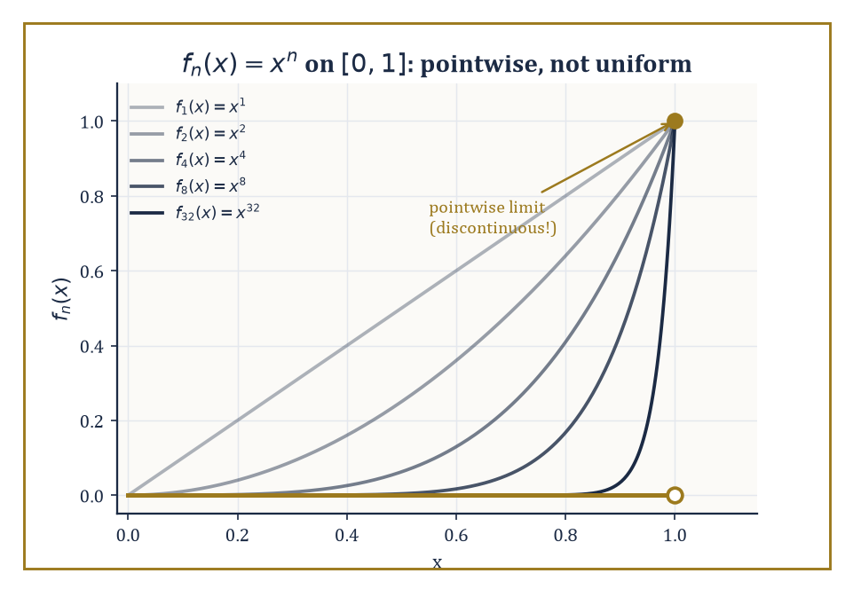
fₙ(x) = xⁿ converges to 0 at every point short of x = 1 — pointwise, obediently, and without ever agreeing to do it at a uniform rate.
sₙ = a₁ + a₂ + … + aₙ
This n-th partial sum is a perfectly ordinary finite number, computable in a perfectly ordinary finite amount of time. The series is then said to converge to S if the sequence s₁, s₂, s₃, … converges to S in the ordinary sequence sense; otherwise the series diverges.
This is not a new kind of limit dressed up to look impressive — it is exactly the limit machinery of sequences, applied to a sequence we happen to have built by repeated addition. Everything we already know about convergent sequences — uniqueness of the limit, the algebra of limits, the Cauchy criterion — transfers over immediately, which is one of the more comforting facts in analysis.
Numeric example — Worked example — a geometric series and its remainder. Consider the series formed by adding successive tenths of 3, i.e. Σ 3·(1/10)ⁿ for n = 0, 1, 2, …:
S = 3 + 0.3 + 0.03 + 0.003 + …
The partial sums are:
s₁ = 3, s₂ = 3.3, s₃ = 3.33, s₄ = 3.333
In general:
sₙ = 3.33…3 (n threes) = 10/3 − (1/3)·(1/10)ⁿ⁻¹
As n → ∞ the correction term shrinks to nothing, so the partial sums converge to the familiar repeating decimal:
sₙ → 10/3 = 3.333…
The remainder after four terms is:
R₄ = S − s₄ = 10/3 − 3.333 = 0.000333…
You can check directly that this equals the 'rest of the series':
0.0003 + 0.00003 + … = 3·(1/10)⁴/(1 − 1/10) = 0.0003/0.9 = 0.000333…
This is the whole game in miniature: a partial sum you can actually write down, plus a remainder you can bound, adding up to a limit you never quite reach but can approximate as closely as you like.
Absolute convergence means that the series of absolute values, Σ|aₙ|, converges. This is a strictly stronger demand than ordinary ('conditional') convergence, and it buys something valuable: an absolutely convergent series can be rearranged — its terms shuffled into any order whatsoever — without changing the sum.
Ordinary convergence offers no such guarantee, and the next room contains a genuinely unsettling example of what goes wrong when you rely on it anyway.
Numeric example — Worked example — an absolutely convergent alternating series. Take the series:
Σ (−1)ⁿ⁻¹/n² = 1 − 1/4 + 1/9 − 1/16 + …
Its series of absolute values is Σ1/n², which converges (we will confirm this properly with the integral test in the next room), so the original series converges absolutely.
The partial sums are:
s₁ = 1, s₂ = 0.75, s₃ = 0.75 + 0.1111 = 0.8611, s₄ = 0.8611 − 0.0625 = 0.7986, s₅ = 0.7986 + 0.04 = 0.8386
These values are visibly oscillating but visibly settling. The true value is a named constant, π²/12 ≈ 0.822467 (a close cousin of the more famous Σ1/n² = π²/6, which we will meet again before this storey ends).
Because the convergence here is absolute, you may add these terms in any order you fancy — leaves-of-a-tree order, if you like — and still land on π²/12.
Everything above concerned series of numbers. A function series is a series whose terms are themselves functions, Σ fₙ(x), and now there are two flavours of convergence to keep straight.
Pointwise convergence asks, for each individual x, that the numerical series Σ fₙ(x) converge — a separate, private negotiation at every point of the domain.
Uniform convergence is the more demanding and more useful notion: it asks that the rate of convergence not depend on x, that one tail estimate work simultaneously across the whole domain.
Uniform convergence is worth the extra effort because it preserves continuity of the limit, and — under mild further hypotheses — it licenses differentiating or integrating the series term by term, which is usually the entire point of writing the series down in the first place.
Abstract example — Structural example — pointwise without uniform. Let fₙ(x) = xⁿ on the interval [0, 1]. For each fixed x in [0, 1), the numbers xⁿ shrink to 0, so fₙ(x) → 0.
At x = 1, fₙ(1) = 1 for every n, so fₙ(1) → 1.
The pointwise limit function is therefore f(x) = 0 for x < 1 and f(1) = 1 — a function with a jump, glued together from infinitely many perfectly smooth, perfectly continuous functions xⁿ.
Since a uniform limit of continuous functions is always continuous (a theorem worth memorising precisely because it is so useful in the contrapositive), and our limit f is not continuous, the convergence here cannot be uniform.
Nothing went wrong; this is simply what pointwise convergence is allowed to do when nobody is enforcing a uniform rate.
The practical power of all this lies in approximation. A partial sum is a finite object you can compute on a calculator, a computer, or the back of an envelope; the remainder tells you the price you pay for stopping early.
Controlling that remainder — bounding it, shrinking it, choosing exactly how many terms are 'enough' — is the central technical task of the whole subject, and it is the thread that runs through convergence tests, Taylor's theorem, and Fourier analysis alike.
Every worked example in this storey is, underneath the notation, an exercise in exactly that.

Room 16.2: Numerical Series: Convergence Tests
A field guide to things that do, and do not, add up
Deciding whether Σaₙ converges is, in general, hard — hard enough that mathematicians have assembled a small arsenal of tests, each suited to a different shape of term.
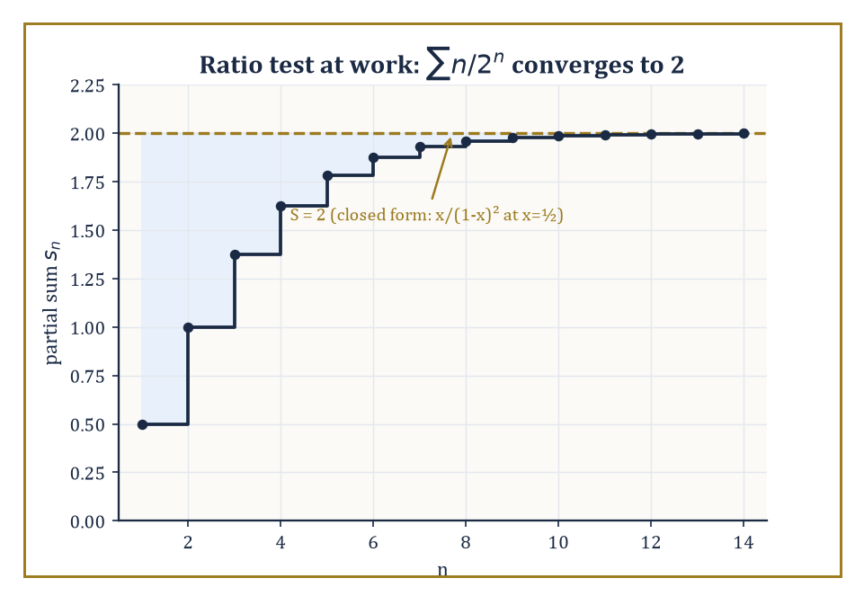
The partial sums of Σ n/2ⁿ climb the staircase the ratio test promised, settling in on 2 and never overshooting.
The comparison test says that if 0 ≤ aₙ ≤ bₙ and Σbₙ converges, then Σaₙ converges too (and, run backwards, that if Σaₙ diverges then so does the larger Σbₙ).
The limit-comparison test relaxes this to aₙ/bₙ → L for some finite positive L, which is often easier to check.
The ratio test looks at the limit of |aₙ₊₁/aₙ|: if it is less than 1 the series converges absolutely, if greater than 1 it diverges, and if exactly 1 the test simply shrugs and declines to comment.
Numeric example — Worked example — the ratio test. Take Σ n/2ⁿ for n = 1, 2, 3, …. The ratio of consecutive terms is:
aₙ₊₁/aₙ = [(n+1)/2ⁿ⁺¹] / [n/2ⁿ] = (n+1)/(2n)
This ratio tends to 1/2 as n → ∞. Since 1/2 < 1, the series converges absolutely.
In fact this series has a closed form — it is a standard identity that:
Σ n xⁿ = x/(1−x)², for |x| < 1
At x = 1/2 this gives:
(1/2)/(1/2)² = (1/2)/(1/4) = 2
Check it against partial sums:
s₁ = 0.5, s₂ = 0.5 + 0.5 = 1.0, s₃ = 1.0 + 0.375 = 1.375, s₄ = 1.375 + 0.25 = 1.625, s₅ = 1.625 + 0.15625 = 1.78125, s₆ = 1.78125 + 0.09375 = 1.875
These partial sums climb steadily toward 2, exactly as the ratio test promised it would settle down, and exactly as the closed form confirms it must.
The root test asks instead for the limit of |aₙ|^(1/n): less than 1 means convergence, greater than 1 means divergence, and 1 again means no verdict.
It is especially well suited to terms that already come dressed as n-th powers — which, not coincidentally, is exactly the shape a power series coefficient takes, so this test will do most of the heavy lifting when the radius of convergence appears in the next room.
Numeric example — Worked example — the root test. Take Σ (n/(2n+1))ⁿ. Here:
|aₙ|^(1/n) = n/(2n+1) → 1/2, as n → ∞
(Divide top and bottom by n to see it: 1/(2 + 1/n) → 1/2.) Since 1/2 < 1, the series converges.
The individual terms confirm the decay is fast:
a₁ = (1/3)¹ ≈ 0.3333, a₂ = (2/5)² = 0.16, a₃ = (3/7)³ ≈ 0.0787, a₄ = (4/9)⁴ ≈ 0.0390
Each term is comfortably smaller than the last, well before the limiting ratio of 1/2 has fully kicked in, and the partial sums settle to a finite value with no drama at all.
The integral test compares a series of positive, decreasing terms to the improper integral of the corresponding function: Σaₙ converges exactly when ∫f(x)dx converges, where f(n) = aₙ.
It is the tool of choice for the borderline p-series Σ1/nᵖ and its logarithmic cousins, and it is where the harmonic series first reveals its bad manners.
Numeric example — Worked example — the integral test on two p-series. For Σ1/n² compare to the integral:
∫₁^∞ dx/x² = [−1/x]₁^∞ = 0 − (−1) = 1
This is a finite value, so the series converges (its exact sum, famously, is π²/6 ≈ 1.644934 — the Basel problem, and we have not seen the last of it).
For Σ1/n compare to the integral:
∫₁^∞ dx/x = [ln x]₁^∞
This diverges to infinity because ln x has no ceiling. The harmonic series therefore diverges, despite its terms shrinking to zero — a fact every student meets once and never quite recovers from.
The dividing line sits exactly at p = 1: any exponent above it converges, any exponent at or below it diverges.
The alternating-series test (Leibniz's test) covers series whose terms alternate in sign and decrease in absolute value to zero: such a series always converges, and — usefully — the error after truncating is never larger than the size of the first omitted term.
This is what lets us distinguish absolute convergence from the merely conditional kind: the alternating harmonic series Σ(−1)ⁿ⁺¹/n converges by Leibniz's test, even though the harmonic series of absolute values does not.
Rearrangement theorems then deliver the genuinely alarming punchline: a conditionally convergent series can be reordered to converge to any real number you like, or to diverge entirely, simply by choosing which terms to add when.
Absolute convergence is what restores the ordinary schoolbook freedom to add things in whatever order is convenient.
Numeric example — Worked example — Leibniz's test in action. For the alternating harmonic series:
Σ(−1)ⁿ⁺¹/n = 1 − 1/2 + 1/3 − 1/4 + …
the partial sums are:
s₁ = 1, s₂ = 0.5, s₃ = 0.8333, s₄ = 0.5833, s₅ = 0.7833, s₆ = 0.6167, s₇ = 0.7595
These values are visibly oscillating, each one landing between its two predecessors. The true sum is ln 2 ≈ 0.693147.
Leibniz's error bound says |S − sₙ| ≤ aₙ₊₁; check n = 6:
|0.693147 − 0.6167| = 0.0765, and a₇ = 1/7 ≈ 0.1429
Indeed 0.0765 < 0.1429. The series converges, but conditionally: strip the signs away and you are left with the divergent harmonic series, so this convergence is entirely a gift of cancellation, not of decay.
Abstract example — Structural example — rearranging to order. Riemann's rearrangement theorem is best understood by watching it work. The alternating harmonic series has a divergent positive part (1 + 1/3 + 1/5 + … diverges to +∞) and a divergent negative part (−1/2 − 1/4 − 1/6 … diverges to −∞).
To force the rearranged series toward a target value L — say L = 1 — proceed greedily: add positive terms 1, 1/3, 1/5, … until the running total first exceeds 1; then add negative terms −1/2, −1/4, … until the running total first drops back below 1; then resume adding unused positive terms until it exceeds 1 again, and so on forever.
Because the positive terms alone sum to infinity, you can always find enough of them to push the total back above L; because the negative terms alone sum to negative infinity, you can always find enough of them to pull it back below.
The overshoots and undershoots get smaller each pass, since the individual terms 1/n shrink to zero, so the running total is squeezed ever closer to L.
The same construction, aimed at any other target, or aimed at no target at all, produces a rearrangement that diverges. The terms never changed; only the order did.
None of this is idle classification. These tests measure exactly how fast terms must decay for an infinite sum to be meaningful at all.
That same decay-rate bookkeeping is precisely what will let us pin down a power series' radius of convergence, bound a Taylor remainder, and justify swapping a sum with an integral or a derivative — every one of which is coming up before this storey is out.

Room 16.3: Power Series and Radius of Convergence
Every power series owns a comfortable disk, and declines to discuss the edge
A power series centred at a is an expression Σ cₙ(x − a)ⁿ — a polynomial, in spirit, that never stops.
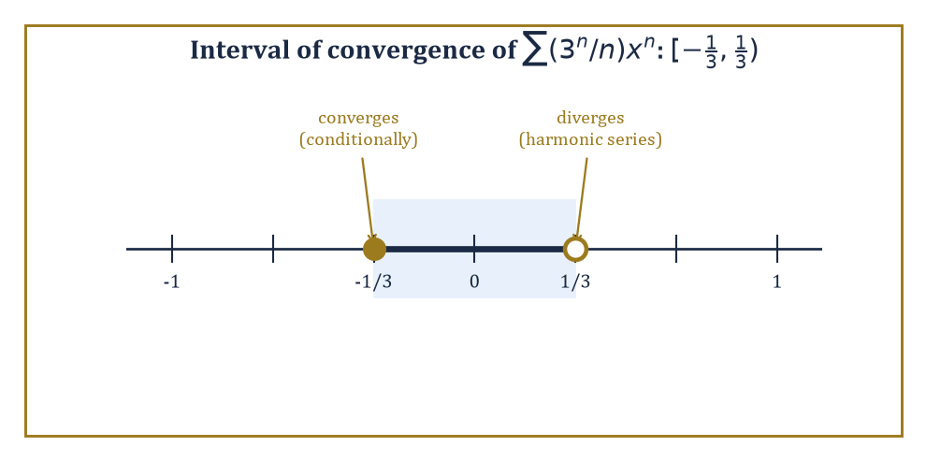
Σ(3ⁿ/n)xⁿ converges on [−1/3, 1/3) — a radius that is perfectly symmetric right up until you actually check the endpoints.
Fix any particular x, and it becomes an ordinary numerical series of the kind we spent the last room dissecting; ask for which x it converges, and the answer is always strikingly tidy: an interval centred at a, called the interval of convergence, whose half-width R is the radius of convergence.
R can be 0 (the series converges only at the single point x = a), finite, or infinite (the series converges everywhere).
The radius is read directly off the coefficients, using exactly the ratio and root tests from the previous room:
1/R = lim|cₙ₊₁/cₙ| or 1/R = limsup|cₙ|^(1/n)
whichever limit is easier to compute. Inside the open interval (a − R, a + R) the series converges absolutely; outside it, the terms do not even shrink to zero, so it diverges outright.
On the two endpoints, x = a ± R, both formulas go silent — the ratio or root tends to exactly 1 — and the endpoints have to be checked by hand, one at a time, using whichever test from the previous room is willing to help.
Numeric example — Worked example — a radius with an asymmetric endpoint. Consider Σ (3ⁿ/n) xⁿ for n = 1, 2, 3, …, so cₙ = 3ⁿ/n. The ratio is:
|cₙ₊₁/cₙ| = [3ⁿ⁺¹/(n+1)] / [3ⁿ/n] = 3n/(n+1) → 3, as n → ∞
So 1/R = 3, giving R = 1/3. Now check the endpoints by substituting directly.
At x = 1/3, the n-th term is:
(3ⁿ/n)(1/3)ⁿ = (3 · 1/3)ⁿ/n = 1ⁿ/n = 1/n
and Σ1/n is the harmonic series — divergent.
At x = −1/3, the n-th term is:
(3ⁿ/n)(−1/3)ⁿ = (−1)ⁿ/n
and Σ(−1)ⁿ/n converges conditionally by Leibniz's test (it is, up to an overall sign, the alternating harmonic series again).
So the full interval of convergence is [−1/3, 1/3) — closed on the left, open on the right, a genuinely asymmetric boundary that no amount of squinting at the formula for R alone would have revealed. This is why the endpoints always require a separate, individual trial: the radius formula cannot see them.
Numeric example — Worked example — three flavours of endpoint. A quick gallery, for contrast.
Σ xⁿ/n² has R = 1 (ratio n²/(n+1)² → 1), and at both endpoints x = ±1 the series is Σ±1/n² or Σ1/n², absolutely convergent by the p = 2 integral test — so the interval is the fully closed [−1, 1].
Σ nⁿxⁿ has cₙ = nⁿ, and |cₙ|^(1/n) = n → ∞, so 1/R = ∞ and R = 0: the series converges only at the single point x = 0, and is otherwise useless as a function.
Between these extremes sits the earlier example, converging on one side and not the other. A power series, in short, can hug its boundary tightly, reject it entirely, or embrace only half of it — and there is no substitute for checking.
One more subtlety about that boundary before we leave it alone: Abel's theorem promises that if a power series does converge at an endpoint, its sum there is exactly the limit of the sum function as x approaches that endpoint from inside the interval — the function does not develop some rogue, disconnected value right at the edge.
This is what licenses reading a convergent endpoint sum as 'the value of the function there', rather than as some unrelated number the series happens to add up to.
Numeric example — Worked example — Abel's theorem cashing in a boundary sum. The Maclaurin series for ln(1+x) has radius R = 1:
ln(1+x) = x − x²/2 + x³/3 − x⁴/4 + …
At the right endpoint x = 1 it becomes the alternating harmonic series:
1 − 1/2 + 1/3 − 1/4 + …
which Room 16.2 already showed converges (conditionally) to ln 2 ≈ 0.693147 by Leibniz's test.
Abel's theorem guarantees this is not a coincidence: since the series converges at x = 1, its sum there must equal:
limₓ→1⁻ ln(1+x) = ln 2
the same ln 2, arrived at from two different directions, precisely because the theorem forbids the series from disagreeing with the function it approximates right up to a convergent edge.
Inside its interval of convergence, a power series does not merely converge — it defines an honest function, and that function turns out to be infinitely differentiable there, with derivatives obtainable by differentiating the series term by term (a fact that needs uniform convergence on compact sub-intervals to justify properly, which the theory duly supplies).
Evaluate enough of those derivatives at the centre a, and the coefficients fall out:
cₙ = f⁽ⁿ⁾(a)/n!
This single formula is the bridge to the next room — it says that if a function happens to be the sum of some power series, that power series was forced to be a very particular one, built entirely from the function's own derivatives at the centre.
Abstract example — Structural example — recovering coefficients from derivatives. Suppose:
f(x) = Σ cₙxⁿ = c₀ + c₁x + c₂x² + c₃x³ + …
for x in some interval around 0. Evaluate at x = 0: every term with a positive power of x vanishes, leaving f(0) = c₀.
Differentiate once, term by term:
f′(x) = c₁ + 2c₂x + 3c₃x² + …
and evaluate at 0: f′(0) = c₁.
Differentiate again:
f″(x) = 2c₂ + 6c₃x + …
so f″(0) = 2c₂, i.e. c₂ = f″(0)/2!.
One more round:
f‴(x) = 6c₃ + 24c₄x + …
so f‴(0) = 6c₃ = 3!c₃, i.e. c₃ = f‴(0)/3!.
The pattern is now unmistakable and easy to prove by induction: each differentiation multiplies the surviving constant term by the next integer, so after k differentiations the constant term is k! · cₖ, giving:
cₖ = f⁽ᵏ⁾(0)/k!, for every k
Nothing here used any specific function — it is a purely structural fact about power series, and it is exactly the formula the next room promotes to a definition.

Room 16.4: Taylor and Maclaurin Series
Turning a function into the polynomial it always secretly wanted to be
The Taylor series of a smooth function f about a point a is the power series:
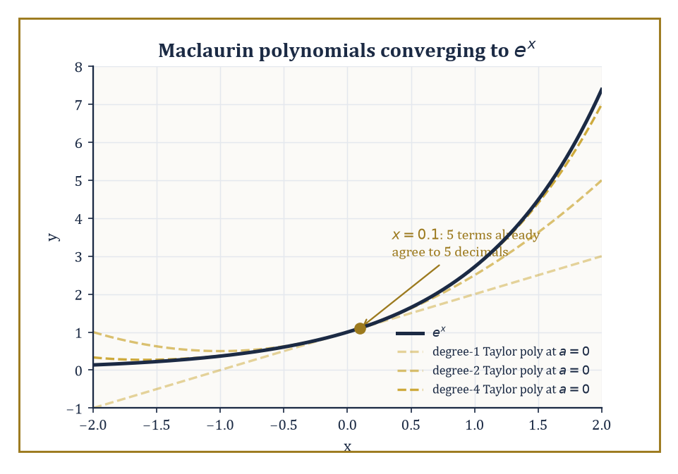
Degree by degree, the Maclaurin polynomials hug eˣ ever more tightly near the origin — and by x = 0.1 they have already all but arrived.
Σ [f⁽ⁿ⁾(a)/n!](x − a)ⁿ
precisely the coefficients the previous room forced upon us, built entirely from the derivatives of f at a. When a = 0 it goes by the friendlier name Maclaurin series.
If this series actually converges to f(x) itself, for x in some neighbourhood of a, we say f is analytic at a — a strong and slightly demanding compliment, not automatically earned by mere smoothness.
Numeric example — Worked example — the Maclaurin series for eˣ near x = 0.1. The Maclaurin series for eˣ is:
eˣ = Σ xⁿ/n! = 1 + x + x²/2! + x³/3! + x⁴/4! + …
It converges to eˣ for every real x (radius of convergence infinite). At x = 0.1, the terms are:
term 0 = 1, term 1 = 0.1, term 2 = 0.01/2 = 0.005, term 3 = 0.001/6 ≈ 0.0001667, term 4 = 0.0001/24 ≈ 0.0000042
The running total is:
1, 1.1, 1.105, 1.1051667, 1.1051708
The true value is e^0.1 = 1.10517091808…, so after just five terms (through x⁴) the approximation is accurate to about five decimal places.
Each new term visibly shrinks the gap by roughly a factor of ten, which is exactly what you would expect from a series whose terms behave like (0.1)ⁿ/n! for a radius-infinite function.
Here is the demanding compliment made concrete: not every infinitely differentiable function is analytic. There exist perfectly smooth, nonzero functions whose Taylor series at some point is identically the zero series — a series that converges everywhere, just not to the function that produced it.
For the elementary functions we actually use day to day, though, the news is good: eˣ, sin x, and cos x are analytic everywhere (infinite radius); ln(1+x), arctan x, and algebraic functions with singularities are analytic only out to the distance of their nearest bad behaviour, giving a finite radius.
Abstract example — Structural example — a smooth function with a lying Taylor series. Define f(x) = e^(−1/x²) for x ≠ 0 and f(0) = 0.
As x → 0, 1/x² races off to +∞, so e^(−1/x²) races down to 0 — and it does so faster than any power of x can keep up, because exponential decay always beats polynomial growth in the long run.
Each derivative of f, computed away from 0 by the chain rule, turns out to be some rational function of 1/x multiplied by e^(−1/x²); since the exponential factor crushes any polynomial-in-1/x factor as x → 0, every derivative also tends to 0 there.
A short induction confirms f⁽ⁿ⁾(0) = 0 for every n ≥ 0. Plug these all-zero derivatives into the Taylor formula and the series is:
0 + 0x + 0x² + …
identically zero, converging (trivially) to the constant function 0 everywhere. But f(x) is strictly positive for every x ≠ 0.
The Taylor series exists, converges, and is simply describing the wrong function. This is precisely why 'smooth' and 'analytic' are different words.
The Lagrange and integral forms of the remainder rescue the situation for practical purposes by quantifying exactly how wrong a truncated Taylor series is allowed to be.
The Lagrange form states that the error after the degree-n term equals:
f⁽ⁿ⁺¹⁾(ξ)/(n+1)! · (x−a)ⁿ⁺¹
for some (unknown, but existent) ξ between a and x — and even without knowing ξ exactly, one can usually bound f⁽ⁿ⁺¹⁾(ξ) over the whole interval and so bound the error outright.
This is the analytic engine behind every 'this many terms guarantees this much accuracy' claim in numerical computation.
Numeric example — Worked example — certifying the eˣ approximation with a remainder bound. Return to e^0.1 truncated after the x³ term (so n = 3, remainder governed by the 4th derivative). The Lagrange remainder is:
R₃ = e^ξ · (0.1)⁴/4!, for some ξ between 0 and 0.1
Since eˣ is increasing, e^ξ < e^0.1 < 1.2 comfortably, so:
|R₃| < 1.2 × 0.0001/24 ≈ 0.000005
Compare to the true error computed above:
|1.10517092 − 1.1051667| ≈ 0.0000042
This is safely under the certified bound of 0.000005, exactly as the theorem promised, and without needing to know e^0.1 in advance to say so.
Beyond eˣ, a short list of standard expansions does most of the working mathematician's heavy lifting.
sin x = x − x³/3! + x⁵/5! − …
cos x = 1 − x²/2! + x⁴/4! − …
Both of these have infinite radius of convergence.
ln(1+x) = x − x²/2 + x³/3 − …
arctan x = x − x³/3 + x⁵/5 − …
Both of these have radius 1, for reasons that become clear once you meet complex analysis and see where their nearest singularities sit.
(1+x)^α = 1 + αx + [α(α−1)/2!]x² + …
This binomial series reduces to the schoolbook binomial theorem when α is a positive integer, and becomes a genuinely infinite series otherwise.
Numeric example — Worked example — ln(1+x) at the edge of comfort. Take x = 0.5, so we are approximating ln(1.5). The terms are:
x − x²/2 + x³/3 − x⁴/4 + x⁵/5 − x⁶/6 + … = 0.5 − 0.125 + 0.041667 − 0.015625 + 0.00625 − 0.0026042 + …
Partial sums:
s₁ = 0.5, s₂ = 0.375, s₃ = 0.416667, s₄ = 0.401042, s₅ = 0.407292, s₆ = 0.404688
The true value is ln 1.5 = 0.405465…, so the error after six terms is about 0.000777.
Leibniz's bound (this series alternates and decreases) certifies the error is under the next term:
a₇ = (0.5)⁷/7 ≈ 0.001116
Indeed 0.000777 < 0.001116. Convergence here is noticeably slower than for eˣ at x = 0.1, because x = 0.5 is roughly half-way to the radius of convergence R = 1, whereas 0.1 was well inside eˣ's infinite one.
The closer you push toward the boundary of convergence, the more terms you must pay for the same accuracy — a foretaste of exactly the endpoint delicacy from the previous room.

Room 16.5: Operations on Power Series
What you are allowed to do to an infinite polynomial without a permit
Within their common interval of convergence, power series behave almost exactly like ordinary polynomials: they may be added term by term, differentiated term by term, integrated term by term, and multiplied together using the Cauchy product, in which the coefficient of xⁿ in the product is:
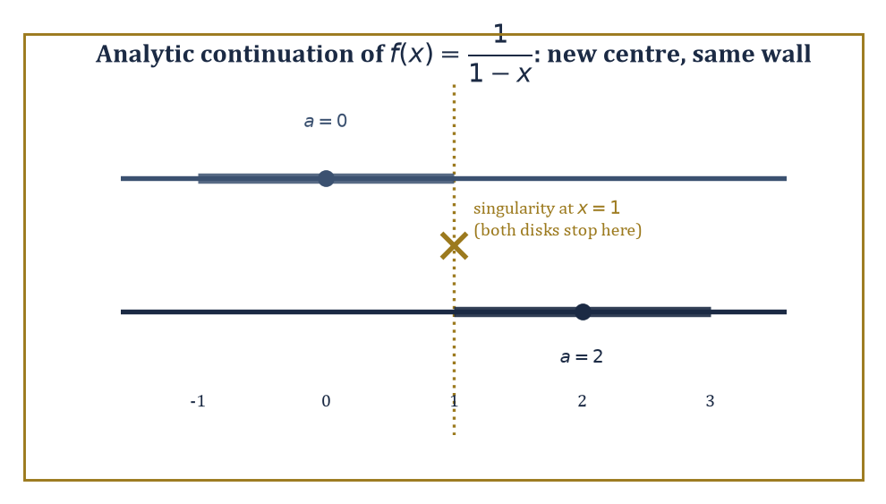
Re-centring at a = 2 opens up genuinely new territory for 1/(1−x) — but the singularity at x = 1 still pins both disks to the same wall.
Σₖ₌₀ⁿ aₖbₙ₋ₖ
This is precisely the rule you would get by multiplying out two long polynomials and collecting like powers. In every case, the resulting series converges (on the smaller of the two radii, at least) to the corresponding operation performed on the original sum functions.
Numeric example — Worked example — the Cauchy product of a geometric series with itself. Let:
f(x) = Σₙ₌₀^∞ xⁿ = 1/(1−x), for |x| < 1
Its Cauchy product with itself has coefficient of xⁿ equal to Σₖ₌₀ⁿ 1·1 = n+1, so:
f(x)² = Σₙ₌₀^∞ (n+1)xⁿ = 1/(1−x)²
At x = 0.5, the closed form gives:
1/(1−0.5)² = 1/0.25 = 4
The series gives terms (n+1)(0.5)ⁿ:
1, 1.0, 0.75, 0.5, 0.3125, 0.1875, 0.109375, 0.0625, …
with partial sums:
1, 2, 2.75, 3.25, 3.5625, 3.75, 3.859375, 3.921875
These sums climb steadily toward 4, confirming the two computations agree.
This term-by-term freedom is more than a convenience: it turns differential equations into recurrence relations for coefficients, letting you solve an ODE by guessing a power series solution and matching powers of x on both sides.
It is also the algebraic backbone of generating functions, which we will meet properly a little further along, and of the asymptotic expansions used to approximate functions that resist a clean closed form.
Abstract example — Structural example — solving f′ = f by power series. Suppose we do not yet know that f′(x) = f(x) with f(0) = 1 has solution eˣ, and want to find it by brute force. Guess:
f(x) = Σₙ₌₀^∞ cₙxⁿ
Differentiating term by term:
f′(x) = Σₙ₌₁^∞ n·cₙxⁿ⁻¹ = Σₘ₌₀^∞ (m+1)cₘ₊₁xᵐ
(relabelling m = n−1). Demanding f′(x) = f(x) forces the coefficients of each power of x to match:
(m+1)cₘ₊₁ = cₘ, for every m ≥ 0
i.e. the recurrence cₘ₊₁ = cₘ/(m+1). The initial condition f(0) = 1 gives c₀ = 1. Unrolling the recurrence:
c₁ = c₀/1 = 1, c₂ = c₁/2 = 1/2, c₃ = c₂/3 = 1/6
and in general cₙ = 1/n!.
The power series method has, entirely on its own, rediscovered:
f(x) = Σ xⁿ/n! = eˣ
exactly the Maclaurin series from the previous room, arrived at from the opposite direction.
Integration term by term is the differentiation trick run backwards, and it is often the more useful direction in practice, since it can manufacture a series for a function whose derivative you already know but whose own Maclaurin series you have not yet bothered to compute directly.
Numeric example — Worked example — integrating the geometric series. Since Σₙ₌₀^∞ tⁿ = 1/(1−t) for |t| < 1, integrate both sides from 0 to x term by term:
Σₙ₌₀^∞ xⁿ⁺¹/(n+1) = ∫₀^x dt/(1−t) = −ln(1−x)
Relabel m = n+1 to read this as:
x + x²/2 + x³/3 + … = −ln(1−x)
At x = 0.5, the right side is:
−ln(0.5) = ln 2 ≈ 0.693147
(That same constant, turning up for the third time this storey — it has rather a habit of doing that.)
The series gives terms:
0.5, 0.125, 0.041667, 0.015625, 0.00625, 0.0026042, …
with partial sums:
0.5, 0.625, 0.666667, 0.682292, 0.688542, 0.691146
These are closing in steadily on 0.693147, exactly as the closed form demands, and obtained here without ever having differentiated −ln(1−x) in the first place.
Analytic continuation is the technique of extending a function beyond its original disk of convergence by re-expanding its power series about a new centre, chosen so that the new disk of convergence reaches into territory the old one never touched.
What ultimately blocks continuation is a singularity — a point where the function genuinely misbehaves — sitting on the boundary of every disk that tries to avoid it; the distance to the nearest such singularity is, in fact, exactly what determines the radius of convergence in the first place.
Worked example — Worked example — continuing past a boundary without touching it. The function f(x) = 1/(1−x) has Maclaurin series Σxⁿ, converging only for x in (−1, 1), because of the singularity sitting at x = 1.
Re-expand about a = 2 instead: write x = 2 + t, so:
f = 1/(1 − 2 − t) = 1/(−1−t) = −1/(1+t) = −Σ(−t)ⁿ = Σ(−1)ⁿ⁺¹tⁿ, for |t| < 1, i.e. for x in (1, 3)
This new series, centred at 2, reaches values like x = 2.5 that the original series centred at 0 could never touch — genuine new territory, unlocked purely by re-expanding.
And yet both disks, (−1,1) and (1,3), still have their boundary pinned at x = 1: the singularity has not moved, and no clever re-centring anywhere in the real line will ever produce a disk that swallows it.
Analytic continuation extends the reach of a single power series representation; it cannot abolish the obstruction that limited the first one.
The upshot is that the formal algebra of power series — addition, multiplication, differentiation, re-centring — is simultaneously a hands-on computational toolkit and a window onto something deeper: the complex-analytic structure of the function being expanded, in which singularities are not embarrassments to be worked around but genuine geographical features that determine, in advance, exactly how far any given expansion is permitted to travel.
We will return to this picture properly once complex analysis enters the Tower.

Room 16.6: Fourier Series: The Basic Theory
Every rhythm is secretly a sum of pure tones
A Fourier series represents a periodic function as an infinite linear combination of sines and cosines — or, in the more compact complex notation, of complex exponentials — at harmonically related frequencies: the fundamental, twice the fundamental, three times it, and so on forever.
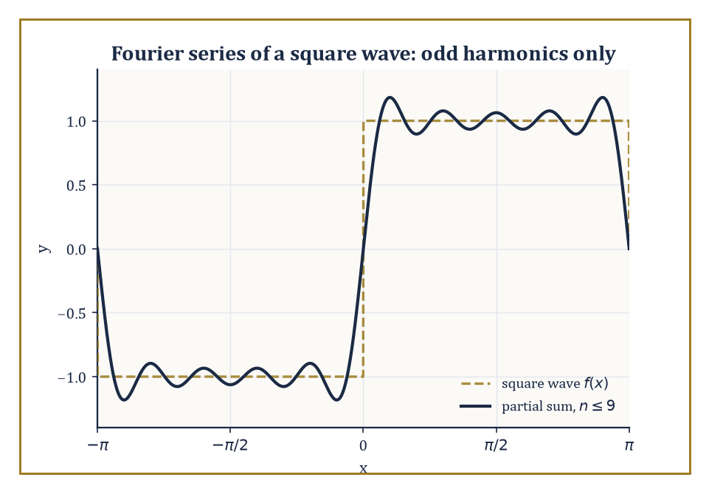
Nine odd harmonics are already enough to rough out the square wave, ripples and all.
For a function f of period 2π, the coefficients are extracted by the integrals:
aₙ = (1/π)∫f(x)cos(nx)dx, bₙ = (1/π)∫f(x)sin(nx)dx
each taken over one full period, with a₀ carrying a slight normalising adjustment (a factor of 1/2 by convention). In the complex form, the single family of coefficients is the integral of f(x)e^(−inx).
These formulas are not arbitrary; they are answers to the question 'how much of pure frequency n is present in f', extracted by a kind of averaging that we are about to see is really a projection.
Numeric example — Worked example — the Fourier coefficients of a square wave. Let f(x) = 1 for 0 < x < π and f(x) = −1 for −π < x < 0, extended with period 2π — the archetypal square wave.
Because f is an odd function (f(−x) = −f(x)) and cos(nx) is even, the product f(x)cos(nx) is odd, and the integral of an odd function over a symmetric interval is 0; so aₙ = 0 for every n.
For bₙ, f(x)sin(nx) is even (odd times odd), so:
bₙ = (2/π)∫₀^π sin(nx)dx = (2/π)[−cos(nx)/n]₀^π = (2/(nπ))[1 − cos(nπ)]
Since cos(nπ) = (−1)ⁿ, this bracket is 2 when n is odd and 0 when n is even. So bₙ = 4/(nπ) for odd n, and bₙ = 0 for even n.
Numerically:
b₁ = 4/π ≈ 1.27324, b₃ = 4/(3π) ≈ 0.42441, b₅ = 4/(5π) ≈ 0.25465
The odd harmonics alone, decaying like 1/n, carry the entire square wave.
These particular formulas fall out of one structural fact: the trigonometric functions {1, cos x, sin x, cos 2x, sin 2x, …} are orthogonal with respect to the L² inner product
⟨f,g⟩ = ∫f(x)g(x)dx
on one period — meaning the integral of the product of any two distinct members of the family is exactly zero.
Orthogonality is what turns the seemingly hard problem of finding the best mean-square approximation to f by a trigonometric sum into a sequence of completely independent one-dimensional projections, one frequency at a time, with no cross-talk between them.
This is precisely the same idea as projecting a vector onto a set of mutually perpendicular axes — a picture we will make fully explicit before this storey closes.
Numeric example — Worked example — verifying orthogonality directly. Check that sin(2x) and sin(3x) are orthogonal on [−π, π]. Using the product-to-sum identity sin A sin B = ½[cos(A−B) − cos(A+B)] with A = 2x, B = 3x:
sin(2x)sin(3x) = ½[cos(x) − cos(5x)]
Now:
∫₋π^π cos(x)dx = [sin x]₋π^π = sin π − sin(−π) = 0 − 0 = 0
∫₋π^π cos(5x)dx = [sin(5x)/5]₋π^π = (sin 5π − sin(−5π))/5 = 0
So the whole integral is ½[0 − 0] = 0, exactly as orthogonality demands.
The same product-to-sum trick proves it for every pair of distinct frequencies, which is why the coefficient formulas above could isolate a single aₙ or bₙ without any interference from the other terms in the sum.
The complex exponential form deserves a word of its own, since it is the version that survives into the next storey unscathed. Euler's formula lets every sine and cosine pair be repackaged as a single exponential:
e^(iθ) = cos θ + i sin θ
The complex coefficients cₙ relate to the real ones by:
cₙ = (aₙ − ibₙ)/2, for n > 0; c₋ₙ = conjugate of cₙ; c₀ = a₀/2
The payoff is not merely tidiness: a single formula
f(x) = Σcₙe^(inx)
with a single integral formula for cₙ, replaces the separate bookkeeping of aₙ and bₙ, and it is this exponential form — not the sines-and-cosines form — that generalises directly into the Fourier transform once periodicity is abandoned.
Numeric example — Worked example — converting the square wave's b₁ to complex form. For the square wave, a₁ = 0 and b₁ = 4/π, so:
c₁ = (0 − i·4/π)/2 = −i(2/π) ≈ −0.6366i, and c₋₁ = i(2/π) ≈ 0.6366i
(c₋₁ is the conjugate of c₁.) Reconstructing the first harmonic:
c₁e^(ix) + c₋₁e^(−ix) = −i(2/π)(cos x + i sin x) + i(2/π)(cos x − i sin x)
Expand: the cos x terms are:
−i(2/π)cos x + i(2/π)cos x = 0
and the sin x terms are:
−i(2/π)(i sin x) + i(2/π)(−i sin x) = (2/π)sin x + (2/π)sin x = (4/π)sin x
Total:
(4/π)sin x = b₁ sin x
This is exactly the real first harmonic from the earlier calculation, recovered intact from its two complex conjugate pieces, as it must be whenever f is real-valued.
Fourier series are the natural language of anything that repeats: a vibrating string, heat diffusing around a ring, the square waves of digital electronics, the frequency spectrum of any recurring signal.
There is even a pleasant physical parable hiding in the square-wave example above — a clarinet, whose bore is (roughly) closed at one end and open at the other, supports predominantly odd harmonics, which is structurally the same phenomenon we just computed (bₙ = 0 for even n), and it is a large part of why a clarinet and a violin playing the identical fundamental pitch still sound unmistakably different: the timbre lives entirely in the relative sizes of the higher coefficients.

Room 16.7: Convergence of Fourier Series and Applications
The series usually knows the answer, except exactly at the cliff edge
Pointwise convergence of a Fourier series is more delicate than for a Taylor series, but the rules are still clean for reasonably well-behaved (piecewise smooth) functions.
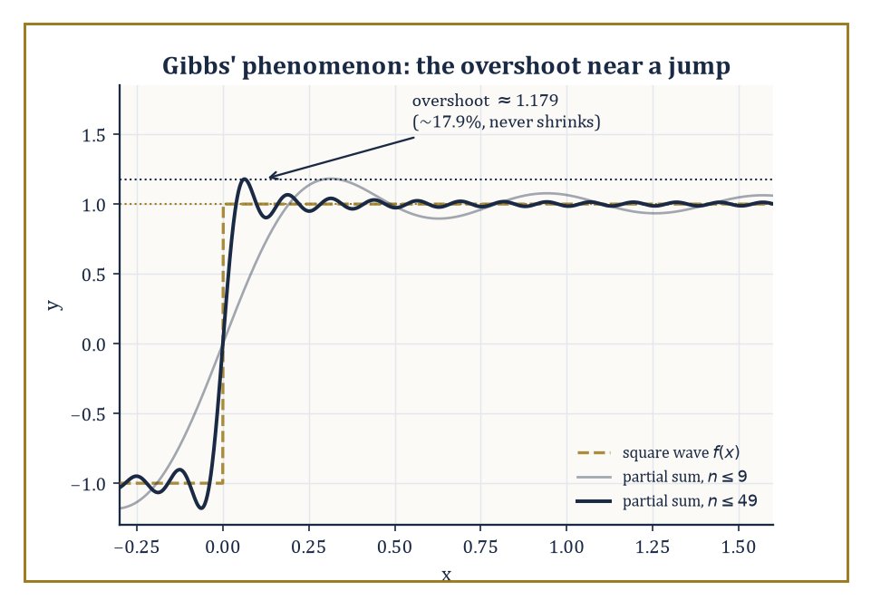
Add as many terms as you like — the overshoot near the jump settles at about 17.9% and simply refuses to shrink any further.
At a point where f is continuous, the series converges to f(x) itself. At a jump discontinuity, it converges instead to the average of the left-hand and right-hand limits — splitting the difference, in a very literal sense.
Uniform convergence, when it holds, requires f to be continuous and periodic with coefficients decaying fast enough to be summable outright.
Numeric example — Worked example — convergence at a continuity point, and at a jump. Return to the square wave from the previous room, with bₙ = 4/(nπ) for odd n. At x = π/2, a point of continuity (strictly between 0 and π), the partial sum is:
Sₙ(π/2) = (4/π)Σ_{k odd ≤ n} sin(kπ/2)/k
Since sin(π/2) = 1, sin(3π/2) = −1, sin(5π/2) = 1, sin(7π/2) = −1, …, the bracketed sum is exactly:
1 − 1/3 + 1/5 − 1/7 + … = π/4
(This is the Leibniz series.) So:
Sₙ(π/2) → (4/π)(π/4) = 1
This matches f(π/2) = 1 precisely, though the partial sums oscillate on the way there:
with 1, 3, 5, 7, 9 terms: 1.273, 0.849, 1.104, 0.922, 1.063
These values bounce above and below 1 but visibly close in, because the bracketed sum is itself a named alternating series: the Leibniz series for π/4 converges by exactly the test met in Room 16.2, and it is a cousin of Room 16.1's π²/12 in the small family of tidy constants that alternating series are prone to producing.
At the jump x = 0, the average of the left- and right-hand limits is (1 + (−1))/2 = 0, and indeed every partial sum gives Sₙ(0) = 0 outright, since sin(k·0) = 0 for every k — the series simply reports the honest midpoint of a discontinuity it cannot otherwise describe.
Mean-square, or L², convergence is a gentler and more robust notion: for any function whose square is integrable, the Fourier partial sums converge to it in the L² norm regardless of how badly behaved f might be pointwise.
Parseval's identity is the accounting statement that comes with this: the 'energy' of the function exactly equals the sum of the squared coefficients —
(1/π)∫f(x)²dx = a₀²/2 + Σ(aₙ² + bₙ²)
the total energy split, with no leftovers, among the frequencies.
Numeric example — Worked example — Parseval's identity, checked exactly. For the square wave, f(x)² = 1 everywhere (since f is always ±1), so the left side of Parseval's identity is:
(1/π)∫₋π^π 1 dx = (1/π)(2π) = 2
On the right side, a₀ = aₙ = 0 for all n, so we need:
Σ_{n odd} bₙ² = Σ_{n odd} [4/(nπ)]² = (16/π²) Σ_{n odd} 1/n²
We already know Σ1/n² = π²/6 (Room 16.2); splitting into even and odd parts, the even part is:
Σ1/(2n)² = (1/4)(π²/6) = π²/24
so the odd part is:
π²/6 − π²/24 = (4π² − π²)/24 = 3π²/24 = π²/8
So the right side is:
(16/π²)(π²/8) = 2
This matches the left side exactly. No approximation, no rounding: both sides really are 2, which is Parseval's identity confirming, in a single concrete case, that not one drop of the square wave's energy has gone missing among its harmonics.
Applications follow immediately from this machinery: the heat equation and the wave equation are both solved by separation of variables into a Fourier series in space, whose coefficients then evolve independently in time; periodic forcing terms in ordinary differential equations are handled the same way, one harmonic at a time; and the whole apparatus underlies the practical computation of frequency spectra in signal processing.
One persistent wrinkle deserves its own name: Gibbs' phenomenon, the stubborn overshoot that Fourier partial sums exhibit near a jump, which does not shrink no matter how many terms you add — it merely narrows in width, hugging the jump ever more tightly while the height of the overshoot stays put.
Worked example — Worked example — Gibbs' overshoot, and how fast heat forgets detail. For the square wave (jump from −1 to +1), the partial sums, however many terms are used, overshoot the target value of 1 near x = 0⁺, peaking at approximately 1.179 before settling back down — an overshoot of about 17.9% of the half-jump that simply refuses to shrink, a small monument to the fact that pointwise convergence and uniform convergence are genuinely different promises.
Contrast this with the heat equation's much friendlier behaviour: if an initial temperature profile is expanded in a Fourier series, each mode of frequency n decays over time like:
e^(−n²t)
At t = 0.1, the fundamental (n = 1) has decayed only to e^(−0.1) ≈ 0.9048 of its original size, while the tenth harmonic (n = 10) has collapsed to e^(−10) ≈ 0.0000454 — roughly twenty thousand times smaller.
Heat, unlike a plucked string's overtones, is a ruthless low-pass filter: fine detail (high n) is smoothed away almost instantly, which is exactly the everyday experience that a lump of ice melts into a featureless puddle rather than retaining its jagged edges.
The classical trigonometric case is, in the end, the prototype for a much larger family: the same ideas extend to Fourier series in other orthogonal systems (Legendre polynomials, Chebyshev polynomials, wavelets — we will meet a taste of these in the next room), and, once the assumption of periodicity is finally discarded altogether, to the Fourier transform on the whole real line, which is precisely where the next storey begins.

Room 16.8: Other Expansions and Generating Functions
A miscellany drawer, though every item still owes you a proof
A Laurent series generalises a power series by allowing negative powers of (z − a) as well as positive ones, and it is the natural tool for describing a function near an isolated singularity: the 'principal part' — the collection of negative-power terms — classifies exactly what kind of singularity it is, from a tame removable one, through poles of finite order, to the genuinely wild essential singularities.
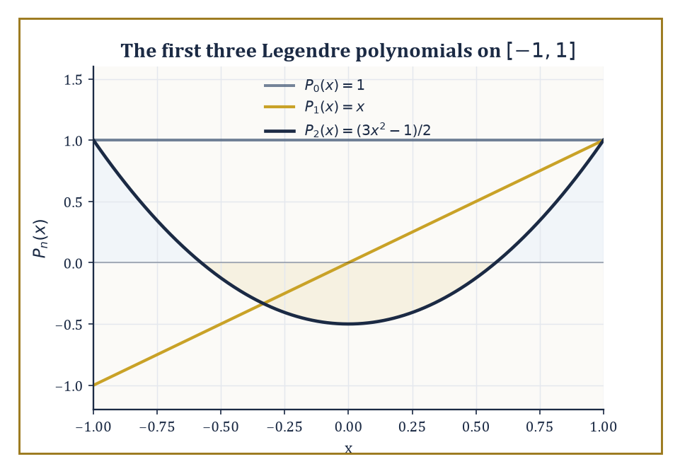
P₀, P₁, and P₂ — the first three Legendre polynomials, orthogonal on [−1,1] by exactly the same odd-function trick that made the Fourier coefficients behave.
We will treat this properly once complex analysis arrives; for now, a single concrete case shows the flavour.
Numeric example — Worked example — a Laurent series around a simple pole. Let f(z) = 1/(z(z−1)). Partial fractions give:
1/(z(z−1)) = −1/z + 1/(z−1) = −1/z − 1/(1−z)
The second piece expands as an ordinary geometric series for |z| < 1:
1/(1−z) = Σₙ₌₀^∞ zⁿ
So:
f(z) = −1/z − 1 − z − z² − z³ − … , valid for 0 < |z| < 1
The principal part is just the single term −1/z, marking z = 0 as a simple pole (a first-order singularity, the mildest kind).
Check numerically at z = 0.1: directly,
f(0.1) = 1/(0.1 × (0.1 − 1)) = 1/(0.1 × −0.9) = 1/(−0.09) = −11.1111
From the series:
−1/0.1 − 1/(1 − 0.1) = −10 − 1.1111 = −11.1111
The two agree exactly, as they must.
A generating function takes an entire sequence of numbers and encodes it as the coefficients of a single power series, converting questions about the sequence into questions about the function.
In particular, it converts a recurrence relation on the sequence into an algebraic or differential equation on the generating function itself, which can then often be solved in closed form.
Numeric example — Worked example — the Fibonacci generating function. The Fibonacci numbers satisfy the recurrence:
Fₙ = Fₙ₋₁ + Fₙ₋₂, for n ≥ 2, with F₀ = 0, F₁ = 1
Let G(x) = ΣFₙxⁿ. Then:
G(x) − xG(x) − x²G(x) = Σ(Fₙ − Fₙ₋₁ − Fₙ₋₂)xⁿ
By the recurrence, every coefficient with n ≥ 2 vanishes; the n = 0 coefficient is just F₀ = 0, and the n = 1 coefficient is F₁ − F₀ = 1 − 0 = 1.
So:
G(x)(1 − x − x²) = x
giving the closed form:
G(x) = x/(1 − x − x²)
Expanding this back out as a power series (by matching coefficients against the same recurrence, run in reverse) reproduces:
0, 1, 1, 2, 3, 5, 8, 13, …
This is the Fibonacci sequence itself, now packaged as the Taylor coefficients of a single rational function, with all the tools of this storey (radius of convergence, singularity location) available to study its growth rate.
Asymptotic series — including, remarkably, divergent ones — provide approximations that get better and better for a fixed number of terms as some parameter tends to a limit, even though summing the whole infinite series would not converge to anything at all.
Stirling's series for the factorial is the classic specimen: it is a spectacularly good approximation for large n, and a spectacularly bad idea to sum indefinitely.
Numeric example — Worked example — Stirling's approximation for 10!. Stirling's formula states:
n! ≈ √(2πn)(n/e)ⁿ
At n = 10:
√(2π × 10) = √62.8319 ≈ 7.9267, and (10/e)¹⁰ ≈ 453999.3
(using 10/e ≈ 3.678794 and computing the tenth power carefully). Multiplying:
7.9267 × 453999.3 ≈ 3,598,716
The true value is 10! = 3,628,800, so Stirling's approximation is off by about 30,084 — a relative error of roughly 0.83%, comfortably under 1% from a formula that never once multiplied ten numbers together.
The catch, and the reason this is called an asymptotic rather than a convergent series, is that adding further correction terms to Stirling's series improves the approximation only up to a certain point; push too many terms in and the series turns on you and starts making things worse.
A useful friend, but not one to be trusted indefinitely — a sentiment with obvious resonances for anyone who has ever taken on one PhD student too many.
Orthogonal expansions with respect to a weight function on some interval generalise the trigonometric orthogonality of the previous two rooms, and produce the classical families of orthogonal polynomials — Legendre, Chebyshev, Hermite, Laguerre — each tailored to a particular geometry or differential operator, and each forming a complete toolkit for approximation and for the spectral methods used to solve differential equations numerically.
Numeric example — Worked example — Legendre polynomials, checked for orthogonality. The first three Legendre polynomials, orthogonal on [−1, 1] with weight 1, are:
P₀(x) = 1, P₁(x) = x, P₂(x) = (3x² − 1)/2
Check:
⟨P₁,P₂⟩ = ∫₋1^1 x · (3x²−1)/2 dx = (1/2)∫₋1^1 (3x³ − x) dx
Both 3x³ and x are odd functions, and the integral of an odd function over the symmetric interval [−1,1] is always 0. So the whole integral is 0, confirming orthogonality exactly as the theory demands — the same structural fact that made the trigonometric coefficients in Room 16.6 into independent projections is at work here too, just with a different family of building blocks.
The thread joining every expansion in this room, however exotic its formula, is the same one that ran through Taylor series and Fourier series alike: a well-chosen expansion converts a stubborn analytic object — a function with a singularity, a sequence defined by a recurrence, a factorial that resists exact computation — into a sequence of coefficients that can be estimated, bounded, computed, or manipulated far more easily than the original object ever could be handled directly.

Room 16.9: Looking Ahead: From Series to Transforms and Functional Analysis
From counting terms to trusting spaces
We have, in the course of nine rooms, assembled the basic vocabulary of series: the convergence tests that decide whether a numerical sum makes sense at all, the power series and Taylor expansions that replace smooth functions with polynomials, the Fourier series that replace periodic functions with sums of pure tones, and a small museum of related expansions — Laurent series, generating functions, asymptotic series, orthogonal polynomials — each converting some stubborn object into a more manageable list of coefficients.
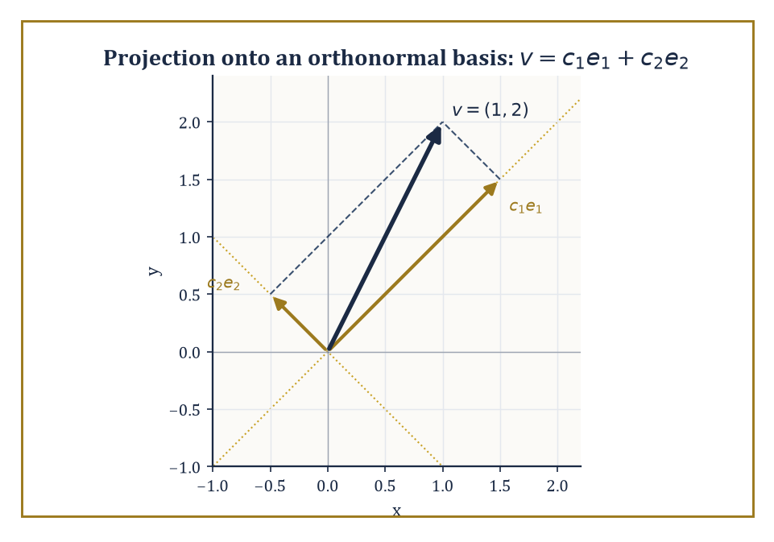
Two projections, dot products in disguise, reassemble v = (1, 2) exactly — the whole of Fourier analysis, rehearsed in two dimensions.
This vocabulary is not decorative; it is the foundation the next several storeys are built on.
Most immediately, the Fourier transform extends the Fourier series from periodic functions to functions defined on the whole real line, and becomes one of the central tools of analysis and of signal processing — the mathematics behind, among a great many other things, every audio compression format and medical scanner you have ever benefited from.
Numeric example — Worked example — watching the frequency comb turn into a continuum. A function of period 2π has Fourier frequencies spaced one integer apart: n = …, −1, 0, 1, 2, …, a spacing of 1.
Stretch the period out to 20π instead, and the same construction produces frequencies spaced:
2π/(20π) = 1/10
apart — ten times as many frequencies packed into the same range. Stretch the period to 2000π and the spacing shrinks to 1/1000.
As the period grows without bound, the comb of discrete frequencies grows finer and finer, and in the limit of an infinite period — a function that is no longer periodic at all — the sum over a discrete comb of frequencies becomes an integral over a continuum of frequencies.
That limiting process, made rigorous, is exactly the passage from Fourier series to the Fourier transform, and it is where the next storey picks up the thread.
Generating functions and formal power series will resurface almost immediately once combinatorics enters the Tower, where they become the standard device for counting: encode a sequence you want to count as the coefficients of a power series, manipulate the series algebraically, and read the answer back off the coefficients — precisely the Fibonacci trick of Room 16.8, generalised to counting almost anything.
Functional analysis, several storeys further up, will take the single idea underlying this entire storey — orthogonality turning approximation into independent projection — and abstract it fully into the language of Hilbert and Banach spaces, where 'function' is simply a point in an infinite-dimensional space and a Fourier series is nothing more exotic than expressing that point in a convenient coordinate system.
Numeric example — Worked example — the finite-dimensional rehearsal for Hilbert space. Take the ordinary vector v = (1, 2) in the plane, and the orthonormal basis e₁ = (1/√2, 1/√2), e₂ = (1/√2, −1/√2) (two perpendicular unit vectors, rotated 45° from the usual axes).
The coordinates of v in this new basis are given by dot products — projections — exactly as Fourier coefficients are given by integrals:
c₁ = v·e₁ = (1)(1/√2) + (2)(1/√2) = 3/√2 ≈ 2.1213
c₂ = v·e₂ = (1)(1/√2) + (2)(−1/√2) = −1/√2 ≈ −0.7071
Reconstructing:
c₁e₁ = (3/√2)(1/√2, 1/√2) = (3/2, 3/2)
c₂e₂ = (−1/√2)(1/√2, −1/√2) = (−1/2, 1/2)
Adding them back together:
(3/2 − 1/2, 3/2 + 1/2) = (1, 2)
This is precisely v, recovered exactly from its two projections. This is the entire content of Fourier analysis, shrunk down to two dimensions: decompose an object along an orthogonal basis by projection, then reassemble it by summing the projections back up.
Function spaces simply replace the two basis vectors with an infinite orthonormal family — sines and cosines, say — and replace the dot product with an integral. Nothing conceptually new happens; the picture just gets an infinite number of axes.
There is one more piece of foreshadowing worth planting here, because it explains why Hilbert spaces insist on being built from L² functions rather than merely continuous ones.
Room 16.7 showed that the partial sums of the square wave's Fourier series — themselves perfectly smooth, perfectly continuous trigonometric polynomials — get closer and closer to each other in the L² sense as more terms are added, which is exactly what it means to be a Cauchy sequence. And yet their limit, the square wave itself, is not continuous at all.
A sequence of well-behaved objects, drawing arbitrarily close together, whose natural limit escapes the space they started in: that is precisely the disease that motivates completing a space in the first place.
Abstract example — Structural example — the same disease that builds the real numbers. Compare this to a far older example: the sequence of rationals:
1, 1.4, 1.41, 1.414, 1.4142, …
gets arbitrarily close together (it is Cauchy) entirely within the rational numbers, yet its limit, √2, is not rational — it escapes the space the sequence lived in.
The real numbers are, by one standard construction, precisely the rationals with every such escaping limit glued back in, i.e. the completion of the rationals.
Hilbert space performs the identical repair on the continuous, trigonometric-polynomial functions Room 16.7 was working with: the Fourier partial sums of the square wave are a Cauchy sequence in the L² sense whose limit — a genuine jump discontinuity — does not belong to the space of continuous functions, so the space of continuous functions is not complete, and analysts complete it by admitting L² functions (discontinuities and all) as legitimate points of the space.
This is the single technical reason Fourier theory is properly a theorem about L² functions rather than about continuous ones, and it is exactly the notion of completeness that will earn a full room to itself once functional analysis arrives.
The deeper lesson of this storey, stripped of its coefficients and its remainder estimates, is a simple and slightly beautiful one: an enormous number of complicated functions are, underneath, infinite combinations of simple ones, and the coefficients of that combination carry the entire essential information about the original object — its smoothness, its energy, its symmetries, all legible directly from a list of numbers.
Learning to expand a function honestly, to estimate exactly how much a remainder is allowed to cost you, and to justify swapping a sum with a derivative or an integral, is therefore not a technical footnote to analysis; it is a permanent and recurring part of the analyst's craft, one we will lean on at every storey still to come.
We have learned to expand — to take a function that refuses to sit still and rewrite it, honestly and with a certified error bound, as an infinite sum of things we already understood perfectly well: powers, or pure tones. That is the whole trick of this storey, dressed up across nine rooms and rather more Greek letters than strictly necessary.
The next storey picks the thread up exactly where Room 16.9 left it dangling: let the period of a Fourier series grow without bound, watch the discrete comb of frequencies aₙ, bₙ dissolve into a continuous spectrum, and the Fourier transform is born — followed shortly by a piece of pure algorithmic cunning, the Fast Fourier Transform, that computes the whole business in roughly N log N operations instead of N², and which quietly, invisibly, runs a sizeable fraction of the audio, imaging, and communications technology in your pocket.
The tower continues upward. We have learned to expand; next, we learn to let the period go — politely, and with the error bars still firmly attached.

Storey 17: Fourier Transforms and FFT
Frequency, Spectrum, and the Art of Decomposing Signals into Waves
Storey 16 taught us to break a periodic function into a sum of sines and cosines — a Fourier series — and to worry, properly, about whether the sum actually converges back to the function we started with. That worry was not wasted effort; it is about to pay for itself. This storey takes the single most audacious step in the whole argument: let the period grow without bound, and watch the discrete chord of frequencies dissolve into a continuous spectrum. What emerges is the Fourier transform, a machine of startling generality that turns differentiation into multiplication, convolution into a simple product, and a great many differential equations into algebra a moderately diligent sixth-former could finish before lunch.
Then, because mathematics rarely pauses to admire its own results for long, we make the whole apparatus computable. The discrete Fourier transform (DFT) does for finite lists of numbers what the continuous transform does for functions defined on the whole line, and the fast Fourier transform (FFT) computes it not in the n² operations a naïve algorithm would demand, but in n log n — a saving so large that for signals of any serious length it is the difference between an algorithm that finishes and one that doesn't, this side of the heat death of the universe. Without the FFT your phone would have no spectrum analyser, your hospital's MRI scanner would produce no image, and digital audio would still be a rumour whispered by analogue engineers.
A small confession, inherited faithfully from whichever earlier hand first wrote it and every bit as true now: the Fourier transform is one of those objects that seems almost too good to be true. A single integral operator diagonalises every constant-coefficient linear differential operator you are ever likely to meet, converts convolution to multiplication, and admits an algorithm that scales almost linearly. The price is paid elsewhere — the transform is nonlocal, so a single sharp spike in frequency space corresponds to a wave rippling across the whole of space, and making the business fully rigorous requires some care about which function spaces we are permitted to work in. We shall enjoy the power and pay the price honestly, in that order.
If series taught us to build functions out of simpler pieces, Fourier analysis teaches us to build them out of pure oscillation — and to hear a signal not as a sequence of moments but as a chord of frequencies sounding together. Let's go and listen.

Room 17.1: From Fourier Series to the Fourier Transform
Letting the Period Run Away to Infinity
Recall the setup from Storey 16. A function f that repeats itself with period T can be written as a sum of complex exponentials whose frequencies are integer multiples of the fundamental frequency 1/T, where the sum runs over all integers n, positive and negative:
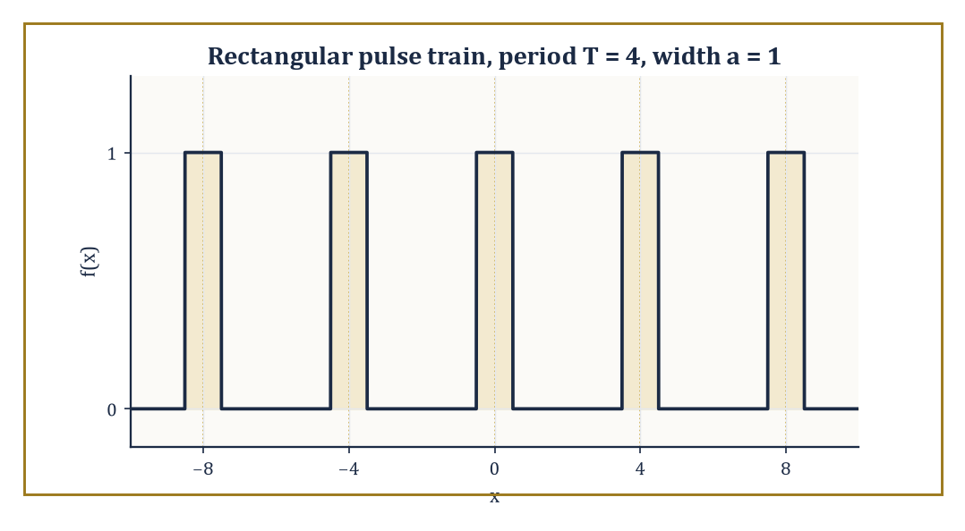
The period-4 pulse train of width 1 whose Fourier coefficients cₙ this Room computes — stretch the gaps to infinity and the comb of frequencies becomes a continuum.
f(x) = Σₙ cₙ e^{2πinx/T}
Each coefficient cₙ is obtained by projecting f against the corresponding exponential — an inner product, exactly as one projects a vector onto a coordinate axis:
cₙ = (1/T) ∫₀ᵀ f(x) e^{−2πinx/T} dx
The allowed frequencies n/T form a discrete comb, evenly spaced 1/T apart along the frequency axis. Whether the resulting sum actually converges back to f, and in what sense (pointwise, uniform, or merely in the averaged L² sense), was the subject of a large and historically important literature that we will not re-litigate here; we take the well-behaved cases as given and press on.
Numeric example — Worked example — Fourier coefficients of a rectangular pulse train. Let f be periodic with period T = 4, equal to 1 on the interval [−0.5, 0.5] and 0 elsewhere within each period — a narrow pulse of width a = 1 repeating every 4 units. A short calculation (integrate e^{−2πinx/T} across the pulse and simplify) gives the general formula, where sinc(x) = sin(πx)/(πx) and sinc(0) = 1 by the usual limiting convention:
cₙ = (a/T)·sinc(na/T)
With a = 1, T = 4:
c₀ = (1/4)·sinc(0) = 0.25
c₁ = (1/4)·sinc(0.25) = (1/4)·[sin(π/4)/(π/4)] = (1/4)·(0.7071/0.7854) = (1/4)·0.9003 = 0.2251
c₂ = (1/4)·sinc(0.5) = (1/4)·[sin(π/2)/(π/2)] = (1/4)·(1/1.5708) = (1/4)·0.6366 = 0.1592
Notice the coefficients shrink as |n| grows but never vanish entirely — a narrow pulse in time needs contributions from a broad range of frequencies to build its sharp edges, a theme that will return with interest in Room 17.8.
Now perform the limiting argument that gives this Room its name. Let the period T grow without bound while the shape of the pulse (its width a) stays fixed. The spacing between adjacent frequencies, 1/T, shrinks toward zero, so the discrete comb of frequencies n/T thickens into a continuum; write ξ = n/T for this continuous frequency variable. The sum over n, each term weighted by the small spacing 1/T, starts to look like a Riemann sum for an integral over ξ. Formally:
f(x) = Σₙ cₙ e^{2πi(n/T)x} = Σₙ (T·cₙ) e^{2πi(n/T)x} · (1/T) → ∫ f̂(ξ) e^{2πixξ} dξ
where the rescaled coefficient T·cₙ converges to a genuine function of the continuous variable ξ. That limiting function is precisely what we shall soon name the Fourier transform, f̂(ξ), and the limiting sum is precisely the Fourier inversion formula we meet properly in Room 17.3. Series become integrals; sums over a discrete ledger of frequencies become continuous spectra.
Numeric example — Worked example — watching the rescaled coefficients converge. Return to the pulse of width a = 1, but now hold the frequency ξ = n/T fixed at 0.25 while letting T grow.
T = 4, n = 1: T·c₁ = 4 × 0.2251 = 0.9003 (using the value computed above)
T = 8, n = 2: cₙ = (1/8)·sinc(2/8) = (1/8)·sinc(0.25) = (1/8)×0.9003 = 0.11254, so T·cₙ = 8 × 0.11254 = 0.9003
T = 16, n = 4: cₙ = (1/16)·sinc(4/16) = (1/16)×0.9003 = 0.056269, so T·cₙ = 16 × 0.056269 = 0.9003
All three agree exactly, because for this particular pulse the rescaled coefficient T·cₙ depends only on the ratio ξ = n/T and not on T and n separately — a foretaste of the Poisson summation formula met in later analysis, which says that periodising a function with period T samples its Fourier transform exactly at the points n/T, provided the copies of the pulse don't overlap. A less obliging function would show the coefficients merely approaching a limit as T grows rather than sitting on it from the start, but the moral — rescaled series coefficients tend to the transform — is the same either way.
The transition from series to transform is therefore two things happening at once: a limiting process (period to infinity, sum to integral) and a change of subject matter (periodic phenomena, which repeat forever, to arbitrary signals that need only be defined once, on the whole real line). A periodic function is really just one pattern stamped out infinitely often; letting the stamping interval run to infinity leaves a single, unrepeated pattern — which is usually the object one actually wants to analyse, whether it is a clap of thunder, a spoken vowel, or a single pulse in a radar system.
Abstract example — Abstract example — from a picket fence to a single post. Picture the period-4 pulse train of the first example as a picket fence: an identical narrow post every 4 units, forever in both directions. Now imagine grabbing the fence at both ends and stretching it — posts stay the same width, but the gaps between them grow.
As the period T increases from 4 to 40 to 4,000, the picture within any fixed viewing window (say, the interval [−10, 10]) tends toward a single isolated post sitting at the origin, with no neighbours in sight; everything else has been pushed off to infinity. The Fourier transform of that single isolated post is exactly the sinc function met above, viewed now as a continuous function of ξ rather than a sequence of samples cₙ. This is the structural content of the limit: periodicity is repetition at a fixed spacing, and removing the repetition by sending the spacing to infinity is what turns a discrete spectrum into a continuous one.

Room 17.2: The Fourier Transform on the Line
One Integral, Every Frequency
For an integrable function f on the real line, define its Fourier transform by
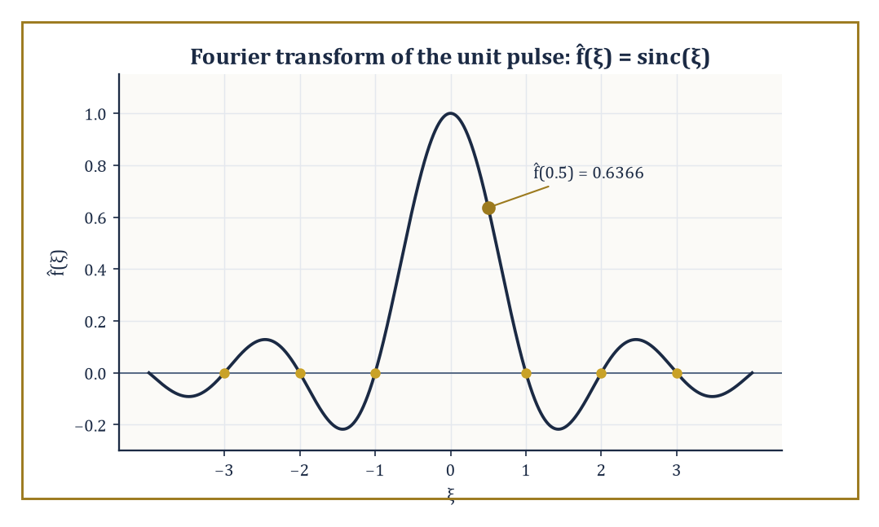
The transform of the unit pulse: f̂(ξ) = sinc(ξ), still rippling long after the box itself has stopped.
f̂(ξ) = ∫_{−∞}^{∞} f(x) e^{−2πixξ} dx
Conventions for where the factors of 2π and the sign of the exponent go vary maddeningly between textbooks, physics papers, and engineering handbooks; we fix the unitary, ordinary-frequency convention used above, in which ξ is measured in cycles per unit x rather than radians per unit x, and no stray constants clutter the inversion formula later.
The transform is linear (the transform of a sum is the sum of the transforms, and constants factor out), it is defined and continuous for every f in L¹ (every absolutely integrable function), and it maps the Schwartz space — smooth functions that, together with all their derivatives, decay faster than any power of x — back into itself. Intuitively, f̂(ξ) measures how strongly the pure oscillation e^{2πixξ} is present inside f: it is the amplitude and phase of the ξ-frequency component of the signal.
Numeric example — Worked example — the transform of a rectangular pulse. Let f(x) = 1 for |x| < 0.5 and f(x) = 0 otherwise (a single rectangular pulse of width 1 centred at the origin — the isolated post from the previous Room). Then
f̂(ξ) = ∫_{−0.5}^{0.5} e^{−2πixξ} dx = [e^{−2πixξ}/(−2πiξ)]_{−0.5}^{0.5}
= (e^{−πiξ} − e^{πiξ})/(−2πiξ) = (−2i sin(πξ))/(−2πiξ)
= sin(πξ)/(πξ) = sinc(ξ)
Evaluate: at ξ = 0.5,
f̂(0.5) = sin(π/2)/(π/2) = 1/1.5708 = 0.6366
At ξ = 1,
f̂(1) = sin(π)/π = 0/π = 0
— the transform vanishes at every nonzero integer frequency, giving the sinc function its characteristic string of zero crossings. A box in time becomes a ripple in frequency, and that ripple never quite dies away — the price, as promised, of a sharp edge in time.
A handful of algebraic rules, each provable by direct manipulation of the defining integral (differentiate under the integral sign, or substitute), turn the transform into a genuine computational tool rather than a curiosity.
Differentiation becomes multiplication: the transform of f′ is
2πiξ·f̂(ξ)
so differentiating in x corresponds to multiplying by a frequency factor in ξ — this single fact is why constant-coefficient differential equations become algebraic equations after transforming.
Translation becomes modulation: if g(x) = f(x − a), then
ĝ(ξ) = e^{−2πiaξ}·f̂(ξ)
— shifting a signal in time doesn't change the magnitude of its spectrum at all, only twists the phase of each frequency component by an amount proportional to that frequency. And a Gaussian transforms to another Gaussian, a fact so useful it earns its own worked example below.
Numeric example — Worked example — verifying the shift rule. Take the unit pulse f above, with f̂(ξ) = sinc(ξ), and shift it two units to the right: g(x) = f(x − 2), i.e. g equals 1 on [1.5, 2.5] and 0 elsewhere. The shift rule predicts
ĝ(ξ) = e^{−4πiξ}·sinc(ξ)
At ξ = 0.25 this gives
ĝ(0.25) = e^{−4πi(0.25)}·sinc(0.25) = e^{−πi}·0.9003 = (−1)(0.9003) = −0.9003
Check this directly:
ĝ(0.25) = ∫_{1.5}^{2.5} e^{−iπx/2} dx
(since 2πξ = π/2). The antiderivative is (2i/π)e^{−iπx/2}; evaluating at x = 2.5 (angle 1.25π = 225°, cos = −0.7071, sin = −0.7071, so e^{−i1.25π} = −0.7071 + 0.7071i) and at x = 1.5 (angle 0.75π = 135°, cos = −0.7071, sin = 0.7071, so e^{−i0.75π} = −0.7071 − 0.7071i), the difference is
(−0.7071 + 0.7071i) − (−0.7071 − 0.7071i) = 1.4142i
Multiplying by (2i/π):
(2i/π)(1.4142i) = 2.8284·i²/π = −2.8284/π = −0.9003
The direct calculation and the shift-rule prediction agree exactly.
The differentiation rule has a deeper reading than mere bookkeeping: it says that the complex exponentials e^{2πixξ} are eigenfunctions of the differentiation operator d/dx, with eigenvalue 2πiξ. An eigenfunction is a function that an operator sends to a scalar multiple of itself — differentiate e^{2πixξ} and you get 2πiξ·e^{2πixξ} back, unchanged in shape, merely rescaled.
Any operator built from d/dx (any constant-coefficient linear differential operator) therefore acts on each frequency component of a signal by simple multiplication, which is exactly why the Fourier transform turns calculus into algebra. This is the fundamental change of variables of harmonic analysis: swap the standard basis of "value at each point x" for the basis of "amplitude at each frequency ξ", and the operators that mattered in the first basis become diagonal — multiplication operators — in the second.
Abstract example — Abstract example — the Gaussian that transforms to itself. Let f(x) = e^{−πx²}. A standard (if slightly fiddly) contour-shifting calculation shows
f̂(ξ) = e^{−πξ²}
— under this particular normalisation, the Gaussian is its own Fourier transform, a genuine mathematical curiosity with real consequences (it is the reason the Gaussian saturates the uncertainty principle in Room 17.8). Sanity check at the origin: f(0) = 1, and
f̂(0) = ∫ e^{−πx²} dx = 1
using the classical Gaussian integral ∫ e^{−ax²} dx = √(π/a) with a = π, giving √(π/π) = 1. The values agree, as self-duality demands. At ξ = 1,
f̂(1) = e^{−π} ≈ 0.04321
— a small but nonzero tail, exactly mirroring how f(1) = e^{−π} as well.
The shift rule has a mirror image, modulation, which will matter enormously once we reach filtering in Room 17.7: multiplying a function by a pure oscillation e^{2πiax} in the time domain shifts its entire spectrum sideways by a in the frequency domain. Symbolically, if g(x) = e^{2πiax}f(x), then
ĝ(ξ) = f̂(ξ − a)
This is the mathematical operation underlying radio broadcasting: a low-frequency audio signal (speech or music, occupying perhaps 0 to 15 kHz) is multiplied by a high-frequency carrier wave, which shifts — modulates — its whole spectrum up to sit around the assigned broadcast frequency, far enough from every other station's assigned slot that a receiver can isolate it again with a suitably tuned band-pass filter.
Numeric example — Worked example — modulation shifts the spectrum sideways. Take the unit pulse f(x) again, f̂(ξ) = sinc(ξ), and modulate it by a = 3: g(x) = e^{2πi·3x}f(x). The modulation rule predicts
ĝ(ξ) = f̂(ξ − 3) = sinc(ξ − 3)
Evaluate at ξ = 3.5: ĝ(3.5) should equal
sinc(3.5 − 3) = sinc(0.5) = 0.6366
the same numerical value computed for f̂(0.5) in the very first worked example of this Room — merely relocated three units along the frequency axis, exactly as the rule promises. The shape of the spectrum (a sinc bump) is preserved perfectly; only its location moves, which is precisely why a radio receiver can tune across the dial and pick up the same audio content wherever the broadcaster chose to park its carrier frequency.

Room 17.3: Inversion, Plancherel, and Parseval
Getting the Function Back, With Its Energy Intact
A transform that could not be undone would be a curiosity, not a tool. Under suitable hypotheses on f (Schwartz class is more than enough; L¹ ∩ L² usually suffices), the original function is recovered from its transform by the inverse Fourier transform:
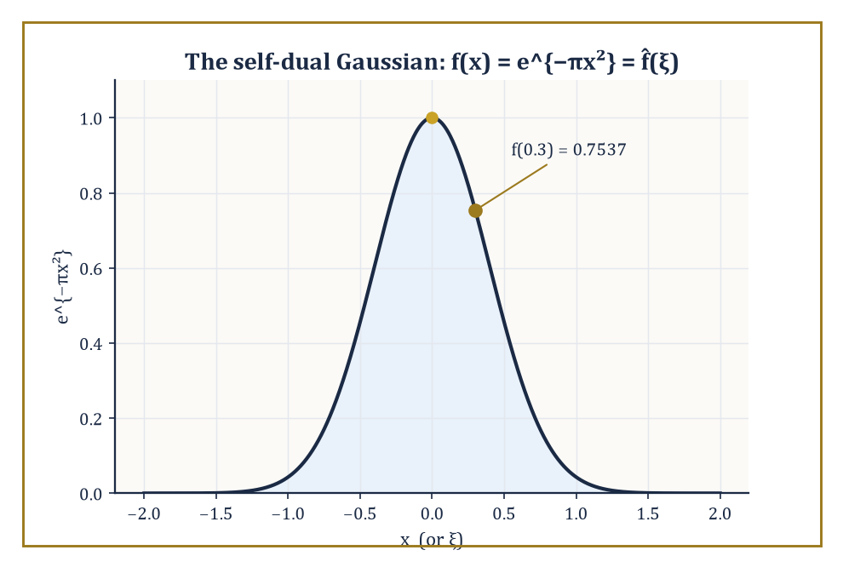
The one function that sits still under the transform: e^{−πx²} is its own Fourier transform, digit for digit.
f(x) = ∫ f̂(ξ) e^{2πixξ} dξ
This is the same formula as the forward transform, but with the sign of the exponent flipped. It is exactly the reconstruction formula that fell out of the limiting argument in Room 17.1: the continuum analogue of resumming a Fourier series.
Its importance is not merely aesthetic. It guarantees that passing to frequency space loses no information whatsoever — the transform is a genuine change of representation, a relabelling of the same data, not a lossy projection onto some smaller space. Anything one computes in frequency space (a filtered spectrum, a solved differential equation) can always be brought back to the original variable by this one formula.
Numeric example — Worked example — inversion checked on the self-dual Gaussian. Take f(x) = e^{−πx²} and f̂(ξ) = e^{−πξ²} from Room 17.2, and verify inversion at x = 0.3. Directly:
f(0.3) = e^{−π(0.3)²} = e^{−π(0.09)} = e^{−0.28274} = 0.7537
Now compute the inversion integral:
∫ e^{−πξ²} e^{2πi(0.3)ξ} dξ
Complete the square in the exponent:
−πξ² + 0.6πiξ = −π(ξ² − 0.6iξ) = −π[(ξ − 0.3i)² + 0.09] = −π(ξ − 0.3i)² − 0.09π
So the integral equals:
e^{−0.09π} ∫ e^{−π(ξ − 0.3i)²} dξ
Shifting the contour of integration off the real axis is justified because the Gaussian is entire and decays in every direction of the strip swept out, and the shifted Gaussian integral still equals 1 (the same value as the unshifted one). So the integral equals:
e^{−0.09π} × 1 = e^{−0.28274} = 0.7537
This matches f(0.3) exactly. The formula, and the machinery, both check out.
Plancherel's theorem strengthens inversion into a statement about size: the Fourier transform extends to a unitary operator on L², meaning it preserves the L² norm exactly:
∫|f(x)|² dx = ∫|f̂(ξ)|² dξ
This is Parseval's identity in its self-paired form. The more general Parseval identity equates the inner product of two functions with the inner product of their transforms:
∫ f(x)·conj(g(x)) dx = ∫ f̂(ξ)·conj(ĝ(ξ)) dξ
Physically, if |f(x)|² is interpreted as an energy density in time (as it is for an electrical signal or a sound wave), then Plancherel says the total energy can be computed equally well by integrating |f̂(ξ)|² over frequency — hence |f̂(ξ)|² is called the energy density (or power spectral density) in frequency. Energy is neither created nor destroyed by the change of representation; it is merely redistributed across the frequency axis, and Plancherel tells us exactly how much stays where.
Numeric example — Worked example — Plancherel for the pulse and its sinc. Take again the unit-width, unit-height pulse f(x) = 1 on (−0.5, 0.5), 0 elsewhere, with f̂(ξ) = sinc(ξ) from Room 17.2. The time-domain energy is:
∫|f(x)|² dx = ∫_{−0.5}^{0.5} 1² dx = 1
A box of height 1 and width 1 has area 1. Plancherel demands that the frequency-domain energy match:
∫|sinc(ξ)|² dξ = ∫ [sin(πξ)/(πξ)]² dξ
This is a classical definite integral whose value is exactly 1 — a nontrivial fact (it is usually proved via Parseval itself, or by contour integration), but here it serves as a numerical confirmation: 1 = 1, energy preserved to the last decimal place, even though the pulse is compactly supported and the sinc function most emphatically is not.
It is worth pausing on why this matters beyond bookkeeping. Inversion says nothing is lost; Plancherel says nothing is lost in a quantitative, measurable sense — the total 'size' of the signal, however you like to measure size, is the same whichever axis you total it up along.
Together they are the two pillars that make the Fourier transform a genuine change of coordinates rather than a one-way street: you can go from time to frequency and back with total confidence, and every calculation you might want to perform (filtering, solving a differential equation, compressing a signal by discarding small frequency components) can be justified by appeal to exactly how much energy such a discarding operation would throw away.
Abstract example — Abstract example — Parseval as Pythagoras in infinite dimensions. In ordinary two-dimensional space, a vector v = (3, 4) has length:
|v| = √(3² + 4²) = √25 = 5
This is just Pythagoras's theorem: the squared length is the sum of the squared coordinates in any orthonormal basis. The complex exponentials e^{2πixξ}, one for every real number ξ, form an (uncountably infinite, continuously indexed) orthonormal basis for L², and f̂(ξ) is exactly the 'coordinate' of f along the ξ-th basis direction.
Plancherel's identity,
∫|f|² = ∫|f̂|²
is Pythagoras's theorem transplanted to this infinite-dimensional setting: the squared length of f equals the sum (now an integral, since the index ξ is continuous rather than discrete) of the squared sizes of its coordinates. The Fourier transform is, in this sense, nothing more exotic than a rotation of coordinate axes in an infinite-dimensional space — a rotation that happens to be extraordinarily well chosen, because it diagonalises differentiation.
One practical consequence of unitarity is worth flagging before we move on, since it will resurface the moment we start computing rather than merely proving theorems. Because the Fourier transform preserves length exactly, it cannot amplify rounding error: a small numerical mistake made while representing a signal in the time domain corresponds to an equally small mistake in the frequency domain, and vice versa, with no hidden factor sneaking in to make things worse.
This stability is quietly assumed every time an engineer trusts a computed spectrum, and it is one further way in which Plancherel earns its keep well beyond the tidiness of the proof.
Numeric example — Worked example — an error does not grow when it crosses domains. Take the unit pulse f(x) again, with f̂(ξ) = sinc(ξ), and imagine a measurement error that adds a small constant bump ε(x) = 0.01 on the tiny sliver (0.49, 0.5) to the recorded signal, so the mistake has time-domain energy:
∫|ε(x)|² dx = (0.01)² × 0.01 = 0.000001
(height squared times width). Plancherel guarantees this error cannot show up in the spectrum with more energy than it started with:
∫|ε̂(ξ)|² dξ = 0.000001
This must hold exactly, not some inflated multiple of it. Contrast this with an ordinary matrix that is not unitary — multiplying a vector of length 0.001 by, say, the matrix [[10,0],[0,10]] would blow the error up to length 0.01, a hundredfold increase in squared energy. The Fourier transform, having no such stretching directions available to it, can only ever preserve the error's size, never magnify it — which is exactly why a numerically computed spectrum can be trusted not to have quietly manufactured noise out of nothing.

Room 17.4: Convolution and the Convolution Theorem
Multiplication's Quieter, More Useful Cousin
The convolution of two functions f and g is defined by the following.
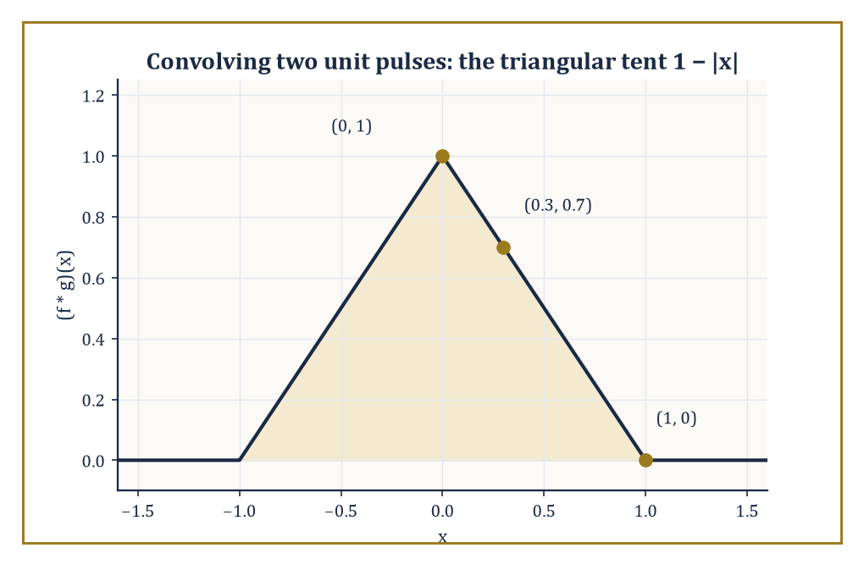
Two sharp-edged unit pulses convolve into one smooth-topped triangle — sharpness averaged away by sliding one box across the other.
(f * g)(x) = ∫ f(y) g(x − y) dy
Read it as a moving, weighted average: to compute (f * g) at the point x, slide a mirror-imaged, shifted copy of g across f, multiply pointwise, and sum (integrate) the result.
It is the continuous analogue of a running average, and it is exactly what happens whenever one linear, time-invariant system (an amplifier, a lens, a resistor–capacitor circuit, a length of optical fibre) processes the output of another, or processes a single signal passing through it: the output is the convolution of the input with the system's characteristic response.
Convolution obeys the same friendly algebra as ordinary multiplication — commutative (f * g = g * f), associative ((f * g) * h = f * (g * h)), and distributive over addition — despite looking, on first encounter, considerably more alarming than multiplication.
Numeric example — Worked example — convolving two rectangular pulses. Let f = g be the unit pulse from before: 1 on (−0.5, 0.5), 0 elsewhere. Their convolution (f * g)(x) equals the length of the overlap between the interval (−0.5, 0.5) and its shift (x − 0.5, x + 0.5).
At x = 0: the two intervals coincide exactly, overlap length 1, so
(f*g)(0) = 1
At x = 0.3: the shifted interval is (−0.2, 0.8); intersecting with (−0.5, 0.5) gives (−0.2, 0.5), length 0.7 — matching the general formula for the triangular 'tent' function:
(f*g)(x) = 1 − |x|, for |x| ≤ 1
since
1 − 0.3 = 0.7
exactly.
At x = 1: the shifted interval is (0.5, 1.5), which just touches (−0.5, 0.5) at a single point — overlap length 0, so
(f*g)(1) = 0
again matching
1 − |1| = 0
Two sharp-edged boxes convolve into one smooth-topped (if still pointed) triangle — convolution is a smoothing operation, which is precisely why moving averages are used to smooth noisy data.
The convolution theorem is the payoff: the Fourier transform turns convolution into ordinary pointwise multiplication.
(f * g)^(ξ) = f̂(ξ) · ĝ(ξ)
There is a dual statement too — the transform of a pointwise product is a convolution of the transforms (with a normalising constant depending on convention) — but it is the first direction that does most of the practical work.
Filtering a signal in the frequency domain is nothing more than multiplying its spectrum by a chosen transfer function; the equivalent operation back in the time domain is convolving the signal with that transfer function's inverse transform, called the impulse response.
This equivalence — a fiddly integral in one domain becoming a simple product in the other — is arguably the single most useful computational fact in the whole of Fourier analysis, and it is the reason the FFT (Room 17.6) is so often used not to look at spectra at all, but simply as a fast way to compute a convolution.
Numeric example — Worked example — checking the convolution theorem by direct integration. Continue with f = g = unit pulse, so f̂ = ĝ = sinc, and the convolution theorem predicts
(f*g)^(ξ) = sinc²(ξ)
At ξ = 0:
(f*g)^(0) = ∫(f*g)(x) dx = area under the triangular tent = ½ × base × height = ½ × 2 × 1 = 1
sinc²(0) = 1² = 1
— agreed.
At ξ = 0.5, sinc(0.5) = 0.6366 (computed in Room 17.2), so
sinc²(0.5) = 0.4053
Checking directly:
(f*g)^(0.5) = ∫_{−1}^{1} (1 − |x|) e^{−iπx} dx
and by symmetry this equals
2∫₀¹ (1 − x)cos(πx) dx
Now
∫₀¹ cos(πx) dx = [sin(πx)/π]₀¹ = 0
and by parts
∫₀¹ x cos(πx) dx = [x sin(πx)/π]₀¹ − ∫₀¹ sin(πx)/π dx = 0 − (1/π)[−cos(πx)/π]₀¹ = −(1/π)[(1/π) + (1/π)] = −2/π²
So
∫₀¹(1−x)cos(πx) dx = 0 − (−2/π²) = 2/π²
and doubling gives
4/π² = 4/9.8696 = 0.4053
— matching sinc²(0.5) exactly.
This same idea, stripped down to finite lists of numbers, is the discrete convolution that will reappear constantly once we reach the DFT: given two finite sequences, slide one across the other, multiply overlapping entries, and sum.
It is exactly what a moving-average filter, a digital equaliser, or a simple blur on an image is doing under the bonnet.
Numeric example — Worked example — a discrete convolution (a taste of things to come). Let a = [1, 2, 3] and let b = [1, 1] be a two-tap moving-average filter. Their (linear) convolution c = a * b has entries
cₖ = Σⱼ aⱼ b_{k−j}
computed as:
c₀ = a₀b₀ = 1×1 = 1
c₁ = a₀b₁ + a₁b₀ = 1×1 + 2×1 = 3
c₂ = a₁b₁ + a₂b₀ = 2×1 + 3×1 = 5
c₃ = a₂b₁ = 3×1 = 3
So
c = [1, 3, 5, 3]
— each output entry is the sum of a pair of neighbouring input entries, exactly the running-sum behaviour one would want from a length-2 moving-average filter (up to the missing division by 2). Room 17.5 will show how to compute exactly this kind of sum via the DFT and the convolution theorem, and Room 17.6 will show how to do it fast.
The dual statement, mentioned only in passing above, deserves a moment's honesty: transforming a pointwise product of two functions gives (up to a normalising constant that depends on the convention chosen) a convolution of their transforms,
(fg)ˆ = f̂ * ĝ
This is why truncating a signal to a finite observation window — a pointwise product with a window function that is 1 on the window and 0 outside — smears its spectrum by convolving it with the window's own transform, an unavoidable side effect that becomes the central concern of Room 17.8.
The two convolution theorems are genuinely dual to one another, one living in each domain, and a working Fourier analyst ends up reaching for whichever one turns the calculation at hand from an integral into a product rather than the other way round.
Abstract example — Abstract example — squaring the pulse is windowing it against itself. Let f(x) be the familiar unit pulse, 1 on (−0.5, 0.5) and 0 elsewhere, and consider the pointwise product f(x)·f(x). Since f only ever takes the values 0 and 1, multiplying it by itself changes nothing:
f(x)·f(x) = f(x)
exactly, because 0×0 = 0 and 1×1 = 1. The dual convolution theorem therefore predicts
(f·f)ˆ = f̂ * f̂
i.e. sinc * sinc must equal sinc itself, on pain of contradiction.
This looks alarming until one recalls what convolving with a rectangular pulse's transform actually does structurally: f is what mathematicians call idempotent under pointwise multiplication (f·f = f), and the transform of an idempotent function is correspondingly a fixed point of convolution with itself under this theorem — a fact worth filing away precisely because it feels surprising the first time, and is a useful sanity check whenever a window function happens to be 0/1-valued, as the rectangular window of Room 17.8 is.

Room 17.5: The Discrete Fourier Transform
Fourier Analysis for Finite Lists of Numbers
Real data — a recorded sound, a digitised image row, a sensor reading — arrives as a finite list of numbers, not a function on the whole real line, so we need a version of the Fourier transform that eats finite sequences. The discrete Fourier transform (DFT) of a sequence x₀, x₁, …, x_{n−1} is another sequence of length n, defined by:
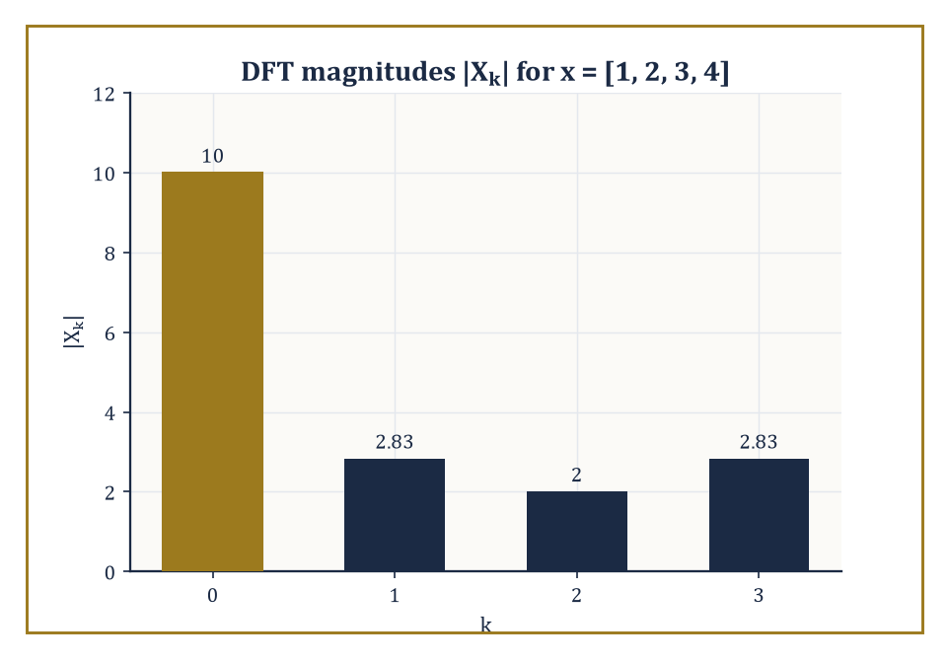
The DFT magnitudes of x = [1, 2, 3, 4] — a lopsided little spectrum, dominated by its own average.
Xₖ = Σ_{j=0}^{n−1} xⱼ e^{−2πijk/n}, for k = 0, 1, …, n − 1
It is the exact finite-dimensional analogue of the continuous transform: each output Xₖ measures how strongly the discrete oscillation of frequency k is present in the input. It is invertible by a closely related formula:
xⱼ = (1/n) Σ_{k=0}^{n−1} Xₖ e^{2πijk/n}
This is the same structure as the forward transform, with the sign of the exponent flipped and a normalising factor of 1/n inserted, exactly mirroring the forward/inverse pair for the continuous transform in Room 17.3.
Numeric example — Worked example — the DFT of a length-4 sequence. Let x = [1, 2, 3, 4] (n = 4), and write ω = e^{−2πi/4} = e^{−iπ/2} = −i, so that ω² = −1, ω³ = i, ω⁴ = 1. Then the four outputs work out as follows.
X₀ = 1 + 2 + 3 + 4 = 10
X₁ = 1·ω⁰ + 2·ω¹ + 3·ω² + 4·ω³ = 1 + 2(−i) + 3(−1) + 4(i) = (1 − 3) + (−2 + 4)i = −2 + 2i
X₂ = 1·ω⁰ + 2·ω² + 3·ω⁴ + 4·ω⁶ = 1 + 2(−1) + 3(1) + 4(−1) = 1 − 2 + 3 − 4 = −2
X₃ = 1·ω⁰ + 2·ω³ + 3·ω⁶ + 4·ω⁹ = 1 + 2(i) + 3(−1) + 4(−i) = (1 − 3) + (2 − 4)i = −2 − 2i
So X = [10, −2+2i, −2, −2−2i].
Since the input is real, we expect conjugate symmetry, X_{n−k} = conj(X_k). Here that predicts X₃ = conj(X₁):
X₃ = conj(X₁) = conj(−2+2i) = −2−2i
This matches the direct computation of X₃ exactly — a useful self-check that costs nothing and catches a great many arithmetic slips.
The DFT can equally well be written as a matrix multiplication:
X = F·x, where F_{kj} = ω^{kj}, ω = e^{−2πi/n}
Because the rows of F are successive powers of the same n numbers (the n-th roots of unity, 1, ω, ω², …, ω^{n−1}), F is a Vandermonde matrix — a matrix built entirely from powers of a fixed list of values, well known throughout algebra for its role in polynomial interpolation, and rather less well known for turning up, uninvited, wherever roots of unity are allowed to mingle.
This matrix structure is what makes the DFT diagonalise circulant matrices (matrices whose rows are cyclic shifts of one another, which describe periodic/cyclic convolution exactly as ordinary convolution described in Room 17.4), and it is what lets the DFT compute discrete convolutions via the same convolution theorem met on the continuous line.
Computed naïvely — literally carrying out the matrix–vector multiplication X = F·x term by term, with no cleverness whatsoever — this costs O(n²) arithmetic operations: n outputs, each a sum of n terms, and not one of them aware that Room 17.6 is about to make ninety per cent of that labour unnecessary.
Abstract example — Abstract example — the DFT matrix for n = 4, made explicit. With ω = e^{−2πi/4} = −i as above, the 4×4 DFT matrix F has entries F_{kj} = ω^{kj}, giving the following four rows.
row k = 0: (ω⁰, ω⁰, ω⁰, ω⁰) = (1, 1, 1, 1)
row k = 1: (ω⁰, ω¹, ω², ω³) = (1, −i, −1, i)
row k = 2: (ω⁰, ω², ω⁴, ω⁶) = (1, −1, 1, −1)
row k = 3: (ω⁰, ω³, ω⁶, ω⁹) = (1, i, −1, −i)
This is a genuine Vandermonde matrix, built from powers of the four fourth roots of unity {1, −i, −1, i}.
Multiplying row k = 1 by x = [1, 2, 3, 4]ᵀ gives:
1(1) + (−i)(2) + (−1)(3) + (i)(4) = 1 − 2i − 3 + 4i = −2 + 2i
This is exactly X₁ from the worked example above — the matrix picture and the direct-sum picture are, of course, the same calculation viewed two ways, but seeing the matrix laid out makes the Vandermonde structure, and the O(n²) cost of using it naïvely, visually unmistakable.
The DFT is, in short, the natural tool for the spectral analysis of any signal that is finite, or periodic, or (as is overwhelmingly the common case in practice) sampled at evenly spaced instants from a continuous signal one is trying to approximate.
It is also, on its own, computationally embarrassing: doubling the length of a signal quadruples the work required to transform it via the naïve matrix–vector product, which for the kind of signal lengths that arise in audio (tens of thousands of samples per second) or imaging (millions of pixels) would make the DFT a theoretical nicety rather than a practical tool.
The DFT is exactly the object that the FFT, met next, computes efficiently — without changing a single one of its mathematical properties, only the arithmetic cost of extracting them.
Before leaving the DFT, it is worth checking that Room 17.3's Plancherel identity survives the crossing from the continuous line to the finite, discrete setting — it does, with the same 1/n factor that appears in the inversion formula. The discrete Parseval identity states that total energy in the samples equals a rescaled total energy in the spectrum:
Σⱼ|xⱼ|² = (1/n) Σₖ|Xₖ|²
Numeric example — Worked example — discrete Parseval for x = [1, 2, 3, 4]. Using x = [1, 2, 3, 4] and X = [10, −2+2i, −2, −2−2i] from above, the time-domain energy is:
Σⱼ|xⱼ|² = 1² + 2² + 3² + 4² = 1 + 4 + 9 + 16 = 30
The frequency-domain side is:
(1/n)Σₖ|Xₖ|² = (1/4)(|10|² + |−2+2i|² + |−2|² + |−2−2i|²)
Evaluating each term individually:
|10|² = 100
|−2+2i|² = (−2)² + 2² = 4 + 4 = 8
|−2|² = 4
|−2−2i|² = (−2)² + (−2)² = 4 + 4 = 8
Summing:
100 + 8 + 4 + 8 = 120, and (1/4)(120) = 30
This matches the time-domain energy exactly, digit for digit, confirming that the DFT (with this normalisation) is just as energy-faithful as its continuous ancestor.

Room 17.6: The Fast Fourier Transform
The Same Answer, For Considerably Less Effort
The fast Fourier transform (FFT) computes exactly the DFT defined in Room 17.5 — bit for bit the same output — but in O(n log n) arithmetic operations rather than O(n²), when n is a power of two (more elaborate versions of the algorithm handle general n, at some cost in elegance).
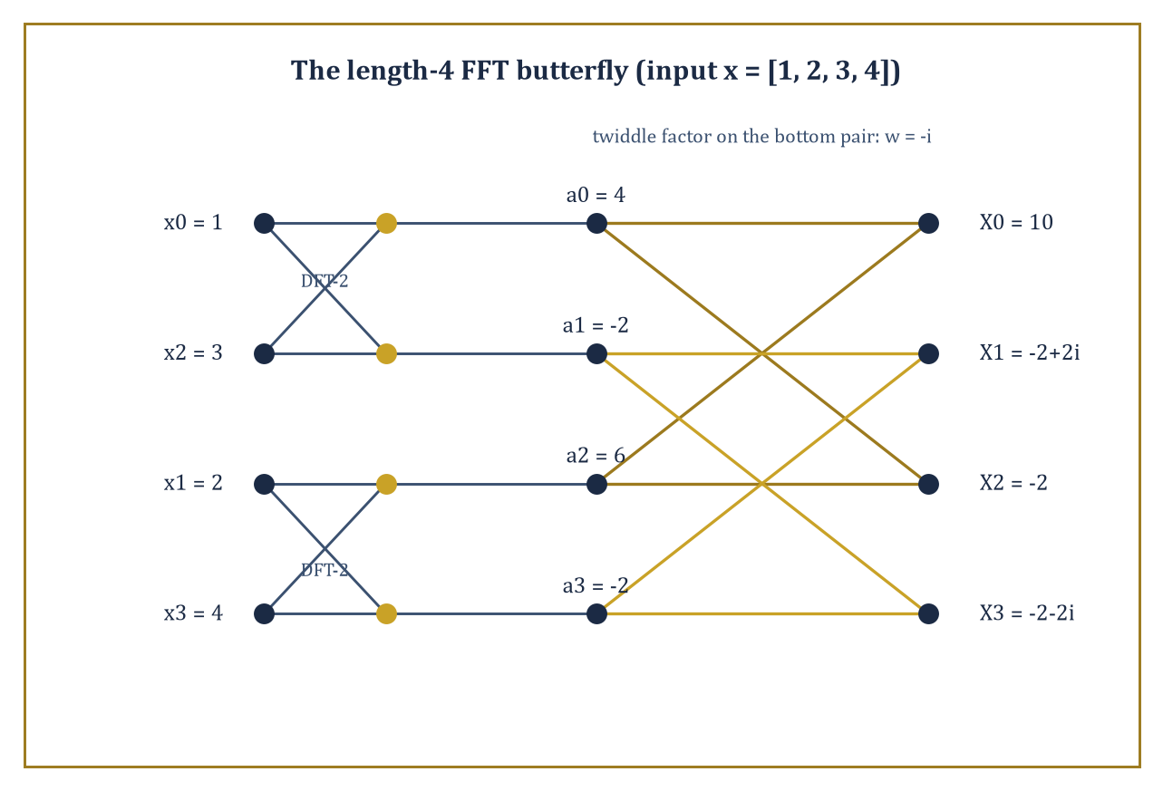
The length-4 FFT butterfly, split and recombined on x = [1, 2, 3, 4] — the same ten, minus-two-plus-two-i answer, for a fraction of the arithmetic.
The classical Cooley–Tukey algorithm achieves this by divide and conquer: split the length-n sum defining Xₖ into two half-length sums, one over the even-indexed inputs and one over the odd-indexed inputs, each of which is itself a length-(n/2) DFT. Combine the two half-length results with a handful of multiplications by 'twiddle factors' (powers of ω) to recover the full length-n answer.
Apply the same splitting trick recursively to each half-length DFT, and the recursion bottoms out after log₂n levels, since each level halves the problem size. The total work across all levels — n operations per level, log₂n levels — is O(n log n).
Numeric example — Worked example — computing the length-4 DFT the fast way. Reuse x = [1, 2, 3, 4] from Room 17.5.
Split into the even-indexed entries [x₀, x₂] = [1, 3] and the odd-indexed entries [x₁, x₃] = [2, 4]. Each is a length-2 DFT, computed by the trivial two-point formula (sum and difference):
E₀ = 1 + 3 = 4
E₁ = 1 − 3 = −2
O₀ = 2 + 4 = 6
O₁ = 2 − 4 = −2
Combine using the butterfly formulas below, with ω = e^{−2πi/4} = −i (n = 4, so k ranges over 0 and 1):
Xₖ = Eₖ + ω^k·Oₖ
X_{k+n/2} = Eₖ − ω^k·Oₖ
For k = 0, ω⁰ = 1, giving:
X₀ = E₀ + 1·O₀ = 4 + 6 = 10
X₂ = E₀ − 1·O₀ = 4 − 6 = −2
For k = 1, ω¹ = −i, giving:
X₁ = E₁ + (−i)·O₁ = −2 + (−i)(−2) = −2 + 2i
X₃ = E₁ − (−i)·O₁ = −2 − 2i
The result, X = [10, −2+2i, −2, −2−2i], matches the direct computation from Room 17.5 exactly — as it must, since the FFT computes nothing new, only faster.
Notice the arithmetic actually performed: two tiny two-point DFTs (pure additions and subtractions, no multiplication at all) plus exactly two nontrivial multiplications in the combine step (by ω⁰ = 1, which is free, and ω¹ = −i).
For n = 4 the saving over the naïve O(n²) route is invisible; scale n up to a million and the saving is the difference between a transform that finishes while you wait and one that doesn't finish this side of the heat death of the universe.
The same divide-and-conquer idea, once you have it, turns out to be reusable well beyond spectrum analysis. Fast discrete convolution (via the convolution theorem of Room 17.4: transform both sequences with the FFT, multiply pointwise, transform back) beats direct convolution for anything but the shortest sequences.
Multiplication of very large integers — the kind of arithmetic needed for cryptography or for computing digits of π — can be phrased as a convolution of digit sequences and accelerated the same way. And certain structured linear systems (those built from circulant or Toeplitz matrices) can be solved via the FFT rather than by general-purpose linear algebra.
Modern software implementations layer further cleverness on top of the basic recursive idea: exploiting cache hierarchies so data stays close to the processor, using vector instructions that perform several arithmetic operations per clock cycle, and exploiting the extra symmetry available when the input data is real-valued (as it usually is) rather than fully complex, to approach the theoretical minimum operation count.
Numeric example — Worked example — multiplying integers by convolving their digits. Multiplying 23 × 21 can be recast as convolving two short sequences.
Write 23 as the coefficient list [3, 2] (units digit first, then tens digit):
23 = 3 + 2×10
and 21 as [1, 2]:
21 = 1 + 2×10
Convolve them exactly as in Room 17.4:
c₀ = 3×1 = 3
c₁ = 3×2 + 2×1 = 6 + 2 = 8
c₂ = 2×2 = 4
The convolved coefficients [3, 8, 4] represent the polynomial:
3 + 8×10 + 4×100 = 3 + 80 + 400 = 483
Check by ordinary multiplication:
23 × 21 = 483
That's correct. For two three-digit numbers or two thousand-digit numbers the idea is identical; only the digit sequences get longer, and it is precisely then that computing the convolution via the FFT (transform, multiply pointwise, invert) rather than directly becomes worth the trouble, turning an O(n²) digit-by-digit multiplication into an O(n log n) one.
A fair question at this point: what happens when n is not a conveniently round power of two? Real signal lengths rarely oblige a mathematician's preference for tidy numbers.
The classical fix is to pad the sequence with zeros up to the next power of two — harmless, since appending zeros to a signal doesn't change the information it carries, merely the length of the list storing it — and more elaborate algorithms (Bluestein's algorithm chief among them) handle arbitrary n directly, at the cost of a slightly more intricate derivation, by re-expressing an arbitrary-length DFT as a convolution that itself can be computed by a power-of-two FFT.
Either way, the qualitative conclusion survives intact: essentially any DFT, of essentially any length, can be computed in very close to n log n time, and the days of paying n² for the privilege are, outside of teaching examples like the ones in this Room, comfortably behind us.

Room 17.7: Applications: Filtering, PDEs, and Signal Processing
What All This Machinery Is Actually For
Linear filtering — removing noise, isolating a wanted frequency band, boosting the bass on a stereo — is, in the frequency domain, nothing more than multiplying a signal's spectrum by a chosen transfer function. A low-pass filter keeps a transfer function near 1 for frequencies below some cutoff and near 0 above it; a high-pass filter does the reverse; a band-pass filter keeps a window in the middle and suppresses everything outside it.
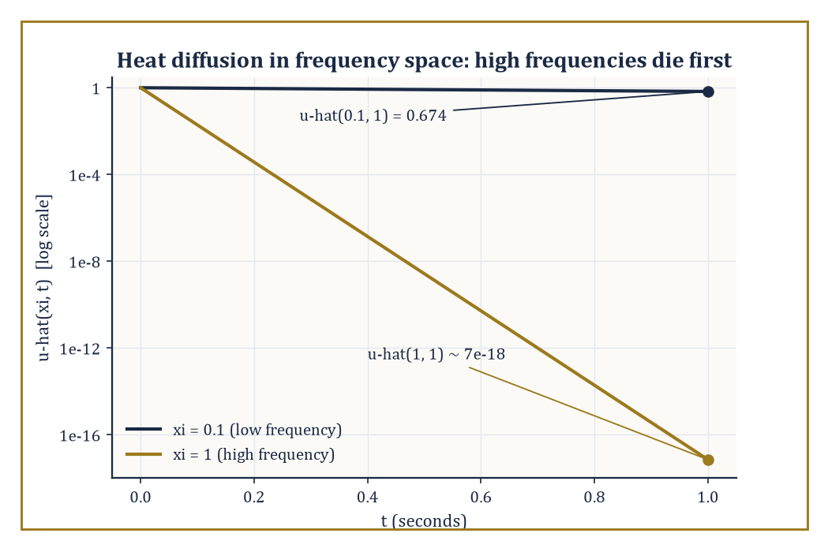
The heat equation solved by inspection in frequency space: high frequencies are annihilated almost at once, low ones linger.
One designs the filter by specifying the desired shape of the transfer function directly in frequency space (where the requirement — 'remove everything above 4 kHz' — is easy to state), then either applies it there via the DFT/FFT, or transforms it back to a time-domain impulse response and applies it as a convolution, whichever is computationally cheaper for the task at hand.
Numeric example — Worked example — the simplest possible low-pass filter. Take the DFT computed in Room 17.5:
x = [1, 2, 3, 4], X = [10, −2+2i, −2, −2−2i]
The crudest imaginable low-pass filter keeps only the zero-frequency (DC) component and discards everything else:
Y = [10, 0, 0, 0]
Inverting via xⱼ = (1/n)Σₖ Yₖ e^{2πijk/n} gives, since only the k = 0 term survives,
xⱼ = (1/4)(10) = 2.5 for every j
The filtered output is the constant sequence [2.5, 2.5, 2.5, 2.5] — and indeed the mean of the original data (1+2+3+4)/4 = 2.5. Keeping only the DC component of a spectrum and inverting always returns the average of the signal: the most extreme possible low-pass filter, with a cutoff of essentially zero, degenerates to computing a mean. Every less extreme low-pass filter interpolates between this constant output and the original, unfiltered signal.
Numeric example — Worked example — and its complementary high-pass filter. The complementary high-pass filter does the opposite: discard only the DC term and keep everything else,
Z = [0, −2+2i, −2, −2−2i]
Because the original spectrum splits exactly as X = Y + Z (low-pass component plus high-pass component, with no overlap and nothing double-counted), the corresponding time-domain signals must also add back to the original: inverting Z gives zⱼ = xⱼ − 2.5, namely
z = [−1.5, −0.5, 0.5, 1.5]
Check: adding the low-pass output [2.5, 2.5, 2.5, 2.5] to this high-pass output gives
[2.5, 2.5, 2.5, 2.5] + [−1.5, −0.5, 0.5, 1.5] = [1, 2, 3, 4]
the original signal, exactly. A high-pass filter, in other words, is precisely what is left over after the mean has been subtracted away — it captures fluctuation around the average, discarding the average itself, which is why high-pass filtering is the standard first step in removing a slowly drifting baseline from a noisy measurement.
Constant-coefficient linear partial differential equations, defined on the whole line or on a periodic domain (a torus), become ordinary differential equations — or, after also transforming time, plain algebraic equations — once Fourier-transformed in the spatial variable. The reason is exactly the eigenfunction fact from Room 17.2: spatial derivatives become multiplication by powers of 2πiξ, so a differential operator in x becomes a polynomial in ξ acting by multiplication. The heat equation, the wave equation, and Laplace's equation all become transparent — often trivial — once transformed; the inverse transform then returns the solution in the original physical variables.
Numeric example — Worked example — the heat equation in Fourier space. The heat equation u_t = u_xx, Fourier-transformed in x (using the rule that ∂²/∂x² becomes multiplication by (2πiξ)² = −4π²ξ²), turns into the ordinary differential equation, for each fixed frequency ξ:
∂û/∂t = −4π²ξ²·û(ξ,t)
This solves immediately:
û(ξ,t) = û(ξ,0)·e^{−4π²ξ²t}
Suppose û(ξ,0) = 1 at ξ = 0.1 (an arbitrarily normalised low-frequency component). After t = 1 second:
û(0.1, 1) = e^{−4π²(0.01)(1)} = e^{−0.3948} = 0.674
the component has decayed to about two-thirds of its initial strength. Compare a higher frequency, ξ = 1, under the same conditions:
û(1,1) = e^{−4π²(1)(1)} = e^{−39.48} ≈ 7 × 10^{−18}
— indistinguishable from zero. High-frequency components (sharp spatial detail) are annihilated by diffusion almost instantly, while low-frequency components (broad, smooth features) persist; this is the Fourier-space explanation of why heat diffusion smooths everything it touches, blurring fine detail long before it erodes the broad shape of a temperature distribution.
In signal processing more broadly, the DFT and FFT are the working engines behind spectrum analysis (turning a recorded waveform into a picture of which frequencies it contains), OFDM communication (splitting a data stream across many narrow, mutually orthogonal frequency subcarriers — orthogonal in exactly the inner-product sense of Room 17.3 — so that many independent channels can share one transmission band without interfering), and MRI reconstruction (where the raw data collected by a scanner is literally samples of the Fourier transform of the tissue's spatial density, and the image itself is recovered by an inverse two-dimensional FFT).
The mathematical structure underneath all three is identical; only the physical meaning attached to the variables x and ξ changes — time and audio frequency, or antenna time-slot and radio frequency, or spatial position and spatial frequency.
It is worth dwelling for a moment on just how strange the MRI case is, because it inverts the usual intuition about what is 'directly observed'. A scanner never measures tissue density itself; the physics of nuclear magnetic resonance hands the machine samples of the Fourier transform of that density, point by point, arranged on a grid engineers call k-space. The clinically useful picture — the image a radiologist actually reads — exists only after an inverse two-dimensional FFT has been applied to that raw data. Every MRI scan performed anywhere in the world is, quite literally, an application of Room 17.3's inversion formula to real, physical measurements; the abstract machinery of this storey is not a metaphor for medical imaging; it is medical imaging.

Room 17.8: Windows, Uncertainty, and Limitations
You Cannot Have It All, and Here Is the Proof
Every real signal is finite in duration — nobody has ever recorded a sound for all eternity, however long certain lectures may have felt. Analysing a finite chunk of an otherwise longer signal is mathematically equivalent to multiplying the ideal (infinite) signal by a window function that is 1 over the observed interval and 0 outside it, and multiplication in time is convolution in frequency (the dual of the convolution theorem from Room 17.4).
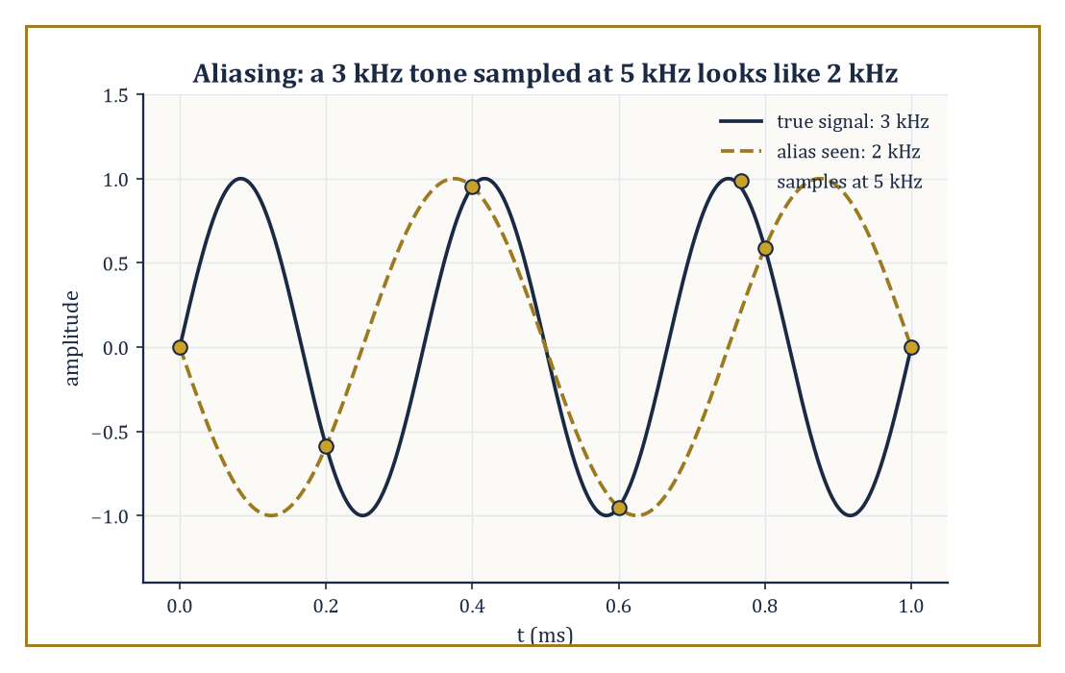
A 3 kHz tone sampled below the Nyquist rate lands, unrecoverably, on exactly the same samples as a 2 kHz tone.
The observed spectrum is therefore not the true spectrum but the true spectrum smeared — convolved — with the transform of the window. A rectangular window (simply chopping the signal off) has a transform that is the sinc function of Room 17.2, whose fat, slowly decaying side-lobes smear energy from a true, sharp spectral line out across many neighbouring frequencies, an effect called spectral leakage.
Softer windows (Hann, Hamming, Kaiser, and other named shapes, each a small taper toward zero at the ends of the observed interval rather than an abrupt cut) trade a wider central lobe (less precise localisation of a true frequency) for smaller side-lobes (less leakage into neighbouring frequencies) — there is no window that improves both simultaneously.
Numeric example — Worked example — how leaky is a plain rectangular window?. The rectangular window's transform is sinc(ξ), with its first zero at ξ = 1 and its first side-lobe peak shortly afterward, near ξ ≈ 1.5. Evaluate there:
sinc(1.5) = sin(1.5π)/(1.5π) = sin(270°)/(4.712) = (−1)/4.712 = −0.2122
Relative to the main peak, sinc(0) = 1, this side-lobe has magnitude 0.2122, or in decibels:
20 log₁₀(0.2122) = 20 × (−0.6733) = −13.5 dB
That figure — a rectangular window's leakage sits only around 13 dB below its main peak, a rather modest amount of suppression — is the textbook justification for reaching for a gentler window whenever a weak spectral feature needs to be resolved next to a strong one; the strong one's leakage would otherwise simply bury it.
Underneath all window design lies a hard mathematical limit, not merely an engineering inconvenience: the uncertainty principle. It states that a function and its Fourier transform cannot both be arbitrarily sharply concentrated — informally, a signal that is very short in time necessarily has a very broad spread of frequencies, and a signal built from a very narrow band of frequencies necessarily rings on for a very long time.
Quantitatively, if σₓ and σξ denote the standard deviations (a measure of spread) of |f(x)|² and |f̂(ξ)|² respectively, then:
σₓ·σξ ≥ 1/(4π)
Equality is achieved only by the Gaussian. This is not a statement about measurement technology or clever engineering getting around a limitation; it is a theorem, as unforgiving as anything in this Tower, and it is the mathematical reason every spectrogram (a picture of how a signal's frequency content changes over time) faces an inescapable trade-off between time resolution and frequency resolution.
Worked example — Worked example — the Gaussian achieves the uncertainty bound exactly. Take f(x) = e^{−πx²} once more, so |f(x)|² = e^{−2πx²}. Its variance in x is:
σₓ² = ∫x²e^{−2πx²}dx / ∫e^{−2πx²}dx
Using the standard Gaussian-integral ratio:
∫x²e^{−ax²}dx / ∫e^{−ax²}dx = 1/(2a)
with a = 2π, this gives:
σₓ² = 1/(4π) ≈ 0.0796, so σₓ ≈ 0.2821
Because f̂(ξ) = e^{−πξ²} has exactly the same functional form (self-duality again earning its keep), the same computation on the transform side gives:
σξ² = 1/(4π) ≈ 0.0796, so σξ ≈ 0.2821
The product is:
σₓ²σξ² = 1/(16π²), i.e. σₓσξ = 1/(4π) ≈ 0.0796
This lands exactly on the uncertainty bound, with equality rather than strict inequality. No other function does better; the Gaussian is, in this precise sense, the most simultaneously localised shape that a signal and its spectrum can ever jointly achieve, which is why it turns up as the 'ideal' window shape in more sophisticated time-frequency analysis, and (not coincidentally) why it saturates the analogous quantum-mechanical uncertainty relation between position and momentum.
A second, entirely separate limitation deserves mention before we leave this Room, since it governs the sampling rate rather than the window shape: the Nyquist–Shannon sampling theorem. It states that a signal containing no frequency component above some limit B can be perfectly reconstructed from samples taken at a rate of at least 2B per unit time; sample any slower, and distinct high frequencies become indistinguishable from — literally fold down onto — lower ones, a phenomenon called aliasing.
This is not a subtle numerical artefact but a hard mathematical consequence of the DFT machinery: sampling a continuous signal is itself a kind of modulation with the sampling comb, and the convolution theorem of Room 17.4 says the resulting spectrum is periodic with period equal to the sampling rate, so any true frequency above half that rate gets reflected back into the range the sampled data can actually represent.
Numeric example — Worked example — aliasing a signal sampled too slowly. Suppose a pure tone at 3 kHz is sampled at 5 kHz — well-intentioned, but short of the 6 kHz that the Nyquist rate (twice the signal frequency) would require. The Nyquist frequency for this sampling rate is half of 5 kHz, i.e. 2.5 kHz, and the true 3 kHz component lies above it, so it cannot be represented faithfully.
The alias it folds down to is found by reflecting 3 kHz around the Nyquist frequency of 2.5 kHz: the reflected frequency is
2×2.5 − 3 = 2 kHz
A listener examining only the sampled data would see, incorrectly but unambiguously, a tone at 2 kHz — the original 3 kHz information is not merely attenuated but permanently and unrecoverably relabelled as a lower frequency that was never actually present. This is precisely why audio equipment places an anti-aliasing (low-pass) filter before the analogue-to-digital converter, removing any content above half the sampling rate before it has the chance to masquerade as something it isn't.
Understanding these limitations is not a footnote to Fourier analysis; it is half of the subject. Every practical use of the transform — every spectrum plotted, every filter designed, every PDE solved numerically — is an approximation shaped by the finite window one was forced to use, the finite sampling rate at which the continuous world was digitised, and the finite precision with which a computer represents a real number.
Signals with genuinely transient features (a sudden click, a short burst) are handled poorly by plain Fourier methods precisely because of the uncertainty trade-off just proved; this is the opening through which wavelets, waiting in Storey 40, make their entrance — they deliberately sacrifice some frequency purity in exchange for simultaneous localisation in time, a bargain that plain sines and cosines, being infinitely long-lived oscillations by nature, are constitutionally unable to strike.

Room 17.9: Looking Ahead: From Fourier to Laplace, Wavelets, and Spectral Theory
The View From the Top of This Storey
We have now assembled the core of Fourier analysis, and it is worth taking stock of the whole climb rather than just the last step.
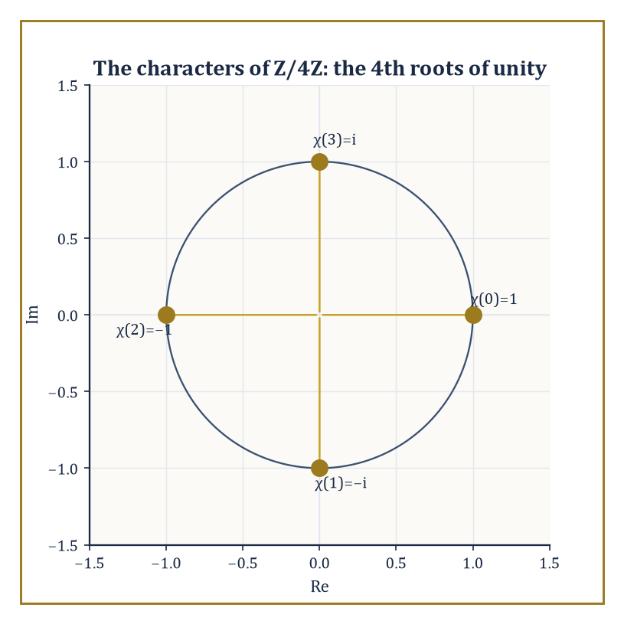
The 4th roots of unity, the characters of ℤ/4ℤ — every DFT matrix entry in this storey was one of these four points all along.
Fourier series (Storey 16) decomposed periodic functions into a discrete comb of pure oscillations; letting the period run to infinity (Room 17.1) turned that comb into a continuum, giving the Fourier transform on the line (Room 17.2).
Inversion and Plancherel (Room 17.3) confirmed that nothing was lost in the process, only relabelled, and that the relabelling preserves a natural notion of energy; the convolution theorem (Room 17.4) turned the transform into the single most useful computational shortcut in the whole toolkit.
The DFT (Room 17.5) transplanted every one of these ideas to finite, computer-friendly data; the FFT (Room 17.6) made that transplant fast enough to matter at scale; and Room 17.7 put the machinery to work on filters, on partial differential equations, and on the signal-processing technologies that quietly run in the background of modern life, before Room 17.8 insisted, rightly, that none of this comes for free.
All of this generalises.
The deepest structural fact underlying the entire storey is that translation-invariant linear operators — operators that treat every point of space or every moment of time alike, with no preferred origin — are exactly the operators diagonalised by the Fourier transform.
Convolution with a fixed function h is one such operator, and we have already seen it act as multiplication by ĥ(ξ) on each frequency component.
This single idea reappears, essentially unchanged in spirit, throughout mathematics and physics: as the spectral theorem for translation-invariant operators (Storey 35 and beyond), as the machinery of Fourier analysis on finite groups and on more exotic algebraic structures such as the adeles in number theory, and as the mathematical language of quantum mechanics, where the Fourier transform relates the position and momentum representations of a quantum state and the uncertainty principle of Room 17.8 is, quite literally, the Heisenberg uncertainty principle in another guise.
Abstract example — Abstract example — a convolution operator, viewed as a diagonal matrix in disguise. Let h be a filter with transfer function
ĥ(ξ) = 1/(1 + ξ²)
A smooth, everywhere-positive low-pass shape that suppresses high frequencies without ever fully zeroing them out. Consider the pure oscillation e^{2πix(2)}, i.e. the frequency-2 component of some signal. Convolving with h acts on this component exactly as an eigenvalue would:
(h * e^{2πi·2x}) = ĥ(2)·e^{2πi·2x} = [1/(1+4)]·e^{2πi·2x} = 0.2·e^{2πi·2x}
The shape of the oscillation is completely unchanged, only its amplitude is scaled, here down to a fifth of its original size. Compare the frequency-0 (constant) component:
ĥ(0) = 1/(1+0) = 1
Left entirely alone. This is the whole content of 'diagonalisation' in one small, checkable instance: in the basis of pure frequencies, the convolution operator h* is represented not by some complicated matrix mixing frequencies together, but by a diagonal matrix whose k-th diagonal entry is simply ĥ(k) — an infinite-dimensional analogue of a diagonal matrix in ordinary linear algebra, where multiplying by a diagonal matrix scales each coordinate axis independently and leaves the axes themselves untouched.
The DFT of Room 17.5, in particular, is nothing other than Fourier analysis on the cyclic group of order n — the group ℤ/nℤ of integers modulo n under addition.
Its n eigen-frequencies, the n-th roots of unity, are precisely the group's characters: the homomorphisms from ℤ/nℤ into the complex numbers of modulus 1, each one respecting the group's addition — a character χ satisfies
χ(a+b) = χ(a)χ(b)
Every finite abelian group has its own such family of characters and its own version of the DFT built from them; the classical DFT is simply the case of a single cyclic group, chosen because it is the shape that time, sampled at evenly spaced instants, naturally takes.
Abstract example — Abstract example — the roots of unity as group characters. Take n = 4 again, so the group is ℤ/4ℤ = {0, 1, 2, 3} under addition modulo 4, and consider the character
χ(k) = ω^k = (−i)^k
Used throughout Room 17.5 and 17.6. Check the defining property χ(a+b) = χ(a)χ(b) for a = 1, b = 2 (so a+b = 3 mod 4):
χ(1)χ(2) = (−i)(−1) = i
χ(3) = (−i)³ = i
They agree. Check also a = 3, b = 2 (so a+b = 5 mod 4 = 1):
χ(3)χ(2) = (i)(−1) = −i
χ(1) = −i
Agreed again. This is the abstract fact hiding inside every DFT computation in this storey: the entries ω^{jk} of the DFT matrix are not an arbitrary convenient choice, but exactly the characters of the group of sample indices, and the DFT is the special case, for this particular group, of a construction (Fourier analysis on locally compact abelian groups) that also produces the classical Fourier series (the group is the circle), the Fourier transform on the line (the group is the real numbers themselves), and — considerably further up this Tower — Fourier analysis on the adeles that underlies parts of modern number theory.
The Fourier transform's near neighbour, waiting immediately next door in Storey 18, is the Laplace transform — built from the same family of exponentials but weighted by a real (or complex, with positive real part) decay rate rather than a purely imaginary oscillation frequency, which suits it particularly well to causal signals (those that switch on at a definite starting moment and are silent before it) and to initial-value problems, where one is given the state of a system at time zero and asked to predict its future rather than to analyse an eternally-existing signal.
Where the Fourier transform asks 'which frequencies are present, for all time', the Laplace transform asks 'given where we start, how does the system evolve' — a change of emphasis rather than a change of underlying machinery, and one that will feel remarkably familiar by the time we arrive.
The deeper lesson of this entire storey, stated plainly, is that a great many of the operators nature actually hands us are diagonalised by waves — and that the mathematics of those waves, having started as a slightly suspicious trick for solving the heat equation two centuries ago, has become both theoretically deep and practically indispensable in roughly equal measure.
Fourier transforms and the FFT are, in the end, the mathematics of frequency: they are what you get when you insist on asking not 'what is happening', but 'at what rate is it oscillating', of absolutely everything.
The Tower continues upward. We have learned to hear the frequencies hidden inside a signal; next, we learn to watch a system evolve from the moment it is switched on.
We have learned to hear the frequencies hidden inside a signal — to take an object that lives, stubbornly, in one variable (time, or position) and rewrite it, losing nothing, in terms of another (frequency) in which the operators we actually care about become almost embarrassingly simple. That rewriting, and the fast algorithm that makes it affordable at any scale worth caring about, is one of the genuine load-bearing pillars of the last hundred years of applied mathematics; very little of modern engineering would run without it, and a surprising amount of pure mathematics leans on it too.
Storey 18 waits next door with the Laplace transform, built from the same family of ideas but tuned to systems that switch on at a definite moment and are asked to evolve forward rather than to have existed, placidly, for all time. The exponentials will look almost identical; the questions we ask of them will not. Mind the step — and bring your newly acquired taste for diagonalising operators with you, because it is about to be tested again.

Storey 18: Laplace Transform
Turning Differential Equations into Algebra, and the Art of Transforming the Time Domain
One storey ago we spent a good while inside the Fourier transform, coaxing a function defined for all eternity — t running from minus infinity to plus infinity — into a spectrum of pure frequencies. It was gorgeous work, and symmetric in the particular way that only things which have never had to meet a deadline can afford to be. Somewhere below the stairwell, though, an engineer was tapping her foot. Her circuits do not exist from the dawn of time; they get switched on at a specific moment, generally by someone flicking a specific switch, and she would very much like a transform willing to agree that history begins at t = 0, thank you, and not one instant before.
That transform already existed, invented — or at least popularised, with a recklessness that scandalised the pure mathematicians of the day — by Oliver Heaviside, an engineer who treated differentiation as an algebraic symbol you could multiply and divide like any other, got startlingly correct answers, and left it to later generations to explain, with some embarrassment, why it had worked all along. The Laplace transform is the tidied-up, fully rigorous version of Heaviside's cheek. It multiplies a function f(t), living only on t ≥ 0, by a decaying exponential e^{−st} and integrates the product from 0 to ∞. That single act of discounting the future is enough to tame integrals that would leave the Fourier transform (which insists on the whole real line and no such discount) staring blankly into space.
What that one act buys us is remarkable: differentiation in time becomes multiplication by s. Integration becomes division by s. A linear differential equation with constant coefficients — the sort of thing we spent earlier storeys solving by separation, integrating factors, and the characteristic-equation trick — collapses into a plain algebraic equation for a new unknown, F(s), which any reasonably numerate teenager can solve. Discontinuous switches and instantaneous shocks, the sort of forcing that makes classical methods break out in a rash of case distinctions, are handled by two or three elementary transform pairs and no drama whatsoever. This storey builds that machine from its definition upward: the basic transforms, the operational rules, the inverse transform by partial fractions, the application to differential equations and systems, the handling of switches and impulses, the convolution theorem, and a first glimpse of the transfer-function language that control engineers speak fluently and everyone else pretends to.
A small confession before we start: the Laplace transform feels like cheating the first time you use it, and it does not entirely stop feeling that way. An equation that looked formidable in the time domain turns, almost insultingly easily, into a rational function that any first-year student can decompose by partial fractions. The cheating is legitimate. The transform has simply relocated the difficulty to a room where ordinary algebra is on duty. Let's transform.

Room 18.1: What the Laplace Transform Actually Is
In Which a Function Meets a Damping Factor and Agrees to Behave
Take a function f(t), defined for t ≥ 0 — no need to worry about what it was doing before the clock started, which is one of the small mercies of this whole enterprise. Multiply it, at every instant t, by the weight e^{−st}, where s is a number (real for now, complex in general) chosen large enough that the weight decays fast. Add up all those weighted values by integrating from 0 to ∞. The result is a new function, F(s), called the Laplace transform of f, and written L{f(t)} or F(s) interchangeably depending on how lazy the author is feeling.
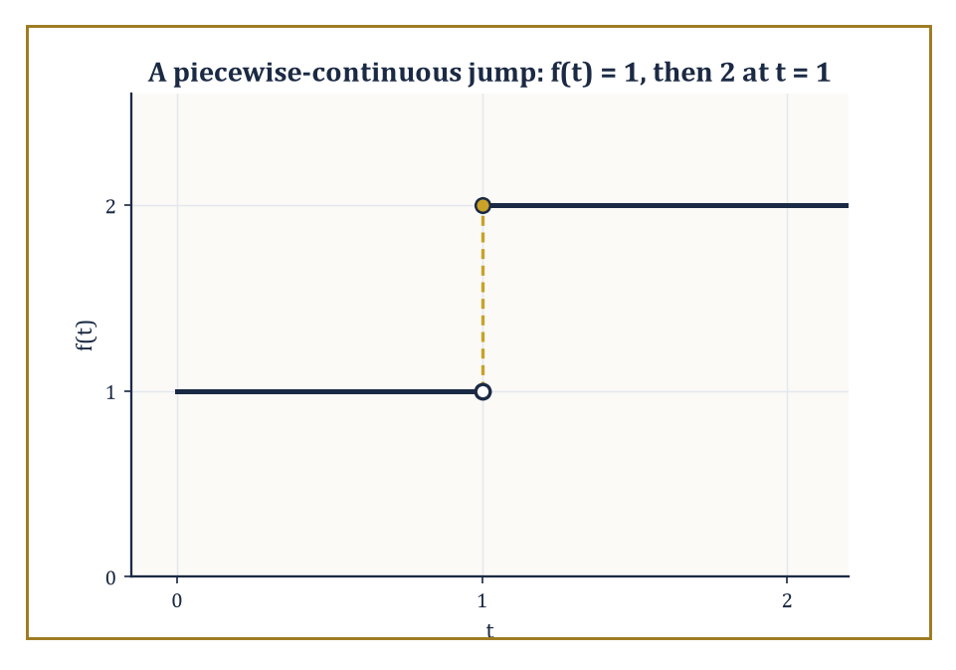
A function that doubles in height at t = 1 — piecewise continuity is all the smoothness the integral ever asks for.
F(s) = ∫₀^∞ e^{−st} f(t) dt
This holds provided the improper integral converges. Think of s as an impatience dial: turn it up, and the transform cares less and less about what f does far in the future, weighting early behaviour heavily and later behaviour into near-irrelevance. This is precisely the discounting that lets the transform succeed where an infinite, undiscounted sum over all of time — the Fourier transform's playground — sometimes fails.
Numeric example — Worked example — the transform of a constant. Let f(t) = 1 for all t ≥ 0. By the definition,
F(s) = ∫₀^∞ e^{−st}·1 dt
Antidifferentiate:
∫ e^{−st} dt = −e^{−st}/s
Evaluate between 0 and ∞, assuming s > 0 so that e^{−st} → 0 as t → ∞:
F(s) = [−e^{−st}/s]₀^∞ = (0) − (−1/s) = 1/s
So L{1} = 1/s, the single most-used entry in the entire table, and a fine illustration of the mechanism: a function that never decays on its own borrows its decay entirely from e^{−st}, and the integral converges precisely because s was chosen positive enough to win that race.
The variable s deserves a proper introduction. In general it is complex, s = σ + iω, and the transform converges for all s with real part σ large enough — a half-plane called the region of convergence. For most of the elementary work in this storey you may simply picture s as a large positive real number without losing anything essential; the complex picture becomes indispensable later, in the discussion of poles, stability, and the inversion integral (Room 18.7 and Room 18.8 will need it).
Notice, too, the deliberate asymmetry with the Fourier transform of the previous storey: Fourier integrated over the whole real line and needed f to be absolutely integrable there, which ruled out perfectly sensible functions such as f(t) = e^{t} or even f(t) = t. Laplace only needs f defined for t ≥ 0, and the decaying weight e^{−st} can absorb a considerable amount of growth in f, provided that growth is at worst exponential — a function is said to be 'of exponential order' if |f(t)| ≤ M e^{ct} for some constants M, c and all large t. Nearly everything you meet in an undergraduate differential-equations course qualifies.
Numeric example — Worked example — the transform of an exponential. Let f(t) = e^{at} for a fixed real constant a. Then
F(s) = ∫₀^∞ e^{−st} e^{at} dt = ∫₀^∞ e^{−(s−a)t} dt
This is the same integral as before with s replaced by s − a, so by the previous result F(s) = 1/(s − a), valid whenever s > a (so that s − a > 0 and the integral converges). Check the boundary behaviour explicitly:
[−e^{−(s−a)t}/(s−a)]₀^∞ = 0 − (−1/(s−a)) = 1/(s−a)
So L{e^{at}} = 1/(s − a). Setting a = 0 recovers L{1} = 1/s from the previous example, as it must.
Two structural facts make the whole storey possible. First, the transform is linear:
L{αf(t) + βg(t)} = αF(s) + βG(s)
This is immediate from the linearity of the integral itself — nothing to prove, everything to exploit. Second, and far less obvious, the transform is essentially one-to-one on the well-behaved functions that show up in applications: this is Lerch's theorem, which says that if two functions, both continuous and of exponential order, have the same Laplace transform, then they are identical. ('Essentially' is doing a small amount of work in that sentence, and we will pin down exactly how much in a moment.) Because the map from f to F is injective on this class, it makes sense to speak of the inverse transform, L⁻¹{F(s)}, as a well-defined operation — solve the algebra for F, and there is exactly one sensible f waiting to be recovered, which is the entire strategy of Room 18.4 in a single sentence.
Abstract example — Abstract example — when the discount isn't enough, and when uniqueness is only 'essential'. Consider f(t) = e^{t²}. For any fixed s, the integrand is e^{−st} e^{t²} = e^{t² − st}, and since t² eventually outgrows st for any fixed s no matter how large, the exponent t² − st → +∞ as t → ∞. The integral diverges for every value of s: f grows faster than exponential order can absorb, and it simply has no Laplace transform.
Contrast this with a subtler case that tests Lerch's theorem itself. Let g(t) = 1 for all t ≥ 0 except g(2) = 100. Since a single point contributes nothing to the value of an integral (it has zero width),
G(s) = ∫₀^∞ e^{−st} g(t) dt = ∫₀^∞ e^{−st}·1 dt = 1/s
This is exactly the same transform as the honest constant function 1. Two genuinely different functions, one Laplace transform between them — which is why Lerch's theorem is stated for continuous functions, where such isolated sabotage cannot happen, and why 'the' inverse transform is unique only up to alterations on a set that never affects anything you would actually compute.
One further practical point, easy to overlook and worth stating plainly: the functions admitted to this club need not be continuous, only piecewise continuous, meaning they are allowed a finite number of jump discontinuities on every bounded interval, provided the left- and right-hand limits exist at each jump. This matters enormously in practice, because it is precisely what licenses the switch-like functions of Room 18.5 — a voltage that snaps from 0 to 5 volts the instant a switch closes is not continuous, but it is piecewise continuous, and the integral defining F(s) does not notice a jump any more than it noticed the isolated altered point in the abstract example above. A single instant of discontinuity, like a single point, has zero width and contributes nothing to the area under the curve.
Numeric example — Worked example — a genuine jump, handled by splitting the integral. Let f(t) = 1 for 0 ≤ t < 1, and f(t) = 2 for t ≥ 1 — a step that doubles in height at t = 1 rather than switching on from nothing, so this is not simply the earlier constant-function example in disguise. The integral defining F(s) does not mind the jump; it merely needs splitting at t = 1:
F(s) = ∫₀¹ e^{−st}·1 dt + ∫₁^∞ e^{−st}·2 dt
The first piece is
[−e^{−st}/s]₀¹ = (1 − e^{−s})/s
The second is
2[−e^{−st}/s]₁^∞ = 2(0 − (−e^{−s}/s)) = 2e^{−s}/s
Adding them:
F(s) = (1 − e^{−s})/s + 2e^{−s}/s = (1 + e^{−s})/s
One discontinuity, one extra line of bookkeeping, and the integral converges exactly as happily as it did for the honest constant function of the very first example — proof, in miniature, that piecewise continuity is all the smoothness this transform ever asks for.
So: a definition, a convergence condition, and a promise that the map is (essentially) reversible. What is still missing is a library — we do not want to re-derive 1/(s − a) from scratch every time an exponential turns up in a differential equation, and we certainly do not want to integrate by parts four times to find the transform of t³. Room 18.2 builds that library, along with the operational rules that turn 'the transform of a derivative' into a one-line algebraic substitution — the single fact on which the rest of this storey depends.

Room 18.2: Basic Transforms and Operational Rules
A Short, Smug Table, and the Rules That Make It Sing
The transforms of the elementary functions — constants, powers, exponentials, sines, cosines, and their hyperbolic cousins — are all rational functions of s, and every one of them can be computed directly from the definition, usually by a single integration by parts or by differentiating under the integral sign with respect to a parameter (the same Feynman-style trick that solves an alarming number of otherwise stubborn integrals). Rather than re-derive each entry here, note the pattern for powers of t: repeated integration by parts on ∫₀^∞ tⁿ e^{−st} dt peels off one power of t and one factor of n/s at a time, giving the tidy closed form
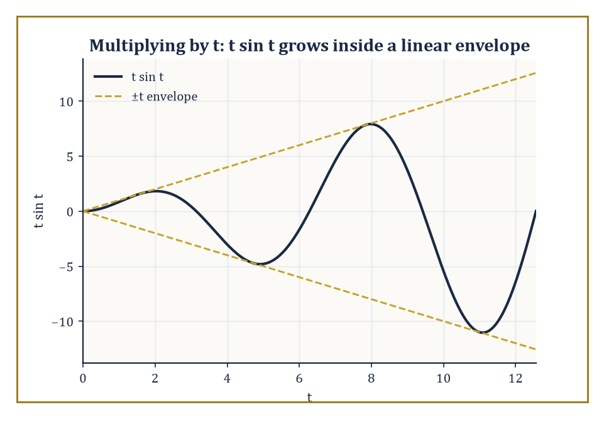
Multiplying by t in the time domain does exactly what it sounds like: it lets the oscillation grow, trapped between the lines ±t.
L{tⁿ} = n!/s^{n+1}, for any non-negative integer n
Set n = 0 and this correctly reduces to 0!/s = 1/s, the constant function's transform from Room 18.1.
Numeric example — Worked example — the transform of t³. By the formula above with n = 3:
L{t³} = 3!/s⁴ = 6/s⁴
To see the pattern that produces it, integrate by parts once: ∫₀^∞ t³ e^{−st} dt, with u = t³, dv = e^{−st} dt, so du = 3t² dt, v = −e^{−st}/s. This gives
[−t³e^{−st}/s]₀^∞ + (3/s)∫₀^∞ t² e^{−st} dt
The boundary term vanishes at both ends (0 at t = 0 since t³ = 0; 0 as t → ∞ since the exponential beats any power of t to zero), leaving (3/s)L{t²}. Repeating the same trick twice more strips off a 2/s and then a 1/s, and finally L{1} = 1/s, so altogether
L{t³} = (3/s)(2/s)(1/s)(1/s) = 6/s⁴
— the '3!' is simply the record of three such peelings.
The table of basic pairs is useful, but the operational rules are the actual engine of the subject, because they are what let a differential equation become an algebraic one. Linearity has already been noted. Far more important is the derivative rule:
L{f′(t)} = sF(s) − f(0)
One derivative in the time domain becomes one multiplication by s in the transform domain, minus a correction term that is nothing but the initial condition, arriving automatically and free of charge. Differentiate again and the pattern iterates:
L{f″(t)} = s²F(s) − s f(0) − f′(0)
This is the single fact that makes Room 18.4 possible — an initial-value problem transforms directly into an algebraic equation with the initial conditions already built in, with no separate step of 'now apply the initial conditions to the general solution' ever required.
Numeric example — Worked example — checking the derivative rule against direct differentiation. Let f(t) = cos(2t), so f(0) = 1 and F(s) = L{cos(2t)} = s/(s² + 4) (a standard pair, derivable the same way as L{sin(bt)} = b/(s² + b²) by differentiating under the integral or by direct integration by parts twice). The derivative rule predicts
L{f′(t)} = sF(s) − f(0) = s·s/(s²+4) − 1 = s²/(s²+4) − 1 = (s² − (s²+4))/(s²+4) = −4/(s²+4)
Now check directly: f′(t) = −2 sin(2t), and
L{−2 sin(2t)} = −2·(2/(s²+4)) = −4/(s²+4)
The two computations agree exactly, as the rule guarantees they always will.
Two further rules round out the operational toolkit for now. The first shifting theorem: multiplying f(t) by e^{at} shifts the transform sideways,
L{e^{at} f(t)} = F(s − a)
— an exponential in time becomes a translation in the frequency-like variable s. The second, less obvious rule concerns multiplying f(t) by t itself: this corresponds to differentiating the transform with respect to s and flipping the sign,
L{t f(t)} = −F′(s)
(A second shifting theorem, going the other way — shifting in time rather than in s — is coming in Room 18.5, once we have a function worth shifting.)
Numeric example — Worked example — first shifting theorem. Find L{e^{3t} sin(2t)}. Start from F(s) = L{sin(2t)} = 2/(s² + 4). By the first shifting theorem with a = 3,
L{e^{3t} sin(2t)} = F(s − 3) = 2/((s−3)² + 4)
No new integration required — the exponential envelope simply relocates the pole structure of the plain sine transform three units to the right along the real s-axis.
Numeric example — Worked example — multiplication by t. Find L{t sin t}. Here F(s) = L{sin t} = 1/(s² + 1) (taking b = 1). Differentiate:
F′(s) = d/ds[(s²+1)^{-1}] = −(2s)/(s²+1)²
By the multiplication-by-t rule,
L{t sin t} = −F′(s) = 2s/(s²+1)²
A quick sanity check on the exponents: t sin t grows only linearly against an oscillation, so a transform with a double pole at s = ±i (rather than the single pole of plain sin t) is exactly the kind of 'slightly worse decay, slightly higher-order pole' behaviour one should expect from an extra factor of t.
The hyperbolic functions round out the basic library, and are worth a moment because they show linearity earning its keep rather than sitting there as a throwaway remark. Recall
sinh(at) = (e^{at} − e^{−at})/2, cosh(at) = (e^{at} + e^{−at})/2
Since the transform is linear and the transform of each exponential piece is already known from Room 18.1, both hyperbolic transforms follow with no new integration whatsoever.
Numeric example — Worked example — a hyperbolic transform from linearity alone. Find L{sinh(2t)}. Write sinh(2t) = (e^{2t} − e^{−2t})/2. By linearity,
L{sinh(2t)} = (1/2)[L{e^{2t}} − L{e^{−2t}}] = (1/2)[1/(s−2) − 1/(s+2)]
Put the bracket over a common denominator:
1/(s−2) − 1/(s+2) = [(s+2) − (s−2)]/((s−2)(s+2)) = 4/(s²−4)
So
L{sinh(2t)} = (1/2)·4/(s²−4) = 2/(s²−4)
This matches the general pattern L{sinh(at)} = a/(s²−a²) with a = 2, and the same argument gives L{cosh(at)} = s/(s²−a²) — note the family resemblance to L{sin(bt)} = b/(s²+b²) and L{cos(bt)} = s/(s²+b²), with a plus sign quietly turned into a minus. That sign flip is the entire algebraic distance between oscillation and exponential growth, and it will resurface the moment a denominator's roots turn out to be real instead of complex.
With this small collection — powers, exponentials, sines and cosines, hyperbolic functions, linearity, the derivative rule, and the two shifting theorems — most transforms encountered in an elementary course can be written down by inspection rather than by integration. The next task is to run the whole apparatus in reverse: given an F(s) that arose from solving an algebraic equation, how does one recover the f(t) that produced it? That is the inverse transform, and Room 18.3 is where partial fractions, already familiar from integral calculus, get a second career.

Room 18.3: The Inverse Transform and Partial Fractions
Undoing What We Did, One Fraction at a Time
Recovering f(t) from F(s) is the inverse Laplace transform, written
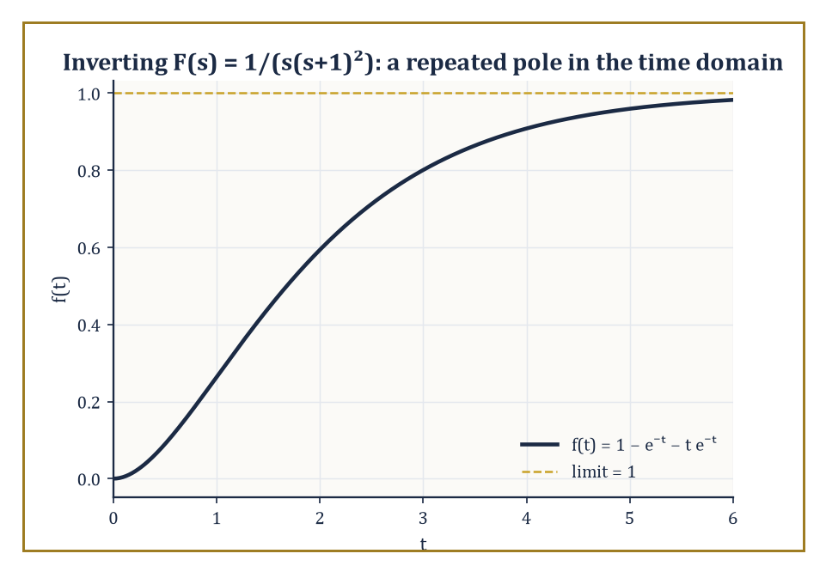
The time-domain payoff of a repeated pole: 1/(s(s+1)²) inverts to a curve that climbs steadily toward 1 and never overshoots.
f(t) = L⁻¹{F(s)}
Room 18.1 already established, via Lerch's theorem, that this operation is well-defined (up to the harmless isolated-point ambiguity we saw there) whenever f is continuous and of exponential order — which covers essentially everything this storey will ask of it.
For the rational functions that arise from solving linear differential equations with constant coefficients, the standard method is partial-fraction decomposition: break F(s) into a sum of simple pieces, each of which is immediately recognisable from the Room 18.2 table.
The algebra involved is identical to the partial-fraction technique from integral calculus; the only difference is that instead of integrating each piece, one simply reads its inverse transform off the table.
Numeric example — Worked example — distinct linear factors. Invert F(s) = (3s + 5)/((s − 1)(s + 2)). Write it as a partial-fraction decomposition:
(3s+5)/((s−1)(s+2)) = A/(s−1) + B/(s+2)
Clear denominators:
3s + 5 = A(s+2) + B(s−1)
Set s = 1, which kills the B term:
3(1)+5 = A(1+2) → 8 = 3A → A = 8/3
Set s = −2, which kills the A term:
3(−2)+5 = B(−2−1) → −1 = −3B → B = 1/3
So:
F(s) = (8/3)/(s−1) + (1/3)/(s+2)
and reading each term off the table:
f(t) = (8/3)e^{t} + (1/3)e^{−2t}
There is a shortcut for the distinct-linear-factor case worth knowing, informally called the cover-up method, and it is pure Heaviside in spirit: to find the coefficient of 1/(s−r) in the decomposition, literally cover up the (s−r) factor in the original denominator with a thumb and evaluate everything else at s = r.
It is exactly what happened algebraically above when we set s = 1 and s = −2 to kill off unwanted terms — the cover-up method simply skips the intermediate step of writing out the cleared-denominator equation.
Numeric example — Worked example — the cover-up method. Reconsider F(s) = (3s+5)/((s−1)(s+2)) from the previous example. To find A, the coefficient of 1/(s−1), cover up (s−1) and evaluate the rest at s = 1:
A = (3(1)+5)/(1+2) = 8/3
To find B, the coefficient of 1/(s+2), cover up (s+2) and evaluate the rest at s = −2:
B = (3(−2)+5)/(−2−1) = (−1)/(−3) = 1/3
Both values match the ones found the longer way, in a fraction of the writing — though the cover-up trick only survives intact when the factors are distinct and linear; repeated or quadratic factors need the fuller method demonstrated next.
Repeated linear factors behave a little differently, and it is worth having the mechanism in hand before it appears, unannounced, in the middle of a differential equation.
A factor of (s − r)^k in the denominator does not just contribute A/(s−r); it contributes a whole chain of terms:
A₁/(s−r) + A₂/(s−r)² + … + Aₖ/(s−r)^k
This is because the inverse transforms of 1/(s−r)², 1/(s−r)³, and so on are, respectively, t e^{rt}, (t²/2)e^{rt}, and further powers of t multiplying the same exponential — repetition in the pole structure becomes a polynomial-in-t envelope in the time domain.
Numeric example — Worked example — a repeated linear factor. Invert F(s) = 1/(s(s+1)²). Set up the partial-fraction decomposition:
1/(s(s+1)²) = A/s + B/(s+1) + C/(s+1)²
Clear denominators:
1 = A(s+1)² + Bs(s+1) + Cs
Set s = 0:
1 = A(1)² = A, so A = 1
Set s = −1:
1 = C(−1) = −C, so C = −1
To find B, expand and match the coefficient of s²: A(s+1)² contributes A = 1 to the s² coefficient, Bs(s+1) contributes B, and Cs contributes nothing to s². The right-hand side must equal the constant 1 (no s or s² term), so:
1 + B = 0, giving B = −1
As a check, the s¹ coefficient is:
2A + B + C = 2(1) + (−1) + (−1) = 0
as required. So:
F(s) = 1/s − 1/(s+1) − 1/(s+1)²
and inverting term by term:
f(t) = 1 − e^{−t} − t e^{−t}
Irreducible quadratic factors — ones that do not split over the reals — call for a third technique: complete the square in the denominator to expose a shifted sine or cosine, exactly the pattern produced by the first shifting theorem of Room 18.2.
A denominator s² + 2as + b becomes:
s² + 2as + b = (s+a)² + (b − a²)
and a numerator can usually be split into a piece proportional to (s+a) — which pairs with the shifted cosine — and a piece that is a pure constant, which pairs with the shifted sine.
Numeric example — Worked example — an irreducible quadratic factor. Invert F(s) = (s+1)/(s² + 2s + 5). Complete the square in the denominator:
s² + 2s + 5 = (s+1)² + 4
So:
F(s) = (s+1)/((s+1)² + 4)
Compare against the shifted-cosine pattern:
L{e^{−at} cos(bt)} = (s+a)/((s+a)²+b²)
Here a = 1 and b = 2 match exactly, with numerator (s+1) already in the required form and no leftover constant term to split off. Hence:
f(t) = e^{−t} cos(2t)
One loose end: what if F(s) is improper, meaning the numerator's degree is at least the denominator's? Long division peels off a polynomial in s, leaving a proper fraction to be handled as above.
The polynomial part corresponds, in the rigorous theory, to derivatives of the Dirac delta function — genuinely singular objects belonging to distribution theory, well beyond elementary work.
In practice, differential-equation problems at this level are set up so that Y(s) always comes out proper, and the issue never bites; it is flagged here only so that, if it ever does turn up, it is recognised as a known phenomenon and not a mistake in the algebra.
Numeric example — Worked example — an improper F(s), and where the leftover points. Suppose a calculation produced F(s) = (s³+2)/(s²+1) — improper, since the numerator's degree (3) is at least the denominator's (2), unlike every Y(s) actually solved in this storey. Long divide:
s³+2 = s·(s²+1) + (2−s)
so:
F(s) = s + (2−s)/(s²+1)
The remainder is proper and inverts normally:
(2−s)/(s²+1) = 2/(s²+1) − s/(s²+1)
giving 2 sin t − cos t by the ordinary table.
The leading term, a bare s left over from the division, has no such well-behaved partner; running the derivative rule backward, a plain factor of s in the transform domain is exactly what a derivative of the Dirac delta function would produce in the time domain.
Nothing here is a mistake — it is simply a reminder of why every Y(s) actually met in this storey came out proper: an improper one is quietly asking for an object this storey has declined to define.
With partial fractions and the completed-square trick in hand, and Lerch's theorem guaranteeing that whatever f(t) they produce is the correct one, the machinery is complete: transform an equation, solve algebraically, invert.
Room 18.4 puts that three-step routine to work on actual differential equations, where its full advantage over the classical methods of earlier storeys finally becomes visible.

Room 18.4: Solving Linear Differential Equations
Where Calculus Quietly Clocks Off and Algebra Takes the Late Shift
The procedure is now entirely mechanical, which is precisely its charm.
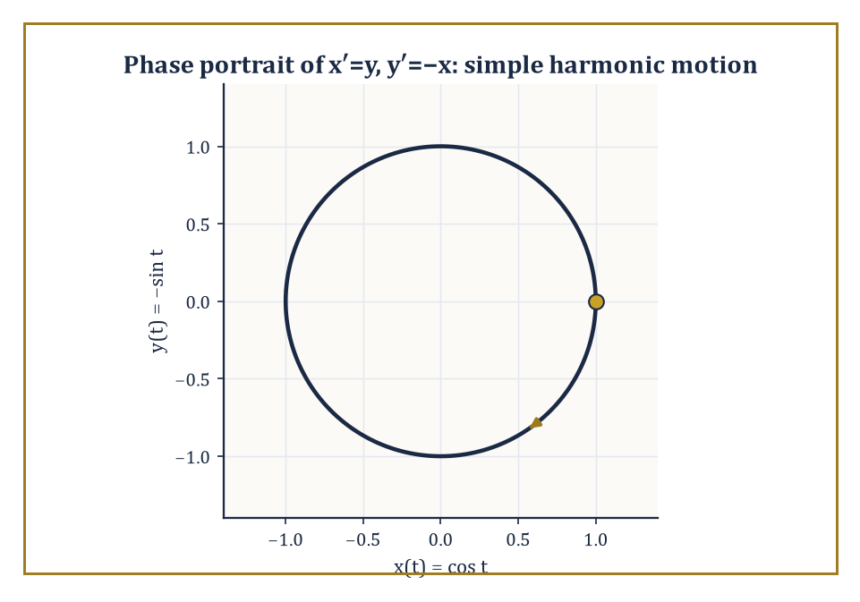
The system x′=y, y′=−x solved purely by algebra, traced out where it always lived: a circle in the phase plane.
Transform both sides of the differential equation, using the derivative rule of Room 18.2 to insert the initial conditions the moment they appear — not afterward, as in the classical method, but immediately, as an unavoidable part of transforming y′ and y″.
Solve the resulting algebraic equation for Y(s), the transform of the unknown function. Invert Y(s) by partial fractions (Room 18.3) or any other applicable method.
What comes out is the unique function satisfying both the differential equation and the prescribed initial conditions — no separate constant-fitting step, because the constants were fitted the instant the initial conditions were substituted into the algebra.
Numeric example — Worked example — a homogeneous initial-value problem. Solve y″ + 3y′ + 2y = 0, with y(0) = 1 and y′(0) = 0. Transform every term:
L{y″} = s²Y − s·y(0) − y′(0) = s²Y − s
L{3y′} = 3(sY − y(0)) = 3sY − 3
L{2y} = 2Y
Summing to zero:
s²Y − s + 3sY − 3 + 2Y = 0
(s² + 3s + 2)Y = s + 3
Y(s) = (s+3)/(s²+3s+2) = (s+3)/((s+1)(s+2))
Partial fractions:
(s+3)/((s+1)(s+2)) = A/(s+1) + B/(s+2)
s+3 = A(s+2) + B(s+1)
At s = −1:
2 = A(1), A = 2
At s = −2:
1 = B(−1), B = −1
So:
Y(s) = 2/(s+1) − 1/(s+2)
y(t) = 2e^{−t} − e^{−2t}
Check:
y(0) = 2 − 1 = 1 ✓
y′(t) = −2e^{−t} + 2e^{−2t}, y′(0) = −2+2 = 0 ✓
y″+3y′+2y = (2e^{−t}−4e^{−2t}) + 3(−2e^{−t}+2e^{−2t}) + 2(2e^{−t}−e^{−2t}) = 0
for every t, exactly as required.
Nonzero forcing terms need no special treatment whatsoever — the transform of the right-hand side is simply computed by the same table and added into the algebra as another term.
This is one of the transform method's genuine advantages over the classical approach, which must guess a particular solution in a form matching the forcing function (a polynomial for polynomial forcing, an exponential for exponential forcing, and an increasingly awkward set of rules for anything more exotic — and a positively miserable set of rules when the forcing happens to match a term already present in the homogeneous solution, the notorious 'resonance case' that earlier storeys handled by multiplying a guess by an extra power of t and hoping for the best).
The Laplace method needs no such guesswork; it treats every forcing function identically, provided its transform is known, resonance and all.
Numeric example — Worked example — a forced first-order equation. Solve y′ + 2y = e^{−t}, with y(0) = 0. Transform:
L{y′} = sY − y(0) = sY
L{2y} = 2Y
L{e^{−t}} = 1/(s+1)
So:
sY + 2Y = 1/(s+1)
Y(s+2) = 1/(s+1)
Y(s) = 1/((s+1)(s+2))
Partial fractions:
1/((s+1)(s+2)) = A/(s+1) + B/(s+2)
1 = A(s+2) + B(s+1)
At s = −1:
1 = A(1), A = 1
At s = −2:
1 = B(−1), B = −1
So:
Y(s) = 1/(s+1) − 1/(s+2)
y(t) = e^{−t} − e^{−2t}
Check:
y(0) = 1 − 1 = 0 ✓
y′(t) = −e^{−t}+2e^{−2t}
y′+2y = (−e^{−t}+2e^{−2t}) + 2(e^{−t}−e^{−2t}) = e^{−t}
matching the forcing term exactly ✓.
Systems of linear differential equations with constant coefficients are handled in precisely the same spirit.
Transforming every equation in the system converts it into a system of linear algebraic equations for the several unknown transforms, which can be solved by ordinary elimination or matrix algebra exactly as one would solve any linear system, and then inverted componentwise, one transform at a time, using the tools already in hand.
No new machinery is required — only patience with slightly more bookkeeping, and for larger systems, a willingness to let Cramer's rule or Gaussian elimination do the tedious part while you keep track of which transform belongs to which unknown.
Numeric example — Worked example — a system of two first-order equations. Solve x′ = y, y′ = −x, with x(0) = 1, y(0) = 0. Transforming both equations:
sX − 1 = Y
sY − 0 = −X
i.e.:
Y = sX − 1
Y = −X/s
Set these equal:
sX − 1 = −X/s
Multiply through by s:
s²X − s = −X
X(s² + 1) = s
X(s) = s/(s²+1)
— the transform of cos t. So x(t) = cos t. Then:
Y = −X/s = −1/(s²+1)
the transform of −sin t, so y(t) = −sin t. Check against the original system:
x′(t) = −sin t
which indeed equals y(t) ✓;
y′(t) = −cos t
which indeed equals −x(t) ✓. (This pair is, unsurprisingly, the Laplace-transform route to simple harmonic motion — the same oscillator that earlier storeys reached by the characteristic-equation method, arriving here purely by algebra.)
It is worth naming, before the next room arrives, exactly why this method earns its keep beyond mere convenience.
The classical route to an initial-value problem finds the general solution first — a family of curves depending on arbitrary constants — and only afterward pins those constants down by substituting the initial conditions, a two-stage process that must be repeated in full whenever the forcing term changes character partway through the motion.
The Laplace route never separates those stages at all: the initial conditions are absorbed the instant the derivative rule is applied.
So far, though, every example here has had smooth, everywhere-defined forcing, which rather undersells the point.
The transform method's real advantage over the classical toolkit shows up when the forcing switches on and off, or strikes instantaneously — precisely the situations that turn classical methods into a thicket of case-by-case matching conditions.
Room 18.5 introduces the two special functions built for exactly that job.

Room 18.5: Discontinuous and Impulsive Forcing
Switches, Bangs, and the Algebra of Interruptions
The unit step function, also called the Heaviside function after the same Heaviside from this storey's opening, is defined as off, then at the instant t = c it switches on and stays on.
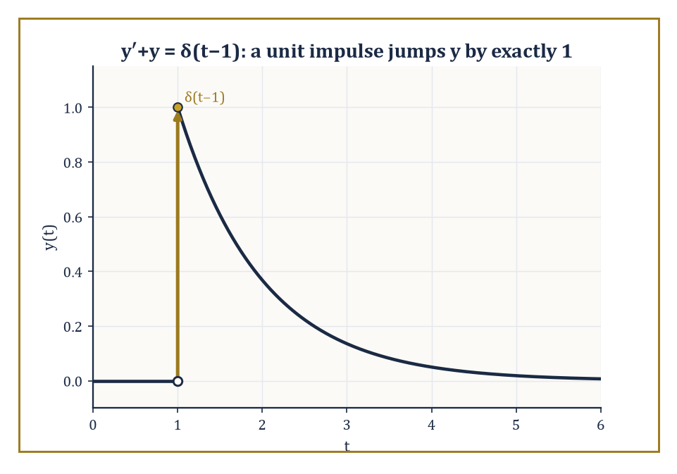
A hammer blow at t = 1: the solution to y′+y=δ(t−1) sits at rest, jumps by exactly one unit, and settles back down.
u_c(t) = 0 for t < c, u_c(t) = 1 for t ≥ c
Its transform is computed directly from the definition, since the integral only picks up contributions from t ≥ c.
L{u_c(t)} = e^{−cs}/s
Multiplying any forcing term by u_c(t) switches that term on at the prescribed instant c and leaves everything before c untouched — exactly the language needed for a circuit closed at t = 3 seconds, or a light turned on at t = c and never off.
Numeric example — Worked example — transform of a delayed step. Directly from the formula with c = 3:
L{u_3(t)} = e^{−3s}/s
To combine a step with a shifted function, the second shifting theorem states:
L{u_c(t) f(t−c)} = e^{−cs} F(s)
where F is the transform of f itself (not shifted). For instance, to find L{u_2(t)(t−2)²}, identify f(t) = t² (so that f(t−2) = (t−2)²) and c = 2. Since L{t²} = 2/s³, the theorem gives:
L{u_2(t)(t−2)²} = e^{−2s}·2/s³
Notice the pairing with the first shifting theorem of Room 18.2: that one shifted the s-domain when multiplying by an exponential in time; this one shifts the time domain when multiplying by a step, and the roles of s and t trade places in a pleasingly symmetric way.
A single step is enough, by itself, to build any rectangular pulse: switch a forcing term on at one instant and off again at a later instant simply by subtracting two steps. The difference u_a(t) − u_b(t), for a < b, is 1 on the interval a ≤ t < b and 0 everywhere else — a forcing term that is on only for the duration of the pulse, and by linearity its transform is just the difference of the two individual step transforms, no new theorem required.
Numeric example — Worked example — a rectangular pulse from two steps. A forcing term is switched on at t = 1 and off again at t = 3:
f(t) = u_1(t) − u_3(t)
By linearity and the step transform from the previous example:
L{f(t)} = L{u_1(t)} − L{u_3(t)} = e^{−s}/s − e^{−3s}/s = (e^{−s} − e^{−3s})/s
No new machinery was needed — the whole pulse is just two applications of a single formula, subtracted.
The Dirac delta function δ(t − c) models an idealised, instantaneous impulse — a hammer blow, a lightning strike, a sudden kick — concentrated entirely at the instant t = c and carrying unit total effect (formally, it is the limit of an increasingly tall, increasingly narrow pulse of constant area 1, though the fully rigorous treatment belongs to distribution theory, which Room 18.9 will nod toward without entering).
Its Laplace transform is remarkably simple, a direct consequence of the delta function's defining 'sifting' property, which plucks out the value of e^{−st} at t = c without any integration drudgery at all.
L{δ(t−c)} = e^{−cs}
A system forced by a delta function responds with a jump: in a first-order equation, the solution itself jumps at t = c; in a second-order equation, it is the derivative that jumps, while the solution stays continuous.
Numeric example — Worked example — an impulse-forced equation. Solve y′ + y = δ(t − 1), with y(0) = 0. Transform both sides:
L{y′} + L{y} = L{δ(t−1)}
(sY − 0) + Y = e^{−s}
Y(s+1) = e^{−s}
Y(s) = e^{−s}/(s+1)
Since L⁻¹{1/(s+1)} = e^{−t}, the second shifting theorem gives:
y(t) = u_1(t) e^{−(t−1)}
That is, y(t) = 0 for t < 1, and y(t) = e^{−(t−1)} for t ≥ 1. At t = 1 the solution jumps from 0 to e^{0} = 1: a jump of size exactly 1, matching the 'strength' of the unit impulse that caused it, and then decays exponentially afterward, exactly as one would expect of a system that got hit once, sharply, and is now settling back down.
Periodic forcing that is not simply sinusoidal — a square wave, a sawtooth, a train of pulses — can be handled by writing the function as a sum of shifted step functions, or more efficiently, by a general formula for the transform of any function periodic with period T.
F(s) = [1/(1 − e^{−sT})] ∫₀^T e^{−st} f(t) dt
The integral is taken over just one period, and the factor 1/(1 − e^{−sT}) accounts for the infinitely repeating copies via a geometric series in e^{−sT} (each successive period contributing a further factor of e^{−sT}, exactly as a geometric series sums 1 + r + r² + … to 1/(1−r)).
Numeric example — Worked example — transform of a square wave. Let f(t) have period T = 2, with f(t) = 1 for 0 < t < 1 and f(t) = 0 for 1 < t < 2, repeating forever — a simple on-off square wave. Compute the one-period integral:
∫₀^1 e^{−st}·1 dt + ∫₁^2 e^{−st}·0 dt = [−e^{−st}/s]₀^1 = (1 − e^{−s})/s
By the periodic formula:
F(s) = (1/(1−e^{−2s})) · (1−e^{−s})/s
Factor the denominator using the difference of squares:
1 − e^{−2s} = (1−e^{−s})(1+e^{−s})
The common factor (1−e^{−s}) cancels top and bottom, leaving the tidy result:
F(s) = 1/(s(1+e^{−s}))
A single closed-form transform standing in for an infinite train of on-off switches, with no sum ever explicitly carried out.
Steps, impulses, and periodic switching cover the forcing terms that appear discontinuously in time; but many differential equations also involve products of two functions of t whose combined behaviour is not simply read off any table — most notably, the response of a system to an arbitrary input, expressed in terms of its response to a single idealised impulse. That relationship is convolution, and it is the subject of Room 18.6.

Room 18.6: Convolution and the Convolution Theorem
Multiplying in One Domain, Smearing in the Other
The convolution of two functions f and g, both defined for t ≥ 0, is itself a new function of t, defined by the integral:
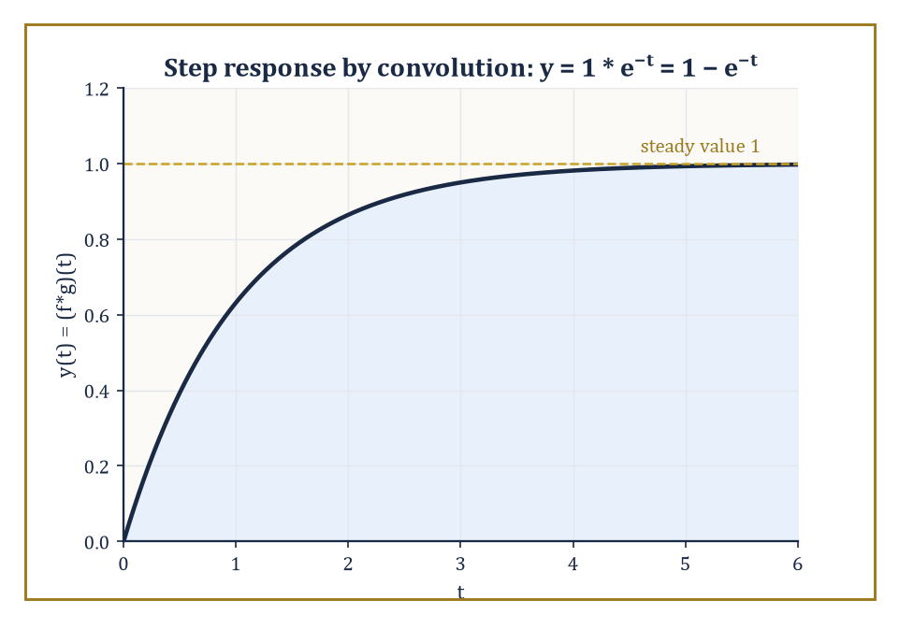
The classic charging curve: a constant input smeared through a decaying impulse response, rising to a steady value of 1 and never overshooting.
(f ∗ g)(t) = ∫₀^t f(τ) g(t−τ) dτ
Intuitively, it smears f through g (or equally, g through f — convolution is symmetric): at each output time t, it sums up contributions from every earlier instant τ, weighted by how f behaved at τ and how g behaves after a further delay of t−τ.
This is exactly the shape of a system with memory — its output at time t depends on the entire history of the input, filtered through the system's own characteristic response.
Numeric example — Worked example — convolution computed directly. Compute (f ∗ g)(t) for f(t) = e^{t} and g(t) = e^{2t}. By the definition:
(f∗g)(t) = ∫₀^t e^{τ} e^{2(t−τ)} dτ = e^{2t} ∫₀^t e^{τ − 2τ} dτ = e^{2t} ∫₀^t e^{−τ} dτ
The remaining integral is:
[−e^{−τ}]₀^t = −e^{−t} − (−1) = 1 − e^{−t}
So:
(f∗g)(t) = e^{2t}(1 − e^{−t}) = e^{2t} − e^{t}
The convolution theorem states that the Laplace transform converts this rather involved-looking integral into plain multiplication:
L{f ∗ g} = F(s)G(s)
(The proof is a short exercise in swapping the order of a double integral — Fubini's theorem, quietly doing its job in the background — followed by a substitution; it is omitted here but is entirely elementary.)
The practical payoff is a genuine shortcut: given a product of two transforms, one may either grind through partial fractions, or recognise the product as F(s)G(s) for two known pairs and write down the convolution integral directly, whichever is less work in a given problem — and, as a bonus, the two routes provide an automatic check on each other.
Numeric example — Worked example — the same answer, reached via the transform. Take F(s) = L{e^t} = 1/(s−1) and G(s) = L{e^{2t}} = 1/(s−2), so:
F(s)G(s) = 1/((s−1)(s−2))
Partial fractions:
1/((s−1)(s−2)) = A/(s−1) + B/(s−2)
so:
1 = A(s−2) + B(s−1)
At s=1:
1 = A(−1), A = −1
At s=2:
1 = B(1), B = 1
So the inverse transform is:
−e^{t} + e^{2t} = e^{2t} − e^{t}
— exactly the result obtained by direct convolution above. The convolution theorem and brute-force partial fractions have, as promised, agreed with each other to the letter.
In the language of linear systems — the language Room 18.7 will speak almost exclusively — the convolution theorem says something both simple and organising: the output of a linear time-invariant system equals its input convolved with its impulse response, the system's characteristic reply to a single instantaneous kick.
That one sentence, sometimes called Duhamel's principle, quietly underlies a large fraction of elementary linear-system theory, from circuit analysis to signal processing, and it is the reason the phrase 'impulse response' gets treated with such reverence in those fields: know it once, and the response to any input whatsoever follows by convolution.
Numeric example — Worked example — the step response of a first-order system. A first-order system with impulse response g(t) = e^{−t} (a system obeying y′ + y = x(t), whose response to a single unit impulse is exactly e^{−t}) is fed a constant unit input, f(t) = 1 for all t ≥ 0.
The output is the convolution:
y(t) = (f∗g)(t) = ∫₀^t 1·e^{−(t−τ)} dτ = e^{−t} ∫₀^t e^{τ} dτ = e^{−t}(e^{t} − 1) = 1 − e^{−t}
This is the classic 'charging curve' of a first-order system — rising smoothly from 0 toward a steady value of 1, never overshooting, governed entirely by the single time constant built into its impulse response. It will reappear, verified by an entirely different route, in Room 18.8.
Convolution obeys the same civilised arithmetic as ordinary multiplication — it is commutative (f∗g = g∗f, already implicit in calling it symmetric above), associative, and distributes over addition — which is unsurprising once one remembers it corresponds, via the theorem, to actual multiplication of transforms, and multiplication is commutative and associative on the nose.
One special case deserves to be singled out, because it closes a loop opened in Room 18.5: convolving any function f with the Dirac delta simply returns f itself, undelayed.
This is not a coincidence but a restatement of the delta function's sifting property in convolution's own language, and it identifies δ as the 'do nothing' element of convolution — its identity, in the same sense that 0 is the identity for addition and 1 for multiplication.
Abstract example — Abstract example — the delta function as convolution's identity element. Let f be any reasonable function and consider:
(f ∗ δ)(t) = ∫₀^t f(τ) δ(t−τ) dτ
The delta function δ(t−τ), as a function of τ, is concentrated entirely at τ = t; the sifting property of the delta function says that integrating any (continuous) function against δ(t−τ) simply evaluates that function at τ = t.
So the integral collapses to f(t) exactly:
(f∗δ)(t) = f(t)
Confirm this is consistent with the convolution theorem: L{f∗δ} should equal
F(s)·L{δ(t)} = F(s)·1 = F(s)
which is indeed the transform of f alone — the delta function, transform-side, multiplies by 1 and changes nothing, exactly mirroring what it does convolution-side.
Duhamel's principle is not merely a slogan; it hands over an explicit formula for the solution of any linear constant-coefficient equation with an arbitrary forcing term, once the impulse response g(t) is known:
y(t) = (g ∗ x)(t) = ∫₀^t g(t−τ) x(τ) dτ
valid for zero initial conditions. This is worth exercising on a forcing term messier than a constant, to see the convolution integral actually earning its place beside partial fractions rather than merely restating a result partial fractions could have found just as fast.
Numeric example — Worked example — Duhamel's formula with a ramp input. Solve y′ + y = t, with y(0) = 0, using convolution.
The impulse response of y′+y=x is g(t) = e^{−t} (from the previous example), and the forcing is x(t) = t.
By Duhamel's formula:
y(t) = ∫₀^t e^{−(t−τ)} τ dτ = e^{−t} ∫₀^t e^{τ} τ dτ
The inner integral is done by parts:
∫τe^{τ}dτ = (τ−1)e^{τ} + C
so:
∫₀^t τe^{τ}dτ = [(τ−1)e^{τ}]₀^t = (t−1)e^{t} − (−1)e^{0} = (t−1)e^{t} + 1
Multiply by e^{−t}:
y(t) = e^{−t}[(t−1)e^{t} + 1] = (t−1) + e^{−t} = t − 1 + e^{−t}
Check:
y(0) = 0 − 1 + 1 = 0 ✓
Differentiate:
y′(t) = 1 − e^{−t}
Then:
y′+y = (1−e^{−t}) + (t−1+e^{−t}) = t
matching the forcing exactly ✓ — the same answer partial fractions on Y(s) = 1/(s²(s+1)) would eventually produce, reached here entirely by smearing the ramp through the system's memory of its own impulse response.

Room 18.7: Systems and Transfer Functions
The System's Signature, Written in s
For a linear, time-invariant system, the transfer function H(s) is defined as the Laplace transform of the system's impulse response — equivalently, by the convolution theorem of Room 18.6, it is the ratio of the transform of the output to the transform of the input, computed under the convenient fiction of zero initial conditions.
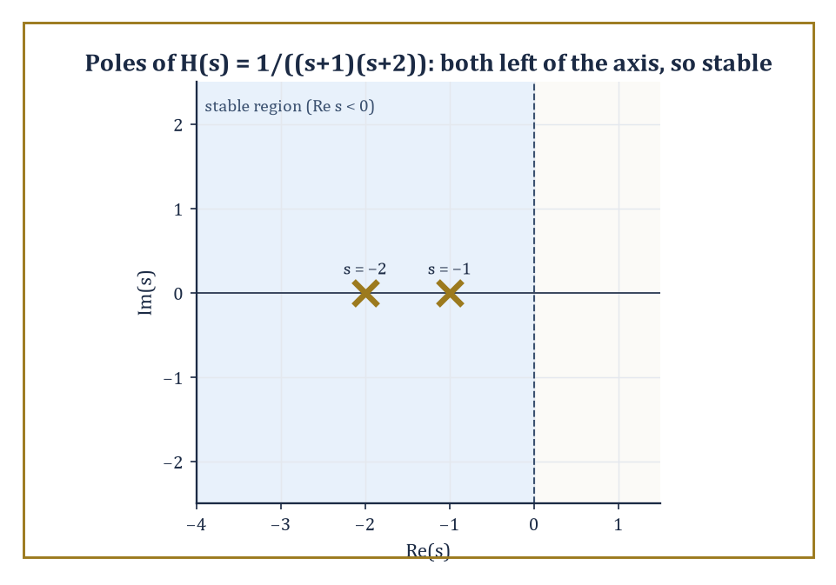
The poles of H(s) = 1/((s+1)(s+2)) sit safely left of the imaginary axis — the entire stability verdict, read off at a glance.
H(s) = Y(s)/X(s)
Once H(s) is known for a system, its response to any input whatsoever follows immediately: multiply X(s) by H(s) and invert. The zeros and poles of H(s) — the values of s where it vanishes or blows up — carry essentially all the qualitative information about the system: poles govern the system's free, unforced response and its stability; zeros govern which inputs the system tends to block or attenuate.
Numeric example — Worked example — transfer function and impulse response. A system obeys y″ + 3y′ + 2y = x(t). With zero initial conditions, transforming gives
(s² + 3s + 2)Y(s) = X(s)
so
H(s) = Y(s)/X(s) = 1/(s² + 3s + 2) = 1/((s+1)(s+2))
The poles are at s = −1 and s = −2 — both with negative real part, which (as the next paragraph explains) means the system is stable. Partial fractions:
1/((s+1)(s+2)) = A/(s+1) + B/(s+2)
1 = A(s+2) + B(s+1)
at s=−1, A=1; at s=−2, B=−1. So
H(s) = 1/(s+1) − 1/(s+2)
and the impulse response is h(t) = e^{−t} − e^{−2t} — a response that rises briefly and then decays away to nothing, the signature of a stable, well-damped system.
Poles determine stability because each pole at s = p contributes a term proportional to e^{pt} to the free response. If the real part of p is negative, e^{pt} decays to zero as t → ∞ — the system settles down after a disturbance. If the real part of p is positive, e^{pt} explodes — the system's response grows without bound, which in a real circuit or mechanical structure usually ends in smoke, snapped components, or a very apologetic engineering report.
(Poles exactly on the imaginary axis produce persistent, undamped oscillation — the marginal case that keeps control engineers, and indeed anyone contemplating their own tenure prospects, awake at night.) Block diagrams, feedback loops, and elementary control systems are analysed entirely by algebraic manipulation of transfer functions: connect two systems in series and their transfer functions multiply; close a feedback loop and a small piece of algebra produces the closed-loop transfer function directly.
Worked example — Worked example — a feedback loop and its stability. A system with open-loop transfer function G(s) = K/(s+1) (a simple first-order plant with adjustable gain K) is placed in a unity-feedback loop, meaning the output is fed straight back and subtracted from the input. Standard feedback algebra gives the closed-loop transfer function
T(s) = G(s)/(1 + G(s)) = [K/(s+1)] / [1 + K/(s+1)]
Multiply numerator and denominator by (s+1):
T(s) = K/((s+1) + K) = K/(s + 1 + K)
The single closed-loop pole sits at s = −(1+K). The system is stable exactly when this pole has negative real part, i.e. when
−(1+K) < 0, which rearranges to K > −1
So for any non-negative gain K the loop is comfortably stable, but push K below −1 (a negative gain large enough to overwhelm the natural damping) and the pole crosses into the right half-plane, and the whole arrangement becomes unstable — a single inequality summarising an entire design constraint.
Numeric example — Worked example — a zero that blocks a constant input. A system has transfer function H(s) = s/(s+1), which has a zero at s = 0. Feed it a constant input, x(t) = 5 for all t ≥ 0, so X(s) = 5/s. The output transform is
Y(s) = H(s)X(s) = [s/(s+1)]·(5/s) = 5/(s+1)
where the zero at s = 0 has cancelled exactly against the pole at s = 0 contributed by the constant input. Inverting,
y(t) = 5e^{−t} → 0 as t → ∞
despite a steady, unchanging input of size 5, the steady-state output decays away to nothing. The zero at the origin has 'blocked' the constant (zero-frequency, or 'DC') component of the input — the transfer-function equivalent of a system that only responds to change, and shrugs off anything that stays put.
One further wrinkle in the pole picture is worth flagging, because Room 18.3 already handed us the tool to deal with it: repeated poles. When two poles coincide — a denominator with a factor (s−p)² rather than two distinct factors (s−p₁)(s−p₂) — the impulse response is no longer a simple sum of exponentials but includes a term of the form t e^{pt}, the same repeated-linear-factor pattern met while inverting F(s) = 1/(s(s+1)²) back in Room 18.3.
Physically, this is the boundary case between an oscillating (underdamped) system and a sluggish, non-oscillating (overdamped) one: the 'critically damped' system, the one an engineer designs for on purpose when overshoot is unacceptable but speed still matters.
Numeric example — Worked example — a critically damped system. A system obeys y″ + 2y′ + y = x(t). Its transfer function is
H(s) = 1/(s²+2s+1) = 1/(s+1)²
a single repeated pole at s = −1 rather than two distinct poles. This is already a recognised pair from the table built in Room 18.2 and Room 18.3:
L⁻¹{1/(s+1)²} = t e^{−t}
So the impulse response is h(t) = t e^{−t} — it rises from 0 (unlike the two-distinct-pole case, which jumps straight up), peaks once, at t = 1 (found by setting the derivative
h′(t) = e^{−t} − t e^{−t} = e^{−t}(1−t)
to zero), and then decays back to zero without ever crossing it a second time. No oscillation, no overshoot, and the fastest possible settling for a system built from a single repeated real pole — precisely why critical damping is a design target, not merely a mathematical curiosity.
The Laplace transform therefore sits precisely at the junction of differential equations and classical control theory. The same operational calculus that solved an initial-value problem in Room 18.4 also designs a compensator, predicts a closed-loop response, and tells an engineer, before a single prototype is built, exactly which gains will make the thing oscillate itself to pieces. Very few pieces of undergraduate mathematics do quite so much useful work for quite so little algebraic effort.

Room 18.8: Further Properties and Techniques
The Bag of Extra Tricks, For When the Table Runs Out
Two theorems let you extract limiting behaviour of f(t) directly from F(s), without ever performing the inversion. The final-value theorem recovers the steady-state value:
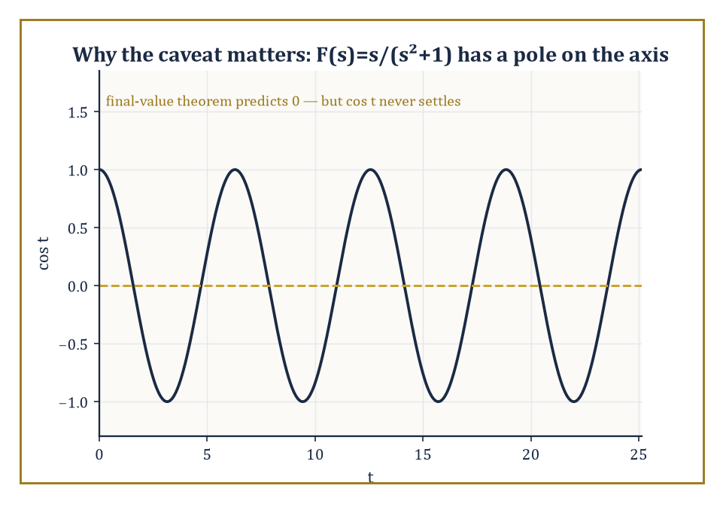
cos t, oscillating forever without settling — the standing reminder that the final-value theorem is a shortcut, not a magic trick.
lim_{t→∞} f(t) = lim_{s→0} sF(s)
This is valid provided that limit exists and (technically) that sF(s) has no poles in the closed right half-plane other than possibly at the origin — a caveat that rules out applying it, say, to an undamped oscillation, which never settles to a steady value at all. The initial-value theorem, its mirror image, recovers the value f(0⁺) from the opposite limit:
f(0⁺) = lim_{s→∞} sF(s)
Both are genuinely useful as sanity checks — a fast way to confirm a hard-won partial-fraction inversion without redoing the whole calculation.
Numeric example — Worked example — checking both theorems at once. Take F(s) = 1/(s(s+1)).
Partial fractions:
1/(s(s+1)) = A/s + B/(s+1)
so 1 = A(s+1) + Bs; at s=0, A=1; at s=−1, 1=B(−1), B=−1.
F(s) = 1/s − 1/(s+1)
f(t) = 1 − e^{−t}
Final-value theorem:
lim_{s→0} sF(s) = lim_{s→0} s/(s(s+1)) = lim_{s→0} 1/(s+1) = 1
Directly:
lim_{t→∞}(1−e^{−t}) = 1
They agree. Initial-value theorem:
lim_{s→∞} sF(s) = lim_{s→∞} 1/(s+1) = 0
Directly:
f(0) = 1 − e^{0} = 0
They agree too — both theorems confirmed on a single example, and incidentally the same function 1−e^{−t} met already as the step response in Room 18.6, now approached from the algebra rather than from convolution.
Abstract example — Abstract example — why the caveat on the final-value theorem is not decorative. Take F(s) = s/(s²+1), the transform of f(t) = cos t (a standard pair from Room 18.2). Blindly apply the final-value theorem:
lim_{s→0} sF(s) = lim_{s→0} s²/(s²+1) = 0
But cos t has no limit at all as t → ∞ — it oscillates between −1 and 1 forever and never settles anywhere, so the theorem's promised answer of 0 is simply wrong. The hypothesis quietly violated here is the one about pole locations: sF(s) = s²/(s²+1) has poles at s = ±i, sitting exactly on the imaginary axis rather than strictly in the left half-plane, and the theorem's guarantee evaporates the instant that happens.
The moral: the final-value theorem is a genuine shortcut, not a magic trick, and it is worth a two-second glance at the poles of sF(s) before trusting whatever number it hands back.
The differentiation-of-a-parameter trick from Room 18.2 (multiplying f by t corresponds to differentiating F and flipping the sign) combines readily with the first shifting theorem to handle products like tⁿe^{at} in one step, since:
L{tⁿ} = n!/s^{n+1}
the shift s → s−a then gives:
L{tⁿe^{at}} = n!/(s−a)^{n+1}
directly, without separately performing the differentiation and the shift.
Numeric example — Worked example — a power times an exponential. Find L{t²e^{3t}}. Using the combined formula with n=2, a=3:
L{t²e^{3t}} = 2!/(s−3)³ = 2/(s−3)³
This can also be reached the long way — differentiate L{e^{3t}} = 1/(s−3) twice with respect to s, picking up the appropriate signs — but the combined shift-and-power formula saves the trouble.
Just as multiplying f(t) by t differentiates F(s), dividing f(t) by t integrates F(s): provided the limit of f(t)/t exists as t → 0⁺,
L{f(t)/t} = ∫_s^∞ F(σ) dσ
the mirror image of the multiplication-by-t rule from Room 18.2, now running the s-domain operation forward instead of backward.
Numeric example — Worked example — dividing by t. Find L{(sin t)/t}. Here F(s) = L{sin t} = 1/(s²+1), and (sin t)/t does tend to a finite limit (namely 1) as t → 0⁺, so the rule applies:
L{(sin t)/t} = ∫_s^∞ dσ/(σ²+1) = [arctan σ]_s^∞ = (π/2) − arctan(s)
Using the identity arctan(s) + arctan(1/s) = π/2 for s > 0, this can equally be written arctan(1/s) — a compact closed form for the transform of a function, (sin t)/t, that has no elementary antiderivative at all in the ordinary sense. The transform did not care.
Completing the square, used already in Room 18.3 to invert irreducible quadratic denominators, is not a special trick reserved for that one situation — it is the general technique for translating any quadratic factor that fails to split over the reals into the shifted sine-and-cosine pattern, and it is worth internalising as a standing habit whenever a denominator refuses to factor cleanly into real linear pieces.
Occasionally partial fractions become genuinely unwieldy — a high-order pole, an awkward combination of factors — and a more powerful tool is available: the Bromwich integral, or inversion integral, which expresses f(t) directly as a contour integral in the complex s-plane:
f(t) = (1/2πi) ∫_{γ−i∞}^{γ+i∞} e^{st} F(s) ds
taken along a vertical line to the right of every singularity of F. Evaluating such an integral is done by summing residues at the poles of F(s), a technique from complex analysis proper.
The method is not needed for anything in this storey's worked examples, but its mere existence is reassuring: it guarantees that an inverse transform exists, and can in principle always be computed, for a vastly larger class of functions than partial fractions alone can reach.
Abstract example — Abstract example — a residue recovering a familiar pair. Consider F(s) = 1/(s−a), which has a single simple pole at s = a. The Bromwich integral reduces, for a function with only isolated simple poles, to summing the residues of e^{st}F(s) at each pole. Here e^{st}F(s) = e^{st}/(s−a), and the residue at the simple pole s=a is found by the standard rule:
Res_{s=a} = lim_{s→a} (s−a)·e^{st}/(s−a) = e^{at}
So the Bromwich integral returns:
f(t) = e^{at}
exactly the pair L{e^{at}} = 1/(s−a) established by direct integration all the way back in Room 18.1. Nothing new is learned about this particular pair, but the agreement is the point: the heavy complex-analytic machinery, when pointed at a case simple enough to check by hand, gives precisely the answer elementary methods already gave, which is as reassuring a piece of consistency as mathematics ever offers.

Room 18.9: Looking Back, and Ahead
Where This Fits, and Where the Tower Goes Next
Take stock of the toolkit assembled across this storey: the definition of F(s) as a discounted integral over t ≥ 0; the operational rules that turn differentiation into multiplication by s; the inverse transform by partial fractions; the mechanical three-step solution of linear differential equations and systems; the step and delta functions for switches and shocks; the convolution theorem linking products of transforms to smeared integrals of the originals; and the transfer-function language in which poles mean stability and zeros mean filtering. Each piece leaned on the one before it, and together they turn a differential equation — a statement about rates of change — into a statement about a rational function of a complex variable, solvable by algebra a good deal less sophisticated than the calculus it replaced.
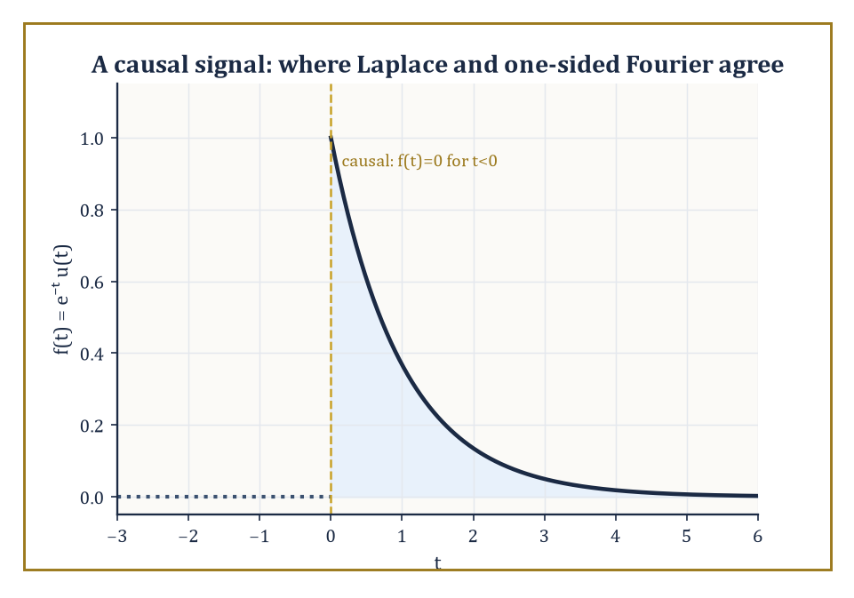
A causal signal, silent before t = 0 — the one feature that quietly distinguishes Laplace from its whole-line cousin, Fourier.
It is worth pausing on the family resemblance to the storey just below this one. The Fourier transform integrated e^{−iωt}f(t) over the whole real line; the Laplace transform integrates e^{−st}f(t) over the half-line t ≥ 0. Set s = iω in a Laplace transform, and — provided the function in question is causal (zero for t<0) and the imaginary axis lies inside its region of convergence — the two constructions coincide exactly. Laplace did not replace Fourier's idea; it generalised the exponent from a pure oscillation iω into a full complex number σ + iω, trading Fourier's requirement of absolute integrability over all time for a one-sided decay condition far more forgiving of the unruly, switch-on-at-t=0 functions that engineering actually produces.
Numeric example — Worked example — Laplace reducing to Fourier. Let f(t) = e^{−t} for t ≥ 0 (and f(t) = 0 for t < 0, making it causal).
Its Laplace transform, from Room 18.1, is valid over a region of convergence that comfortably contains the entire imaginary axis.
F(s) = 1/(s+1), valid for Re(s) > −1
Set s = iω.
F(iω) = 1/(iω + 1)
Now compute the one-sided Fourier transform directly, by the Fourier storey's own definition restricted to t ≥ 0.
∫₀^∞ e^{−t} e^{−iωt} dt = ∫₀^∞ e^{−(1+iω)t} dt = 1/(1+iω)
This converges because:
Re(1+iω) = 1 > 0
The two results, 1/(iω+1) and 1/(1+iω), are identical. Laplace and Fourier were never really strangers — one is simply the other with its decay rate allowed to be a genuine number rather than fixed at zero.
None of this machinery arrived from nowhere. Every single technique in this storey leaned on something built many floors below: complex numbers, without which s could never have grown from a real dial into a full complex-frequency variable; integral calculus, without which the definition itself is meaningless; and the partial-fraction algebra of first-year integration, which did essentially all of the actual work of inverting a transform once the table of pairs was in hand. If there is a single throughline connecting this storey to the rest of the Tower, it is that very little here was conceptually new — what was new was the arrangement, the decision to package differentiation as multiplication and let ordinary algebra do calculus's job by proxy.
Two further storeys wait in the wings of this idea, both left unopened here. Heaviside's own operational calculus, later placed on a fully rigorous algebraic footing by Jan Mikusiński, abstracts away the integral altogether and treats 'differentiation' and 'the delta function' as elements of a formal algebraic structure obeying their own consistent rules — vindicating, roughly a century late, the reckless engineer from this storey's opening paragraph. Distribution theory, in the hands of Laurent Schwartz, supplies the fully rigorous foundation for the delta function and its derivatives that this storey has been carefully working around rather than confronting head-on. Both are, for now, left as promissory notes; a Tower with fifty storeys can only build so much scaffolding on any single floor.
The deeper lesson, worth carrying up every remaining staircase, is that a well-chosen integral transform can convert a hard analytic problem into an easy algebraic one, and that the algebra is very often less trouble than the calculus it replaced. Learning to move fluently between the time domain and the transform domain — thinking in whichever domain makes the current problem tractable, and translating the answer back when finished — is a permanent, load-bearing habit of the working mathematician's toolkit, not a trick specific to this one transform.
The next storey abandons the time domain altogether. Integral Geometry stops asking what a function does moment to moment and asks instead what a shape looks like from every possible angle — integrating not against a decaying exponential but along every line, or every hyperplane, that can be drawn through a region. It sounds like a wild change of subject, and in one sense it is; but the projection-slice theorem ties it straight back to the Fourier transform one storey below us, and the Radon transform at its centre is the actual mathematics running inside every CT scanner ever built: take the Fourier transform of a projection through an object from one angle, and you get exactly one slice through the two-dimensional Fourier transform of the object itself, at the matching angle. Gather enough slices, from enough angles, and the whole object can be reconstructed — a hospital's worth of engineering resting on a theorem about lines and transforms shaking hands. The family of integral transforms, it turns out, is rather larger — and rather more interested in staying in touch with its relatives — than any one storey lets on.
We came up this staircase with a discounted integral and a promise that differentiation would turn into multiplication. We leave it having solved initial-value problems by algebra, switched forcing terms on and off at will, detonated delta functions without flinching, smeared one function through another by convolution, and read the stability of an entire engineered system off the sign of a real part. Not bad for one storey's work, and not one differential equation was harmed by anything more advanced than partial fractions.
The tower continues upward. We have learned to transform.

Storey 19: Integral Geometry
Measures on Spaces of Lines, Planes, and the Art of Reconstructing Shapes from Projections
The previous storey left us in the company of the Laplace transform, turning stubborn differential equations into tractable algebra by integrating a function of time against e^{-st} and trusting that the result would behave itself on the way back. That was a transform of functions. This storey performs a stranger and, I think, more beautiful trick: instead of transforming a function, we are going to integrate a shape — or rather, we are going to integrate over the space of all lines, or all planes, or all rigid motions, and discover that the geometry of a fixed object is quietly encoded in how it interacts, on average, with everything that might pass through it.
This is a genuine change of gears, so it is worth being honest about the vertigo it induces the first time round. Ordinary calculus integrates a function over a fixed domain — you nail down the space (an interval, a disc, a solid) and let the integrand vary. Integral geometry does something closer to the reverse: it nails down the geometric object and lets the domain of integration itself be a space of geometric objects — the collection of all lines in the plane, say, each line now playing the role that a single point played in ordinary calculus. The question ‘what is the length of this curve?’ turns into the question ‘on average, how often does a random line cross it?’, and remarkably these turn out to be the same question wearing different coats.
None of this works, of course, unless we can say what ‘random line’ means without the answer depending on where you happened to put your coordinate axes — which is really the whole subject in one sentence. We will spend the early rooms of this storey pinning down the one honest notion of a uniformly random line or plane, and the rest of the storey watching that single idea generate, with very little further effort, the classical formulas of Crofton and Blaschke, the mathematical machinery of the CT scanner, and a slightly startling amount of practical laboratory technique. If the Fourier transform taught us to hear a function as a chord of pure tones, integral geometry teaches us to reconstruct a shape from its shadows — which is, when you think about it, exactly what a doctor asks a scanner to do to you.
The next storey turns to matrices, and so, for one last time before the tower gets thoroughly linear-algebraic, we get to enjoy geometry behaving like geometry — curves, bodies, and the honest business of measuring them. Let us integrate over the space of lines.

Room 19.1: What Integral Geometry Actually Is
In which we stop integrating functions and start integrating geometry itself
Integral geometry studies a fixed geometric object — a curve, a region, a solid body — by integrating over spaces of other geometric elements that might interact with it: lines, planes, subspaces, or the rigid motions that slide and rotate one body until it meets another.
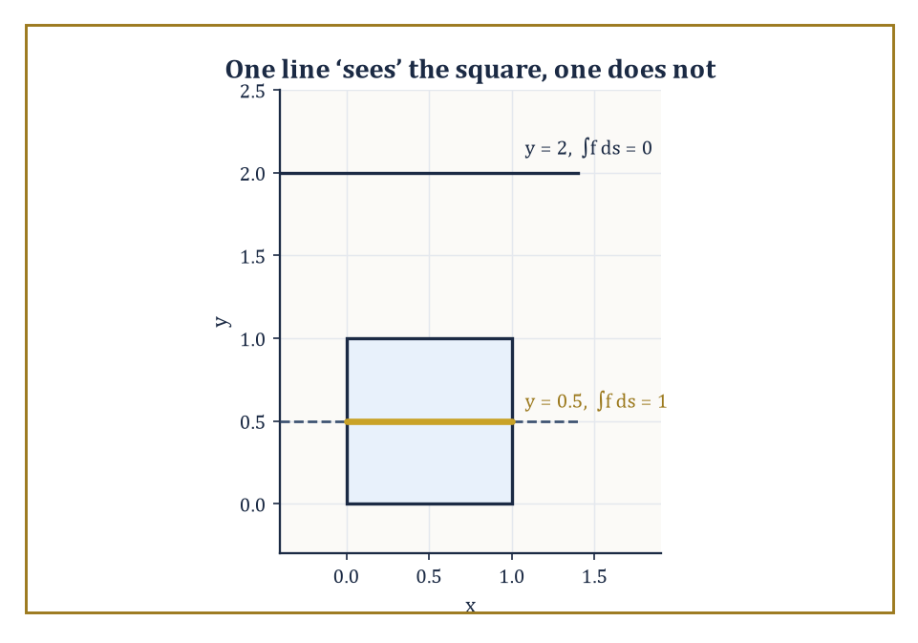
One line reports back a length of 1; a parallel line two units higher reports nothing at all — between them, the raw material of a CT scan.
The measures used for this integration are not arbitrary; they are required to be invariant under the natural symmetries of the ambient space, meaning that translating or rotating everything in sight changes nothing about the answer. That single requirement, as we will see over the next two rooms, turns out to pin the measure down almost uniquely, which is what saves the whole enterprise from being an arbitrary choice dressed up as a theorem.
Numeric example — A first taste of ‘line data’. Let f be the indicator function of the unit square [0,1]×[0,1] — that is, f(x,y)=1 for points inside the square and f(x,y)=0 outside it.
Consider the horizontal line y = 0.5. The integral of f along this line is just the length of the segment where the line lies inside the square: the line enters at x=0 and leaves at x=1, so
∫f ds = 1
Now consider the line y = 2, which never touches the square at all:
∫f ds = 0
Each line gives us one number — how much of the square that particular line ‘sees’. Collect that number for every line in the plane, and you have exactly the raw data a CT scanner works with: not the square itself, but everything every possible line-of-sight through it can tell you.
Rooms 19.6 and 19.7 are devoted to the (surprisingly good) news that this collection of numbers determines the square uniquely.
The classic questions of the subject all have this shape: what is the average length of the intersection of a fixed curve with a random line? What is the average area of the intersection of a fixed surface with a random plane? And, running the whole idea backwards, can we recover a function entirely from the integrals of that function over every line, or every plane, that meets it?
The answers arrive as integral formulas whose kernels are disarmingly simple geometric quantities — a length, an area, a count of intersection points, an Euler characteristic — multiplied against the one true invariant measure on the relevant space of lines or planes. It is this last ingredient, the invariant measure, that does all the real work, and it is the subject of the very next room.
The subject therefore sits at a three-way junction: differential geometry supplies the objects (curves, surfaces, convex bodies), measure theory supplies the legal machinery for integrating over infinite spaces of them, and the representation theory of the Euclidean group — the group of all rigid motions of the plane or of space — supplies the reason the measures are unique.
Its applications range from the purely recreational geometric-probability puzzles of the eighteenth century (a needle, some floorboards, an afternoon to waste) to the entirely un-recreational business of reconstructing the inside of a human skull from X-rays without opening it up, which is the subject of Rooms 19.6 and 19.7.
Abstract example — Invariance in miniature. Before facing an infinite continuous group, it is worth seeing the idea of an ‘invariant measure’ in a setting small enough to check by hand.
Let G be the finite group of the four rotations of a square about its centre: 0°, 90°, 180°, 270°. Put the uniform probability distribution on G, assigning weight 1/4 to each rotation.
This distribution is invariant under G acting on itself by composition: if you take the distribution and shift it by ‘compose everything with a 90° rotation’, each rotation r just gets relabelled as r∘90°, which is still some rotation in the same four-element set, still carrying weight 1/4. Relabelling changes nothing, because every element already had the same weight.
That triviality is the entire content of invariance — no rotation is privileged over any other — and it is exactly this idea, transplanted onto the infinite, continuous group of rigid motions of the plane, that produces the measure dp∧dφ of Room 19.2.
The only difference between the finite case and the continuous case is that in the continuous case somebody (Alfréd Haar, as it happens) had to prove that such a measure exists and is unique at all; in the finite case, dividing by 4 is proof enough.
It is worth being explicit about why invariance is not a fussy technical nicety but the entire point, since the temptation to reach for a more familiar-looking coordinate system is real.
A line in the plane can just as well be written in slope-intercept form,
y = mx + c
and one might be tempted to declare dm∧dc the ‘uniform’ measure on lines instead of dp∧dφ. It is not — and the failure is not subtle.
Numeric example — Why slope-intercept coordinates betray you. Consider two families of lines: those with slope m near 0 (nearly horizontal) and those with slope m near, say, 1000 (nearly vertical).
Under dm∧dc, an interval of slopes of width 1 centred at m = 0 gets exactly the same weight as an interval of slopes of width 1 centred at m = 1000.
But geometrically these are wildly unequal: as m runs from 999.5 to 1000.5, the corresponding lines barely rotate at all — they are already nearly vertical and stay nearly vertical — while as m runs from −0.5 to 0.5, the lines sweep through a very noticeable range of genuinely different directions.
A rotation of the whole plane by, say, 45° would map the ‘boring’ near-vertical family onto a completely different, much more spread-out range of slopes, and the measure dm∧dc of a fixed slope-window changes under that rotation — concretely, the map that describes how a 45° rotation transforms slopes is
m ↦ (m+1)/(1−m)
and this map has a derivative that is emphatically not 1 almost everywhere, so dm∧dc fails the Jacobian-determinant-equals-1 test that dp∧dφ passed in the previous example.
Slope-intercept coordinates are a perfectly good way to write down one line; they are a poor way to average over all of them, because they quietly favour near-vertical lines over near-horizontal ones (or the reverse, depending on how you set them up) purely as an artefact of the coordinate chart, with no geometric justification whatsoever.
This is exactly the kind of silent, coordinate-dependent bias that the invariance requirement of Room 19.2 was designed to outlaw.

Room 19.2: Invariant Measures on Spaces of Lines and Planes
The one true way to pick a random line, and why there is only one
To integrate over the space of lines in the plane, we first need coordinates on that space, and then we need to know which measure on those coordinates deserves to be called ‘uniform’. The standard choice is the normal parametrization: a line ℓ is described by the angle φ that its normal direction makes with a fixed axis, and the signed distance p from the origin to the line, so that ℓ is given by:
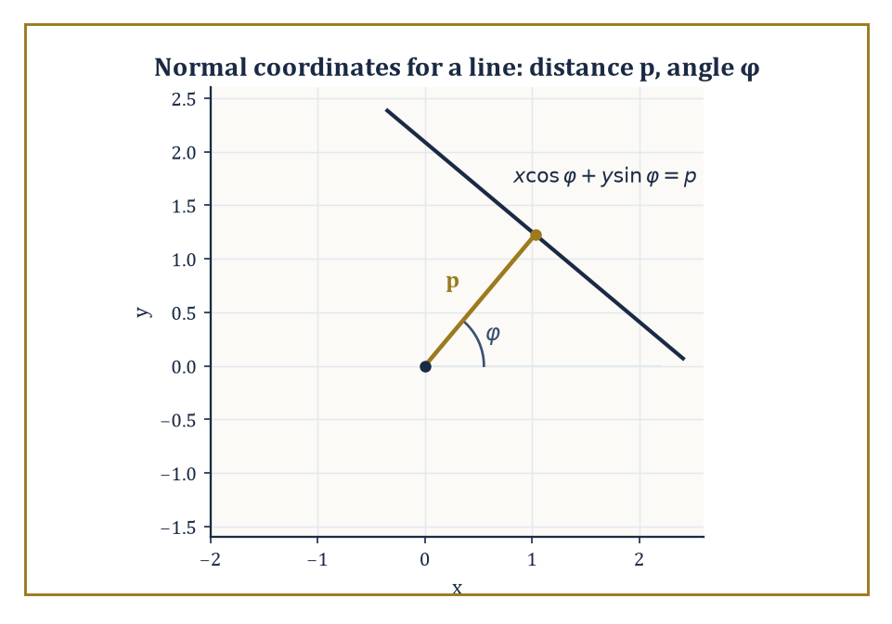
A line's entire biography, reduced to two honest numbers: how far it sits from the origin (p) and which way it faces (φ).
ℓ_{p,φ} = {(x,y) : x cos φ + y sin φ = p}
Taking φ ∈ [0,π) and p ∈ ℝ gives each line in the plane exactly one address, with no line counted twice. The claim — which we verify below rather than merely asserting — is that the measure dμ = dp ∧ dφ on this space is invariant under every rigid motion of the plane, and that up to an overall constant it is the only such measure. A measure with this property, on a space acted on transitively by a group, is called a Haar measure, after Alfréd Haar, who proved in the 1930s that any reasonably well-behaved group carries exactly one (up to scale).
Abstract example — Checking invariance directly. Take the plane and rotate it about the origin by an angle α. A line with parameters (p,φ) keeps the same distance p from the origin — rotating about the origin cannot change how far a line sits from the point you are rotating about — while its normal direction simply rotates along with everything else, becoming φ+α (reduced mod π). So the transformation on coordinates is:
(p,φ) ↦ (p, φ+α)
Its Jacobian matrix is the identity matrix, determinant 1, so dp∧dφ is unchanged: rotation-invariance confirmed directly. Now take a translation of the plane by a fixed vector (a,b). A short calculation (project the translation vector onto the line's normal direction) shows the new signed distance is:
p′ = p + (a cos φ + b sin φ)
Here φ is untouched — shove the line further out along its own normal and its distance from the origin grows, not shrinks, which the plus sign is merely confirming. The Jacobian of (p,φ) ↦ (p′,φ) is the triangular matrix with 1 on the diagonal (∂p′/∂p = 1, ∂φ/∂φ = 1) and some messy off-diagonal entry that does not affect the determinant of a triangular matrix — so again the determinant is 1, and dp∧dφ survives translation intact. Since every rigid motion of the plane is built from rotations and translations, dp∧dφ is invariant under the full Euclidean group, exactly as claimed.
In three-dimensional space the same idea produces an invariant measure on the space of planes (each plane described by a unit normal direction, living on the sphere, together with a signed distance from the origin — three parameters in all) and a four-dimensional invariant measure on the space of lines in space, since a line in ℝ³ needs a direction (two parameters, a point on the sphere) plus a point of closest approach to the origin within the plane perpendicular to that direction (two more parameters).
Existence and uniqueness of these measures follow from the same general Haar-measure machinery already invoked for the plane; the only work required for elementary calculations is writing the measures out in convenient coordinates, which has already been done for us by generations of geometers with more patience than most.
Numeric example — The measure of all lines meeting a disc. As a sanity check that dp∧dφ behaves the way a measure of ‘random lines’ ought to, compute the total measure of the set of lines that meet a disc of radius R = 3 centred at the origin. For a fixed direction φ, a line ℓ_{p,φ} meets the disc exactly when |p| < 3, i.e. when p ranges over an interval of length 2×3 = 6. This does not depend on φ at all, since the disc looks the same from every angle, so the total measure is:
μ = ∫₀^π 6 dφ = 6π
For general radius R the same computation gives:
μ = 2πR
which, amusingly, is exactly the circumference of a circle of that same radius. It is not a coincidence, and by the end of Room 19.3 you will be able to see why in one line. For R = 3 this evaluates to 6π ≈ 18.850, and it is this number — the ‘total amount of random-line-ness’ available near a body of that size — that the Cauchy–Crofton and Crofton formulas of the next two rooms turn into hard geometric quantities like length and area.
The ‘up to a constant’ clause in the uniqueness statement deserves a moment's honesty: Haar's theorem guarantees a unique invariant measure only up to an overall positive scale factor, and different textbooks make different choices for that scale — some absorb a factor of 2 or π into the measure itself, others leave the measure bare and instead adjust the constant sitting in front of each formula.
This storey fixes the convention once and keeps it fixed throughout (bare dp∧dφ, fundamental domain φ∈[0,π)), precisely so that the constants appearing in Rooms 19.3 through 19.5 can be trusted at face value rather than re-derived from scratch every time a new formula appears.
It is not that any convention is more correct than another; it is that conventions, like Standard-track vs Circle-line platforms at a busy interchange, only cause trouble when two of them are used without announcing which is which.
Numeric example — The measure of lines meeting a square — and a small theorem for free. Take K to be a square of side s = 2, centred at the origin with sides parallel to the axes. Its support function — the maximum value of x cos θ + y sin θ over the square, for each direction θ — works out to:
h(θ) = (s/2)(|cos θ| + |sin θ|)
achieved at whichever corner has matching signs. The width of the square in direction θ (its full extent measured perpendicular to that direction), using the square's symmetry about the origin, is:
w(θ) = h(θ) + h(θ+π) = s(|cos θ| + |sin θ|)
The total measure of lines meeting K is:
μ = ∫₀^π w(θ) dθ = s ∫₀^π (|cos θ| + |sin θ|) dθ
Both pieces were already computed in Room 19.3:
∫₀^π |cos θ| dθ = 2
and, by the same reasoning (sin θ ≥ 0 throughout [0,π], so no sign-splitting is even needed):
∫₀^π sin θ dθ = [−cos θ]₀^π = 1 − (−1) = 2
So:
μ = s(2+2) = 4s
and with s = 2 this gives μ = 8 — which is exactly the perimeter of a square of side 2 (namely 4×2 = 8). This is no accident: the same computation run in general —
μ = ∫₀^π (h(θ)+h(θ+π)) dθ = ∫₀^{2π} h(θ) dθ
— and that last integral is precisely the classical formula for perimeter in terms of the support function, shows that the measure of lines meeting any convex body always equals that body's perimeter, exactly, for every convex shape and not merely the round ones — a small, free theorem sitting inside the definitions, waiting to be noticed.

Room 19.3: The Cauchy–Crofton Formula
Measuring a piece of string by asking how often it gets crossed
The Cauchy–Crofton formula converts a question about length into a question about how often random lines hit a curve, and it is the prototype from which every other formula in this storey is descended.
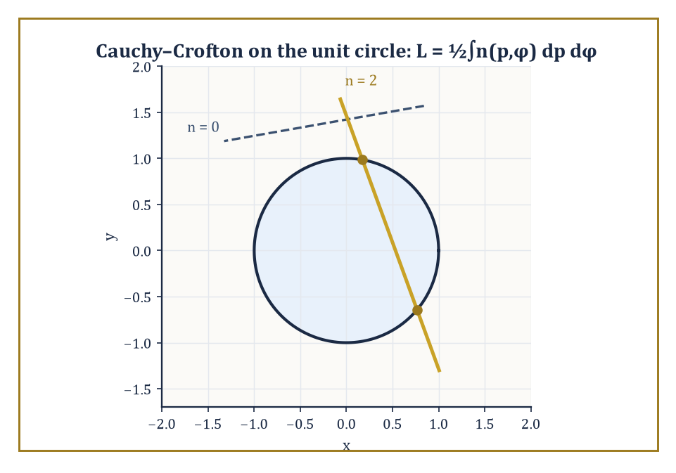
A generic line meets the unit circle twice or not at all — Room 19.3's whole argument, drawn rather than integrated.
Let C be a rectifiable curve — meaning, roughly, a curve whose length can be sensibly approximated by inscribed polygons, with the approximations converging to a finite number as the polygons get finer, so that ‘length’ is not an act of faith but an honest limit. For (almost) every line ℓ_{p,φ}, let n(p,φ) be the number of points where the line crosses C.
The Cauchy–Crofton formula states:
L(C) = ½ ∫₀^π ∫_{−∞}^{∞} n(p,φ) dp dφ
Here φ ranges over the fundamental domain [0,π) of Room 19.2, in which every line is counted exactly once.
(You will occasionally meet this formula written with a constant of ¼ instead of ½ — that happens when the author lets φ range over the full circle [0,2π) instead, which counts every line twice over, since (p,φ) and (−p,φ+π) then describe the same line twice. Both conventions are correct; they simply disagree about whether a line gets one address or two, which is the sort of dispute mathematicians can sustain indefinitely without ever coming to blows.)
Numeric example — Recovering the circumference of a circle. Take C to be the unit circle, radius R = 1. A generic line meets this circle in exactly 2 points if it passes within distance 1 of the centre, and 0 points otherwise (tangent lines, which meet it in exactly 1 point, form a measure-zero set of directions and can be ignored).
So n(p,φ) = 2 for p ∈ (−1,1), and n(p,φ) = 0 otherwise, regardless of φ.
Step 1: integrate over p for fixed φ:
∫_{−1}^{1} n(p,φ) dp = 2 × (length of the interval (−1,1)) = 2 × 2 = 4
Step 2: integrate that constant value over φ ∈ [0,π):
∫₀^π 4 dφ = 4π
Step 3: apply the formula's constant of ½:
L = ½ × 4π = 2π
The true circumference of a unit circle is 2π × 1 = 2π. They match exactly, and no approximation was involved anywhere — the formula is not a heuristic, it is an identity.
It is worth pausing on why the constant has to come out to exactly ½ and not something else, because the reasoning generalises to every Crofton-type formula in this storey.
For a convex body, at each fixed direction φ the set of p-values for which the line meets the body is an interval whose length equals the body's width in that direction, and on that interval n is constant, equal to 2 (the line goes in and comes back out).
Integrating n over p therefore gives twice the width; integrating the width over all φ ∈ [0,π) sums the widths in every direction across a half-turn, and a body's total width summed across a half-turn of directions is exactly its perimeter — this is itself a small, classical fact about convex bodies (their perimeter equals the integral of their support function over a full turn, and integrating width across a half-turn double-counts in exactly the way that produces this same perimeter once you track the bookkeeping).
The upshot is that the p-and-φ integral always comes out to twice the length, and dividing by 2 undoes that automatically, whatever the shape of C.
This is also why a practical estimate of length is possible without ever computing an integral: overlay the curve with a grid of equally spaced parallel lines at several angles, count the crossings, and the average crossing count — suitably scaled — estimates the length.
Foresters, geologists, and pathologists have been doing exactly this since long before anyone told them it was a theorem; we will see the same trick made rigorous, as a proper unbiased estimator, in Room 19.8.
Numeric example — A straight segment, as a consistency check. For a straight segment (not a closed curve) of length L₀ = 5 lying along the x-axis, a generic line meets it in at most one point, so n(p,φ) ∈ {0,1}.
For direction φ, the segment's projection onto the normal direction has length L₀|cos φ| (the projection of a horizontal segment onto a direction φ shrinks by a factor of |cos φ|), and a line in that direction crosses the segment exactly when p falls in that projected interval, contributing n = 1 throughout. So the inner integral over p is simply L₀|cos φ|.
The outer integral needs ∫₀^π |cos φ| dφ, computed directly by splitting at φ = π/2:
∫₀^π |cos φ| dφ = ∫₀^{π/2} cos φ dφ + ∫_{π/2}^{π} (−cos φ) dφ = [sin φ]₀^{π/2} + [−sin φ]_{π/2}^{π} = (1−0) + (0−(−1)) = 1 + 1 = 2
So the double integral is L₀ × 2 = 10, and the formula gives:
L = ½ × 10 = 5 = L₀
This exactly recovers the segment's own length. It is a slightly circular-feeling check — of course a formula for length gives back the length — but it confirms the constant ½ is correct for a shape simple enough to verify by hand, which is precisely the sort of due diligence a formula deserves before you trust it on a coastline.
Nothing in the formula required C to be convex, or even connected, and it is worth seeing explicitly that non-convex and disconnected curves are handled without a single change to the machinery — n(p,φ) is simply allowed to exceed 2, and the integral totals everything up correctly regardless.
Numeric example — A disconnected curve, and n greater than 2. Let C be the disjoint union of two unit circles, one centred at the origin and the other centred at (5,0), far enough apart that they never overlap.
The horizontal line y = 0 (which has φ = π/2, p = 0 in the normal parametrization, since its normal direction points straight up) crosses the first circle at x = −1 and x = 1, and the second circle at x = 4 and x = 6 — four intersection points in total, so n(0, π/2) = 4 for this particular line, comfortably exceeding the value of 2 seen for a single convex curve.
The Cauchy–Crofton formula does not need to know, or care, that C is secretly two separate circles rather than one connected curve; it simply integrates n(p,φ) over the whole space of lines and, because the integral is linear, automatically returns:
L(C) = L(circle 1) + L(circle 2) = 2π + 2π = 4π
This is the correct total length of both circles combined, obtained without ever having to notice, let alone exploit, that the curve fell apart into pieces.

Room 19.4: Crofton Formulas in the Plane and in Space
From counting crossings to measuring area, by the same trick one dimension up
The Cauchy–Crofton formula measured length via how often lines cross a curve. The next formula in the family measures area via how much of a line lies inside a region, and the reasoning behind it is, refreshingly, just Cavalieri's principle wearing a disguise — the same slicing idea used long ago to compute volumes by integrating cross-sectional areas.
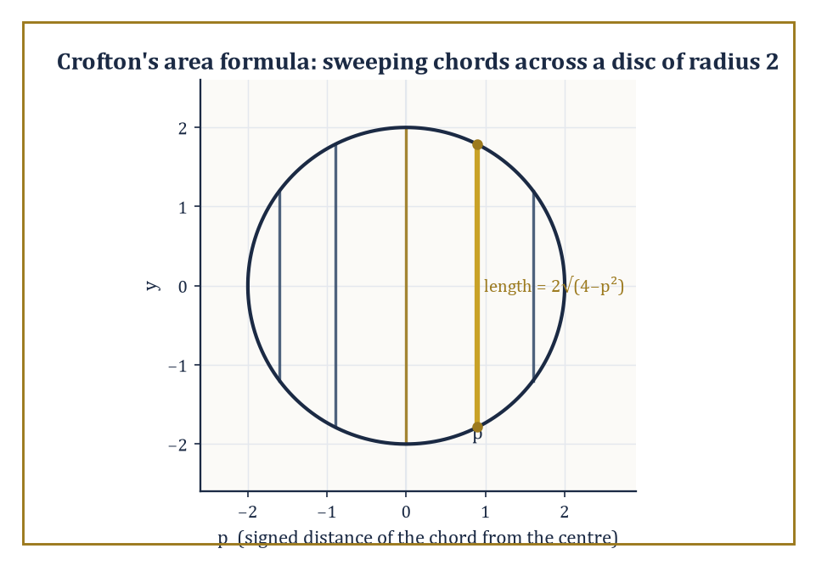
Slicing the disc of radius 2 into parallel chords and adding up their lengths is Cavalieri's principle wearing a Crofton hat.
Fix a direction φ. Slicing a convex body K by the family of parallel lines with that normal direction, and integrating the length of each slice over p, sweeps out the whole of K exactly once: that integral is simply Area(K), for every single φ, with no dependence on the direction chosen.
Now integrate that constant value of Area(K) over the half-turn of directions φ ∈ [0,π): the result is π × Area(K), since you are adding up the same number π times over (once for each infinitesimal direction, and there are 'π radians worth' of them). Divide by π to undo the redundancy, and you have the Crofton formula for area:
Area(K) = (1/π) ∫₀^π ∫_{−∞}^{∞} length(K ∩ ℓ_{p,φ}) dp dφ
Numeric example — The area of a disc, the slow way. Take K to be a disc of radius R = 2, area πR² = 4π. Fix any φ; the chord of K at signed distance p from the centre has length 2√(4−p²) for p ∈ (−2,2).
Step 1: integrate over p. This integral is precisely the standard formula for the area of a disc of radius 2 computed by horizontal slicing (Cavalieri again), and it evaluates to π × 2² = 4π — exactly as the general argument above predicted, independent of φ:
∫_{−2}^{2} 2√(4−p²) dp = π × 2² = 4π
Step 2: integrate that constant 4π over φ ∈ [0,π):
∫₀^π 4π dφ = 4π × π = 4π²
Step 3: divide by the formula's constant π:
4π²/π = 4π
This matches Area(K) = π(2)² = 4π exactly. Notice that the entire calculation was, in disguise, just computing the area of the disc twice — once by direct slicing, once by relentlessly re-deriving the same slicing formula and then dividing out the redundancy — which is either a reassuring consistency check or a slightly expensive way to learn that π×4=4π, depending on your mood.
In three-dimensional space the same family of ideas produces formulas for the volume of a solid via the measure of planes meeting it, for its surface area via the measure of lines meeting it, and for its mean width — the average, over every direction in space, of how far the body extends in that direction — via still other integral-geometric quantities.
Perhaps the most quotable of these is Cauchy's projection formula: the surface area of a convex body in space equals 4 times the average area of its orthogonal shadow, averaged over all directions of projection with respect to the invariant measure on directions.
Numeric example — The surface area of a sphere, via its own shadow. Let K be a ball of radius R = 3. Because a ball is rotationally symmetric, its orthogonal projection onto a plane is a disc of radius 3 no matter which direction you project from — there is nothing to average, every shadow is identical. That shadow has area:
π(3)² = 9π
Cauchy's formula then gives:
Surface area = 4 × 9π = 36π
The true surface area of a sphere of radius 3 is:
4πR² = 4π(9) = 36π
They agree exactly. For a lumpier convex body — an egg, say, or a lentil — the projected shadow genuinely does change shape as you rotate it, and the formula demands an honest average over all directions rather than this shortcut; but the ball, with its total indifference to direction, makes an excellent first specimen precisely because it lets you check the arithmetic without also having to compute an average.
One more plane intrinsic quantity is worth naming before we leave two dimensions for space: the mean width of a convex body is simply the average, over every direction θ ∈ [0,π), of the body's width w(θ) in that direction — how far it extends, measured between two parallel supporting lines perpendicular to θ.
Room 19.2 already computed, as an unplanned bonus, that the following integral equals the body's perimeter exactly:
∫₀^π w(θ) dθ = Perimeter
Dividing by the length π of the interval of directions turns that total into an average, so for every convex body in the plane, without exception:
mean width = Perimeter/π
Numeric example — Mean width, from a perimeter already in hand. For the disc of radius R from Room 19.2, the width is the same constant w(θ) = 2R in every direction (a disc looks equally wide from every angle), so its mean width is trivially 2R — its diameter, which is exactly what one would hope 'average width' means for a perfectly round object. Checking against the general formula:
Perimeter/π = 2πR/π = 2R
Agreement, as it should be. Now take the square of side s = 2 from Room 19.2's other example, whose perimeter was computed there to be 8. Its mean width is:
Perimeter/π = 8/π ≈ 2.546
a single number sitting sensibly between the square's smallest width (2, straight across a face) and its largest (2√2 ≈ 2.828, corner to corner), which is exactly the sort of sanity check a newly defined average ought to pass before being trusted.
These identities are stated most cleanly for convex bodies, where an intersection with a line or plane is itself convex (hence connected, hence easy to measure), but many of them survive, in modified form, for the wider class of sets of finite perimeter — sets whose boundary, however wrinkled or fractal-looking, still has finite (n−1)-dimensional measure.
Think of a coastline: it may be absurdly jagged, but so long as its total 'edge length' (suitably defined) stays finite, the Crofton machinery still applies. This is the first hint, in this storey, of the more general geometric measure theory that Room 19.9 gestures towards.

Room 19.5: Kinematic Formulas and the Principal Kinematic Formula
Inclusion–exclusion, but for two shapes bumping into each other at random
The Crofton formulas of the last two rooms concerned a single fixed body meeting a random line or plane. The kinematic formulas of Blaschke and Santaló ask a richer question: given two bodies K and L, what is the measure of the set of rigid motions g (rotations combined with translations) that bring a moved copy gL into contact with K?
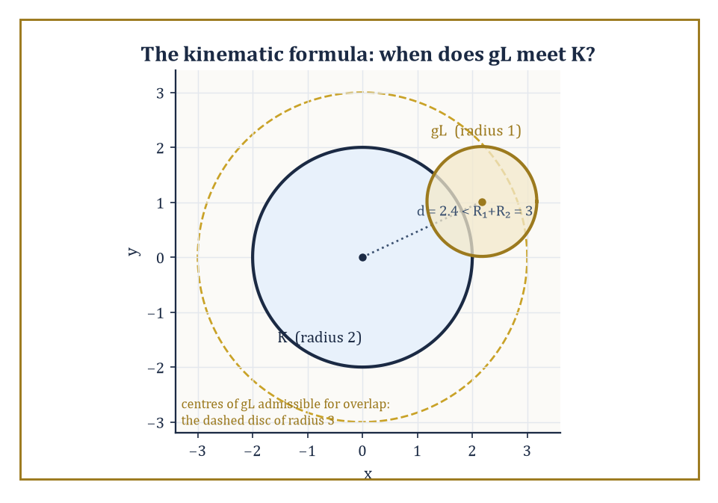
Two discs collide exactly when their centres drift within R₁+R₂ of each other — the kinematic formula, made visible.
The answer is expressed in terms of the intrinsic volumes (also called Quermassintegrals, from the German for ‘cross-section-mass integrals’, a term coined by people who were clearly not being paid by the syllable) of the two bodies separately. In the plane there are three intrinsic volumes worth naming: the area, (a multiple of) the perimeter, and the Euler characteristic — a topological invariant equal to 1 for any body that is a single connected blob with no holes, and more generally counting connected pieces minus holes. In space there are four: volume, surface area, mean width, and Euler characteristic.
The principal kinematic formula for two convex bodies K, L in the plane reads:
∫ χ(K ∩ gL) dg = 2π(Area(K) + Area(L)) + Perimeter(K)·Perimeter(L)
Here dg is the invariant (Haar) measure on the group of rigid motions — a rotation angle ψ ∈ [0,2π) together with a translation in the plane — and χ(K∩gL) is 1 if the moved copy meets K and 0 if it misses entirely (since the intersection of two convex sets, when nonempty, is itself convex and hence connected, with Euler characteristic exactly 1).
Numeric example — Two unit discs bumping into each other. Let K and L both be discs of radius 1, so Area(K) = Area(L) = π and Perimeter(K) = Perimeter(L) = 2π. The formula gives:
∫ χ(K∩gL) dg = 2π(π+π) + (2π)(2π) = 2π·2π + 4π² = 4π² + 4π² = 8π²
Now check this independently, by direct geometric reasoning rather than the formula. Because a disc is rotationally symmetric, rotating L before placing it changes nothing, so the rotation angle ψ contributes a free factor of its own total range, 2π, doing no useful work.
All that matters is the translation: the two unit discs overlap exactly when their centres are less than 1+1 = 2 apart, i.e. when the translation vector t lands inside a disc of radius 2 around the origin, which has area:
π(2)² = 4π
So the total measure is (rotation range) × (translation area):
2π × 4π = 8π²
This agrees with the formula exactly. This case is unusually transparent because the rotational symmetry of the disc lets the two calculations be checked against each other in one's head; for a less symmetric shape — a bent rod, say, or a stubbornly asymmetric amoeba — the rotation genuinely matters, and it is exactly the perimeter term Perimeter(K)·Perimeter(L) in the general formula that accounts for the work rotation does.
Numeric example — Two discs of different sizes, for generality. The equal-disc example above is reassuring but slightly too symmetric to build full confidence, so it is worth repeating with two differently sized discs. Let K have radius 2 (area 4π, perimeter 4π) and L have radius 1 (area π, perimeter 2π). The formula gives:
∫χ(K∩gL) dg = 2π(4π+π) + (4π)(2π) = 2π(5π) + 8π² = 10π² + 8π² = 18π²
The direct check proceeds exactly as before: rotating L still does nothing observable, since both bodies are round, so the rotational factor again contributes its full range 2π for free; the two discs overlap exactly when their centres are within R₁+R₂ = 2+1 = 3 of each other, a translation region of area:
π(3)² = 9π
Total measure:
2π × 9π = 18π²
This agrees with the formula. What has changed from the equal-radius case is only that the perimeter term (4π)(2π) = 8π² and the area term 2π(4π+π) = 10π² are no longer equal contributors in the same simple way they were when K = L — a first hint that for genuinely different bodies, area and perimeter pull their separate weight rather than moving in lockstep.
The three-dimensional principal kinematic formula follows the same architecture, with volume, surface area, mean width, and Euler characteristic of K and L combining pairwise (again with binomial-flavoured coefficients tracking how many ways a given pair of intrinsic volumes can add up to the right total dimension) rather than just area and perimeter — the plane's kinematic formula is simply the low-dimensional case of a pattern that keeps the same spirit however many intrinsic volumes join the party.
This storey will not chase the exact three-dimensional coefficients, since doing so honestly requires the normalization constant of the Haar measure on the rotation group SO(3) — a number one should look up rather than reconstruct from memory under pressure, and precisely the kind of bookkeeping detail that the valuation-theoretic viewpoint below exists to make painless.
The formula is the integral-geometric cousin of the inclusion–exclusion principle from elementary set theory, and it is worth seeing the family resemblance explicitly, since it demystifies why the kinematic formula has the additive structure it does.
Numeric example — Inclusion–exclusion, the finite ancestor. For finite sets A and B, the inclusion–exclusion principle states:
|A∪B| = |A| + |B| − |A∩B|
Take |A| = 5, |B| = 7, |A∩B| = 3: then
|A∪B| = 5 + 7 − 3 = 9
Both inclusion–exclusion and the kinematic formula are instances of a valuation — a set function v satisfying:
v(A∪B) = v(A) + v(B) − v(A∩B)
The intrinsic volumes (area, perimeter, Euler characteristic, and their higher-dimensional relatives) are precisely the valuations that are also invariant under rigid motions and continuous in a suitable sense. A theorem of Hadwiger shows that, remarkably, these intrinsic volumes are essentially the only such valuations there are, which is why they keep reappearing as the universal currency of integral geometry rather than one convenient choice among many.
The principal kinematic formula is the source of a great many inequalities and average-value statements in geometric probability — how likely two randomly placed objects are to collide, on average how much overlap two random translates share, and so on.
Modern treatments derive it either from the theory of valuations sketched above or from the representation theory of the Euclidean group; the elementary route taken here, by successive integration of Crofton densities, is older, slower, and considerably easier to check by hand, which recommends it to anyone meeting the subject for the first time.

Room 19.6: The Radon Transform
Turning a function into all of its shadows at once
The Radon transform is the analytic heart of integral geometry, and it is the operator that turns the informal ‘line data’ of Room 19.1 into a proper mathematical object. For a function f on the plane, its Radon transform Rf assigns to every line ℓ_{p,φ} the integral of f along that line:
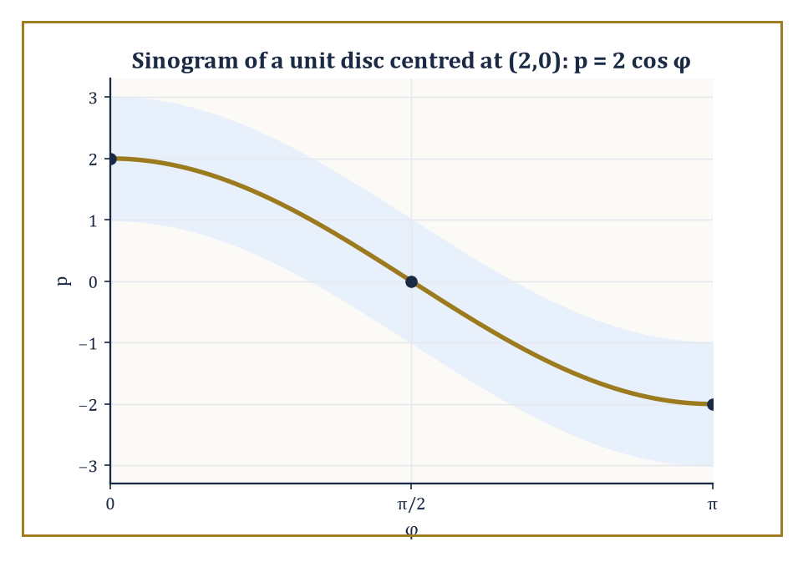
Every off-centre point traces a cosine curve through the projection data — which is the entire reason it's called a sinogram.
(Rf)(φ,p) = ∫_{ℓ_{p,φ}} f ds
So Rf is a new function, but its input is no longer a point of the plane — it is an entire line, addressed by the same (p,φ) coordinates of Room 19.2.
You have, in fact, already computed two Radon transforms without being told they wore that name: the chord-length function 2√(R²−p²) from the disc examples of Room 19.4 is exactly the Radon transform of the disc's indicator function, and it does not depend on φ only because the disc is rotationally symmetric — for a less symmetric shape, Rf genuinely depends on the viewing angle, which is precisely why a CT scanner has to rotate around the patient rather than taking one X-ray and calling it a day.
Numeric example — The Radon transform of a disc, in numbers. Let f be the indicator function of the unit disc (R = 1). We already know its Radon transform, independent of φ:
Rf(φ,p) = 2√(1−p²), for |p| ≤ 1
At p = 0 (a line through the centre):
Rf = 2√(1−0) = 2
This is correct, since a diameter of the unit disc has length exactly 2.
At p = 0.6 (a line offset from the centre by 0.6):
Rf = 2√(1−0.36) = 2√0.64 = 2 × 0.8 = 1.6
This is the length of that particular chord.
At p = 1 (a tangent line, just grazing the boundary):
Rf = 2√(1−1) = 0
This correctly records that a tangent line meets the disc in a single point of zero length. Every one of these numbers is something an X-ray detector could, in principle, measure directly, as the total attenuation of a beam passing along that line.
The deep link between the Radon transform and the Fourier transform (met several storeys back, in a life that now feels comfortingly free of lines and planes) is the projection-slice theorem: the one-dimensional Fourier transform, taken in the p variable, of the projection Rf(φ,·) at a fixed angle φ equals the restriction — the ‘slice’ — of the full two-dimensional Fourier transform of f along the line through the origin in direction φ.
In other words, each individual X-ray projection secretly hands you one entire radial line's worth of the 2D Fourier transform of the patient's interior, for free, and gathering projections from every angle gathers the whole 2D Fourier transform, one slice at a time — at which point an ordinary inverse Fourier transform finishes the job.
This is the theoretical engine behind the reconstruction algorithms of the next room.
In practice, Rf is displayed as an image in its own right, with one axis for the angle φ and the other for the offset p, and the resulting picture is called a sinogram — a name that turns out to be no mere flourish, as the next example shows directly, rather than by assertion.
Numeric example — Where the word ‘sinogram’ actually comes from. Let f be the indicator function of a unit disc, but now centred at (2,0) rather than at the origin. The line ℓ_{φ,p} has the equation:
x cos φ + y sin φ = p
The perpendicular distance from the centre (2,0) to this line is:
|2 cos φ − p|
(This follows by substituting the centre into the left-hand side and subtracting p, using that (cos φ, sin φ) is a unit vector.) Whenever this distance is less than 1, the line clips the disc, with chord length:
Rf(φ,p) = 2√(1 − (2 cos φ − p)²)
Rf(φ,p) = 0, otherwise
The brightest points of the sinogram — where the chord length peaks at its maximum value of 2, a full diameter — occur exactly when 2 cos φ − p = 0, that is, along the curve:
p = 2 cos φ
At φ = 0 this gives p = 2 (the line straight through the centre, offset 2 from the origin, exactly as expected); at φ = π/2 it gives p = 0 (a line through the origin, which happens to also pass through the disc's centre once the geometry is followed through); at φ = π it returns to p = −2.
Plotted with φ along one axis and p along the other, the locus of brightest pixels is literally a cosine curve — a sine wave shifted by a quarter turn — which is exactly why radiologists and their equipment manuals call the raw (φ,p) display of projection data a sinogram: every off-centre point in the object being scanned really does trace out a sine curve across the data, and the reconstruction algorithm's entire job is to read a whole picture's worth of overlapping sine curves and infer where each bright point actually was.
Worked example — Projection-slice theorem, worked in full for a Gaussian. Let f(x,y) = e^{−π(x²+y²)}, the two-dimensional Gaussian that is famously its own Fourier transform. Parametrize the line ℓ_{φ,p} as:
(x,y) = (p cos φ − t sin φ, p sin φ + t cos φ), for t ∈ ℝ
A short algebraic check (expand and use cos²+sin²=1, watching the cross terms cancel) shows:
x² + y² = p² + t²
This holds exactly, for every φ — rotating coordinates cannot change distance from the origin, which is really all this identity is saying. So f along the line becomes e^{−π(p²+t²)}, and the Radon transform is:
Rf(φ,p) = ∫_{−∞}^{∞} e^{−π(p²+t²)} dt = e^{−πp²} ∫_{−∞}^{∞} e^{−πt²} dt = e^{−πp²} × 1 = e^{−πp²}
This uses the standard normalized Gaussian integral ∫e^{−πt²}dt = 1. Notice the projection is itself Gaussian, and — crucially for the theorem — it does not depend on φ at all.
Its one-dimensional Fourier transform is, by the self-duality of the Gaussian under this normalization:
e^{−πk²}
Compare this against the full 2D Fourier transform of f, which is (by the same self-duality, applied in two dimensions):
e^{−π(kx²+ky²)}
Restricted to the line through the origin in direction φ, this reads e^{−πk²} — the exact same function. The slice matches the transformed projection precisely, confirming the projection-slice theorem in a case simple enough to check by hand rather than merely cite, which is exactly why Gaussians are the test pattern of choice when calibrating real scanning equipment.

Room 19.7: Inversion of the Radon Transform and Tomography
Reconstructing the inside of something without cutting it open
Inversion formulas recovering f from Rf exist in every dimension, though they take a slightly different shape in even and odd dimensions — a mild but genuine asymmetry that traces back to how the Fourier transform's inversion formula itself behaves differently depending on parity.
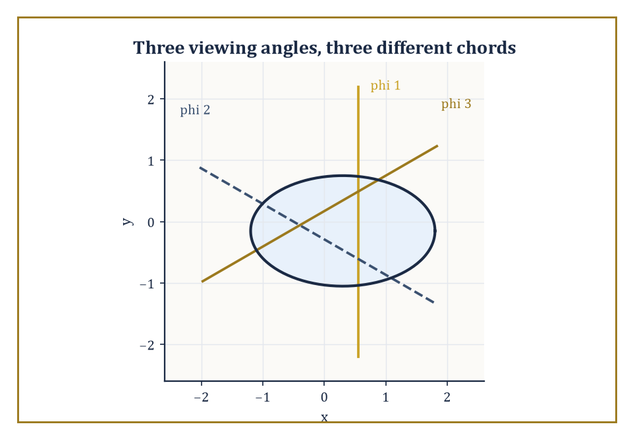
Two viewing angles can leave two different objects looking identical; a third almost always tells them apart.
In two dimensions the standard route runs directly through the projection-slice theorem of the previous room: take the Fourier transform of every projection, assemble the results into the full two-dimensional Fourier transform (one radial slice at a time), and invert.
In practice, working directly with a discretely sampled grid of frequencies is numerically unpleasant, so real scanners instead use filtered back-projection: each 1D projection is first passed through a specific frequency filter (which compensates for the fact that naively smearing raw, unfiltered projections back across the image plane produces a characteristically blurred reconstruction, since low frequencies get over-represented when data arrives from many angles at once), and only then smeared — ‘back-projected’ — across the plane and summed over all angles.
Numeric example — Why one or two projections are never enough. Consider a 2×2 grid of unknown values a, b (top row), c, d (bottom row), and suppose we are told only the row sums and column sums — the crudest possible discrete stand-in for a two-angle X-ray scan.
a+b = 5, c+d = 3 (row projections)
a+c = 4, b+d = 4 (column projections)
One solution is a=2, b=3, c=2, d=1: check the row sums and column sums.
2+3=5 ✓, 2+1=3 ✓ (row sums); 2+2=4 ✓, 3+1=4 ✓ (column sums)
But a second, entirely different solution also fits: a=4, b=1, c=0, d=3, giving row sums and column sums that also check out.
4+1=5 ✓, 0+3=3 ✓ (row sums); 4+0=4 ✓, 1+3=4 ✓ (column sums)
Two genuinely different grids produce identical data from only two projection angles — the reconstruction is not unique, which is the toy-model version of the limited-angle artifacts mentioned below.
Add a third projection, the two diagonal sums:
For the first grid: a+d = 2+1 = 3 and b+c = 3+2 = 5
For the second grid: a+d = 4+3 = 7 and b+c = 1+0 = 1
These differ, so a single extra viewing angle is enough to tell the two grids apart. This is the whole justification, in miniature, for why a real scanner gathers projections from hundreds of angles rather than two: more angles do not just refine an existing answer, they can be the difference between a unique answer and an ambiguous one.
The 2×2 grid example generalises in a way worth stating precisely, since it explains exactly why real scanners insist on so many viewing angles rather than settling for a tidy pair of perpendicular ones.
An n×n grid has n² unknown entries, but only 2n independent-looking equations arrive from row sums and column sums together — and even that count is generous, since the sum of all row sums always equals the sum of all column sums (both equal the grand total), so one equation is automatically redundant, leaving at most 2n−1 genuinely independent constraints.
For any n ≥ 2, n² comfortably outstrips 2n−1, and the shortfall grows without bound as n grows: two orthogonal projection directions, however finely you subdivide the grid, are never going to be enough.
Numeric example — The same ambiguity, one size up. Take the 3×3 grid with entries 1,2,3 / 4,5,6 / 7,8,9 (reading left to right, top to bottom). Its row sums and column sums are:
Row sums: 1+2+3=6, 4+5+6=15, 7+8+9=24
Column sums: 1+4+7=12, 2+5+8=15, 3+6+9=18
Now alter only the top-left 2×2 block by a ‘cycle swap’: add 1 to the entries at positions (row 1, col 1) and (row 2, col 2), and subtract 1 from the entries at (row 1, col 2) and (row 2, col 1), leaving row 3 untouched entirely. The new grid reads 2,1,3 / 3,6,6 / 7,8,9.
Check the row sums: all unchanged.
2+1+3=6 ✓, 3+6+6=15 ✓, 7+8+9=24 ✓
Check the column sums: also all unchanged.
2+3+7=12 ✓, 1+6+8=15 ✓, 3+6+9=18 ✓
Two visibly different 3×3 grids share every row sum and every column sum, exactly as the degrees-of-freedom count above predicted (9 unknowns, at most 5 independent constraints from two directions, leaving 4 dimensions worth of grids — including this one — all consistent with the same two-directional data).
The cycle-swap trick used here to manufacture the ambiguity is precisely the same bookkeeping move that turns up in transportation and assignment problems, which is a tidy reminder that tomography, logistics, and elementary linear algebra are, underneath the surface, having the same argument.
Stability estimates quantify how noise present in the raw projection data propagates into the reconstructed image — a delicate business, because the inversion formula involves a differentiation-like step (in the Fourier-domain picture, high frequencies get amplified by the filtering stage) that can turn small measurement noise into large reconstruction artifacts if one is not careful.
Incomplete data — a limited range of viewing angles, or angles sampled too sparsely — produces its own characteristic streaking and blurring artifacts, visible to any radiologist who has ever had to work with a scan taken too quickly, and understanding exactly how much data suffices for a stable reconstruction remains an active area of research rather than a settled matter.
The same circle of ideas, with the details of what is being measured changed but the mathematics essentially untouched, underlies SPECT (single-photon emission computed tomography, tracking gamma rays emitted by a radioactive tracer injected into the patient) and PET (positron emission tomography, tracking the pairs of gamma rays produced when an emitted positron annihilates with a nearby electron) — and several other imaging modalities besides.
Integral geometry, which began this storey as an elegant piece of pure geometric probability, ends up as unglamorous working machinery inside hospital basements the world over, which is about as good an advertisement for pure mathematics as the subject ever manages to produce.

Room 19.8: Stereology and Practical Measurement
Estimating a whole body from a few slices through it, honestly
Stereology is the applied end of this storey: the discipline of estimating geometric quantities — volume, surface area, length, number of objects — from lower-dimensional samples such as thin sections, projections, or probing lines, using exactly the Crofton and kinematic formulas developed above, only now deployed by biologists and materials scientists rather than pure geometers.
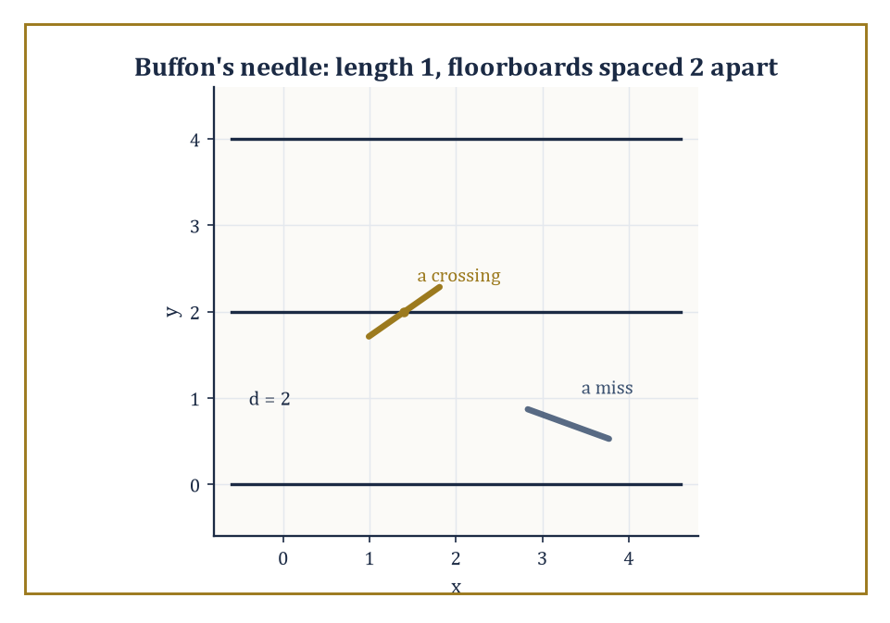
A length-1 needle dropped onto floorboards 2 apart: sometimes it crosses a line, sometimes it doesn't, and the ratio secretly knows π.
The two founding results of the field are Delesse's principle and the Buffon needle problem, and it is worth seeing that the second of these is nothing but a disguised, probabilistic restatement of the Cauchy–Crofton formula of Room 19.3.
Numeric example — Buffon's needle, as Cauchy–Crofton in a lab coat. Drop a needle of length ℓ = 1 at random onto a floor ruled with parallel lines spaced d = 2 apart (with ℓ ≤ d, so the needle cannot possibly cross two lines at once).
The classical result — provable directly from first principles, or read off as a special case of Room 19.3's machinery applied to a random needle position rather than a random line — is that the probability the needle crosses a line equals:
p = 2ℓ/(πd)
Plugging in the numbers:
p = 2(1)/(π·2) = 2/(2π) = 1/π ≈ 0.3183
So roughly 31.83% of needle-drops should cross a line, and this single number, multiplied by a large sample of drops, gives an experimental (if slow and faintly ridiculous) way to estimate π — historically one of the earliest Monte Carlo methods, discovered a good two centuries before anyone owned a computer to run one properly.
Numeric example — Running Buffon's experiment the other way. The probability p = 2ℓ/(πd) can be inverted to estimate π from an observed crossing count, which is exactly how Buffon's problem earned its footnote in the early history of Monte Carlo methods.
Suppose an (unusually patient) experimenter drops the same ℓ = 1, d = 2 needle N = 1000 times and observes 316 crossings.
Solving p = 2ℓ/(πd) for π gives:
π = 2ℓN/(d × crossings)
Substituting:
π̂ = 2(1)(1000) / (2 × 316) = 2000/632 ≈ 3.1646
Not a spectacular estimate — 1000 drops is a small sample, and the true value 3.14159… sits comfortably outside three decimal places of agreement — but it is an honest, unbiased one, and it is worth appreciating that this entire estimation procedure, historically first performed with actual needles and actual floorboards, is nothing more than the Cauchy–Crofton formula of Room 19.3 run as a physical experiment rather than a symbolic integral.
It is, incidentally, a spectacularly inefficient way to compute π — modern algorithms manage millions of correct digits from a laptop in seconds — but as a demonstration that a random physical process can be made to compute something, it has never really been bettered for charm.
One caveat is worth stating plainly, since it is exactly the theme this storey opened with: none of these stereological estimators are unbiased unless the sampling is genuinely isotropic — the test grid (or the sectioning plane, or the probing line) must be applied at a uniformly random orientation with respect to the structure being measured, using the same invariant measure of Room 19.2, rather than always cutting sections in whatever direction happens to be convenient on the microtome.
A structure with a strong preferred orientation (muscle fibres, say, which mostly run one way) measured only with horizontal test lines will yield a systematically biased estimate no matter how many sections are counted; the fix is not more data but the right kind of data, sampled without favouritism as to direction — invariance, once again, doing the entire moral work of the theorem.
Delesse's principle states that the area fraction occupied by a structure of interest on a random planar section, averaged over many sections, equals the volume fraction that structure occupies in the original three-dimensional body — a statement that sounds almost too convenient to be true, but which follows directly from the Crofton-style slicing argument of Room 19.4 (integrating the sliced area over all positions of the section recovers the volume, exactly as integrating chord length over all p recovered area).
It licenses one of the most useful tricks in quantitative microscopy: the point-counting grid.
Numeric example — Estimating volume fraction by counting points. A pathologist overlays a regular grid of 200 test points on a microscope image of a tissue section and counts how many of those points fall on cell nuclei, finding 30.
By Delesse's principle, the observed area fraction, computed as
30/200 = 0.15 = 15%
is an unbiased estimate of the volume fraction of nuclei within the original three-dimensional tissue sample, with no need to physically slice the tissue into infinitesimally thin layers and reconstruct it in 3D.
Repeating the count across several independent sections, and averaging, tightens the estimate in the usual statistical way (more samples, smaller standard error) without ever requiring anything cleverer than counting dots landing on purple blobs.
Modern stereology extends this same toolkit to unbiased estimators for surface area (via counting how often a test-line probe crosses a boundary — Cauchy–Crofton once more), for total length of a curved structure such as a blood vessel network (via counting intersections with a grid of test planes), and for the raw number of discrete objects such as cells, via cleverly designed three-dimensional counting frames that avoid double-counting objects straddling the edge of a sample.
None of the underlying mathematics is new — it is entirely the Crofton and kinematic formulas of Rooms 19.3 through 19.5 — and the practical success of these methods, quietly running inside pathology labs worldwide, is a standing reminder that a piece of geometric measure theory need not stay abstract to remain elegant.

Room 19.9: Looking Ahead: From Integral Geometry to Geometric Measure Theory and Advanced Topics
What this storey's vocabulary quietly opens the door to
We have, over the last eight rooms, acquired a genuinely useful working vocabulary: invariant measures on spaces of lines and planes, the Cauchy–Crofton and higher Crofton formulas, the principal kinematic formula, the Radon transform together with its inversion, and the practical stereological toolkit built from all of the above. It is a shorter list than it feels while you are inside it, and that compression is itself the lesson of the subject — a great many classical formulas turn out to be the same one idea, applied at different orders.
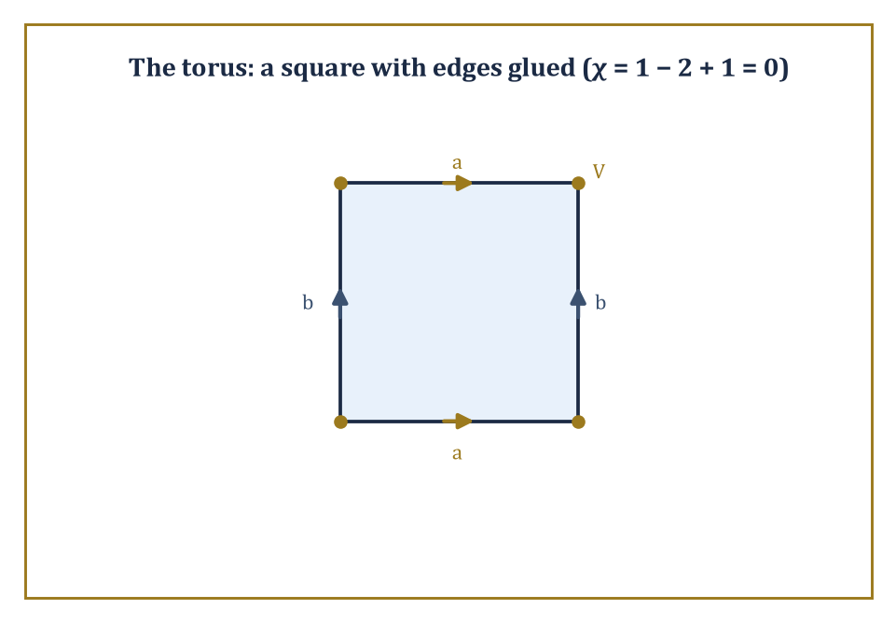
Glue the edges of a square as marked and the four corners collapse into one vertex — a torus, and an Euler characteristic of zero, built from paper and tape.
Several later parts of the tower grow directly out of this vocabulary.
Geometric measure theory supplies the analytic foundations — currents (roughly speaking, generalized oriented surfaces, defined not by parametrizing them directly but by how they act on differential forms, rather as a distribution is defined by how it acts on test functions) and varifolds (generalized, possibly singular surfaces equipped with a well-defined notion of area but without insisting on an orientation) — that let the classical Crofton and kinematic formulas extend far beyond smooth, well-behaved domains, into the realm of sets so ragged that 'boundary' itself needs a more careful definition than the one supplied by an ordinary calculus course.
Considerably further up the tower, a more advanced pass through this same territory takes up higher-rank kinematic formulas, the general theory of convex valuations gestured at in Room 19.5, and integral geometry on homogeneous spaces well beyond flat Euclidean space — hyperbolic and spherical geometry both have their own Crofton formulas, differing from the flat case in ways that are individually charming and collectively too much for one storey.
Tomography and inverse problems, meanwhile, resurface wherever applied mathematics meets an instrument that can only look at something from the outside.
Numeric example — A first taste of a valuation beyond length, area, and volume. The Euler characteristic χ, introduced informally in Room 19.5 as one of the intrinsic volumes, extends the family of length, area, and volume into purely topological territory — it measures connectivity rather than size, and geometric measure theory needs invariants of exactly this flavour once it starts admitting shapes too wild for ordinary measurement. For a cube, the classical formula is:
χ = V − E + F
where V, E, F count vertices, edges, and faces. A cube has V = 8 vertices, E = 12 edges, and F = 6 faces, giving:
χ = 8 − 12 + 6 = 2
— the same value obtained for any convex polyhedron, and indeed for any solid topologically equivalent to a sphere, which is precisely the sense in which χ is a topological rather than a geometric quantity: it does not care whether your solid is a cube, a tetrahedron, or a lopsided potato, only how many holes it has (none, in every one of those cases).
Numeric example — A torus, to show χ actually detects the hole. The cube's Euler characteristic of 2 is shared by every solid topologically equivalent to a sphere, which raises the obvious question of what a shape with an actual hole in it gives instead. Take the surface of a doughnut (a torus), built from the standard construction of a single square with opposite edges glued together (top edge to bottom edge, left edge to right edge).
After gluing, all four corners of the square become a single point, so V = 1. The four edges of the square pair up into just two distinct edges after gluing (top-with-bottom becomes one loop, left-with-right becomes another), so E = 2. The interior of the square becomes a single face, so F = 1. This gives:
χ = V − E + F = 1 − 2 + 1 = 0
— different from the cube's value of 2, and correctly so, since a torus has one handle (one hole) where a cube, topologically, has none.
The general pattern — each additional handle lowers χ by exactly 2 — is the first real evidence that χ is measuring something genuinely topological (a count of holes) rather than anything to do with size, angles, or curvature, which is exactly the flavour of invariant that geometric measure theory needs once it starts admitting shapes too singular for ordinary length and area to say anything useful about at all.
The deeper lesson of this storey, if it must be compressed into one sentence for the lift journey to the next floor, is that a great many geometric quantities are most naturally expressed as integrals over spaces of lower-dimensional objects, and that the correct measures on those spaces are dictated entirely by invariance, not by convenience or convention.
Once that viewpoint is adopted, a large family of classical results — Buffon's needle, the perimeter of a convex body, the surface area of a sphere via its own shadow, the mathematics inside a CT scanner — stops looking like a miscellany of clever tricks and starts looking like one idea, examined from several angles.
Integral geometry is, in that sense, both a beautiful chapter of pure geometry and a thoroughly practical language for reconstructing the invisible from its projections — which is a fair description of what a great deal of applied mathematics is quietly trying to do, in one guise or another, all the way up this tower.
We have, in short, learned to integrate over the space of lines — and, with rather less fuss than the phrase might suggest, discovered that a curve's length, a body's area, and the entire mathematics of the CT scanner are all just this one idea wearing different hats. It is one of the tower's tidier storeys: a single principle (invariant measure, dictated by symmetry) generating an entire toolkit almost by itself, with barely a stray constant left unexplained.
The next storey turns to matrices — a rather different kind of object, admittedly, arrays of numbers rather than clouds of lines, but do not be surprised if the invariance instinct sharpened here keeps proving useful: eigenvalues, after all, are exactly the numbers that stay put no matter which basis you rotate your coordinates into, which is a symmetry argument by any other name. The tower continues upward.

Storey 20: Matrices
Arrays of Numbers, Linear Maps, and the Art of Organizing Linear Information
Storey 19 spent its pages proving that you can measure a convex body's perimeter by firing random lines at it and counting how often they hit - a discipline that manages to make geometry feel like a rather elegant carnival game. It was, in its way, a storey about turning geometric objects into numbers by averaging over infinitely many probes. This storey performs a related trick in the opposite direction: it takes numbers - a great many of them, arranged in a grid - and turns them into geometric objects, namely transformations of space itself.
You have, of course, met matrices already, in whichever earlier storey first made you solve three equations in three unknowns and wish you hadn't. Until now they have been scaffolding: a tidy way of writing down the coefficients of a linear system so that Gaussian elimination didn't require rewriting 'x', 'y', and 'z' four hundred times. From this storey onward the scaffolding becomes the building. A matrix will be an object with its own arithmetic - one can add matrices, multiply them by scalars, multiply them by each other (subject to a size restriction that trips up every student at least once), and, when luck and non-singularity permit, invert them.
The plan for the climb ahead: what a matrix is and why it is shaped the way it is; the arithmetic, including the famously uncommutative multiplication; inverses and the elementary matrices that build them; determinants, which compress an entire matrix into one number that somehow knows whether the matrix is invertible; row reduction and rank; the reinterpretation of matrices as linear maps between coordinate spaces; a first, deliberately restrained look at eigenvalues and eigenvectors; and a tour of the special matrices - diagonal, triangular, symmetric, orthogonal - that make life easier when you're lucky enough to meet one. The deeper theory that this all serves - vector spaces without coordinates, the spectral theorem, canonical forms - waits one storey further up, in Linear Algebra. Here we stay resolutely concrete: rows, columns, numbers, arithmetic.
One warning before we start climbing. Matrix multiplication is the first piece of algebra most people meet that refuses to behave: AB and BA are, in general, two entirely different matrices, sitting there looking similar and meaning nothing alike, rather like twins who turned out to have opposite personalities and opposite politics. This is not a design flaw. It is the entire point, and by the end of the next room you will see exactly why the formula has to work this way. Let's multiply arrays.

Room 20.1: What a Matrix Actually Is
In Which Numbers Learn to Stand in Formation
A matrix is a rectangular array of numbers - or, if you insist on generality, of elements of any field, though we shall mostly stick to the real numbers and only occasionally glance nervously at the complex ones - arranged into rows and columns.
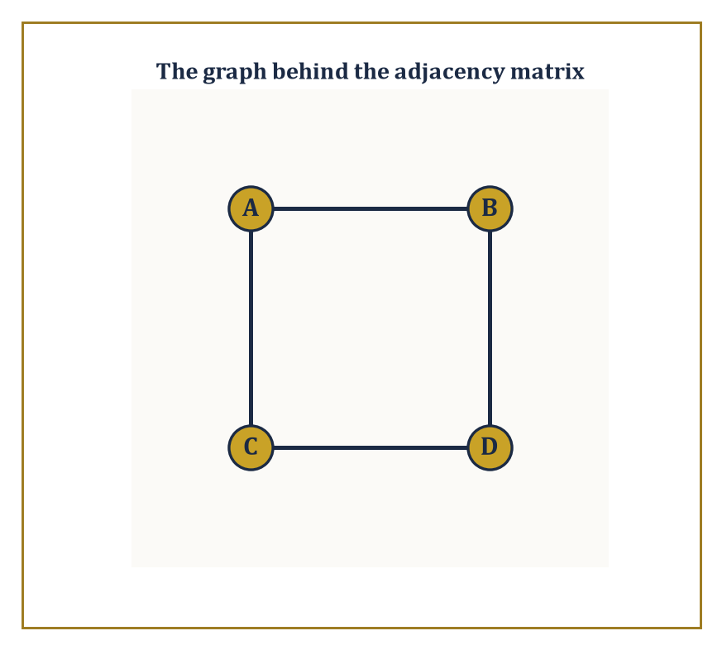
The square graph behind the adjacency matrix of Room 20.1 - four vertices, four edges, and a matrix that already knows every one of them.
An m x n matrix has m rows and n columns, and by convention (a convention worth memorising now, because getting it backwards causes hours of quiet suffering later) rows are listed first: 'm by n' means m rows, n columns, in that order. The entry sitting in row i and column j is written a_{ij}, with the row index always first.
Think of a matrix as a spreadsheet with the headers stripped off: a single symbol, A, standing in for an entire grid of numbers that could otherwise take up half a page.
Numeric example — Worked example. Consider the matrix:
A = [[2, -1, 5], [0, 3, 7]]
This is a 2 x 3 matrix: two rows, three columns, six entries in total. Reading off individual entries by the a_{ij} convention:
a_{11} = 2 (row 1, column 1), a_{12} = -1, a_{13} = 5, a_{21} = 0, a_{22} = 3, a_{23} = 7
Note that A is not square - it has more columns than rows - and so, whatever else happens in this storey, A itself will never possess an inverse; only square matrices are even eligible to apply.
Matrices earn their keep by showing up everywhere numbers need to be organised in two dimensions. They are the coefficient arrays of linear systems (the use that will occupy Room 20.5). They are tables of data - a spreadsheet of exam scores, rows for students and columns for subjects, is a matrix whether or not anyone in the room calls it one.
They are adjacency matrices of graphs, recording which vertices are joined to which. They represent linear transformations once a basis has been chosen (Room 20.6). And in more advanced settings they act as discrete stand-ins for the integral kernels met a storey ago - a matrix is, in a sense, what an integral operator looks like once you've chopped continuous space into finitely many pixels.
The arithmetic we are about to impose on matrices - addition, multiplication, the lot - is not handed down from on high; it is reverse-engineered from these uses, chosen precisely because it makes each of these interpretations work correctly.
Numeric example — Worked example. Consider four vertices A, B, C, D joined in a square: edges A-B, B-D, D-C, C-A (so that walking A to B to D to C to A traces the square). List the vertices in the order A, B, C, D and record a 1 in position (i,j) whenever vertex i is joined to vertex j, and 0 otherwise.
Vertex A is joined to B and C but not D, giving row (0,1,1,0). Vertex B is joined to A and D, giving (1,0,0,1). Vertex C is joined to A and D, giving (1,0,0,1). Vertex D is joined to B and C, giving (0,1,1,0).
The adjacency matrix is therefore:
[[0,1,1,0],[1,0,0,1],[1,0,0,1],[0,1,1,0]]
- symmetric, as adjacency matrices of undirected graphs always are, since an edge from i to j is inescapably also an edge from j to i.
Each row sums to 2, which is simply the number of edges at that vertex; a matrix, it turns out, can recite the degree sequence of a graph without anyone having to draw a single picture.
Two matrices are equal exactly when they have the same size and every corresponding entry agrees; there is no partial credit; a matrix that is 'almost' equal to another is simply a different matrix.
The zero matrix, written 0 with size understood from context, has every entry zero and plays the role in matrix addition that the number 0 plays among ordinary numbers.
Square matrices - those with m = n - are the aristocracy of the subject: only a square matrix can be multiplied by itself, raised to a power, or hope to possess an inverse, and so almost everything in Rooms 20.3, 20.4, and 20.7 is stated for square matrices specifically, with rectangular matrices left to make cameo appearances in systems of equations.
Numeric example — Worked example. Consider the following three matrices:
A = [[1,2],[3,4]], B = [[1,2],[3,4]], C = [[1,2],[3,5]]
Then, entry for entry:
A = B
But A is not equal to C, and it does not matter that they differ in only one place out of four - the (2,2) entries are 4 and 5 respectively, so C is simply a different matrix from A, full stop.
Meanwhile the 2x2 zero matrix is:
[[0,0],[0,0]]
A + 0 = A
exactly as you'd hope; it is the null result of the addition operation we are about to define properly in the next room.
Here is the payoff for all this bookkeeping. A system of m linear equations in n unknowns can be written as the single matrix equation:
Ax = b
where A is the m x n coefficient matrix, x is the column of n unknowns, and b is the column of m constants. What used to be a paragraph of aligned equals signs becomes three symbols and a multiplication.
This is not merely typographical tidiness: once a system is a single equation Ax = b, questions about it - does a solution exist? is it unique? how does it change if b changes? - become questions about the matrix A, answerable by the machinery (determinants, rank, inverses) built over the rest of this storey. Compression is not just convenient; it is the beginning of a genuinely new way of thinking about the problem.
Numeric example — Worked example. Take the system:
x + 2y = 5, 3x - y = 1
In matrix form this is Ax = b with:
A = [[1,2],[3,-1]], x = [x, y]^T, b = [5,1]^T
Solving by substitution in the usual way: from the first equation,
x = 5 - 2y
substituting into the second gives:
3(5 - 2y) - y = 1
15 - 6y - y = 1
15 - 7y = 1
y = 2
and then:
x = 5 - 2(2) = 1
Check directly against the matrix equation:
Ax = [[1,2],[3,-1]] * [1,2]^T = [1*1+2*2, 3*1+(-1)*2]^T = [1+4, 3-2]^T = [5,1]^T = b
The single symbol Ax = b really is hiding the pair of equations we started with, and this same matrix A will resurface in Room 20.4 when we compute its determinant by a completely different route and get an answer that still, reassuringly, tells us this system had exactly one solution.

Room 20.2: Matrix Arithmetic: Addition, Scalar Multiplication, Multiplication
Or: Why AB and BA Are Barely on Speaking Terms
Addition and scalar multiplication are exactly as unimaginative as you'd hope. Two matrices of the same size are added entrywise: the (i,j) entry of A + B is given by adding the corresponding entries.
(A + B)_{ij} = a_{ij} + b_{ij}
Scalar multiplication multiplies every entry by the scalar.
(cA)_{ij} = c * a_{ij}
These two operations, so simple they barely need announcing, are enough to make the set of all m x n matrices into a vector space in its own right - you can add matrices, scale them, and everything behaves exactly as vector addition and scaling ought to. Since an m x n matrix has mn entries, each free to be anything, this vector space has dimension mn: an m x n matrix is, structurally, nothing more than a list of mn numbers wearing a rectangular costume.
Numeric example — Worked example. Let A = [[1,2],[3,4]] and B = [[5,-1],[0,2]].
A + B = [[1+5, 2+(-1)],[3+0, 4+2]] = [[6,1],[3,6]]
Entry by entry, no surprises.
3A = [[3*1, 3*2],[3*3, 3*4]] = [[3,6],[9,12]]
Note that A is a 2x2 matrix, hence lives in a vector space of dimension 2*2 = 4 - and indeed A is entirely determined by the ordinary list of four numbers (1,2,3,4), read off row by row.
Multiplication is where matrices stop being polite. The product AB is defined only when the number of columns of A equals the number of rows of B - an m x n matrix can only be multiplied on the right by an n x p matrix, and the result is m x p. The (i,j) entry of AB is the dot product of row i of A with column j of B: you march along a row and down a column simultaneously, multiplying corresponding entries and adding up.
This rule looks, on first encounter, like something a committee designed to be memorable rather than sensible. It is not arbitrary. It is exactly the rule that makes the following true for every compatible column vector x:
(AB)x = A(Bx)
That is, multiplying by AB has precisely the same effect as multiplying by B first and then by A. Matrix multiplication is defined the way it is so that it corresponds to composing the linear maps that A and B represent: do B, then do A. Once you see multiplication as 'do this, then do that', the row-times-column formula stops being an arbitrary hoop and becomes the only formula that could possibly have worked.
Numeric example — Worked example. Let A = [[1,0,2],[-1,3,1]] (2x3) and B = [[3,1],[2,1],[1,0]] (3x2). Since A has 3 columns and B has 3 rows, AB is defined and will be 2x2.
Entry (1,1): row 1 of A, (1,0,2), dotted with column 1 of B, (3,2,1).
1*3 + 0*2 + 2*1 = 3+0+2 = 5
Entry (1,2): row 1 of A dotted with column 2 of B, (1,1,0).
1*1 + 0*1 + 2*0 = 1
Entry (2,1): row 2 of A, (-1,3,1), dotted with column 1 of B.
-1*3 + 3*2 + 1*1 = -3+6+1 = 4
Entry (2,2): row 2 of A dotted with column 2 of B.
-1*1 + 3*1 + 1*0 = -1+3+0 = 2
So:
AB = [[5,1],[4,2]]
Notice that BA would also be defined here (B is 3x2, A is 2x3, inner dimensions 2 and 2 match), and would come out 3x3 - a completely different shape from AB, which is your first hint that order matters rather a lot.
Matrix multiplication is associative and distributes over addition - both facts inherited directly from the composition-of-functions interpretation, since composing functions is always associative:
(AB)C = A(BC)
A(B+C) = AB+AC
What it is not, in general, is commutative: AB and BA need not be equal, and frequently are not even the same size.
Sitting quietly among the square n x n matrices is the identity matrix I_n, with 1's down the main diagonal and 0's everywhere else, satisfying:
AI = IA = A
for every n x n matrix A. It is the matrix world's answer to the number 1: multiplying by it changes nothing, which is precisely why we shall spend Room 20.3 asking which matrices have a partner that undoes them.
Numeric example — Worked example. Let A = [[1,1],[0,1]] and B = [[1,0],[1,1]] - both 2x2, so both products are defined and both come out 2x2, removing the easy excuse of mismatched shapes.
Computing AB entry by entry:
entry (1,1) = 1*1+1*1 = 2
entry (1,2) = 1*0+1*1 = 1
entry (2,1) = 0*1+1*1 = 1
entry (2,2) = 0*0+1*1 = 1
AB = [[2,1],[1,1]]
Now BA:
entry (1,1) = 1*1+0*0 = 1
entry (1,2) = 1*1+0*1 = 1
entry (2,1) = 1*1+1*0 = 1
entry (2,2) = 1*1+1*1 = 2
BA = [[1,1],[1,2]]
Same two matrices, same order of operations reversed, and AB is not equal to BA - they don't even share a top-left entry. If multiplication were commutative here, the (1,1) entries would match; they are 2 and 1, and no amount of wishful thinking closes that gap.
For a square matrix A, powers are defined the obvious way - A^2 = A times A, A^3 = A times A times A, and so on - and since matrix multiplication is associative, these behave exactly as you'd expect powers to behave:
A^p * A^q = A^(p+q)
Once powers exist, so do polynomials in A: an expression like the following is perfectly well-defined, obtained by computing the powers of A and combining them with scalar multiples of A and of the identity:
p(A) = A^2 - 2A + I
This might look like idle generalisation, but polynomials in a matrix will turn out to be central later - the characteristic polynomial of Room 20.7 and the whole theory of the Jordan form (waiting one storey further up) are built entirely from this idea.
Numeric example — Worked example. Let A = [[2,1],[0,2]]. Then A^2 = A times A, computed entry by entry:
entry (1,1) = 2*2+1*0 = 4
entry (1,2) = 2*1+1*2 = 4
entry (2,1) = 0*2+2*0 = 0
entry (2,2) = 0*1+2*2 = 4
A^2 = [[4,4],[0,4]]
Now evaluate p(A) = A^2 - 2A + I. We have:
2A = [[4,2],[0,4]]
I = [[1,0],[0,1]]
p(A) = [[4-4+1, 4-2+0],[0-0+0, 4-4+1]] = [[1,2],[0,1]]
Keep an eye on this particular A - it is going to reappear in Room 20.7 wearing a rather embarrassing secret: it has only one independent eigenvector, despite being 2x2, and this is exactly the kind of matrix that keeps Jordan-form theorists in gainful employment.

Room 20.3: The Identity, Inverses, and Elementary Matrices
Undoing What Has Been Done, When Possible
A square matrix A is called invertible (or nonsingular) if there is some matrix A^-1 that undoes it, satisfying
AA^-1 = A^-1A = I
When such a matrix exists it is unique - if B and C both undid A, a short algebraic manoeuvre shows B = C, so there is never any ambiguity about which matrix is 'the' inverse:
B = BI = B(AC) = (BA)C = IC = C
Invertible matrices are exactly the matrices that represent invertible linear maps: maps that can be run backwards without losing information.
Equivalently, A is invertible precisely when the system Ax = b has one and only one solution x for every possible b - invertibility is a statement about the matrix, but it is also, simultaneously, a statement about the solvability of an entire family of linear systems.
Not every square matrix qualifies, and this is worth dwelling on for a moment, because the temptation is to think of 'inverse' the way one thinks of reciprocals of ordinary numbers, where only zero misbehaves.
Among matrices the failure mode is more interesting: a matrix fails to be invertible whenever its rows (or columns) are not independent of one another - whenever one row can be written as a combination of the others, some information about the input vector is irretrievably thrown away by the map, and no amount of algebraic cleverness can build a machine to recover what was never recorded.
Numeric example — Worked example. For a general 2x2 matrix A = [[a,b],[c,d]], provided ad - bc is not zero, the inverse is given by swapping the diagonal entries, negating the off-diagonal ones, and dividing by the determinant (a quantity we shall meet properly next room, but which is already doing useful work here):
A^-1 = (1/(ad-bc)) * [[d,-b],[-c,a]]
Take A = [[2,1],[1,1]]: here ad - bc = 2*1 - 1*1 = 1, so the inverse works out to
A^-1 = (1/1) * [[1,-1],[-1,2]] = [[1,-1],[-1,2]]
Check: AA^-1 = [[2,1],[1,1]] * [[1,-1],[-1,2]]. Entry (1,1) = 2*1+1*(-1) = 1; entry (1,2) = 2*(-1)+1*2 = 0; entry (2,1) = 1*1+1*(-1) = 0; entry (2,2) = 1*(-1)+1*2 = 1. So:
AA^-1 = [[1,0],[0,1]] = I
exactly as promised.
Elementary matrices are a small, useful family: each is obtained from the identity matrix by performing exactly one elementary row operation - swap two rows, multiply a row by a nonzero scalar, or add a multiple of one row to another.
Every elementary matrix is invertible (each of the three operations is itself reversible: swap back, divide by the same scalar, subtract the same multiple back off), and the reason they matter is a small piece of magic: left-multiplying any matrix A by an elementary matrix E performs on A the exact row operation that was used to build E from the identity.
Row reduction, in other words, is secretly a sequence of matrix multiplications by elementary matrices, dressed up in more casual clothing.
Numeric example — Worked example. The elementary matrix for 'swap row 1 and row 2' in the 2x2 setting is obtained by taking the identity and swapping its rows:
E = [[0,1],[1,0]]
Apply it to A = [[2,1],[1,1]] by left multiplication: EA has entry (1,1) = 0*2+1*1 = 1; entry (1,2) = 0*1+1*1 = 1; entry (2,1) = 1*2+0*1 = 2; entry (2,2) = 1*1+0*1 = 1. So:
EA = [[1,1],[2,1]]
exactly A with its two rows swapped, as advertised, and no dot-product gymnastics were needed to see it coming.
Because every elementary row operation is achieved by left-multiplying by an elementary matrix, and because Gaussian elimination reduces any invertible matrix to the identity by a finite sequence of such operations, it follows that any invertible A can be written as a product of elementary matrices:
E_k ... E_2 E_1 A = I
A^-1 = E_k ... E_2 E_1
This is not just a structural curiosity - it hands us a genuine algorithm. If we apply the same sequence of row operations that reduces A to I to the identity matrix I sitting alongside it, we get exactly A^-1 for free.
In practice this means: write the augmented block [A | I], row-reduce the left half to the identity, and read the inverse off the right half.
This is, in fact, the only sane way to invert anything bigger than a 3x3 matrix by hand; the cofactor-and-adjugate formula that generalises the 2x2 shortcut of the previous example exists, technically, for every size of matrix, but its cost explodes so violently with n that nobody outside an examination hall has used it on a matrix larger than 3x3 in living memory.
Numeric example — Worked example. Take the same A = [[2,1],[1,1]] as before, and confirm its inverse by the row-reduction method rather than the 2x2 formula, so the two routes can check each other. Start from the augmented block:
[A | I] = [[2,1|1,0],[1,1|0,1]]
Operation 1: replace row 1 with row 1 minus row 2:
[2-1, 1-1 | 1-0, 0-1] = [1,0 | 1,-1]
The block is now [[1,0|1,-1],[1,1|0,1]]. Operation 2: replace row 2 with row 2 minus row 1:
[1-1, 1-0 | 0-1, 1-(-1)] = [0,1 | -1,2]
The block is now [[1,0|1,-1],[0,1|-1,2]]. The left half is the identity, so the right half is the inverse:
A^-1 = [[1,-1],[-1,2]]
precisely what the formula gave a moment ago. The two methods agreeing is not a coincidence; it is the same fact, computed two different ways, which is exactly the kind of consistency check a suspicious mathematician (that is, any competent one) should always perform.

Room 20.4: Determinants
One Number That Somehow Knows Everything
The determinant is a single scalar computed from a square matrix, written det(A) or |A|, with the crucial property that it detects singularity: it vanishes exactly when A is singular (non-invertible).
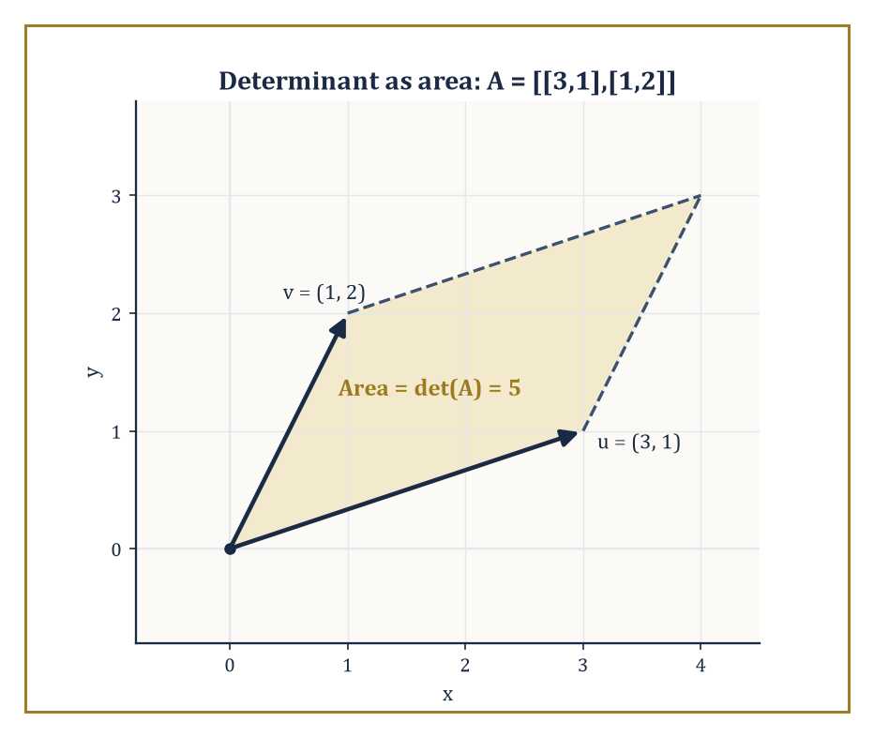
The parallelogram spanned by u = (3,1) and v = (1,2), with area exactly 5 - the determinant caught in the act of measuring.
det(A) = 0 (exactly when A is singular)
It can be introduced in at least three equivalent ways: by the Leibniz formula, a signed sum over all n! permutations of {1,...,n}; by an axiomatic characterisation as the unique function that is multilinear in the rows, alternates sign when two rows are swapped, and sends the identity to 1; or recursively, by cofactor expansion along any row or column, reducing an n x n determinant to a signed sum of (n-1) x (n-1) determinants.
All three definitions produce the same number; which one you reach for is a matter of taste, patience, and how many rows your matrix has.
Numeric example — Worked example. Let M = [[1,2,3],[0,1,4],[5,6,0]]. Expand along the first row.
det(M) = 1*det[[1,4],[6,0]] - 2*det[[0,4],[5,0]] + 3*det[[0,1],[5,6]]
Each bracket is a 2x2 determinant, computed as (top-left times bottom-right) minus (top-right times bottom-left):
det[[1,4],[6,0]] = 1*0 - 4*6 = -24
det[[0,4],[5,0]] = 0*0 - 4*5 = -20
det[[0,1],[5,6]] = 0*6 - 1*5 = -5
Substituting:
det(M) = 1*(-24) - 2*(-20) + 3*(-5) = -24 + 40 - 15 = 1
Since det(M) = 1, not zero, M is invertible - a fact we now know without doing a shred of row reduction.
Determinants obey a short, useful list of rules.
The determinant of a product is the product of the determinants, for any two square matrices of the same size - a fact that is far from obvious from the Leibniz formula but drops out cleanly from the axiomatic definition.
det(AB) = det(A) det(B)
The determinant of a triangular matrix (all entries above or below the diagonal zero) is simply the product of its diagonal entries - no expansion needed. Swapping two rows flips the sign of the determinant. Multiplying a single row by a scalar c multiplies the whole determinant by c.
These rules are precisely what make Gaussian elimination a viable way to compute determinants of large matrices: track the sign flips from row swaps and the scalar factors from row scalings, reduce to triangular form, and multiply the diagonal.
Numeric example — Worked example. Let A = [[1,2],[0,1]] and B = [[2,0],[1,3]]. Directly:
det(A) = 1*1 - 2*0 = 1
det(B) = 2*3 - 0*1 = 6
Now compute AB, entry by entry:
entry (1,1) = 1*2+2*1 = 4
entry (1,2) = 1*0+2*3 = 6
entry (2,1) = 0*2+1*1 = 1
entry (2,2) = 0*0+1*3 = 3
So AB = [[4,6],[1,3]], and:
det(AB) = 4*3 - 6*1 = 12 - 6 = 6
Compare with det(A) times det(B):
det(A) * det(B) = 1*6 = 6
They agree, as the product rule guarantees they must - for any pair of square matrices you care to try, not just this obliging one.
Geometrically, for a 2x2 matrix, |det(A)| is the area of the parallelogram spanned by its two columns (equivalently its two rows); for a 3x3 matrix, |det(A)| is the volume of the parallelepiped spanned by its three columns.
In higher dimensions the pattern continues: |det(A)| measures the factor by which the linear map x maps to Ax scales n-dimensional volume, and the sign of det(A) records whether the map preserves or reverses orientation (whether it flips the space over, like a reflection, or not).
A determinant of zero says the map squashes n-dimensional volume down to something lower-dimensional - a plane's worth of area collapsed onto a line, say - which is exactly the geometric reason a singular matrix cannot be inverted: you cannot un-squash a pancake back into a loaf.
Numeric example — Worked example. Let u = (3,1) and v = (1,2) be the two columns of a matrix, so A = [[3,1],[1,2]].
det(A) = 3*2 - 1*1 = 6 - 1 = 5
So the parallelogram with sides u and v has area 5. As a sanity check by a completely different route: the parallelogram sits inside a 3-by-2 bounding rectangle of area 6, and a quick sketch confirms an area a little under 6 is entirely plausible - 5 passes the smell test, which is always worth doing before trusting an arithmetic answer.
Cramer's rule expresses each coordinate of the solution to a nonsingular system Ax = b as a ratio of determinants, where A_i is A with its i-th column replaced by b.
x_i = det(A_i)/det(A)
It is a genuinely elegant formula and a genuinely poor algorithm - computing that many determinants costs far more arithmetic than Gaussian elimination once the system has more than three or four unknowns, so Cramer's rule survives mainly as a theoretical tool and an exam question, rather than as something anyone actually runs on a computer.
One more fact worth banking now and cashing in Room 20.7: the determinant is (up to sign) the constant term of the characteristic polynomial, and therefore equals the product of all the eigenvalues of A, counted with multiplicity - a single number that, remarkably, already knows the product of quantities we haven't even defined yet.
Numeric example — Worked example. Recall the system from Room 20.1: x + 2y = 5, 3x - y = 1, with A = [[1,2],[3,-1]] and b = [5,1]^T.
det(A) = 1*(-1) - 2*3 = -1 - 6 = -7
For x, replace column 1 of A with b: A_x = [[5,2],[1,-1]].
det(A_x) = 5*(-1) - 2*1 = -5 - 2 = -7
x = det(A_x)/det(A) = -7/-7 = 1
For y, replace column 2 of A with b: A_y = [[1,5],[3,1]].
det(A_y) = 1*1 - 5*3 = 1 - 15 = -14
y = det(A_y)/det(A) = -14/-7 = 2
This matches x = 1, y = 2 exactly as found by substitution back in Room 20.1 - three different methods (substitution, matrix inversion in spirit, and now determinants) converging on the same answer, which is either deeply reassuring about the consistency of mathematics or a sign that we chose a suspiciously well-behaved example. Both, really.

Room 20.5: Row Reduction, Rank, and Solving Systems
The Algorithm Underneath Everything Else in This Storey
Gaussian elimination reduces a matrix to row-echelon form - a staircase pattern where each row's leading nonzero entry sits strictly to the right of the leading entry in the row above, and any all-zero rows sink to the bottom - using only the three elementary row operations from Room 20.3.
Pushing further to eliminate entries above each leading entry as well (not just below) yields reduced row-echelon form, the process usually called Gauss-Jordan elimination.
Applying exactly the same operations to the augmented matrix [A | b] simultaneously transforms both the coefficient matrix and the constants, so that at the end you can read off the solution to Ax = b directly.
Or you discover, from a row that reduces to the following, that no solution exists at all:
0 = (nonzero number)
Numeric example — Worked example. Solve the following system of three equations in three unknowns:
x + y + z = 6, 2x - y + z = 3, x + 2y - z = 2
Written as an augmented matrix:
[A | b] = [[1,1,1|6],[2,-1,1|3],[1,2,-1|2]]
Eliminate the first column below row 1: row 2 becomes row 2 minus 2 times row 1, and row 3 becomes row 3 minus row 1.
row 2: [0,-3,-1|-9]
row 3: [0,1,-2|-4]
The augmented matrix is now:
[[1,1,1|6],[0,-3,-1|-9],[0,1,-2|-4]]
Swap rows 2 and 3 for a tidier leading entry:
[[1,1,1|6],[0,1,-2|-4],[0,-3,-1|-9]]
Eliminate below the new row 2: row 3 becomes row 3 plus 3 times row 2.
[0, -3+3, -1-6 | -9-12] = [0,0,-7|-21]
Back-substitute. From row 3:
-7z = -21, so z = 3
From row 2:
y - 2z = -4, so y = -4 + 2*3 = 2
From row 1:
x + y + z = 6, so x = 6 - 2 - 3 = 1
Check against all three original equations:
x+y+z = 1+2+3 = 6
2x-y+z = 2-2+3 = 3
x+2y-z = 1+4-3 = 2
All three check out correctly. The system has the unique solution (x,y,z) = (1,2,3).
The rank of a matrix is the number of nonzero rows in its row-echelon form - equivalently, the dimension of its column space (the span of its columns) or of its row space (the span of its rows, which, remarkably, always has the same dimension as the column space, even though rows and columns are entirely different objects).
Rank does not change under elementary row operations, nor under transposition, which is exactly why 'the number of nonzero rows after elimination' is a safe and well-defined thing to count regardless of which sequence of legal row operations you happened to use to get there.
Rank is also connected to a theorem we shall only preview here and prove properly next storey - the rank-nullity theorem - which says that for an n-column matrix:
rank + dim(null space) = n
Every dimension you 'lose' to a smaller rank shows up, without exception, as extra freedom in the null space.
Numeric example — Worked example. Let N be the following matrix. Notice row 2 is exactly twice row 1 - a dependency that ought to cost the matrix a dimension of rank.
N = [[1,2,3],[2,4,6],[1,0,1]]
Row reduce: row 2 becomes row 2 minus 2 times row 1, and row 3 becomes row 3 minus row 1.
row 2: [0,0,0]
row 3: [0,-2,-2]
The echelon form is:
[[1,2,3],[0,-2,-2],[0,0,0]]
(with the now-redundant all-zero row sitting at the bottom, where it belongs). There are two nonzero rows, so rank(N) = 2, not the full 3 you might have naively expected from a 3x3 matrix.
This matrix will turn out to have a one-dimensional null space, as the rank-nullity theorem predicts (3 columns minus rank 2 equals nullity 1), and we shall confirm that directly in the next room.
For a square n x n matrix, the following statements are all equivalent - each implies all the others, so any one of them is a complete test for invertibility:
A is invertible <=> rank(A) = n (full rank) <=> the reduced row-echelon form of A is the identity matrix <=> det(A) is not zero
Any one test failing means all of them fail simultaneously. In practice the determinant test is usually fastest for small matrices done by hand, while row reduction (which you'd often be doing anyway, to solve a system) is the practical test for anything larger.
It is worth pausing to notice how much weight this short list is carrying: a purely algebraic condition (a formula involving no geometry at all evaluates to a nonzero number), a purely computational condition (an algorithm terminates in a particular way), and a purely dimension-counting condition (a count of independent rows reaches its maximum possible value) all turn out to be exactly the same fact, seen through three different lenses.
Whenever one of them is easy to check and the others are not, you now have the right to check the easy one and trust the rest for free.
Numeric example — Worked example. Compare A with B, defined as follows:
A = [[2,1],[1,1]], B = [[2,4],[1,2]]
For A, compute the determinant:
det(A) = 2*1 - 1*1 = 1
This is not zero, and row-reducing A (row 1 minus row 2 gives [1,0]; row 2 stays [1,1], and further reduction confirms two independent nonzero rows) gives rank 2, full rank; A is invertible, consistent with Room 20.3.
For B, compute the determinant:
det(B) = 2*2 - 4*1 = 4 - 4 = 0
Indeed row 2 = (1/2) times row 1, so row-reducing gives:
[[2,4],[0,0]]
Only one nonzero row, so rank(B) = 1, less than 2. All three tests (determinant, rank, echelon form) agree that B is singular: there is no B^-1, and the system Bx = b will have either no solution or infinitely many, depending on b, but never exactly one.

Room 20.6: Matrices as Linear Maps
What A Actually Does to a Vector
Every m x n matrix A defines a function from R^n to R^m by the rule x maps to Ax - feed in a column vector with n entries, and matrix-vector multiplication (the one-column special case of the multiplication rule from Room 20.2) hands back a column vector with m entries.
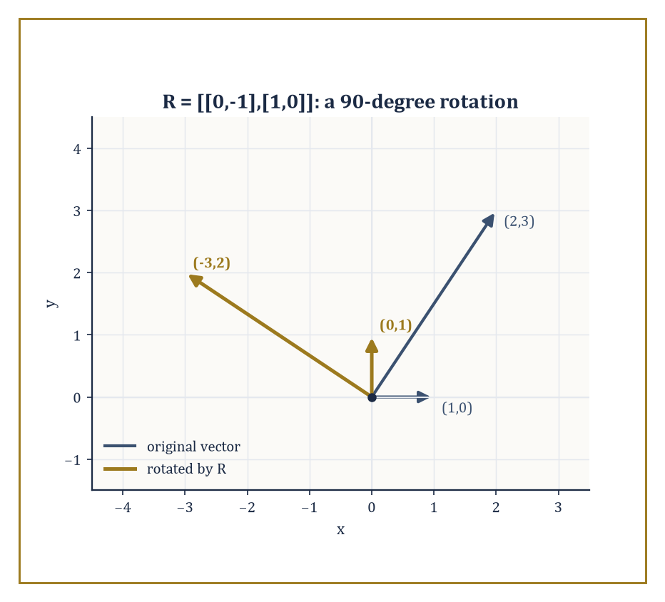
R turning (1,0) into (0,1) and (2,3) into (-3,2) - the same quarter-turn, applied faithfully to every vector it meets.
This function is linear, both immediate from the distributive and scalar properties of matrix arithmetic:
A(x+y) = Ax + Ay
A(cx) = cAx
The converse also holds, once you fix bases for the source and target: every linear map between coordinate spaces arises from exactly one matrix.
And matrix multiplication, which looked like an arbitrary row-times-column rule when you first met it, now reveals its true purpose - AB corresponds exactly to the composite map 'first apply the map for B, then apply the map for A', which is precisely why the formula had to be defined the way it was back in Room 20.2.
Numeric example — Worked example. The matrix R = [[0,-1],[1,0]] represents a 90-degree counterclockwise rotation of the plane.
Apply it to (1,0):
R*(1,0)^T = (0*1+(-1)*0, 1*1+0*0)^T = (0,1)^T
The point due east has rotated to due north, exactly as a 90-degree turn should send it.
Apply it to (2,3):
R*(2,3)^T = (0*2+(-1)*3, 1*2+0*3)^T = (-3,2)^T
Check this is genuinely a 90-degree rotation of (2,3) rather than some other transformation: the length is preserved (the square root of 2^2+3^2 is the square root of 13, and the square root of (-3)^2+2^2 is also the square root of 13), and the vector (-3,2) is indeed (2,3) turned a quarter-circle anticlockwise about the origin.
Two subspaces attached to A deserve names because they answer the two most natural questions about the map x maps to Ax: where can it land, and what does it destroy?
The column space of A - the span of its columns - is exactly the range of the map, the set of all possible outputs Ax.
The null space of A is the set of all x with Ax = 0 - exactly the kernel of the map, the vectors the map collapses to the origin.
Rank, defined in the previous room as a count of nonzero rows in echelon form, is simultaneously the dimension of the column space, i.e. of the range: a purely computational recipe (count the rows) and a purely geometric quantity (the dimension of where the map can land) turn out to be the same number, which is one of those small miracles linear algebra keeps producing once you look for them.
Numeric example — Worked example. Recall N = [[1,2,3],[2,4,6],[1,0,1]] from Room 20.5, with rank 2 and echelon form [[1,2,3],[0,-2,-2],[0,0,0]].
Since N has 3 columns and rank 2, the rank-nullity theorem promises a null space of dimension 3 - 2 = 1: exactly one free direction of vectors that N crushes to zero.
Solve Nx = 0 using the echelon form: row 2 gives
-2x_2 - 2x_3 = 0
so x_2 = -x_3; set x_3 = 1, giving x_2 = -1.
Row 1 gives
x_1 + 2x_2 + 3x_3 = 0
x_1 = -2(-1) - 3(1) = 2 - 3 = -1
So x = (-1,-1,1) spans the null space.
Check directly against the original N.
row 1: 1(-1)+2(-1)+3(1) = -1-2+3 = 0
Correct.
row 2: 2(-1)+4(-1)+6(1) = -2-4+6 = 0
Correct.
row 3: 1(-1)+0(-1)+1(1) = -1+0+1 = 0
Correct.
The vector (-1,-1,1) really does vanish under N, and - because N has rank 2, not 3 - it is not alone; every scalar multiple of it vanishes too.
A single linear map can be written as many different matrices, depending on which basis you use to name your coordinates - the map itself doesn't change, but its numerical description does.
If P is the change-of-basis matrix whose columns are the new basis vectors expressed in the old coordinates, then the matrix representing the same linear map with respect to the new basis is
P^-1 A P
This operation - sandwiching A between P^-1 and P - is called conjugation, and it is one of the most important formulas in the whole subject: two matrices related by
A' = P^-1 A P
are called similar, they represent the same underlying map, and an enormous amount of the theory awaiting you next storey (the search for the 'nicest possible' matrix representing a given map, culminating in the Jordan form and the spectral theorem) is really the search for a basis in which P^-1 A P looks as simple as possible.
Numeric example — Worked example. Let A = [[2,0],[0,3]] (a map that stretches by 2 along one axis and by 3 along the other) and let P = [[1,1],[0,1]] describe a new basis whose vectors are (1,0) and (1,1) in the old coordinates.
First, P^-1: since
det(P) = 1*1 - 1*0 = 1
swapping-diagonal-negating-off-diagonal gives
P^-1 = [[1,-1],[0,1]]
Compute AP first:
entry (1,1) = 2*1+0*0 = 2; entry (1,2) = 2*1+0*1 = 2; entry (2,1) = 0*1+3*0 = 0; entry (2,2) = 0*1+3*1 = 3
AP = [[2,2],[0,3]]
Now P^-1(AP):
entry (1,1) = 1*2+(-1)*0 = 2; entry (1,2) = 1*2+(-1)*3 = -1; entry (2,1) = 0*2+1*0 = 0; entry (2,2) = 0*2+1*3 = 3
P^-1 A P = [[2,-1],[0,3]]
The underlying map - stretch by 2 in one direction, by 3 in another - hasn't changed one iota, but its matrix has: diagonal in the old basis, no longer diagonal in the new one, because the new basis vectors aren't aligned with the directions the map actually stretches along.
Choosing the right basis, as this example quietly demonstrates, is the difference between a matrix that explains itself at a glance and one that doesn't.

Room 20.7: Eigenvalues and Eigenvectors: A First Look
Directions a Matrix Refuses to Bend
An eigenvector of a square matrix A is a nonzero vector x satisfying the relation
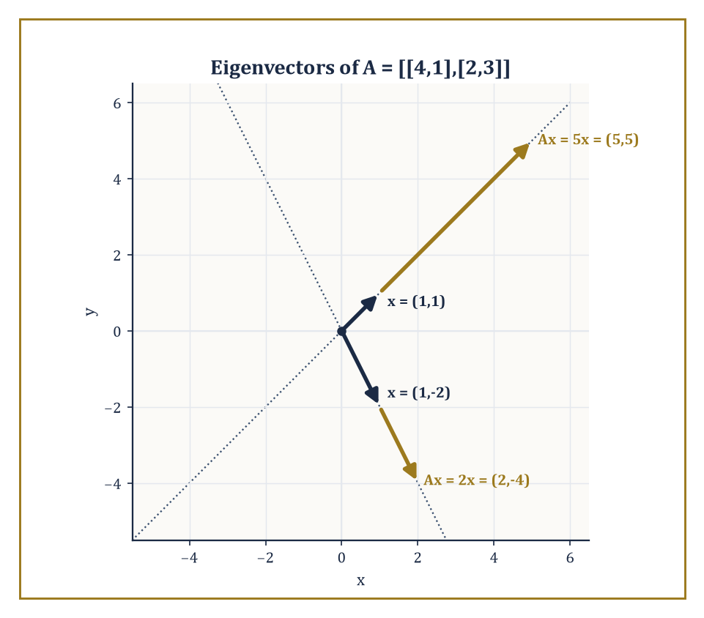
The two eigenvector directions of A = [[4,1],[2,3]], each simply stretched in place - by 5 along (1,1), by 2 along (1,-2) - with no rotation anywhere in sight.
Ax = lambda x
for some scalar lambda, called the corresponding eigenvalue - a direction that the map doesn't rotate or shear, only stretches or shrinks (and possibly flips, if lambda is negative).
Rearranging, Ax = lambda x means
(A - lambda I)x = 0
so x is a nonzero solution of a homogeneous system, which by Room 20.5's equivalences exists exactly when A - lambda I is singular, i.e. when
det(A - lambda I) = 0
This equation, expanded out, is a polynomial in lambda called the characteristic polynomial of A; its roots are precisely the eigenvalues.
For an n x n matrix the characteristic polynomial has degree n, so there are (counting complex roots and multiplicity) exactly n eigenvalues - though as we shall see shortly, 'counting multiplicity' hides a subtlety that will matter a great deal in the next storey.
Numeric example — Worked example. Let A = [[4,1],[2,3]]. The characteristic polynomial is
det(A - lambda I) = det([[4-lambda,1],[2,3-lambda]]) = (4-lambda)(3-lambda) - 1*2 = (12 - 4*lambda - 3*lambda + lambda^2) - 2 = lambda^2 - 7*lambda + 10 = (lambda-5)(lambda-2)
So the eigenvalues are lambda = 5 and lambda = 2.
For lambda = 5, solve (A - 5I)x = 0, where
A - 5I = [[-1,1],[2,-2]]
The first row gives -x_1 + x_2 = 0, so x_2 = x_1; taking x_1 = 1 gives the eigenvector (1,1). Check:
A*(1,1)^T = (4*1+1*1, 2*1+3*1)^T = (5,5)^T = 5*(1,1)^T
correct. For lambda = 2:
A - 2I = [[2,1],[2,1]]
This gives 2x_1 + x_2 = 0, so x_2 = -2x_1; taking x_1 = 1 gives (1,-2). Check:
A*(1,-2)^T = (4*1+1*(-2), 2*1+3*(-2))^T = (2,-4)^T = 2*(1,-2)^T
correct. Two eigenvalues, two independent eigenvector directions - a thoroughly well-behaved matrix, of the sort eigenvalue theory was invented to describe.
Eigenvalues and eigenvectors will be studied properly, with proofs and generality, in the next storey; here we only reconnoitre. Even at this concrete stage, though, the geometric content is already visible: eigenvectors are the special directions along which a matrix acts by pure scaling, ignoring everything else the map might be doing elsewhere.
This turns out to matter enormously in practice - the stability of a dynamical system, the vibration modes of a bridge or a molecule, and the directions of greatest variance in a cloud of data (the starting point of principal component analysis) are all, underneath the application-specific language, questions about eigenvalues. Whenever a matrix gets applied to a vector repeatedly, it is the eigenvalue of largest magnitude that eventually dominates what happens - smaller eigenvalues get outrun.
Numeric example — Worked example. Using the same A = [[4,1],[2,3]] with eigenvalues 5 and 2, start from an arbitrary vector v_0 = (1,0) and apply A repeatedly.
v_1 = A v_0 = (4,2)
v_2 = A v_1 = (4*4+1*2, 2*4+3*2) = (18,14)
v_3 = A v_2 = (4*18+1*14, 2*18+3*14) = (72+14, 36+42) = (86,78)
Look at the ratio of the two coordinates at each stage: 4/2 = 2, then 18/14 which is about 1.29, then 86/78 which is about 1.10 - steadily approaching 1, the ratio of the coordinates of the dominant eigenvector (1,1) found above. And the overall length is growing by roughly a factor of 5 at each step, converging on the dominant eigenvalue 5.
Repeated application of A is, quite literally, hunting down the eigenvector with the largest eigenvalue and ignoring everything else, a fact that entire numerical algorithms (power iteration, and its descendants used to rank web pages and search results) are built directly on top of.
For 2x2 and 3x3 matrices the characteristic polynomial can be written out explicitly and its roots found by the quadratic or cubic formula, or more often by inspection and a bit of luck with integer roots.
One subtlety is worth flagging now, even though its full resolution waits for the next storey: the algebraic multiplicity of an eigenvalue (how many times it appears as a root of the characteristic polynomial) and its geometric multiplicity (the dimension of the corresponding eigenspace, i.e. how many independent eigenvectors it actually has) need not agree.
Geometric multiplicity can never exceed algebraic multiplicity, but it can fall short - and when it does, the matrix is called defective, and cannot be diagonalised. This discrepancy is the first hint of the Jordan form, the canonical shape that rescues defective matrices from being merely awkward.
Numeric example — Worked example. Take A = [[2,1],[0,2]] - you may recognise this fellow from Room 20.2, where it was subjected to some perfectly innocent polynomial evaluation and gave no hint of the trouble brewing underneath. Its characteristic polynomial is
det(A - lambda I) = det([[2-lambda,1],[0,2-lambda]]) = (2-lambda)^2 - 0 = (2-lambda)^2
so lambda = 2 is a root of multiplicity 2 - algebraic multiplicity 2, and it is the only eigenvalue. Now hunt for eigenvectors:
A - 2I = [[0,1],[0,0]]
and (A-2I)x = 0 gives simply x_2 = 0, with x_1 completely free. The eigenspace is the span of (1,0) alone - a single independent direction, so geometric multiplicity 1, strictly less than the algebraic multiplicity of 2.
This matrix has only one eigen-direction to its name despite being 2x2, and no basis of eigenvectors exists for it; it is defective, and diagonalising it is simply impossible. It will need the Jordan form to be tamed, which is precisely the kind of unfinished business this storey is content to leave dangling for the next one to pick up.

Room 20.8: Special Matrices and Factorizations
A Rogues' Gallery of Well-Behaved Arrays
Diagonal matrices - nonzero entries only on the main diagonal, zero everywhere else - are the easiest matrices there are to work with.
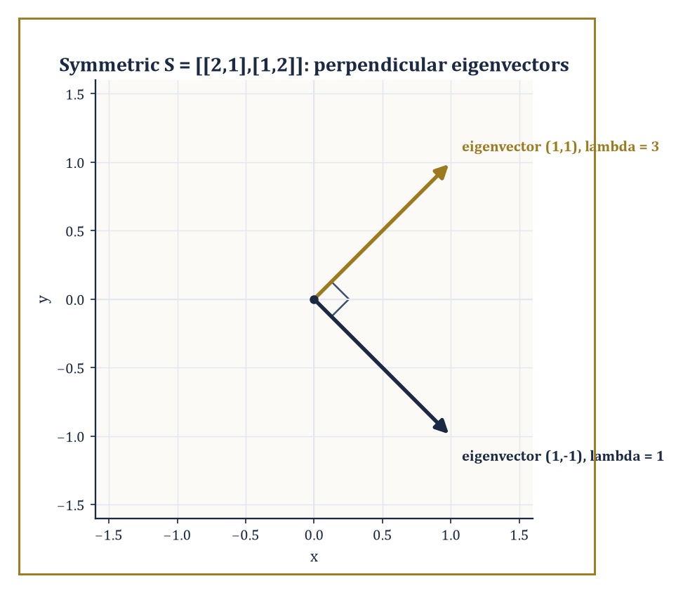
The eigenvectors of symmetric S = [[2,1],[1,2]] meeting at a perfect right angle - the spectral theorem, glimpsed a storey early.
Multiplying two diagonal matrices just multiplies corresponding diagonal entries; raising a diagonal matrix to a power just raises each diagonal entry to that power; and a diagonal matrix is invertible exactly when none of its diagonal entries is zero, with the inverse obtained by simply reciprocating each entry.
Much of the theory in the next storey (diagonalisation, the spectral theorem) is, at bottom, an elaborate scheme for finding a basis in which some more complicated matrix turns out to be secretly diagonal, precisely so that all this effortless arithmetic becomes available.
Numeric example — Worked example. Let D = [[2,0,0],[0,-1,0],[0,0,3]]. Then D^3 is obtained by cubing each diagonal entry:
D^3 = [[2^3,0,0],[0,(-1)^3,0],[0,0,3^3]] = [[8,0,0],[0,-1,0],[0,0,27]]
Compare the effort this took with what cubing a generic 3x3 matrix would require (two full matrix multiplications, each involving twenty-seven multiply-and-add operations) - diagonal matrices are, quite simply, cheating in the best possible way.
Triangular matrices - upper triangular if every entry below the diagonal is zero, lower triangular if every entry above is - are the next best thing to diagonal.
Their determinant is the product of the diagonal entries (a special case of cofactor expansion always collapsing along the zero entries), and, more remarkably, their eigenvalues are exactly their diagonal entries too, with no further computation required: the characteristic polynomial of a triangular matrix factors immediately into
(d_1 - lambda)(d_2 - lambda)...(d_n - lambda)
since det(A - lambda I) of a triangular matrix is again triangular, hence again just a product of its diagonal entries.
Numeric example — Worked example. Let U = [[2,3,1],[0,-1,4],[0,0,5]]. This is upper triangular, so det(U) is simply the product of the diagonal:
det(U) = 2*(-1)*5 = -10
And the eigenvalues of U can be read off in the same glance, with no characteristic-polynomial computation whatsoever: lambda = 2, -1, 5 - the three diagonal entries. As a sanity check, the product of the eigenvalues should equal the determinant (a fact promised back in Room 20.4):
2*(-1)*5 = -10
matching det(U) exactly.
Symmetric matrices are those with
A^T = A
meaning the matrix equals its own transpose (rows and columns swapped). They enjoy two remarkable properties that will be proved in full next storey under the name of the spectral theorem: all their eigenvalues are real (no complex numbers sneak in, even though nothing in the definition rules them out a priori), and eigenvectors belonging to different eigenvalues are automatically orthogonal (perpendicular) to one another.
Orthogonal matrices are those satisfying
A^T A = I
so that
A^T = A^-1
They represent rigid motions: rotations, reflections, and their combinations. They preserve lengths and angles exactly, which is precisely why they correspond to switching between two orthonormal bases (bases whose vectors are unit length and mutually perpendicular) without distorting the geometry along the way.
Numeric example — Worked example. Let S = [[2,1],[1,2]], symmetric since it equals its own transpose by inspection. The characteristic polynomial is:
det(S - lambda I) = (2-lambda)^2 - 1 = 0
(2-lambda)^2 = 1
2 - lambda = plus or minus 1
so lambda = 1 or lambda = 3 - both real, as promised.
For lambda = 3:
(S-3I) = [[-1,1],[1,-1]]
giving x_1 = x_2; take (1,1).
For lambda = 1:
(S-I) = [[1,1],[1,1]]
giving x_1 = -x_2; take (1,-1).
Check orthogonality:
(1,1) dot (1,-1) = 1*1 + 1*(-1) = 1 - 1 = 0
a dot product of exactly zero, confirming the two eigenvectors are perpendicular, exactly as the spectral theorem (still one storey away from being proved, but already visibly true) predicts for any symmetric matrix.
Numeric example — Worked example. Let R = [[0.5, -0.8660],[0.8660, 0.5]], a rotation by 60 degrees (0.8660 approximates the square root of 3 divided by 2). Compute R^T:
R^T = [[0.5, 0.8660],[-0.8660, 0.5]]
Check R^T R entry by entry:
entry (1,1) = 0.5*0.5 + 0.8660*0.8660 = 0.25 + 0.75 = 1.00
entry (1,2) = 0.5*(-0.8660) + 0.8660*0.5 = -0.4330 + 0.4330 = 0
entry (2,1) = (-0.8660)*0.5 + 0.5*0.8660 = -0.4330+0.4330 = 0
entry (2,2) = (-0.8660)*(-0.8660) + 0.5*0.5 = 0.75+0.25 = 1.00
So:
R^T R = [[1,0],[0,1]] = I
to the precision shown, confirming R is orthogonal: applying it to any vector rotates it by 60 degrees without stretching or shrinking it by so much as a hair's breadth.
The LU factorisation writes a matrix A as a product
A = LU
of a lower-triangular matrix L (with 1's on its diagonal, by convention) and an upper-triangular matrix U - possibly after first permuting rows, for matrices that need it. It is nothing more than Gaussian elimination recorded in matrix form: U is the row-echelon form you'd reach by elimination, and L records the multipliers used to get there.
The practical payoff is speed: once you have L and U for a given A, solving Ax = b for many different right-hand sides b becomes two easy triangular solves (forward-substitute for L, back-substitute for U) instead of redoing the entire elimination from scratch each time.
Numeric example — Worked example. Let A = [[4,3],[6,3]]. Eliminate the (2,1) entry: the multiplier is 6/4 = 1.5, so row 2 becomes row 2 minus 1.5 times row 1, giving:
[6-1.5*4, 3-1.5*3] = [0, -1.5]
So U = [[4,3],[0,-1.5]], and L records the multiplier used: L = [[1,0],[1.5,1]]. Check LU entry by entry:
entry (1,1) = 1*4+0*0 = 4
entry (1,2) = 1*3+0*(-1.5) = 3
entry (2,1) = 1.5*4+1*0 = 6
entry (2,2) = 1.5*3+1*(-1.5) = 4.5-1.5 = 3
So:
LU = [[4,3],[6,3]] = A
exactly, and any future system with this same coefficient matrix A can now be solved twice as cheaply as before, for free.
Other factorisations - QR (a matrix as an orthogonal matrix times an upper triangular one), Cholesky (a symmetric positive-definite matrix as LL^T for a triangular L), and the singular value decomposition (which factors any matrix at all, square or not, invertible or not, into a product of two orthogonal matrices and a diagonal one) - will have to wait until inner-product spaces and orthogonality are on a firmer footing, next storey.
What is already visible, even without the details, is the recurring strategic move: take a complicated matrix and rewrite it as a product of simpler, structured pieces - triangular, diagonal, orthogonal - each of which is individually easy to compute with. Factorisation, in matrix algebra as in arithmetic, is how you turn a hard problem into several easy ones.

Room 20.9: Looking Ahead: From Matrices to Linear Algebra
The Tower Continues Upward
We have, over the last eight rooms, acquired the working vocabulary of matrices: how to add, scale, and multiply them; how to invert them, and how elementary matrices make that inversion algorithmic; how to compress an entire matrix into the single revealing number that is its determinant; how to row-reduce, and how rank falls out of that process as both a computational count and a geometric dimension; how to read a matrix as a linear map, complete with a range, a kernel, and a change-of-basis formula; a first, careful look at eigenvalues and eigenvectors, complete with a warning about defective matrices; and a small museum of special matrices - diagonal, triangular, symmetric, orthogonal - together with the LU factorisation that makes solving repeated systems cheap.
These tools are the concrete, computational foundation for the storey immediately above this one, Linear Algebra, which takes the same ideas and strips away the coordinates: vector spaces in place of R^n, abstract linear maps in place of matrices, and proofs - real, general proofs - of the spectral theorem, the Jordan form, and the theory of inner-product spaces and least squares that this storey could only gesture towards. Nothing computed here becomes wasted effort.
Once bases are chosen, every abstract vector space collapses back down to R^n and every abstract linear map collapses back down to exactly the kind of matrix we have been multiplying, inverting, and eigen-decomposing throughout this storey. The abstraction to come is not a replacement for this material; it is what this material looks like once you stop needing the coordinates as a crutch.
Every loose thread left dangling here has already been named: the discrepancy between algebraic and geometric multiplicity from Room 20.7 becomes the Jordan form; the orthogonality of eigenvectors noticed by hand in Room 20.8 becomes the spectral theorem, proved for every symmetric matrix at once rather than checked example by example; and the LU factorisation's habit of breaking a matrix into simpler pieces becomes, in due course, QR and the singular value decomposition. None of this is new subject matter arriving from nowhere - it is this storey's half-finished sentences, finally allowed to finish.
The deeper lesson of this storey, stripped of its arithmetic, is this: a rectangular array of numbers, once equipped with the right multiplication rule, stops being a mere table and becomes a precise, manipulable encoding of a linear relationship between spaces.
The algebra of these arrays - closed under addition, multiplication, and (when luck permits) inversion - turns out to be rich enough to solve any system of linear equations, to represent any linear transformation once coordinates are fixed, and, through the determinant and the eigenvalues, to reveal geometric facts (volumes, stretching factors, invariant directions) that were never explicitly written into the numbers to begin with.
That a grid of numbers can know its own geometry is, when you stop to think about it, rather remarkable, and it is a fact this storey has tried to earn honestly, one worked example at a time, rather than simply assert.
Numeric example — Worked example, by way of a closing flourish. Recall the matrix A from Room 20.7.
A = [[4,1],[2,3]]
Its eigenvalues, 5 and 2, were found by solving the characteristic equation
det(A - lambda I) = 0
Compute det(A) directly, the ordinary way:
det(A) = 4*3 - 1*2 = 12 - 2 = 10
Now compute the product of the eigenvalues:
5 times 2 = 10
They match exactly, confirming the fact flagged back in Room 20.4 - the determinant is the product of the eigenvalues - using two completely independent calculations that have no right, on the face of it, to agree, and yet always do.
If a single closing image is wanted for everything this storey has been about, it is this: determinant, eigenvalues, rank, invertibility, geometry - all different windows onto the same matrix, and all of them, when the arithmetic is done honestly, telling exactly the same story.
Matrices, then, are both a practical calculating device - the thing you actually multiply, invert, and row-reduce when a real system needs solving - and the entry point to one of the central subjects of modern mathematics, the one that quietly underlies statistics, physics, computer graphics, machine learning, and more branches of pure mathematics than any tenure committee could comfortably enumerate in one sitting.
It is worth remembering, as we leave this storey, how much was accomplished with nothing more exotic than addition, multiplication, and a great deal of careful bookkeeping about rows and columns: no calculus, no topology, no infinite processes of the kind that gave earlier storeys their existential vertigo, just finite arithmetic performed correctly and interpreted geometrically. That restraint is precisely what makes matrices such a reliable foundation to build on - there is nowhere for an error to hide in a finite grid of numbers, which is more than can be said for several storeys we have already climbed.
We have learned to multiply arrays. Whether the arrays know what we've done to them is a question the next storey, mercifully, does not require us to answer.
And so the tower gains another storey, built out of nothing grander than rectangular grids of numbers - which turned out, against all reasonable first impressions, to add, multiply, invert, and confess their own geometric secrets the moment you asked the right question of them in the right notation.
Immediately above us waits Linear Algebra, where every trick performed here with coordinates and entries gets performed again with no coordinates at all - vector spaces standing in for R^n, linear maps standing in for matrices, and the spectral theorem finally proved in full rather than merely glimpsed through a pair of orthogonal eigenvectors that happened to behave. Nothing from this storey is left behind; it simply stops needing to mention its own scaffolding out loud.
For now, though, the scaffolding has done honest work: nine rooms, a great many correctly multiplied rows and columns, and a matrix or two that will be waiting, slightly smugly, to reappear once the abstraction arrives. Onward and upward.

Storey 21: Linear Algebra
Vector Spaces, Linear Maps, and the Art of Seeing Structure Beneath Coordinates
The last storey left you fluent in matrices — rectangular grids of numbers you could multiply, invert (sometimes), and coax into revealing eigenvalues after enough determined arithmetic. That fluency was hard-won and it is not wasted; nothing in this Tower is ever wasted, which is either its great virtue or its great cruelty depending on how the exam went. But a matrix, for all its usefulness, is secretly a costume. Underneath it is something wearing no coordinates at all: a linear map between two spaces of arrows, doing its business quietly while the matrix takes the applause.
This storey removes the costume. A vector space is any set in which you can add things together and scale them by numbers, obeying a short list of entirely unsurprising rules — the kind of rules you already believed about arrows, or polynomials, or functions, long before anyone wrote them down as axioms. A linear map is any function between two such sets that respects both operations. Once you have these two definitions, bases and dimension and rank and eigenvalues stop being properties of a particular grid of numbers and become properties of the underlying thing itself — true no matter which coordinate system you happen to be standing in when you look.
This is not abstraction for its own polish. The moment you stop insisting that a vector space must look like ℝⁿ, the same theorems start applying to spaces of polynomials, spaces of continuous functions, solution sets of differential equations, and the tangent spaces you will meet properly two storeys from now in analytic geometry. The matrix theory of Storey 20 turns out to be the special case where the space happens to be ℝⁿ and someone has already chosen the standard basis for you. Most of life is not that considerate.
A small confession before we start climbing: the move from matrices to abstract vector spaces is, for a great many students, the first moment mathematics starts to feel like it is about symbols rather than about things. That feeling is real, and it is temporary. The symbols name relationships that were already sitting inside your matrix calculations, doing useful work in disguise; abstraction only removes the disguise. If matrices taught us to compute with linear maps, this storey teaches us to understand them. Let us forget the bases — temporarily, and entirely on our own terms.

Room 21.1: Vector Spaces and Subspaces
In Which Everything Becomes an Arrow, Whether It Looks Like One or Not
A vector space over a field F is a set V equipped with an addition (any two elements combine to give a third) and a scalar multiplication (any element can be scaled by a member of F), satisfying the axioms you would write down if someone handed you a pencil and asked you to formalise what arrows do: addition is associative and commutative, there is a zero vector that changes nothing, every vector has a negative, scalar multiplication distributes over both vector addition and scalar addition, and multiplying by the field's own 1 does nothing.
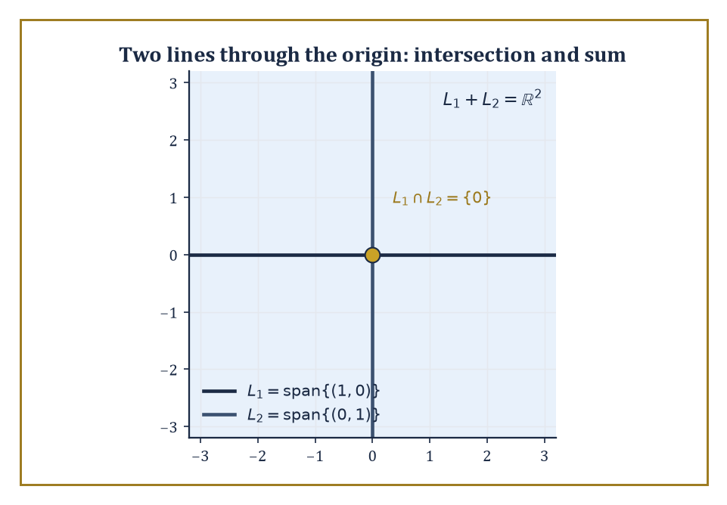
Two lines through the origin: their intersection collapses to the point {0}, while their sum climbs back up to fill the entire plane.
The field F is usually ℝ or ℂ in this storey, but nothing in the definition cares — the same axioms work over any field, a fact that will matter enormously two storeys hence, in the storey on coding theory and finite fields, and not at all today.
Notice what has been deliberately left out of the definition: there is no mention of length, no mention of angle, no mention of coordinates. Those are luxuries, added later by an inner product (Room 21.6) or a choice of basis (Room 21.2). A vector space, in its bare form, only knows how to add and how to scale. Everything else is decoration.
Numeric example — Worked example — checking the axioms actually hold. Take u = (1, −2, 3), v = (0, 5, −1), and w = (4, 4, 4) in ℝ³, and check associativity of addition directly.
Left side: (u + v) + w. First compute u + v, then add w.
u + v = (1+0, −2+5, 3−1) = (1, 3, 2)
(u+v) + w = (1+4, 3+4, 2+4) = (5, 7, 6)
Right side: u + (v + w). First compute v + w, then add u.
v + w = (0+4, 5+4, −1+4) = (4, 9, 3)
u + (v+w) = (1+4, −2+9, 3+3) = (5, 7, 6)
Both sides equal (5, 7, 6) — associativity holds, as it must, since it holds coordinate-by-coordinate in ℝ and vector addition is just three copies of ordinary addition running in parallel.
Now check distributivity: 2(u + v) should equal 2u + 2v.
2(u + v) = 2(1,3,2) = (2,6,4)
2u + 2v = (2,−4,6) + (0,10,−2) = (2,6,4)
They match. This is the entire content of 'the axioms hold' for ℝⁿ — every one of them reduces to a true statement about real numbers, applied three (or n) times side by side.
A subspace of V is a subset that is itself a vector space using the same operations — which, since the axioms are automatic once you inherit them, reduces to a single practical check: is the subset closed under addition and scalar multiplication, and does it contain the zero vector?
Two structural facts follow almost immediately and get used constantly. First, the intersection of any collection of subspaces is again a subspace — if every vector in a set of subspaces is closed under the operations, so is anything lying in all of them at once.
Second, the sum of two subspaces U and W, meaning the set of all vectors u + w with u ∈ U and w ∈ W, is also a subspace — a genuinely new subspace built by letting the two originals mix freely.
The span of a set of vectors is the smallest subspace containing them: take every possible linear combination and you cannot get anything larger, nor is there any smaller subspace that still contains the original set.
Abstract example — Worked example — the trace-zero matrices form a subspace. Let V be the space of all 2×2 real matrices, and let U be the subset of matrices whose trace (the sum of the diagonal entries) is zero.
Take M₁ = [[1, 2], [3, −1]] and M₂ = [[−2, 0], [5, 2]], and check that both lie in U.
trace(M₁) = 1 + (−1) = 0
trace(M₂) = −2 + 2 = 0
Both lie in U. Now check closure under addition and scaling.
M₁ + M₂ = [[−1, 2], [8, 1]], trace = −1 + 1 = 0
3M₁ = [[3, 6], [9, −3]], trace = 3 + (−3) = 0
Both remain in U, and the zero matrix trivially has trace 0. So U is closed under addition and scalar multiplication and contains the zero matrix: it is a subspace of the 4-dimensional space of all 2×2 matrices, even though nobody drew you a picture of it as an arrow. This is the abstraction earning its keep — 'subspace' meant something purely algebraic here, with no geometric picture required to check it.
Span, intersection, and sum give you a small toolkit for building and combining subspaces, and it is worth seeing them work on something concrete before trusting the general theory.
Two distinct lines through the origin in ℝ² are each one-dimensional subspaces; their intersection is forced down to the single point {0} (two different lines can only cross at the origin), while their sum climbs back up to fill the whole plane, since any vector can be written as a combination of one vector from each line.
Span behaves more subtly when the input vectors are not independent — feeding in redundant vectors does not enlarge the span at all, a fact that becomes the entire subject of the next room.
Numeric example — Worked example — intersection, sum, and a collapsing span. Let L₁ = span{(1, 0)} and L₂ = span{(0, 1)} in ℝ². Their intersection is forced down to the single point {0}, since a vector on the x-axis and on the y-axis simultaneously must be the origin.
L₁ ∩ L₂ = {(0,0)}
Their sum climbs back up to fill the whole plane, since any vector can be written as a combination of one vector from each line.
L₁ + L₂ = ℝ², since any (a, b) = a(1,0) + b(0,1)
Now consider span{(1,2,3), (2,4,6)} in ℝ³ — because the second vector is just twice the first,
(2,4,6) = 2·(1,2,3)
the second vector adds nothing new: every combination is just a multiple of (1,2,3).
c₁(1,2,3) + c₂(2,4,6) = (c₁ + 2c₂)(1,2,3)
So this span is only the line {t(1,2,3) : t ∈ ℝ} — a one-dimensional subspace, despite having been fed two vectors. Redundancy does not buy you extra dimensions; it only buys you extra typing.
The point of stating the axioms so sparsely is that an enormous zoo of objects satisfies them. ℝⁿ is the obvious example, but so is the space of all m×n matrices, the space of polynomials of degree at most n, the space of continuous real-valued functions on an interval, and — perhaps least obviously — the solution set of a homogeneous linear differential equation.
That last example deserves a moment's pause, because it is the one that makes the abstraction pay for itself immediately: if y₁ and y₂ both solve a homogeneous linear differential equation, so does any combination c₁y₁ + c₂y₂, by linearity of the derivative.
The solution set is therefore automatically a vector space, with no further checking required, purely because differentiation is a linear operation.
Few axioms, many examples — that ratio is the entire reason linear algebra shows up everywhere from quantum mechanics to search engines.
Worked example — Worked example — the solution space of y′′ + y = 0. Consider the differential equation below.
y′′ + y = 0
It has general solution, for arbitrary constants A, B, given by the equation below — a fact from calculus, taken here as given.
y = A cos x + B sin x
The solution set is therefore a two-dimensional vector space with basis {cos x, sin x}: every solution is a coordinate pair (A, B) in disguise. Check linearity concretely with A = 3, B = −2, giving the solution below.
y = 3 cos x − 2 sin x
Differentiate twice.
y′ = −3 sin x − 2 cos x
y′′ = −3 cos x + 2 sin x = −(3 cos x − 2 sin x) = −y
So:
y′′ + y = −y + y = 0
This confirms this combination is indeed a solution — exactly as the vector-space structure promised, without needing to solve the differential equation again from scratch for this particular combination. The abstract machinery did the work; the calculus only had to be done once, for the basis vectors.

Room 21.2: Linear Independence, Bases, and Dimension
Counting What Cannot Be Cancelled
A set of vectors is linearly independent if the only linear combination of them that equals the zero vector is the trivial one — every coefficient zero.
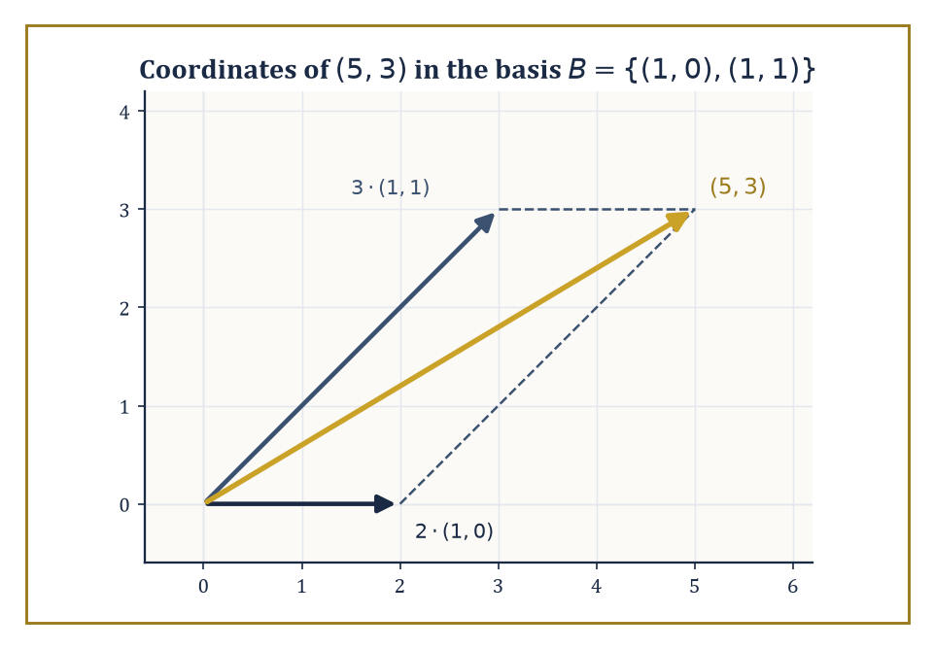
The vector (5,3) as a parallelogram built from 2 copies of (1,0) and 3 copies of (1,1) — coordinates are just instructions for a walk.
c₁v₁ + ⋯ + cₙvₙ = 0 forces every cᵢ = 0
Equivalently, and more usefully in practice, no vector in the set can be written as a combination of the others; each one is pulling its own weight, contributing a genuinely new direction rather than freeloading off its neighbours.
This is worth internalising as the real content of the definition, because the formal statement above can look like an arbitrary piece of algebra until you see it as 'nobody here is redundant.'
Numeric example — Worked example — catching a hidden dependence. Are (1,2,3), (4,5,6), (7,8,9) linearly independent in ℝ³? Try to find a nontrivial combination equalling zero — check whether the following holds.
(1,2,3) − 2(4,5,6) + (7,8,9) = 0
Work it out step by step.
2(4,5,6) = (8,10,12)
(1,2,3) − (8,10,12) = (−7,−8,−9)
(−7,−8,−9) + (7,8,9) = (0,0,0)
So the combination c₁ = 1, c₂ = −2, c₃ = 1 (not all zero) produces the zero vector — the three vectors are linearly dependent. Geometrically, the third row is exactly twice the second minus the first; the pattern was visible all along in the fact that each row's entries increase by a constant step (the classic 'arithmetic progression' matrix), which always produces exactly this kind of dependency.
A basis is a linearly independent set that also spans the whole space — independent enough that nothing is wasted, and large enough that nothing is missing.
Every vector space possessing a finite spanning set has a basis, and the deep and slightly surprising fact is that any two bases of the same space contain exactly the same number of vectors.
That common number is the dimension of the space — a single, well-defined integer, not a property of whichever basis you happened to write down first.
Once a basis is fixed, every vector in the space acquires unique coordinates relative to it: a list of scalars telling you exactly how much of each basis vector to add together.
Numeric example — Worked example — finding coordinates in a non-standard basis. Take the basis B = {(1,0), (1,1)} for ℝ². Check independence first by seeing what forces the combination below to vanish.
c₁(1,0) + c₂(1,1) = 0
This gives c₁+c₂=0 and c₂=0, forcing c₁=c₂=0, so B is independent, and two independent vectors in a 2-dimensional space automatically span it.
Now find the coordinates of (5,3) relative to B by solving the equation below.
a(1,0) + b(1,1) = (5,3)
That is, a + b = 5 and b = 3. From the second equation b = 3, substituting into the first gives a = 2.
So (5,3) has coordinates (2,3) relative to B.
(5,3) = 2·(1,0) + 3·(1,1)
Check: 2(1,0) = (2,0), 3(1,1) = (3,3), and their sum is (5,3). Correct. The vector itself never changed; only the labels describing it did.
The Steinitz exchange lemma (also called the replacement theorem) is the piece of machinery that makes 'dimension is well-defined' more than wishful thinking: it says that if you have an independent set inside a spanning set, you can trade members of the independent set in for members of the spanning set one at a time, always keeping the result spanning, until the independent set has been fully absorbed.
Run the argument in both directions between two candidate bases and you find neither can be strictly larger than the other — hence they are the same size.
This storey stays almost entirely within finite-dimensional spaces, where such arguments terminate cleanly; infinite-dimensional spaces, where a 'basis' has to be handled far more carefully, are held in reserve as the motivating puzzle for the functional analysis storeys much later in the Tower.
Abstract example — Worked example — an exchange in ℝ³. Start with the standard spanning set {e₁, e₂, e₃} = {(1,0,0), (0,1,0), (0,0,1)} of ℝ³, and the independent set {(1,1,0), (0,1,1)}.
Exchange proposes replacing e₁ and e₂ with these two new vectors while keeping e₃, and claims the set below still spans ℝ³ — indeed forms a basis.
{(1,1,0), (0,1,1), (0,0,1)}
Check independence via the determinant of the matrix with these as rows.
det [[1,1,0],[0,1,1],[0,0,1]] = 1·(1·1 − 1·0) − 1·(0·1 − 1·0) + 0 = 1·1 − 1·0 + 0 = 1
A nonzero determinant confirms independence, and three independent vectors in a 3-dimensional space automatically form a basis. The exchange succeeded exactly as promised: two members of the old spanning set were swapped out for two members of the new independent set, one survivor (e₃) held its ground, and the result still spans everything.
Once a basis is chosen, the abstract vector space and the coordinate space ℝⁿ (or ℂⁿ) become interchangeable — every vector is a list of numbers, and every linear map (as the next room shows) is a matrix.
This is precisely the bridge back to Storey 20: matrices were never a separate topic from vector spaces, only vector spaces observed through the particular lens of a chosen basis.
Change the basis and the same abstract object wears a different list of numbers, but the object itself never moved.
Numeric example — Worked example — a polynomial's coordinates. The space of polynomials of degree at most 2 has a natural basis {1, x, x²}.
p(x) = 3 − 2x + 5x²
This polynomial then has coordinate vector (3, −2, 5) relative to this basis — read straight off the coefficients.
This is not a metaphor for coordinates; it is literally the same bookkeeping as writing (5,3) for a vector in ℝ², once you accept that 'polynomial' and 'arrow in the plane' are just two costumes for the idea of a vector. Change the basis to {1, (x−1), (x−1)²} instead, and the same polynomial p would need entirely different coordinates — an exercise in substitution left for the reader with a free afternoon and a grudge against algebra.

Room 21.3: Linear Maps and Matrices with Respect to Bases
Same Map, Different Disguise
A linear map T: V → W is a function between vector spaces satisfying the two conditions below, for all vectors u, v and scalars λ.
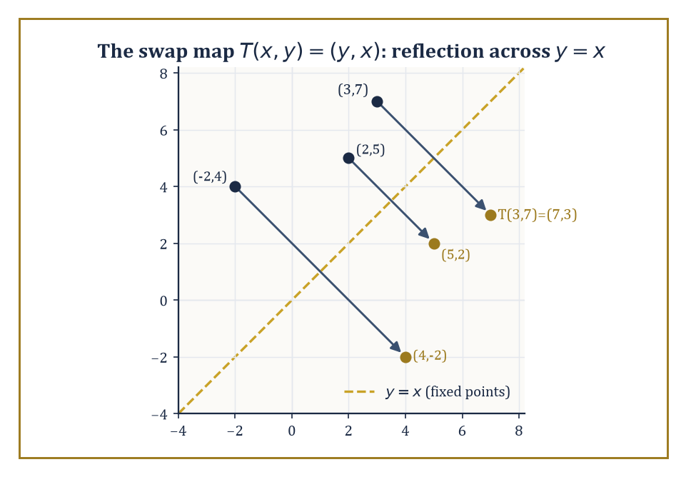
The swap map T(x,y)=(y,x) is nothing more mysterious than a reflection across the line y=x, sending each point to its mirror image.
T(u + v) = T(u) + T(v)
T(λu) = λT(u)
It respects both of the operations a vector space actually has, and nothing more is asked of it.
Two subspaces travel with every linear map: the kernel (or null space), the set of vectors sent to zero, and the image (or range), the set of vectors actually hit.
Both are genuinely subspaces, not merely subsets — a fact worth checking once and trusting forever afterwards, since it follows in one line from linearity itself.
Composition of linear maps is again linear, and the identity map is linear, so linear maps between fixed spaces form their own well-behaved algebraic world.
Numeric example — Worked example — the coordinate swap. Let T: ℝ² → ℝ² be the swap map defined below.
T(x, y) = (y, x)
Check linearity on specific vectors: compute the left- and right-hand sides of T((2,5) + (1,−3)) = T(2,5) + T(1,−3) separately.
T((2,5) + (1,−3)) = T(3, 2) = (2, 3)
T(2,5) + T(1,−3) = (5,2) + (−3,1) = (2,3)
They match, as linearity demands.
For the kernel, T(x,y) = (0,0) forces y = 0 and x = 0, so the kernel is just {(0,0)} — nothing but the zero vector gets swapped away to nothing. The image is all of ℝ², since every (a,b) is T(b,a).
A map that is both injective (trivial kernel) and surjective (full image) between spaces of the same finite dimension — this is no coincidence, and Room 21.4 explains exactly why it never is.
Fix a basis of V and a basis of W. Then T is represented by a unique matrix A: the coordinate vector of T(v), relative to the chosen basis of W, equals A times the coordinate vector of v, relative to the chosen basis of V.
Constructing A is mechanical — the k-th column of A is simply the coordinate vector of T applied to the k-th basis vector of V.
This is the precise sense in which 'a matrix is a linear map with a basis chosen': change the basis and the matrix changes, but the map underneath does not.
Numeric example — Worked example — building the matrix of the swap map. For T(x,y) = (y,x) with the standard basis {e₁, e₂} = {(1,0), (0,1)} on both sides, build the matrix column by column.
T(e₁) = T(1,0) = (0,1)
T(e₂) = T(0,1) = (1,0)
So the matrix is:
A = [[0,1],[1,0]]
Check it reproduces T on a fresh vector, say (3,7).
A·(3,7)ᵀ = (0·3 + 1·7, 1·3 + 0·7) = (7,3)
And indeed T(3,7) = (7,3). The matrix and the map agree, as they must once the basis has been used to build the matrix in the first place.
Change the basis of V (and, for an endomorphism, use the same new basis on both sides) and the matrix of T transforms by conjugation, where P is the matrix whose columns are the new basis vectors expressed in the old coordinates.
new matrix = P⁻¹AP
This single formula is the concrete shadow of an abstract idea: two matrices A and B are similar exactly when they represent the same linear map with respect to two different bases.
B = P⁻¹AP (for some invertible P)
Similarity of matrices, which in Storey 20 looked like an arbitrary algebraic relation worth checking by computation, turns out to mean something geometric: 'these are the same transformation, photographed from two different angles.'
Numeric example — Worked example — diagonalizing the swap map by choosing a better basis. The swap matrix A = [[0,1],[1,0]] looks unremarkable in the standard basis, but try the new basis {(1,1), (1,−1)}.
A·(1,1) = (1,1)
The vector (1,1) is unmoved — an eigenvalue-1 direction.
A·(1,−1) = (−1,1) = −1·(1,−1)
An eigenvalue-(−1) direction. Let P be the matrix whose columns are the new basis vectors.
P = [[1,1],[1,−1]]
Its determinant is 1·(−1) − 1·1 = −2, so:
P⁻¹ = (1/−2)·[[−1,−1],[−1,1]] = [[1/2,1/2],[1/2,−1/2]]
Compute AP first: its columns are A·(1,1) = (1,1) and A·(1,−1) = (−1,1), so:
AP = [[1,−1],[1,1]]
Now compute P⁻¹AP row by row.
row 1 = [1/2·1 + 1/2·1, 1/2·(−1) + 1/2·1] = [1, 0]
row 2 = [1/2·1 + (−1/2)·1, 1/2·(−1) + (−1/2)·1] = [0, −1]
P⁻¹AP = [[1,0],[0,−1]]
Diagonal, with the two eigenvalues sitting plainly on the diagonal. Same map, dramatically simpler disguise.
Composition of linear maps corresponds exactly to matrix multiplication once bases are fixed — the single fact that justifies defining matrix multiplication the peculiar way it is defined in the first place, back in Storey 20.
This is the payoff of the whole coordinate-dependent machinery: abstract questions about maps become concrete questions about matrix arithmetic, and matrix computations become readable as statements about maps, translated freely in either direction.
Numeric example — Worked example — composition as matrix multiplication. Let T₁(x,y) = (y,x) with matrix A₁ = [[0,1],[1,0]], and T₂(x,y) = (x+y, x−y) with matrix A₂ = [[1,1],[1,−1]].
T₂∘T₁(x,y) = T₂(y,x) = (y+x, y−x)
Its matrix should be A₂A₁ — compute row by row.
row 1 = [1·0 + 1·1, 1·1 + 1·0] = [1,1]
row 2 = [1·0 + (−1)·1, 1·1 + (−1)·0] = [−1,1]
A₂A₁ = [[1,1],[−1,1]]
Apply this to (x,y): first component x+y, second component −x+y — exactly matching T₂(T₁(x,y)) = (y+x, y−x) computed directly. Matrix multiplication is composition of maps, no more and no less.
Everything so far has quietly assumed the domain and codomain use the same basis before and after a change — fine for an endomorphism, but linear maps between spaces of different dimension need the more general formula.
If the domain's basis changes via a matrix P and the codomain's basis is left alone, the new matrix representing T is simply AP, with no inverse needed on either side, because only the input labelling has changed.
new matrix = AP
If the codomain's basis also changes, via some matrix Q, the fully general rule is Q⁻¹AP — of which P⁻¹AP was only the special case where domain and codomain coincide and share a basis.
new matrix = Q⁻¹AP
Numeric example — Worked example — changing only the domain's basis. Let T(x,y,z) = (x+y, y+z), a map ℝ³ → ℝ², with standard-basis matrix below (the same matrix examined for its fundamental subspaces in Room 21.4).
A = [[1,1,0],[0,1,1]]
Change the domain's basis to B = {(1,0,0), (1,1,0), (1,1,1)}, keeping the codomain's basis standard. The new matrix's columns are T applied to each new basis vector, expressed in the unchanged codomain basis.
T(1,0,0) = (1,0)
T(1,1,0) = (1+1, 1+0) = (2,1)
T(1,1,1) = (1+1, 1+1) = (2,2)
So the new matrix is obtained as AP, where P = [[1,1,1],[0,1,1],[0,0,1]] has the new basis vectors as its columns.
new matrix = [[1,2,2],[0,1,2]]
Check one column directly.
A·(1,1,0)ᵀ = (1·1+1·1+0·0, 0·1+1·1+1·0) = (2,1)
This matches the second column above. No inverse was needed anywhere, precisely because the codomain's basis never moved.

Room 21.4: Rank, Nullity, and the Fundamental Theorem
Where the Missing Dimensions Go
The rank of a linear map T is the dimension of its image — how much of the target space actually gets used.
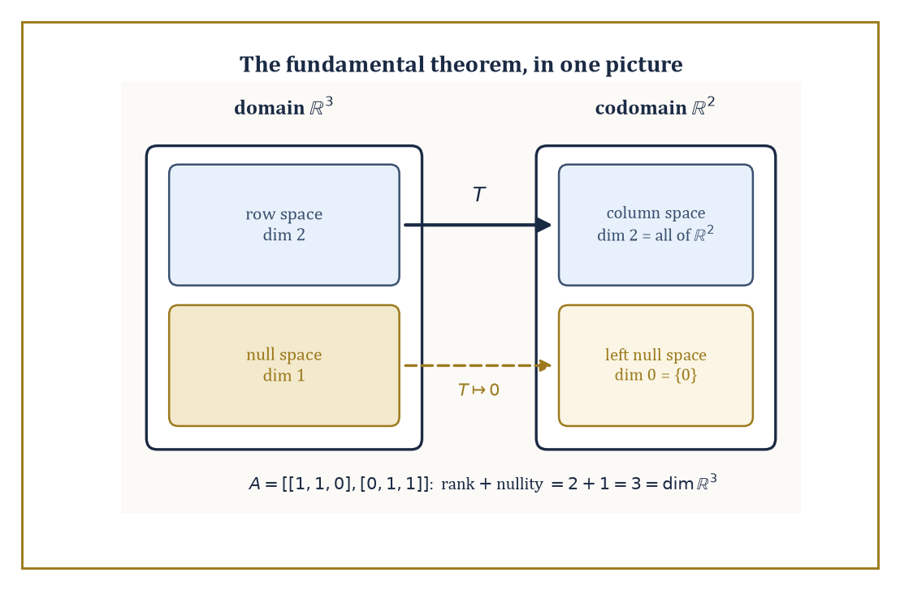
The four fundamental subspaces of A = [[1,1,0],[0,1,1]]: the row space survives the trip intact, the null space is quietly sent to zero.
The nullity is the dimension of its kernel — how much of the source space gets collapsed to zero.
The rank-nullity theorem states that, for any linear map T out of a finite-dimensional space V:
rank(T) + nullity(T) = dim V
Every dimension of the input either survives into the output (contributing to rank) or gets annihilated (contributing to nullity); there is nowhere else for it to go.
This is less a deep theorem than an accounting identity, but it is the accounting identity that makes the rest of linear algebra balance.
Numeric example — Worked example — rank and nullity of a rank-deficient matrix. Let A = [[1,2,3],[2,4,6]], viewed as a map ℝ³ → ℝ². Row 2 is exactly twice row 1, so the two equations for the null space are really the same equation.
x+2y+3z = 0 and 2x+4y+6z = 0
For the rank: the image is spanned by the columns (1,2), (2,4), (3,6) — all multiples of (1,2) — so the image is the one-dimensional line span{(1,2)}.
rank(A) = 1
For the nullity, solve x + 2y + 3z = 0 for a basis of the null space. Set y=1, z=0.
x = −2, giving (−2,1,0); check: −2+2(1)+3(0) = 0
Set y=0, z=1.
x = −3, giving (−3,0,1); check: −3+2(0)+3(1) = 0
These two vectors are independent (neither is a multiple of the other), so:
nullity(A) = 2
Total:
rank + nullity = 1 + 2 = 3 = dim ℝ³
Exactly as the theorem demands.
One striking corollary applies only to endomorphisms (linear maps from a finite-dimensional space to itself): such a map is injective if and only if it is surjective, if and only if it is bijective.
If the kernel is trivial (nullity 0), rank-nullity forces the rank to equal the full dimension, meaning the image is everything — injective forces surjective. Run the logic the other way and surjective forces injective too.
This collapse of three different properties into one is a genuinely finite-dimensional phenomenon; it fails the moment the space is infinite-dimensional, which is worth seeing go wrong at least once, if only so the finite-dimensional miracle is properly appreciated rather than taken for granted.
Abstract example — Worked example — the collapse holds in ℝ², and fails in infinite dimensions. In ℝ², let A = [[1,2],[3,4]]. Compute its determinant.
det(A) = 1·4 − 2·3 = 4 − 6 = −2 ≠ 0
A nonzero determinant means the kernel is trivial (the only solution to Ax=0 is x=0), so A is injective; rank-nullity then forces rank 2, so A is also surjective, and hence bijective — exactly as promised, checkable purely from one nonzero number.
Now consider the infinite-dimensional right-shift operator S on the space of all real sequences, defined below.
S(a₁, a₂, a₃, …) = (0, a₁, a₂, …)
S is injective: if S(a) is the zero sequence, every aᵢ must have been zero already. But S is not surjective: no sequence maps to (1, 0, 0, …), since the first output entry is always forced to be 0.
Injective without surjective, in flat contradiction of the finite-dimensional rule — because there is no finite dimension count to force the two properties to march together. The theorem needed finiteness, and here is the sequence space cheerfully doing without it.
Every matrix A carries four fundamental subspaces: the column space (span of the columns, equivalently the image of A), the row space (span of the rows), the null space (kernel of A), and the left null space (kernel of Aᵀ, equivalently vectors y with yᵀA = 0).
Rank-nullity relates their dimensions — column space and row space always share the same dimension, the rank, a fact that is far less obvious than it sounds until you have proved it once.
And, once an inner product is available (Room 21.6), the row space and null space turn out to be orthogonal complements of each other inside the domain, as do the column space and left null space inside the codomain.
Numeric example — Worked example — all four subspaces of a small matrix. Let A = [[1,1,0],[0,1,1]], a map ℝ³ → ℝ².
Row space: span{(1,1,0), (0,1,1)} ⊂ ℝ³, a 2-dimensional plane (the two rows are independent, since neither is a multiple of the other).
Column space: span of (1,0), (1,1), (0,1) in ℝ²; since the rows are independent the rank is 2, and a 2-dimensional subspace of ℝ² is all of ℝ².
Null space: solve x+y=0 and y+z=0, giving y=−x and z=−y=x.
(x,y,z) = x·(1,−1,1); check: 1·1+1·(−1) = 0, 1·(−1)+1·1 = 0
null space = span{(1,−1,1)}, dimension 1
Left null space: solve yᵀA = 0 for y=(y₁,y₂): from column 1, y₁·1=0 gives y₁=0; from column 3, y₂·1=0 gives y₂=0.
left null space = {(0,0)}, dimension 0
Check the bookkeeping.
row space (2) + null space (1) = 3 = dim ℝ³
column space (2) + left null space (0) = 2 = dim ℝ²
This machinery is precisely the theory behind solving Ax = b: the equation has a solution exactly when b lies in the column space of A.
When it does, the general solution is one particular solution plus anything from the null space — which is why an underdetermined system (positive nullity) has infinitely many solutions rather than one.
Existence lives in the column space; the shape of the solution set, if existence is granted, lives in the null space.
Numeric example — Worked example — solvability via the column space. Using A = [[1,1,0],[0,1,1]] again, is Ax = (1,1) solvable? Since the column space of A is all of ℝ² (rank 2, computed above), yes automatically.
Find one solution: try z=0, then the second equation y+z=1 gives y=1, and the first equation x+y=1 gives x=0.
A·(0,1,0)ᵀ = (0+1, 1+0) = (1,1)
The general solution is (0,1,0) plus any multiple of the null space direction (1,−1,1) — for instance:
(0,1,0) + 2(1,−1,1) = (2,−1,2)
A·(2,−1,2)ᵀ = (2−1, −1+2) = (1,1)
A second, different solution to the same system, exactly as a nontrivial null space guarantees.

Room 21.5: Eigenvalues, Eigenvectors, and Diagonalization
Finding the Directions a Map Refuses to Bend
An eigenvector of an endomorphism T is a nonzero vector v such that, for some scalar λ called the eigenvalue:
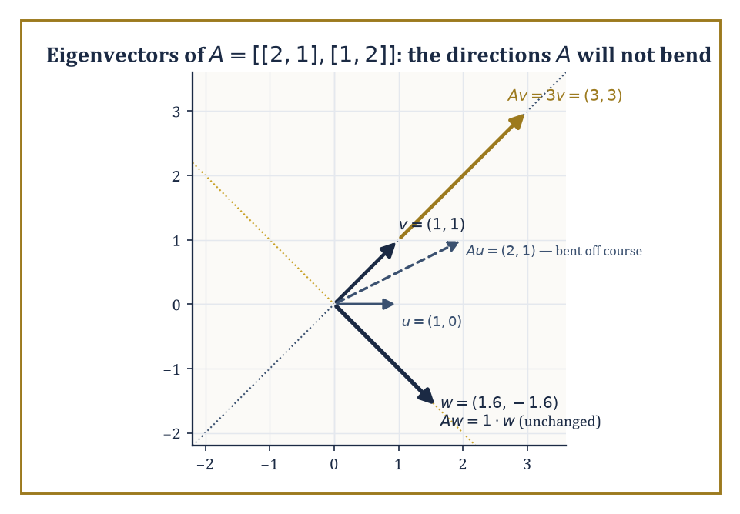
Along the eigen-directions of A, the map only stretches; everywhere else, like the plain vector (1,0), it bends the arrow off its own line.
T(v) = λv
T does not rotate or shear v at all, only stretches or shrinks it along its own direction.
The eigenspace belonging to λ is the set of all vectors satisfying this, which is precisely the kernel of T − λI, and is therefore automatically a subspace (Room 21.1's closure facts, quietly at work again).
The characteristic polynomial det(T − λI) does not depend on which basis you use to compute the determinant — similar matrices, as Room 21.3 showed, share the same characteristic polynomial — and its roots are exactly the eigenvalues of T.
Numeric example — Worked example — finding eigenvalues and eigenvectors by hand. Let A = [[2,1],[1,2]]. Find its characteristic polynomial.
det(A − λI) = det [[2−λ, 1],[1, 2−λ]] = (2−λ)² − 1
Expand.
(2−λ)² = 4 − 4λ + λ²
λ² − 4λ + 4 − 1 = λ² − 4λ + 3 = (λ−1)(λ−3)
Roots: λ=1 and λ=3.
For λ=3, solve (A−3I)v=0.
[[−1,1],[1,−1]]v = 0, giving −x+y=0, so y=x; eigenvector (1,1)
A·(1,1) = (2+1, 1+2) = (3,3) = 3·(1,1)
For λ=1, solve (A−I)v=0.
[[1,1],[1,1]]v = 0, giving x+y=0, so y=−x; eigenvector (1,−1)
A·(1,−1) = (2−1, 1−2) = (1,−1) = 1·(1,−1)
Two eigenvalues, two eigenvector directions, both confirmed by direct substitution.
T is diagonalizable if V has a basis consisting entirely of eigenvectors of T — equivalently, if the algebraic multiplicity (how many times an eigenvalue appears as a root of the characteristic polynomial) equals the geometric multiplicity (the dimension of its eigenspace) for every eigenvalue.
When this holds, T acts on the eigenbasis as nothing more complicated than independent scalings along each direction — arguably the simplest description any linear map can possibly have, which is exactly why diagonalization is worth pursuing whenever it is available.
Numeric example — Worked example — diagonalizing A = [[2,1],[1,2]]. Using the eigenvectors found above, let P have the eigenvectors as columns, ordered to match eigenvalues 3 then 1.
P = [[1,1],[1,−1]]
Its determinant is 1·(−1) − 1·1 = −2, so:
P⁻¹ = [[1/2, 1/2], [1/2, −1/2]]
Compute AP: column 1 is A·(1,1) = (3,3); column 2 is A·(1,−1) = (1,−1).
AP = [[3,1],[3,−1]]
Now compute P⁻¹AP row by row.
row 1 = [1/2·3 + 1/2·3, 1/2·1 + 1/2·(−1)] = [3, 0]
row 2 = [1/2·3 + (−1/2)·3, 1/2·1 + (−1/2)·(−1)] = [0, 1]
P⁻¹AP = [[3,0],[0,1]]
Diagonal, eigenvalues on the diagonal in the order chosen for P's columns. Diagonalization achieved and independently verified, not merely asserted.
Not every matrix is diagonalizable, and the obstruction is precisely a shortfall of eigenvectors: some eigenvalue's algebraic multiplicity outruns its geometric multiplicity, meaning the characteristic polynomial promises more copies of an eigenvalue than there turn out to be independent eigenvector directions to match.
The size of that shortfall is measured exactly by the Jordan block sizes of Room 21.8; the discrepancy between the two multiplicities is the first, unmistakable warning sign that a matrix will need a more elaborate canonical form than a plain diagonal one.
Numeric example — Worked example — a matrix that refuses to diagonalize. Let A = [[1,1],[0,1]]. Its characteristic polynomial is found using the fact that the matrix is upper triangular, so the determinant is the product of its diagonal entries.
det [[1−λ,1],[0,1−λ]] = (1−λ)²
So λ=1 is a root of multiplicity 2 (algebraic multiplicity 2) — the characteristic polynomial promises a two-dimensional eigenspace, if diagonalization is to succeed. Check the actual eigenspace by solving (A−I)v=0.
[[0,1],[0,0]]v = 0, which forces y=0 with x free
The eigenspace is span{(1,0)} — only one-dimensional (geometric multiplicity 1). Algebraic multiplicity 2 versus geometric multiplicity 1: the shortfall is exactly 1, and A cannot be diagonalized. No amount of clever basis-hunting produces a second independent eigenvector, because there genuinely isn't one to find.
A preview worth planting now, to be harvested properly in Rooms 21.6 and 21.7: the eigenvectors of a symmetric matrix belonging to distinct eigenvalues are automatically orthogonal to each other, with no Gram-Schmidt cleanup required.
This is not a coincidence about the particular matrix used above; it is a theorem, and it is the single fact that makes the spectral theorem work.
Numeric example — Worked example — orthogonality falling out for free. The eigenvectors found for A = [[2,1],[1,2]] were (1,1) for eigenvalue 3 and (1,−1) for eigenvalue 1. Check their dot product.
(1,1)·(1,−1) = 1·1 + 1·(−1) = 1 − 1 = 0
Orthogonal, with no adjustment needed. Contrast this with the earlier basis-change example in Room 21.3, where a basis had to be chosen somewhat by inspection; here, for a symmetric matrix, the eigenvectors arrange themselves at right angles automatically, purely as a consequence of symmetry. Room 21.7 explains precisely why.
Two cheap sanity checks are worth keeping in the back pocket whenever eigenvalues have just been computed by hand, since arithmetic slips are the second-most reliable cause of exam despair (the most reliable being a forgotten minus sign in a determinant).
The sum of the eigenvalues always equals the trace of the matrix (the sum of the diagonal entries), and the product of the eigenvalues always equals the determinant.
Both facts follow from expanding the characteristic polynomial and comparing coefficients, but they are far more useful as a quick arithmetic check than as anything requiring proof mid-calculation.
Numeric example — Worked example — checking eigenvalues against trace and determinant. For A = [[2,1],[1,2]], the trace is:
trace(A) = 2 + 2 = 4
The eigenvalues found earlier were 1 and 3, summing to:
1 + 3 = 4
Matching. The determinant is:
det(A) = 2·2 − 1·1 = 4 − 1 = 3
And the product of the eigenvalues is:
1 · 3 = 3
Also matching. Had either check failed, it would have been a signal to go back and recheck the characteristic polynomial before trusting the eigenvectors built on top of it — a habit worth forming before the matrices get larger than 2×2 and the arithmetic stops being forgiving.

Room 21.6: Inner-Product Spaces and Orthogonality
Bringing Back the Angles We Pretended Not to Miss
An inner product on a real vector space is a positive-definite symmetric bilinear form — a rule ⟨u,v⟩ assigning a scalar to every pair of vectors, linear in each argument, symmetric, and positive on nonzero vectors; over ℂ the symmetry is replaced by conjugate-symmetry, giving a Hermitian form.
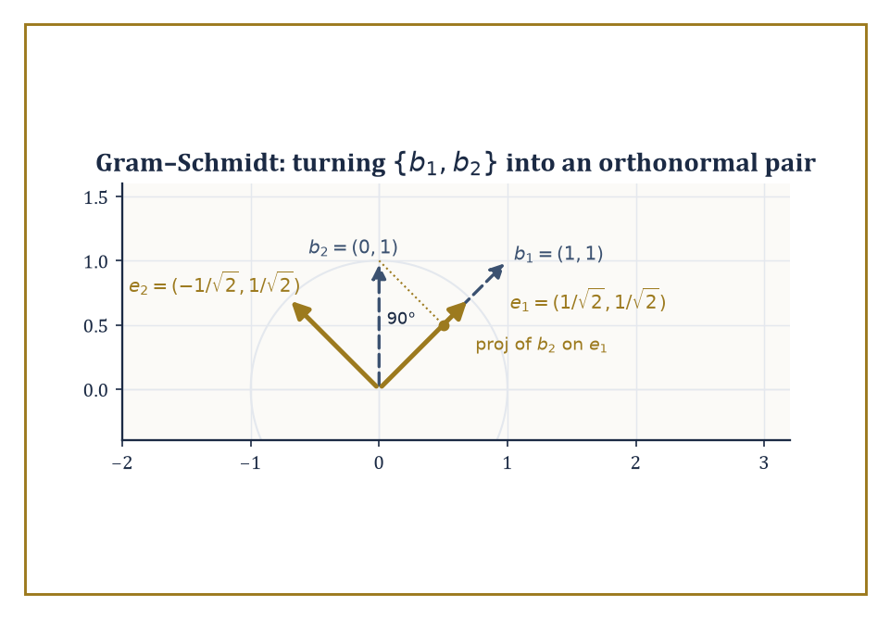
Gram-Schmidt in action: subtract the projection of b₂ onto e₁, normalize what is left, and the result meets e₁ at a perfect right angle.
⟨u,v⟩ = ⟨v,u⟩ (symmetry); ⟨v,v⟩ > 0 unless v = 0 (positivity)
Once an inner product is chosen, length and angle return to the picture.
‖v‖ = √⟨v,v⟩
And two vectors are orthogonal exactly when ⟨u,v⟩=0.
The orthogonal complement of a subspace U, written U⊥, is the set of all vectors orthogonal to every vector in U — itself a subspace — and V splits as the direct sum of any subspace and its orthogonal complement: every vector decomposes uniquely into a piece inside U and a piece inside U⊥.
Numeric example — Worked example — a plane and its orthogonal complement. In ℝ³ with the standard dot product, let U be the xy-plane, spanned by (1,0,0) and (0,1,0). Its orthogonal complement U⊥ is claimed to be the z-axis, spanned by (0,0,1) — check.
(1,0,0)·(0,0,1) = 0 and (0,1,0)·(0,0,1) = 0
So (0,0,1) is indeed orthogonal to everything in U, and no vector with a nonzero x or y component can be orthogonal to both (1,0,0) and (0,1,0) simultaneously, so U⊥ is exactly this line.
Every vector (a,b,c) decomposes uniquely, the first piece in U, the second in U⊥.
(a,b,c) = (a,b,0) + (0,0,c)
dim U (2) + dim U⊥ (1) = 3 = dim ℝ³
A direct sum — another instance of the additive bookkeeping this whole storey keeps returning to.
Orthonormal bases — bases whose vectors are mutually orthogonal and each of length 1 — are especially convenient, because the coordinate of a vector along a basis direction is simply its inner product with that basis vector; no linear system needs solving, as it did back in Room 21.2.
The Gram-Schmidt process converts any basis into an orthonormal one: take each basis vector in turn, subtract off its projection onto everything already processed, and normalize what remains.
Numeric example — Worked example — Gram-Schmidt on two vectors in ℝ². Start with the basis {(1,1), (0,1)}. First, normalize (1,1): its norm is √(1²+1²) = √2, so:
e₁ = (1/√2, 1/√2)
Second, take (0,1) and subtract its projection onto e₁. The projection coefficient is:
⟨(0,1), e₁⟩ = 0·(1/√2) + 1·(1/√2) = 1/√2
So the projection itself is:
(1/√2)·e₁ = (1/√2)·(1/√2, 1/√2) = (1/2, 1/2)
Subtract:
(0,1) − (1/2,1/2) = (−1/2, 1/2)
Normalize: its norm is √((1/2)² + (1/2)²) = √(1/2) = 1/√2, so:
e₂ = (−1/2,1/2)/(1/√2) = (−1/√2, 1/√2)
Check orthonormality.
e₁·e₂ = (1/√2)(−1/√2) + (1/√2)(1/√2) = −1/2 + 1/2 = 0
Both e₁ and e₂ visibly have norm 1 by construction. {(1/√2,1/√2), (−1/√2,1/√2)} is the resulting orthonormal basis.
The adjoint of a linear map T is the unique linear map T* satisfying the relation below, for all v, w — the operator that can be legally moved from one side of the inner product to the other.
⟨T(v), w⟩ = ⟨v, T*(w)⟩
For a real matrix with the standard dot product, the adjoint is simply the transpose.
Three special families of operator are defined entirely in terms of their relationship to their own adjoint: self-adjoint (T = T*, symmetric matrices being the prototypical example), unitary (T* = T⁻¹, meaning T preserves lengths and angles exactly), and normal (TT* = T*T, the umbrella condition covering both of the previous two).
These three names are about to become the entire cast of the next room.
Numeric example — Worked example — checking self-adjointness directly. Let A = [[2,1],[1,2]] again, with the standard inner product on ℝ², so the adjoint is the transpose — and A is symmetric (Aᵀ = A), so it should be self-adjoint. Verify the defining relation on specific vectors v=(1,0), w=(0,1).
Av = (2,1); ⟨Av,w⟩ = (2,1)·(0,1) = 0+1 = 1
Aw = (1,2); ⟨v,Aw⟩ = (1,0)·(1,2) = 1+0 = 1
Both sides equal 1, matching as the self-adjoint relation requires. This is not a coincidence of these particular vectors — it follows for every v,w whenever A is symmetric, using Aᵀ=A in the middle step.
⟨Av,w⟩ = (Av)ᵀw = vᵀAᵀw = vᵀAw = v·(Aw) = ⟨v,Aw⟩
Once a direction is normalized, the orthogonal projection of any vector onto it is given by a single clean formula, for a unit vector e.
proj(v) = ⟨v,e⟩·e
This is the algebraic heart of Gram-Schmidt (each step subtracts exactly such a projection) and also the operation behind least-squares fitting and principal-component analysis, both of which reduce, at bottom, to projecting a high-dimensional vector onto a lower-dimensional subspace and asking how much was lost in the process.
Numeric example — Worked example — projecting onto a unit vector. Let e = (1/√2, 1/√2), a unit vector along the line y=x, and project v=(2,3) onto it. The projection coefficient is:
⟨v,e⟩ = 2·(1/√2) + 3·(1/√2) = 5/√2
The projection itself is:
(5/√2)·e = (5/√2)·(1/√2,1/√2) = (5/2, 5/2)
Sanity check: the leftover vector should be orthogonal to e, since a projection is defined to leave behind exactly the perpendicular remainder.
v − proj(v) = (2,3) − (5/2,5/2) = (−1/2, 1/2)
(−1/2)(1/√2) + (1/2)(1/√2) = −1/(2√2) + 1/(2√2) = 0
Confirmed orthogonal, exactly as an honest projection requires.
It is worth being honest about what a choice of inner product actually costs you, since it is easy to mistake it for a free upgrade.
Fixing ⟨·,·⟩ singles out one particular notion of 'right angle' and 'unit length' among many that could have been chosen on the same underlying vector space — a different inner product on the same set V would declare a different pair of directions orthogonal, and a different set of vectors to have length 1.
The vector space itself, with its bare addition and scalar multiplication, is neutral on the question; the inner product is an extra structure laid on top, chosen because it is useful, not because the space demanded it.
Numeric example — Worked example — orthogonality is relative to the inner product chosen. Under the standard dot product, (1,1) and (1,−1) are orthogonal, as Room 21.5 already checked.
1·1 + 1·(−1) = 0
Now define a different, equally legitimate inner product on the same ℝ², the weighted form below (positive-definite and symmetric, so it qualifies).
⟨u,v⟩ = 2u₁v₁ + u₂v₂
Recompute.
⟨(1,1),(1,−1)⟩ = 2·1·1 + 1·(−1) = 2 − 1 = 1 ≠ 0
The very same pair of vectors, sitting in the very same vector space ℝ², is orthogonal under one inner product and not under another. Orthogonality was never a property of the vectors alone; it was always a property of the vectors together with whichever inner product had been chosen to measure them.

Room 21.7: The Spectral Theorem and Quadratic Forms
Diagonal at Last, and Orthogonally So
The spectral theorem is the reward for everything built so far: every self-adjoint operator on a finite-dimensional inner-product space is diagonalizable by an orthonormal basis of eigenvectors — not merely diagonalizable in the loose sense of Room 21.5, but diagonalizable using a basis that is also orthonormal, the best possible kind of basis to have.
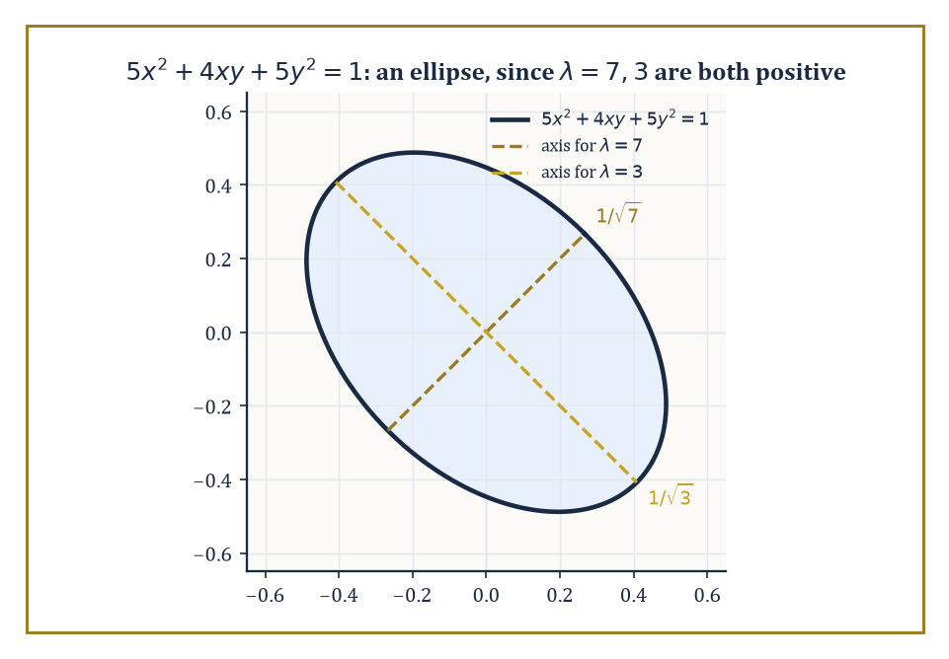
The conic 5x²+4xy+5y²=1 is an ellipse whose axes point along the eigenvectors, with lengths 1/√λ set by the eigenvalues 7 and 3.
Over ℂ the same conclusion holds for the wider class of normal operators; the real, symmetric-matrix version is the one that shows up constantly in applications, precisely because so many matrices arising from physical or statistical problems (covariance matrices, moment-of-inertia tensors, Hessians at a critical point) are symmetric by construction.
Numeric example — Worked example — the spectral theorem in action on A = [[2,1],[1,2]]. Room 21.5 found eigenvalues 3 and 1 for A = [[2,1],[1,2]], with eigenvectors (1,1) and (1,−1). Normalizing gives an orthonormal eigenbasis.
u₁ = (1/√2, 1/√2) (for eigenvalue 3)
u₂ = (1/√2, −1/√2) (for eigenvalue 1)
Check orthonormality.
u₁·u₂ = 1/2 − 1/2 = 0
Both have norm 1 by construction. This is exactly the spectral theorem's promise delivered concretely: because A is symmetric, its eigenvectors for distinct eigenvalues came out orthogonal automatically (as flagged at the end of Room 21.5), and normalizing them costs nothing extra.
The matrix Q = [u₁ u₂] is then orthogonal, and the diagonalization is achieved by an orthogonal change of basis rather than merely an invertible one.
QᵀQ = I
QᵀAQ = diag(3,1)
A quadratic form is an expression built from a symmetric matrix, of the shape below.
Q(x,y) = ax² + bxy + cy² = vᵀAv
The spectral theorem diagonalizes quadratic forms by exactly the same orthonormal change of coordinates that diagonalizes the underlying symmetric matrix, eliminating all cross terms (the xy-type terms) and leaving a pure sum of squares weighted by the eigenvalues.
The signature of the form — the number of positive, negative, and zero eigenvalues — is an invariant of the form itself, unaffected by which orthonormal coordinates you use to view it, and it completely classifies the form up to change of orthonormal coordinates: positive definite (all eigenvalues positive), negative definite, indefinite, or degenerate, depending on the signs present.
Numeric example — Worked example — diagonalizing a quadratic form. Let Q(x,y) = 2x² + 2xy + 2y², whose matrix is [[2,1],[1,2]] — check that it matches.
vᵀAv = [x y]·[[2,1],[1,2]]·[x;y] = 2x²+xy+xy+2y² = 2x²+2xy+2y²
It matches Q exactly. Using the orthonormal eigenbasis from above, introduce new coordinates along the eigenvalue-3 and eigenvalue-1 directions.
u = (x+y)/√2, v = (x−y)/√2
The spectral theorem guarantees Q becomes the following in these coordinates, with the cross term gone entirely.
Q = 3u² + v²
Verify at the point (x,y)=(1,1). Directly:
Q(1,1) = 2+2+2 = 6
In the new coordinates:
u = (1+1)/√2 = √2, v = (1−1)/√2 = 0
3u²+v² = 3·2 + 0 = 6
Matching. Since both eigenvalues (3 and 1) are positive, the signature is (2 positive, 0 negative, 0 zero): Q is positive definite, meaning Q(x,y) > 0 for every nonzero (x,y).
This machinery underwrites some of the most-used tools in applied mathematics, generally without the tools themselves admitting it.
Principal-component analysis diagonalizes a data set's covariance matrix to find the directions of greatest variance, which is a great deal more dignified a description than 'finding out which way the cloud of points is leaning.'
The classification of conics and quadrics (ellipses, hyperbolas, and their higher-dimensional cousins, who rarely get invited to the introductory course) reduces to reading off the signature of a quadratic form after an orthonormal change of coordinates has removed the cross terms.
The stability analysis of an equilibrium in mechanics checks whether the Hessian of a potential energy function is positive definite at that point — exactly the signature question above, applied to a matrix of second derivatives instead of a matrix of coefficients, and asked with rather higher stakes than a homework problem.
Numeric example — Worked example — classifying a conic by its eigenvalues. Classify the curve below.
5x² + 4xy + 5y² = 1
Its matrix is A = [[5,2],[2,5]] (the cross-term coefficient 4 splits into 2 and 2 off the diagonal) — check.
vᵀAv = 5x²+2xy+2xy+5y² = 5x²+4xy+5y²
The characteristic polynomial:
det [[5−λ,2],[2,5−λ]] = (5−λ)² − 4 = λ² − 10λ + 25 − 4 = λ² − 10λ + 21
Factor.
λ² − 10λ + 21 = (λ−7)(λ−3)
Giving eigenvalues 7 and 3. Both positive, so the quadratic form is positive definite, and the curve is an ellipse — no further sketching required, the sign pattern of the eigenvalues has already settled the question.
The complex, normal-operator version of the spectral theorem is worth one concrete glance, if only so it does not remain a purely rhetorical extension of the real case.
A unitary operator (U* = U⁻¹, the complex analogue of an orthogonal matrix) is automatically normal, since the two possible orders of multiplication agree trivially once U* and U⁻¹ are literally the same matrix.
UU* = UU⁻¹ = I = U⁻¹U = U*U
Rotation matrices are the standard real example of this phenomenon: they preserve length and angle exactly, which is precisely what being orthogonal (the real cousin of unitary) means.
Numeric example — Worked example — a rotation matrix is orthogonal, hence normal. Let R be rotation by 90°.
R = [[0,−1],[1,0]]
Its transpose is:
Rᵀ = [[0,1],[−1,0]]
Compute RᵀR row by row.
row 1 = [0·0 + 1·1, 0·(−1) + 1·0] = [1, 0]
row 2 = [−1·0 + 0·1, −1·(−1) + 0·0] = [0, 1]
RᵀR = I
R is orthogonal, meaning Rᵀ = R⁻¹, the real special case of unitary. Since R* (=Rᵀ here) equals R⁻¹, R is automatically normal by the argument above, and the complex spectral theorem applies to it even though, geometrically, all a rotation matrix does is turn the plane — no stretching along any real direction at all, which is exactly why its eigenvalues (i and −i, for this particular R) turn out to be complex rather than real: a pure rotation has no real eigenvector to diagonalize along, a fact the real spectral theorem quietly sidesteps by restricting itself to symmetric matrices in the first place.

Room 21.8: Jordan Form, SVD, and Canonical Forms
The Last Word on What a Matrix Really Is
Every endomorphism of a finite-dimensional complex vector space has a Jordan canonical form: a block-diagonal matrix whose blocks are Jordan blocks, each a square array with a single eigenvalue repeated down the diagonal and 1's on the superdiagonal immediately above it.
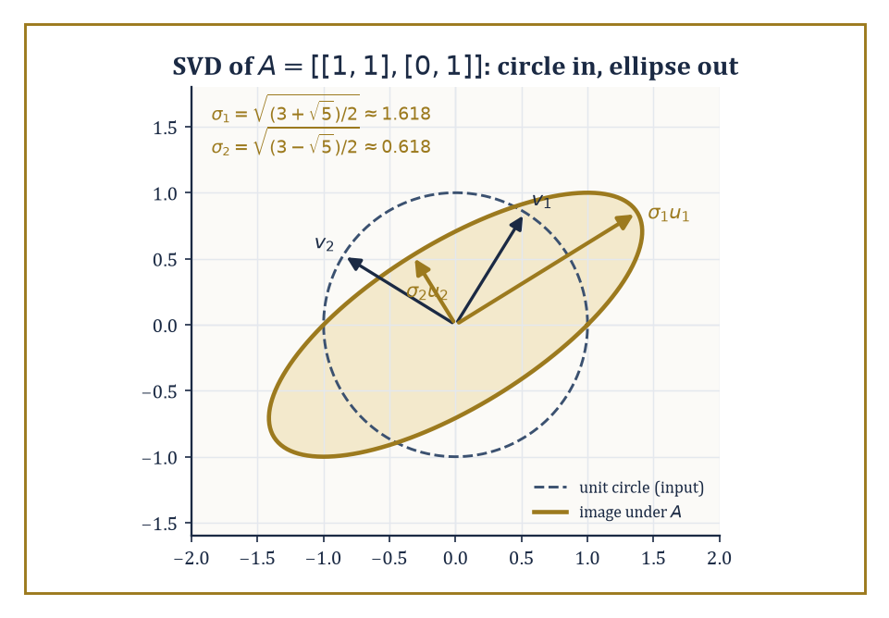
The SVD of the stubbornly non-diagonalizable A = [[1,1],[0,1]]: the unit circle still becomes a perfectly respectable ellipse, with golden-ratio singular values.
The size of each block is fixed by the dimensions of the kernels of the successive powers of (T − λI); the Jordan form is unique up to reordering the blocks.
Where diagonalization fails, as it did for the matrix in Room 21.5, Jordan form is the fallback: it is the closest any matrix can get to diagonal once the eigenvector shortage makes true diagonalization impossible.
Numeric example — Worked example — the Jordan form of a non-diagonalizable matrix. Recall A = [[1,1],[0,1]] from Room 21.5, with eigenvalue 1 (algebraic multiplicity 2) but only a one-dimensional eigenspace span{(1,0)}. Since A is already upper triangular with 1's on the diagonal and a single 1 on the superdiagonal, it is already sitting in Jordan form: one Jordan block of size 2 for eigenvalue 1.
To see the generalized eigenvector that fills out the missing dimension, solve (A−I)v₂ = v₁ where v₁=(1,0) is the ordinary eigenvector.
(A−I) = [[0,1],[0,0]], so 0·x + 1·y = 1, giving y=1 with x free; choose v₂=(0,1)
The pair {(1,0), (0,1)} — here, unsurprisingly, the standard basis — is a genuine Jordan basis.
A(1,0) = (1,0) = 1·(1,0)
A(0,1) = (1,1) = 1·(0,1) + 1·(1,0)
This is exactly the eigenvalue-plus-superdiagonal-1 pattern a Jordan block demands.
The singular value decomposition writes an arbitrary m×n matrix A — square or not, diagonalizable or not — as the product below, where U and V are orthogonal (unitary), and Σ is diagonal with non-negative entries called the singular values.
A = UΣVᵀ (or UΣV* for complex matrices)
The singular values are precisely the square roots of the eigenvalues of AᵀA, which is always symmetric and positive semi-definite, so those eigenvalues are always real and non-negative — the spectral theorem of Room 21.7 guaranteeing the SVD's existence behind the scenes.
Because the SVD makes no demand that A be square, self-adjoint, or even diagonalizable, it is the single most universally applicable matrix factorization in numerical linear algebra and data science.
Numeric example — Worked example — a full SVD, reusing familiar eigenwork. Let A = [[1,0],[1,1],[0,1]], a 3×2 matrix. Compute AᵀA, where row 1 of Aᵀ is (1,1,0) and row 2 is (0,1,1).
(AᵀA)₁₁ = 1·1+1·1+0·0 = 2; (AᵀA)₁₂ = 1·0+1·1+0·1 = 1; (AᵀA)₂₁ = 1; (AᵀA)₂₂ = 0·0+1·1+1·1 = 2
AᵀA = [[2,1],[1,2]]
This is exactly the matrix diagonalized in Rooms 21.5 and 21.7, with eigenvalues 3 and 1 and orthonormal eigenvectors v₁=(1/√2,1/√2), v₂=(1/√2,−1/√2). The singular values are σ₁=√3, σ₂=1.
Compute u₁ = Av₁/σ₁.
Av₁ = (1·1/√2+0, 1/√2+1/√2, 0+1/√2) = (1/√2, √2, 1/√2)
u₁ = (1/√2, √2, 1/√2)/√3 = (1/√6, √(2/3), 1/√6)
Check its norm.
1/6 + 2/3 + 1/6 = 1/6+4/6+1/6 = 1
Compute u₂ = Av₂/σ₂.
Av₂ = (1/√2, 1/√2−1/√2, −1/√2) = (1/√2, 0, −1/√2), norm 1/2+0+1/2 = 1
A third vector u₃, orthogonal to both and spanning the leftover dimension of ℝ³ (since A has rank 2 but lands in a 3-dimensional space), works out to:
u₃ = (1/√3,−1/√3,1/√3)
Assembling the pieces:
U=[u₁ u₂ u₃], Σ = [[√3,0],[0,1],[0,0]], V=[v₁ v₂]
Multiplying UΣVᵀ back out reconstructs A exactly (row 1 gives (1,0), row 2 gives (1,1), row 3 gives (0,1)) — arithmetic best done slowly with a pencil, but it closes perfectly.
Notice what the SVD does that Jordan form cannot: it exists for every matrix, rectangular or square, diagonalizable or not, because it never asks for eigenvectors of A itself — only of the always-symmetric AᵀA.
Even the stubborn Jordan-block matrix [[1,1],[0,1]] from earlier in this room, which has no eigenbasis to speak of, has a perfectly respectable SVD, since AᵀA = [[1,1],[1,2]] is symmetric and positive definite regardless of A's own eigenvector shortage.
Jordan form answers 'what does this map look like in its own best basis?' — a question that can have an ugly answer, or none at all outside ℂ. SVD answers 'what does this map look like between its own best pair of orthonormal bases, one for input and one for output?' — a question that always has a clean answer.
Together they complete the classification of linear maps: Jordan form up to ordinary change of basis, SVD up to orthonormal change of basis on each side.
Numeric example — Worked example — SVD surviving where Jordan form struggles. For A = [[1,1],[0,1]], compute AᵀA. More carefully: Aᵀ = [[1,0],[1,1]], so:
AᵀA = [[1,0],[1,1]]·[[1,1],[0,1]]
Row by row:
row1 = [1·1+0·0, 1·1+0·1] = [1,1]
row2 = [1·1+1·0, 1·1+1·1] = [1,2]
AᵀA = [[1,1],[1,2]]
Symmetric as required. Its characteristic polynomial:
(1−λ)(2−λ) − 1 = λ² − 3λ + 2 − 1 = λ² − 3λ + 1
With roots below — both positive, since their sum is 3 and their product is 1, both positive quantities forcing two positive roots.
λ = (3 ± √5)/2
So the singular values are:
σ = √((3±√5)/2)
These exist and are perfectly real, even though A itself, as Room 21.5 showed, has no eigenbasis at all. The SVD does not care that Jordan form was struggling next door.
One more fact worth carrying forward: the rank of a matrix equals the number of its nonzero singular values, since a zero singular value corresponds precisely to an eigenvalue of AᵀA equal to zero — a direction that A collapses entirely, contributing nothing to the image.
This gives the SVD a second life as a rank-detector, and, in practice, as a rank-repairer: keeping only the largest few singular values and discarding the rest produces the best possible low-rank approximation to a matrix, which is the entire mathematical engine behind image compression and recommender systems.
Numeric example — Worked example — rank read off from singular values. For A = [[1,0],[1,1],[0,1]], the singular values found earlier were √3 and 1 — both strictly positive, so all of them are nonzero. The rank of A is therefore 2, which matches direct inspection: the two columns (1,1,0) and (0,1,1) are independent (neither is a multiple of the other).
rank(A) = 2
Exactly as the singular-value count predicts. Had a third singular value existed and been zero, it would have signalled a hidden dependency among the columns worth hunting down directly.

Room 21.9: Looking Ahead: From Linear Algebra to Modules, Representations, and Functional Analysis
Packing the Toolbox for the Climb Ahead
Stand back and take stock of the equipment now in hand: vector spaces and subspaces, independence and dimension, linear maps and their matrices, rank-nullity, eigenvalues and diagonalization, inner products and orthogonality, the spectral theorem, and finally Jordan form and the SVD as the complete classification of what a linear map can look like.
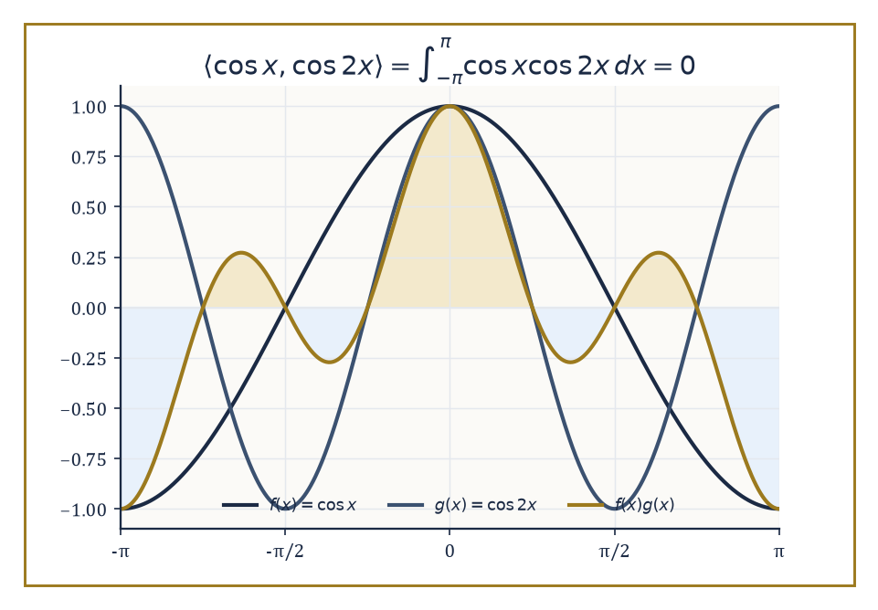
cos x and cos 2x look nothing alike, but their product's positive lobes (gold) and negative lobes (blue) balance out exactly — the seed of the Fourier basis.
It is a remarkably short list of ideas for how much weight it carries — which is, again, precisely the point of building a subject on few axioms and many examples.
These tools are not a self-contained destination; they are load-bearing walls for a great deal of what the Tower builds above this storey.
Modules over rings generalize vector spaces by replacing the field of scalars with a mere ring — and the loss of division turns out to matter enormously.
Representation theory studies linear actions of groups on vector spaces, turning abstract group elements into concrete matrices that can be multiplied and diagonalized.
Functional analysis extends this entire theory to infinite-dimensional spaces of functions, where 'basis' and 'orthonormal' need considerably more care than they did here.
Quantum mechanics identifies physically observable quantities with self-adjoint operators — Room 21.6's adjoint, doing genuine physical work.
And numerical linear algebra studies the stability and computational cost of the very algorithms — Gram-Schmidt, eigenvalue-finding, SVD — sketched by hand in this storey but in practice run by machine, on matrices far too large for a human to diagonalize with a pencil.
Abstract example — Worked example — why a module is not just a vector space with a different name. Consider ℤ as a module over itself (the ring ℤ acting on the set ℤ by ordinary multiplication). In a vector space over a field, you can always divide by a nonzero scalar; in the ℤ-module ℤ, you generally cannot. Is there an integer x with:
3x = 2
No — 2/3 is not an integer, so this simple equation, trivially solvable in any vector space over ℝ or ℚ, has no solution here.
Worse, consider ℤ/2ℤ = {0,1} as a ℤ-module, where 2 is congruent to 0 modulo 2, so:
2·1 = 0
In a vector space over a field, λv=0 with λ≠0 forces v=0 — but here 2≠0 (as a ring element) and 1≠0 (as a module element), yet 2·1=0 anyway.
This 'torsion' phenomenon has no counterpart in ordinary linear algebra; it is the first sign that modules are a genuinely harder and richer subject than their vector-space cousin, precisely because rings, unlike fields, are allowed to have elements with no multiplicative inverse.
Abstract example — Worked example — a first taste of representation theory. Let C₃ = {e, r, r²} be the cyclic group of order 3 (rotations by 0°, 120°, 240°). Represent it on ℝ² by rotation matrices.
R(e) = I
R(r) = [[−1/2,−√3/2],[√3/2,−1/2]]
R(r²) = [[−1/2,√3/2],[−√3/2,−1/2]]
A representation must respect the group's multiplication, so R(r)·R(r) should equal R(r²). Compute row by row.
row 1 = [(−1/2)(−1/2)+(−√3/2)(√3/2), (−1/2)(−√3/2)+(−√3/2)(−1/2)] = [1/4−3/4, √3/4+√3/4] = [−1/2, √3/2]
row 2 = [(√3/2)(−1/2)+(−1/2)(√3/2), (√3/2)(−√3/2)+(−1/2)(−1/2)] = [−√3/4−√3/4, −3/4+1/4] = [−√3/2, −1/2]
R(r)² = [[−1/2,√3/2],[−√3/2,−1/2]] = R(r²)
Exactly matching the group law r·r=r². The abstract group's structure has been faithfully translated into matrix multiplication — the entire ambition of representation theory in one small, checkable example.
The deeper lesson beneath all the specific results is that linearity is an extraordinarily powerful simplifying assumption — powerful enough that an enormous amount of mathematics is built by first finding the linear approximation to a hard nonlinear problem (a tangent plane, a derivative, a linearized differential equation) and only afterward wrestling with what the linear picture leaves out.
The structure theory developed in this storey — dimension, rank, eigenvalues, spectral decomposition — is both complete, in the precise sense that Jordan form and SVD leave nothing further to classify, and applicable far beyond the matrix setting where it was first discovered.
Abstract example — Worked example — orthogonality surviving the leap to infinite dimensions. In the space of functions on [−π, π] with the inner product below, the functions {1, cos x, sin x, cos 2x, sin 2x, …} form an infinite orthogonal set — the Fourier basis, and the exact infinite-dimensional analogue of the Gram-Schmidt-built orthonormal bases of Room 21.6.
⟨f,g⟩ = ∫_{−π}^{π} f(x)g(x) dx
Check one instance.
⟨cos x, cos 2x⟩ = ∫_{−π}^{π} cos x cos 2x dx
Using the product-to-sum identity below, the integral splits in two.
cos x cos 2x = ½[cos(x) + cos(3x)]
½∫cos x dx + ½∫cos 3x dx over [−π,π]
Both integrate to [sin(·)] evaluated at ±π.
∫_{−π}^{π} cos x dx = sin π − sin(−π) = 0 − 0 = 0
∫_{−π}^{π} cos 3x dx = (1/3)[sin 3x] from −π to π = (1/3)(sin 3π − sin(−3π)) = 0
So the whole integral is 0 — cos x and cos 2x are orthogonal, by exactly the same criterion (inner product zero) used throughout Room 21.6, only now the 'vectors' are functions and the 'dot product' is an integral. This orthogonality is the seed from which the storeys on functional analysis, much higher up the Tower, will grow an entire theory of Fourier series.
Numerical linear algebra, mentioned only in passing above, deserves one concrete warning before we leave it: solving a linear system on a computer is not the same problem as solving it on paper, because a computer's arithmetic is rounded, and some matrices amplify rounding error catastrophically while others barely notice it.
The technical name for this sensitivity is conditioning, and a matrix that is 'nearly singular' — close to having a zero determinant, close to losing a dimension of rank — tends to be badly conditioned, however innocent it looks written down.
Numeric example — Worked example — a matrix that looks harmless and is not. Compare A = [[1,1],[1,1]] (singular, columns identical) with B = [[1,1],[1,1.0001]] (technically invertible). Check their determinants.
det(A) = 1·1 − 1·1 = 0
det(B) = 1·1.0001 − 1·1 = 0.0001
B's determinant is tiny but nonzero, so on paper it is perfectly solvable.
In practice, inverting B involves dividing by 0.0001, which multiplies any small input error by roughly 10,000 — meaning a rounding error of size 10⁻⁶ in the input data could produce an error of size 10⁻² in the computed solution, a hundred-fold amplification.
Nothing in the determinant's bare nonzero-ness warns you of this; only the size of the determinant relative to the entries does. This is precisely the kind of question — how much does a small input error get amplified — that numerical linear algebra exists to answer properly, and that the eigenvalue and SVD machinery of this storey turns out to be exactly the right language for measuring.
Linear algebra, in the end, is the backbone of modern mathematical science — not because linear problems are the interesting ones, but because they are the ones we know how to solve completely, and every harder problem gets attacked, sooner or later, by finding the linear structure hiding somewhere inside it.
We came up this storey holding matrices as concrete grids of numbers; we leave it having learned to see the structure sitting quietly beneath the coordinates, waiting to be recognised in whatever costume it turns up wearing next.
The eigenvectors may now retire, at least for a storey. Storey 22 descends from this abstraction back into something you can genuinely sketch on paper: analytic geometry, where the plane and space of school mathematics — lines, circles, conics, and the angles between them — get re-derived properly, using coordinates chosen with intent rather than inherited by habit. Much of what felt like a leap of faith here (why should 'inner product' deserve the name it borrows from ordinary dot products; why should a quadratic form's signature classify an ellipse) will turn out to have been exactly that dot product and exactly that ellipse all along, merely wearing the more general clothing this storey insisted on giving it first.
It is a peculiar shape for a piece of mathematics to take: climb up into abstraction for an entire storey, then climb straight back down into the concrete for the next one. But that, it turns out, is rather the honest shape of understanding anything properly — you go up to see the structure, and you come back down to remember what it was structure of. The Tower continues upward, and for once, the descent is part of the plan.

Storey 22: Analytic Geometry
Coordinates, Curves, Surfaces, and the Art of Turning Geometry into Algebra
The previous storey left us fluent in a language nobody speaks at dinner parties: vectors, matrices, eigenvalues, the whole grammar of linear structure. Fluency, however, is only interesting once you have somewhere to use it. This storey is where the accent finally gets tested against something you can actually draw — lines, circles, cones, the whole geometric menagerie — and it turns out linear algebra was the native tongue all along.
Analytic geometry is, at bottom, a seventeenth-century bargain that has never stopped paying dividends: Descartes and Fermat noticed that if you nail down a coordinate grid, every point becomes a pair (or triple) of numbers, and every curve — however proud and geometrical it feels about itself — becomes an equation. A shape stops being a shape you contemplate and becomes a shape you can compute with. This is either the moment geometry became modern or the moment it became homework, depending on your temperament and how the last problem set went.
The plan of this storey is to climb the second-degree ladder in an orderly fashion: coordinates for lines and planes first (the easy, load-bearing stuff), then distances and angles (still easy, marginally more fiddly), then circles and spheres, and finally the conic sections and their three-dimensional cousins the quadric surfaces — ellipsoids, hyperboloids, paraboloids, and a small zoo of degenerate cases where the equation gives up and becomes a point, a line, or nothing at all. Underneath almost all of it sits one recurring fact: classifying a quadratic equation is really just diagonalising a symmetric matrix and reading off the eigenvalues. The spectral theorem, last seen doing honest work in Storey 21, turns out to be the engine room of the entire subject.
A small confession before we begin, in the spirit of full disclosure required of anyone about to hand you a great many formulas: analytic geometry has a well-earned reputation as a subject that is ninety per cent memorising which formula goes with which shape. That reputation is not entirely fair. Most of the formulas are the same formula, wearing a different coat, and by the end of this storey the coats should stop fooling you.

Room 22.1: What Analytic Geometry Actually Is
Or: Descartes, and the Point of Naming Points
Analytic geometry studies geometric objects by means of coordinates and algebraic equations. It begins, as school mathematics always does, with the Cartesian plane: fix an origin, fix two perpendicular axes, and every point in the plane becomes an ordered pair (x, y) — a promise that the point is x units along the first axis and y units along the second.
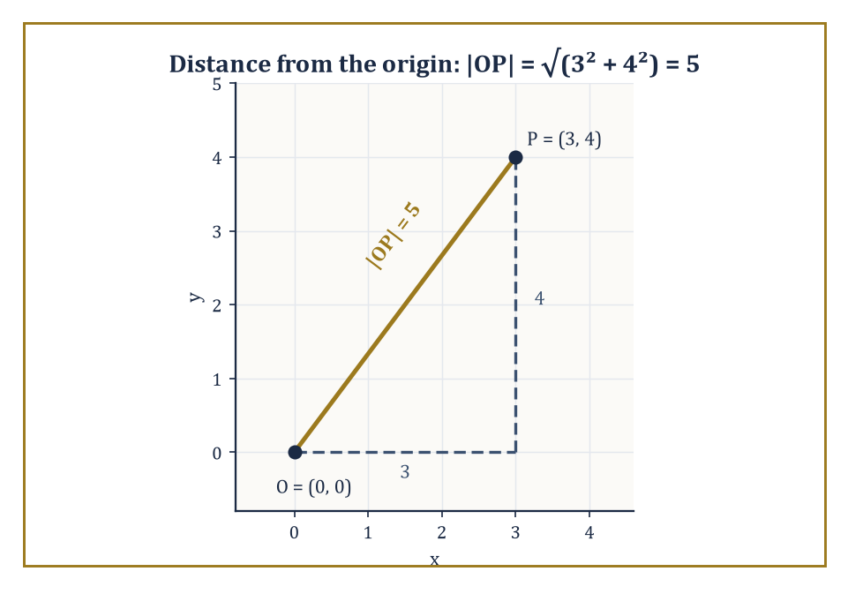
The point P = (3, 4), its distance from the origin, and the 3-4-5 triangle doing the work underneath the square root.
The trick, once made, refuses to stay two-dimensional: add a third perpendicular axis and every point in space becomes an ordered triple (x, y, z), and nothing about the method minds being pushed to four coordinates, or four hundred, except our ability to draw a picture of it. The geometry does not become harder in higher dimensions so much as it becomes unillustrated.
Numeric example — Worked example. Locate the point P = (3, 4) in the plane: three units along the x-axis, four along the y-axis. Its distance from the origin O = (0,0) is given by the Euclidean norm:
|OP| = √(3² + 4²) = √(9+16) = √25 = 5
— the famous 3-4-5 right triangle, now demoted to a special case of a coordinate formula. Extend to space: the point Q = (3, 4, 12) is at distance from the origin:
√(3²+4²+12²) = √(9+16+144) = √169 = 13
The method did not care that we added a dimension; it simply extended the sum under the square root.
The whole subject rests on one deliberate act of faith: that geometric statements and algebraic statements can be translated into each other without loss. 'The point lies on the line' becomes 'the coordinates satisfy the linear equation'; 'the curve is a circle' becomes 'the equation, once the squares are completed, has the form:
(x−h)² + (y−k)² = r²
This translation is exact — nothing is lost crossing from geometry to algebra and back — for every object elementary geometry studies, and it remains the working model for every more advanced geometry built on top of it.
Numeric example — Worked example. Consider the line with equation 3x − y − 1 = 0. Does the point (1, 2) lie on it? Substitute:
3(1) − 2 − 1 = 3 − 2 − 1 = 0
The equation is satisfied, so yes — (1, 2) is on the line, purely as a matter of arithmetic, without any picture having been drawn. Now test (0, 0):
3(0) − 0 − 1 = −1 ≠ 0
so the origin is not on the line. Geometric incidence has become a one-line calculation.
Vectors and matrices supply the compact grammar for all of this. A plane through a point x₀ with normal vector n is the set of points x satisfying the condition that the vector from x₀ to x is perpendicular to n:
n · (x − x₀) = 0
The distance from a point to a line, in the plane or in space, comes out of a projection formula built from dot products (or, in three dimensions, a cross product); and the classification of conic sections — which of ellipse, parabola, or hyperbola a given quadratic equation describes — turns out to be nothing more exotic than applying the spectral theorem of Storey 21 to a 2×2 symmetric matrix.
Analytic geometry is therefore not merely a subject in its own right; it is linear algebra, still warm from the previous storey, put immediately to work.
Numeric example — Worked example. Let the normal vector be n = (1, 2, 2) and let the plane pass through x₀ = (1, 0, 0). The condition n · (x − x₀) = 0 expands as:
1(x−1) + 2(y−0) + 2(z−0) = 0, i.e. x + 2y + 2z = 1
Check that x₀ itself satisfies it:
1 + 0 + 0 = 1 ✓
Now find another point on the plane by setting y = 1, z = 0: the equation gives
x + 2 = 1, so x = −1
and (−1, 1, 0) is a second point on the plane — found by pure algebra, with no ruler in sight.
There is a two-way benefit here worth pausing on. Geometry gives algebra something to picture — an otherwise abstract equation acquires a shape, a symmetry, a reason to be true.
Algebra gives geometry something to prove — a claim that looks obvious in a hand-drawn diagram ('clearly these two lines meet at one point') becomes a guaranteed fact once it is reduced to solving simultaneous equations, immune to the possibility that the diagram was drawn slightly wrong.
Every theorem in this storey will be proved algebraically and explained geometrically, in that order of reliability if not of charm.
Numeric example — Worked example. Sketch, freehand, the three lines x + y = 4, 2x − y = 2, and x − 2y = −5. On paper they can look as though they pass through a common point — freehand sketches are forgiving that way. Algebra is not: solving the first two simultaneously (add them):
3x = 6, so x = 2, then y = 2
gives the point (2, 2). Substitute (2, 2) into the third:
2 − 2(2) = 2 − 4 = −2, not −5
The third line misses the other two's intersection point by a comfortable margin, a fact no amount of squinting at the sketch would have caught.

Room 22.2: Lines and Planes in Coordinates
Four Ways to Write Down the Same Straight Idea
A line in the plane can be written in bewilderingly many equivalent ways, each suited to a different piece of given information.
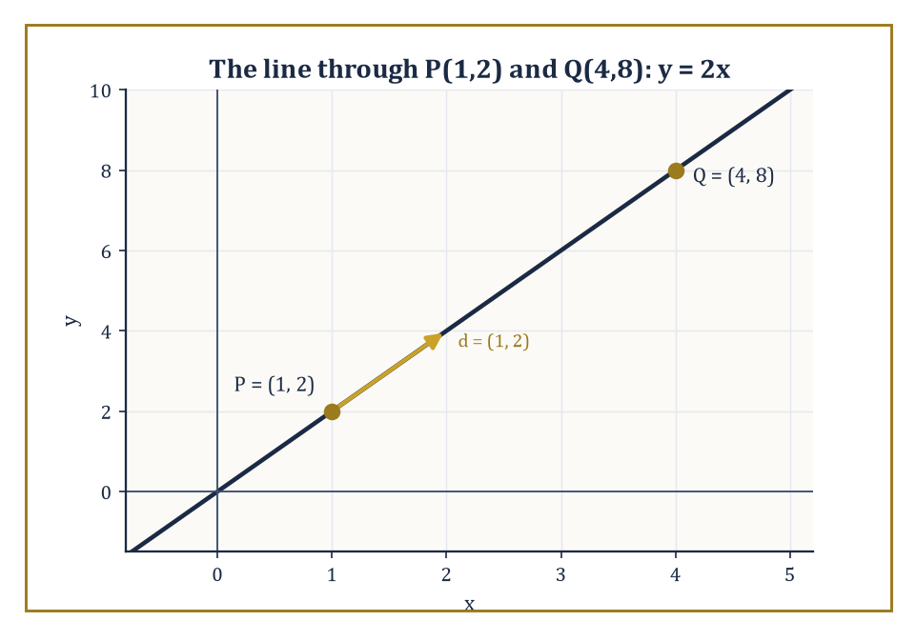
The line through P(1,2) and Q(4,8), with its direction vector d = (1, 2) doing all the travelling.
In parametric form, a point moves along the line as the parameter t ranges over all real numbers, starting at x₀ and travelling in direction d.
x = x₀ + t d
In point-slope form, the line is pinned down by one point and a slope m.
y − y₀ = m(x − x₀)
In two-point form, the slope is computed from two given points before point-slope form is applied.
And in general linear form, the line is simply the level set of a linear function.
ax + by + c = 0
This is the form that generalises most cleanly to planes and hyperplanes in higher dimensions.
Numeric example — Worked example. Find the line through P = (1, 2) and Q = (4, 8).
The slope is computed from the two points:
m = (8−2)/(4−1) = 6/3 = 2
Using point-slope form at P:
y − 2 = 2(x − 1)
which rearranges to:
y = 2x
Check both points:
x = 1, y = 2(1) = 2 ✓; x = 4, y = 2(4) = 8 ✓
In general linear form this is:
2x − y = 0
In parametric form, starting at P with direction vector d = Q − P = (3, 6) (or the simplified (1,2)), the line is:
(x,y) = (1,2) + t(1,2)
At t = 3 this reaches Q, as it should:
(1+3, 2+6) = (4, 8) = Q
In space, a single linear equation no longer pins down a line — it pins down a plane, since one equation in three unknowns leaves a two-parameter family of solutions.
A line in space is therefore best given parametrically, the same recipe as before with one more coordinate to carry:
x = x₀ + t d
A plane, meanwhile, can be specified either by a single linear equation:
ax + by + cz = d
or by a point x₀ together with two non-parallel direction vectors u and v lying in the plane, via:
x = x₀ + s u + t v
Numeric example — Worked example. The line through (1, 0, −1) with direction (2, 1, 3) is:
(x, y, z) = (1+2t, t, −1+3t)
At t = 0 this is the starting point, at t = 1 it moves further along, and at t = −1 it moves the other way:
t = 0: (1, 0, −1); t = 1: (3, 1, 2); t = −1: (−1, −1, −4)
Three points, one formula, and the parameter t is doing all the work of ‘how far along’.
The normal vector to a plane ax + by + cz = d is read off without any work at all: it is simply the vector of coefficients,
n = (a, b, c)
Two planes are parallel exactly when their normals are parallel (scalar multiples of each other), and perpendicular exactly when their normals are perpendicular, i.e. their dot product vanishes.
This is one of the small mercies of the subject — an entire angular relationship between two infinite flat objects reduces to a question about two triples of numbers.
Numeric example — Worked example. Take the planes x + y + z = 1 (normal n₁ = (1,1,1)) and x − 2y + z = 0 (normal n₂ = (1,−2,1)).
Their dot product is:
n₁ · n₂ = (1)(1) + (1)(−2) + (1)(1) = 1 − 2 + 1 = 0
so the planes are perpendicular.
Compare with x + y + z = 1 and 2x + 2y + 2z = 5: the second normal (2,2,2) is exactly 2n₁, so these two planes are parallel — and, since 2x+2y+2z=5 means x+y+z=2.5 rather than 1, they are distinct parallel sheets that never meet.
When two planes are not parallel, they meet in a line, and there are two equivalent ways to find it.
One can solve the two linear equations simultaneously, treating one variable as a free parameter.
Or — more elegantly — one can note that the direction of the intersection line must be perpendicular to both normals, and the cross product n₁ × n₂ is exactly the vector perpendicular to both.
A single point on the line, found by solving the system for one convenient slice, then completes the description.
Numeric example — Worked example. Take the planes x+y+z=6 and x−y+z=2, with normals n₁=(1,1,1) and n₂=(1,−1,1). The cross product is:
n₁ × n₂ = (1·1 − 1·(−1), 1·1 − 1·1, 1·(−1) − 1·1) = (1+1, 1−1, −1−1) = (2, 0, −2)
so the direction (1, 0, −1) will do (after halving).
For a point on the line, set z = 0: the equations become:
x+y=6 and x−y=2
Adding gives:
2x=8, so x=4 and y=2
giving the point (4, 2, 0). Check it satisfies both original planes:
4+2+0=6 ✓ and 4−2+0=2 ✓
The line of intersection is:
(x,y,z) = (4,2,0) + t(1,0,−1)
These descriptions are, by design, the easy end of the subject — first-year material dressed in slightly more formal clothing.
But they already demonstrate the method's whole ambition: geometric incidence, parallelism, and perpendicularity, concepts that used to require a protractor and a certain amount of squinting, have all become linear algebra.

Room 22.3: Distances, Angles, and Projections
Pythagoras, Generalised Until He Wouldn't Recognise Himself
The distance between two points is simply the length — the Euclidean norm — of the vector joining them. If A and B are points with position vectors a and b, the distance is given by:
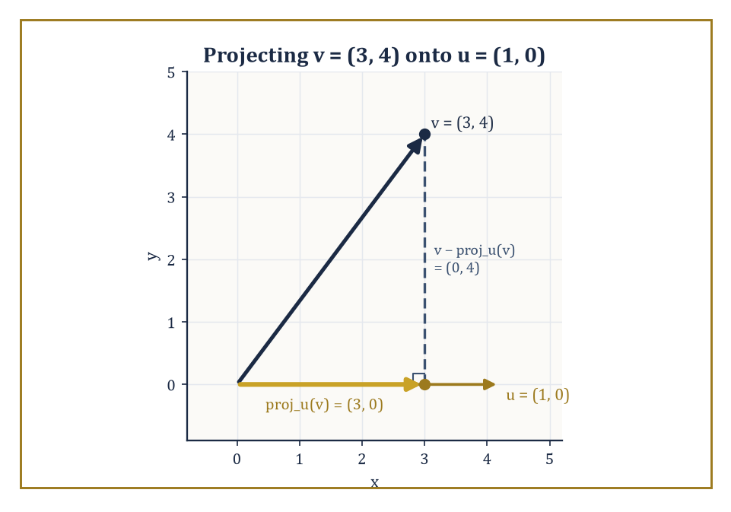
The vector v = (3, 4) splits uniquely into its shadow along u and the perpendicular leftover — the whole subject in one picture.
|AB| = |b − a| = √((b−a)·(b−a))
In coordinates this is the familiar square-root-of-sum-of-squared-differences formula. It works identically in the plane, in space, or in as many dimensions as you have the nerve to write down.
Numeric example — Worked example. Let A = (1,2,3) and B = (4,6,3). The difference vector is B − A = (3,4,0), and its length is:
|AB| = √(3² + 4² + 0²) = √(9+16) = √25 = 5
Note that the third coordinate contributed nothing here, since both points share z = 3 — the calculation automatically noticed that the real work was happening in a 3-4-5 triangle sitting inside the plane z = 3.
Distance from a point to a line or a plane is a slightly more interesting calculation. The idea is to take the vector from a known point on the line or plane to the external point, and project it onto the direction perpendicular to the line or plane (the 'orthogonal complement' of the line's or plane's own direction space). The length of that perpendicular component is the distance.
Worked out in coordinates, this collapses into a short formula: for a plane ax+by+cz=d and a point (x₀,y₀,z₀), the distance is:
distance = |ax₀+by₀+cz₀−d| / √(a²+b²+c²)
Numeric example — Worked example. Find the distance from P=(1,1,1) to the plane x+2y+2z=9. Here a=1, b=2, c=2, d=9, so the formula gives:
|a x₀+b y₀+c z₀ − d| / √(a²+b²+c²) = |1+2+2−9| / √(1+4+4) = |−4| / 3 = 4/3
To check this directly: the foot of the perpendicular from P is P + t n where n=(1,2,2); substituting into the plane equation gives:
(1+t)+2(1+2t)+2(1+2t)=9, i.e. 5+9t=9, so t=4/9
The foot is (1+4/9, 1+8/9, 1+8/9) = (13/9, 17/9, 17/9). Its distance from P is:
|t|·|n| = (4/9)(3) = 4/3
This matches the formula exactly.
The angle between two lines is, by definition, the angle between their direction vectors (or its supplement, since a line has no preferred sense of travel); the angle between two planes is the angle between their normals; and the angle between a line and a plane is obtained from the angle between the line's direction and the plane's normal, then subtracted from a right angle, since direction and normal point in perpendicular senses when the line lies in the plane.
In every case the working formula is the same:
cos θ = (u · v)/(|u||v|)
Numeric example — Worked example. Find the angle between the lines with direction vectors d₁=(1,1,0) and d₂=(1,0,1). Their dot product is:
d₁·d₂ = 1·1+1·0+0·1 = 1
Their lengths are:
|d₁| = √(1+1+0) = √2, |d₂| = √(1+0+1) = √2
So:
cos θ = 1/(√2·√2) = 1/2, giving θ = 60°
The two lines, though defined by rather arbitrary-looking direction vectors, meet at exactly the angle of an equilateral triangle.
Orthogonal projection is the linear map quietly doing all this work behind the scenes. The projection of a vector v onto a direction u is:
proj_u(v) = ((v·u)/(u·u)) u
This is the 'shadow' v casts along u — and subtracting this shadow from v leaves the component of v perpendicular to u. Every vector splits uniquely into a piece parallel to a given direction and a piece perpendicular to it, and this decomposition is precisely what the distance and angle formulas above are built from.
Numeric example — Worked example. Project v=(3,4) onto u=(1,0). Compute:
proj_u(v) = ((v·u)/(u·u)) u = ((3)/(1)) (1,0) = (3,0)
The perpendicular component is:
v − proj_u(v) = (3,4) − (3,0) = (0,4)
Check the two pieces are genuinely perpendicular, and that they sum back to v:
(3,0)·(0,4) = 0 ✓, (3,0)+(0,4) = (3,4) = v ✓
In this simple case the projection is just 'keep the x-coordinate, discard the y', because u happened to point exactly along the x-axis — the general formula reduces gracefully to the obvious answer when the obvious answer is available.
For the special case of a line meeting a plane, the natural angle to report is the one between the line and the plane itself, not between the line and the plane's normal — and since a line lying in the plane is exactly perpendicular to the normal, the line-plane angle and the line-normal angle are complementary, so a small subtraction from 90° finishes the job.
Numeric example — Worked example. Find the angle between the line with direction d=(1,0,1) and the plane z=0 (the xy-plane, normal n=(0,0,1)). First find the angle between d and n:
cos φ = (d·n)/(|d||n|) = (0+0+1)/(√2 · 1) = 1/√2, so φ = 45°
The angle between the line and the plane itself is:
90° − φ = 90° − 45° = 45°
In this particular case the two angles happen to coincide numerically, because 45° is its own complement — a coincidence of this example, not a general fact.
All of these quantities — distances, angles, the lengths of projected shadows — are invariant under rigid motions: rotate or translate the whole picture, and none of them change, precisely because rotations and translations preserve dot products. They are, in other words, the first worked examples in this storey of a running theme: geometric invariants computed by linear algebra.

Room 22.4: Circles, Spheres, and Simple Quadric Surfaces
Completing the Square, One More Time, For Old Times' Sake
A circle with centre (h,k) and radius r is the set of points at distance exactly r from the centre.
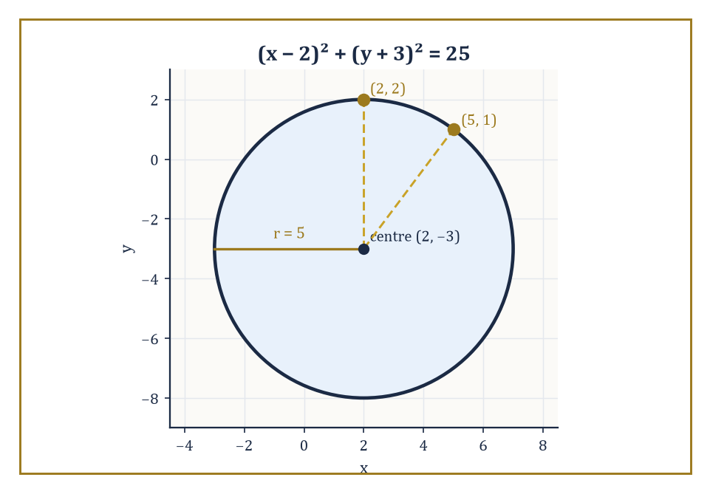
The circle (x−2)² + (y+3)² = 25, with the two checked points sitting obediently on its rim.
(x−h)²+(y−k)²=r²
This is the distance formula from the previous room, squared to avoid an unnecessary square root, and set equal to a constant.
Numeric example — Worked example. The circle with centre (2,−3) and radius 5 has equation
(x−2)²+(y+3)²=25
Check the point (2,2):
(2−2)²+(2+3)²=0+25=25 ✓
so it lies on the circle. Check (5,1):
(5−2)²+(1+3)²=9+16=25 ✓
Also on the circle, and incidentally the same 3-4-5 triangle from Room 22.1 turning up again, this time as the radius itself rather than a chord.
A circle rarely arrives pre-packaged in centre-radius form; it more often turns up as a general equation
x²+y²+Dx+Ey+F=0
and the job of recovering the centre and radius is completing the square in x and in y separately.
(x−h)²+(y−k)²=r²
The process either succeeds in producing this form with r²>0 (a genuine circle), or reveals r²=0 (the locus is a single point), or reveals r²<0 (the locus is empty — a circle of imaginary radius, which is a beautiful piece of algebra describing absolutely nothing in the real plane).
Numeric example — Worked example. Take
x²+y²−4x+6y−3=0
Group and complete the square:
(x²−4x) + (y²+6y) = 3
Completing each square:
x²−4x+4=(x−2)², adding 4
y²+6y+9=(y+3)², adding 9
Add the same 4+9=13 to the right side:
(x−2)²+(y+3)² = 3+13 = 16
So the centre is (2,−3) and the radius is √16=4 — the same centre as the previous example, but a different circle.
Nothing about this procedure minds an extra variable. In three dimensions, the general equation
x²+y²+z²+Dx+Ey+Fz+G=0
completes the square in exactly the same way to give
(x−h)²+(y−k)²+(z−l)²=r²
the equation of a sphere of radius r centred at (h,k,l).
Numeric example — Worked example. Take
x²+y²+z²−2x+4y−6z+5=0
Complete each square:
x²−2x+1=(x−1)², adding 1
y²+4y+4=(y+2)², adding 4
z²−6z+9=(z−3)², adding 9
So the equation becomes
(x−1)²+(y+2)²+(z−3)² = −5+1+4+9 = 9
The centre is (1,−2,3) and the radius is √9=3.
Some surfaces are best understood as something simpler dragged or spun through space. A cylinder is a plane curve extended uniformly along a perpendicular direction; the circular cylinder
x²+y²=r²
(with z left completely unconstrained) is simply the circle of radius r in the xy-plane, copied at every height.
A cone is obtained by joining every point of a curve to a fixed apex by straight lines; the right circular cone
x²+y²=z²
is generated by lines through the origin at a constant angle to the z-axis.
A surface of revolution, more generally, is formed by rotating a plane curve about an axis; slicing any of these surfaces with a well-chosen plane is precisely how the ancient Greeks first produced the conic sections, which is where the next room picks up the story.
Numeric example — Worked example. Take the line z=y in the yz-plane (for y≥0) and rotate it about the z-axis. A point at parameter y=1 (so z=1) sweeps out, at rotation angle θ, the point (cos θ, sin θ, 1) — a circle of radius 1 at height 1. Check this lies on x²+y²=z²:
cos²θ+sin²θ = 1 = 1² ✓, for every θ
The rotated line has produced exactly the cone x²+y²=z², regardless of which value of θ we chose — which is the whole point of a surface of revolution: every rotational copy of the generating curve satisfies the same equation.
Every horizontal slice of the cone x²+y²=z² is itself a circle, and it is worth checking how that circle's radius depends on height, since exactly this kind of dependence is what will turn an oblique slice into an ellipse rather than a circle once the next room starts tilting the cutting plane.
Numeric example — Worked example. At height z=k, the cone's equation x²+y²=z² becomes
x²+y²=k², a circle of radius |k|
At z=3 this is
x²+y²=9, a circle of radius 3
at z=5 it is
x²+y²=25, a circle of radius 5
The radius grows in exact proportion to the height — double the height, double the radius — which is precisely the straight-line widening that gives a cone its familiar shape, and precisely the pattern that a tilted slicing plane will disturb in Room 22.5.
The circle equation's completing-the-square procedure can also fail gracefully rather than producing a genuine circle, and it is worth watching both failure modes happen with the same coefficients D and E, varied only in the constant term F, to see how thin the line between 'shape' and 'no shape at all' really is.
Numeric example — Worked example. Take
x²+y²−6x+8y+25=0
Complete the square:
(x−3)²−9+(y+4)²−16+25=0
i.e.
(x−3)²+(y+4)² = 9+16−25 = 0
A sum of two squares equal to zero forces both squares to be zero, so the only solution is the single point (3,−4) — a 'circle' of radius zero. Now change only the constant term to 30:
x²+y²−6x+8y+30=0
gives
(x−3)²+(y+4)² = 9+16−30 = −5
A sum of two real squares can never be negative, so this equation has no solutions at all — an empty locus, sometimes called an imaginary circle, produced by changing a single digit in the original equation.
A cylinder need not be built from a circle at all: take any plane curve and drag it uniformly along a perpendicular axis, and whatever the curve's own equation happens to be becomes the cylinder's equation unchanged, simply reinterpreted as living in one extra, unconstrained variable.
Numeric example — Worked example. Take the parabola y=x² in the xy-plane and drag it freely along the z-axis to form a parabolic cylinder, with equation y=x² (z entirely unconstrained). Check the point (2,4,7):
y=x² requires 4=2²=4 ✓
and z=7 played no role whatsoever in the check — exactly as it should not, since the cylinder contains the point (2,4,z) for every real z, not just z=7.

Room 22.5: Conic Sections: Classification and Properties
Ellipse, Parabola, Hyperbola: A Discriminating Trio
A conic section is, classically, whatever curve results from slicing a double cone with a plane — a definition that is elegant, three-dimensional, and slightly awkward to compute with. The algebraic definition is more useful in practice: a conic is the locus of a second-degree equation
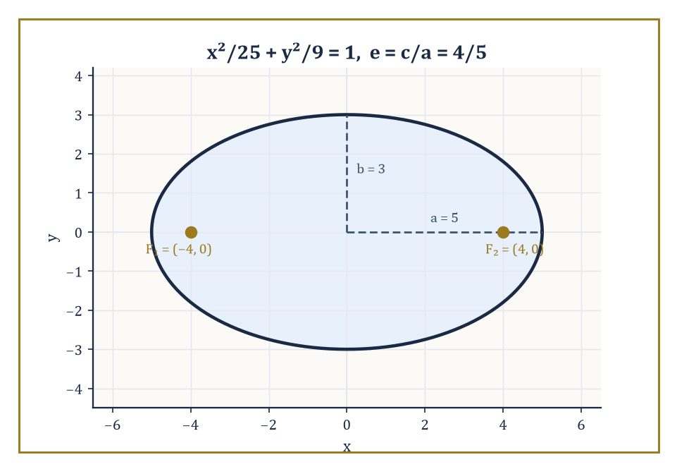
The ellipse x²/25 + y²/9 = 1, with its two foci sitting safely inside — eccentricity 4/5, fairly elongated as ellipses go.
ax²+bxy+cy²+dx+ey+f=0
The type of curve this describes — ellipse, parabola, or hyperbola — is read off from the discriminant b²−4ac: negative for an ellipse, zero for a parabola, positive for a hyperbola (with a short list of degenerate cases — a point, a line, a pair of lines, or nothing at all — arising when the equation factors or otherwise fails to describe a proper curve).
Numeric example — Worked example. Classify three curves by their discriminant. First, consider the curve
4x²+9y²−36=0
Here a=4, b=0, c=9, so
b²−4ac = 0−4(4)(9) = −144 < 0
an ellipse (indeed x²/9+y²/4=1, semi-axes 3 and 2). Second, consider
y²−4x=0
Here a=0 (no x² term), b=0, c=1, so
b²−4ac = 0−0 = 0
a parabola (this is the familiar y²=4x). Third, consider
x²−y²−1=0
Here a=1, b=0, c=−1, so
b²−4ac = 0−4(1)(−1) = 4 > 0
a hyperbola (the standard x²−y²=1).
Beyond the bare classification, each conic carries a geometric personality captured by its eccentricity e — the ratio, in the focus-directrix definition, of distance to a fixed point (the focus) over distance to a fixed line (the directrix).
Circles have e=0; ellipses have 0<e<1; parabolas sit exactly at e=1; hyperbolas have e>1.
Each type also carries a reflective property that makes it useful rather than merely pretty: an ellipse reflects rays from one focus to the other (the principle behind whispering galleries), a parabola reflects rays parallel to its axis through a single focus (the principle behind satellite dishes and car headlights), and a hyperbola reflects rays aimed at one focus away from the other.
Numeric example — Worked example. For the ellipse
x²/25+y²/9=1
we have a²=25 and b²=9, so a=5 and b=3. The focal distance satisfies
c²=a²−b²=25−9=16
so c=4. The eccentricity is
e=c/a=4/5=0.8
— fairly elongated, as ellipses go — and the foci sit at (±4,0), safely inside the ellipse, exactly as the focus-directrix definition requires.
Hyperbolas work the same way, save for a change of sign in the relationship between a, b, and c: since a hyperbola's two arms flare outward forever rather than closing into a loop, the defining relation becomes
c²=a²+b²
rather than the ellipse's c²=a²−b², and the eccentricity always comes out greater than 1.
Numeric example — Worked example. For the hyperbola
x²/9−y²/16=1
we have a²=9 and b²=16, so a=3 and b=4. Here
c²=a²+b²=9+16=25
so c=5. The eccentricity is
e=c/a=5/3≈1.67
comfortably above 1, and the foci sit at (±5,0) — this time outside the curve's own vertices at (±3,0), since a hyperbola's foci lie beyond where the curve itself ever reaches.
When the cross term bxy is present, the conic's axes are tilted relative to the coordinate axes, and a rotation of coordinates removes the tilt: choosing the rotation angle correctly makes the xy-term vanish in the new coordinates.
A subsequent translation, completing the square as in the previous room, then reduces the equation to one of the standard forms.
Both steps are, once again, linear algebra in disguise: the quadratic terms ax²+bxy+cy² correspond to a symmetric 2×2 matrix, the rotation that eliminates the cross term is exactly the orthogonal matrix that diagonalises it, and the diagonal entries after rotation are its eigenvalues.
Numeric example — Worked example. Consider the equation
xy=1
an equation with an obvious cross term and no x² or y² term at all. Rotate axes by 45°, substituting
x=(x′−y′)/√2 and y=(x′+y′)/√2
(the standard 45° rotation formulas). Then
xy = [(x′−y′)/√2]·[(x′+y′)/√2] = (x′²−y′²)/2
The equation xy=1 becomes
(x′²−y′²)/2=1, i.e. x′²−y′²=2
— a hyperbola in standard form, with its axes now aligned with the new x′ and y′ axes rather than sitting at 45° to them, as the original x and y axes were.
The focus-directrix definition is easiest to see in its purest form on a parabola, where there is only one focus and one directrix to keep track of, rather than the two of each that an ellipse or hyperbola requires.
Numeric example — Worked example. The parabola
y²=4x
has focus (1,0) and directrix x=−1 (the standard form y²=4px has p=1 here). Take the point (1,2) on the curve — check it satisfies the equation:
2²=4=4(1) ✓
Its distance to the focus (1,0) is
√((1−1)²+(2−0)²) = √4 = 2
Its distance to the directrix x=−1 is the horizontal gap
1−(−1) = 2
The two distances agree, exactly as the focus-directrix definition of a parabola requires — every point on the curve is equidistant from a fixed point and a fixed line.
The same threefold classification reappears well outside pure geometry: orbits under an inverse-square force (planets, comets, the occasional ambitious spacecraft) are always conic sections, with the type determined by the total energy of the orbit — negative energy gives an ellipse, zero gives a parabola, positive gives a hyperbola.
Perspective drawing, too, projects circles into ellipses as a matter of course, which is why a coin sketched at an angle always ends up looking suspiciously like an ellipse rather than a circle, no matter how carefully the artist rounds it.

Room 22.6: The General Second-Degree Equation
One Matrix to Rule Them All (the 2×2 Kind, At Least)
The previous room's rotation trick generalises into a full algorithm. Write the quadratic part ax²+bxy+cy² as the matrix expression xᵀAx, where x=(x,y) and A is the symmetric matrix
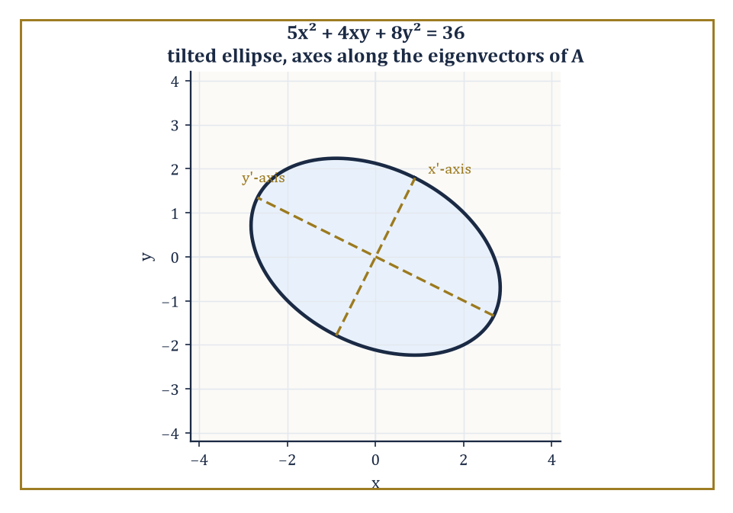
5x² + 4xy + 8y² = 36, tilted in the xy-plane but perfectly upright once you look along its own eigenvectors.
A = [[a, b/2], [b/2, c]]
Note the cross-term coefficient is split evenly between the two off-diagonal entries, so that the matrix is symmetric and xᵀAx correctly reproduces bxy when the off-diagonal contributions are added together. Since A is symmetric, the spectral theorem (Storey 21, and not for the last time) guarantees it can be diagonalised by an orthogonal matrix — a rotation — whose columns are the eigenvectors of A.
In the rotated coordinates the cross term is gone, and the quadratic part becomes
λ₁x′² + λ₂y′²
for the eigenvalues λ₁,λ₂. A subsequent translation completes the square in each variable, exactly as before, to reach a standard form or a degenerate one.
Numeric example — Worked example. Classify the conic given by
5x²+4xy+8y²=36
The associated symmetric matrix is
A=[[5,2],[2,8]]
since the cross-term coefficient 4 splits into 2 and 2. Its eigenvalues solve det(A−λI)=0, which expands as follows.
(5−λ)(8−λ)−4=0
40−13λ+λ²−4=0
λ²−13λ+36=0
By the quadratic formula,
λ=(13±√(169−144))/2=(13±√25)/2=(13±5)/2
giving λ=9 or λ=4. As a check: the trace of A is 5+8=13, and 9+4=13 ✓; the determinant of A is 5·8−2·2=36, and 9·4=36 ✓. In the rotated coordinates the equation becomes
9x′²+4y′²=36, i.e. x′²/4+y′²/9=1
an ellipse with semi-axes 2 and 3, its tilt in the original x,y coordinates now completely accounted for by the eigenvectors of A.
The parabolic case corresponds to one of the two eigenvalues vanishing outright: the quadratic form is degenerate in one direction, which is exactly why a parabola opens up indefinitely rather than closing into a bounded curve the way an ellipse does.
Numeric example — Worked example. Rewrite y²=4x as
y²−4x=0
with a=0 (coefficient of x²), b=0, c=1 (coefficient of y²). The matrix is
A=[[0,0],[0,1]]
already diagonal, with eigenvalues simply its diagonal entries, 0 and 1. The zero eigenvalue is the matrix-theoretic fingerprint of the parabolic type, agreeing exactly with the discriminant test from Room 22.5:
b²−4ac=0−4(0)(1)=0
The pleasant surprise is that one need not actually perform the rotation to classify the conic. Certain combinations of the coefficients are invariant under rigid motions — they do not change when the coordinate axes are rotated or translated — and these invariants alone determine the type.
The trace and determinant of the 2×2 matrix A determine the eigenvalues (hence whether the conic is an ellipse, parabola, or hyperbola), while the determinant of the full 3×3 matrix built from all the coefficients (quadratic, linear, and constant) determines whether the conic is degenerate.
Exactly the same programme — bigger matrices, same idea — classifies quadric surfaces in space, which is where the next room is headed.
Numeric example — Worked example. For
5x²+4xy+8y²−36=0
(no linear terms, for simplicity), the full 3×3 matrix, with rows and columns ordered (x,y,1), is
[[5, 2, 0], [2, 8, 0], [0, 0, −36]]
Its determinant, expanding along the bottom row, is
(−36)·det[[5,2],[2,8]] = (−36)·(40−4) = (−36)(36) = −1296
which is nonzero — confirming the conic is non-degenerate, consistent with the genuine ellipse found in the previous example. Had this determinant come out to be zero, the equation would have described a degenerate conic — a point, a line, or a pair of lines — rather than a proper curve.
It is worth seeing a genuinely degenerate case up close, since the classification machinery handles it just as gracefully as it handles honest curves.
When the second-degree equation factors into two linear expressions, the ‘conic’ is nothing but a pair of intersecting (or parallel, or coincident) lines — a limiting case the ancient Greeks would have politely declined to call a conic section at all, but which the algebra cannot help producing.
Numeric example — Worked example. Take
x²−4y²=0
This factors directly.
x²−4y² = (x−2y)(x+2y)
So the equation
(x−2y)(x+2y)=0
holds exactly when x−2y=0 or x+2y=0 — two straight lines through the origin, y=x/2 and y=−x/2. Checking with the matrix machinery:
A=[[1,0],[0,−4]]
already diagonal, no rotation needed, with eigenvalues 1 and −4 — one positive, one negative, which is exactly the ellipse/hyperbola-type signature, except that the constant term is zero, so the ‘hyperbola’ has degenerated to its own pair of asymptotes. The invariant test (the 3×3 determinant, here built from A and a zero constant row) comes out to zero, correctly flagging degeneracy.
The full invariant test can even distinguish a genuine ellipse from its empty, purely imaginary twin — a distinction the eigenvalues alone cannot make, since two equations can share identical quadratic terms, and hence identical eigenvalues, while describing entirely different loci.
The difference lives in the sign of the constant term relative to those eigenvalues, which is exactly what the diagonalised form makes transparent.
Numeric example — Worked example. Compare
5x²+4xy+8y²=36
diagonalised earlier to
9x′²+4y′²=36, i.e. x′²/4+y′²/9=1
a genuine ellipse — with the equation
5x²+4xy+8y²=−36
which has exactly the same quadratic part and hence the same eigenvalues 9 and 4. Diagonalised, this becomes
9x′²+4y′²=−36
But the left-hand side, a sum of two non-negative terms (since 9 and 4 are both positive and squares are non-negative), can never be negative. The equation has no real solutions whatsoever: an empty locus produced by nothing more than flipping the sign of the constant term.

Room 22.7: Quadric Surfaces in Space
The Conic Sections Grow Up and Move to Three Dimensions
A quadric surface is the three-dimensional generalisation of a conic section: the locus of a second-degree equation in three variables.
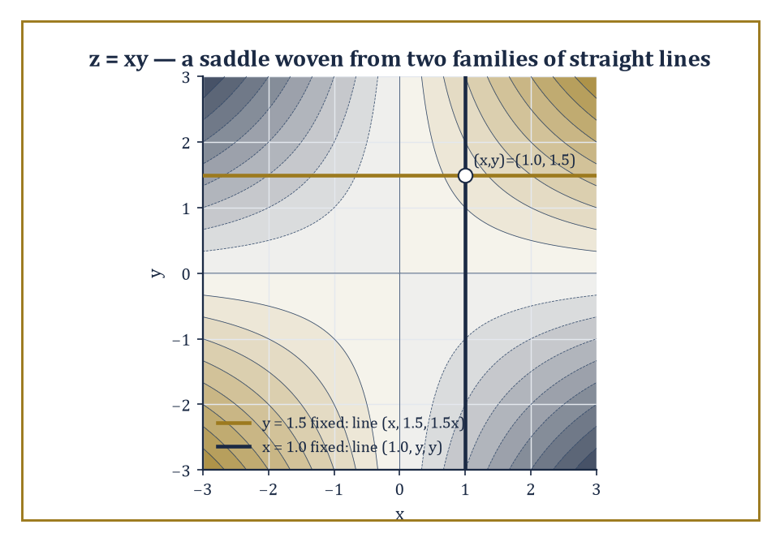
z = xy shown as a contour map, with the two straight generating lines through one point — a curved saddle built from nothing but straight beams.
The standard catalogue — every non-degenerate quadric is, after a suitable rotation and translation, one of these — comprises the ellipsoid, the hyperboloid of one sheet, the hyperboloid of two sheets, the elliptic paraboloid, the hyperbolic paraboloid, the (elliptic) cone, and the various cylinders.
Each has a normal form reached exactly as in the planar case: rotate coordinates to diagonalise the quadratic part, then translate to simplify or eliminate the linear terms.
Numeric example — Worked example. Consider the ellipsoid below, which has semi-axes 2, 3, and 4 along the x, y, and z directions respectively.
x²/4+y²/9+z²/16=1
Check the point (2,0,0):
4/4+0+0=1 ✓
the ‘tip’ of the ellipsoid along the x-axis. Check (0,3,0):
0+9/9+0=1 ✓
the tip along the y-axis. Now check that (2,3,4) is NOT on the surface, despite being made of exactly the three semi-axis lengths:
4/4+9/9+16/16=1+1+1=3≠1
— a useful reminder that the semi-axes are where the ellipsoid meets each axis individually, not a point you can combine freely.
The hyperboloids differ from the ellipsoid by a single sign, with dramatic consequences for their shape.
A hyperboloid of one sheet is a single connected surface that pinches in toward a waist and flares outward in both directions along the z-axis — think of a power-station cooling tower.
x²/a²+y²/b²−z²/c²=1
A hyperboloid of two sheets is the opposite: two separate bowl-shaped surfaces, one for x≥a and one for x≤−a, with a genuine gap between them where no real points exist at all.
x²/a²−y²/b²−z²/c²=1
Numeric example — Worked example. Consider the one-sheet hyperboloid below.
x²/4+y²/9−z²/16=1
Check the point (2,0,0):
4/4+0−0=1 ✓
on the surface. At height z=4, the equation becomes:
x²/4+y²/9=1+16/16=2
an ellipse of larger size than the waist ellipse at z=0 — confirming the surface flares outward, but never breaks into two pieces, as z ranges over all real numbers. Now consider the two-sheet hyperboloid:
x²/4−y²/9−z²/16=1
At x=0, the equation reads:
−y²/9−z²/16=1
impossible for real y,z since the left side is never positive — confirming there are no points with x=0, i.e. a genuine gap. At x=2, it reads:
1−y²/9−z²/16=1
forcing y=z=0 — the single point (2,0,0), the very tip of the nearer sheet.
The elliptic paraboloid is a bowl:
z=x²/a²+y²/b²
The hyperbolic paraboloid is the celebrated saddle shape, curving upward in one direction and downward in the perpendicular direction:
z=x²/a²−y²/b²
Two members of this catalogue carry a further surprise: the hyperboloid of one sheet and the hyperbolic paraboloid are ruled surfaces, meaning that despite their curved appearance, they are entirely covered by straight lines — a fact exploited by architects, who can build a curved-looking roof out of nothing but straight beams.
Abstract example — Worked example. Take the hyperbolic paraboloid below (a rescaled version of the standard form).
z=xy
Fix x at a constant value a: the equation becomes:
z=ay
which — as y varies with x held fixed at a — traces out the straight line {(a, y, ay) : y∈ℝ} in three-dimensional space. Check this satisfies z=xy:
z=ay and xy=a·y=ay ✓
for every y. Symmetrically, fixing y=b gives the line {(x, b, bx) : x∈ℝ}, since:
z=bx=xy when y=b
Through every point of the surface there pass two such straight lines — one from each family — which is exactly why a hyperbolic paraboloid can be built from a lattice of straight steel beams and still look like a saddle.
The classification of a quadric proceeds exactly as for conics, with one dimension added throughout: the eigenvalues of the 3×3 symmetric matrix of quadratic terms determine which of the standard shapes is present, and the rank of the full 4×4 matrix (quadratic, linear, and constant terms together) determines whether the quadric is degenerate.
Quadric surfaces are not merely a museum exhibit, either: they appear as wave fronts in physics, as equipotential surfaces around charge distributions, and — perhaps most usefully for anyone destined for later storeys on optimisation and statistics — as the level sets of quadratic functions, where a positive-definite matrix of second derivatives produces an ellipsoid (a well-behaved bowl with a single minimum) and an indefinite matrix produces a saddle-shaped hyperbolic paraboloid (a stationary point that is neither a maximum nor a minimum, and considerably more annoying to optimise near).
Numeric example — Worked example. Consider the function:
f(x,y)=2x²+3y²
Its matrix of second derivatives (Hessian) is [[4,0],[0,6]], with eigenvalues 4 and 6, both positive — a positive-definite matrix — and the level sets f(x,y)=k for k>0 are ellipses:
2x²+3y²=k
nested around the single minimum at the origin, f(0,0)=0. Contrast this with:
g(x,y)=x²−y²
Hessian [[2,0],[0,−2]], eigenvalues 2 and −2 (one of each sign, an indefinite matrix): the origin is a saddle point, g increases as x moves away from 0 but decreases as y moves away from 0, and the level sets g(x,y)=k are hyperbolas for k≠0 — the same shape catalogue from conic sections, now doing useful work diagnosing whether a stationary point is a comfortable minimum or a treacherous saddle.

Room 22.8: Transformations and Invariants
What Survives the Trip: A Traveller's Guide to Invariants
Rigid motions — rotations, translations, reflections, and their combinations — act on an equation by substitution: replace x by its expression in the new coordinates, and the equation transforms accordingly.
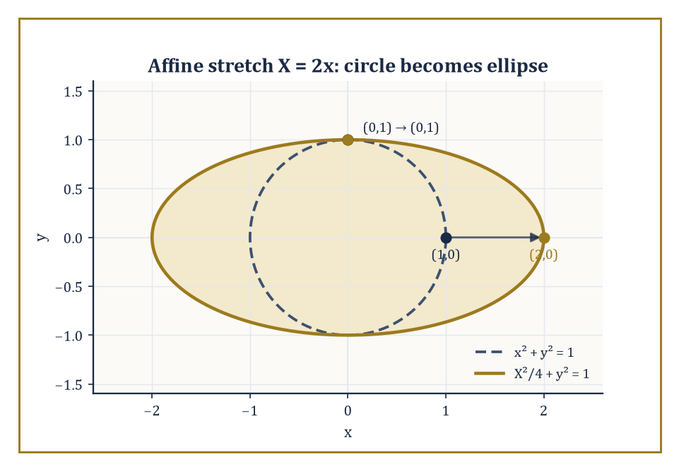
An affine stretch turns the unit circle into an ellipse — roundness lost, but the shape's status as a bounded conic survives the trip.
Because rigid motions preserve distances and angles, they preserve the geometric character of a locus outright: a circle stays a circle, an ellipse stays an ellipse of the same shape (though possibly relocated and reoriented).
This preserved character is exactly what the invariants of Rooms 22.6 and 22.7 — the trace, determinant, and rank of the associated matrices — are built to detect, without needing to watch the transformation happen.
Numeric example — Worked example. Consider the circle
x²+y²=25
centred at the origin with radius 5. Translate it by (3,−2) — substitute x→x−3, y→y+2 to shift the centre to (3,−2) — giving
(x−3)²+(y+2)²=25
Check a point: (5,0) was on the original circle since
5²+0²=25
Its translated image is (5+3, 0−2)=(8,−2); check
(8−3)²+(−2+2)²=5²+0²=25 ✓
confirming the point moved rigidly with the whole curve, radius and shape completely unchanged.
Affine transformations are a notch more general still than rigid motions — they allow stretching along the axes as well as rotating and translating — and they preserve straightness and parallelism, though no longer distances or angles.
A circle need not stay a circle under an affine transformation, but it always becomes an ellipse, since the transformation remains linear on the quadratic part of the equation.
Numeric example — Worked example. Apply the stretch that doubles every x-coordinate and leaves y alone,
X=2x
to the circle
x²+y²=1
Substituting x=X/2 gives
(X/2)²+y²=1, i.e. X²/4+y²=1
an ellipse with semi-axes 2 and 1. Check the point (1,0) on the original circle: it maps to X=2(1)=2, giving (2,0); substitute into
X²/4+y²=4/4+0=1 ✓
Check (0,1): it maps to X=2(0)=0, giving (0,1); substitute:
0+1=1 ✓
The circle's roundness did not survive the stretch, but its status as a bounded, closed conic did.
Rigid motions are a fairly conservative group of transformations — they cannot turn an ellipse into a hyperbola, since the discriminant's sign is a rigid-motion invariant.
Enlarge the group to include projective transformations, however, and the distinctions start to dissolve: every non-degenerate conic — ellipse, parabola, hyperbola alike — becomes projectively equivalent to every other.
The tool that makes this precise is homogeneous coordinates: represent the point (x,y) by the triple [x:y:1], and more generally identify any two triples [X:Y:Z] and [λX:λY:λZ] (λ≠0) as the same point.
The projective plane becomes, in effect, the vector space ℝ³ with scaling forgotten — and linear algebra, once again, supplies the entire language.
Abstract example — Worked example. Homogenise the circle
x²+y²=1
by substituting x=X/Z, y=Y/Z and clearing denominators:
X²+Y²=Z²
At infinity, where Z=0, this forces
X²+Y²=0
whose only real solution is X=Y=0 — not a valid projective point (the triple [0:0:0] is excluded by definition), so the circle has no real points at infinity at all.
Now homogenise the hyperbola
x²−y²=1
the same way:
X²−Y²=Z²
At infinity, Z=0 gives
X²=Y², so X=±Y
— two genuine points at infinity, [1:1:0] and [1:−1:0]. These are exactly the directions of the hyperbola's two asymptotes, y=x and y=−x, now revealed as the points where the curve 'reaches' infinity.
The ellipse and the hyperbola, so different as real curves, are distinguished projectively only by how many real points of the line at infinity they happen to pass through — nought for the ellipse, two for the hyperbola.
A quick check would show the same for the parabola
y²=4x
whose homogenisation is
Y²=4XZ, giving Y²=0 at Z=0
a single repeated point [1:0:0] — exactly one, with multiplicity two, for the parabola sitting exactly on the boundary between the two cases.
Two further projective notions round out the picture and will resurface, transformed almost beyond recognition, much later in the Tower: the cross ratio, a numerical quantity attached to four collinear points that survives projective transformations even though individual distances and ratios of distances do not.
And poles and polars, a duality that pairs points with lines relative to a given conic, exchanging incidence for incidence in a way that turns every theorem about points into a theorem about lines, free of charge.
Together with the projective classification of quadric surfaces — which follows the same rank-and-signature logic as Room 22.7, now up to the larger projective group — these ideas form a natural bridge toward algebraic geometry, the subject of higher-degree curves and surfaces that Storey 22 has spent its whole length preparing the ground for.
Numeric example — Worked example. For four collinear points A, B, C, D with coordinates a, b, c, d measured along the line, the cross ratio is defined as
(A,B;C,D) = [(c−a)(d−b)] / [(c−b)(d−a)]
Take a=0, b=1, c=3, d=6.
(c−a)=3, (d−b)=5
so the numerator is
3·5=15
and
(c−b)=2, (d−a)=6
so the denominator is
2·6=12
The cross ratio is
15/12 = 5/4
This single number — 5/4 — depends only on how the four points sit relative to one another, and it is a theorem of projective geometry (the details of which take more machinery than fits in this room) that it stays exactly 5/4 under any projective transformation of the line, however drastically the individual gaps between the points are stretched or shrunk in the process.
Numeric example — Worked example. For the circle
x²+y²=9
(radius 3), the polar line of the external point P=(5,0) is found by the standard substitution rule
x·5+y·0=9, i.e. x=9/5
This vertical line is the polar of P; geometrically, it passes through the two points where the tangent lines from P touch the circle. Check it is sensible: the point (9/5, y) lies on the circle when
(9/5)²+y²=9
i.e.
y²=9−81/25=(225−81)/25=144/25, so y=±12/5
— two real touching points, exactly as expected since P=(5,0) lies outside the circle (distance 5 from the centre, greater than the radius 3).

Room 22.9: Looking Ahead: From Analytic Geometry to Differential Geometry and Algebraic Geometry
The View From the Top Floor of This Particular Storey
We have now acquired the basic vocabulary of analytic geometry: coordinate descriptions of lines and planes, distance and angle formulas built from dot products, circles and spheres from completed squares, conic sections and quadric surfaces classified by the eigenvalues of a symmetric matrix, and — in the last room — a first glimpse of the projective plane, where even the difference between an ellipse and a hyperbola becomes a question of how many points at infinity one is willing to count.
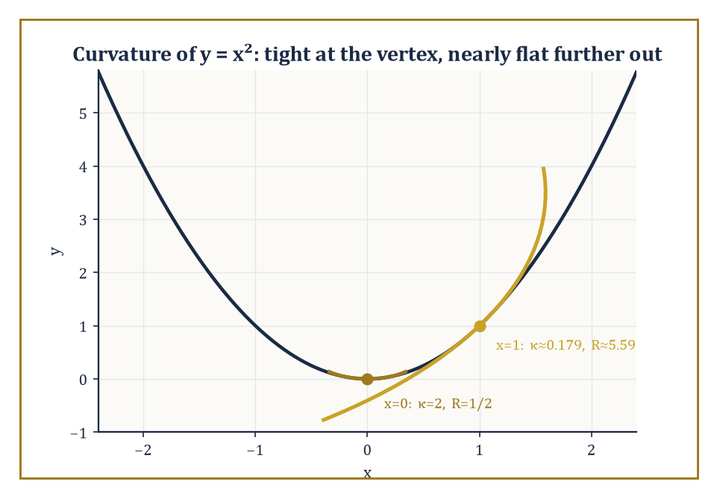
The parabola y = x², hugged by two osculating circles — tightly curved at the vertex, almost forgetting it is curved at all further along.
These tools are the foundation of later geometric subjects, and it is worth naming the two most direct descendants. Differential geometry, first, replaces the global algebraic equation of a curve or surface with a local parametrisation — a description of the surface piece by piece, as the image of a map from a flat parameter domain.
It studies differential invariants such as curvature (how sharply a curve bends) and torsion (how much a space curve twists out of its own osculating plane) that no single algebraic equation captures directly.
Numeric example — Worked example. A circle of radius r has constant curvature at every point — the sharper the bend, the smaller the circle, the larger the curvature.
κ=1/r
Take r=2:
κ=1/2
This holds everywhere on the circle, with no exceptions. Contrast this with the parabola y=x², whose curvature at a point is given by
κ=|y″|/(1+y′²)^(3/2)
with y′=2x and y″=2. At the vertex x=0:
κ=2/(1+0)^1.5=2/1=2
At x=1: y′=2, so
κ=2/(1+4)^1.5=2/5^1.5=2/(5√5)≈2/11.18≈0.179
The parabola's curvature has dropped by more than a factor of ten between these two points — it is sharply curved at its vertex and flattens out rapidly further along, a genuinely local piece of information that the single global equation y=x² does not display without this extra calculation. This is precisely the kind of quantity — varying from point to point rather than fixed for the whole curve — that differential geometry is built to track.
Algebraic geometry, second, keeps the coordinate method of this storey but drops the restriction to degree two. A conic meets a line in at most two points (count them with multiplicity, over the complex numbers, and it is always exactly two); a cubic curve — degree three — meets a line in up to three points, a quartic in up to four, and so on, a pattern formalised by Bézout's theorem.
The zoo of shapes available at degree three alone (nodes, cusps, and the elliptic curves that underpin large parts of modern cryptography) already dwarfs the three-item catalogue — ellipse, parabola, hyperbola — that occupied most of this storey.
Abstract example — Worked example. Take the cubic curve y²=x³−x and intersect it with the line y=0. Setting y=0 gives
0=x³−x=x(x²−1)=x(x−1)(x+1)
with three roots x=0,1,−1 — three real intersection points, (0,0), (1,0), (−1,0), matching the degree of the cubic exactly. Compare with a conic, say the circle x²+y²=4 intersected with the line y=0:
x²=4, giving only x=±2
— two points, matching the conic's degree of two. The pattern (degree of curve = number of intersection points with a generic line) is Bézout's theorem in its simplest instance, and it is the organising principle of the entire subject that algebraic geometry becomes once the degree is allowed to climb past two.
Computational geometry, a third and more recent descendant, takes the same objects — points, lines, circles, polygons — and asks not what their equations are but how efficiently a computer can decide questions about them: does this point lie inside that polygon, do these two line segments cross, what is the smallest convex shape containing a given cloud of points.
The algebra developed in this storey — the sign of a determinant deciding which side of a line a point falls on, for instance — is exactly the machinery such algorithms are built from underneath their loops and data structures.
Numeric example — Worked example. To decide whether a point C=(x₃,y₃) lies to the left or right of the directed line through A=(x₁,y₁) and B=(x₂,y₂), compute the sign of the determinant
D = (x₂−x₁)(y₃−y₁) − (y₂−y₁)(x₃−x₁)
Take A=(0,0), B=(4,0), C=(2,3):
D = (4−0)(3−0) − (0−0)(2−0) = 12 − 0 = 12 > 0
so C lies to the left of the directed line from A to B (travelling along the positive x-axis, 'left' means positive y, which C indeed has). This one-line determinant test, run millions of times per second, is the entire basis of computational-geometry routines for convex hulls, polygon triangulation, and line-segment intersection — the algebra of this storey, doing manual labour.
The deeper lesson, buried under all the formulas, is that geometry and algebra are two languages for the same underlying relationships, and that fluency in both is considerably more powerful than fluency in either alone — a geometric picture supplies intuition an equation alone would not volunteer, and an algebraic derivation supplies certainty a picture alone cannot guarantee.
Analytic geometry is the classical meeting ground where the two languages were first made to speak fluently to each other, and every subject built on top of it in the storeys still to come — differential geometry, algebraic geometry, and considerably further afield — is, at bottom, still having that same conversation.
So much, then, for turning shapes into equations and equations back into shapes. We have lines and planes reduced to linear conditions, circles and spheres reduced to a norm equalling a constant, conics and quadrics reduced to the eigenvalues of a symmetric matrix, and — right at the end — a glimpse of the projective plane, where even the distinction between an ellipse and a hyperbola turns out to be a matter of how many points at infinity you are prepared to count as real.
There is a pleasing symmetry in where the Tower goes next. This storey took the plane ℝ² — two independent real coordinates, dutifully kept apart, one for x and one for y — and taught it to carry circles, conics, and quadratic forms. Storey 23 takes the very same plane and performs a small act of arithmetic sorcery: it declares that the second coordinate is not a second number at all, but an imaginary partner to the first, glued on by i² = −1, and that the resulting single complex number z = x + iy can be differentiated, integrated, and reasoned about with a rigidity that real functions of two variables can only envy. Coordinates got us this far by brute algebraic force; complex analysis is about to show what happens when geometry and algebra stop merely cooperating and start conspiring.
Onward, then — same plane, new rules, considerably stranger consequences.

Storey 23: Complex Analysis
Holomorphic Functions, Contours, and the Art of Calculus in the Complex Plane
The last storey left us bending lines into ellipses and teaching coordinates to gossip about angles, all the while confined to the real line's dreary, one-dimensional honesty. We now do something reckless: we invent a number whose entire personality is that it is the square root of −1, bolt it onto the real numbers, and see what happens. What happens, it turns out, is one of the most astonishing plot twists in the whole Tower. On the real line, being differentiable is a fairly modest achievement — smooth enough not to have a corner, roughly speaking. On the complex plane, the same-looking definition turns out to be almost absurdly demanding, and a function that satisfies it is rewarded with an entire cascade of miracles it did nothing to deserve.
That is the theme of this storey, so let us state it plainly before we start proving anything: a function that is complex-differentiable just once, at every point of an open set, is automatically differentiable infinitely often there, equals its own Taylor series near every point, integrates to zero around every closed loop it bounds, and has its values on the interior of a region entirely determined by its values on the boundary. None of this is true for real-differentiable functions, which can be as badly behaved as they like the moment you look away. Complex analysis is the storey in which a mathematician first gets the distinct, slightly suspicious feeling that a theory is too good to be true. The feeling is half right. The theorems really are that strong. But they are also, provably, entirely true — the rigidity is forced by the geometry of the plane, not smuggled in by a hopeful author.
We will climb from the algebra of complex numbers and the geometry of the plane, through the Cauchy–Riemann equations that define holomorphic (complex-differentiable) functions, into contour integration and Cauchy's theorem — the single fact from which nearly everything else in this storey descends like obedient dominoes. From there: power series, Laurent series, singularities, residues, and the practical business of using all this machinery to evaluate real integrals that resist every method from earlier storeys. We finish with conformal mapping, harmonic functions, and a glance up the stairwell towards Riemann surfaces.
One last piece of throat-clearing. Everything here is, in a sense, a variation on a single idea: differentiability in two real dimensions, done the complex way rather than the multivariable-calculus way, is a far more exclusive club than it looks. Membership is hard to get and extraordinarily generous once granted. Let's go and meet the doorman.

Room 23.1: Complex Numbers and the Complex Plane
In which we invent a number whose only job is to be its own negative square root
A complex number is an expression a + bi, where a and b are ordinary real numbers and i is a new symbol obeying the rule
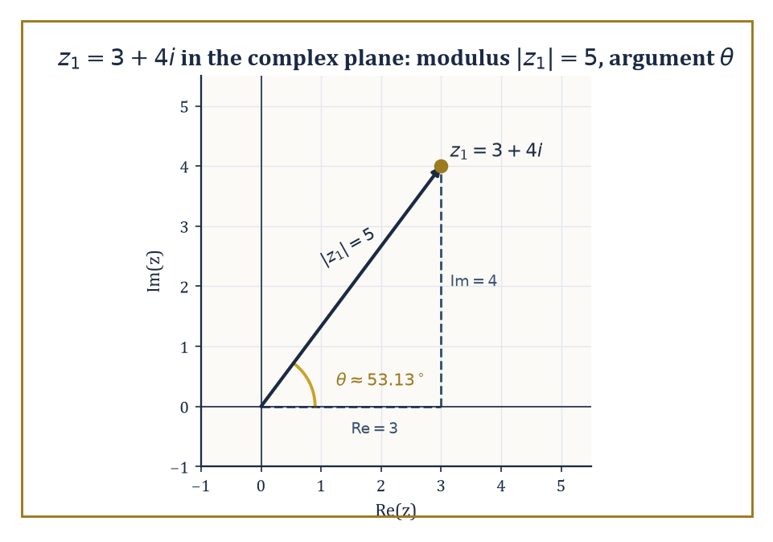
z₁ = 3 + 4i plotted with its modulus, argument, and the 3-4-5 triangle hiding underneath the algebra.
i² = −1
Descartes coined the word ‘imaginary’ for such numbers, meaning it as an insult; the name stuck, rather unfairly, because these numbers turned out to be indispensable to nearly every branch of mathematics and physics that came after him.
The set of complex numbers, written ℂ, forms a field: you can add, subtract, multiply, and divide (by anything nonzero) using the ordinary rules of algebra, with the single extra fact i² = −1 thrown in whenever it's needed.
Addition is done componentwise:
(a + bi) + (c + di) = (a + c) + (b + d)i
Multiplication follows the distributive law and then simplifies using i² = −1:
(a + bi)(c + di) = (ac − bd) + (ad + bc)i
A complex number a + bi is visualised as the point (a, b) in a plane — the real part a is the horizontal coordinate, the imaginary part b the vertical one — so ℂ is, geometrically, just the ordinary Cartesian plane with a multiplication rule bolted on.
Numeric example — Worked example: arithmetic in ℂ. Let z₁ = 3 + 4i and z₂ = 1 − 2i.
Addition:
z₁ + z₂ = (3 + 1) + (4 − 2)i = 4 + 2i
Multiplication:
z₁z₂ = (3 + 4i)(1 − 2i) = 3(1) + 3(−2i) + 4i(1) + 4i(−2i) = 3 − 6i + 4i − 8i²
Since i² = −1, the last term −8i² becomes +8, giving:
3 + 8 − 6i + 4i = 11 − 2i
The modulus of z₁, written |z₁|, is its distance from the origin:
|z₁| = √(3² + 4²) = √25 = 5
— the classic 3-4-5 triangle, hiding in plain sight inside the algebra. The argument of z₁, written arg(z₁), is the angle its position vector makes with the positive real axis:
arg(z₁) = arctan(4/3) ≈ 53.13°
Because a complex number is a point in the plane, it is often more useful to describe it by distance and direction rather than by horizontal and vertical offset — exactly as you might give directions as ‘200 metres, north-east’ rather than ‘140 metres east and 140 metres north’.
This is the polar form, abbreviated using Euler's notation as:
z = r(cos θ + i sin θ) = re^{iθ}
where r = |z| is the modulus and θ = arg(z) is the argument.
The payoff of polar form is that it converts the fiddly business of complex multiplication into simple addition: multiplying two complex numbers multiplies their moduli and adds their arguments.
Raising a complex number to a whole-number power n, then, just multiplies the argument by n and raises the modulus to the n-th power — this is De Moivre's theorem:
(r e^{iθ})^n = r^n e^{inθ}
and it turns what looks like a tedious repeated multiplication into a single rotation-and-rescaling.
Numeric example — Worked example: De Moivre's theorem. Compute (1 + i)⁴.
First find polar form:
|1 + i| = √(1² + 1²) = √2
arg(1 + i) = 45° = π/4
(since the point (1, 1) sits on the diagonal). So:
1 + i = √2 · e^{iπ/4}
By De Moivre:
(1 + i)⁴ = (√2)⁴ · e^{i·4·(π/4)} = 4 · e^{iπ} = 4(cos π + i sin π) = 4(−1 + 0i) = −4
Check by direct multiplication:
(1 + i)² = 1 + 2i + i² = 1 + 2i − 1 = 2i
(2i)² = 4i² = −4
The two routes agree, as they must — but the polar route needed no expansion of brackets at all, only one multiplication of angles.
The most important holomorphic function in the entire storey — indeed in most of mathematics — is the complex exponential e^z, defined for z = x + iy by:
e^z = e^x(cos y + i sin y)
which is Euler's formula smuggled into a definition. Two consequences are worth sitting with.
First, e^z is periodic with period 2πi: adding 2πi to z leaves e^z unchanged, because cosine and sine have period 2π. The real exponential function has no periodicity whatsoever; the complex one is compelled to repeat itself forever along vertical strips, purely because rotating by a full turn gets you back where you started.
Second, e^z maps horizontal lines (constant y, varying x) to rays from the origin — since the argument y is fixed and the modulus e^x sweeps through all positive reals — and maps vertical lines (constant x, varying y) to circles of radius e^x centred at the origin, since now the modulus is fixed and the argument sweeps around. A rectangular grid goes in; a polar grid of rays and circles comes out.
Numeric example — Worked example: values of e^z. Compute e^{iπ/2}. Using Euler's formula with x = 0, y = π/2:
e^{iπ/2} = cos(π/2) + i sin(π/2) = 0 + i(1) = i
So raising e to a purely imaginary power π/2 lands you exactly on i — a quarter-turn around the unit circle.
Compute e^{1+iπ}. Here x = 1, y = π:
e^{1+iπ} = e¹(cos π + i sin π) = e(−1 + 0i) = −e ≈ −2.71828
This is the complex form of the identity sometimes called (with a straight face, remarkably) the most beautiful equation in mathematics:
e^{iπ} + 1 = 0
here with an extra factor of e along for the ride.
Before we can talk about differentiating functions on regions of the plane, we need the vocabulary for describing those regions, mostly borrowed and lightly modified from the topology you'll meet properly several storeys from now.
An open set is one where every point has a little disc of wiggle-room around it still inside the set (so no boundary points included). A domain is a connected open set — one piece, no islands.
A path is a continuous journey through the plane, and a domain is simply connected if every closed loop drawn inside it can be shrunk continuously down to a point without ever leaving the domain — informally, the domain has no holes.
It's worth adding one point at infinity to the plane, obtained by letting |z| → ∞ from every direction simultaneously and calling the result a single point ∞; the result is the Riemann sphere, on which even a function like f(z) = 1/z, badly behaved at the origin in the plane, becomes a perfectly continuous map (it just sends 0 to ∞ and back again).
Abstract example — Worked example: simply connected or not?. Take the open unit disc:
D = {z : |z| < 1}
Any closed loop drawn inside D can be shrunk continuously to a point (say, the centre) while staying inside D the whole time — just shrink it radially. So D is simply connected.
Now take the annulus:
A = {z : 1 < |z| < 2}
a ring-shaped region with a hole punched through its middle. A loop that winds once around the inner boundary — for instance the circle |z| = 1.5 traversed once — cannot be shrunk to a point without at some stage crossing the missing disc |z| ≤ 1, which isn't part of A. So A is not simply connected.
This distinction looks like topological housekeeping now; by Room 23.3 it will decide, quite literally, whether a contour integral is forced to vanish or is free to be anything it likes.

Room 23.2: Holomorphic Functions and the Cauchy–Riemann Equations
Where differentiability becomes an extremely exclusive members' club
A function f, defined on an open subset of ℂ, is holomorphic at a point z (the words complex-differentiable and analytic are used interchangeably, and we shall not apologise for the redundancy) if the limit f′(z) exists, where h is itself a complex number allowed to approach 0 from any direction whatsoever.
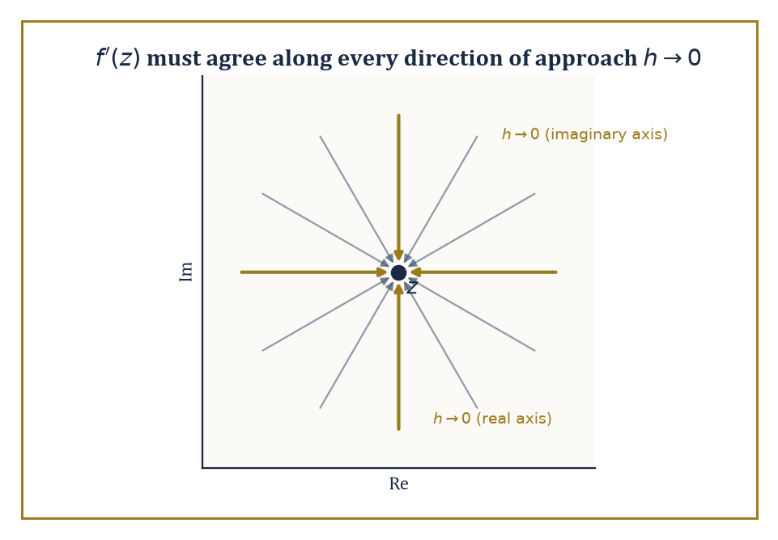
The limit defining f′(z) has to agree along every one of infinitely many directions of approach — not just the two the real line ever bothers to offer.
f′(z) = lim_{h→0} [f(z + h) − f(z)] / h
That last clause is the entire story. On the real line, h can only sneak up on 0 from the left or the right, so ‘the limit exists’ means those two one-sided limits agree — already a meaningful constraint, but only a two-way negotiation.
In the plane, h can approach 0 along any of infinitely many directions — straight in from the east, spiralling in like a moth, anything — and the definition demands the same answer from every single one of them.
It is not obvious that any non-trivial function could survive such a demand. Remarkably, an enormous and useful class of functions does.
Writing f(z) = u(x, y) + iv(x, y), where z = x + iy and u, v are the real and imaginary parts of f (each an ordinary real-valued function of two real variables), we can extract the consequence of that all-directions requirement by testing just two directions and insisting they agree.
f(z) = u(x, y) + iv(x, y)
Approach along the real axis (h real, h → 0): the difference quotient tends to u_x + iv_x, where the subscript denotes partial derivative. Approach along the imaginary axis (h = ik, k real, k → 0): the difference quotient tends to −iu_y + v_y (the extra factor of i in the denominator flips a sign when you divide it out).
For f′(z) to exist, these two must be equal:
u_x + iv_x = v_y − iu_y
Matching real and imaginary parts separately gives the Cauchy–Riemann equations:
u_x = v_y and u_y = −v_x
These two partial differential equations are the real-variable translation of ‘complex-differentiable’, and they are ferociously restrictive — two ordinary real functions u and v, chosen independently, will essentially never satisfy them both.
Numeric example — Worked example: verifying the Cauchy–Riemann equations. Let f(z) = z². Writing z = x + iy, we expand:
z² = (x + iy)² = x² + 2ixy + i²y² = (x² − y²) + i(2xy)
So u(x, y) = x² − y² and v(x, y) = 2xy.
Compute the four partials:
u_x = 2x, u_y = −2y, v_x = 2y, v_y = 2x
Check Cauchy–Riemann:
u_x = v_y becomes 2x = 2x ✓
u_y = −v_x becomes −2y = −2y ✓
Both equations hold at every point, so f(z) = z² is holomorphic everywhere (it is entire, meaning holomorphic on the whole plane).
At the specific point z = 1 + 2i (so x = 1, y = 2): u_x = 2, v_y = 2, and the derivative works out to:
f′(z) = u_x + iv_x = 2x + i(2y) = 2(x + iy) = 2z
At z = 1 + 2i this gives:
f′(1 + 2i) = 2 + 4i
This is exactly what you'd get by the ordinary power rule (z²)′ = 2z, computed the naive way. The Cauchy–Riemann machinery and the familiar calculus rule agree, as of course they must, since z² was always going to be holomorphic; the machinery earns its keep on functions where the answer isn't obvious in advance.
Holomorphic functions behave, on the whole, exactly as one hopes: sums, products, and compositions of holomorphic functions are holomorphic, quotients are holomorphic wherever the denominator is nonzero, and all the familiar differentiation rules (product rule, chain rule, and so on) carry over unchanged from real calculus.
What doesn't carry over is how rare holomorphic functions turn out to be once you go looking for them. A non-constant holomorphic function is an open map, meaning it sends open sets to open sets — it cannot, for instance, squash a whole disc down onto a line segment or a single point, the way (x, y) ↦ x can in ordinary two-variable calculus.
It also obeys the maximum-modulus principle: |f(z)| cannot attain a maximum at an interior point of a domain unless f is constant there — the modulus can only peak on the boundary, rather as a soap film stretched over a wire frame can only bulge as far as the frame allows.
And the zeros of a non-constant holomorphic function are isolated: you cannot have a whole little disc's worth of points where f vanishes without f vanishing everywhere.
Abstract example — Worked example: a function that fails Cauchy–Riemann everywhere. Let f(z) = z̄, complex conjugation:
z̄ = x − iy
Here u(x, y) = x and v(x, y) = −y.
Compute the partials:
u_x = 1, v_y = −1
Cauchy–Riemann requires u_x = v_y, i.e.
1 = −1
which is false at every single point of the plane. So z̄ is nowhere complex-differentiable, despite being about as innocuous and continuous a function as you could hope to meet — it just reflects the plane in the real axis, no drama involved in the real-variable picture at all.
This is the crucial lesson of the room: differentiability as a function of two real variables (which z̄ certainly has — u and v are both perfectly smooth) is a completely different, much weaker condition than complex-differentiability.
The extra requirement — that the limit agree from every direction of approach, not just along two axes independently — rules out almost every function you could write down using x and y separately.
It does not, however, rule out functions built purely from z itself (no bare x, y, or z̄ allowed) using addition, multiplication, and composition; those survive by construction, which is why z² sailed through the previous example while z̄ crashes here.
The rigidity promised in this storey's opening pages is already visible. A holomorphic function on a connected domain is completely determined by its values on any subset that has a limit point inside the domain — even an infinite sequence of points converging to a single point is enough to pin the function down everywhere (this is the identity theorem, which we will meet properly once power series are available, in Room 23.4).
A real-differentiable function of two variables enjoys no such privilege whatsoever: you can build a perfectly smooth real function that is zero on an entire disc and nonzero just outside it (the so-called bump functions, beloved of physicists and analysts alike), and no amount of real differentiability prevents this.
Complex differentiability, imposed at every point of an open set, forbids any such localised misbehaviour. One demand — the limit must agree from every direction — and an entire zoo of pathological functions is banished from the premises.
Abstract example — Worked example: pinned down by a sequence. Let f and g both be holomorphic on the open disc D = {z : |z| < 1}, and suppose f(1/n) = g(1/n) for every positive integer n = 1, 2, 3, ….
The points 1/n accumulate at 0, which lies inside D — so they have a limit point inside the domain, exactly the hypothesis the identity theorem asks for.
Set h(z) = f(z) − g(z), itself holomorphic on D.
Then h(1/n) = 0 for every n, and by continuity:
h(0) = lim_{n→∞} h(1/n) = 0
So h vanishes at 0 and at every point of a sequence converging to 0 — a limit point of zeros inside the domain. The identity theorem says this forces h to vanish identically on all of D.
Hence f = g everywhere on D, not merely at the points 1/n where we happened to check.
Contrast this with the real-variable version of the same setup: a smooth real function can vanish at every point 1/n and at 0 itself while being nonzero everywhere else on (−1, 1) (a suitably sculpted bump function manages exactly this).
No such freedom exists once you insist on complex differentiability — agreement on a mere sequence with a limit point is already enough to force agreement everywhere.

Room 23.3: Contour Integrals and Cauchy's Theorem
The one fact from which almost everything else in this storey descends
To integrate a complex-valued function along a curve, parametrise the curve by a real variable and integrate the resulting complex-valued function of that real variable, exactly as you would integrate a vector field along a path in ordinary multivariable calculus. Concretely: if γ is a curve traced out by z(t) for t running from a to b, the contour integral of f along γ is defined as follows, where the right-hand side is an ordinary integral (split into real and imaginary parts if you like, and integrate each separately):
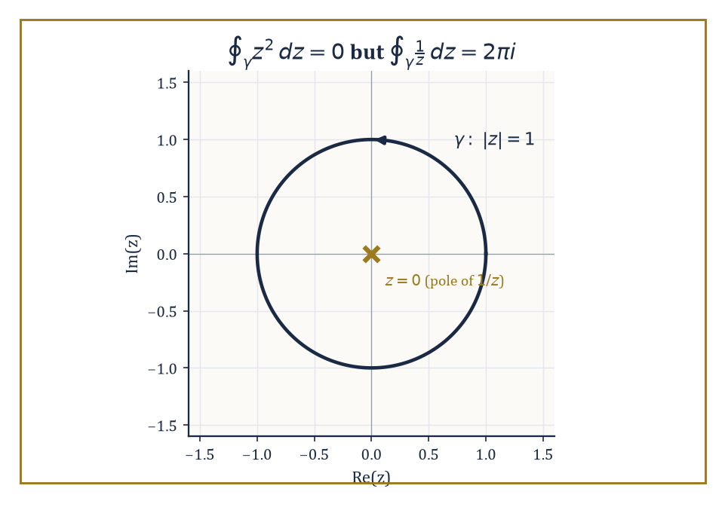
The same unit circle gives 0 for z² and 2πi for 1/z — the entire difference between having a singularity inside and not.
∫_γ f(z) dz = ∫_a^b f(z(t)) z′(t) dt
Two basic facts are worth having ready: the value of the integral does not depend on which parametrisation you choose for the curve, only on the curve itself and its direction of travel; and reversing the direction of travel along γ negates the integral, exactly as reversing the limits of an ordinary definite integral does.
Numeric example — Worked example: a contour integral along a line segment. Let f(z) = z, and let γ be the straight segment from 0 to 1 + i. Parametrise z(t) = t(1 + i) for t ∈ [0, 1], so z′(t) = 1 + i.
∫_γ z dz = ∫₀¹ t(1 + i) · (1 + i) dt = (1 + i)² ∫₀¹ t dt = (1 + i)² · [t²/2]₀¹ = (1 + i)² · (1/2)
We already computed (1 + i)² = 2i in Room 23.1. So the integral is 2i · (1/2) = i.
Sanity check: since z is entire and has the antiderivative z²/2 (just as in real calculus, where (x²/2)′ = x, so here F(z) = z²/2 satisfies F′(z) = z), the Fundamental Theorem of Calculus for contour integrals gives:
∫_γ z dz = F(1 + i) − F(0) = (1 + i)²/2 − 0 = 2i/2 = i
This matches exactly — confirming that for a holomorphic function with a known antiderivative, the integral only cares about the endpoints, not the path taken between them.
Cauchy's theorem is the load-bearing wall of the entire subject: if f is holomorphic throughout a simply connected domain, and γ is any closed contour lying inside that domain, then:
∫_γ f(z) dz = 0
The standard route to proving it starts, perhaps surprisingly, with triangles: Goursat showed that the integral of a holomorphic function around the boundary of any triangle inside the domain is zero, by repeatedly quartering the triangle into four smaller similar triangles and showing the error can be squeezed to nothing as the pieces shrink. Since any polygon can be triangulated, and any closed contour can be approximated as closely as you like by a polygon, the triangle case bootstraps its way up to the general statement.
A useful corollary, homotopy invariance, falls out immediately: if two closed contours can be continuously deformed into one another without ever leaving the domain on which f is holomorphic, their integrals of f agree — deforming the path costs nothing, provided you never cross a point where f misbehaves.
Numeric example — Worked example: zero versus 2πi, and why the difference matters. First take f(z) = z² (holomorphic everywhere) and let γ be the unit circle |z| = 1, traversed once counterclockwise. Since z² is entire and the disc |z| ≤ 1 is simply connected, Cauchy's theorem guarantees the following without any computation at all:
∮_γ z² dz = 0
Indeed, using the antiderivative z³/3, the integral over any closed loop is F(start) − F(start) = 0 automatically.
Now take f(z) = 1/z and the same contour γ, the unit circle traversed once counterclockwise. Parametrise z = e^{iθ}, dz = ie^{iθ} dθ, θ running from 0 to 2π:
∮_γ (1/z) dz = ∫₀^{2π} (1/e^{iθ}) · i e^{iθ} dθ = ∫₀^{2π} i dθ = i · 2π = 2πi
This is emphatically not zero, and it is not a mistake: 1/z is holomorphic everywhere except at z = 0, and z = 0 lies inside the contour, and the punctured disc {0 < |z| < 1} is not simply connected in the sense that matters — you cannot shrink the unit circle to a point without passing through the very singularity where f blows up. Cauchy's theorem simply doesn't apply here, because one of its hypotheses (holomorphic throughout, including the interior) fails.
The size of the discrepancy, 2πi, is not an accident either — it is the first sighting of the residue, the star of Rooms 23.5 and 23.6.
It's hard to overstate how much of the rest of this storey is just Cauchy's theorem wearing different hats. The Cauchy integral formula (next room) follows by applying the theorem to a cleverly chosen contour with a small circle cut out around a singularity. The residue theorem (Room 23.6) follows by applying the same trick to several singularities at once.
Even the fact that holomorphic functions are infinitely differentiable and equal their own Taylor series — the single most surprising claim in the whole storey — is, at bottom, a consequence of Cauchy's theorem plus a little bookkeeping. If you remember only one theorem from this storey when you're revising at three in the morning before an exam, make it this one; everything else can, in principle, be rederived from it, though your examiner will not thank you for doing so under time pressure.

Room 23.4: The Cauchy Integral Formula and Power Series
In which the inside of a region turns out to be a hostage of its boundary
The Cauchy integral formula is the precise statement of a claim that sounds too strong to be true: the value of a holomorphic function at any interior point of a domain is completely determined by its values on the boundary.
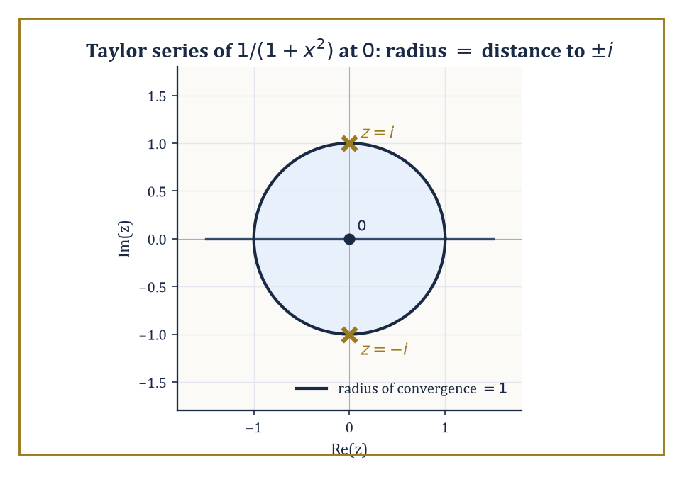
1/(1+x²) looks perfectly innocent on the real line, but its Taylor series stalls at radius 1 because ±i are lurking just off-stage.
Formally, if f is holomorphic on and inside a simply connected region and γ is a closed contour winding once counterclockwise around a point a inside that region, then:
f(a) = (1/(2πi)) ∮_γ f(z)/(z − a) dz
The proof is a direct application of Cauchy's theorem from the previous room: cut a small circular disc of radius ε out of the region around a, apply Cauchy's theorem to the resulting region (which no longer contains the troublesome point z = a, since 1/(z − a) blows up there), and then shrink ε to 0, using the fact that f is continuous at a to show the small-circle contribution converges to exactly f(a) times 2πi.
The upshot is remarkable: knowing f only on some encircling curve γ, you can recover its value at any point strictly inside — the interior has no freedom the boundary hasn't already spent.
Numeric example — Worked example: applying the Cauchy integral formula. Let f(z) = z² (entire, hence holomorphic everywhere), and let γ be the circle |z| = 2 traversed once counterclockwise. Take a = i, which satisfies |i| = 1 < 2, so a lies inside γ.
The Cauchy integral formula says f(a) = (1/(2πi)) ∮_γ f(z)/(z − a) dz — that is, for this particular f, a, and γ:
∮_γ z²/(z − i) dz = 2πi · f(i)
Compute:
f(i) = i² = −1
So the contour integral equals:
2πi · (−1) = −2πi
Notice what just happened: we evaluated a contour integral — the kind of object that, in Room 23.3, required parametrising and grinding through a real integral — by simply plugging a into f and multiplying by 2πi. This is the computational payoff the formula is famous for: contour integrals of the shape ∮ f(z)/(z − a) dz, with f holomorphic and a inside the contour, are read off almost by inspection.
Differentiating the Cauchy integral formula under the integral sign (a manoeuvre that is entirely legitimate here, though it would need justifying carefully in other settings) produces formulas for every derivative of f, not just its value:
f^{(n)}(a) = (n!/(2πi)) ∮_γ f(z)/(z − a)^{n+1} dz
Since the right-hand side is manifestly well-defined for every n = 0, 1, 2, 3, …, we get the single most startling structural fact in the whole storey for free: a function that is complex-differentiable just once on an open set is automatically differentiable infinitely often there.
There is no such thing as a complex function that is differentiable but not twice-differentiable, or twice but not three-times, the way there routinely is on the real line (|x|³ is twice but not three-times differentiable at 0, for instance — a whole industry of counterexamples like this exists in real analysis and simply has no complex-analytic counterpart).
Once through the door marked ‘holomorphic’, you get every subsequent derivative thrown in as a free upgrade.
Numeric example — Worked example: recovering a derivative from a contour integral. Let f(z) = e^z, and let γ be the unit circle |z| = 1. We know directly, from ordinary calculus, that f″(z) = e^z (differentiating e^z twice just gives e^z back), so:
f″(0) = e⁰ = 1
Cauchy's derivative formula with n = 2, a = 0 reads:
f″(0) = (2!/(2πi)) ∮_γ e^z/z³ dz
Substituting f″(0) = 1:
1 = (2/(2πi)) ∮_γ e^z/z³ dz
∮_γ e^z/z³ dz = 2πi/2 = πi
So without ever parametrising the unit circle or grinding through a real integral of e^{cos θ}(cos(sin θ) + i sin(sin θ)) — which is exactly the mess a direct parametrisation would produce — the derivative formula hands us the exact value πi, purely from knowing that e^z differentiates to itself.
This is the formula's real value: it turns fearsome-looking contour integrals into ordinary calculus problems about the numerator function.
Because a holomorphic function equals its own Taylor series near every point of its domain, it is natural to ask how far that series can be trusted — the answer is the radius of convergence, and it has an unexpectedly clean geometric description: the radius of convergence of the Taylor series of f centred at a is exactly the distance from a to the nearest point where f fails to be holomorphic (a singularity).
Inside that radius the series converges to f exactly; on or beyond it, convergence is not guaranteed.
This single fact resolves a puzzle left dangling since early storeys on real calculus, where the Taylor series of a perfectly smooth real function was sometimes observed to have an oddly small radius of convergence for no visible reason.
The reason was invisible because it was hiding off the real line, in the complex plane, all along.
Numeric example — Worked example: radius of convergence via distance to the nearest singularity. Take f(z) = 1/(1 − z). This has a single singularity, at z = 1 (where the denominator vanishes). Expanded as a Taylor series about z = 0:
f(z) = 1 + z + z² + z³ + …
(the familiar geometric series), and its radius of convergence is the distance from 0 to the singularity at 1, namely 1 — exactly matching the well-known fact that the geometric series converges precisely for |z| < 1.
Now take f(z) = 1/(1 + x²), thought of as a real function of x with a perfectly innocent-looking graph — smooth, bounded, no visible bumps or corners anywhere on the real line.
Viewed as a complex function f(z) = 1/(1 + z²), it has singularities where 1 + z² = 0, i.e. at z = i and z = −i, each at distance 1 from the origin.
So the Taylor series of 1/(1 + x²) about x = 0 has radius of convergence exactly 1, even though the real function itself shows no sign of trouble at x = ±1 or anywhere else on the real line.
The instability was there all along; it was simply positioned a unit's distance off the real axis, invisible to anyone who insisted on only ever looking along it.
Two famous consequences round off the room. Liouville's theorem states that a bounded entire function (holomorphic on the whole plane, with |f(z)| ≤ M for some constant M and all z) must be constant — intuitively, a Taylor series valid on the whole plane with bounded coefficients has nowhere left to hide any nontrivial variation, and the Cauchy derivative formula, applied on ever-larger circles, forces every derivative beyond the zeroth to vanish.
From Liouville's theorem the Fundamental Theorem of Algebra falls out almost as an afterthought: every non-constant polynomial has a root in ℂ.
And the identity theorem, promised in Room 23.2, now has its proof: two holomorphic functions that agree on a set with a limit point inside a connected domain must agree everywhere on that domain, because agreement on such a set forces every Taylor coefficient at the limit point to match, and the Taylor series determines the function completely nearby, and nearby propagates to everywhere by a connectedness argument.
Abstract example — Worked example: proving the Fundamental Theorem of Algebra from Liouville. Claim: every non-constant polynomial p(z) has a root in ℂ. Suppose, for contradiction, that p(z) has no root anywhere — so p(z) ≠ 0 for every z.
Then define:
g(z) = 1/p(z)
This g is defined and holomorphic on the whole plane (entire), since its only possible singularities would be at roots of p, and there are none by assumption.
Because p is a non-constant polynomial, |p(z)| → ∞ as |z| → ∞ (the highest-degree term eventually dominates and swamps everything else). So:
|g(z)| = 1/|p(z)| → 0 as |z| → ∞
meaning g is bounded on the whole plane — certainly bounded near infinity, and bounded on any fixed large disc too, since g is continuous there.
By Liouville's theorem, a bounded entire function must be constant. So g is constant, hence p = 1/g is constant too — contradicting the assumption that p is non-constant.
The contradiction shows no such root-free polynomial can exist: every non-constant polynomial has at least one root in ℂ.
It's a curious feature of this proof that it establishes the existence of a root without ever exhibiting one — very much in the spirit of the whole storey, where existence statements routinely arrive long before anyone can compute anything.

Room 23.5: Laurent Series and Singularities
A taxonomy of the ways a function can misbehave at a point
Taylor series describe a holomorphic function on a disc, but plenty of interesting functions have a nasty point right in the middle of the region we care about — 1/z at the origin, say. On an annulus (a ring-shaped region a < |z − c| < b, avoiding the trouble spot entirely), a function holomorphic throughout the annulus admits a Laurent series, a two-sided generalisation of the Taylor series, where negative powers of (z − a) are allowed alongside the usual non-negative ones:
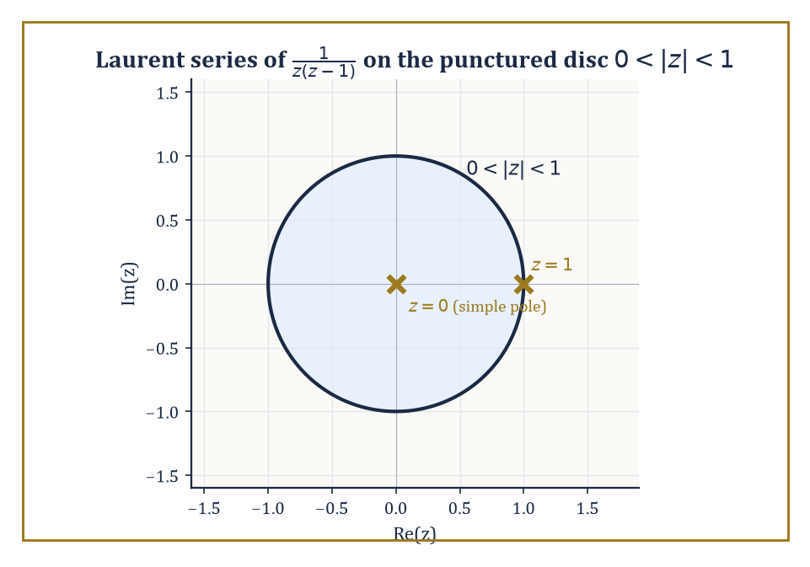
The punctured disc 0 < |z| < 1, home to the Laurent series of 1/(z(z−1)), with its pole at the centre and its excluded neighbour at z = 1.
f(z) = Σ_{n=−∞}^{∞} c_n(z − a)^n
The terms with negative exponent are called the principal part of the series, and it is the principal part alone that encodes how badly f misbehaves at the missing centre a — the non-negative-power part behaves exactly like an ordinary Taylor series and contributes nothing pathological.
Numeric example — Worked example: finding a Laurent series by partial fractions. Let f(z) = 1/(z(z − 1)), and find its Laurent series on the punctured disc 0 < |z| < 1 (avoiding both z = 0 and z = 1, the two places f is undefined).
Partial fractions: write 1/(z(z − 1)) = A/z + B/(z − 1). Clearing denominators:
A(z − 1) + Bz = 1
Setting z = 0: −A = 1, so A = −1. Setting z = 1: B = 1. So:
f(z) = −1/z + 1/(z − 1)
Now expand 1/(z − 1) as a series valid for |z| < 1, using the geometric series (valid since |z| < 1):
1/(z − 1) = −1/(1 − z) = −(1 + z + z² + z³ + …)
Combining:
f(z) = −1/z − (1 + z + z² + z³ + …) = −1/z − 1 − z − z² − z³ − …
The principal part is just the single term −1/z; every other term has a non-negative power. This tells us immediately, by the classification below, that f has a simple pole at z = 0 with residue −1 (the coefficient of the 1/z term).
The principal part sorts isolated singularities — points where f is holomorphic on a punctured neighbourhood but not defined (or not holomorphic) exactly at the centre — into exactly three types.
If the principal part is entirely zero (no negative powers at all), the singularity is removable: f simply forgot to be defined at that one point, and extending it by its limiting value there patches the hole with no loss of holomorphy, a fact formalised as Riemann's removable singularity theorem.
If the principal part is a finite sum ending at (z − a)^{−m} for some positive integer m (that is, the lowest power appearing is −m), the singularity is a pole of order m — f blows up to infinity there, in a controlled, polynomial-like way, roughly like 1/(z − a)^m near a.
If the principal part has infinitely many nonzero negative-power terms, the singularity is essential — and essential singularities are where complex analysis stops being polite.
Picard's Great Theorem states that near an essential singularity, f comes arbitrarily close to every complex value (with at most one exception) infinitely often in any punctured neighbourhood, however small — a function near such a point is not just badly behaved, it is behaved with a kind of manic, unbounded enthusiasm.
Numeric example — Worked example: classifying three singularities at z = 0. 1) f(z) = sin(z)/z. Using the Taylor series sin(z) = z − z³/3! + z⁵/5! − …, dividing by z gives:
sin(z)/z = 1 − z²/6 + z⁴/120 − …
There are no negative powers at all — the principal part is zero — so z = 0 is a removable singularity, and defining f(0) = 1 (matching the well-known limit lim_{z→0} sin(z)/z = 1) makes f entire.
2) f(z) = 1/z³. This is already exactly its own Laurent series, with a single term at power −3 and nothing else. The lowest power is −3, so z = 0 is a pole of order 3.
3) f(z) = e^{1/z}. Substituting w = 1/z into the exponential series e^w = Σ_{n=0}^∞ w^n/n! gives:
e^{1/z} = Σ_{n=0}^∞ (1/z)^n/n! = 1 + 1/z + 1/(2z²) + 1/(6z³) + …
Every negative power of z appears, with no stopping point — infinitely many nonzero terms in the principal part. So z = 0 is an essential singularity: exactly the kind of point where Picard's theorem applies and e^{1/z} takes on (almost) every complex value infinitely often in any neighbourhood of 0, no matter how small you make it.
The coefficient c_{−1} — the coefficient of the (z − a)^{−1} term in the Laurent expansion — is singled out with its own name, the residue of f at a, written Res_{z=a} f.
It earns the special treatment because it is the only coefficient in the entire Laurent series that survives integration around a small circle centred at a: every other power (z − a)^n with n ≠ −1 has an antiderivative that is single-valued on the circle and so integrates to zero around a closed loop, while (z − a)^{−1} alone integrates to 2πi (exactly the computation we did by hand for 1/z in Room 23.3).
This single surviving coefficient is about to become the entire content of the residue theorem in the next room, so it pays to get comfortable computing it.
Numeric example — Worked example: computing two residues. Residue of e^{1/z} at z = 0: from the expansion above, e^{1/z} = 1 + 1/z + 1/(2z²) + …, the coefficient of the 1/z term is 1. So:
Res_{z=0} e^{1/z} = 1
Residue of f(z) = 1/(z²(z − 1)) at z = 0 (a pole of order 2, so the direct series trick needs slightly more care than a simple pole): near z = 0, expand 1/(z − 1) as a series:
1/(z − 1) = −1/(1 − z) = −(1 + z + z² + …)
f(z) = (1/z²) · [−(1 + z + z² + …)] = −1/z² − 1/z − 1 − z − …
Reading off the coefficient of the 1/z term:
Res_{z=0} f = −1
As a check, the standard formula for a pole of order m at a is:
Res_{z=a} f = (1/(m−1)!) · lim_{z→a} d^{m−1}/dz^{m−1} [(z − a)^m f(z)]
Here m = 2, a = 0, so:
Res = lim_{z→0} d/dz [z² f(z)] = d/dz [1/(z − 1)] = −1/(z − 1)²
Evaluated at z = 0:
Res = −1/(−1)² = −1/1 = −1
Both methods agree.

Room 23.6: The Residue Theorem and Applications
Turning contour integrals into a finite shopping list of coefficients
The residue theorem is the payoff for all the bookkeeping in the previous room: if f is holomorphic on and inside a closed contour γ except for finitely many isolated singularities a₁, …, a_k inside γ, then
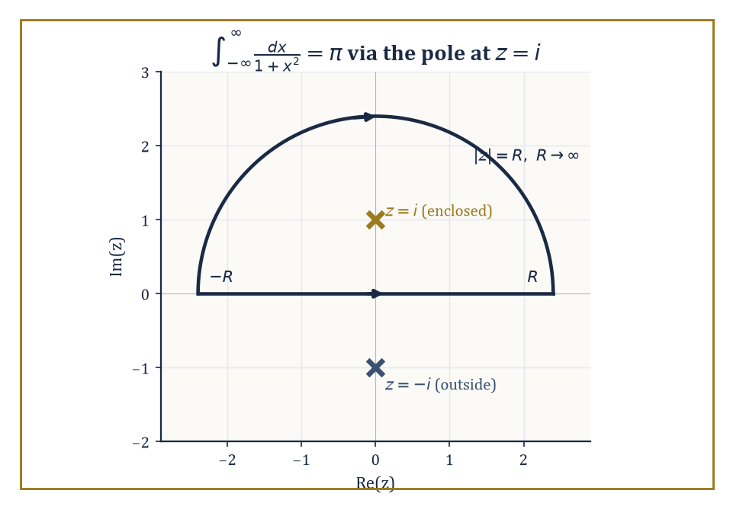
Close the real axis with a semicircle out to infinity, and only the pole at z = i ever gets caught in the net — the other one, at −i, never even shows up to the trial.
∮_γ f(z) dz = 2πi Σ_{j=1}^{k} Res_{z=a_j} f
In words: instead of parametrising the contour and grinding through a real integral, you locate the singularities trapped inside the loop, compute the residue at each one (a purely local, algebraic calculation, as the previous room demonstrated), add them up, and multiply by 2πi.
An integral over an entire curve has been reduced to a finite sum of numbers, each computed by looking only at a single point.
Cauchy's theorem is the special case where there happen to be no singularities inside γ at all — the empty sum is zero, matching what we already knew.
Numeric example — Worked example: applying the residue theorem. Let f(z) = 1/(z²(z − 1)), and let γ be the circle |z| = 2, traversed once counterclockwise, which encloses both singularities of f: z = 0 (pole of order 2) and z = 1 (simple pole), since both |0| = 0 < 2 and |1| = 1 < 2.
From the previous room, Res_{z=0} f = −1. For the simple pole at z = 1, use the formula for a simple pole:
Res_{z=1} f = lim_{z→1} (z − 1) f(z) = lim_{z→1} 1/z² = 1/1² = 1
Sum of residues:
−1 + 1 = 0
By the residue theorem:
∮_γ f(z) dz = 2πi · 0 = 0
This is a genuinely useful sanity check on the method: two singularities, each individually contributing a nonzero residue, can still conspire to make the total contour integral vanish. Nothing in the calculation was wasted — you still needed both residues to discover that they cancel.
The most celebrated practical use of the residue theorem is evaluating certain real definite integrals that resist every technique from ordinary calculus — typically integrals over the whole real line of a rational function, or of a rational function multiplied by a trigonometric or exponential factor.
The trick is to view the real integral as one piece of a closed contour: run along the real axis from −R to R, then close the loop with a large semicircular arc in the upper (or lower) half-plane back to the starting point.
If the integrand decays fast enough at infinity, the contribution from the arc vanishes as R → ∞, leaving the real integral equal to 2πi times the sum of residues trapped inside the closed semicircle — which, for large enough R, means every pole in the upper half-plane.
Numeric example — Worked example: evaluating a real integral by residues. Evaluate the following integral by contour methods (the answer is known from ordinary calculus to be π, via arctan, so this is a good test case for the machinery):
I = ∫_{−∞}^{∞} dx/(1 + x²)
Let f(z) = 1/(1 + z²) = 1/((z − i)(z + i)), which has simple poles at z = i and z = −i. Close the real-axis integral with a large semicircular arc in the upper half-plane; only the pole at z = i lies inside this closed contour (z = −i is in the lower half-plane, outside).
Residue at z = i:
Res_{z=i} f = lim_{z→i} (z − i) f(z) = lim_{z→i} 1/(z + i) = 1/(2i)
On the large semicircular arc, |f(z)| behaves like 1/R² while the arc's length grows only like R, so the arc's contribution to the integral shrinks like 1/R and vanishes as R → ∞ — this is the standard estimate that justifies discarding the arc.
By the residue theorem, the closed contour integral equals:
2πi · Res_{z=i} f = 2πi · 1/(2i) = π
Since the arc contributes nothing in the limit, the real-axis piece alone must account for the whole answer:
∫_{−∞}^{∞} dx/(1 + x²) = π
This exactly matches the arctan calculation from ordinary calculus — a satisfying handshake between two entirely different storeys' worth of technique.
Two further tools round out the toolkit. The argument principle states the following relation between a contour integral and a count of zeros and poles:
(1/(2πi)) ∮_γ f′(z)/f(z) dz = (number of zeros of f inside γ) − (number of poles of f inside γ)
Each zero and pole is counted with multiplicity. It works because f′/f has a simple pole at every zero and every pole of f, with residue equal to +m at a zero of order m and −m at a pole of order m, so the residue theorem turns the count into a contour integral.
Rouché's theorem is the practical cousin of this fact: if f and g are holomorphic inside and on a closed contour γ, and |g(z)| < |f(z)| for every z on γ, then f and f + g have the same number of zeros inside γ.
Intuitively, g is too small on the boundary to ever perturb f enough to create or destroy a zero — the boundary comparison controls the interior count, which is the whole storey's leitmotif turning up once more.
Abstract example — Worked example: locating roots with Rouché's theorem. Claim: every root of p(z) = z⁴ + 6z + 3 lies inside the circle |z| = 2.
Split p as f(z) + g(z) with f(z) = z⁴ and g(z) = 6z + 3. On the circle |z| = 2, bound each piece separately, using the triangle inequality for g:
|f(z)| = |z|⁴ = 2⁴ = 16
|g(z)| = |6z + 3| ≤ 6|z| + 3 = 6(2) + 3 = 15
Since 15 < 16, we have |g(z)| < |f(z)| everywhere on |z| = 2, so Rouché's theorem applies: p = f + g has the same number of zeros inside |z| < 2 as f alone.
The function f(z) = z⁴ has a single zero, z = 0, of multiplicity 4 — so f has 4 zeros (counted with multiplicity) inside |z| < 2.
Therefore p(z) = z⁴ + 6z + 3 also has exactly 4 zeros inside |z| < 2, counted with multiplicity.
Since p has degree 4, that accounts for all of its roots — every root of this particular quartic lies inside the disc of radius 2, a fact we've now established without solving the quartic, or indeed finding a single root explicitly.

Room 23.7: Conformal Mapping and the Riemann Mapping Theorem
Angle-preserving maps, and the astonishing claim that almost every shape is secretly a disc
A holomorphic function f with f′(z) ≠ 0 at a point is conformal there: it preserves angles between curves crossing at that point, and it preserves orientation (it doesn't flip things into a mirror image).
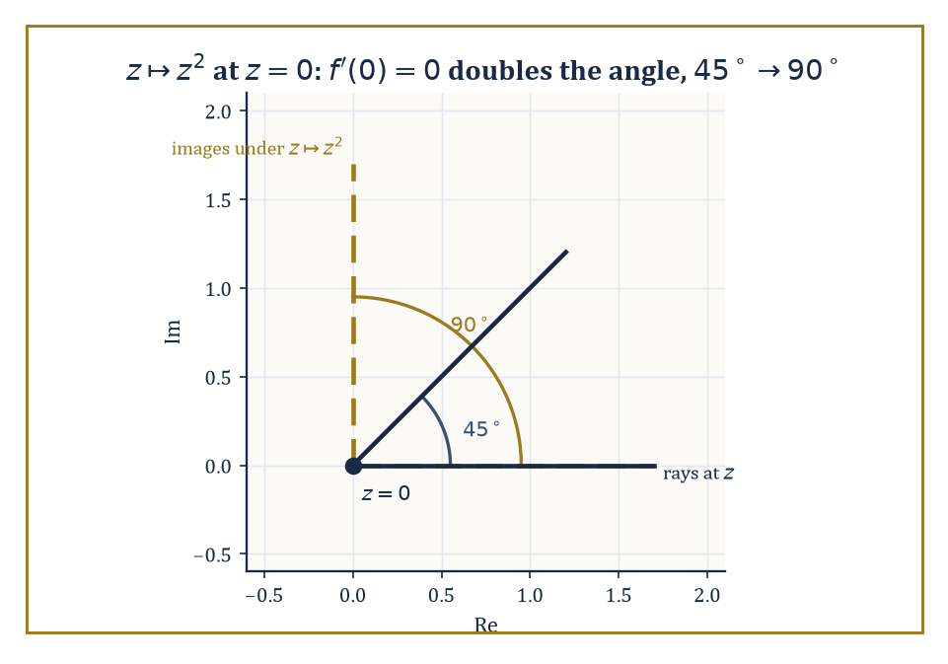
At the one point where f′ vanishes, z ↦ z² stops being polite: a 45° angle walks in and a 90° angle walks out.
The geometric reason is close to the algebra of Room 23.2: locally, near a point where f′(z₀) ≠ 0, f behaves almost exactly like multiplication by the complex number f′(z₀) — which, as we saw with polar form back in Room 23.1, is a rotation (by arg f′(z₀)) combined with a uniform rescaling (by |f′(z₀)|).
Rotating and rescaling uniformly preserves the angle between any two crossing curves, since both curves get rotated by the same amount.
Infinitesimally small circles around z₀ get mapped to infinitesimally small circles around f(z₀) — squashed or stretched, perhaps, but not sheared into ellipses, which is precisely what makes conformal maps the natural change of coordinates for any problem built on Laplace's equation, as Room 23.8 will exploit directly.
Numeric example — Worked example: conformal except where the derivative vanishes. Let f(z) = z², with derivative f′(z) = 2z.
At z = 1, the derivative is nonzero, so f is conformal there:
f′(1) = 2 ≠ 0
Consider two rays leaving z = 1: one along the positive real direction (angle 0) and one at 45° to it.
Locally, f acts like multiplication by f′(1) = 2 — a pure rescaling by factor 2 with zero rotation — so the 45° angle between the two rays is preserved exactly at the image point f(1) = 1.
Now look at z = 0, where the derivative vanishes — conformality's hypothesis fails, and indeed the conclusion fails too:
f′(0) = 2(0) = 0
Take the ray at angle 0 (the positive real axis) and the ray at angle π/4 (45°), both leaving the origin.
Under the squaring map, a ray at angle θ maps to a ray at angle 2θ:
f(z) = z² = r²e^{i2θ}
The angle-0 ray maps to the angle-0 ray, and the angle-π/4 ray maps to the angle-π/2 ray:
2 × 0 = 0
2 × π/4 = π/2
The original 45° angle between the two rays has become a 90° angle between their images — doubled, not preserved.
This is exactly what the vanishing derivative warns you about:
f′(0) = 0
At a point where the derivative vanishes, the local rotation-and-rescaling picture breaks down, and angles are free to distort.
The Riemann mapping theorem is one of the most quietly astonishing existence statements in classical analysis: every simply connected domain in the plane, other than the whole plane itself, is conformally equivalent to the open unit disc — meaning there exists a holomorphic bijection between the two, with a holomorphic inverse, that preserves angles throughout.
Stop and register how strong this is: a domain shaped like a jagged, five-pointed star, or a long thin crescent, or the inside of a maple leaf, is — provided it's simply connected and not the entire plane — secretly, conformally, just a disc wearing a costume.
The theorem, as usually proved, is non-constructive: it guarantees the map exists without necessarily telling you a formula for it.
But for a great many domains that actually arise in practice, explicit conformal maps are known and computable: Möbius transformations (ratios of linear expressions) for discs, half-planes, and circles; power maps z ↦ z^n for wedge-shaped sectors; and the Schwarz–Christoffel formula for polygons of any shape.
Abstract example — Worked example: an explicit conformal map, half-plane to disc. Claim: the Möbius transformation below maps the upper half-plane {z : Im(z) > 0} conformally onto the open unit disc {w : |w| < 1}, sending the real axis to the unit circle.
w = (z − i) / (z + i)
First check the centre: z = i (a point comfortably in the upper half-plane) maps to the centre of the disc — a promising sign:
w = (i − i)/(i + i) = 0/(2i) = 0
Now check that real points land exactly on the unit circle. For any real x, the distances to i and to −i are equal, since conjugating x − i (which is x + i, as x is real) doesn't change the modulus:
|x − i| = √(x² + 1) and |x + i| = √(x² + 1)
So the whole real axis maps onto the unit circle:
|w| = |x − i|/|x + i| = 1 for every real x
Spot-check two points. At x = 0:
w = (0 − i)/(0 + i) = −i/i = −1
and indeed |−1| = 1. At x = 1, multiply numerator and denominator by the conjugate (1 − i):
w = (1 − i)/(1 + i) = (1 − i)²/((1 + i)(1 − i)) = (1 − 2i + i²)/(1 − i²) = (1 − 2i − 1)/(1 + 1) = −2i/2 = −i
And indeed |−i| = 1. Both boundary points check out, and since z = i (interior) maps to w = 0 (interior), the map sends the upper half-plane's interior to the disc's interior, exactly as claimed — a single algebraic formula, and an entire half-plane's worth of geometry has been folded losslessly onto a disc.
The practical value of all this is that conformal maps let you relocate a hard problem to easier ground.
Many boundary-value problems — solving Laplace's equation subject to prescribed values on a boundary, for instance — are difficult on an awkwardly-shaped domain but have clean, well-understood solutions on the unit disc or the upper half-plane (via the Poisson kernel or Fourier series, which we'll meet properly in Room 23.8).
The strategy is: conformally map your awkward domain to the disc, transport the boundary data across using the map, solve the easy problem on the disc, and map the solution back.
Since conformal maps preserve the structure that Laplace's equation cares about (this is not a coincidence — it follows from the fact that harmonic functions are exactly the real and imaginary parts of holomorphic functions, our very next topic), the solution translates back faithfully, angle-preservation and all.

Room 23.8: Harmonic Functions and Boundary-Value Problems
Laplace's equation, and the unreasonable usefulness of splitting a function into two halves
A twice-differentiable real function u(x, y) is harmonic if it satisfies Laplace's equation — the sum of its two second partial derivatives vanishes everywhere.
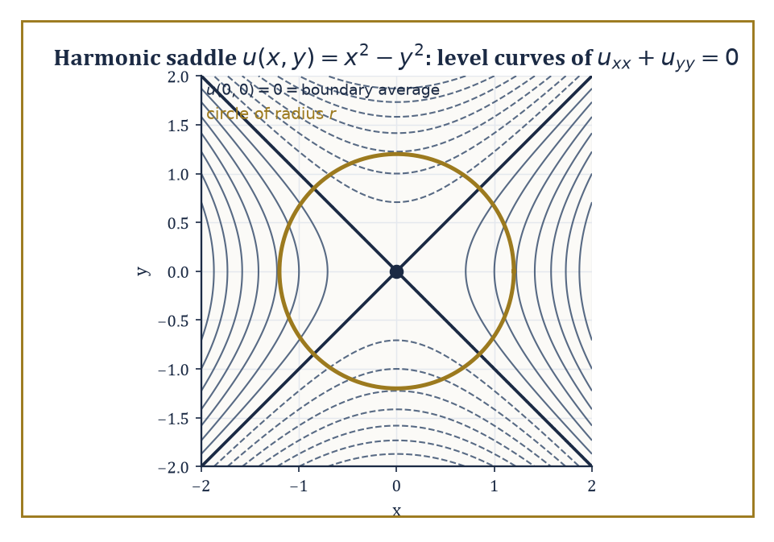
The saddle u = x² − y², real part of z², with a circle drawn round the origin to check that its boundary average really is the centre value: zero.
u_xx + u_yy = 0
Laplace's equation shows up constantly in physics (steady-state heat distribution, electrostatic potential, the shape of a stretched membrane at rest), which is reason enough to care about it, but the connection to this storey is direct and startling: the real part and the imaginary part of any holomorphic function are each individually harmonic.
This follows almost immediately from the Cauchy–Riemann equations of Room 23.2.
u_x = v_y
u_y = −v_x
Differentiate the first equation with respect to x and the second with respect to y, and (using the fact that holomorphic functions have continuous partial derivatives of every order, from Room 23.4) the mixed partials of v cancel, leaving the following.
u_xx + u_yy = 0
The converse holds too, on a simply connected domain: every harmonic function u is the real part of some holomorphic function f = u + iv, where v (called the harmonic conjugate of u) can be recovered from u by integrating the Cauchy–Riemann equations.
Numeric example — Worked example: verifying harmonicity and finding a conjugate. Let u be the function given below.
u(x, y) = x² − y²
Compute u_xx: first differentiate once,
u_x = 2x
then differentiate again.
u_xx = 2
Compute u_yy the same way: first differentiate once,
u_y = −2y
then differentiate again.
u_yy = −2
Sum the two:
u_xx + u_yy = 2 + (−2) = 0
✓ — u is harmonic.
To find its harmonic conjugate v, use Cauchy–Riemann. From v_y = u_x, we have the following.
v_y = u_x = 2x
Integrate with respect to y.
v = 2xy + g(x)
for some function g(x) depending only on x (the 'constant' of integration with respect to y can depend on x). Differentiate this v with respect to x.
v_x = 2y + g′(x)
The other Cauchy–Riemann equation says the following.
v_x = −u_y = −(−2y) = 2y
So g′(x) = 0, meaning g is a genuine constant; take it to be 0 for simplicity. So:
v(x, y) = 2xy
Reconstruct f = u + iv.
f = u + iv = (x² − y²) + i(2xy)
Compare with z².
z² = (x + iy)² = x² + 2ixy + i²y² = (x² − y²) + i(2xy)
Exactly the same expression. So u = x² − y² is, unsurprisingly given where we plucked it from, the real part of f(z) = z², and its harmonic conjugate is v = 2xy, the imaginary part of the same function.
Because harmonic functions inherit their good behaviour directly from holomorphic ones, several of the storey's earlier theorems translate over almost word for word. The mean-value property holds: the value of a harmonic function at the centre of a disc equals the average of its values around the boundary circle (this follows from applying the Cauchy integral formula to the associated holomorphic function and taking real parts).
The maximum principle holds too: a non-constant harmonic function attains no interior maximum or minimum — its extreme values live entirely on the boundary of its domain, just like the maximum-modulus principle from Room 23.2.
And on the unit disc specifically, there is an explicit reconstruction formula, the Poisson integral formula, expressing the value of a harmonic function at any interior point as a weighted average of its boundary values, with weights (the Poisson kernel) that concentrate more heavily near the interior point in question and fall off elsewhere.
Numeric example — Worked example: the mean-value property in action. Take u(x, y) = x² − y², already confirmed harmonic in the previous example, and check the mean-value property on the circle of radius r centred at the origin.
u(0, 0) = 0² − 0² = 0
Parametrise the circle as x = r cos θ, y = r sin θ, θ running from 0 to 2π. Then:
u = r² cos²θ − r² sin²θ = r²(cos²θ − sin²θ) = r² cos(2θ)
using the double-angle identity. The average value around the circle is the following.
(1/2π) ∫₀^{2π} r² cos(2θ) dθ
Since cos(2θ) completes exactly two full periods as θ runs from 0 to 2π, it integrates to zero over the interval.
∫₀^{2π} cos(2θ) dθ = [sin(2θ)/2]₀^{2π} = 0 − 0 = 0
So the average is:
r² · 0 = 0
The boundary average, 0, matches the centre value u(0, 0) = 0 exactly, for every radius r — the mean-value property confirmed on a concrete example, without needing to invoke the Cauchy integral formula that proves it in general.
These facts combine into a genuinely practical method for solving Dirichlet problems — find a harmonic function on a domain that matches prescribed values on the boundary — on domains that are not themselves the disc.
If your domain D can be conformally mapped to the unit disc (and, by the Riemann mapping theorem of the previous room, essentially any simply connected domain other than the whole plane can), the recipe is: map D to the disc, carry the boundary data across using the same map, solve the now-easy Dirichlet problem on the disc using the Poisson integral formula, and map the solution back to D using the inverse map.
Because conformal maps preserve harmonicity (a fact easiest to see via holomorphic functions: if h is holomorphic and u is harmonic, then u composed with h is again harmonic, essentially because composing with a holomorphic map preserves the 'is the real part of a holomorphic function' property), the transported solution is guaranteed to be harmonic on D and to match the prescribed boundary values, solving the original problem exactly.
Abstract example — Worked example: solving a Dirichlet problem by transport. Suppose we want a harmonic function on the upper half-plane matching some prescribed values on the real axis (its boundary). Direct solution on the half-plane is possible but fiddly; instead, use the map from Room 23.7, which sends the upper half-plane conformally to the unit disc and the real axis to the unit circle.
w = (z − i)/(z + i)
Step 1: transport the boundary data. Every real point x on the boundary of the half-plane corresponds, via the map, to a specific point on the unit circle; carry the prescribed boundary value at x over to that corresponding circle point.
Step 2: solve the easy problem. On the disc, with boundary data now sitting on the unit circle, the Poisson integral formula hands you an explicit harmonic function U(w) matching that data — no further cleverness required, just an integral against the Poisson kernel.
Step 3: pull back. Define u(z) = U(w(z)), i.e. compose U with the map below.
w = (z − i)/(z + i)
Because composing a harmonic function with a holomorphic map yields another harmonic function, u is harmonic on the upper half-plane; and because the map sends each boundary point x to the corresponding circle point where U already matches the transported data, u matches the original prescribed boundary values on the real axis.
The hard problem on the half-plane has been solved entirely by solving an easy problem on the disc and translating the answer back — conformal mapping doing the heavy lifting so that Poisson's formula never has to leave its comfort zone.

Room 23.9: Looking Ahead: From Complex Analysis to Riemann Surfaces and Several Complex Variables
A landing at the top of the stairs, with several unmarked doors leading further up
We have, in eight rooms, acquired the core of classical complex analysis: what it means for a function to be holomorphic, why that one demand (agreement of a limit from every direction) forces an entire cascade of consequences — Cauchy's theorem, the Cauchy integral formula, infinite differentiability and Taylor series, Laurent series and the classification of singularities, the residue theorem and its very concrete uses for evaluating real integrals and counting roots, conformal mapping and the Riemann mapping theorem, and finally the bridge to harmonic functions and boundary-value problems.
It is worth pausing, before we climb further, to notice how much of this was really one idea worked out in exhaustive, satisfying detail: complex differentiability is a far more exclusive club than real differentiability, and everything else in the storey is a description of exactly how generous the club is to the functions lucky enough to get in.
Several doors lead onward from here, none of which we'll walk through in this storey, but each worth naming so you know where to look later in the Tower.
The most immediate is the theory of Riemann surfaces — the natural habitat for multi-valued functions like the square root or the logarithm, which cannot be made single-valued on the punctured plane no matter how you try, but become perfectly single-valued, holomorphic functions once you replace the plane with a more elaborate surface built specifically to accommodate them.
Abstract example — Worked example: the Riemann surface of the square root. Consider the function
f(z) = √z
This is a headache on ℂ \ {0}, because every nonzero z has two square roots, and there's no way to choose one consistently all the way around a loop that encircles the origin.
For instance, start at z = 1 with √1 = 1, walk once counterclockwise around the origin back to z = 1, and continuous tracking of the square root brings you back to −1, not 1 — the two branches have swapped.
The fix is to stop insisting on a single copy of the plane. Take two copies of ℂ \ {0}, slit each one open along the positive real axis, and glue the top edge of the slit in copy one to the bottom edge of the slit in copy two, and vice versa (top of two to bottom of one) — a bit like taping two sheets of paper together so that walking off the edge of one lands you on the other.
The result is a single connected surface, wrapping around the origin twice before closing up on itself, on which √z is now perfectly well-defined and holomorphic at every point: what looked like a two-valued function on the plane is a single-valued function on this doubled-up surface.
This is the smallest possible taste of Riemann surface theory — the general theory builds such surfaces for arbitrarily complicated multi-valued functions, and the resulting objects turn out to be deeply entangled with algebraic geometry and topology, since the surface's shape (how many handles it has, essentially) turns out to control which functions can live on it.
Several complex variables — functions of more than one complex variable simultaneously — turns out not to be a straightforward generalisation but a genuinely different subject, with phenomena that have no single-variable analogue at all.
Hartogs' phenomenon, for instance, shows that a function holomorphic near the boundary of certain regions in several variables is automatically forced to extend holomorphically into the interior too, whether it likes it or not — there is no several-variable equivalent of a function like 1/z that can be holomorphic on an annulus without extending across the hole, and the whole notion of a domain of holomorphy (a region that is, so to speak, maximally resistant to such forced extension) becomes a subtle and interesting question in its own right.
Complex dynamics, meanwhile, studies what happens when you iterate a holomorphic map — apply it, then apply it again to the result, and again, forever — and produces two of the most recognisable objects in all of mathematics, the intricately fractal Julia sets and the Mandelbrot set, both built from nothing more exotic than repeatedly squaring a complex number and adding a constant.
And the theory of modular forms and special functions, which underlies deep results in number theory (including, famously, the proof of Fermat's Last Theorem), leans on complex-analytic techniques — holomorphicity, growth estimates, contour integration — at nearly every step.
The deeper lesson of this storey, if it must be compressed into a single sentence for the lift doors closing behind us, is this: an apparently modest local requirement — that a limit exist and agree from every direction of approach — imposes a global structure of extraordinary rigidity, reaching from the humble arithmetic of a + bi all the way to the shape of fractal sets and the proofs of centuries-old number-theoretic conjectures.
Complex analysis is at once a formidable computational engine (ask any physicist who has ever evaluated an integral by closing a contour in the upper half-plane and thanking a pole for its trouble) and one of the purest, most satisfying demonstrations in the whole Tower that algebra, geometry, and analysis are, deep down, telling the same story in three different accents.
We have learned, then, that differentiability in the plane is a miracle — one demanded lightly, in a single limiting condition, and repaid extravagantly, in an entire cathedral of theorems about integrals, series, and boundaries determining interiors. It is the kind of subject that makes a mathematician briefly suspicious of their own good fortune, before the proofs arrive and confirm that no, actually, you really are allowed to have all of this.
The next storey descends rather sharply from continuity into its opposite: Discrete Mathematics trades the smooth, infinitely-divisible plane we have just spent nine rooms exploring for a world of counting, graphs, and objects that come one at a time, with no meaningful notion of ‘in between’ at all. It will feel, for a room or two, like leaving a well-appointed concert hall for a gravel car park. Bear with it — the gravel, it turns out, has its own extraordinary architecture, and a rather large fraction of the computers reading this very sentence (metaphorically speaking, since none of them can read yet) run on nothing but discrete mathematics underneath the hood.
The Tower continues upward. Mind the step; the handrail on this next flight is, appropriately enough, made of integers.

Storey 24: Counting Carefully
Counting, Graphs, Logic, and the Art of Reasoning About Finite Structures
The previous storey left us in the company of holomorphic functions — objects so rigid that knowing one on a thimbleful of the plane determines it everywhere else, forever, whether it likes it or not. It was, in its way, a storey about infinite generosity: an analytic function cannot help but tell you everything it knows. This storey has rather a different temperament. Here we deal with objects that owe you nothing beyond what you can actually count, and the first rule of this floor is that you are not permitted to wave a limit at a problem and hope it embarrasses itself into submission. If you want the answer, you count it.
Discrete mathematics studies structures that are, unsurprisingly, discrete: sets, graphs, integers, propositions, finite machines — things you could in principle list one by one, even if the list would outlast your career, your pension, and quite possibly the heat death of the universe. There is no differentiating, no integrating, no ε trailing nervously after δ in the small hours. There is only counting, deciding, and building — and counting, it turns out, is a great deal harder than it sounds once the quantities involved have more digits than you have fingers, toes, and complaining colleagues combined.
This is also, not coincidentally, the mathematics underneath your laptop. Every algorithm is a discrete object — a finite recipe of finitely many steps — and every claim that an algorithm works, or works quickly, is a discrete mathematics proof wearing a lab coat. Over the rooms ahead we shall count things properly (Room 24.2), watch sequences define themselves in terms of their own past selves (24.3), draw pictures of dots and lines that turn out to encode entire transport networks, molecules, and family trees (24.4–24.5), learn to argue with the icy precision the rest of mathematics only pretends to have (24.6), tidy up what a “relation” and a “function” really are once infinity is barred from the premises (24.7), and finish by totting up what all this counting and arguing actually costs to carry out on a machine (24.8) — which is, as it happens, most of what a computer scientist is paid to lie awake worrying about.
One warning, delivered now so it cannot later claim to have been sprung on you: in Room 24.6 we shall need a small trick called diagonalization, invented by a gentleman arguing about lists that stubbornly refuse to be made complete. Here it looks like a parlour trick — a neat way to show that no clever enumeration scheme quite catches everything. In the next storey, Set Theory & Logic, the very same trick is turned loose on infinity itself, and infinity does not survive the encounter with its dignity fully intact. Consider this a preview. Discrete mathematics, for all its scrupulous finitude, keeps one foot wedged in the door to the infinite next door. We shall walk through properly, and with considerably less caution, very soon. For now: let us count carefully.

Room 24.1: What Discrete Mathematics Actually Is
In Which We Put Away the Ruler
Discrete mathematics is the study of structures that are fundamentally discrete rather than continuous — objects to be counted rather than measured, relations that are finite rather than infinitesimal, algorithms that terminate after finitely many steps rather than sneaking up on an answer through a limiting process. Where the continuous storeys behind us asked “how does this quantity change as we nudge the input by an infinitesimal amount?”, this storey asks “exactly how many of these things are there, and can you list them without dying of old age first?”
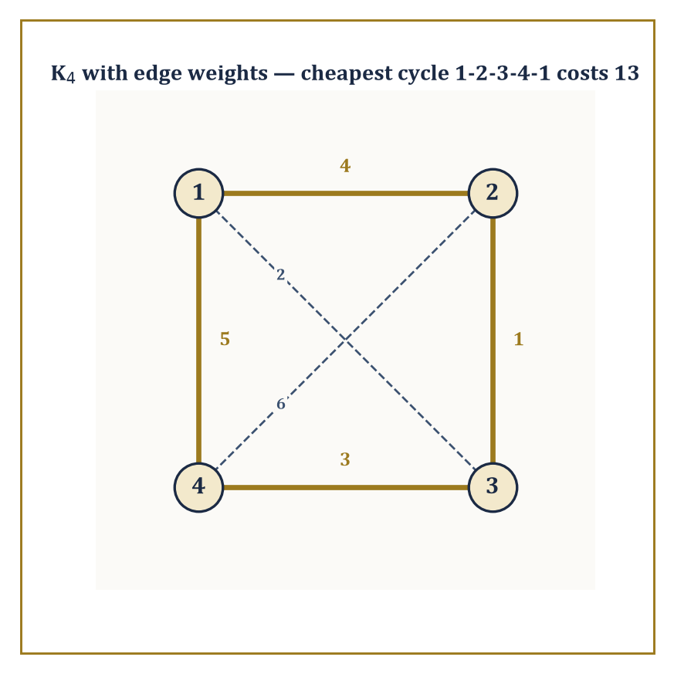
Four weighted routes through K4; gold traces the cheapest tour, at a total cost of 13 — the humble ancestor of the Travelling Salesman Problem.
It sounds like a modest ambition. It is not. Exact counting, done honestly, is one of the more unforgiving disciplines in mathematics, because there is nowhere to hide an error behind an “approximately.”
Numeric example — Worked example — counting handshakes. Suppose five people arrive at a rather small party and everyone shakes hands with everyone else exactly once. How many handshakes occur? Each handshake corresponds to an unordered pair of people, so we want the number of 2-element subsets of a 5-element set, written C(5,2).
C(n,k) = n! / (k!(n−k)!)
C(5,2) = 5! / (2!·3!) = (5·4·3·2·1) / (2·6) = 120/12 = 10
Direct check: label the guests A, B, C, D, E. The pairs are AB, AC, AD, AE, BC, BD, BE, CD, CE, DE — count them: that is exactly ten. No calculus was harmed in the production of this answer, and none was needed.
The subject organises itself around four recurring questions, and it is worth naming them once, cleanly, because they will recur under different disguises for the rest of the storey.
Enumeration asks how many objects of a given kind exist. Existence asks merely whether at least one exists — a much weaker and sometimes much harder question, since proving something exists without producing it is a peculiar art in itself.
Construction asks whether we can actually build an example, efficiently, rather than merely proving one is out there somewhere sulking. Optimization asks, among all the objects that exist, which is best by some measure of cost or value.
A single problem can be attacked from all four angles, and doing so is usually the fastest way to understand it properly.
Abstract example — Worked example — one graph, four questions. Take the complete graph K4 on four vertices {1,2,3,4}, where every pair of vertices is joined by an edge, and ask about Hamiltonian cycles — cycles that visit every vertex exactly once and return to the start.
Existence: does one exist? Trivially yes, since K4 has every possible edge available.
Construction: exhibit one — the cycle 1→2→3→4→1 works, since edges 1-2, 2-3, 3-4, 4-1 are all present.
Enumeration: how many distinct such cycles are there? For Kₙ the count is (fixing a starting vertex to kill rotational duplicates, then dividing by 2 for the two directions round the same cycle):
(n−1)!/2
For n=4 that is:
3!/2 = 6/2 = 3
Listing them confirms it: 1-2-3-4-1, 1-2-4-3-1, and 1-3-2-4-1 — three genuinely different cycles.
Optimization: now weight the edges — say 1-2:4, 1-3:2, 1-4:5, 2-3:1, 2-4:6, 3-4:3 — and ask for the cheapest cycle.
Cycle 1-2-3-4-1 costs 4+1+3+5 = 13
Cycle 1-2-4-3-1 costs 4+6+3+2 = 15
Cycle 1-3-2-4-1 costs 2+1+6+5 = 14
The cheapest is the first, at 13 — which is, incidentally, a miniature and entirely honest instance of the Travelling Salesman Problem, a question so innocuous-looking that entire university departments have built careers on failing to answer it quickly for large n.
The methods that answer these four questions form the working toolkit of the whole storey, and it is worth having their names in advance even before we have earned the right to use them properly: induction (prove a statement for all natural numbers by proving it for the first one and showing each case drags the next one along with it), bijection (prove two sets have the same size by pairing their elements off perfectly, with nobody left over), and inclusion–exclusion (count a union by adding the pieces and then correcting for double-counting the overlaps).
The remaining methods are generating functions (encode an entire infinite sequence of counts as a single algebraic object and let algebra do the counting for you), recurrence relations (define a sequence in terms of its own earlier values), and algorithm analysis (count not objects but operations, to work out how expensive a computation will be).
Every one of these gets a proper room to itself before this storey is done.
Numeric example — Worked example — a bijection in miniature. Here is the bijection method doing real work on the smallest possible scale. Claim: a set of 3 elements has exactly this many subsets:
2³ = 8
Proof by bijection: pair each subset of {1,2,3} with a binary string of length 3, where position i is 1 if element i is included and 0 otherwise. The pairing is:
∅↔000, {1}↔100, {2}↔010, {3}↔001, {1,2}↔110, {1,3}↔101, {2,3}↔011, {1,2,3}↔111
Every subset gets exactly one string and every string gets exactly one subset — a perfect pairing, with nothing left over on either side.
Since there are obviously 2³ = 8 binary strings of length 3 (two choices per position, three positions), there must be exactly 8 subsets too.
No subset was directly counted; the count was borrowed, honestly, from an easier problem next door. This is the entire strategy of bijective counting in one paragraph, and we shall lean on it constantly.

Room 24.2: Counting Principles and Generating Functions
Or: How Many Ways Can This Possibly Go
The two founding rules of counting are almost embarrassingly simple to state and endlessly useful to apply.
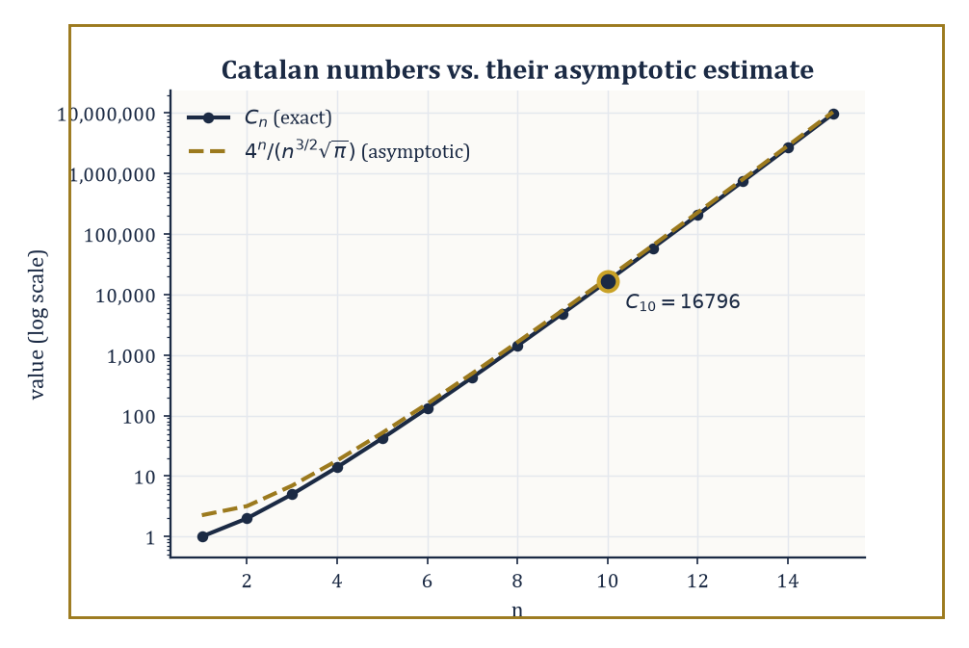
The exact Catalan numbers and their asymptotic estimate, agreeing rather smugly once n reaches double digits.
The sum rule: if a choice can be made in one of two mutually exclusive ways, offering m options and n options respectively, the total number of options is m + n.
The product rule: if a compound choice consists of an independent first choice with m options followed by a second choice with n options, the total number of combined outcomes is m × n.
Almost every counting argument in this room is these two rules, dressed up and applied repeatedly.
Numeric example — Worked example — a set menu. A restaurant offers 3 starters, 4 mains, and 2 desserts.
By the product rule, a full three-course meal (one from each) can be chosen in the following number of ways — each independent choice multiplies the possibilities:
3 × 4 × 2 = 24
Now suppose instead a diner in a hurry wants just one course, either a starter or a dessert (never both, and the two lists share no dishes).
By the sum rule, that is:
3 + 2 = 5
Notice the rules answer different questions: product rule for “this AND that AND that,” sum rule for “this OR that,” with the crucial proviso that the “or” options must be genuinely mutually exclusive, or you will double-count and a pedant (or an examiner) will notice.
A permutation is an ordered arrangement of r objects chosen from n distinct objects, counted by:
P(n,r) = n!/(n−r)!
A combination is an unordered selection of r objects from n, counted by:
C(n,r) = n!/(r!(n−r)!)
The relationship between them is exactly the overcounting correction from the previous paragraph: every combination of r objects can be arranged in r! different orders, so:
P(n,r) = C(n,r) × r!
Dividing by r! is precisely how one recovers C(n,r) from P(n,r).
Numeric example — Worked example — shelving versus selecting. You own 5 distinct books but only 3 slots on a display shelf, and order on the shelf matters (leftmost is most prominent).
The number of ways to fill the shelf is:
P(5,3) = 5!/(5−3)! = 5!/2!
5!/2! = (5·4·3·2·1)/(2·1) = 120/2 = 60
Equivalently, directly: 5 choices for the first slot, 4 remaining for the second, 3 remaining for the third —
5×4×3 = 60
matching exactly.
Now suppose instead you are simply choosing 3 of the 5 books to take on holiday, with no shelf and no order. That is:
C(5,3) = 5!/(3!·2!) = 120/(6·2)
120/(6·2) = 120/12 = 10
Check the relationship:
P(5,3)/3! = 60/6 = 10 = C(5,3)
This holds exactly as the theory promises, since each of the 10 unordered trios can be arranged on the shelf in 3! = 6 different orders, and 10 × 6 = 60.
The binomial theorem states:
(x+y)ⁿ = Σₖ₌₀ⁿ C(n,k) xᵏ yⁿ⁻ᵏ
The coefficients C(n,k) obey Pascal’s recurrence:
C(n,k) = C(n−1,k−1) + C(n−1,k)
This is a fact with a lovely combinatorial proof rather than merely an algebraic one: an n-element subset of size k either contains a fixed element (choose the remaining k−1 from the other n−1) or does not (choose all k from the other n−1), and these two cases are exhaustive and non-overlapping, so the counts simply add.
Numeric example — Worked example — expanding (x+y)⁴. Row four of Pascal’s triangle is 1, 4, 6, 4, 1 (each entry the sum of the two above it: 4 = 1+3, 6 = 3+3, from row three’s 1,3,3,1).
So:
(x+y)⁴ = x⁴ + 4x³y + 6x²y² + 4xy³ + y⁴
As a sanity check, set x = y = 1: the left side is
2⁴ = 16
and the right side is
1+4+6+4+1 = 16
They agree, which is no accident, since setting x=y=1 counts every subset of a 4-element set by size, and there are 2⁴ subsets in total.
The principle of inclusion–exclusion corrects the sum rule for the case where the “or” categories overlap:
|A ∪ B| = |A| + |B| − |A ∩ B|
The general pattern — add the singles, subtract the pairwise overlaps, add back the triple overlaps, and so on, alternating sign — extends to any number of sets.
Numeric example — Worked example — divisible by 3 or by 5. How many integers from 1 to 100 are divisible by 3 or by 5?
Let A be those divisible by 3:
|A| = ⌊100/3⌋ = 33
Let B be those divisible by 5:
|B| = ⌊100/5⌋ = 20
The overlap A∩B is those divisible by both, i.e. by 15:
|A∩B| = ⌊100/15⌋ = 6
By inclusion–exclusion:
|A∪B| = 33 + 20 − 6 = 47
Naively adding 33+20 = 53 would have double-counted the 6 multiples of 15 (such as 15, 30, 45, ...) — inclusion–exclusion is precisely the bookkeeping that removes that double-count exactly once, no more, no less.
Stars and bars counts the number of ways to distribute k indistinguishable objects into n distinguishable bins:
C(k+n−1, n−1)
The trick is to represent the distribution as a row of k stars (the objects) separated by n−1 bars (the bin dividers); any arrangement of k stars and n−1 bars corresponds to exactly one distribution, so the count reduces to choosing which k+n−1 positions in the row hold stars — a bijection, once again, turning a hard-looking problem into an easy one.
Numeric example — Worked example — sweets for three children. Ten identical sweets are to be distributed among three children (some may get none).
Here k=10 objects, n=3 bins, so the count is:
C(10+3−1, 3−1) = C(12,2) = 12!/(2!·10!) = (12·11)/2 = 66
As a spot check on a tiny case: distributing 2 sweets among 2 children should give:
C(2+2−1,2−1) = C(3,1) = 3
And indeed the possibilities are (2,0), (1,1), (0,2), which is exactly three ways. The formula scales correctly.
Certain counting problems recur so often that their answers have been given names and studied as sequences in their own right.
The Catalan numbers count, among many equivalent things, the number of ways to correctly balance n pairs of parentheses:
Cₙ = C(2n,n)/(n+1)
The Stirling numbers count partitions of a set into a given number of non-empty blocks (Stirling numbers of the second kind) or permutations by cycle structure (first kind).
What makes these sequences worth naming is that wildly different-looking problems — balanced parentheses, binary tree shapes, triangulations of a polygon, paths that never cross a diagonal — all turn out to be secretly the same problem, and hence share the same answer.
Numeric example — Worked example — balancing three pairs of parentheses. How many ways can 3 pairs of parentheses be validly balanced (never a closing bracket with no matching open bracket to its left)?
By the formula:
C₃ = C(6,3)/(3+1) = 20/4 = 5
Listing them by hand to check: ()()(), (())(), ()(()), (()()), ((())) — five valid strings, and no others work (try, for instance, )(()( — invalid immediately at the first character). The formula and the exhaustive list agree.
A generating function encodes an entire sequence a₀, a₁, a₂, ... as the coefficients of a single formal power series:
A(x) = Σₙ aₙxⁿ
The word “formal” is doing real work here: we never actually plug in a value of x and worry about convergence — the series is simply a clothes-line on which to hang the sequence, one term per peg.
Its power is that combinatorial constructions translate directly into algebraic operations on generating functions: a disjoint union of structures corresponds to adding generating functions; independently combining two structures corresponds to multiplying them; and “zero or more copies of a structure” corresponds to the geometric-series operation 1/(1−f(x)).
Worked example — Worked example — the generating function for subsets. Consider (1+x)ⁿ as the generating function that tracks subsets of an n-element set by size: the coefficient of xᵏ is exactly C(n,k), the number of k-element subsets.
For n=3:
(1+x)³ = 1 + 3x + 3x² + x³
Read off the coefficients: 1 subset of size 0 (the empty set), 3 of size 1, 3 of size 2, 1 of size 3 (the whole set) — matching the earlier list for {a,b,c} exactly: ∅; {a},{b},{c}; {a,b},{a,c},{b,c}; {a,b,c}.
The algebraic operation “multiply out (1+x)(1+x)(1+x)” has silently performed the combinatorial operation “for each of the three elements, independently decide in or out” — which is precisely the product rule, wearing algebra as a disguise.
A close cousin, the exponential generating function (EGF), replaces xⁿ with xⁿ/n! and is the natural tool when the objects being arranged are labelled and distinguishable — permutations, labelled trees, and the like — because division by n! is exactly the correction needed to account for the n! ways of ordering n labels.
Beyond enumeration, generating functions have an asymptotic superpower: the growth rate of a combinatorial sequence is governed by the location of the nearest singularity of its generating function to the origin — a genuinely startling bridge back to the complex analysis of the previous storey, where “singularity” meant a point where a function misbehaves.
Here it means the same thing, and it tells you, almost for free, how fast your sequence grows.
Numeric example — Worked example — Catalan growth from a singularity. The Catalan generating function has a singularity at x = 1/4, and the resulting asymptotic estimate is:
Cₙ ≈ 4ⁿ / (n^(3/2)·√π)
Test it at n=10, where the true value is C₁₀ = 16796 (the Catalan sequence runs 1, 1, 2, 5, 14, 42, 132, 429, 1430, 4862, 16796, ...).
The estimate proceeds step by step:
4¹⁰ = 1,048,576
n^(3/2) = 10^1.5 ≈ 31.62
√π ≈ 1.772
denominator ≈ 31.62 × 1.772 ≈ 56.05
estimate ≈ 1,048,576 / 56.05 ≈ 18,710
Compared to the true 16,796, the estimate is about 11% high — respectable but not exact, exactly as expected from an asymptotic formula at a modest n=10; the relative error shrinks steadily as n grows, and the formula is provably exact in the limit.
The singularity at x=1/4 is precisely why the base of the exponential growth is 4 — a fact you would be hard-pressed to extract by staring at balanced parentheses alone.

Room 24.3: Recurrence Relations
Sequences That Look Back Before Moving Forward
A recurrence relation expresses each term of a sequence in terms of one or more earlier terms, together with enough initial conditions to get the whole thing started. It is the discrete cousin of a differential equation — instead of relating a function to its instantaneous rate of change, a recurrence relates a term to its immediate predecessors — and, pleasingly, many of the solution techniques carry straight over with only cosmetic changes.
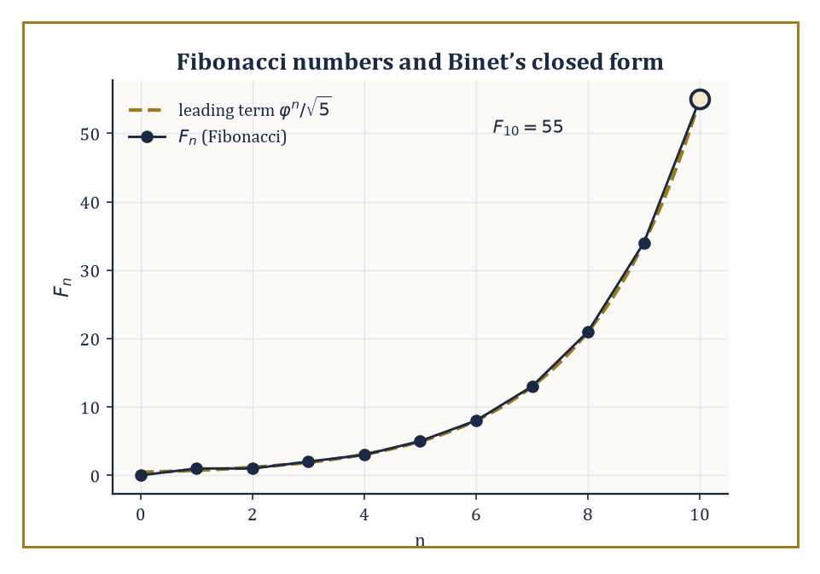
Fibonacci's stepped growth against the smooth exponential curve it was obeying all along.
Numeric example — Worked example — the simplest possible recurrence. Let aₙ be defined by the recurrence
aₙ = 2aₙ₋₁, a₀ = 1
Unrolling it:
a₁ = 2·1 = 2
a₂ = 2·2 = 4
a₃ = 2·4 = 8
a₄ = 2·8 = 16
a₅ = 2·16 = 32
The pattern aₙ = 2ⁿ is obvious by now and easily confirmed by induction.
base case: a₀ = 2⁰ = 1 ✓
inductive step: if aₖ = 2ᵏ then aₖ₊₁ = 2·2ᵏ = 2ᵏ⁺¹ ✓
Trivial, yes — but every technique in this room is ultimately a more industrial-strength version of exactly this unrolling process.
For a linear recurrence with constant coefficients — one where each term is a fixed linear combination of a bounded number of predecessors — the standard method is the characteristic equation: guess a solution of the form aₙ = rⁿ, substitute into the recurrence, and the exponents cancel, leaving a plain polynomial equation in r. Solve that polynomial for its roots, and a general solution is a linear combination of rⁿ for each root r (with a little extra care if a root repeats). This is precisely the method used to solve linear differential equations with constant coefficients — same idea, discrete clothing.
Numeric example — Worked example — Fibonacci via the characteristic equation. The Fibonacci recurrence Fₙ = Fₙ₋₁ + Fₙ₋₂, with F₀=0, F₁=1, gives the characteristic equation:
r² = r + 1, i.e. r² − r − 1 = 0
By the quadratic formula, r = (1 ± √5)/2, giving:
φ = (1+√5)/2 ≈ 1.6180339887, ψ = (1−√5)/2 ≈ −0.6180339887
Fitting the initial conditions yields Binet's formula:
Fₙ = (φⁿ − ψⁿ)/√5
Test it at n=10, using the identity xⁿ = Fₙ·x + Fₙ₋₁ (valid for any root x of the characteristic equation, since the recurrence itself supplies it):
φ¹⁰ = F₁₀·φ + F₉
We don't know F₁₀ yet — that is what we are solving for — so instead compute directly, using the same identity with F₅=5, F₄=3:
φ⁵ = 5φ+3 ≈ 5(1.6180339887)+3 = 8.0901699435+3 = 11.0901699435
φ¹⁰ = (φ⁵)² ≈ 122.9918693729
Similarly:
ψ⁵ = 5ψ+3 ≈ 5(−0.6180339887)+3 = −3.0901699435+3 = −0.0901699435
ψ¹⁰ = (ψ⁵)² ≈ 0.0081306135
Then:
Fₙ = (φ¹⁰ − ψ¹⁰)/√5 ≈ (122.9918693729 − 0.0081306135)/2.2360679845 ≈ 122.9837387594/2.2360679845 ≈ 55.0000
Direct iteration confirms it: 0,1,1,2,3,5,8,13,21,34,55 — the tenth Fibonacci number (starting the count at F₀=0) is indeed 55. A formula built entirely from irrational numbers conspires, term by term, to output a perfect integer — which is either beautiful or deeply suspicious, depending on how much sleep you have had.
Generating functions offer a second route to the same destination, and one that scales more gracefully to recurrences the characteristic-equation method finds awkward: multiply the recurrence by xⁿ, sum over all valid n, and the resulting equation involves only the generating function A(x) itself — algebra, not a case-by-case unrolling.
After which solving for A(x) and expanding it as a power series reads off the closed form directly from the coefficients.
Numeric example — Worked example — solving aₙ = 3aₙ₋₁ by generating function. Consider the recurrence aₙ = 3aₙ₋₁ for n≥1, with a₀=2, and set the generating function:
A(x) = Σₙ₌₀^∞ aₙxⁿ
Then:
A(x) − a₀ = Σₙ₌₁^∞ aₙxⁿ = Σₙ₌₁^∞ 3aₙ₋₁xⁿ = 3x·Σₙ₌₁^∞ aₙ₋₁x^(n−1) = 3x·A(x)
So:
A(x) − 2 = 3x·A(x)
A(x)(1−3x) = 2
A(x) = 2/(1−3x)
Recognising 1/(1−3x) as the geometric series Σ(3x)ⁿ, we get:
A(x) = 2·Σ(3x)ⁿ = Σ 2·3ⁿ xⁿ
so:
aₙ = 2·3ⁿ
Check at n=3: formula gives 2·27 = 54; direct iteration gives a₀=2, a₁=6, a₂=18, a₃=54 — matches exactly.
Divide-and-conquer algorithms — the ones that split a problem into smaller copies of itself, solve those, and stitch the results together — obey recurrences of the shape:
T(n) = a·T(n/b) + f(n)
where a is the number of subproblems, n/b is their size, and f(n) is the cost of splitting and recombining.
The Master theorem reads off the growth rate of T(n) by comparing f(n) against n^(log_b a): if f(n) grows strictly slower, the recursive calls dominate; if strictly faster, the combining step dominates; and if they match (up to logarithmic factors), the two contributions balance and contribute equally.
Numeric example — Worked example — merge sort's recurrence. Merge sort splits an array in two, recursively sorts each half, then merges in linear time:
T(n) = 2T(n/2) + n
Here a=2, b=2, so:
n^(log_b a) = n^(log₂2) = n¹ = n
This exactly matches f(n) = n — the Master theorem's balanced case — giving:
T(n) = Θ(n log n)
Tracing actual values with base case T(1)=1:
T(2) = 2T(1)+2 = 2·1+2 = 4
T(4) = 2T(2)+4 = 2·4+4 = 12
T(8) = 2T(4)+8 = 2·12+8 = 32
Compare against n·log₂n at n=8:
8·3 = 24
T(8)=32 is not equal to 24 — Θ describes matching order of growth, not an exact value, and the gap is entirely explained by the constant baked in by the base case T(1)=1. The ratio T(n)/(n log n) stays bounded as n grows, which is all Θ ever promised.
The Fibonacci recurrence is not merely a famous curiosity; the identical recurrence relation governs several outwardly unrelated counting problems, and recognising the shared skeleton is often the whole trick to solving a new problem instantly.
Numeric example — Worked example — tiling a 2×n strip with dominoes. How many ways can a 2×n rectangular strip be tiled with 1×2 dominoes (placed either horizontally or vertically)? Let T(n) be the count.
The rightmost column is either covered by a single vertical domino (leaving a 2×(n−1) strip to tile in T(n−1) ways) or by two horizontal dominoes stacked, covering the last two columns together (leaving a 2×(n−2) strip in T(n−2) ways).
These two cases are exhaustive and disjoint, so:
T(n) = T(n−1) + T(n−2)
This is the Fibonacci recurrence exactly, with base cases T(1)=1 (one vertical domino) and T(2)=2 (two verticals, or two horizontals stacked).
T(3) = T(2)+T(1) = 2+1 = 3
T(4) = T(3)+T(2) = 3+2 = 5
T(5) = T(4)+T(3) = 5+3 = 8
A 2×5 strip can be tiled in exactly 8 ways — and the number is a Fibonacci number purely because the case-split has the identical shape as rabbits breeding, with no rabbits, breeding, or biology involved anywhere.
Numeric example — Worked example — the Euclidean algorithm's worst case. The Euclidean algorithm finds gcd(a,b) by repeated division with remainder. It is a classical fact (Lamé's theorem) that consecutive Fibonacci numbers force the algorithm to take its maximum possible number of steps for numbers of that size.
Trace gcd(55,34), where 55=F₁₀ and 34=F₉:
55 = 1·34 + 21
34 = 1·21 + 13
21 = 1·13 + 8
13 = 1·8 + 5
8 = 1·5 + 3
5 = 1·3 + 2
3 = 1·2 + 1
2 = 2·1 + 0
That is 8 division steps before the remainder hits zero, giving gcd(55,34) = 1. Notice the remainders themselves — 21, 13, 8, 5, 3, 2, 1 — are simply the Fibonacci sequence marching downward.
Every step but the last produces a quotient of exactly 1 — the smallest quotient a division with remainder can produce without terminating outright, and so the slowest possible way to shrink the pair — with only the final, terminating division (2 = 2·1 + 0) breaking the pattern, which is precisely why consecutive Fibonacci numbers are the algorithm's nemesis.

Room 24.4: Graph Theory: Basics, Paths, and Trees
Dots, Lines, and the Networks They Secretly Are
A graph consists of a set V of vertices and a set E of edges, each edge joining a pair of vertices.
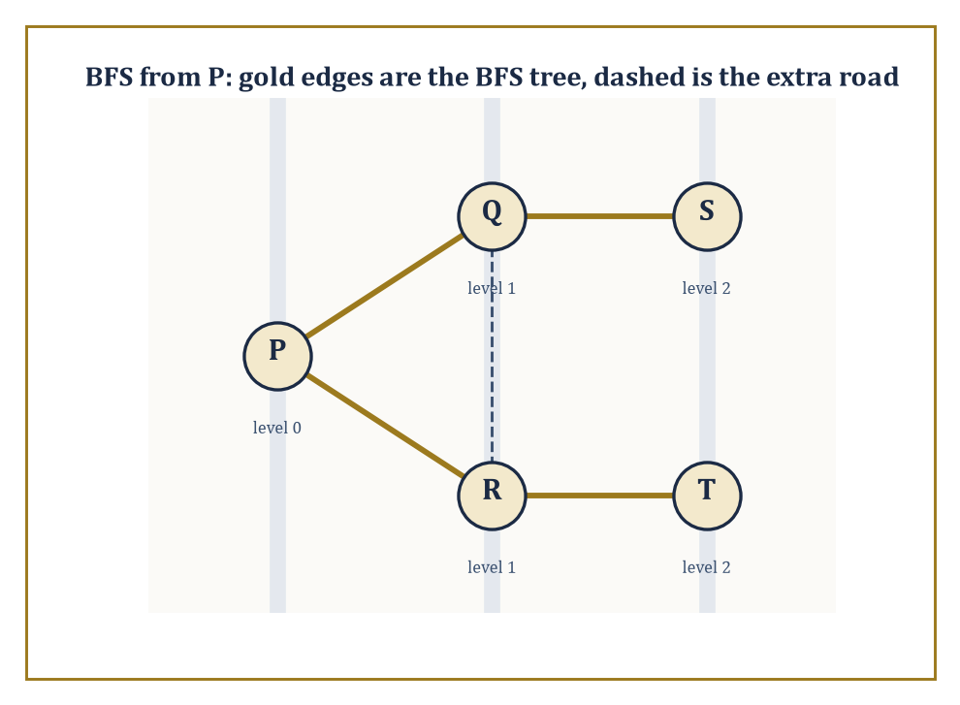
BFS from town P: gold roads form the shortest-path tree, the dashed road is scenic but redundant.
G = (V,E)
That is the entire definition, and its very sparseness is the source of its power: a graph can equally well represent a road network, a social network, a molecule’s bonds, a project’s task dependencies, or the layout of this very Tower’s corridors, because all these situations reduce to “some things, and some pairwise connections between them,” with everything else stripped away as irrelevant detail.
Variants enlarge the vocabulary as needed: directed graphs give edges a direction (an arrow, not a line), weighted graphs attach a number — distance, cost, capacity — to each edge, and multigraphs permit more than one edge between the same pair of vertices.
Numeric example — Worked example — a small road network. Five towns P, Q, R, S, T are connected by roads P–Q, P–R, Q–R, Q–S, R–T, S–T (six roads in total).
The maximum conceivable number of roads, if every pair of towns were directly connected, would be:
C(5,2) = 10
This network uses 6 of those 10 possible connections, making it a fairly well-connected but not complete graph. This same five-town map will serve as our running example for the rest of the room.
A walk is any route through a graph that follows edges, possibly revisiting vertices or edges. A path is a walk that never revisits a vertex. A cycle is a path that returns to its starting vertex (with no other repeats along the way).
Two graphs on the same vertices can look wildly different depending purely on which walks happen to close up into cycles and which do not, and this single structural fact — cyclic or acyclic — turns out to be the fork in the road that separates “graph” from “tree,” as we shall see shortly.
Numeric example — Worked example — a path and a cycle in the same map. In the P–Q–R–S–T road network above, P–Q–R–P is a cycle: the edges P–Q, Q–R, and R–P (the same road as P–R) are all present, and it returns to its start without repeating any other vertex.
Meanwhile P–Q–S–T is a path: the edges P–Q, Q–S, and S–T are all present, no vertex repeats, and it does not close up into a loop.
Incidentally, this graph has the following degree sequence:
deg(P)=2, deg(Q)=3, deg(R)=3, deg(S)=2, deg(T)=2
sum = 12 = 2×6 edges
as it must, since every edge contributes exactly 2 to the total degree count. Exactly two vertices, Q and R, have odd degree — a fact that will matter enormously in the very next paragraph.
An Eulerian circuit is a closed walk using every edge exactly once; an Eulerian path does the same without needing to return to the start.
Euler’s own theorem (from the famous Königsberg bridges problem, arguably the founding puzzle of graph theory) says a connected graph has an Eulerian circuit exactly when every vertex has even degree, and an Eulerian path exactly when the number of odd-degree vertices is 0 or 2.
A Hamiltonian circuit, by contrast, visits every vertex exactly once rather than every edge, and there is no equally tidy criterion for its existence — deciding whether one exists is, in general, believed to be computationally hard, a fact we will return to with some relish in Room 24.8.
Numeric example — Worked example — the Königsberg bridges, honestly. The original puzzle: the city of Königsberg had two riverbanks and two islands, joined by seven bridges, and the question was whether a walker could cross every bridge exactly once.
Modelling the four land masses as vertices, the degree sequence works out to 5, 3, 3, 3 (one land mass had five bridges touching it, the other three had three apiece), summing as follows:
14 = 2×7 bridges
as required. All four vertices have odd degree.
Since an Eulerian circuit needs zero odd-degree vertices and an Eulerian path needs exactly two, and here there are four, neither exists — no route crosses every bridge exactly once, however cleverly you plan the walk.
Euler proved this in 1736 by exactly this counting argument, without drawing a single diagram of the city, which remains one of the great early demonstrations that graph theory is about structure, not geography.
A tree is a connected graph with no cycles.
This single definition secretly packs in several equivalent characterisations that are worth knowing simultaneously: a tree is the minimal connected graph on its vertex set (delete any edge and it falls apart into two pieces), the maximal acyclic graph on its vertex set (add any edge and you create a cycle), and — most usefully for counting — a tree on n vertices has exactly n−1 edges, no more, no less.
A spanning tree of a connected graph G is a tree using all of G’s vertices but only some of its edges — a minimal “skeleton” that still holds everything together.
Cayley’s formula gives a strikingly clean count of how many spanning trees the complete graph Kₙ possesses:
n^(n−2)
Numeric example — Worked example — spanning trees of K4. By Cayley’s formula, K4 (four vertices, all six possible edges present) has:
4^(4−2) = 4² = 16 distinct spanning trees
Each spanning tree uses exactly 4−1 = 3 of the 6 available edges and must connect all 4 vertices without forming a cycle.
As a partial check: the total number of ways to choose 3 edges out of 6 is:
C(6,3) = 20
and of those 20 triples of edges, some form a cycle (e.g. the three edges of a triangle on 3 of the 4 vertices, leaving the fourth vertex disconnected — not spanning at all) and are therefore excluded, leaving fewer than 20 valid spanning trees; the formula tells us the exact surviving count is 16, sparing us the tedium of checking all 20 by hand.
Breadth-first search (BFS) and depth-first search (DFS) are the two fundamental algorithms for systematically exploring a graph, and between them they underpin almost every other graph algorithm you will ever meet.
BFS explores level by level from a starting vertex — visiting all neighbours first, then all neighbours of neighbours, and so on — using a queue, and the resulting BFS tree has the property that distance from the root in the tree exactly equals the shortest-path distance in the original graph (a fact provable by a clean induction on the level number).
DFS instead plunges as deep as possible before backtracking, using a stack (or recursion, which is a stack in disguise), and the resulting DFS tree instead reveals the graph’s cycle structure through its characteristic “back edges.”
Numeric example — Worked example — BFS on the road network. Run BFS on the P–Q–R–S–T network (edges P–Q, P–R, Q–R, Q–S, R–T, S–T) starting from P. Level 0: {P}.
Visit P’s unvisited neighbours Q and R — both go into level 1.
Process Q: its neighbours are P (visited), R (visited), S (unvisited) — S enters level 2.
Process R: its neighbours are P (visited), Q (visited), T (unvisited) — T enters level 2.
Process S and T: all their neighbours are already visited, so nothing new is added.
Final levels:
P=0, Q=1, R=1, S=2, T=2
These level numbers are exactly the shortest-path distances from P in an unweighted graph — for instance, the shortest route from P to T genuinely is 2 edges (P–R–T), not 1, since P and T share no direct road.

Room 24.5: Connectivity, Colorings, and Matchings
How Robust, How Colourful, How Well Matched
The connectivity of a graph — how many vertices (or edges) must be removed to disconnect it — measures how robust a network is against failure, and is worth caring about for exactly the reasons an engineer or an epidemiologist would guess: it tells you how many simultaneous failures a network can survive before falling apart.
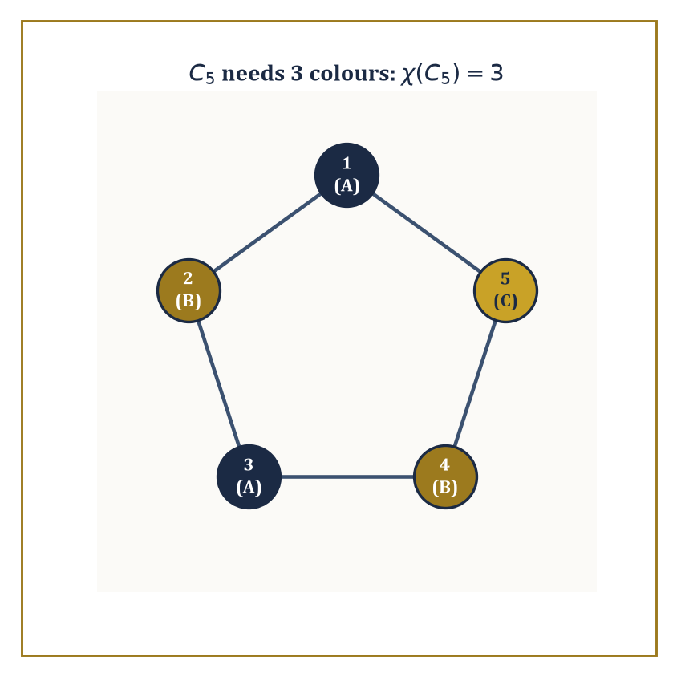
Three colours, no shortcuts: C5 flatly refuses to be tamed by two.
Menger's theorem supplies the deep reason connectivity is the right measure: the minimum number of vertices needed to separate two non-adjacent vertices equals the maximum number of vertex-disjoint paths that can be found between them. Robustness and redundancy, it turns out, are the same quantity viewed from two directions.
Numeric example — Worked example — connectivity of a 5-cycle. Take the 5-cycle C₅ on vertices 1-2-3-4-5-1. Removing any single vertex leaves a path on the remaining four, which is still connected — so one removal never disconnects it.
Removing two non-adjacent vertices, say 1 and 3: the surviving edges are only 4–5 (since edges 1-2, 2-3, 3-4, 5-1 all touch a removed vertex), leaving vertex 2 isolated from vertices 4 and 5 — disconnected.
So the connectivity of C₅ is exactly 2: some pair of removals disconnects it, and no single removal does. Menger's theorem predicts this should match the maximum number of vertex-disjoint paths between two non-adjacent vertices, say 1 and 3: indeed there are exactly two — the direct route 1-2-3, and the long way round 1-5-4-3 — sharing no intermediate vertices. Two disjoint paths, connectivity 2: theorem and direct check agree.
A planar graph is one that can be drawn in the plane with no edges crossing. For any connected planar graph drawn this way, Euler's formula relates vertices, edges, and the faces the drawing carves the plane into (where F includes the single unbounded outer face):
V − E + F = 2
Kuratowski's theorem then characterises planarity completely: a graph is planar if and only if it contains no subdivision of K5 (the complete graph on 5 vertices) or K3,3 (the complete bipartite graph on two sets of 3) as a subgraph — those two small graphs are, in a precise sense, the only fundamental obstructions to being drawable without crossings.
Numeric example — Worked example — Euler's formula on a cube. The graph of a cube's vertices and edges (as drawn, say, flattened onto the plane as a planar projection) has V=8 vertices, E=12 edges, and F=6 faces (the six square faces of the cube). Check:
V − E + F = 8 − 12 + 6 = 2
Exactly as Euler's formula demands. This is no coincidence restricted to cubes — every convex polyhedron, when its edge-graph is drawn as a planar graph, satisfies the identical relation, a fact Euler noticed for polyhedra centuries before graph theory existed as a separate subject.
Abstract example — Worked example — why K3,3 refuses to be planar. K3,3, the "utility graph" (three houses, three utilities, each utility connected to each house), has V=6 and E=9 (each of 3 vertices on one side connects to all 3 on the other):
3×3 = 9 edges
For any planar bipartite graph (no odd cycles, hence no triangular faces), a consequence of Euler's formula bounds the edge count by E ≤ 2V − 4. Here:
2V − 4 = 2(6) − 4 = 8
But E = 9 > 8, violating the bound outright. Therefore K3,3 cannot be drawn in the plane without a crossing — no amount of clever rearranging will ever route three houses to three utilities without at least one pipe crossing another, a fact many a frustrated puzzle-solver has rediscovered the hard way.
Graph colouring assigns colours to vertices so that no edge joins two vertices of the same colour, and the chromatic number χ(G) is the fewest colours needed to do this. A simple greedy argument shows χ(G) ≤ Δ(G) + 1, where Δ(G) is the largest vertex degree (colour the vertices in any order, and each vertex always has at least one colour left over from its at most Δ neighbours).
For planar graphs specifically, the celebrated four-colour theorem — proved in 1976 with the aid of a computer checking an enormous number of cases, to the considerable discomfort of mathematicians who prefer their proofs to fit on a napkin — asserts that four colours always suffice, however intricate the map.
Numeric example — Worked example — colouring an odd cycle. Return to C₅ (the 5-cycle 1-2-3-4-5-1). Try to 2-colour it by alternating: 1=A, 2=B, 3=A, 4=B, and now vertex 5 is adjacent to both vertex 4 (colour B) and vertex 1 (colour A) — every remaining colour is already forbidden by a neighbour, so 2 colours are not enough.
This is not a failure of cleverness; it is structural: any odd cycle cannot be 2-coloured, because 2-colourability is exactly equivalent to bipartiteness, and an odd cycle is famously not bipartite.
Three colours do work: 1=A, 2=B, 3=A, 4=B, 5=C. Check every edge: 1-2 (A,B) fine, 2-3 (B,A) fine, 3-4 (A,B) fine, 4-5 (B,C) fine, 5-1 (C,A) fine.
So χ(C₅) = 3, consistent with the greedy bound χ ≤ Δ+1 = 2+1 = 3 (each vertex of C₅ has degree 2), and this bound happens to be tight here.
A matching is a set of edges no two of which share a vertex — pairing things up with no double-booking. Hall's marriage theorem gives a clean existence criterion for a perfect matching in a bipartite graph: one exists if and only if, for every subset S of one side, the set of vertices it connects to on the other side (its neighbourhood) is at least as large as S itself — no group of "suitors" may collectively be interested in fewer "partners" than their own number.
König's theorem then connects matching to another quantity entirely: in a bipartite graph, the size of the maximum matching equals the size of the minimum vertex cover (a smallest set of vertices touching every edge) — a genuinely useful equivalence, since one of these quantities is often far easier to compute than the other, and Tutte's theorem extends the existence question to general, non-bipartite graphs.
Numeric example — Worked example — assigning workers to jobs. Three workers W1, W2, W3 are qualified for jobs as follows: W1 can do J1 or J2; W2 can only do J1; W3 can do J2 or J3. Check Hall's condition for every subset of workers:
{W1}→{J1,J2}, size 2≥1 ✓
{W2}→{J1}, size 1≥1 ✓
{W3}→{J2,J3}, size 2≥1 ✓
{W1,W2}→{J1,J2}, size 2≥2 ✓
{W1,W3}→{J1,J2,J3}, size 3≥2 ✓
{W2,W3}→{J1,J2,J3}, size 3≥2 ✓
{W1,W2,W3}→{J1,J2,J3}, size 3≥3 ✓
Every subset's neighbourhood is large enough, so a perfect matching exists by Hall's theorem.
Constructing it: W2 has only one option, so W2 must take J1. That forces W1 away from J1, leaving W1 to take J2. That in turn forces W3 away from J2, leaving W3 to take J3.
Final matching: W1–J2, W2–J1, W3–J3 — every worker placed, every job filled, no conflicts, exactly as Hall's theorem promised it must be possible.

Room 24.6: Logic, Proofs, and Boolean Algebra
The Grammar of Certainty
Propositional logic studies compound statements built from simpler ones by connectives: ∧ (and), ∨ (or), ¬ (not), → (implies), and ↔ (if and only if).
A truth table lists every possible combination of truth values for the component propositions and records the resulting truth value of the whole compound statement — a small, exhaustive, and entirely mechanical way to settle any question of logical validity, since there are only finitely many rows to check.
Numeric example — Worked example — the truth table for implication. For p→q (“p implies q”), the truth table has four rows, one per combination of p and q:
p=T,q=T gives T
p=T,q=F gives F
p=F,q=T gives T
p=F,q=F gives T
The only row making the whole statement false is p true and q false — “p implies q” fails precisely when p happens but q does not, and is (perhaps counterintuitively at first) considered true whenever p itself is false, since a promise about a hypothetical that never arises is never broken.
This is the famous “vacuous truth,” and yes, it does mean “if pigs fly, then 2+2=5” is a logically true statement, in exactly the sense that matters for proofs.
Two statements are logically equivalent if they share the same truth table — the same truth value on every row, regardless of the underlying propositions’ actual meaning. De Morgan’s laws are the workhorse equivalences for rewriting statements into normal forms (conjunctive normal form, a big AND of ORs, or disjunctive normal form, a big OR of ANDs):
¬(p∧q) ≡ ¬p∨¬q
¬(p∨q) ≡ ¬p∧¬q
Every Boolean formula can be rewritten into either form — a fact that underlies both automated theorem proving and the design of digital circuits.
Numeric example — Worked example — checking De Morgan by exhaustion. Verify ¬(p∧q) ≡ ¬p∨¬q across all four rows.
p=T,q=T: p∧q=T so ¬(p∧q)=F; and ¬p=F, ¬q=F, so ¬p∨¬q=F. Match.
p=T,q=F: p∧q=F so ¬(p∧q)=T; ¬p=F, ¬q=T, so ¬p∨¬q=T. Match.
p=F,q=T: p∧q=F so ¬(p∧q)=T; ¬p=T, ¬q=F, so ¬p∨¬q=T. Match.
p=F,q=F: p∧q=F so ¬(p∧q)=T; ¬p=T, ¬q=T, so ¬p∨¬q=T. Match.
All four rows agree, so the equivalence holds — proved not by cleverness but by simply refusing to leave any case unchecked, which is rather the point of a truth table.
Predicate logic extends propositional logic with quantifiers: ∀x P(x) (“for all x, P(x) holds”) and ∃x P(x) (“there exists an x for which P(x) holds”).
The order in which quantifiers are nested is not a stylistic nicety — it changes the meaning entirely, and mixing up ∀∃ with ∃∀ is one of the most common and most consequential logical errors a student (or, let it be said quietly, an occasional don) can make.
Numeric example — Worked example — quantifier order changes everything. Let P(x,y) mean “y > x” over the integers.
Consider ∀x ∃y P(x,y): for every integer x, does some larger integer y exist? Yes — given any x, take y=x+1, and y>x always holds. The statement is true.
Now consider ∃y ∀x P(x,y): does a single integer y exist that is larger than every integer x? No — the integers are unbounded above, so for any candidate y, taking x=y itself (or larger) breaks the claim. The statement is false.
Swapping merely the order of two symbols flipped a true statement into a false one — the ∀∃ version allows the witness y to depend on x (a new, larger y for each x), while the ∃∀ version demands one fixed y that dominates every x simultaneously, which is a vastly stronger and here impossible requirement.
The standard proof techniques of discrete mathematics are worth naming explicitly, since half the difficulty of writing a proof is choosing the right shape for it before you start.
Direct proof assumes the hypothesis and derives the conclusion by a chain of valid steps.
Proof by contrapositive proves “not Q implies not P” instead of “P implies Q” — logically identical, but sometimes far easier to work with.
Proof by contradiction assumes the conclusion is false and derives an absurdity.
Mathematical induction proves a statement for all natural numbers by establishing a base case and an inductive step that carries truth from n to n+1 (or, in strong induction, from all values up to n).
Diagonalization constructs an object that provably differs from every item on a proposed complete list, thereby proving the list cannot have been complete after all.
Numeric example — Worked example — induction proves the sum formula. Claim:
1+2+3+...+n = n(n+1)/2 for every positive integer n
Base case, n=1: left side is 1; right side is
1·2/2 = 1
They match. Inductive step: assume the formula holds for some k, i.e.
1+2+...+k = k(k+1)/2 (the inductive hypothesis)
Then for k+1:
1+2+...+k+(k+1) = k(k+1)/2 + (k+1) = (k+1)[k/2 + 1] = (k+1)(k+2)/2
which is exactly the formula evaluated at n=k+1. Since the base case holds and each case drags the next one along, the formula holds for every positive integer n — not merely the ones we happened to check by hand, but literally all of them, an infinite claim proved in two finite steps.
As a spot check at n=6: formula gives
6·7/2=21
and direct addition
1+2+3+4+5+6=21
Matches.
Abstract example — Worked example — diagonalization, in miniature. Suppose someone claims to have listed every infinite sequence of 0s and 1s, as an infinite list s₁, s₂, s₃, s₄, .... To see the list must be missing something, build a new sequence t by flipping the n-th digit of the n-th sequence:
t’s n-th digit is 1 minus sₙ’s n-th digit
As a concrete taste, suppose the list begins:
s₁=0110..., s₂=1011..., s₃=0001..., s₄=1100...
The diagonal digits are s₁’s 1st digit (0), s₂’s 2nd digit (0), s₃’s 3rd digit (0), s₄’s 4th digit (0); flipping each gives
t = 1111...
By construction t differs from s₁ in position 1, from s₂ in position 2, from s₃ in position 3, and from s₄ in position 4 — and this pattern continues no matter how far down the (infinite) list you look, since t’s n-th digit is defined specifically to disagree with sₙ’s n-th digit. So t cannot equal any sequence on the list, however the list was constructed, proving the list was never complete to begin with.
This is a small, contained taste of an argument that becomes considerably more consequential — and considerably more unsettling — in the very next storey.
Boolean algebra is the algebraic structure of truth values themselves, with operations ∧, ∨, ¬ obeying laws — commutativity, associativity, distributivity, De Morgan’s laws, absorption — that are, symbol for symbol, identical to the laws of set algebra (∩, ∪, complement) and to the laws governing switching circuits (AND gates, OR gates, NOT gates).
This is not a superficial analogy dressed up to look profound: all three are models of the same abstract algebraic structure, which is precisely why a circuit designer, a logician, and a set theorist can, and regularly do, borrow each other’s simplification tricks without needing to translate anything.
Numeric example — Worked example — simplifying a Boolean circuit. Simplify:
(A∧B)∨(A∧¬B)
By the distributive law this factors as
A∧(B∨¬B)
and since B∨¬B is always true (a tautology — one of B or ¬B must hold), the whole expression collapses to simply A. Check by exhaustive truth table:
A=1,B=1: (1∧1)∨(1∧0) = 1∨0 = 1 = A ✓
A=1,B=0: (1∧0)∨(1∧1) = 0∨1 = 1 = A ✓
A=0,B=1: (0∧1)∨(0∧0) = 0∨0 = 0 = A ✓
A=0,B=0: (0∧0)∨(0∧1) = 0∨0 = 0 = A ✓
All four rows confirm the simplification. In circuit terms, this means a circuit built from two AND gates and one OR gate, wired exactly this way, can be replaced by a single wire carrying A — one gate’s worth of hardware doing the work three gates were previously doing, which is exactly the kind of saving that keeps circuit designers, and their budgets, cheerful.

Room 24.7: Sets, Relations, and Functions (Discrete View)
Tidying Up Before the Infinite Arrives
Finite sets are counted either directly, by inclusion–exclusion when categories overlap, or — most elegantly — by exhibiting a bijection with some other set whose size is already known, as we practised back in Room 24.1. A very ordinary but genuinely useful counting fact concerns divisors: if a positive integer n has prime factorisation
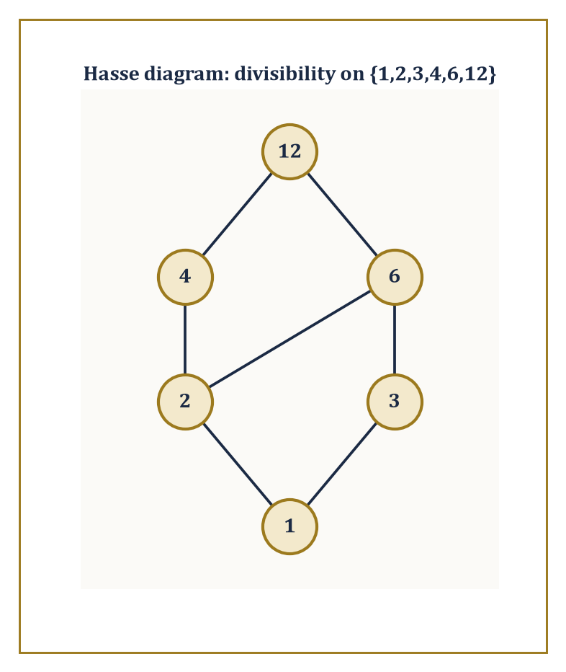
The divisibility order on {1,2,3,4,6,12}, with every edge that transitivity already implies tactfully left off the picture.
n = p₁^a₁ · p₂^a₂ · ... · pₖ^aₖ
the number of positive divisors of n is
(a₁+1)(a₂+1)...(aₖ+1)
because choosing a divisor amounts to independently choosing, for each prime, how many copies of it (from 0 up to aᵢ) to include, and that is the product rule again, quietly running the show.
Numeric example — Worked example — counting the divisors of 60. Factorise 60.
60 = 2² · 3¹ · 5¹
The divisor-count formula gives
(2+1)(1+1)(1+1) = 3·2·2 = 12
divisors. Listing them directly to check:
1, 2, 3, 4, 5, 6, 10, 12, 15, 20, 30, 60
— exactly twelve numbers, and each one does divide 60 evenly.
60/4=15, 60/6=10, 60/12=5, 60/15=4, 60/20=3, 60/30=2
— all exact. The formula and the exhaustive list agree, and the formula would remain just as fast even if 60 were replaced by a number with forty digits, which the listing approach very much would not.
A relation on a set S is simply a set of ordered pairs from S×S — a formal way of saying "these elements are related, and those are not." Relations are classified by which structural properties they satisfy: reflexive (every element relates to itself), symmetric (if a relates to b, then b relates to a), transitive (if a relates to b and b relates to c, then a relates to c), and antisymmetric (if a relates to b and b relates to a, then a=b — no distinct pair relates both ways).
A relation that is reflexive, symmetric, and transitive is called an equivalence relation, and equivalence relations are important precisely because of what they do to a set, described in the next paragraph.
Numeric example — Worked example — congruence mod 3 is an equivalence relation. Define a ~ b on {0,1,2,...,8} to mean "a and b leave the same remainder when divided by 3." Reflexive: a always has the same remainder as itself. Symmetric: if a and b share a remainder, so do b and a — trivially. Transitive: if a and b share a remainder, and b and c share a remainder, then a and c share that same remainder too.
All three properties hold, so ~ is an equivalence relation. Grouping the nine elements by shared remainder gives three classes:
{0,3,6} (remainder 0), {1,4,7} (remainder 1), {2,5,8} (remainder 2)
This is not a coincidence specific to remainders: every equivalence relation on a set partitions that set into disjoint, non-empty classes (its equivalence classes) whose union is the whole set, and conversely every partition of a set defines an equivalence relation ("related" meaning "in the same block").
The two notions — equivalence relation and partition — are, in fact, exactly the same idea described in two different vocabularies, a small but genuinely useful piece of intellectual economy.
Numeric example — Worked example — the partition, counted. Continuing the mod-3 example: the three equivalence classes {0,3,6}, {1,4,7}, {2,5,8} are pairwise disjoint (no element sits in two classes at once) and their union recovers the whole original set {0,1,...,8}. As a count:
3+3+3 = 9
matching the original set's size exactly — every element accounted for precisely once, which is the defining feature of a genuine partition.
A partial order is a relation that is reflexive, antisymmetric, and transitive — like an equivalence relation's stricter, less forgiving cousin, one that organises a set into a hierarchy rather than into flat, interchangeable clusters. Divisibility on the positive integers is a classic example: a ≤ b meaning "a divides b." A Hasse diagram draws only the covering relations — the direct "one level up" connections, omitting anything implied by transitivity — giving an economical picture of the whole order at a glance.
Abstract example — Worked example — the divisibility Hasse diagram on {1,2,3,4,6,12}. Check every pair for a covering relation (a covers b if b|a with nothing dividing strictly between them). 1 covers 2 (nothing between 1 and 2 in the divisibility order) and 1 covers 3, similarly. 2 covers 4 (divisors of 4 are 1,2,4 — nothing strictly between 2 and 4) and 2 covers 6 (divisors of 6 touching 2 are just 2 and 6 itself). 3 covers 6 by the same reasoning. 4 covers 12 (no divisor of 12 sits strictly between 4 and 12) and 6 covers 12 likewise.
Note that 1 does NOT directly cover 4 in the diagram, even though 1 divides 4, because 2 sits strictly in between
1|2|4
that relation is implied by transitivity and so is left off the picture. The resulting diagram has three levels: {1} at the bottom, {2,3} above it, {4,6} above that, and {12} at the top, joined by the covering edges just listed — a compact, uncluttered map of an order relation that, drawn in full with every implied pair, would have needed far more ink.
A function f: A→B assigns each element of A exactly one element of B. It is injective (one-to-one) if distinct inputs always give distinct outputs; surjective (onto) if every element of B is hit by something; and bijective if both hold at once — the strongest and most useful condition, since a bijection is precisely a perfect pairing, the very tool we relied on throughout Room 24.1.
Numeric example — Worked example — counting injections. How many injective functions are there from {1,2,3} to {a,b,c,d}? Each element of the domain needs a distinct image: 4 choices for f(1), then 3 remaining choices for f(2) (it must differ from f(1)), then 2 remaining for f(3) — giving
4×3×2 = 24
total, which is exactly P(4,3) from Room 24.2's permutation formula:
P(4,3) = 4!/(4−3)! = 24/1 = 24
None of these 24 functions can be surjective, incidentally, since the domain has only 3 elements to cover a codomain of 4 — one element of {a,b,c,d} is always left unhit, which brings us directly to the next, rather more forceful, observation.
The pigeonhole principle states, with almost insulting simplicity, that if more than n objects are placed into n boxes, some box contains more than one object — equivalently, no injection can exist from a strictly larger finite set into a smaller one.
Simple to state, yet it proves results that feel far too strong to have come from something so obvious; the generalised version sharpens this to: distributing N objects into n boxes forces some box to contain at least ⌈N/n⌉ objects.
Numeric example — Worked example — birthdays, guaranteed. Among any 13 people, at least two must share a birth month, since there are only 12 months and 13 > 12 — the basic pigeonhole principle applied directly.
Now sharpen it: among 25 people and 12 months, the generalised pigeonhole principle guarantees some month contains at least ⌈25/12⌉ people. Compute:
25/12 ≈ 2.083
and rounding up gives
⌈25/12⌉ = 3
So at least 3 of the 25 people were born in the same month — not a probability, not a likelihood, but a mathematical certainty, guaranteed purely by counting, with no need to know anything at all about how birthdays are actually distributed.

Room 24.8: Introduction to Algorithms and Complexity
What All This Counting Costs
An algorithm is a finite, deterministic procedure that transforms an input into an output in a bounded number of steps.
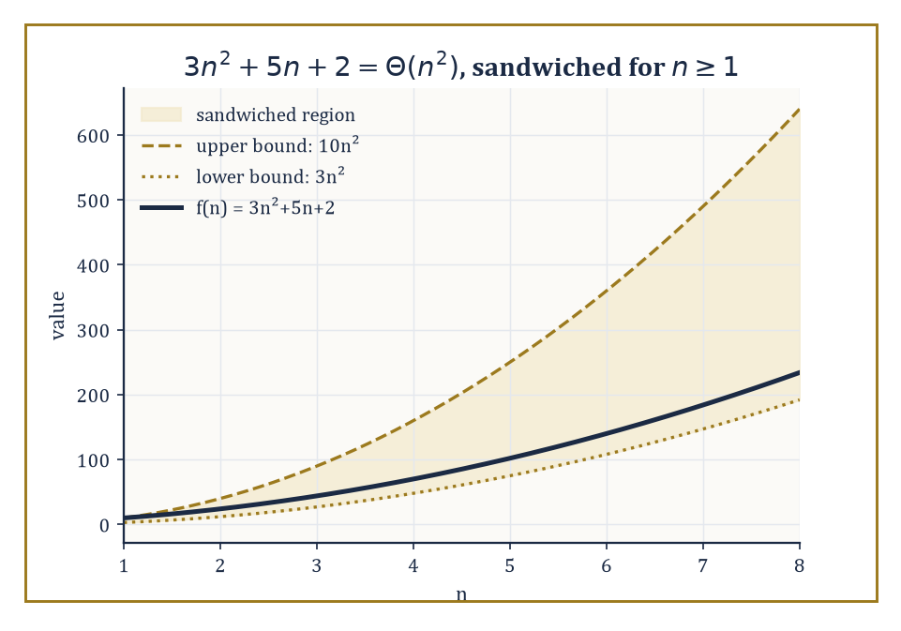
3n²+5n+2 kept honestly between two straight-faced multiples of n² — that is all Θ(n²) has ever promised.
Correctness is established not by running it and hoping, but by proving a loop invariant — a statement that is true before the process begins, remains true after every step, and, once the process finishes, implies the desired result.
This is induction again, wearing yet another disguise: the invariant is the inductive hypothesis, and each step of the algorithm is the inductive step.
Numeric example — Worked example — linear search, traced and verified. Search for the value 7 in the array [3, 9, 7, 1, 5] by checking each element in order.
Index 0: compare 3 to 7 — no match (1 comparison so far). Index 1: compare 9 to 7 — no match (2 comparisons). Index 2: compare 7 to 7 — match, return index 2 (3 comparisons total).
The loop invariant here is simply “the target has not been found among the elements examined so far,” which trivially holds before the loop starts (nothing examined yet), is preserved by each failed comparison, and — the moment it is violated by a successful comparison — immediately hands us the correct answer.
Three comparisons were needed for a five-element array; in the worst case (target absent, or in the last position), linear search on n elements needs exactly n comparisons.
Running time is measured as a function of input size n, and to avoid drowning in irrelevant detail, we describe it up to constant factors and lower-order terms using asymptotic notation.
f(n) = O(g(n))
This means f is eventually bounded above by some constant multiple of g.
f(n) = Ω(g(n))
This means f is bounded below similarly.
f(n) = Θ(g(n))
This means both at once — f and g grow at genuinely the same rate, up to a constant.
Numeric example — Worked example — proving 3n² + 5n + 2 is Θ(n²). We need constants c₁, c₂ > 0 and a threshold n₀ such that the following sandwich holds for all n ≥ n₀.
c₁n² ≤ 3n²+5n+2 ≤ c₂n²
Lower bound: since 5n+2 ≥ 0 for all n ≥ 0, we always have 3n²+5n+2 ≥ 3n², so c₁=3 works for every n₀ ≥ 0.
Upper bound: we need 5n+2 ≤ (c₂−3)n² for n ≥ n₀; trying c₂=10 means checking whether the following holds.
5n+2 ≤ 7n²
At n=1: left side 5+2=7, right side 7·1=7 — equality holds. For n≥1 the quadratic term grows faster than the linear one, so the inequality only strengthens as n increases (at n=2: left=12, right=28).
3n² ≤ 3n²+5n+2 ≤ 10n²
So with c₁=3, c₂=10, n₀=1, this sandwich holds for all n≥1, confirming the following.
3n²+5n+2 = Θ(n²)
The “+5n+2” is, from the point of view of asymptotic growth, entirely beneath our notice.
Comparison-based sorting algorithms — those that decide the final order purely by pairwise comparisons — face an unavoidable lower bound.
Model every possible sequence of comparisons as a binary decision tree: each internal node is one comparison, each leaf is one possible sorted output.
Since there are n! possible orderings of n distinct elements, the tree needs at least n! leaves, and a binary tree with n! leaves must have depth at least the following.
depth ≥ ⌈log₂(n!)⌉
That means any correct comparison sort needs at least that many comparisons in the worst case, for every algorithm, no matter how cleverly written.
Numeric example — Worked example — the comparison lower bound for 5 elements. For n=5, there are the following number of possible orderings.
5! = 120
We need ⌈log₂(120)⌉. Since
2⁶ = 64 and 2⁷ = 128
log₂(120) lies strictly between 6 and 7 (closer to 7), so
⌈log₂(120)⌉ = 7
No comparison-based algorithm can correctly sort 5 arbitrary elements using fewer than 7 comparisons in the worst case — and this bound is not merely theoretical throat-clearing, either: it is a known, tight result that exactly 7 comparisons both suffice and are necessary to sort 5 elements optimally. The theoretical floor and the best achievable algorithm meet exactly, which happens far less often in complexity theory than one might hope.
Graph traversal algorithms such as BFS and DFS (Room 24.4) run in the following time.
O(V+E)
That means visiting every vertex once and examining every edge once — which is as fast as any algorithm could possibly be, since it must at minimum read its own input.
Numeric example — Worked example — counting the work in a traversal. Take a graph with V=6 vertices and E=7 edges: {1,2,3,4,5,6} with edges 1-2, 1-3, 2-4, 3-4, 4-5, 5-6, 3-6.
A BFS or DFS from any starting vertex performs work proportional to the following.
V+E = 6+7 = 13
That means visiting each of the 6 vertices once and inspecting each of the 7 edges (in an appropriate representation) at most twice, once from each endpoint, which is still a constant factor and so still counted as O(V+E), not something worse.
Doubling the graph’s size (12 vertices, 14 edges, say, by attaching a similar structure) roughly doubles the running time — genuinely linear behaviour, the best a traversal algorithm could possibly hope for.
The deepest open question in the whole of computer science is whether P equals NP. P is the class of problems solvable in time polynomial in the input size. NP is the class of problems whose proposed solutions can be verified in polynomial time, even if finding a solution from scratch might take vastly longer.
Every problem in P is trivially in NP (if you can solve it quickly, you can certainly check a solution quickly), but whether the reverse holds — whether easy verification always implies easy solving — remains unresolved, with a rather large prize attached to whoever settles it convincingly.
SAT (Boolean satisfiability), the clique problem, vertex cover, and the Hamiltonian cycle problem from Room 24.1 are all NP-complete: each is in NP, and each is at least as hard as every other problem in NP, so that a fast algorithm for any one of them would instantly yield a fast algorithm for all of them, collapsing the entire question at a stroke.
Abstract example — Worked example — verifying, versus finding, a SAT solution. Consider the 3-SAT formula (x₁∨x₂∨¬x₃) ∧ (¬x₁∨x₃) ∧ (x₂∨¬x₃), and the proposed assignment x₁=False, x₂=True, x₃=True.
Verification is fast.
clause 1: x₁∨x₂∨¬x₃ = F∨T∨F = T ✓ (since ¬x₃=¬True=False)
clause 2: ¬x₁∨x₃ = T∨T = T ✓ (since ¬x₁=¬False=True)
clause 3: x₂∨¬x₃ = T∨F = T ✓
All three clauses are satisfied, confirmed in three quick checks — polynomial-time verification, exactly as NP membership requires.
Finding this assignment in the first place, though, without being handed it, is a different matter: with 3 boolean variables there are only the following number of possible assignments to check.
2³ = 8
That is entirely manageable by brute force here — but for a formula with, say, 100 variables, brute force means checking up to the following number of possibilities.
2¹⁰⁰
That is a number so large that no computer built from the atoms of the observable universe, running since the Big Bang, could finish the search.
That gulf — trivial to check, ruinous to search — is the entire content of the P versus NP question, and it is a question this Tower, for all its many storeys, is not going to settle today.

Room 24.9: Looking Ahead: From Discrete Mathematics to Combinatorics, Graph Theory, and Theoretical CS
The View From the Landing
We have now acquired the working vocabulary of discrete mathematics: counting, recurrences, graphs, logic, relations, and a first taste of what algorithms cost to run.
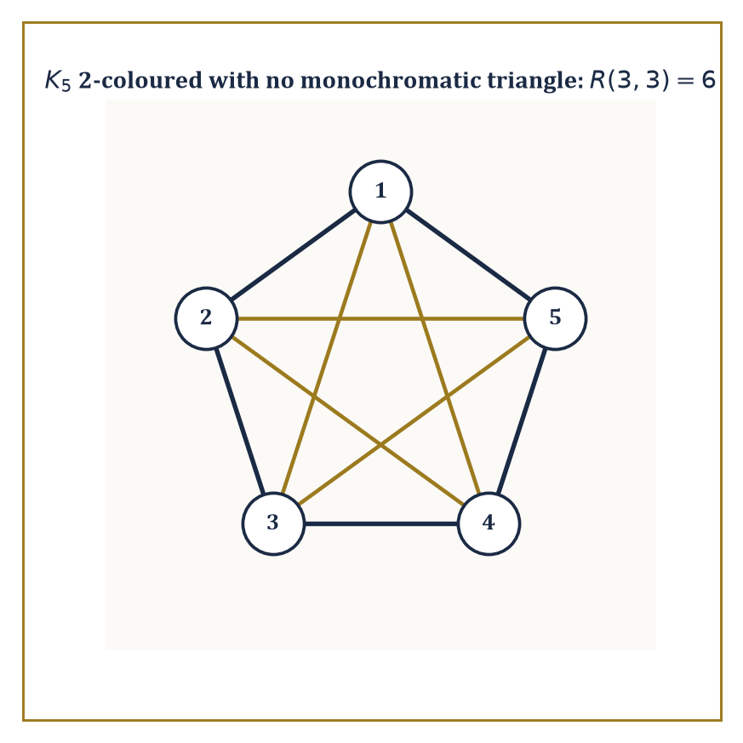
One pentagon, one pentagram, zero monochromatic triangles — a sixth vertex would have made this picture impossible to draw.
It is worth pausing on the landing before the next flight of stairs, because each of these threads keeps unspooling well past the point where this storey chose to stop, and it is useful to know roughly where each one leads.
Enumerative combinatorics takes the counting toolbox of Room 24.2 and pushes it much further, into partitions, symmetric functions, and species theory.
Extremal and probabilistic combinatorics ask a subtly different question: not “how many exactly,” but “how large or small can a structure with a given property possibly be,” and they answer it with startling arguments that mix counting with probability.
Numeric example — Worked example — a taste of Ramsey theory. The Ramsey number R(3,3) is a classic extremal result: colour every edge of the complete graph K₆ either red or blue, in absolutely any way you like, and a monochromatic triangle (three vertices, all three connecting edges the same colour) is unavoidable — guaranteed to appear, with no possible clever colouring scheme dodging it.
Yet K₅ can be 2-coloured to avoid one entirely (colour the edges of one pentagon red and the edges of the complementary five-pointed star blue, and check: no triangle is monochromatic). So 6 is the exact threshold — five vertices can escape, six cannot — which is precisely why R(3,3) is defined as follows.
R(3,3) = 6
Ramsey theory’s general slogan, of which this is the founding example, is that complete disorder is impossible: past a certain size, structure is forced to appear whether you want it or not.
Algebraic graph theory links graphs to linear algebra by studying a graph’s adjacency matrix and its eigenvalues, which turn out to encode an astonishing amount of structural information — connectivity, bipartiteness, even how quickly a random walk on the graph mixes — inside a purely algebraic object.
Numeric example — Worked example — eigenvalues of a 4-cycle. For the cycle graph Cₙ, the adjacency matrix eigenvalues are known in closed form.
λₖ = 2cos(2πk/n), for k = 0, 1, ..., n−1
For C₄ (n=4), compute each eigenvalue in turn.
λ₀ = 2cos(0) = 2
λ₁ = 2cos(π/2) = 2×0 = 0
λ₂ = 2cos(π) = 2×(−1) = −2
λ₃ = 2cos(3π/2) = 2×0 = 0
The eigenvalues are {2, 0, 0, −2}.
2 + 0 + 0 − 2 = 0
Notice they sum to zero, which must hold for any graph’s adjacency matrix, since the diagonal of the adjacency matrix — the trace, which equals the sum of eigenvalues — is entirely zero (no vertex is adjacent to itself, absent unusual conventions). A structural fact about the drawing (no self-loops) forced an algebraic fact about the eigenvalues, without either side needing to consult the other directly.
Formal languages and automata theory systematise the notion of computation itself, starting from finite-state machines — tiny devices with a handful of states and simple transition rules — and building upward through increasingly powerful models.
Numeric example — Worked example — a finite automaton that computes remainders. Build a 3-state machine with states S₀, S₁, S₂ (representing “remainder 0, 1, 2 mod 3 so far”), reading a binary number one bit at a time from the most significant end, with the following transition rule: on reading bit b in state s, move to a new state.
new state = (2s + b) mod 3
This works because appending a bit to a binary number doubles the number and adds the bit, so the remainder mod 3 updates the same way. Trace the binary string 110 (which represents the decimal number 6): start at S₀.
Read '1': (2×0+1) mod 3 = 1 → move to S₁
Read '1': (2×1+1) mod 3 = 3 mod 3 = 0 → move to S₀
Read '0': (2×0+0) mod 3 = 0 → stay at S₀
The machine ends in state S₀, correctly signalling that 6 is divisible by 3 — a tiny, entirely mechanical device with only three internal states has just computed a remainder, with no arithmetic circuitry beyond the three transition rules themselves.
Cryptography and coding theory, meanwhile, lean heavily on finite fields and the discrete logarithm problem — the fact that computing xʸ mod p is fast, while recovering y from xʸ mod p (given only x and the result) is believed to be extraordinarily hard for suitably large primes p, an asymmetry that much of modern secure communication is quietly built on top of.
Numeric example — Worked example — a discrete logarithm, small enough to solve by hand. Work in the integers mod 7, using base 3. Compute successive powers.
3¹ = 3
3² = 9 mod 7 = 2
3³ = 3×2 = 6 mod 7 = 6
3⁴ = 3×6 = 18 mod 7 = 4
3⁵ = 3×4 = 12 mod 7 = 5
3⁶ = 3×5 = 15 mod 7 = 1
The powers cycle through {3,2,6,4,5,1} — all six nonzero residues mod 7 — before repeating, which makes 3 a “primitive root” mod 7. Suppose someone hands you the value 6 and asks: what power of 3, mod 7, gives 6? Scanning the table above, 3³=6, so the discrete logarithm of 6 base 3 (mod 7) is 3.
For a modulus this small, scanning the whole table by hand takes seconds. For a modulus hundreds of digits long, the equivalent table has more entries than there are atoms to write them on, and no faster method than essentially exhaustive search is publicly known — which is precisely the gap that keeps this small, symmetric-looking arithmetic exercise underpinning a great deal of the world’s encrypted traffic.
The deeper lesson threading through this entire storey is that finite structures admit a rich, precise theory of their own, every bit as deep as anything in the continuous world we left behind two storeys ago — and that the same theory underpins both pure combinatorial mathematics and the design and analysis of every algorithm that has ever run on a computer.
Discrete mathematics is the mathematics of the finite, and the finite, as it happens, is where computation actually lives.
We have learned to count carefully and to argue precisely — two skills that sound modest until you notice how much of the rest of mathematics quietly depends on both being done correctly, and how often, in ordinary life, neither is.
But scrupulous finitude was never going to be the whole story, and by now you have almost certainly noticed the loose thread we kept tugging at and refusing to pull all the way: diagonalization, back in Room 24.6, dressed up as a modest trick for showing a list of binary strings could not be complete. That trick did not stay modest for long. In the next storey, Set Theory & Logic, the very same argument is aimed squarely at infinity itself, and it turns out that not all infinities are the same size — that there are, in a perfectly rigorous sense, more real numbers than there are counting numbers, and stranger sizes still above those. Sets, which this storey treated as tame, countable, list-it-and-be-done objects, are about to become considerably less tame, and considerably more interesting.
The tower continues upward. Mind the step — the next one is rather larger than it looks.

Storey 25: Set Theory & Logic
Foundations, Infinite Sets, and the Art of Reasoning About Reasoning
The last storey left us rather pleased with ourselves. We had spent it reasoning cleanly about finite structures — graphs, counting arguments, algorithms that always terminate — the sort of mathematics you could, in principle, verify by hand, given enough hands and an unreasonable amount of patience. This storey asks a ruder question, the kind a small child asks and a career mathematician spends decades trying to stop being asked: what, precisely, is a 'thing'? And once we have things, what does it mean to reason about them correctly at all?
Every mathematical object met on the climb so far — numbers, functions, spaces, the graphs of the last storey — can be formalised inside set theory, a subject built from a single primitive relation (membership, ∈) and a handful of careful rules about which collections are allowed to exist. Logic, its constant companion, supplies the grammar: the connectives and quantifiers and inference rules that let one sentence follow validly from another, and that let a proof be checked rather than merely admired. Together they are not the mathematics anyone does day to day — nobody visualises their theorem as a chain of set-builder notation — but they are the guarantee sitting quietly underneath every other storey of this Tower: if a proof is ever pushed hard enough, it can be cashed out in these terms, all the way down to the empty set.
A small confession, before we start: set theory and logic can feel remote from the concrete calculation of earlier storeys, all those clean numeric answers replaced by talk of infinities and inference rules. The remoteness is only apparent. The cardinality that classifies infinite sets in this storey is the same cardinality that separated countable from uncountable bases many storeys back; the quantifiers ∀ and ∃ that structure predicate logic are the very quantifiers buried inside every ε-δ definition of a limit; the inductive constructions that build the natural numbers here are the same technique, one storey removed, that built the formulas of every formal language since.
If the last storey taught us to reason about finite, countable structures with total confidence, this one teaches us to reason about the infinite, and about the act of reasoning itself, with the same rigour. Let's begin, as one always must in this subject, with the empty set.

Room 25.1: What Set Theory and Logic Actually Are
In which we build the number three out of nothing at all
Set theory is the study of collections of objects — called sets — together with the single relation that matters most in mathematics: membership, written ∈. From membership alone, an entire universe can be built: pairs, functions, numbers, spaces, the lot.
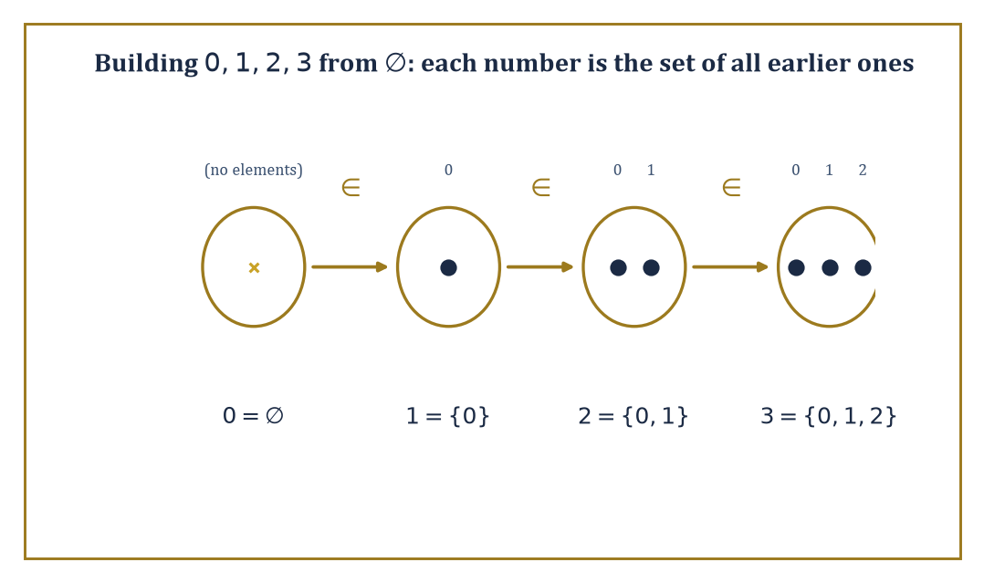
Four sets, one membership chain: 0∈1∈2∈3, built from ∅ using nothing but Pairing and Union.
Mathematical logic, meanwhile, is the study of formal languages and the rules by which one sentence may be validly obtained from others. Where set theory asks 'what exists?', logic asks 'what follows?' — and mathematics, as a going concern, needs answers to both.
Numeric example — Building the numbers 0-3 from nothing. Set theory's boldest party trick is manufacturing the natural numbers out of the empty set ∅ and nothing else, defining each successor as 'the set of everything built so far.'
0 = ∅
1 = {∅} = {0}
2 = {∅,{∅}} = {0,1}
3 = {∅,{∅},{∅,{∅}}} = {0,1,2}
Here 0 is the set with no elements, 1 a set containing one element, 2 a set containing two elements, and 3 a set containing three elements. Two things are worth checking, and both are true: first, each number genuinely has as many elements as its name suggests — 3 has exactly three elements, 0, 1, and 2 — so 'size' falls straight out of the construction. Second, membership tracks order:
0∈1∈2∈3
and in fact 0∈3, 1∈3, 2∈3 as well, since each later number contains all the earlier ones. The number 4 is built the same way, and so on forever — the entire edifice of arithmetic (Storeys 1-3 of this Tower) can, if you insist, be re-derived from these bare sets. Nobody does this in daily practice, for the same reason nobody derives their morning coffee from the standard model of particle physics — but the fact that one could is precisely the point of a foundation.
None of this works without care, though. The naive idea that 'any description you can state carves out a set' cannot be maintained without contradiction — Room 25.2 will watch it collapse in real time — so the working axioms of set theory, Zermelo–Fraenkel with Choice (ZFC), replace unrestricted set-formation with a short, narrowly worded list of construction permits: an empty set exists; the pair of any two existing sets exists; the union of any existing collection exists; the subset of an existing set carved out by a formula exists; and a handful more in the same bureaucratic spirit.
It looks like paperwork. It is paperwork. It is also the only reason the rest of this Tower is standing on solid ground rather than quietly resting on Russell's paradox.
Abstract example — The Pairing axiom, at work. ZFC's Pairing axiom licenses exactly one move: for any two sets a and b, the set {a,b} exists. This single narrow permission is doing more work than it looks.
Given only ∅, Pairing produces {∅,∅}, which — since a set cannot list the same element twice — is just {∅}, precisely the number 1 from the construction above:
{∅,∅} = {∅} = 1
Feed Pairing the two existing sets ∅ and {∅}, and it produces {∅,{∅}} directly — already exactly 2, no further assembly required, because 2 happens to be built from precisely two existing sets and Pairing's whole job is producing sets from precisely two:
{∅,{∅}} = 2
Building 3 needs one more ingredient, because Pairing only ever hands you a set of one or two elements, never three: apply Pairing once more to get the singleton {2}:
{2} = {{∅,{∅}}}
then apply the Union axiom to merge 2 = {∅,{∅}} with {2}, producing:
{∅,{∅},{∅,{∅}}} = 3
exactly as promised. Every step of the numeral construction above is licensed this way, by a specific, named axiom — Pairing to combine two known sets, Union to merge collections when more than a pair is needed, and so on — never by the unrestricted 'any property you can state defines a set' that gets Russell's paradox off the ground. The numbers are built entirely legally, one permit at a time, and that, in miniature, is what an axiomatic foundation buys over a naive one.
This is what it means to say set theory and logic form a foundation: every mathematical object — numbers, functions, groups, manifolds — can in principle be coded as a set, and every mathematical proof can in principle be rewritten as a formal derivation obeying explicit rules of inference.
The foundation is not how mathematicians actually think from day to day (nobody visualises a topologist's manifold as a von Neumann ordinal in disguise), but it is the guarantee sitting quietly underneath: if a proof is ever challenged closely enough, it can be cashed out in these terms.
Abstract example — From an ordinary claim to a formal one. Take the everyday fact 'the sum of two even numbers is even.' In predicate logic, with Even(x) standing for 'x is even', this becomes:
∀x ∀y (Even(x) ∧ Even(y) → Even(x+y))
Nothing has been added mathematically — but everything has been made explicit: the universal quantifiers ∀x∀y say precisely which objects are being generalised over, the connective ∧ says both hypotheses must hold, and → says the conclusion follows.
A proof of this sentence in a formal system would spell out, symbol by symbol, exactly how Even(x+y) follows from Even(x) and Even(y) via the definitions:
x=2m, y=2n, so x+y=2(m+n)
— the same proof you'd give informally, merely with every appeal to intuition converted into a licensed rule of inference. This translation step, tedious as it looks, is what makes automated proof-checking possible: a computer cannot follow intuition, but it can follow ∀, ∧, and →.
The subject is not merely infrastructure for everything else, however; it produces its own headline results, several of which are among the most celebrated theorems of the twentieth century. Cantor proved that no set can be put in bijection with its own power set — so there is no largest infinity, ever, at any scale (Room 25.3).
Gödel and Cohen together showed that the continuum hypothesis, Cantor's guess about exactly how much bigger the reals are than the naturals, can be neither proved nor refuted from the standard axioms — it is simply independent of them, floating free.
And Gödel's incompleteness theorems (Room 25.8) show that any formal system strong enough to do ordinary arithmetic must leave some true statements about the natural numbers forever unprovable within itself. These are not obscure curiosities; they are the moments when mathematics turned around, looked at itself, and discovered its own edges.
Numeric example — A finite rehearsal of Cantor's theorem. The full argument (Room 25.3) works for infinite sets, but its shape is visible already in the finite case. Let S = {a, b, c}, a set with |S| = 3 elements. Its power set 𝒫(S) — the set of all subsets of S — is:
𝒫(S) = {∅, {a}, {b}, {c}, {a,b}, {a,c}, {b,c}, {a,b,c}}
Count them: that's 8 subsets, and indeed
2³ = 8
So
|𝒫(S)| = 8 > 3 = |S|
the power set is strictly bigger than the set, for the boring reason that 2ⁿ > n for every natural number n. Cantor's theorem is the statement that this inequality survives even when 'n' stops being a number you can count to — that the power set of an infinite set is a strictly bigger infinity than the set itself. The finite case is arithmetic; the infinite case is where the theorem earns its keep.

Room 25.2: Naive Set Theory: Operations, Relations, Functions
In which everything turns out to be a set, including, unfortunately, the things that shouldn't be
Sets combine by four basic operations.
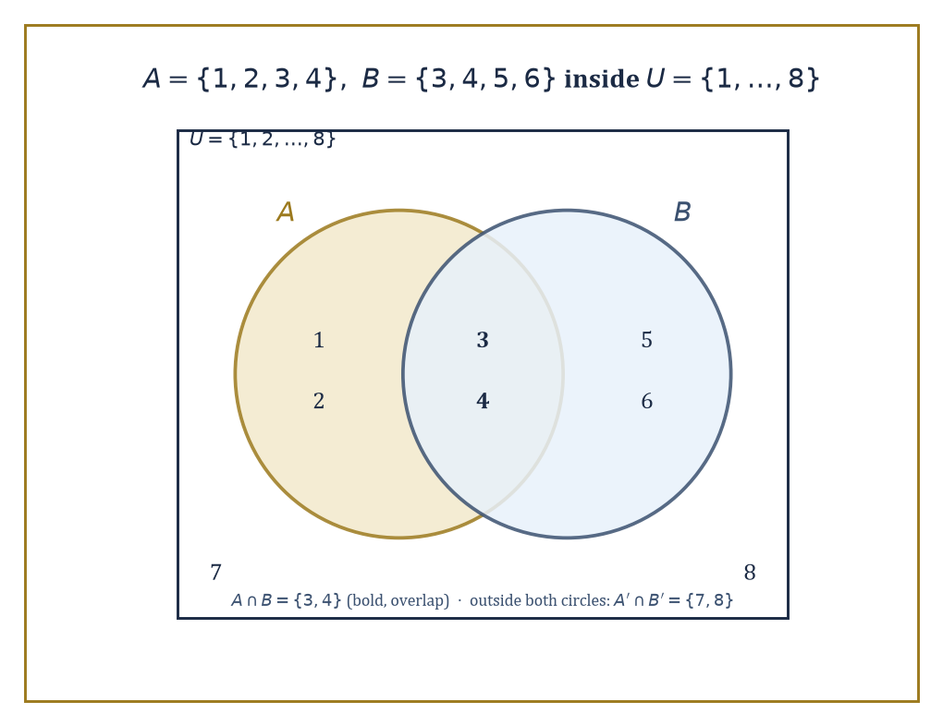
A∪B, A∩B, and the rest, drawn out for A={1,2,3,4} and B={3,4,5,6} inside U={1,…,8}.
The union A∪B collects everything in A or B (or both); the intersection A∩B keeps only what's in both; the difference A\B keeps what's in A but not B; and, relative to some fixed universal set U, the complement keeps everything outside A:
A' = U\A
The power set 𝒫(A) — met already in Room 25.1 — is the set of all subsets of A, including ∅ and A itself.
Numeric example — The four operations, computed. Let A = {1,2,3,4} and B = {3,4,5,6}, both subsets of a universe U = {1,2,...,8}.
A∪B = {1,2,3,4,5,6}
everything in either.
A∩B = {3,4}
only the overlap.
A\B = {1,2}
in A, kicked out because it's also in B: 3 and 4 leave.
B\A = {5,6}
the symmetric idea, the other way.
A' = U\A = {5,6,7,8}
everything in U not in A.
𝒫(A∩B) = 𝒫({3,4}) = {∅, {3}, {4}, {3,4}}
a set of 4 = 2² elements, since A∩B itself has 2 elements. Every one of these is a fact you could, if pressed, verify by literally checking each of the eight elements of U against each set — tedious, finite, and completely rigorous.
Sets alone cannot express order — {1,2} and {2,1} are the same set — so ordered pairs need a separate trick. The standard device, due to Kuratowski, defines the ordered pair as:
(a,b) := {{a},{a,b}}
From ordered pairs, the Cartesian product is defined as:
A×B := {(a,b) : a∈A, b∈B}
collecting all pairs with first coordinate from A and second from B. A relation between A and B is simply any subset of A×B — a rule for which pairs 'count' as related. Functions are the special case of relations that are single-valued and total: for every input in A there is exactly one related output in B.
Numeric example — Pairs that remember their order. Check that Kuratowski's trick actually distinguishes (1,2) from (2,1). By the definition:
(1,2) = {{1},{1,2}}
(2,1) = {{2},{1,2}}
These are different sets, because {1} ∈ (1,2) but {1} ∉ (2,1) — the set {{2},{1,2}} contains only {2} and {1,2}, neither of which equals {1}. So the ordered pair genuinely encodes which coordinate came first, using nothing but braces and membership.
For the product: with A = {1,2} and B = {x,y}:
A×B = {(1,x), (1,y), (2,x), (2,y)}
exactly
|A|·|B| = 2·2 = 4
pairs, as expected.
Not every relation is a function, and the distinction matters enormously — it is, for instance, exactly the difference between 'a rule that assigns each student one grade' and 'a rule that assigns some students several grades and others none.'
Numeric example — Function or merely a relation?. Let A = {1,2,3} and B = {a,b}. Consider the relation:
R = {(1,a), (2,b), (3,a)} ⊆ A×B
R is a function: every element of A appears as a first coordinate exactly once (1 pairs only with a, 2 only with b, 3 only with a), so each input gets exactly one output.
Contrast:
R' = {(1,a), (1,b), (2,a)}
here 1 appears twice, paired with both a and b — R' is a perfectly good relation (a subset of A×B), but it is not a function, since it fails to assign 1 a single, unambiguous value.
R'' = {(1,a), (2,b)}
R'' is single-valued but not total (3 has no output at all) — also not a function on all of A. A function needs both properties: exactly one output, for every input, no exceptions.
Two further structures deserve names. An equivalence relation ~ on a set is one that is reflexive, symmetric, and transitive; it partitions the set into disjoint equivalence classes, and the set of these classes is the quotient set, written A/~.
A partial order, by contrast, need not relate every pair of elements, but where it does relate them, it does so consistently (reflexively, antisymmetrically, transitively) — producing a hierarchy rather than a partition. Both constructions are used constantly throughout mathematics, frequently without anyone pausing to remark that a quotient set is, underneath, exactly what was just defined here.
Numeric example — Congruence mod 3 chops nine numbers into three piles. Let S = {0,1,2,3,4,5,6,7,8} and define x ~ y iff x and y leave the same remainder on division by 3 (equivalently, 3 divides x−y). Check the three axioms hold: reflexive, since x−x=0 is divisible by 3; symmetric, since if 3 | x−y then 3 | y−x; and transitive, since if 3 | x−y and 3 | y−z then 3 | x−z, because (x−y)+(y−z)=x−z. So this is a genuine equivalence relation.
The equivalence classes are:
[0] = {0,3,6}
[1] = {1,4,7}
[2] = {2,5,8}
These three classes are disjoint and their union is all of S — a partition, exactly as promised. The quotient set:
S/~ = {[0],[1],[2]}
has just 3 elements, even though S itself had 9; this three-element quotient is, in fact, the set usually written ℤ/3ℤ once S is extended to all the integers. 'Clock arithmetic' on a three-hour clock is nothing more exotic than this quotient set.
All of this — unions, products, relations, quotients — is 'naive' set theory: intuitive, unrestricted, and, as it turns out, dangerous if pushed too far.
The trouble is unrestricted comprehension: the assumption that any property you can state defines a set (the set of all x such that [property]). Bertrand Russell noticed in 1901 that this assumption collapses under its own weight.
Abstract example — Russell's paradox, in full. Suppose, naively, that for any property you can define, there is a set of exactly the things with that property. Consider the property 'x is not a member of itself,' and let R be the resulting set:
R = {x : x∉x}
Now ask the innocent question: is R a member of itself? Case one: suppose R∈R. Then, by R's defining property, R must satisfy x∉x — that is:
R∉R
Contradiction. Case two: suppose R∉R. Then R does satisfy the defining property 'x∉x', so by definition of R:
R∈R
Contradiction again. Either answer refutes itself; R can be neither a member of itself nor not a member of itself, which is absurd for something that is supposed to be a well-defined set. The fault lies not with logic but with the assumption that every property carves out a set — an assumption axiomatic set theory (ZFC) repairs by replacing unrestricted comprehension with more careful, restricted axioms (Separation, Replacement, and friends) that build new sets only from ones already known to exist. It is, in a phrase, the mathematical equivalent of realising you cannot simply declare a barber who shaves everyone who does not shave themselves, and then ask who shaves the barber.

Room 25.3: Infinite Sets, Cardinality, and Cantor's Theorems
In which some infinities turn out to be more infinite than others
Two sets have the same cardinality — the same 'size', even if both are infinite — if there is a bijection between them: a function that is one-to-one and onto, pairing every element of one set with exactly one element of the other and leaving nothing unpaired on either side. This single idea is what lets us compare infinities at all.
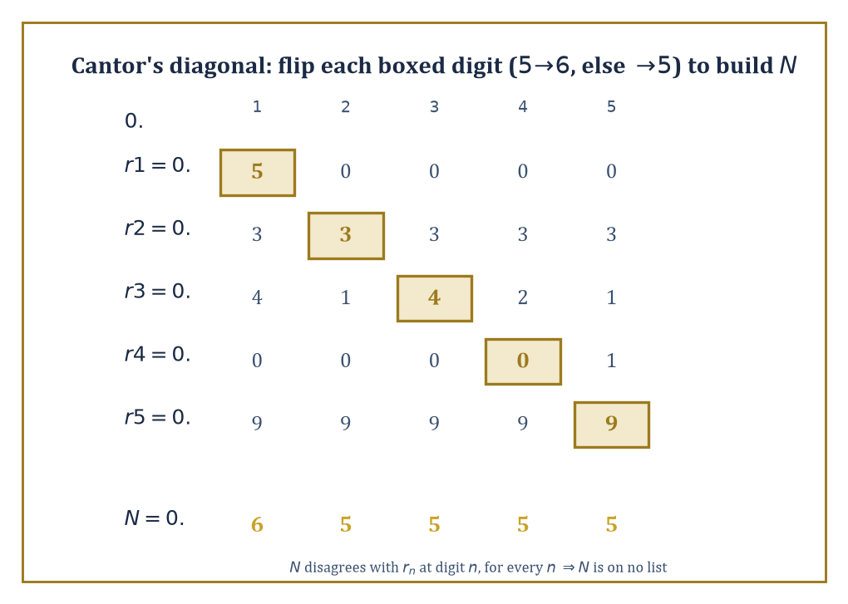
The diagonal argument on the room's own five rows: flip each boxed digit to build a number no list could have contained.
A set is called infinite, in fact, precisely when it can be put in bijection with a proper subset of itself — a property no finite set can have (you cannot pair five items with four of them and leave none out), but which every infinite set has in abundance.
Numeric example — The naturals and the integers are the same size. It looks obvious that ℤ = {...,-2,-1,0,1,2,...} should be 'twice as big' as ℕ = {0,1,2,3,...}, since ℕ is missing all the negative numbers. Cardinality disagrees. Define f: ℕ→ℤ by:
f(n) = n/2 if n is even, and f(n) = -(n+1)/2 if n is odd
Compute the first few values:
f(0)=0, f(1)=-1, f(2)=1, f(3)=-2, f(4)=2, f(5)=-3, f(6)=3
The outputs march through ℤ as 0, -1, 1, -2, 2, -3, 3, ... — every integer appears exactly once, positive and negative alike, zig-zagging outward. This f is a bijection: injective (no output repeats, checked by working through the even/odd cases separately) and surjective (every integer k≥0 is hit by n=2k, every integer k<0 is hit by n=-2k-1). So |ℕ| = |ℤ|, despite the strong intuitive pull the other way. This common size is called ℵ₀ (aleph-nought), the smallest infinite cardinal, and any set in bijection with ℕ is called countably infinite.
Not every infinite set is countable, and the proof that some are not is one of the great pieces of mathematical theatre: Cantor's diagonal argument. It shows that the real numbers cannot be listed off against the naturals — there are, in a precise sense, strictly more reals than naturals.
Numeric example — Cantor's diagonal argument, digit by digit. Suppose, for contradiction, someone hands you a complete list of all real numbers between 0 and 1, enumerated as r₁, r₂, r₃, .... Say the list begins:
r₁ = 0.50000..., r₂ = 0.33333..., r₃ = 0.41421..., r₄ = 0.00001..., r₅ = 0.99999...
Read off the diagonal digit from each row — the 1st digit of r₁, the 2nd digit of r₂, the 3rd digit of r₃, and so on: here, 5, 3, 4, 0, 9. Now build a new number N by changing every diagonal digit according to one fixed rule (to dodge decimal-representation ambiguities like 0.4999...=0.5000...): if the diagonal digit is 5, write 6; otherwise write 5. Applied to 5,3,4,0,9 this gives new digits 6,5,5,5,5, so:
N = 0.65555...
Check that N differs from every row on the list:
N ≠ r₁, N ≠ r₂, N ≠ r₃, N ≠ r₄, N ≠ r₅
— disagreeing respectively at digit 1 (6 vs 5), digit 2 (5 vs 3), digit 3 (5 vs 4), digit 4 (5 vs 0), and digit 5 (5 vs 9). Continuing this recipe down an infinite list produces a real number N ∈ [0,1] that disagrees with row n at digit n for every single n — so N cannot equal any r on the list, no matter how the list was drawn up. But N was supposed to be in [0,1], and the list was supposed to contain every real number in [0,1]. Contradiction: no such complete list can exist. The reals are uncountable.
Cantor's theorem generalises the diagonal trick from ℝ to every set whatsoever: the power set of any set S is strictly larger than S itself:
|𝒫(S)| > |S|
with no exceptions — not for finite sets (Room 25.1 checked 2³>3), and, this is the point, not for infinite ones either. Since 𝒫(ℕ) turns out to have the same cardinality as ℝ (via representing subsets as binary digit-sequences), this is really the same argument as the diagonal proof above, dressed differently.
Abstract example — Cantor's theorem, in general. Suppose, for contradiction, that some set S did have a bijection f: S → 𝒫(S) matching each element to a subset of S. Define the 'diagonal set':
D = {x ∈ S : x ∉ f(x)}
the set of elements that are not members of their own assigned subset. Since f is supposed to be onto, D = f(a) for some a ∈ S. Now ask: is a ∈ D?
If a ∈ D, then by D's definition a ∉ f(a) = D — contradiction. If a ∉ D, then a ∉ f(a), which is exactly D's membership condition, so a ∈ D — contradiction again.
Either way, disaster: no such a can consistently exist, so f cannot have been onto after all, and no bijection S → 𝒫(S) exists. Compare this argument, element by element, to Russell's paradox in Room 25.2: 'x ∉ f(x)' is playing exactly the role that 'x ∉ x' played there. This is not a coincidence — Russell's paradox is Cantor's theorem applied to the (illegal) 'set of all sets', with f taken to be the identity.
Iterating the power-set operation — ℕ, then 𝒫(ℕ), then 𝒫(𝒫(ℕ)), and so on forever — produces an endless, strictly increasing tower of infinite cardinals, with no largest one at any stage (Cantor's theorem forbids it).
Cardinal arithmetic — addition, multiplication, exponentiation of these sizes — turns out to be strangely simple once the axiom of choice (Room 25.4) is assumed: for infinite cardinals κ and λ:
κ+λ = κ·λ = max(κ,λ)
It is exponentiation, 2^κ, that stays genuinely mysterious — mysterious enough that the question of exactly where 2^ℵ₀ sits in the hierarchy (the continuum hypothesis) is independent of the usual axioms altogether.
Worked example — Cardinal addition and multiplication collapse to the max. Check the rule κ+λ = κ·λ = max(κ,λ) on the smallest infinite cardinal, κ=λ=ℵ₀.
For addition, ℵ₀+ℵ₀ is the size of two disjoint copies of ℕ combined; send the first copy to the even numbers 0,2,4,... and the second copy to the odds 1,3,5,..., and this is a bijection from (copy 1 ⊔ copy 2) onto ℕ itself — so:
ℵ₀+ℵ₀ = ℵ₀ = max(ℵ₀,ℵ₀)
For multiplication, ℵ₀·ℵ₀ is the size of ℕ×ℕ, the full grid of pairs (m,n); the same zig-zagging-along-the-diagonals idea used on the rationals below (or the closed-form Cantor pairing function
(m,n) ↦ (m+n)(m+n+1)/2 + n
lists every pair off against a single natural number, so:
ℵ₀·ℵ₀ = ℵ₀ = max(ℵ₀,ℵ₀)
Both answers land exactly on the rule. Exponentiation refuses to cooperate: 2^ℵ₀ is not ℵ₀ at all, but the strictly larger cardinality of ℝ — the very fact the diagonal argument earlier in this room spent an entire example proving. Addition and multiplication of infinities are almost insultingly tame; exponentiation is where all the actual difficulty in the subject lives.
Countable sets — those of cardinality at most ℵ₀ — are more plentiful than the diagonal argument might suggest. The rational numbers ℚ are countable, despite being dense (between any two rationals sits another); so are the algebraic numbers (roots of polynomials with integer coefficients); so is the set of all finite binary strings.
Once you leave this discrete, listable realm, though, uncountability becomes the rule rather than the exception: ℝ, 𝒫(ℕ), the set of all functions ℕ→ℕ, the set of all subsets of ℝ — all uncountable, all strictly bigger than ℵ₀, and mostly bigger than each other.
Numeric example — Listing the rationals without missing any. It looks impossible to enumerate ℚ, since between any two rationals there are infinitely many more. Cantor's fix: arrange the positive rationals p/q in a grid, rows indexed by numerator p, columns by denominator q, and read off the grid along its diagonals (constant p+q), skipping any fraction not already in lowest terms (to avoid, say, counting both 1/1 and 2/2).
The diagonal with p+q=2 contributes:
1/1
The diagonal p+q=3 contributes:
1/2, 2/1
The diagonal p+q=4 contributes (2/2 skipped, already counted as 1/1):
1/3, 3/1
The diagonal p+q=5 contributes:
1/4, 2/3, 3/2, 4/1
Strung together, the enumeration begins:
1/1, 1/2, 2/1, 1/3, 3/1, 1/4, 2/3, 3/2, 4/1, ...
Every positive rational appears exactly once, eventually, at some finite position in this list (interleave in 0 and the negatives, by the same zig-zag trick as the ℤ example above, to get all of ℚ). A set that looked hopelessly dense turns out to be exactly as countable as ℕ itself.

Room 25.4: The Axiom of Choice and Its Equivalents
In which we agree to pick one sock from every pair, no questions asked
The axiom of choice (AC) says: given any family of nonempty sets, however large or however alien, there exists a function that selects one element from each set simultaneously — a 'choice function'.
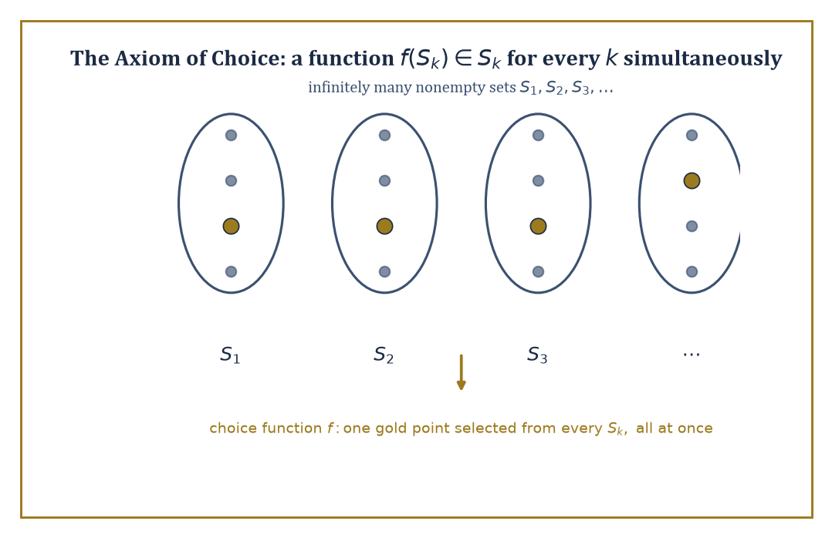
A choice function in action: one gold representative plucked from every one of infinitely many sets, all at once, no rule supplied.
Stated baldly like that, it sounds too obvious to deserve a name, let alone a century of controversy. The trouble is entirely about infinite families with no rule for choosing.
Abstract example — Russell's shoes and socks. Suppose you own infinitely many pairs of shoes, and infinitely many pairs of socks, and must pick one shoe and one sock from every pair, all at once.
For the shoes, no axiom is needed: declare 'always pick the left one' — a single explicit rule that works uniformly across every pair, because left and right shoes are distinguishable.
For the socks, assumed identical within each pair, no such rule exists; there is nothing that says 'pick this one, not that one' for a pair of indistinguishable socks.
You can certainly imagine having made a selection from each pair — but imagining infinitely many independent, unjustified selections all at once, with no rule to justify any of them, is precisely the content of the axiom of choice. It is the difference between an explicit algorithm and a bare assertion that a choice is possible.
AC is independent of the other axioms of ZFC — it can be neither proved nor disproved from them — yet it is quietly required for a striking number of theorems mathematicians would be reluctant to give up: every vector space (including infinite-dimensional ones) has a basis; every product of compact topological spaces is compact (Tychonoff's theorem); every surjective function has a right inverse (a 'section', undoing the surjection on some chosen preimage of each output).
Abstract example — A basis for an infinite-dimensional space, via Zorn's Lemma. Zorn's Lemma — logically equivalent to AC — says: if every chain (totally ordered subset) in a partially ordered set has an upper bound within the set, then the set has a maximal element.
Apply it to build a basis for a vector space V (say, V = ℝ as a vector space over ℚ, an infinite-dimensional space with no obvious finite list of 'axes'). Let P be the collection of all linearly independent subsets of V, partially ordered by inclusion ⊆.
Take any chain — a family of linearly independent sets totally ordered by inclusion — and let its union U be the proposed upper bound. Is U linearly independent? Any finite subset of U consists of finitely many vectors, each drawn from some set in the chain; since the chain is totally ordered, the largest of those finitely many sets contains all the others, so the whole finite subset already sits inside one linearly-independent set from the chain — hence it is linearly independent.
So U is linearly independent, and Zorn's Lemma applies: P has a maximal element B. If B failed to span V, some vector v ∉ span(B) could be added, and B∪{v} would still be linearly independent (standard linear algebra) — contradicting B's maximality. So B spans V and is linearly independent: a basis.
No one has ever written down an explicit basis of ℝ over ℚ (a 'Hamel basis'), nor ever will; Zorn's Lemma guarantees one exists without supplying so much as a hint of what it looks like. This is the flavour of every AC-powered proof: existence without exhibition.
AC comes in many logically equivalent disguises — Zorn's Lemma above, the well-ordering theorem (every set can be well-ordered, Room 25.5), the statement that every ring with identity has a maximal ideal — each more convenient than the others in different corners of mathematics.
The price of admission is non-constructivity, and, occasionally, outright pathology: the Vitali set (choose one representative from each coset of ℚ inside [0,1] under the equivalence x~y iff x−y∈ℚ) turns out to be non-measurable — it cannot be assigned any sensible notion of length at all. The Banach–Tarski theorem goes further still, showing a solid ball can be split into finitely many pieces and reassembled, using only rotations, into two solid balls each the same size as the original. Both constructions require AC essentially; without it, such monstrosities cannot be built.
Abstract example — Why the Vitali set has no length. Build a Vitali set V by AC: partition [0,1) into equivalence classes under x~y iff x−y∈ℚ, and choose — via AC, since there is no rule for preferring one representative over another — exactly one point from each class, collecting the choices into V.
List the rationals in [0,1) as q₀,q₁,q₂,... (Room 25.3 showed such a list exists) and form the translated copies:
Vₙ = {v+qₙ mod 1 : v∈V}
for each n. These copies are pairwise disjoint — two of them sharing a point would put two points of V in the same equivalence class, contradicting how V was built to hold exactly one representative per class — and their union is all of [0,1), since every x there equals v+q mod 1 for v the representative of x's class and q the appropriate rational.
Suppose, for contradiction, V has some well-defined length m (a Lebesgue measure); every translate Vₙ has the same length m, since sliding a set along the line cannot change its length. Summing the countably many disjoint pieces must reproduce the length of the whole:
1 = Σₙ m
But a countable sum of one constant m, added to itself over and over, is either 0 (if m=0) or infinite (if m>0) — never exactly 1. No value of m survives the check, so V has no length at all: a set too pathological for ordinary geometry to measure, built by AC and unbuildable without it.
One theorem so ordinary it barely feels like a theorem exposes just how invisibly AC gets used: 'a countable union of countable sets is countable.' It is assumed constantly, and it genuinely does require a choice principle — not the full-strength axiom, but a weaker cousin called countable choice — because proving it means simultaneously selecting an enumeration for each of the countably many sets involved, and nothing but a choice principle licenses infinitely many simultaneous, unjustified selections like that.
Abstract example — Why the union needs a choice, not just a listing. Suppose A₁, A₂, A₃, ... is a countably infinite family of countable sets, and the goal is to show their union ⋃ₙ Aₙ is countable, by listing its elements off against ℕ.
Each Aₙ, being countable, does have some enumeration — some bijection (or surjection) ℕ→Aₙ. But 'does have' is not 'has been handed to you'; for each n there are typically many different valid enumerations of Aₙ, and nothing in the hypothesis 'Aₙ is countable' picks out one over another.
To build a single enumeration of the whole union — interleave enumeration 1 of A₁, enumeration 2 of A₂, and so on, in the same zig-zag style as Room 25.3's rationals argument — requires first selecting one enumeration per Aₙ, simultaneously, out of infinitely many equally valid candidates with no distinguishing rule between them: precisely a choice function on an infinite family, and precisely what countable choice supplies.
Deny yourself even this weak form of AC, and it becomes logically consistent that ℝ itself is a countable union of countable sets — a statement that sounds like nonsense (it would make the uncountability proof of Room 25.3 collapse) and is exactly the sort of thing set theorists mean when they warn that AC's absence does not just remove convenience, it lets in new pathologies of its own.
Most working mathematicians accept AC without a second thought — the convenience is simply too large to refuse, and the pathologies it enables (Vitali sets, Banach–Tarski) are safely non-constructive curiosities rather than everyday hazards.
The finer question of exactly which theorems genuinely need AC, and which survive without it, is a specialised pursuit belonging to set theorists rather than to the rest of us — a bit like asking exactly which structural beams a building could, in principle, do without. Best left to people who enjoy load calculations.

Room 25.5: Ordinals, Well-Ordering, and Transfinite Induction
In which counting keeps going long after the numbers run out
An ordinal is the order type of a well-ordered set — a set equipped with a total order in which every nonempty subset has a least element (so there are no infinite descending chains). The finite ordinals are just the natural numbers 0,1,2,3,..., but well-ordering does not stop there: after every finite ordinal comes ω, the order type of ℕ itself — the first infinite ordinal, standing for 'the whole endless queue of finite numbers, viewed as a single completed object.'
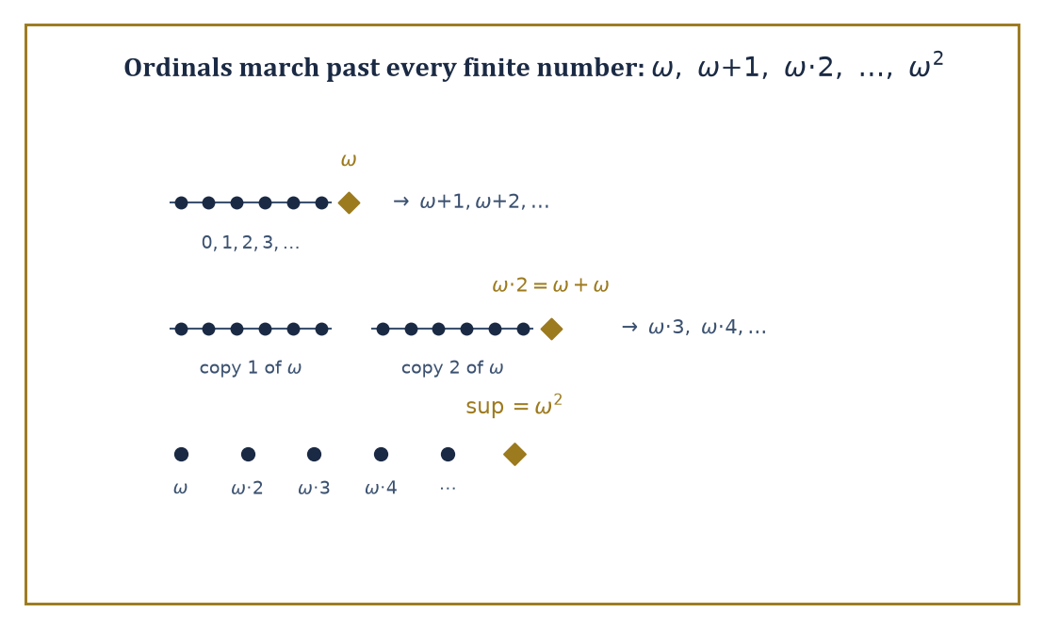
Counting past infinity: ω, then ω+1, then two copies of ω laid end to end, then the whole tower's supremum ω².
Beyond ω come ω+1, ω+2, ..., then ω·2 (two copies of ω back to back), then ω·3, and so on to
ω·ω = ω²
then ω³, and eventually ω^ω, and further still, all the way to ω₁, the first ordinal too big to be reached by any countable process at all — the first uncountable ordinal.
Worked example — Ordinal addition and multiplication do not commute. In ordinary arithmetic 1+ω would just be another name for ω+1, and 2·ω the same as ω·2. Ordinals disagree, because addition means 'lay one order after the other' — order matters.
Compute 1+ω: put a single new point before the usual ω-sequence 0,1,2,3,.... The result — one point, then infinitely many more, none of them a top element — is order-isomorphic to ω itself (just relabel: the new point becomes position 0, old position n becomes position n+1). So:
1+ω = ω
Now compute ω+1: put a single new point after the ω-sequence. The result has a top element — something greater than every one of 0,1,2,3,... — and ω itself has no such maximum. So:
ω+1 ≠ ω
it is a strictly larger ordinal, ω with one more rung.
Multiplication shows the same asymmetry. ω·2 means two copies of ω laid end to end: 0,1,2,...,then 0,1,2,... again — this equals ω+ω, which (like ω+1) has infinitely many elements with infinitely many predecessors, so:
ω·2 ≠ ω
strictly bigger. But 2·ω means ω copies of the 2-element order {0,1}, laid end to end: 0,1,0,1,0,1,.... Every element here still has only finitely many predecessors (the element in the n-th copy, at position 2n or 2n+1, has exactly that many predecessors — always a finite number), so this whole arrangement is order-isomorphic to ω after all:
2·ω = ω
Conclusion:
2·ω = ω, but ω·2 = ω+ω ≠ ω
multiplication depends on which side the multiplier sits, and the two answers are not even close.
Transfinite induction and transfinite recursion extend ordinary induction and recursive definition past ω, to any well-ordered index set.
Transfinite induction proves a statement holds for every ordinal by handling three cases: the base case (0), the successor case (assuming it holds at α, prove it at α+1), and — the genuinely new ingredient — the limit case (if it holds at every ordinal below a limit ordinal λ, prove it holds at λ itself, with no single 'previous step' to appeal to). Transfinite recursion defines objects the same way, stage by stage, taking limits at limit stages.
Worked example — Building ω² by transfinite recursion. Define a sequence of ordinals by recursion:
a₀ = ω, and aₙ₊₁ = aₙ + ω for each finite n
Unwind it:
a₀ = ω
a₁ = a₀+ω = ω+ω = ω·2
(matching the previous example)
a₂ = a₁+ω = ω·2+ω = ω·3
In general aₙ = ω·(n+1) — each step tacks on one more copy of ω. At the limit stage (n reaching ω itself, the recursion's first limit ordinal), the natural definition is:
a_ω = sup{aₙ : n<ω} = sup{ω, ω·2, ω·3, ...} = ω·ω = ω²
This single small recursion, run past its first limit stage, has just manufactured ω² out of nothing but ω and repeated addition — exactly the pattern (successor steps building, limit steps collecting) that every transfinite construction in this Tower ultimately follows.
Every well-ordered set, however exotic, is order-isomorphic to exactly one ordinal — ordinals are, in this sense, the complete catalogue of possible well-orderings, one representative of each 'shape'. And the axiom of choice (Room 25.4) turns out to be logically equivalent to the well-ordering theorem: the assertion that every set whatsoever — including ℝ, including 𝒫(ℝ) — can be well-ordered by some relation, even sets whose usual order is nothing like a well-order.
Numeric example — Well-ordering ℤ, the sneaky way. The integers ℤ, under their usual order ..., -2, -1, 0, 1, 2, ..., are not well-ordered: the whole set has no least element (for any candidate least element k, k−1 is smaller still). Yet the well-ordering theorem insists ℤ can be well-ordered somehow — and here it costs nothing to exhibit the somehow explicitly, because ℤ is countable.
Reuse the zig-zag bijection from Room 25.3's ℕ-to-ℤ example:
0,-1,1,-2,2,-3,3,...
Define a brand new order ≺ on ℤ by declaring that whichever integer appears earlier in this list counts as smaller:
0 ≺ -1 ≺ 1 ≺ -2 ≺ 2 ≺ -3 ≺ 3 ≺ ...
Under ≺, every nonempty subset of ℤ has a ≺-least element (namely, whichever of its elements appears earliest in the zig-zag list) — so (ℤ, ≺) is a well-order, with order type exactly ω, even though (ℤ, <) manifestly is not a well-order at all.
For a countable set like ℤ this reordering trick is easy and entirely explicit. For an uncountable set like ℝ, the well-ordering theorem still guarantees such a reordering exists — but no one has ever written one down, nor (it can be shown) could anyone ever write one down explicitly using the usual rules of construction. It is existence by decree, courtesy of AC, with the details permanently classified.

Room 25.6: Propositional and Predicate Logic
In which sentences get truth tables, and truth gets sentences
Propositional logic studies truth-functional combinations of atomic propositions — statements like p ('it is raining') and q ('the match is cancelled') combined via connectives: ¬ (not), ∧ (and), ∨ (or), → (implies), ↔ (if and only if).
A formula's truth value is completely determined, mechanically, by the truth values of its atoms via a truth table listing every possible combination. A tautology is a formula that comes out true on every row of its truth table — true no matter what the atoms mean, purely by its logical shape.
Numeric example — Checking a tautology, row by row. Verify that (p→q) ↔ (¬p∨q) is a tautology — a well-known identity that rewrites 'implies' using only 'or' and 'not'. There are four rows, one for each combination of p,q ∈ {True, False}.
Row 1, p=T, q=T:
p→q = T; ¬p∨q = F∨T = T; (T)↔(T) = T
true implies true is true. Row 2, p=T, q=F:
p→q = F; ¬p∨q = F∨F = F; (F)↔(F) = T
true cannot imply false. Row 3, p=F, q=T:
p→q = T; ¬p∨q = T∨T = T; (T)↔(T) = T
false implies anything. Row 4, p=F, q=F:
p→q = T; ¬p∨q = T∨F = T; (T)↔(T) = T
Every row lands on T, so the biconditional holds regardless of p and q's actual truth values: it is a tautology, and p→q and ¬p∨q are logically interchangeable everywhere. (This identity, incidentally, is exactly why 'if pigs fly, I'm the Pope' is not a promise to check the sky: with p false, p→q is automatically true, whatever nonsense q happens to be.)
Truth tables are correct but do not scale — a formula with 20 atoms needs a table with 2²⁰ rows, well over a million, which is a poor way to spend an afternoon.
Practical tools instead convert formulas into normal forms — conjunctive normal form (CNF), an AND of ORs of (possibly negated) atoms — and hunt for contradictions using resolution: from two clauses containing a literal and its negation, resolution cancels that literal and merges what remains into a single new, shorter clause.
Numeric example — Resolution finds a contradiction. Take three clauses in CNF:
(p∨q), (¬p∨q), (¬q)
and ask whether they can all be true at once (satisfiability). Resolve the first two on p: (p∨q) and (¬p∨q) contain p positively and negatively respectively, so cancel p and merge the remainders — q from one side, q from the other, which collapse into a single copy — leaving the new clause:
(q)
Now resolve this derived unit clause (q) with the third original clause (¬q): both are single-literal clauses on the same variable, so cancelling q leaves nothing behind on either side — the empty clause, a clause with no literals left at all, which stands for an outright contradiction. Deriving the empty clause proves the original three clauses cannot be satisfied simultaneously by any assignment of p and q.
(Check directly if in doubt: working through all 4 rows of a truth table for p,q confirms no row makes (p∨q), (¬p∨q), and (¬q) all true together — resolution just established this in two mechanical cancellations instead of four table rows, which is exactly the scalability resolution is for.)
Predicate logic extends this by adding quantifiers (∀ 'for all', ∃ 'there exists'), variables ranging over some domain, and predicates (relations like Prime(x) or properties like Even(x)) applied to them.
The semantics is given by a structure: a chosen domain of objects together with an interpretation telling you exactly what each predicate and function symbol means on that domain. A sentence is satisfied in a structure if it comes out true once its symbols are interpreted there; it is valid if it comes out true in every structure whatsoever, and a logical consequence of a set of sentences if it is true in every structure where those sentences are true.
Worked example — Formalising, and checking, Goldbach's conjecture. Formalise 'every even number greater than 2 is the sum of two primes' in predicate logic:
∀n (n>2 ∧ Even(n) → ∃p ∃q (Prime(p) ∧ Prime(q) ∧ n=p+q))
interpreted in the structure ℕ with the usual meanings of Even, Prime, +, and >. Check the sentence's inner claim on a few concrete instances, the way any structure's satisfaction relation is checked one case at a time:
n=4: 2+2=4
witnessed by p=q=2, since 2 is prime.
n=6: 3+3=6
witnessed by p=q=3, since 3 is prime.
n=8: 3+5=8
witnessed by p=3, q=5, since 3 and 5 are both prime. Each individual instance checks out, cheaply, by exhibiting explicit primes. What nobody has ever managed — this is Goldbach's actual, still-open conjecture — is a proof (or refutation) that the universally quantified sentence holds for every even n>2 at once; the ∀ at the front is doing genuinely infinite work that no finite list of checked instances, however long, can discharge. This is the recurring gap between 'true in every case I've tried' and 'valid' in the strict logical sense — a gap first-order logic is built precisely to keep visible.
First-order logic's expressive power is precisely calibrated, and precisely limited. It cannot, with a single sentence, directly say 'there are infinitely many x such that...' — quantifiers only ever range over individual elements, never over 'how many' in bulk.
And, more surprisingly, it cannot distinguish infinite cardinalities at all: the Löwenheim–Skolem theorems show that any first-order theory with an infinite model has models of every infinite cardinality, so no first-order sentence can pin down 'the model has exactly ℵ₀ elements' versus 'exactly 2^ℵ₀'. Higher-order logics (quantifying over sets or functions, not just individuals) and infinitary logics (allowing infinitely long formulas) buy back this expressive power — at the cost of the completeness theorem itself (Room 25.7), which holds for first-order logic and fails, in general, for its more powerful cousins.
Abstract example — Saying 'infinite' without saying it. No single first-order sentence directly asserts 'the domain is infinite' — yet infinity can still be forced indirectly, through infinitely many finite sentences working together. For each n, let φₙ be the sentence:
φₙ = ∃x₁...∃xₙ ⋀ᵢ<ⱼ xᵢ≠xⱼ
('there exist at least n distinct elements'). No individual φₙ says anything about infinity — each just demands a finite lower bound on the domain's size. But consider the infinite theory:
T = {φ₁, φ₂, φ₃, ...}
all at once. Any model satisfying every φₙ simultaneously must have at least n elements for every n — and a set that has at least n elements for every natural number n is, by definition, infinite. So T's models are forced to be infinite, even though the route there passed through nothing but finite, individually modest sentences. This is the seed of compactness, the tool that makes the trick fully rigorous — the subject of Room 25.7.

Room 25.7: Formal Proofs, Completeness, and Soundness
In which proof and truth shake hands, formally
A formal proof system fixes a stock of axioms (formulas accepted without proof) and a small set of inference rules (ways of producing a new formula from earlier ones). A derivation is a finite sequence of formulas, each one either an axiom or the output of a rule applied to earlier formulas in the sequence; the last formula in the sequence is the thing derived.
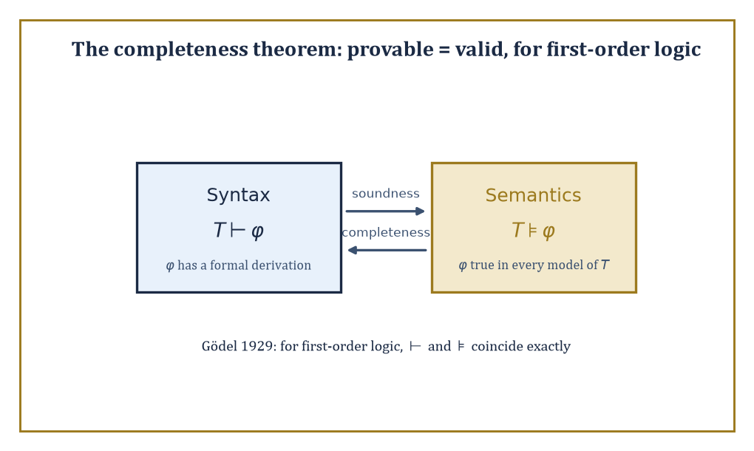
Soundness carries truth from syntax to semantics; completeness carries it back — for first-order logic, the two arrows meet.
Two properties matter above all others: soundness (every formula the system can derive really is valid — true in every structure) and completeness (every formula that really is valid can, in fact, be derived by the system). Soundness without completeness leaves truths unreachable; completeness without soundness lets falsehoods through.
A good proof system needs both, in the same way a good witness needs both to know things and to tell the truth about them — a system with only one of the two virtues is, if anything, worse than a system with neither, since at least the useless one is honestly useless.
Abstract example — A short derivation, step by step. Derive p→r from the premises p→q and q→r, using only modus ponens (from X and X→Y, derive Y) and the standard technique of conditional proof (to derive X→Y, temporarily assume X, derive Y, then discharge the assumption).
Line 1: p (temporary hypothesis, to be discharged)
Line 2: p→q (given premise)
Line 3: q, by modus ponens from lines 1 and 2
Line 4: q→r (given premise)
Line 5: r, by modus ponens from lines 3 and 4
Line 6: p→r, discharging the assumption from line 1
since assuming p led to r, this conclusion no longer depends on the temporary assumption. Six lines, two premises, one rule applied twice, and the classical 'hypothetical syllogism' p→q, q→r ⊢ p→r drops out mechanically — no cleverness required, just faithful bookkeeping. This is what 'formal proof' buys over informal argument: every step is checkable by a machine with no understanding of what p, q, and r actually mean.
Soundness is checked first, always, for good reason: a proof system's derivations are only trustworthy once soundness is nailed down, and an unsound system is worse than no system at all, since it can manufacture confident-looking 'proofs' of statements that are simply false.
Abstract example — An unsound rule, and the nonsense it licenses. Suppose someone proposes a shiny new inference rule: from ∃x P(x) ('some x has property P'), derive P(c), where c is any constant already in use elsewhere in the proof ('so the particular thing named c has property P'). It looks like harmless existential instantiation, done a little carelessly.
Apply it to a genuine, true premise:
∃x Prime(x)
true of ℕ, since (say) 7 is prime. Suppose the constant c already in play elsewhere in the proof happens to name 4, which is not prime. The flawed rule cheerfully licenses deriving:
Prime(4)
manifestly false, obtained from a true premise, via a single plausible-looking line of inference.
The actual, sound version of existential instantiation adds one crucial restriction: c must be a brand-new constant, never previously used for anything else in the proof, precisely to block this leak — a fresh name cannot smuggle in a false assumption about who it secretly refers to.
The moral: an inference rule is not innocent until proven guilty. Every rule in a formal system has to earn its soundness by an actual argument; 'looks reasonable' is not such an argument, and the gap between the two is exactly where unsound systems go to hide.
Gödel's completeness theorem (1929, his other, considerably more reassuring theorem) proves that the standard proof systems for first-order logic really are complete with respect to the usual structure-based semantics: syntax (derivability) and semantics (truth in every structure) coincide exactly.
A powerful corollary, compactness, follows almost for free: a set of sentences has a model if and only if every finite subset of it has a model. Compactness sounds like a technicality but is one of the sharpest tools in the box for building models with deliberately engineered properties — including, as glimpsed in Room 25.6, models that are forced to be infinite by nothing but finite pieces of evidence.
Abstract example — Building a nonstandard model of arithmetic, via compactness. Let T be the true first-order theory of the natural numbers (all first-order sentences true in ℕ, including the ordinary axioms of arithmetic). Extend the language with a brand-new constant symbol c, and add infinitely many new axioms:
c>0, c>1, c>2, c>3, ...
(one axiom c>n for every natural number n). Call the combined theory T'. Check compactness's hypothesis: does every finite subset of T' have a model? Any finite subset mentions only finitely many of the new axioms, say up to c>k for some largest k; interpret c as the standard number k+1 (or larger) inside ℕ itself, and every sentence in that finite subset is satisfied — so yes, every finite subset has a model.
Compactness then guarantees the full, infinite theory T' has a model too — call it ℕ*. In ℕ*, the element interpreting c must be greater than 0, greater than 1, greater than every single standard natural number simultaneously (since ℕ* satisfies every one of the infinitely many axioms c>n at once). No such number exists inside ordinary ℕ; ℕ* is therefore a genuinely different, 'nonstandard' model of arithmetic, containing an entire extra layer of infinite numbers that first-order arithmetic cannot tell apart from the standard ones using any single sentence. Compactness conjured a new mathematical universe from nothing but a consistency check on finite fragments.
The completeness theorem is, in the end, the fundamental theorem of first-order logic: it is the bridge guaranteeing that 'provable' (a syntactic, mechanical, checkable notion) and 'true in every structure' (a semantic, conceptual notion) are one and the same thing, for this particular logic.
It is worth savouring, because Room 25.8 is about to show that its cousin for arithmetic — 'every truth about the natural numbers is provable within a single fixed system' — is false. Completeness holds for the logic; it fails for the theory. The distinction is the entire content of the next room.

Room 25.8: Incompleteness and Undecidability
In which mathematics discovers its own edges
Gödel's first incompleteness theorem (1931) is the sobering counterpart to the completeness theorem of Room 25.7: it states that any consistent, sufficiently strong, effectively axiomatised theory of arithmetic — one that can express and prove basic facts about + and × — is necessarily incomplete. There exist sentences in the language of arithmetic that the theory can neither prove nor disprove, true or not.
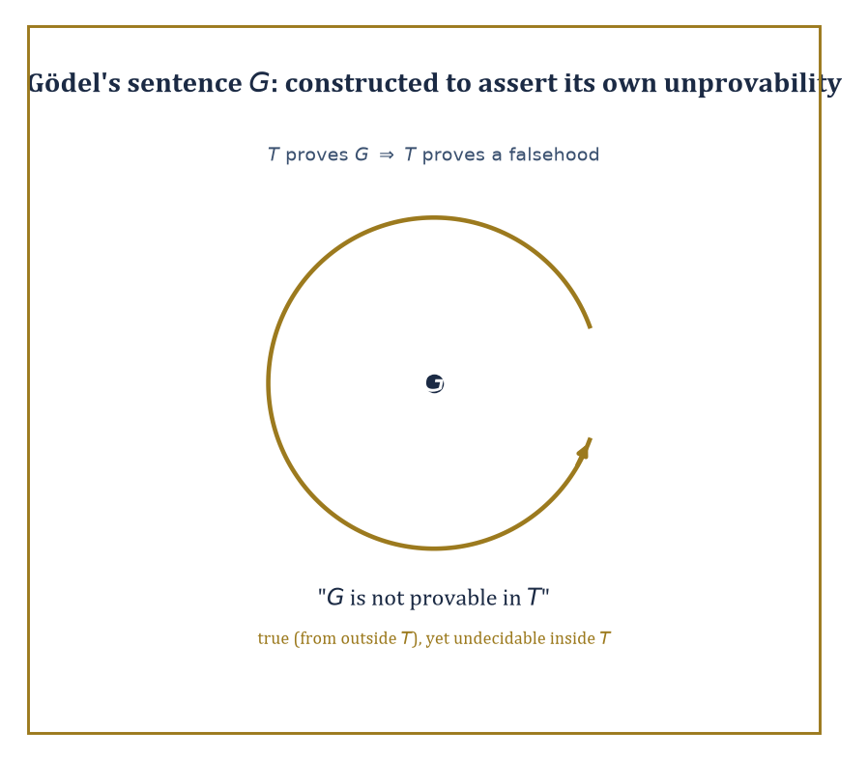
Gödel's sentence G, chasing its own tail: engineered to say exactly one true thing — that T cannot prove it.
The second incompleteness theorem sharpens the blow: such a theory cannot even prove its own consistency, using only its own resources — it would need to step outside itself to vouch for itself, and nothing can do that.
Abstract example — The sentence that talks about itself. Gödel's method (heavily compressed, and the technical machinery genuinely does deserve an entire storey to itself, not a paragraph) assigns every formula and every proof in a formal theory T a unique natural number — a 'Gödel number' — so that T's own arithmetic can talk about T's own sentences and proofs as numbers.
Using this coding, Gödel constructs a specific sentence G, cleverly engineered so that G asserts, in effect, 'G is not provable in T.'
Now reason about G assuming T is consistent. If T could prove G, then (since G says it's unprovable) T would be proving something false about itself — deeply suspicious for a consistent theory, and in fact ruled out by the careful version of the argument.
If T could prove ¬G instead, T would be asserting that G is provable — while G, if genuinely unprovable as ¬G claims it's provable, creates its own tangle that a fully rigorous treatment resolves in T's disfavour.
Either way, provided T is consistent, T can prove neither G nor its negation: G is undecidable within T, despite being — from outside T, looking in — recognisably true (it truthfully reports its own unprovability).
I am eliding a genuine technical hypothesis or two here, of the sort that has filled entire careers; readers wanting the full, watertight argument should consult a dedicated text on proof theory, and readers wanting the takeaway without the scar tissue should simply trust that the construction works.
A close cousin of incompleteness, discovered independently by Turing, is the undecidability of the halting problem: there is no algorithm that, given an arbitrary computer program and input, always correctly decides whether the program eventually halts or runs forever.
A related result, Church's theorem, shows there is likewise no algorithm deciding, for an arbitrary first-order sentence, whether it is valid. Both are undecidability results in the strict technical sense: not 'nobody has found the algorithm yet', but 'no algorithm can possibly exist, ever, for anyone.'
Abstract example — Turing's diagonal proof that halting is undecidable. Suppose, for contradiction, some program H(P, I) exists that always correctly decides whether program P halts on input I, outputting 'halts' or 'loops'.
Build a new program D that, on input P, runs H(P,P): if H reports 'halts', D deliberately loops forever; if H reports 'loops', D immediately halts. D is a perfectly legitimate program, built entirely out of the (assumed) H.
Now ask the fatal question: what does D do when run on itself, i.e. what is D(D)?
If D(D) halts, then by D's own construction that only happens when H(D,D) reported 'loops' — meaning H predicted D would loop on itself. But D(D) halted. H was wrong.
If D(D) loops forever, then by D's construction that only happens when H(D,D) reported 'halts' — meaning H predicted D would halt on itself. But D(D) loops. H was wrong again.
Either outcome contradicts H's assumed perfect reliability. So no such H can exist: the halting problem is undecidable, by an argument that is, move for move, structurally the same diagonal trick as Cantor's argument in Room 25.3 and Gödel's self-referential sentence above — swap 'is a member of' for 'halts on', and the three proofs become the same proof wearing different coats.
Gödel's own G is a strange, self-referential construction, seemingly invented purely to break the system — which invites a natural worry that incompleteness might just be a logician's parlour trick, of no consequence to ordinary mathematics.
It isn't. Concrete, mathematically meaningful statements exist that are true of the natural numbers yet unprovable in Peano Arithmetic (the standard first-order axioms for arithmetic), with no explicit self-reference in sight.
Abstract example — Goodstein sequences: ordinary-looking, secretly transfinite. A Goodstein sequence starts from a number, writes it in 'hereditary base 2' (base 2, with the exponents themselves also written in base 2, and so on all the way down), then repeatedly bumps the base up by one and subtracts 1, re-expanding in hereditary form at each new base.
Goodstein's theorem states that every such sequence, however wildly the base-bumping makes the intermediate numbers balloon — and they balloon spectacularly, starting from numbers as small as 4 or 5 and climbing, before they finally turn around, to values with far more digits than there are atoms in the observable universe — eventually reaches 0.
The theorem is true: it has a proof, but the proof requires transfinite induction up the ordinal ε₀, a limit ordinal built by the very successor-and-limit recursion of Room 25.5, only very much further out than the ω² of that room's worked example.
And here is the sting: Goodstein's theorem is provably unprovable within Peano Arithmetic itself (Kirby and Paris, 1982) — PA is simply too weak, as a formal system, to formalise the transfinite induction its own proof needs. This is Gödel's phenomenon exactly, dressed in ordinary natural-number clothing rather than in a sentence engineered to talk about itself: proof that incompleteness is not a curiosity confined to logicians' self-referential toys, but a genuine limitation with genuine mathematical casualties.
None of this — incompleteness, undecidability — means mathematics is unreliable, still less that '2+2 might secretly equal 5 somewhere.' It means something more precise and, properly understood, rather beautiful: no single formal system, however carefully built, can capture the entirety of mathematical truth about even so modest an object as the natural numbers. Truth outruns provability.
These are the edges of formalisation, discovered by formalisation's own tools — mathematics, quite late in its career, turned its most powerful method upon itself, and the method reported back, honestly, that it has limits. Few subjects manage to prove their own boundaries; set theory and logic did, in the space of about two years, in the early 1930s, and mathematics has been living with the news ever since — mostly by getting on with its work, since almost none of the sentences one actually needs to prove turn out to be Gödel sentences in disguise.

Room 25.9: Looking Ahead: From Foundations to Category Theory, Model Theory, and Beyond
In which the reflective core reflects on itself, one last time
We have, over the last eight rooms, acquired the basic vocabulary of set theory and logic: sets and their operations, cardinality and Cantor's hierarchy of infinities, the axiom of choice and its many disguises, ordinals and transfinite induction, propositional and predicate logic, the completeness theorem, and — the sobering capstone — incompleteness and undecidability.
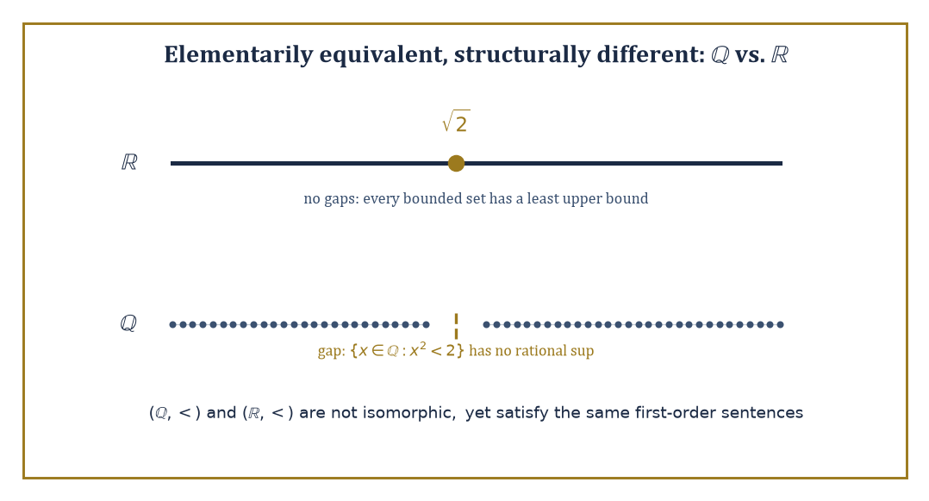
ℝ has no gaps and ℚ has a gap right at √2 — yet no first-order sentence about < alone can tell the two orders apart.
It is, by some distance, the most self-referential storey in the Tower so far: a subject that spent much of its energy examining its own foundations, and came away with results about itself rather than merely about numbers or shapes. We began the storey with nothing but ∅; we end it with an entire strictly-increasing universe of infinities, a hierarchy of formal systems none of which can fully certify itself, and a toolkit sturdy enough to build every remaining storey of this Tower upon.
These tools underwrite the rest of mathematics, but they also open directly onto further foundational subjects, each of which could easily have been its own storey. Model theory studies the relationship between formal languages and the structures that interpret them — asking, for instance, which properties a structure can and cannot 'see' using only first-order sentences.
Proof theory analyses the internal structure of formal proofs themselves, as combinatorial objects worth studying independently of what they prove. Category theory offers an entirely different foundation for mathematics, organised around morphisms (structure-preserving maps) rather than membership — a perspective some mathematicians find more natural than sets, and which reappears throughout the upper storeys of this Tower. Set-theoretic topology and the study of large cardinal axioms push further still into the higher reaches of the set-theoretic universe, well past anything this storey has had room to touch.
Abstract example — A glimpse of model theory: two orders that agree on everything sayable. The rational numbers (ℚ, <) and the real numbers (ℝ, <) are not isomorphic as orders — ℝ has no 'gaps' (it is complete: every bounded set has a least upper bound) while ℚ is riddled with them:
{x∈ℚ : x²<2} has no rational least upper bound, since √2 is irrational
Yet remarkably, (ℚ,<) and (ℝ,<) satisfy exactly the same first-order sentences in the language of order — they are what model theorists call elementarily equivalent. No first-order sentence about < alone can tell them apart, because 'completeness' (every bounded set has a least upper bound) is a statement about arbitrary subsets, and first-order logic, as Room 25.6 showed, cannot quantify over subsets at all — only over individual elements.
It takes second-order logic, quantifying over sets of elements, to state completeness and finally distinguish the two orders. This single example is model theory's entire opening question in miniature: exactly what can, and cannot, a formal language see?
Abstract example — Measuring a proof's strength in ordinals. Proof theory does not just check whether a proof exists; it measures how much proof-theoretic strength a formal system has — often, remarkably, in ordinals. Peano Arithmetic's proof-theoretic strength is calibrated by the ordinal ε₀, the very same ordinal that appeared in Room 25.8's Goodstein sequences as exactly the transfinite induction PA cannot perform.
Stronger theories are calibrated by larger ordinals still, each one a further stop along Room 25.5's tower of ω, ω², ω^ω, and beyond; each step up that ordinal hierarchy corresponds to a step up in what a formal theory can prove.
Proof theory, in other words, takes Room 25.5's abstract tower of ordinals and Room 25.8's abstract account of unprovability and turns them into a genuine measuring instrument — a single ordinal that tells you how strong a formal system is, and hence exactly how far its arithmetic can reach before it, too, meets a Gödel sentence of its own.
Abstract example — A group with no elements: category theory's alternative. Category theory's alternative to sets-and-membership is arrows-and-composition: a category consists of objects and morphisms between them, composable and associative, with an identity morphism at each object — nothing here mentions what the objects 'contain'.
Remarkably, an entire familiar structure can be recovered from arrows alone: take a category with exactly one object •, and suppose every morphism •→• is invertible (has a two-sided inverse under composition).
The collection of morphisms, with composition as the operation, is then a group — composition serves as the group operation, the identity morphism serves as the identity element, and invertibility supplies inverses; the group axioms (associativity, identity, inverses) are exactly the category axioms, read off directly.
A group, ordinarily defined as a set with a binary operation satisfying certain equations, has just been redefined with no reference to a 'set' or an 'element' in sight — purely as a pattern of arrows. This is category theory's founding move, generalised across the whole of mathematics: describe a structure by how it relates to everything around it, rather than by what, internally, it is made of.
The deeper lesson of this storey is that mathematics can turn around and examine its own foundations — and that the examination produces both reassuring theorems (first-order logic is complete; syntax and semantics agree) and sobering ones (arithmetic is incomplete; some truths will always sit just out of formal reach).
The foundations are solid enough to build every storey of this Tower upon, and interesting enough, in their own right, to have consumed some of the finest minds of the twentieth century for their own sake. Set theory and logic are, in the end, the reflective core of mathematics: the one part of the subject whose job is to watch the rest of the subject at work, and to report back, with total honesty, on exactly what it can and cannot promise.
Set theory and logic are the reflective core of mathematics — the storey where the Tower stops climbing for a moment and inspects its own foundations, floor by floor, with a torch and a slightly worried expression. We have learned to reason about the infinite (there is always a bigger infinity; there is no view from the top) and about reasoning itself (there is always a true sentence just out of reach; there is no system that proves everything about itself). Both facts are, on reflection, oddly comforting: an infinite hierarchy of infinities means the mathematician's job security is, at minimum, transfinite; and a theory that cannot prove its own consistency is, when you think about it, in exactly the same position as everyone applying for tenure.
The tower continues upward, and rather more concretely from here. Everything the next storey needs — the real line as a completed, gap-free continuum; limits defined by quantifiers (∀ε∃δ, straight out of Room 25.6's predicate logic); the guarantee that the reals really do behave the way many prior storeys of calculus assumed they would — rests on the set-theoretic construction of ℝ this storey has only gestured at. Storey 26 takes all of that as read, and puts it to work modelling how quantities change: differential and integro-differential equations, the mathematics of rates, accumulation, and everything in the universe that refuses to sit still.
We came up from the empty set. We leave with a universe of infinities, stacked one atop the next, forever, and the sober knowledge that no tower of reasoning — not even this one, not even at storey fifty — could ever prove everything true about it. Onward, undaunted, to equations that actually move.

